To see which devices are connected to our notebooks at this moment –

from tensorflow.python.client import device_lib

device_lib.list_local_devices()

**to get GPU --**

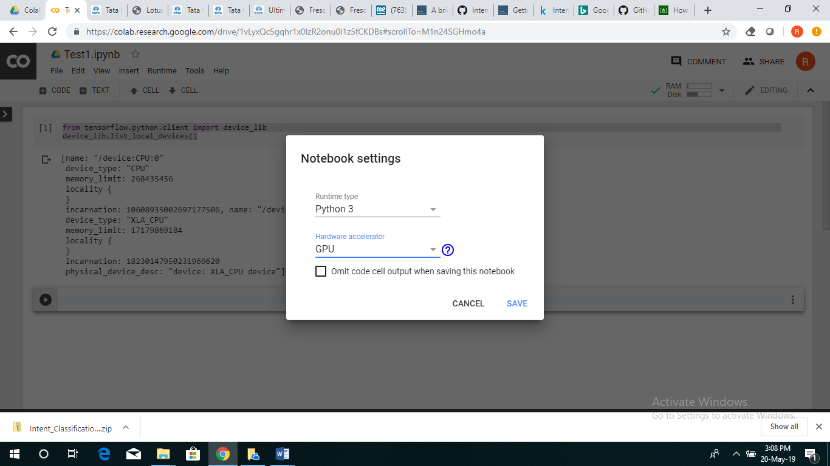

3. !pip install tensorflow

4. %cd ../

5. !ls – to see content of directory

6.

from google.colab import files

import pandas as pd

7. uploaded = files.upload()

<https://github.com/Dark-Sied/Intent_Classification/blob/master/Intent_classification_final.ipynb>

<https://github.com/ajinkyaT/CNN_Intent_Classification>

<https://blog.rasa.com/rasa-nlu-in-depth-part-1-intent-classification/>

<https://github.com/ugik/notebooks/blob/master/Tensorflow%20Rx%20chat-bot%20(build%20model).ipynb> Context setting and Response output

<https://chatbotsmagazine.com/contextual-chat-bots-with-tensorflow-4391749d0077>

<https://chatbotslife.com/text-classification-using-algorithms-e4d50dcba45>

<https://mrbot.ai/blog/natural-language-processing/understanding-intent-classification/>

<https://blog.vsoftconsulting.com/blog/intent-classification-and-its-significance-in-chatbot-development>

machine learning integration

<https://codelabs.developers.google.com/codelabs/cloud-dialogflow-bqml/index.html?index=..%2F..cloudai#0>

<https://medium.freecodecamp.org/how-i-made-a-smarter-chatbot-with-intents-5e6ad6e0fd71>

<https://cloudacademy.com/blog/how-to-build-an-intelligent-chatbot-with-python-and-dialogflow/>

<https://www.wabion.com/en/news/presse/dialogflow-google-machine-learning-fuer-chatbots-und-mehr/>

rasa

<https://github.com/sathyamoorthyrr/intent-classification-rasa-nlu>

Demystifying RasaNLU

<https://www.youtube.com/watch?v=s_ht4AKnWZg>

<https://www.youtube.com/watch?v=T_afaArR0E8>

<https://www.youtube.com/watch?v=-UYyyeYJAoQ> - IBM Watson demo

<https://www.bing.com/videos/search?q=how+to+deploy+machine+learning+model+on+server+to+make+api+call&&view=detail&mid=7FC1A4EB22DCAC67D8237FC1A4EB22DCAC67D823&rvsmid=ADC149B80BE54B0B031DADC149B80BE54B0B031D&FORM=VDQVAP>

<https://towardsdatascience.com/how-to-deploy-a-machine-learning-model-on-aws-lambda-24c36dcaed20> --- aws lambda