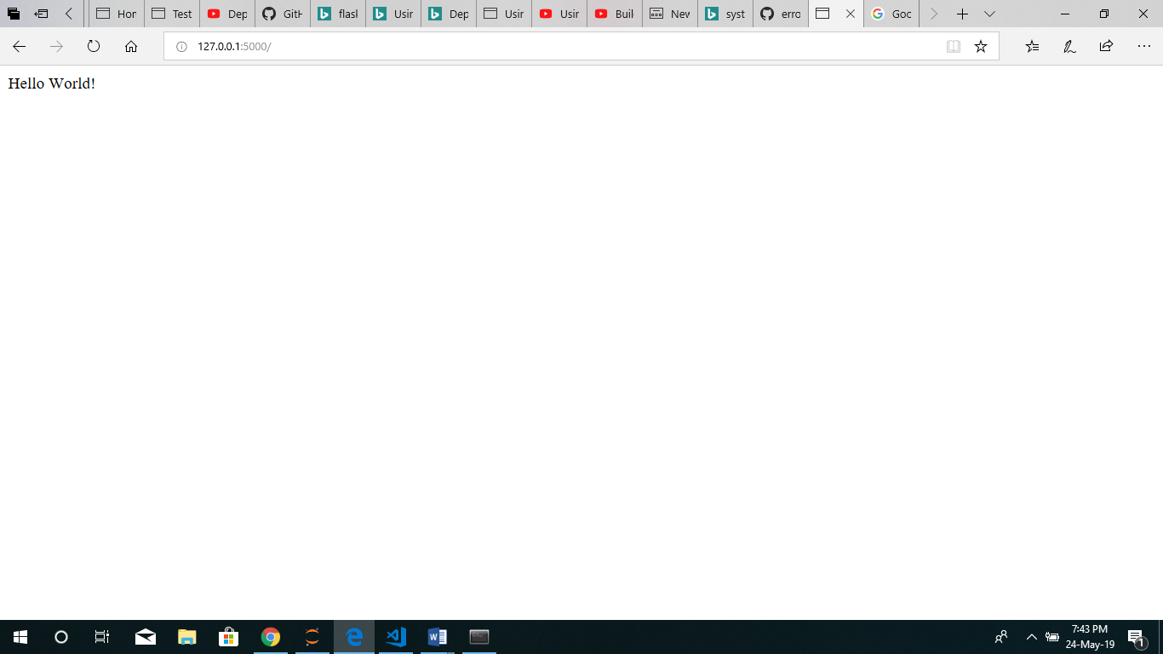

https://cl.ly/0ce22aa72ad9