InterQuartile Range

The quartiles of a ranked set of data values are three points that divide the data into exactly four equal parts, each part comprising quarter data.

Q1 = middle number between smallest value and the median
Q2 = median of the data
Q3 = middle number between median and the highest value

The InterQuartile tells where the majority of the data lies and identifies outliers in a data set.

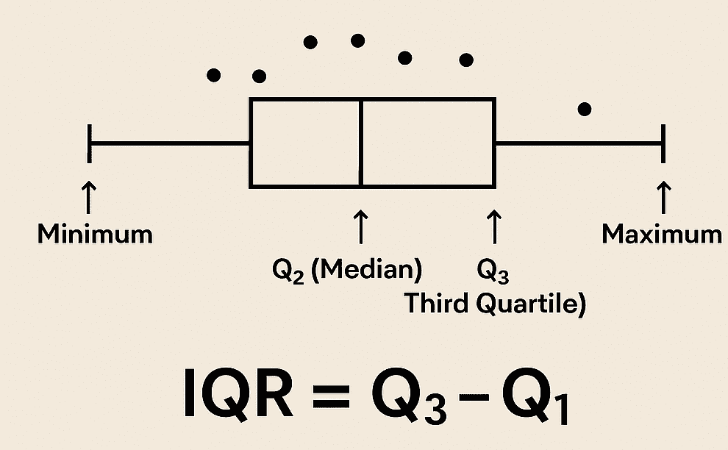

Outlier Detection : The IQR method follows 1.5 as its scale to detect outliers as it closely follows Gaussian distribution.
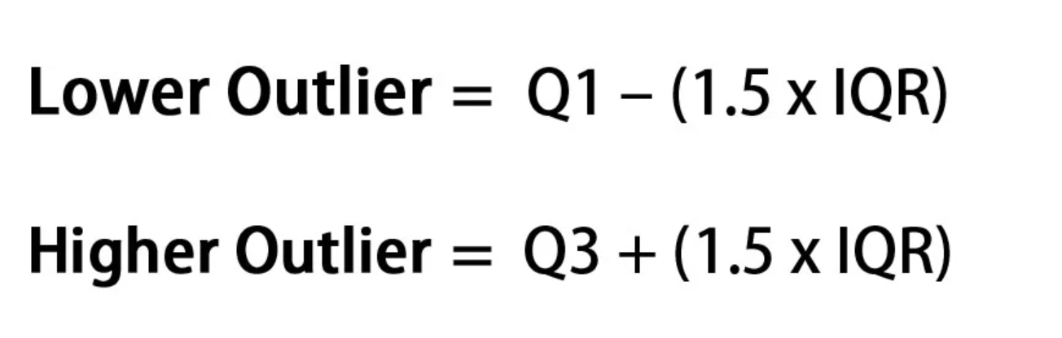

The method dictates that any data point that's 1.5 points below the lower bound quartile or above the upper bound quartile is an outlier.

