Dashboard Overview – Project Documentation
Author: Radhika Vasant Wakte
Date: 09 December 2025

Introduction
This project is a simple and interactive Dashboard Overview webpage created using HTML and CSS. It displays learning progress cards and an employee records table with a clean design.

Technologies Used
• HTML5
• CSS3

Software Used
• VS Code
• Any Web Browser

Features
• Dashboard title and subtitle
• Four learning progress cards
• Employee table with striped rows and hover effect
• Simple and responsive UI

Screenshot
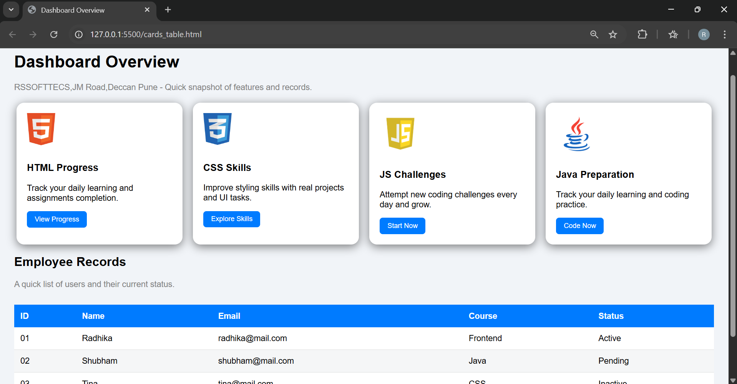

Conclusion
This dashboard webpage is clean, simple, and responsive, presenting information in a professional layout.

