The following screenshots are to look at the effect of inserting High Pass and Low Pass filters in my SDR. The first shot is of the radio with a 1.7 MHz HP and a 60 MHz LP filter
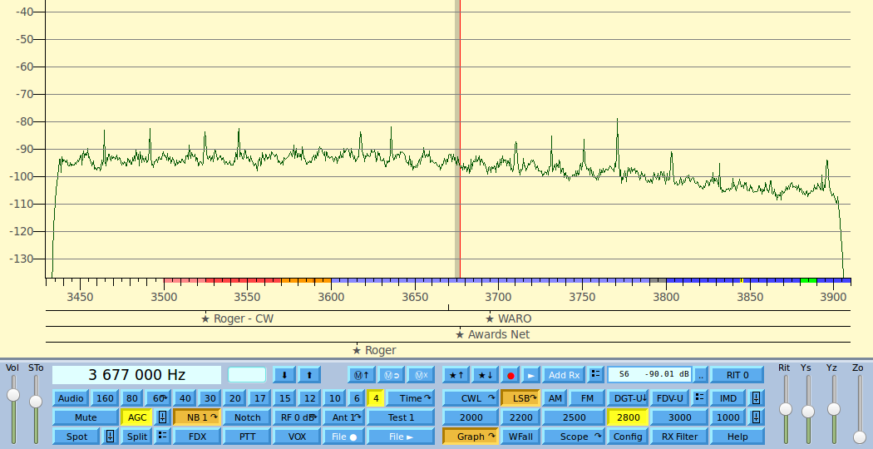
Next is with an added 3.5 MHz HP filter where improvement can be seen of ~4 dB with a .9 dB insertion loss filter i.e. at least 3 dB noise reduction.
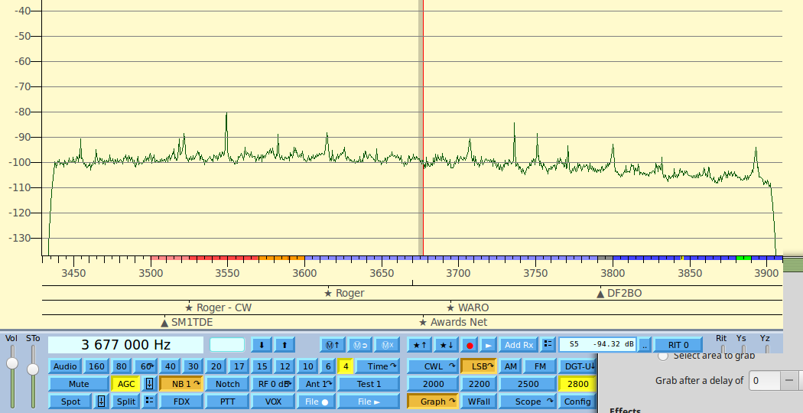
Finally the same as before with an added 4 MHz LP filter to give a bandpass for 80 M band.
