The following are a set of plots for suitable Hi pass filters for Hermes lite. All filters are 5 pole Cauer and designed with a maximum of 2 E12 caps in parallel but in most cases will be a single capacitor.

160 Metre Plot and schematic follow
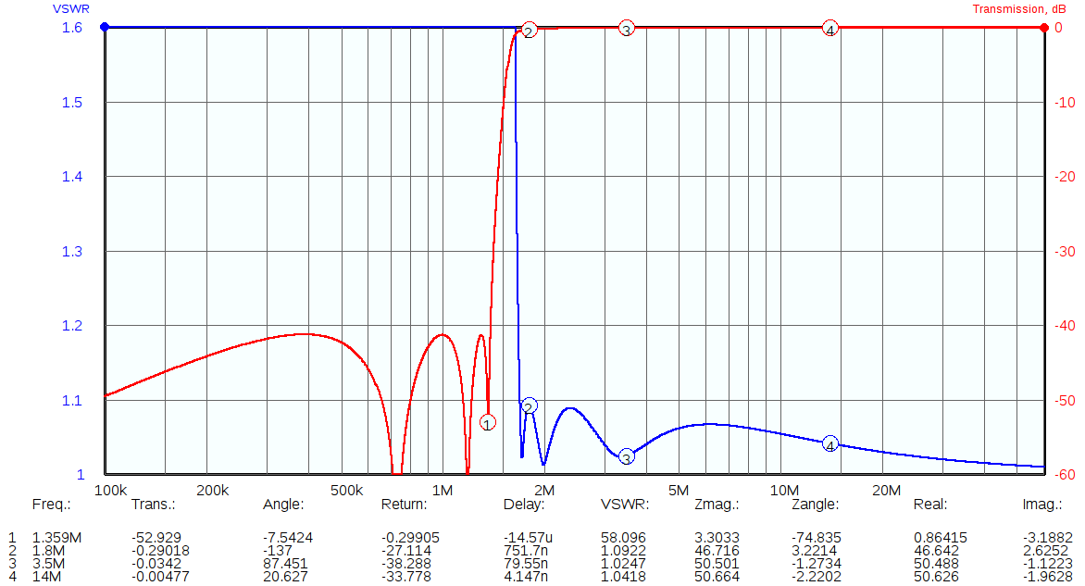
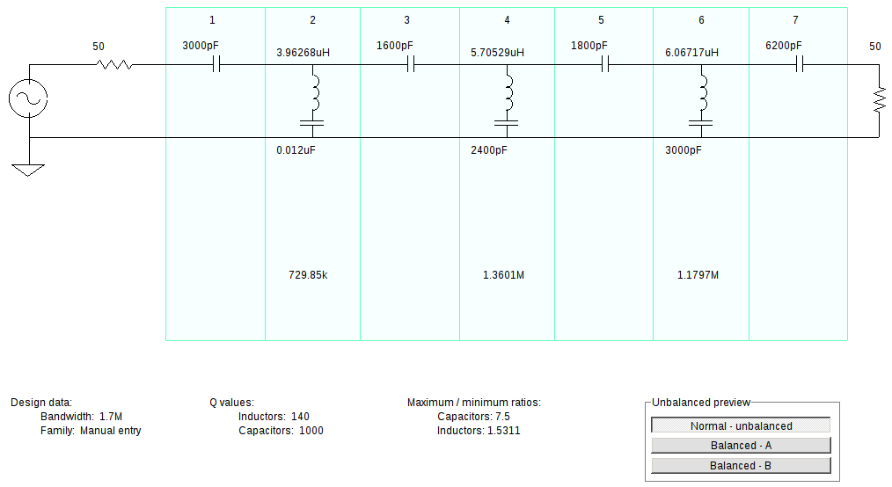

80 Metre Plot and schematic follow
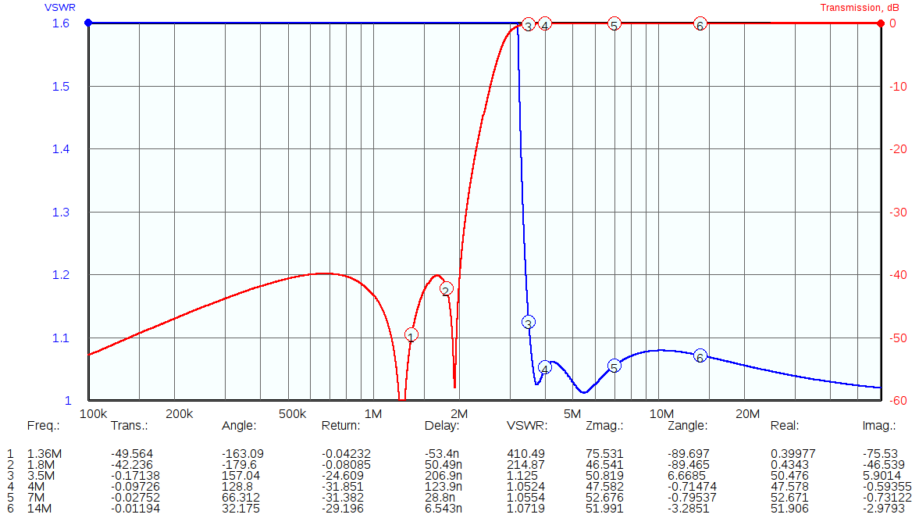
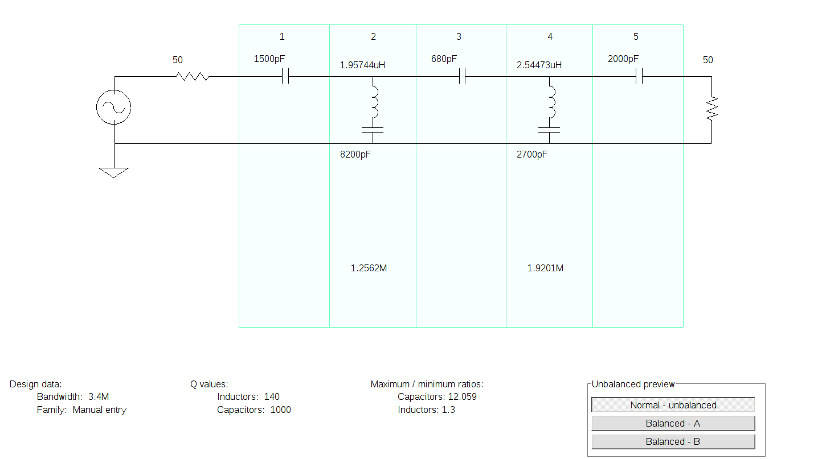

40 Metre Plot and schematic follow
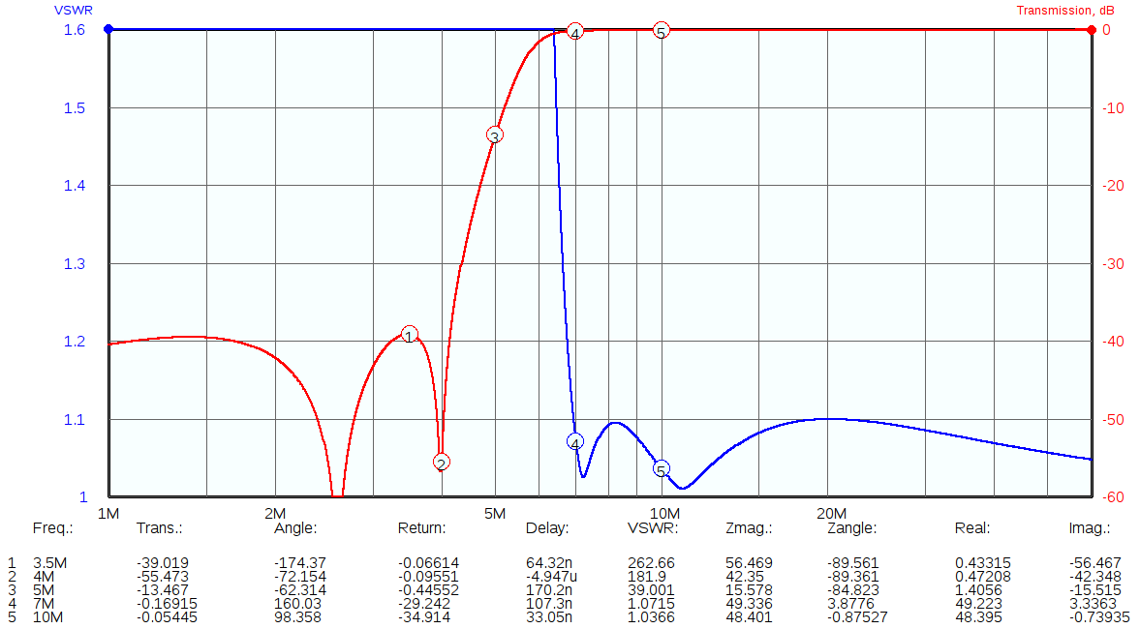
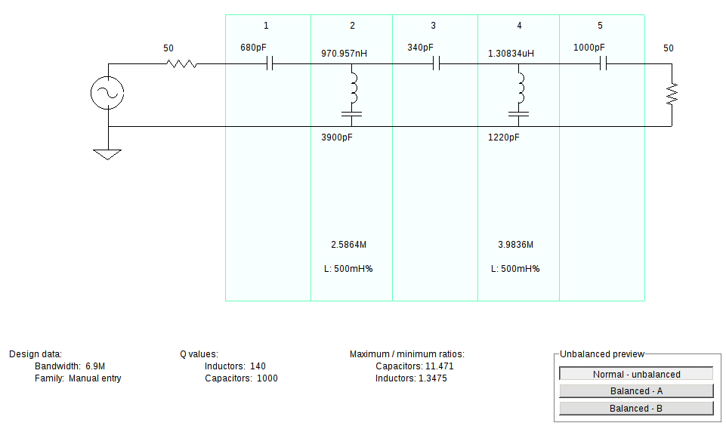
30-20 Metre Plot and schematic follow
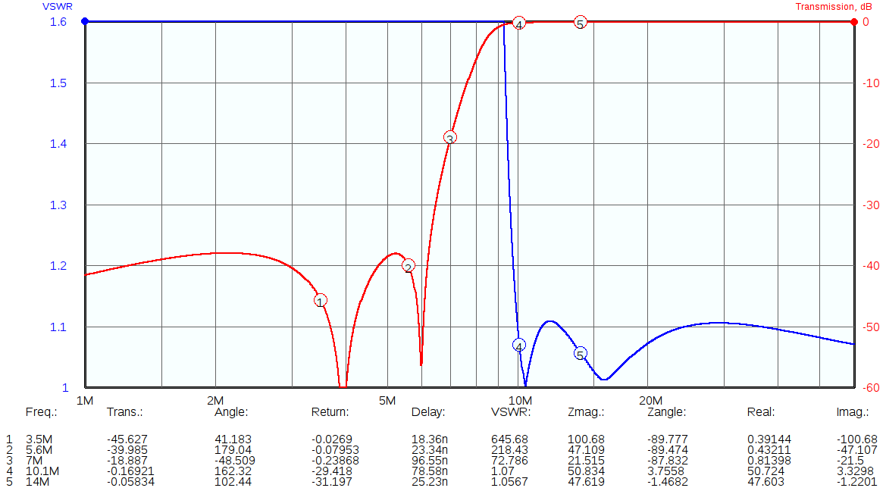
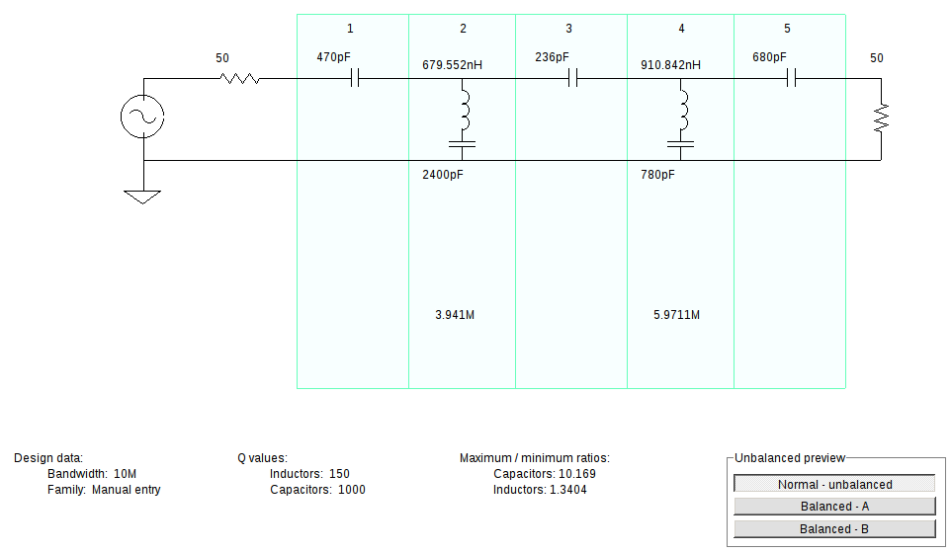

17-15 Metre Plot and schematic follow
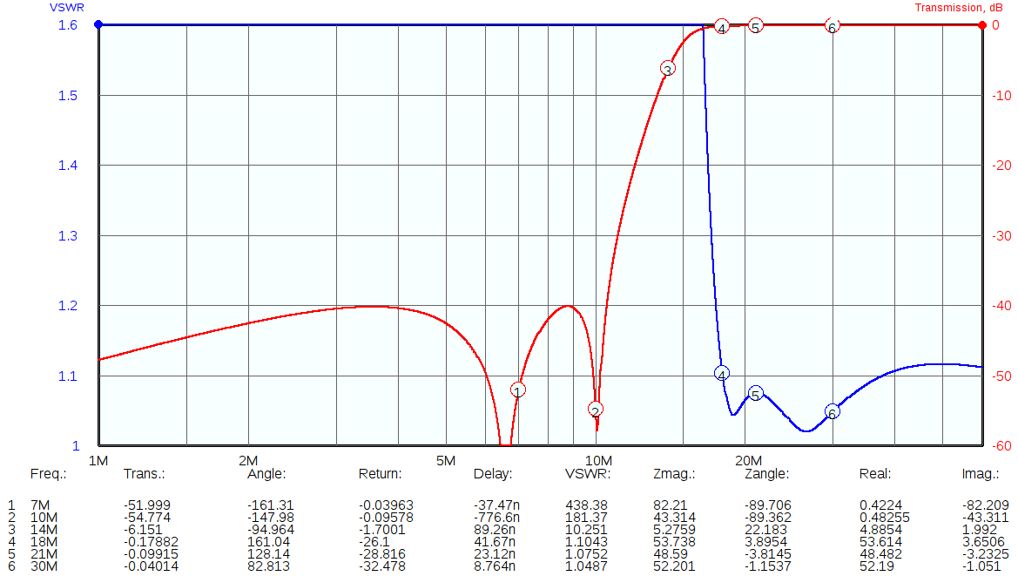
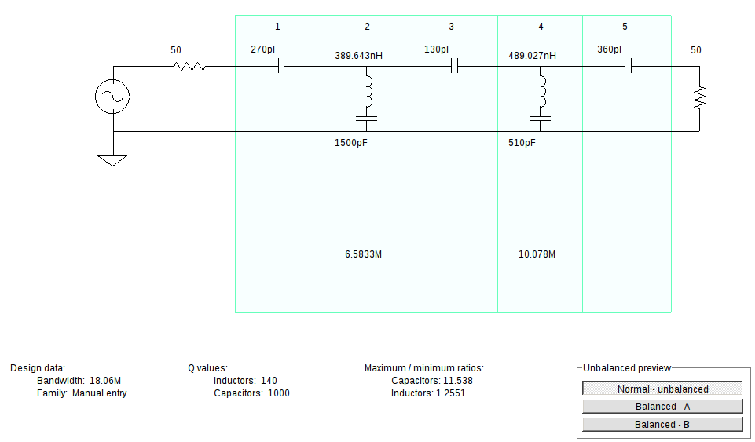

12-10 Metre Plot and schematic follow
