The following are a set of plots for suitable Hi pass filters for Hermes lite. All filters with the exception of the 30 Mhz roofing filter are 5 pole Cauer and designed with a maximum of 2 E12 caps in parallel but in most cases will be a single cap.

160 Metre Plot and schematic follow
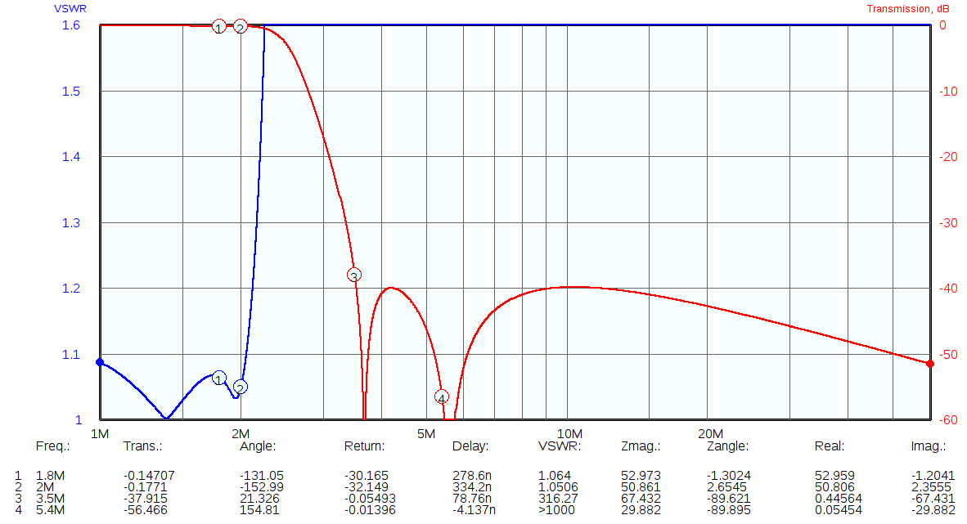
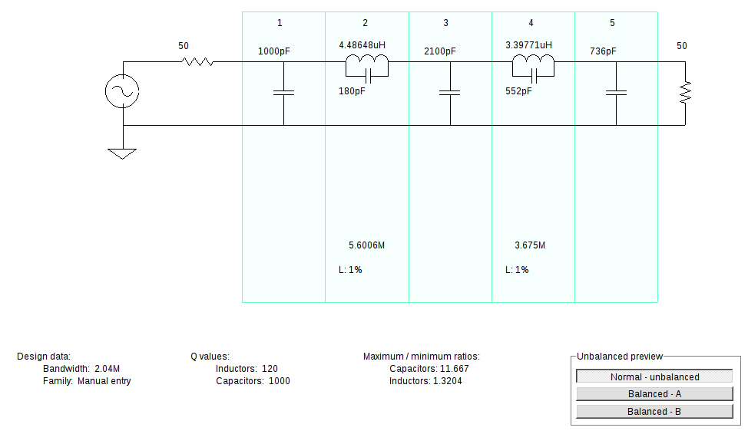

80 Metre Plot and schematic follow

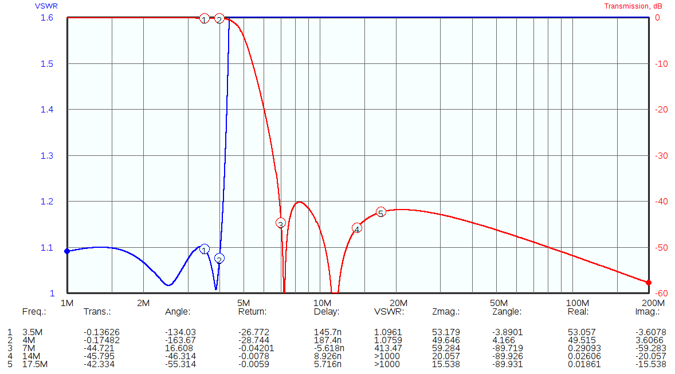
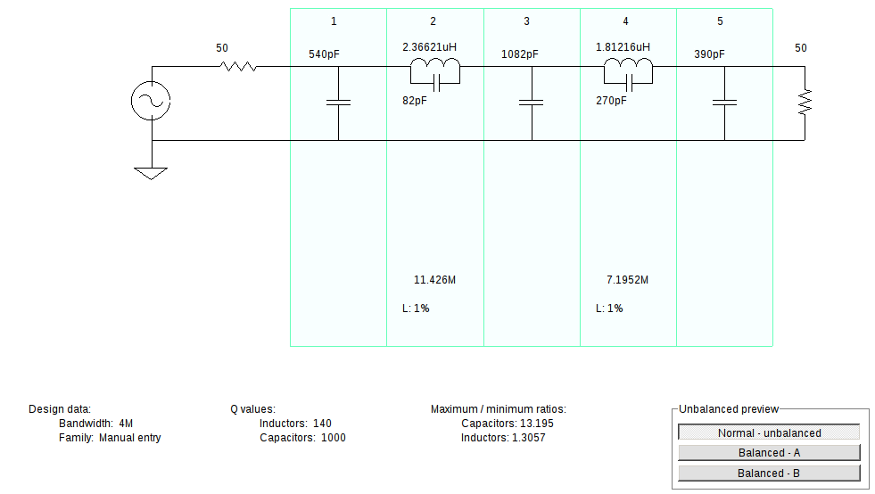

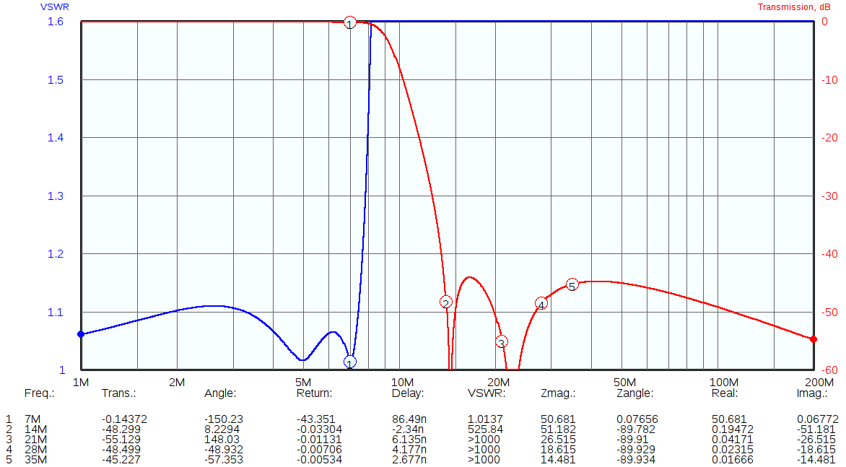
40 Metre Plot and schematic follow

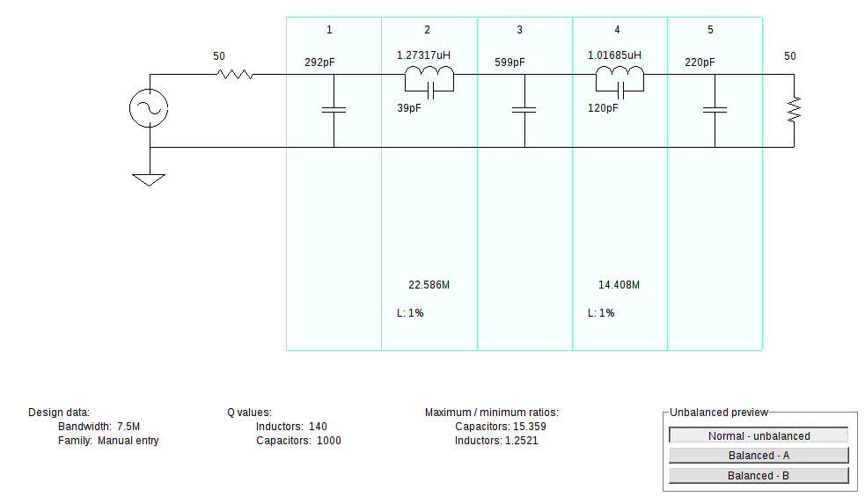

60/40 Metre Plot and schematic follow. This filter compromises the absolute stopband floor to accommodate the 60 metre band with a value of around 35 dB stopband attenuation.

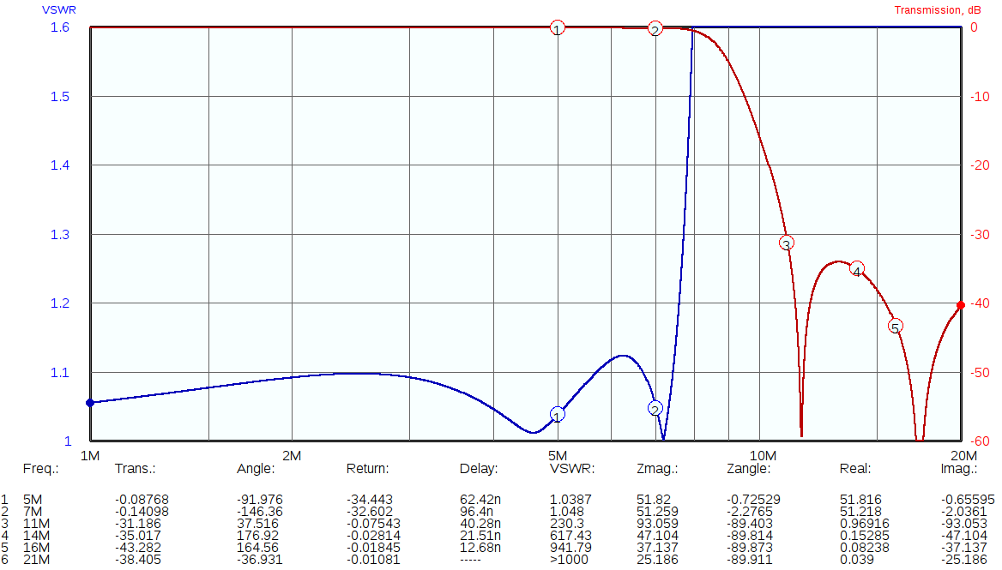

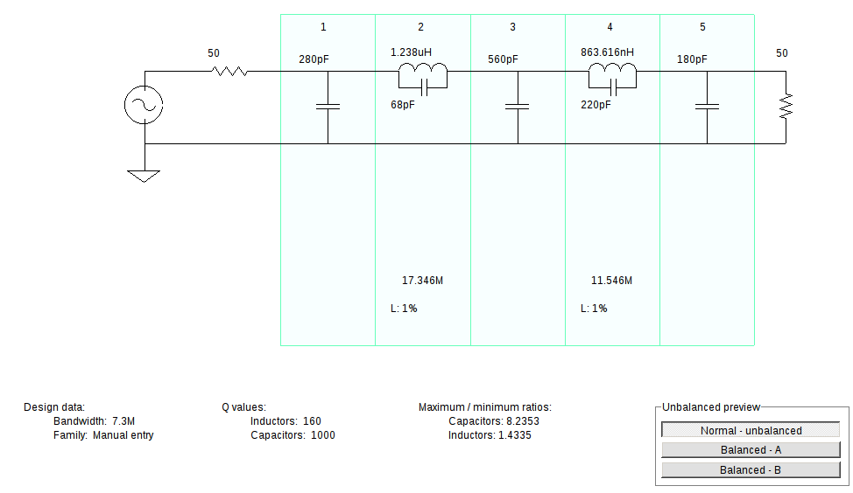

30-20 Metre Plot and schematic follow
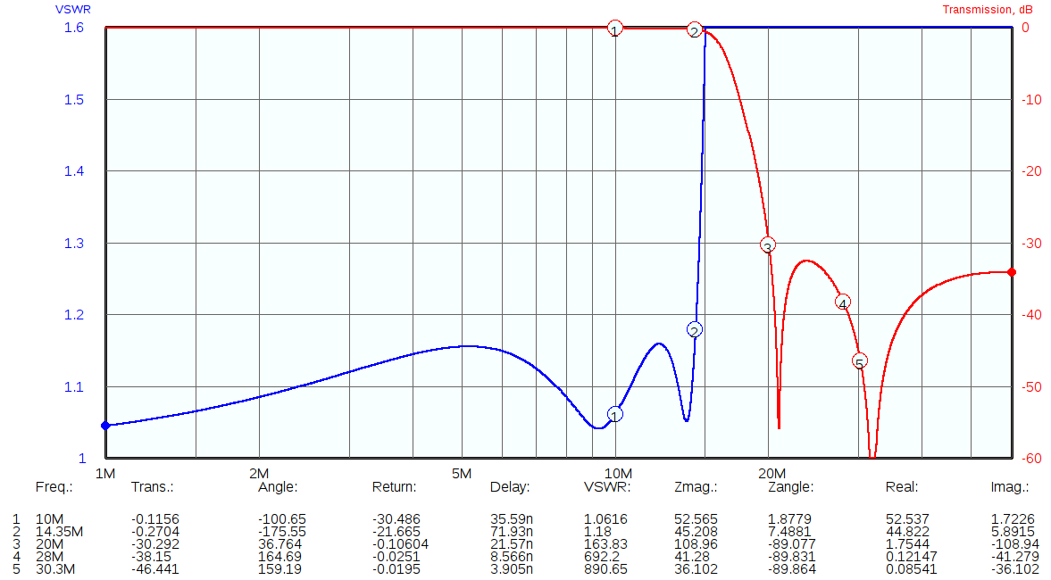
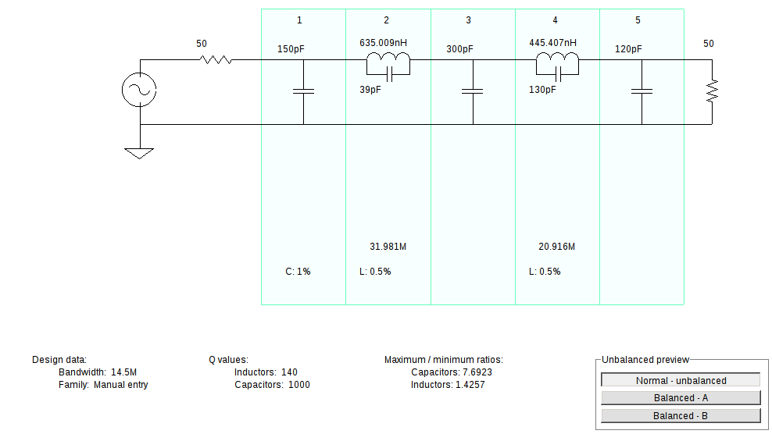

17-15 Metre Plot and schematic follow
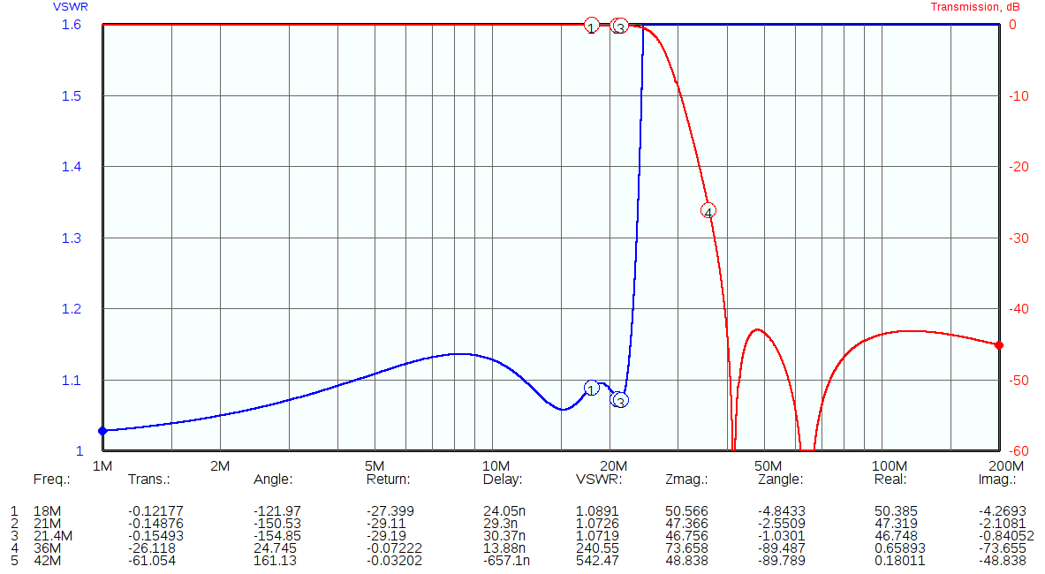
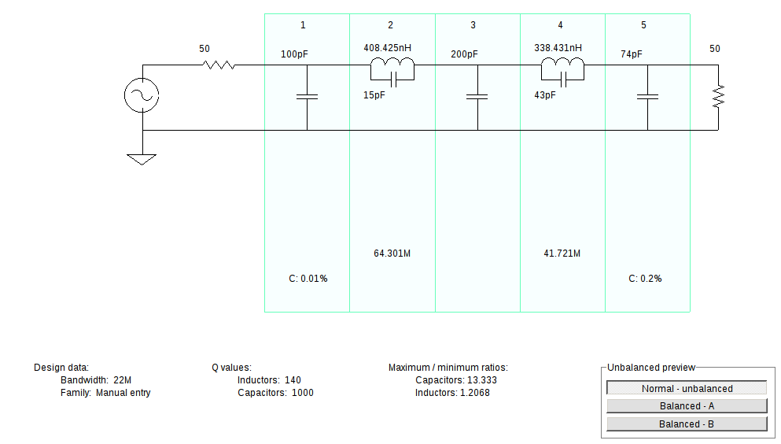
12-10 Metre Plot and schematic follow
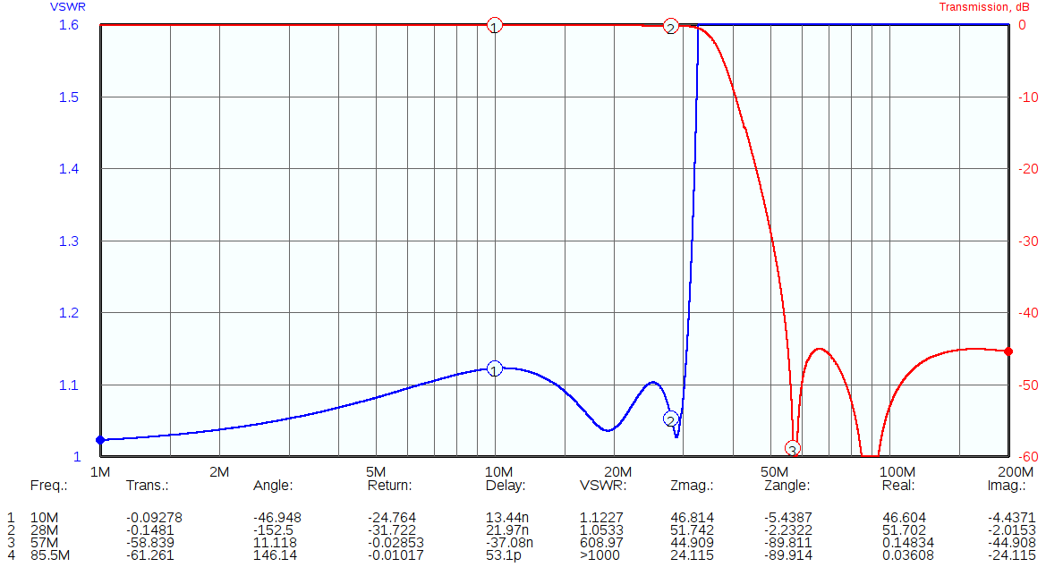
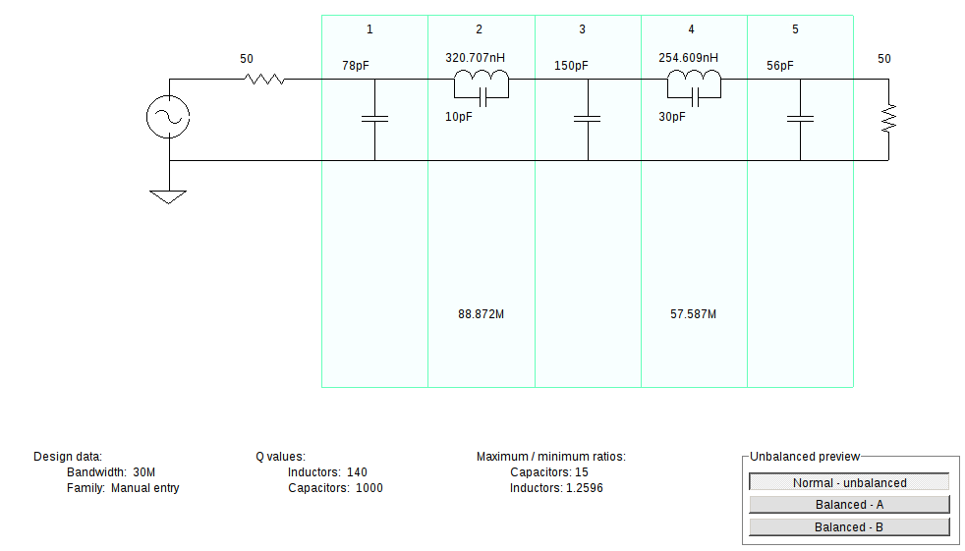
This is an improved 12/10 M filter with better VSWR in passband. A trivial amount of attenuation was sacrificed to get this result. 318.849 nH = 11t and 243.026 nH = 10t all on t37-10 cores.

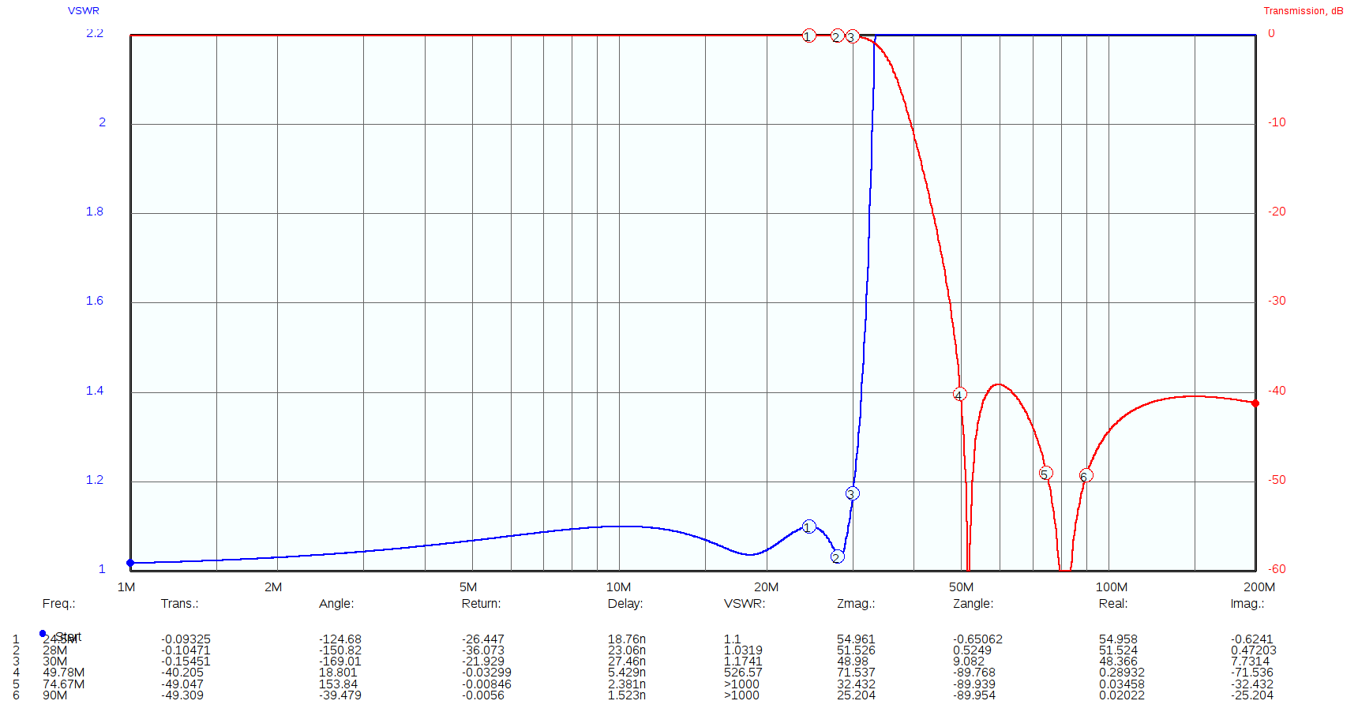
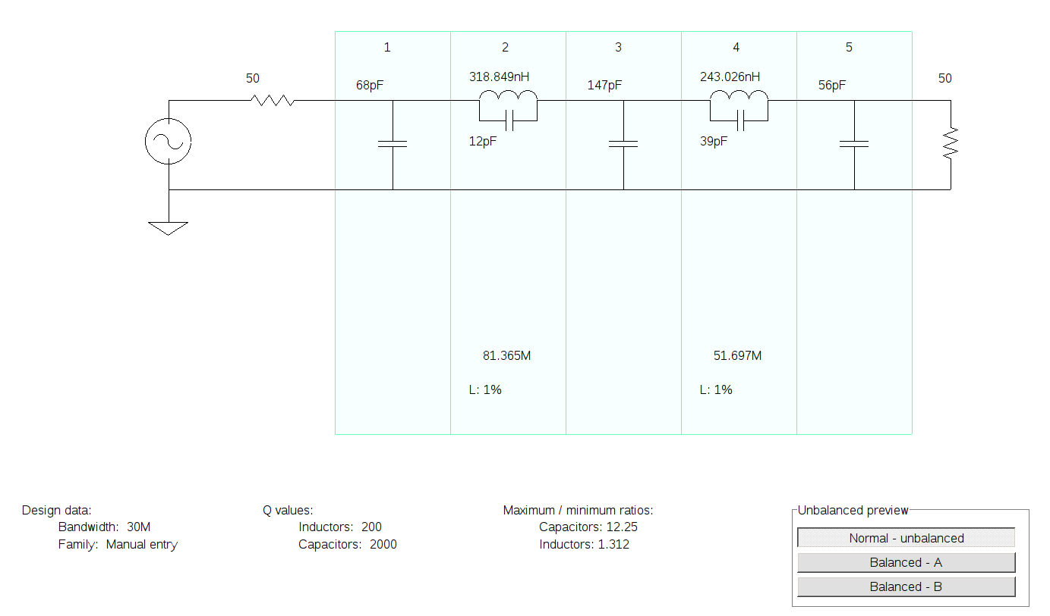

6 Metre Plot and schematic follow
