ShiftRegister connection
The library has been tested with varios configurations and shiftregisters. Please see schematics below for information.
Other ASICs are not supported, but it should be straight forward to do so.

Non Latching Shift Register
Schematics from the original project home: Shift Register project home
Two wire non latching Shift Register Schematic. 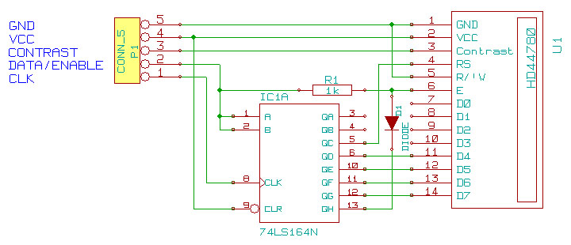
#include <LCD.h>
#include <LiquidCrystal_SR.h>

// constructor prototype parameter:
// LiquidCrystal_SR lcd(DataPin, ClockPin);
LiquidCrystal_SR lcd(2, 3);

void setup ( )
{
lcd.begin ( 16, 2 );

// your code here...
}

void loop ()
{
// your code here ...
}
Three wire non latching Sh

