The advantages of high speed switching (QSK) without the clatter of relays lead me to investigate the feasibility of a PIN diode T/R relay. In my research I came across the claim that 1N4007 diode had an intrinsic layer added between its P and N Junction to increase the voltage rating of the diode compared to the 1N4004's or 1N4006's. It appears that a number of radios use the 1N4007 for switching including the Elecraft K2 and an excellent article was written by Wes Hayward W7ZOI in QEX (ref 1) and his book Experimental Methods in RF Design Ref (2) and an excellent implementation of the method was done by Gary Johnson WB9JPS (ref 3) which is easier to get access to than the Hayward articles. The switch presented here is designed for up to 50 watts and is intended for a QRP rig or a driver for a linear etc. It has been soak tested at 100 watts though and coped splendidly.

Briefly the PIN diode (fig1) operates on the principle of a positive and negative junction formed on each side of an intrinsic layer of silicon to increase the minority carrier lifetime. Simply this means that when the diode is reverse biased the minority carriers cause the diode to continue to conduct briefly and it acts as a resistor for this period which in a good low frequency PIN diode will be hundreds of nano seconds. Supposedly the 1N4007 was manufactured this way and at 50 or 60 Hz the slow turn off has no effect but does at 2 MHz upwards. It seems to me that originally this may have been the case but I suspect that current manufacturers do not use the original dies and simply make a diode that fits 1 KV PIV and 1 Amp forward current. In my junk box I have a packet of 40 year old 1N4007's and have done all my experimenting with them. An excellent investigation into the minority carrier lifetime of the 1N400x series was done by Jack Smith of Clifton Laboratories (Ref 4) and this whole site is a goldmine of information generously shared with the world. While slow turn off PIN characteristic diodes have huge advantages, any diode will switch RF as long as the forward current is greater than the RF current so maybe the minority carrier lifetime is less important in practice.

PIN diode switches take the form of fig 2. where forward bias via the current limiting resistor and the isolating chokes being applied to the diode causes it to become a very low value resistor and reverse bias causes it to become a small capacitor. The DC bias supply itself is isolated by the RF chokes with the current being limited by the resistor to typically 50 to 100 mA. The RF path is through the input and output capacitors and the diode itself. The RF losses are caused by the impedance of the coupling capacitors and the shunting effect of the chokes plus the resistance of the diode. In the turned off state the leakage across the switch is created by the capacitance across the junction of the diode, coupling between the chokes, radiation from the input and general coupling around the circuit. Remember we are looking at achieving around 60 dB of isolation and need to be very careful of layout here. A practical measurement of the 1N4007 showed about .03 dB of forward loss from 1.8 to 50 MHz but the reverse bias case was a disappointing 40 dB at 1.8 MHz falling to 20 dB at 21 MHz and 14 dB at 50 MHz and generally follows the curve of the coupling via the approximately 11 pF reverse bias capacitance of the diode. This was clearly not acceptable but did prove the switching action of the 1N4007. I also experimented with increasing the reverse voltage on the diode and was surprised to find that raising the reverse voltage from 12 volts to 40 volts only gave a 2 dB overall improvement in isolation and in spite of the reverse voltages of around 120 volts used in the designs in ref 1,2 and 3 the gains for the complexity of providing 120 volts in battery operated QRP equipment etc. were small so I decided to continue the research with 12 volts reverse bias. I next investigated running 100 watts of RF through the switch for an extended period and checking for increased harmonics or close in products compared to no switch at all. No discernable degradation of the signal or unwanted products were observed with a very small warming of the diode occurring.

The receive port of the Hayward circuit is shown in fig 3a. and it can be seen that 2 diodes have been placed in series to halve the feed-through capacitance when reverse biased with a good resulting improvement but still insufficient for good isolation. See table 1.
Gary Johnson WB9JPS took the Hayward circuit and improved it by adding a shunt diode at the output end as shown in fig-3b with the resulting improvement making the isolator good for 1.8 to 50 MHz. and a trace of the curve is shown in fig-4 for a 1N4007 version of the switch using 12 volts bias while conducting and fig-5 for isolating.

Looking at the circuit of fig-3b it can be seen that when the shunt diode is conducting, the reverse bias on the right hand series diode is heavily reduced raising its capacitance and subsequently feed-through of RF. To overcome this I modified the circuit to that of fig-3c so that the full reverse bias was applied to the right hand series diode while forward bias was applied to the shunt diode. The trade-off (there always is one) is that the bias current for both of the series diodes flows through R1 which means a higher wattage resistor and the possibility of a slight imbalance in current through each diode but there is improved attenuation when isolating.

In fig-3d and alternative way of biasing the diodes is shown which requires one less DC isolating inductor. The disadvantage here is that in reverse bias mode the voltage is split equally across the diodes and their balancing resistors giving each of them only half of the available reverse bias. If plenty of reverse bias is available this is a preferred method but in the case of 12 volts and high capacitance rectifier diodes this option is not suitable and the extra complexity of the additional DC isolation components must be accepted.

In the prototype testing phase, for all series feedthrough capacitors I used a 2 in parallel combination of 2 x 0.1 uF 1206 smd capacitors connected in series for the same total capacitance as a single chip but with twice the current carrying capacity and twice the voltage rating. The smd's are as cheap as chips and this turned out to be very successful. The inductors were originally 2.5 mH RFC's made by Q Inductance but caused losses at 50 MHz and some coupling between them. To avoid the coupling and improve the HF performance I wound chokes with 40 turns on Phillips xxx toroid cores for an inductance of approx nn mH. A huge improvement was gained for slight losses creeping in at the 1.8 MHz end of the spectrum as can be seen by examining table 1, 3rd and 4th rows from bottom. All bypass capacitors were 0.1 uF 1206 smd. Bias resistors were 5 watt wire wound devices to ensure adequate dissipation as the self inductance was of no consequence. The switching voltage was provided from my bench PSU set at 12.6 volts and I simply clipped the leads in opposite directions on the bias points to changeover the TR switch. The layout was on a scrap of printed circuit board and I used the method of scraping thin isolating tracks with the tip tooth of a broken hacksaw blade in a padsaw handle for a quick and dirty PCB. No attempt was made on the prototype to provide inter stage shields although this would be addressed in the final unit. All frequency sweeps were performed using a Vector Network Analyser kindly loaned by Ian ZL2IH as my software defined radio in VNA mode has a high frequency limitation of 62 mHz and I wished to observe higher than that.

In the early stages of testing I observed a spike in through attenuation at 8 mHz which was eventually traced to the self resonance of the choke connedted to the centre point of the diodes. When reverse biased they are of course approximately 10 pF capacitors and the choke was now effectively not loaded by external components and the parallel self resonance caused the big blip. A 2k2 resistor was sufficient to damp it and has a negilgible effect in a 50 ohm circuit in pass through mode.

Encouraged by the results so far I decided to look for a more readily available choke and settled on 100uH SMD Type EMI/RFI Suspression Chokes from Jaycar CAT. NO. LF1400. These chokes turned out to be very suitable as high Q was not an issue and even these required damping in the diode midpoint choke. They were not used for the prototype tests but were for the final version.
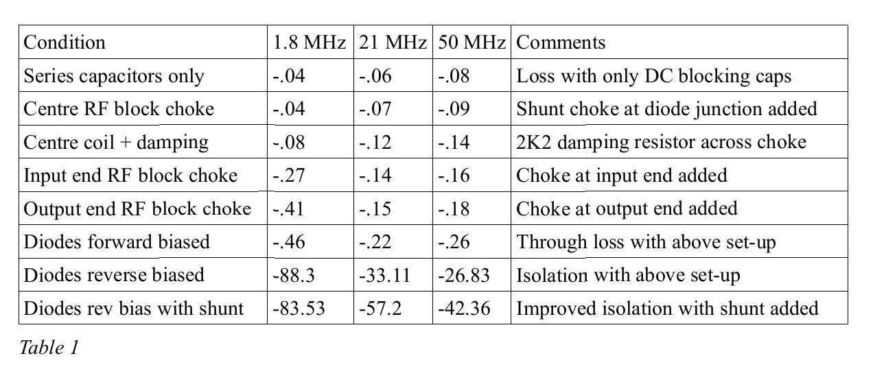
Table 1 is a compilation of the isolation and conduction measurements during progressive construction and testing of a prototype switch shown in fig-3c. The effect of series isolating capacitance and shunt inductance shows clearly as they are added. To measure the effect of the series capacitors and shunt chokes the diodes were substituted with a wire bridge. The shunts were then replaced with the series diodes and the forward and reverse measurements were made. Finally the shunt diode was added and resulting isolation measured. The effect of the shunt chokes were quite detrimental in comparison to series capacitance and the higher loss at 1.8 MHz is due to insufficient inductance at that frequency although adding more inductance raises the losses at 50 MHz so a compromise needed to be struck. The nearly 20 dB of additional isolation by adding the shunt diode rescued the switch and makes it practical up to 50 MHz.

I decided to have a look at a current 1N4007 to see if it was still suitable as a poor man's PIN diode and began by checking if the minority carrier lifetime was sufficient. The arrangement of fig-6 was used with a power out of 10 watts. Two tests were carried out with a 1N4148 high speed diode and the other with a 1N4007 diode. The results are shown in photo-1 (1N4148) and photo-2 (1N4007). As can be seen the 1N4148 rectifies the signal perfectly while the 1N4007 due to minority carrier lifetime acts as a resistor. The results were similar for all bands from 1.8 MHz to 28 MHz. If you look closely at photo-2 you will observe the rising side of the negative ½ cycle (270 to 360 deg.) is just beginning to show a tiny sign of rectification and only shows on 1.8 MHz which would indicate the minority carriers are starting to decay at that time interval. This means that current 1N4007's are still showing PIN characteristics which makes them suitable so far.

The next check was for the performance under reverse bias conditions where the capacitance is the dominant feature. The set-up of fig-7 was used and my home-brew LC meter based on Phil Rice VK3BHR's design (ref 5) was used for the measurement. The results were plotted on the graph shown in fig-8 with the capacitance at 12 volts being 11 pF and explains the high coupling through the switch at higher frequencies and the need for 2 series diodes supplemented with a shunt diode. I plotted over the range of 0 volts to 67.5 volts as this was the extent of the range of my bench PSU.

The 1N4007's have shown to be suitable as a PIN diode but it was felt that perhaps there were better diodes out there. I scrutinised the high voltage diodes by doing parametric searches looking at the reverse capacitance and typical reverse recovery time in the search criteria applied. The reverse recovery time is a good indicator of the minority carrier lifetime of the diode and needs to be in the range of microseconds rather than nanoseconds. I looked for surface mount diodes but found none so turned to leaded diodes where I came upon the GP10Y diode the capacitance of which is shown in fig-nn and it has a typical maximum Tr (reverse recovery time) of 3 mSec which is pretty long for a rectifier diode, suggesting possible better results than the 1N4007. The same tests were applied as for the 1N4007 previously and the results confirmed that this indeed was the case.

Ref 1. Electronic Antenna Switching by Wes Hayward, QEX May 1995
Ref 2. Experimental Methods in RF Design [Paperback] by Wes Hayward W7ZOI, Rick Campbell KK7B, and Bob Larkin W7PUA
Publication Date: March 31, 2009 | ISBN-10: 087259923X | ISBN-13: 978-0872599239 | Edition: Revised 1st Edition
Ref 3. http://wb9jps.com/Gary_Johnson/TR_Switch.html
Ref 4. http://www.cliftonlaboratories.com/diode_turn-on_time.htm#1N4007
Ref 5 https://sites.google.com/site/vk3bhr/home/index2-html

