**Table Of Content**

**Acknowledgement 3**

**Abstract 4**

**Chapter 1: Introduction 5**

1.1 Introduction to the project 5

1.1.1 Ticket Booking and Reservation: 5

1.1.2 Seat Selection: 5

1.1.3 Schedule Management: 5

1.1.4 Mobile Accessibility: 5

1.1.5 Passenger Management: 5

1.2 Purpose: 6

1.2.1 Convenient Booking: 6

1.2.2 Improved Efficiency: 6

1.2.3 Real-Time Availability: 6

1.3 Problem Definition 6

1.4 Objectives of the Project 7

1.5 Scope and Limitations of the project 8

1.6 Literature Review 9

**Chapter 2: System Analysis 10**

2.1 Requirement Collection and Analysis 10

2.1.1 Functional Requirement 10

2.1.1.1 Use Case Diagram: 10

2.1.2 Non-functional requirement: 11

2.1.2.1 Performance: 11

2.1.2.2 Reliability: 11

2.1.2.3 Security: 11

2.1.2.4 Scalability: 11

2.1.2.5 Usability: 12

2.1.2.6 Maintainability: 12

2.1.2.7 Integration: 12

2.1.2.8 Compliance: 12

2.2 Feasibility Study: 13

2.2.1 Technical Feasibility: 13

2.2.2 Operational Feasibility: 13

2.2.3 Economic Feasibility: 13

2.2.4 Legal Feasibility: 13

2.2.5 Schedule Feasibility: 14

**Chapter 3: System Design 15**

3.1 ER Diagram: 15

Fig 3.1.1: ER Diagram 15

3.2 Flowchart: 16

Fig 3.2.1: Flowchart 16

3.3 Sequence Diagram 17

Fig 3.3.1: Sequence Diagram 17

**Chapter 4: Implementation and Testing 18**

4.1 Requirements Gathering: 18

4.2 System Design: 18

4,3 Development: 18

4.4 Integration: 18

4.5 Testing: 18

4.5.1 Unit Testing: 18

4.5.2 Integration Testing: 19

4.5.3 System Testing: 19

4.5.4 Performance Testing: 19

**Chapter 5: Conclusion 20**

4.1 Conclusion 20

4.2 Enhancements 20

4.2.1 Integration with GPS Tracking: 20

4.2.2 Personalized Recommendations: 20

4.2.3 Loyalty Programs and Rewards: 21

4.2.4 Social Media Integration: 21

4.2.5 Multi-Language Support: 21

4.2.6 Integration with Other Travel Services: 21

4.2.7 Advanced Analytics and Reporting: 21

4.2.8 Voice Assistance and Chatbots: 21

**References 22**

**Appendix 23**

### 

### **Acknowledgement**

I would like to express my heartfelt gratitude to my teacher, Mr Gopi Prajapati, for providing me with the invaluable opportunity to build an ecommerce application. His unwavering support, guidance, and trust has been instrumental for the success of this project.

His expertise in the field of ecommerce and willingness to share his knowledge has been truly inspiring. His mentorship and insightful feedback has played a pivotal role in shaping my understanding of the industry and guiding me in making informed decisions.

I am deeply grateful for the resources and infrastructure he provided, which allowed me to work with the latest technologies and tools. His continuous encouragement and belief in my abilities has motivated me to push my limits and deliver a high-quality application.

Lastly, I would like to acknowledge the trust he has placed in me to deliver a successful ecommerce application. His belief in my capabilities has been a driving force behind my determination and perseverance.

I thank Mr Gopi Prajapati once again for his guidance, support, and the invaluable opportunity to work on this ecommerce application. His mentorship has been transformative, and I am grateful for the knowledge and experience gained through this endeavor.

With utmost gratitude,

Prayag Dhakal

### 

### **Abstract**

This abstract provides an overview of the software development process for a bus ticketing system, which aims to streamline ticket purchases, bookings, and real-time information access for passengers. The development process encompasses several key stages, starting with requirements gathering to identify the desired functionalities and goals of the system. Subsequently, system design defines the architecture, database structure, and user interface. The implementation phase involves the development of various modules, including ticket booking, seat selection, payment integration, and passenger management. These modules are built using appropriate programming languages, frameworks, and libraries to ensure scalability and security. The benefits of a well-designed bus ticketing system are numerous, including convenient online ticket purchases, reduced reliance on physical ticket counters, and improved passenger data management for targeted marketing and personalized services. The system's analytics and reporting capabilities enable operators to gain insights into passenger preferences, optimize routes, and enhance operational efficiency. However, challenges such as data security and privacy must be addressed to safeguard sensitive passenger information. Scalability is also a crucial consideration to handle high transaction volumes during peak travel periods. Successfully implementing the bus ticketing system can significantly enhance public transportation services, providing passengers with a more convenient and efficient travel experience.

### **Chapter 1: Introduction**

#### **1.1 Introduction to the project**

BusSewa is a software solution that automates and streamlines the process of selling, managing, and tracking bus tickets. It serves as a digital platform for passengers to book and purchase tickets, while also providing bus operators with tools to manage their ticket inventory, routes, and passenger information. Here's an overview of the key components and features in this project:

##### **1.1.1 Ticket Booking and Reservation:**

Passengers can search for available routes, select desired travel dates and times, choose seats, and make reservations through various channels such as online portals, mobile applications, or ticket counters. The system allows for secure online payments and issues electronic tickets or booking confirmations.

##### **1.1.2 Seat Selection:**

Passengers can view a seating layout of the bus and choose their preferred seats based on availability. This feature enhances the customer experience and allows for personalized preferences.

##### **1.1.3 Schedule Management:**

Bus operators can define and manage bus schedules, including departure and arrival times, frequency, and route information. The system helps optimize schedules, track real-time updates, and accommodate changes or cancellations.

##### **1.1.4 Mobile Accessibility:**

Many bus ticketing systems offer mobile applications that allow passengers to book tickets, access their reservations, receive notifications, and manage their bookings on the go.

##### **1.1.5 Passenger Management:**

The system maintains a database of passenger information, including contact details, travel history, preferences, and loyalty programs. This data helps personalize the customer experience, offer targeted marketing campaigns, and provide efficient customer support.

Overall, a bus ticketing system enhances the efficiency, convenience, and customer experience of bus travel by digitizing the ticketing process and providing bus operators with tools for effective management and operations.

### 

#### **1.2 Purpose:**

The purpose of bus ticketing software is to automate and streamline the ticketing process for bus travel, benefiting both passengers and bus operators. Here are the key purposes and benefits of using bus ticketing software:

##### **1.2.1 Convenient Booking:**

Bus ticketing software provides passengers with a convenient and user-friendly platform to search for available routes, select travel dates and times, choose seats, and make reservations. It eliminates the need for manual ticket purchases and allows passengers to book tickets from the comfort of their homes or on the go.

##### **1.2.2 Improved Efficiency:**

By automating the ticketing process, bus ticketing software significantly improves efficiency for both passengers and bus operators. It reduces long queues at ticket counters, eliminates paperwork, and enables quick and hassle-free transactions. Passengers can save time and effort by easily accessing and booking tickets online or through mobile applications.

##### **1.2.3 Real-Time Availability:**

Bus ticketing software provides real-time information on seat availability, departure times, and bus schedules. Passengers can instantly see which seats are vacant and choose their preferred seats accordingly. This feature helps avoid overbooking and ensures accurate availability information to passengers.

Overall, the purpose of bus ticketing software is to digitize and streamline the ticketing process, making bus travel more convenient, efficient, and customer-centric. It benefits passengers by offering a seamless booking experience, while bus operators gain improved operational efficiency, better management of ticket inventory, and enhanced customer service capabilities.

#### **1.3 Problem Definition**

The current online bus ticketing system suffers from several significant issues that impact the overall user experience. Firstly, the ticket booking process is inefficient, making it difficult for users to find suitable bus routes, select seats, and make payments. This results in a frustrating and time-consuming experience. Additionally, the system has limited integration with various bus operators, leading to a lack of available options for users. They may have to navigate multiple platforms to find suitable buses, causing inconvenience and dissatisfaction. Furthermore, users often lack real-time updates regarding bus schedules, delays, cancellations, or changes in boarding points, leading to confusion and inconvenience. The refund and cancellation process is also cumbersome, with challenges in initiating cancellations and delays in obtaining refunds. Inadequate customer support channels exacerbate the situation, making it difficult for users to seek assistance when needed. The lack of loyalty programs and integration with other travel services further diminishes the platform's appeal. Addressing these problems is crucial to improve user satisfaction, streamline the booking process, and foster the growth of the online bus ticketing system.

#### **1.4 Objectives of the Project**

Improve User Experience: The primary objective of the project is to enhance the overall user experience of the online bus ticketing system. This includes making the ticket booking process more streamlined, user-friendly, and efficient. The aim is to provide users with a seamless and convenient experience from start to finish.

* Increase Bus Operator Integration: The project aims to integrate a wide range of bus operators into the online ticketing system. By collaborating with multiple bus operators, the platform can offer users a comprehensive selection of routes, schedules, and bus types. This increases the chances of users finding suitable options for their travel needs.
* Real-Time Updates and Notifications: The project focuses on implementing a robust real-time update system to keep users informed about bus schedules, delays, cancellations, and changes in boarding points. By providing timely and accurate information, users can plan their journeys more effectively and avoid any inconveniences.
* Streamline Refund and Cancellation Process: One of the objectives is to simplify and streamline the refund and cancellation process for bus tickets. This involves implementing a user-friendly interface for initiating cancellations, reducing processing times, and minimizing any additional charges or complications.
* Enhance Customer Support: The project aims to improve customer support channels and services. This includes providing multiple channels for users to seek assistance, such as live chat, email support, or a dedicated helpline. The objective is to ensure that users can easily reach out for help and receive prompt and effective support.
* Expand Payment Options: The project intends to offer a wide range of payment options to accommodate users' preferences. This includes integrating popular payment gateways, mobile wallets, and other secure payment methods to provide users with flexibility and convenience during the booking process.
* Develop a Mobile-Friendly Interface: The project focuses on developing a responsive and user-friendly mobile interface for the online bus ticketing system. This allows users to make bookings, access their tickets, and receive updates conveniently using their mobile devices. The objective is to cater to the increasing number of users who prefer to use mobile platforms for online transactions.
* Ensure Data Security and Privacy: A key objective is to implement robust security measures to protect user data and payment information. This includes encryption protocols, secure storage practices, and compliance with data protection regulations. By ensuring data security and privacy, the project aims to build trust among users and mitigate any concerns related to data breaches.
* Implement Loyalty Programs: The project aims to introduce loyalty programs and rewards for frequent users. This encourages repeat bookings, enhances user retention, and promotes user loyalty. The objective is to provide incentives for users to continue using the online bus ticketing system.
* Foster Integration with Other Travel Services: The project focuses on integrating the online bus ticketing system with other travel services, such as flight bookings, hotel reservations, or car rentals. This allows users to plan their entire travel itinerary through a single platform, providing convenience and a seamless travel experience.

By achieving these objectives, the project aims to transform the online bus ticketing system into a user-friendly, comprehensive, and efficient platform that meets the needs and expectations of users while fostering growth and success in the market.

#### **1.5 Scope and Limitations of the project**

**Scope of the Online Bus Ticketing System:**

The online bus ticketing system aims to provide users with a comprehensive and convenient ticket booking experience. It includes features such as searching for bus routes, viewing schedules, selecting seats, and making online bookings. The system will integrate with multiple bus operators, ensuring a wide range of options for different routes and bus types. Real-time updates will be available to users, keeping them informed about bus schedules, delays, cancellations, and changes in boarding points. Secure online payment processing, refund and cancellation functionalities, multiple customer support channels, a mobile-friendly interface, and data security measures are all part of the system's scope.

**Limitations of the Online Bus Ticketing System:**

There are several limitations to consider when implementing an online bus ticketing system. First, the availability of bus operators is a factor that can limit the system's scope. Limited integration may result in a restricted choice of bus operators and routes for users. Secondly, the system relies on internet connectivity, and the lack of access or poor connectivity can hinder users' ability to use the platform. User awareness and adoption of online ticket booking can also be a limitation, as some users may be unfamiliar with technology or prefer traditional ticket purchasing methods. Additionally, external factors such as bus availability, road conditions, and weather conditions can affect the accuracy of real-time updates and scheduling information. The system may rely on third-party services, and any limitations or issues with these services can impact the overall performance. Compliance with legal and regulatory requirements, as well as ensuring data protection and privacy, may impose limitations on certain functionalities or operational aspects of the system. Lastly, the scalability of the system, especially during peak travel seasons or high-demand periods, may present challenges. It is important to consider and address these limitations when developing and managing an online bus ticketing system.

#### **1.6 Literature Review**

There exist several sites working commercially, providing several features as online bus ticketing platform. Some of them are listed below with all there working schema, customer support and services:

**RedBus:**

RedBus is a popular online bus ticketing platform that offers a wide range of bus operators and routes across various countries. It provides a user-friendly interface for searching routes, selecting seats, and making online bookings. RedBus also offers real-time updates, secure payment processing, and customer support services.

**Busbud:**

Busbud is another online bus ticketing platform that operates globally. It connects travelers with bus operators in multiple countries, allowing users to search for routes, compare prices, and book tickets online. Busbud provides real-time bus schedules, seat selection, and various payment options.

**Goibibo:**

Goibibo is a comprehensive travel platform that offers online bus ticketing services along with flight bookings, hotel reservations, and other travel-related services. It allows users to search for bus routes, view schedules, and book tickets. Goibibo provides real-time updates, secure payment processing, and 24/7 customer support.

**MakeMyTrip:**

MakeMyTrip is a well-known travel platform that offers online bus ticketing services in addition to flights, hotels, and other travel services. Users can search for bus routes, view schedules, select seats, and make bookings through the platform. MakeMyTrip provides real-time updates, secure payment processing, and customer support.

**AbhiBus:**

AbhiBus is a dedicated online bus ticketing platform that operates in India. It offers a wide range of bus operators and routes across the country. Users can search for bus routes, view schedules, select seats, and book tickets through AbhiBus. The platform provides real-time updates, secure payment options, and customer support services.

These are just a few examples of software platforms that provide online bus ticketing services. Each platform may have its own features, coverage area, and user experience. It's important to explore and compare different platforms to find the one that best suits your specific requirements.

### **Chapter 2: System Analysis**

#### **2.1 Requirement Collection and Analysis**

##### **2.1.1 Functional Requirement**

The major functional requirements of the system are as follows:

1. Enter the origin and destination
2. Select the date of travel
3. Search for and display the buses available on the given time and date
4. Display the informations regarding number of seats available and facilities provided
5. Allow the selection of seat within seat layout for further personalization

###### **2.1.1.1 Use Case Diagram:**

### 

##### **2.1.2 Non-functional requirement:**

The online bus ticketing system must meet several non-functional requirements for optimal performance. Firstly, it should ensure high performance by efficiently handling a large number of users, providing fast response times, and minimizing downtime during peak periods. Security measures, such as data encryption and secure payment processing, must be implemented to protect user data and ensure the confidentiality of sensitive information. Usability is crucial, and the system should feature an intuitive and user-friendly interface that is accessible across devices, allowing users of varying technical proficiency to navigate and utilize the platform easily. Reliability is of utmost importance, with the system designed to minimize service disruptions and errors through appropriate backup solutions and data recovery protocols. Additionally, the system should exhibit scalability, allowing for future growth and accommodating increasing user demands without sacrificing performance. Integration capabilities are also necessary to seamlessly connect with external systems, such as payment gateways and bus operator APIs, enabling smooth data exchange and interoperability. Meeting these non-functional requirements is essential for the effective functioning of the online bus ticketing system.

Non-functional requirements for a bus ticketing system can include the following:

###### **2.1.2.1 Performance:**

The system should be able to handle a large volume of concurrent users without significant performance degradation. Response times for various operations, such as ticket booking, cancellation, and seat availability checks, should be within acceptable limits.

###### **2.1.2.2 Reliability:**

The system should be highly reliable and available at all times. It should be able to recover from failures, such as server crashes or network disruptions, without significant impact on the user experience. It should also have backup mechanisms in place to prevent data loss.

###### **2.1.2.3 Security:**

The system should ensure the security of user information and financial transactions. It should implement appropriate encryption measures to protect sensitive data, such as credit card details, and have measures in place to prevent unauthorized access to user accounts.

###### **2.1.2.4 Scalability:**

The system should be scalable to accommodate future growth and increased user demand. It should be able to handle a growing number of buses, routes, and users without significant performance degradation. The architecture should support horizontal scaling, allowing for the addition of more servers or resources as needed.

###### **2.1.2.5 Usability:**

The system should be user-friendly and intuitive, with a clear and well-designed user interface. It should be accessible to users with disabilities and support multiple languages, if required. The ticket booking process should be easy to understand and navigate, with clear instructions and error handling.

###### **2.1.2.6 Maintainability:**

The system should be easily maintainable, allowing for efficient bug fixes, updates, and enhancements. The code should be well-structured and modular, facilitating future modifications or additions to the system. Proper documentation should be provided to aid in system maintenance and troubleshooting.

###### **2.1.2.7 Integration:**

The system should be able to integrate with other relevant systems, such as payment gateways, bus tracking systems, and customer support tools. It should support standard APIs and data exchange formats to facilitate seamless integration with third-party services.

###### **2.1.2.8 Compliance:**

The system should comply with relevant legal and regulatory requirements, such as data protection and privacy laws. It should also adhere to industry standards and best practices, ensuring the system's security, reliability, and interoperability.

#### 

#### **2.2 Feasibility Study:**

##### **2.2.1 Technical Feasibility:**

Technical feasibility for an online ticketing system involves assessing system requirements, scalability, security measures, integration with existing systems, user experience, performance and reliability, mobile compatibility, and data backup and recovery. The system should be capable of handling varying levels of demand, secure customer data and transactions, integrate smoothly with other systems, provide a user-friendly interface, deliver optimal performance and reliability, be accessible on mobile devices, and have robust data backup and recovery mechanisms. Considering these factors ensures the successful development and implementation of a technically feasible online ticketing system.

##### **2.2.2 Operational Feasibility:**

Operational feasibility involves evaluating factors such as the alignment of the system with business goals and processes, the availability of necessary resources, the impact on staff and stakeholders, and the overall feasibility of implementing the system within the organization. It requires assessing whether the online ticketing system can seamlessly integrate with existing operations, such as event management, customer support, and financial processes. The system should be compatible with the organization's infrastructure and workflows, and should not disrupt daily operations. Additionally, the availability of sufficient resources, including budget, personnel, and technical support, is essential for successful implementation. Ensuring that staff and stakeholders are adequately trained and prepared for the new system is crucial. By addressing these operational feasibility factors, an organization can determine if the online ticketing system can be implemented effectively and contribute positively to its operations.

##### **2.2.3 Economic Feasibility:**

Economic feasibility involves assessing the costs and benefits associated with developing, implementing, and maintaining the online ticketing system. The initial development costs, including software development, hardware, infrastructure setup, and any necessary integrations, should be weighed against the expected benefits, such as increased ticket sales, cost savings from reduced manual processes, and improved operational efficiency. Ongoing maintenance and support costs should also be considered. The system should be cost-effective and provide a positive return on investment within a reasonable timeframe. Additionally, the potential revenue streams, such as transaction fees or additional services, should be evaluated to determine their contribution to the economic viability of the system.

##### **2.2.4 Legal Feasibility:**

Legal feasibility involves ensuring that the online ticketing system adheres to applicable laws related to data protection, privacy, consumer rights, and intellectual property. It is important to comply with regulations such as the General Data Protection Regulation (GDPR) or similar data protection laws, which govern the collection, storage, and processing of customer information. Implementing appropriate security measures, obtaining necessary consents, and providing transparent privacy policies are crucial to meet legal requirements.

##### **2.2.5 Schedule Feasibility:**

Schedule feasibility for an online ticketing system involves assessing whether the system can be developed and implemented within the desired timeframe. It requires considering factors such as system complexity, customization needs, resource availability, dependencies on third-party services, and external factors like regulatory approvals. Effective project management techniques, regular communication, and collaboration are crucial to meet established timelines and milestones. By carefully planning and monitoring the project schedule, organizations can ensure timely implementation of the online ticketing system, minimizing disruptions and maximizing benefits.

### 

### **Chapter 3: System Design**

#### **3.1 ER Diagram:**

##### **Fig 3.1.1: ER Diagram**

#### 

#### **3.2 Flowchart:**

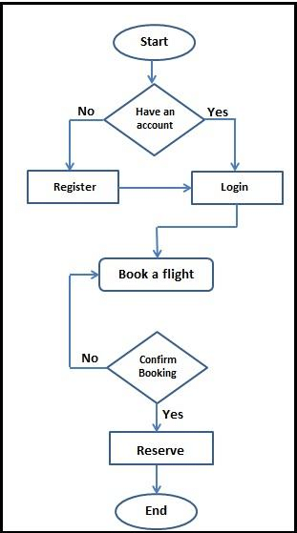

##### **Fig 3.2.1: Flowchart**

#### **3.3 Sequence Diagram**

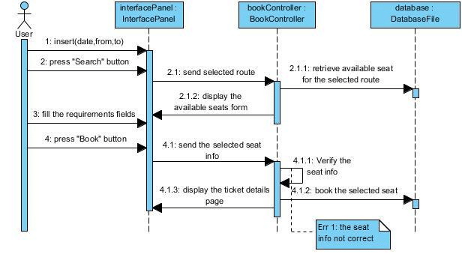

##### **Fig 3.3.1: Sequence Diagram**

### 

### **Chapter 4: Implementation and Testing**

The implementation and testing phases of a bus ticketing system software involve several key steps to ensure the successful development and deployment of the system.

#### **4.1 Requirements Gathering:**

The first step is to gather the requirements for the bus ticketing system. This involves understanding the needs of the stakeholders, such as bus operators, ticket sellers, and passengers. The requirements are documented to serve as a foundation for the implementation process.

#### **4.2 System Design:**

In this phase, the overall architecture and design of the bus ticketing system are created. This includes defining the system components, modules, and their interactions. The design also incorporates considerations such as security, scalability, and user experience.

#### **4,3 Development:**

The actual implementation of the bus ticketing system software takes place in this phase. The development team writes the code for various modules, including ticket booking, payment processing, passenger management, and reporting. They follow software development best practices and use appropriate programming languages, frameworks, and databases.

#### **4.4 Integration:**

Once the individual modules are developed, they need to be integrated into a cohesive system. This involves ensuring that different components can communicate with each other seamlessly. Integration testing is conducted to verify the correct functioning of the integrated system.

#### **4.5 Testing:**

Testing plays a crucial role in identifying and fixing defects in the software. Various types of testing are performed, such as unit testing, integration testing and system testing. Unit tests focus on testing individual components, while integration and system tests validate the system as a whole. The bus ticketing system software undergoes various testing phases to ensure its reliability, functionality, and adherence to requirements.

##### **4.5.1 Unit Testing:**

In this phase, individual software components or units are tested in isolation. Each unit is tested to ensure that it performs as expected and meets its specified requirements. Unit testing involves writing test cases that cover different scenarios and edge cases for each unit. The goal is to identify and fix any defects at the lowest level of granularity.

##### **4.5.2 Integration Testing:**

Integration testing focuses on testing the interactions between different components or modules of the bus ticketing system. It verifies that the integrated system functions correctly and the modules work together seamlessly. Integration testing may involve simulating real-world scenarios and testing various communication channels, data exchanges, and dependencies between the modules.

##### **4.5.3 System Testing:**

System testing is conducted to evaluate the entire bus ticketing system as a whole. It involves testing the system's behavior and functionality from end to end. This phase verifies that the system meets all the specified requirements and functions correctly in its intended operating environment. System testing may include tests for ticket booking, payment processing, seat allocation, reporting, and any other core features of the system.

##### **4.5.4 Performance Testing:**

Performance testing evaluates the system's performance and scalability under different load conditions. It ensures that the bus ticketing system can handle a large number of concurrent users and transactions without performance degradation. Performance tests measure response times, throughput, resource utilization, and other performance metrics to identify bottlenecks and optimize system performance.

Throughout the implementation and testing phases, collaboration within the development team was crucial. Clear communication, thorough testing, and a focus on meeting the requirements were essential to the successful implementation of a bus ticketing system software.

### **Chapter 5: Conclusion**

#### **4.1 Conclusion**

The software development project for online bus ticketing has been successfully implemented. The project aimed to provide a convenient and efficient platform for users to book bus tickets online. Throughout the development process, several key features were incorporated to ensure a seamless user experience and efficient ticket management system.

The software development project followed a structured approach, beginning with thorough planning and requirement gathering. The development team worked closely with stakeholders to understand their needs and incorporate essential features.

#### **4.2 Enhancements**

In the ever-evolving and fast-paced software industry, the pursuit of improvement and innovation remains a constant driving force. With advancements in technology, changing user expectations, and emerging market trends, software development projects must adapt and evolve to stay competitive. This dynamic landscape presents endless opportunities for enhancing existing systems, introducing new features, and refining user experiences. From user interface design to performance optimization, security enhancements to scalability improvements, software professionals continuously strive to push the boundaries of what is possible. The industry thrives on a culture of continuous learning, feedback-driven iterations, and a commitment to delivering exceptional software solutions. Embracing this mindset, software developers, engineers, and project teams recognize that there is always room for improvement, inspiring them to relentlessly pursue excellence in their quest to meet and exceed customer expectations. Below are some ideas for further enhancements that can make the project more intuitive and user friendly:

###### **4.2.1 Integration with GPS Tracking:**

Integrating GPS tracking technology into the system can provide real-time bus tracking for users. This feature would allow passengers to track their bus's location, estimated arrival time, and any delays, providing them with up-to-date information and reducing uncertainty.

###### **4.2.2 Personalized Recommendations:**

Implementing a recommendation engine based on user preferences and past booking history can enhance the user experience. The system could suggest popular routes, preferred seat types, or relevant offers

###### **4.2.3 Loyalty Programs and Rewards:**

Introducing a loyalty program or rewards system can incentivize repeat bookings and customer loyalty.

###### **4.2.4 Social Media Integration:**

Integrating the online bus ticketing platform with popular social media platforms can facilitate easy sharing of travel plans, promotions, and discounts. Users could share their upcoming trips with friends, allowing for group bookings or collaborative planning, thereby increasing the platform's visibility and user engagement.

###### **4.2.5 Multi-Language Support:**

Providing multi-language support would cater to a wider user base, especially in regions with diverse language preferences. Users should be able to choose their preferred language for the interface, making it more accessible and user-friendly.

###### **4.2.6 Integration with Other Travel Services:**

Collaborating with other travel-related services such as hotel bookings, car rentals, or tour packages can create a comprehensive travel platform. Users would have the convenience of accessing multiple services through a single platform, enhancing the overall travel experience.

###### **4.2.7 Advanced Analytics and Reporting:**

Implementing advanced analytics and reporting features can provide valuable insights into user behavior, popular routes, and ticket sales trends. These insights can help bus operators optimize their services, adjust pricing, and improve overall operational efficiency.

###### **4.2.8 Voice Assistance and Chatbots:**

Integrating voice assistance and chatbot features can enhance customer support and provide instant responses to user queries. Users could have the option to interact with a chatbot or use voice commands for quick and efficient assistance, improving the overall customer service experience.  
  
By implementing these enhancements, the online bus ticketing project can further improve user experience, increase user engagement, and expand its reach in the market.

### **References**

1. Javatpoint, https://www.javatpoint.com/kotlin-android-json-parsing-using-url

2. Android Documentation, https://developer.android.com/kotlin

3. BusSewa by Diyalo Technologies (for API)

4. Dribbble, for design ideas, <https://dribbble.com>

5. Stack Overflow, https://stackoverflow.com/questions/72485950/kotlin-null-safety

### **Appendix**

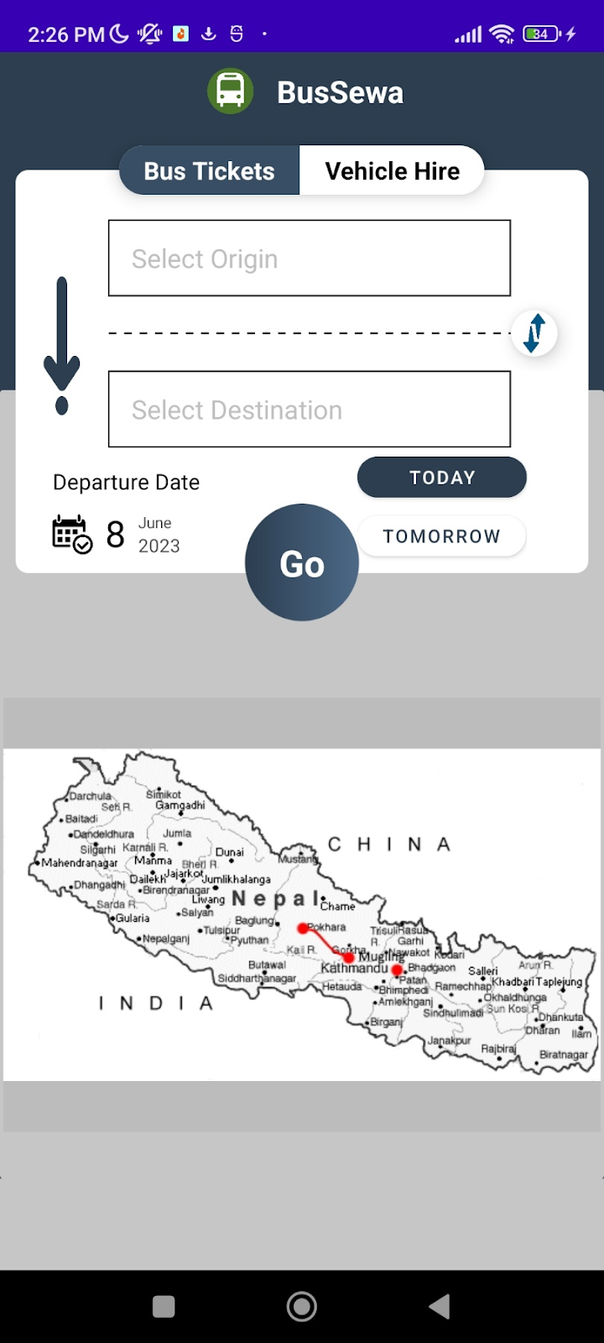

**Fig 5.1: Homepage**

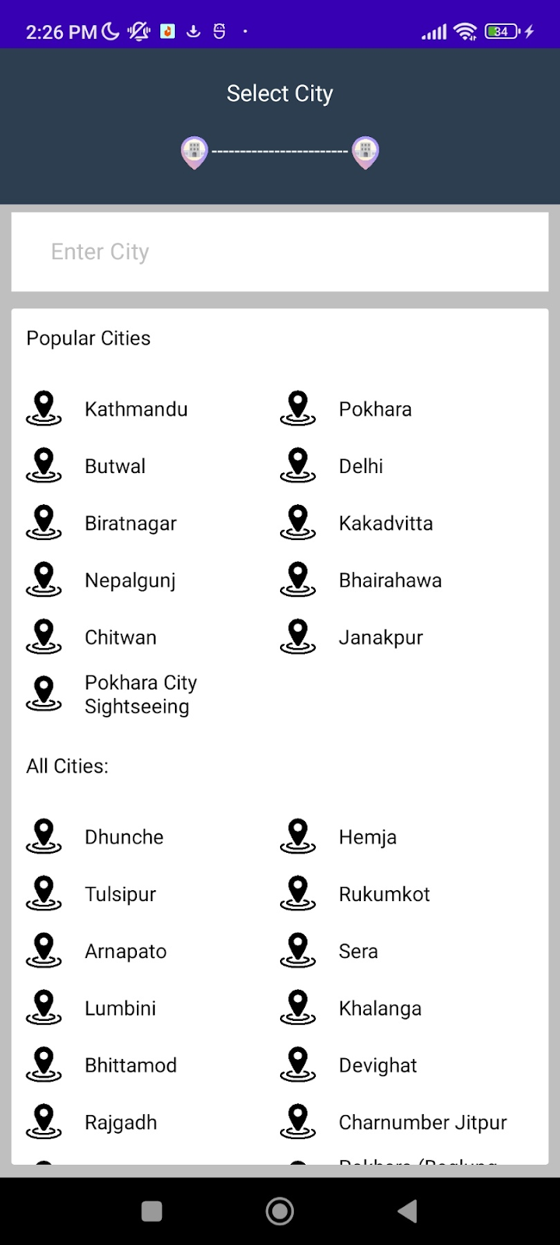

**Fig 5.2: Selection of location**

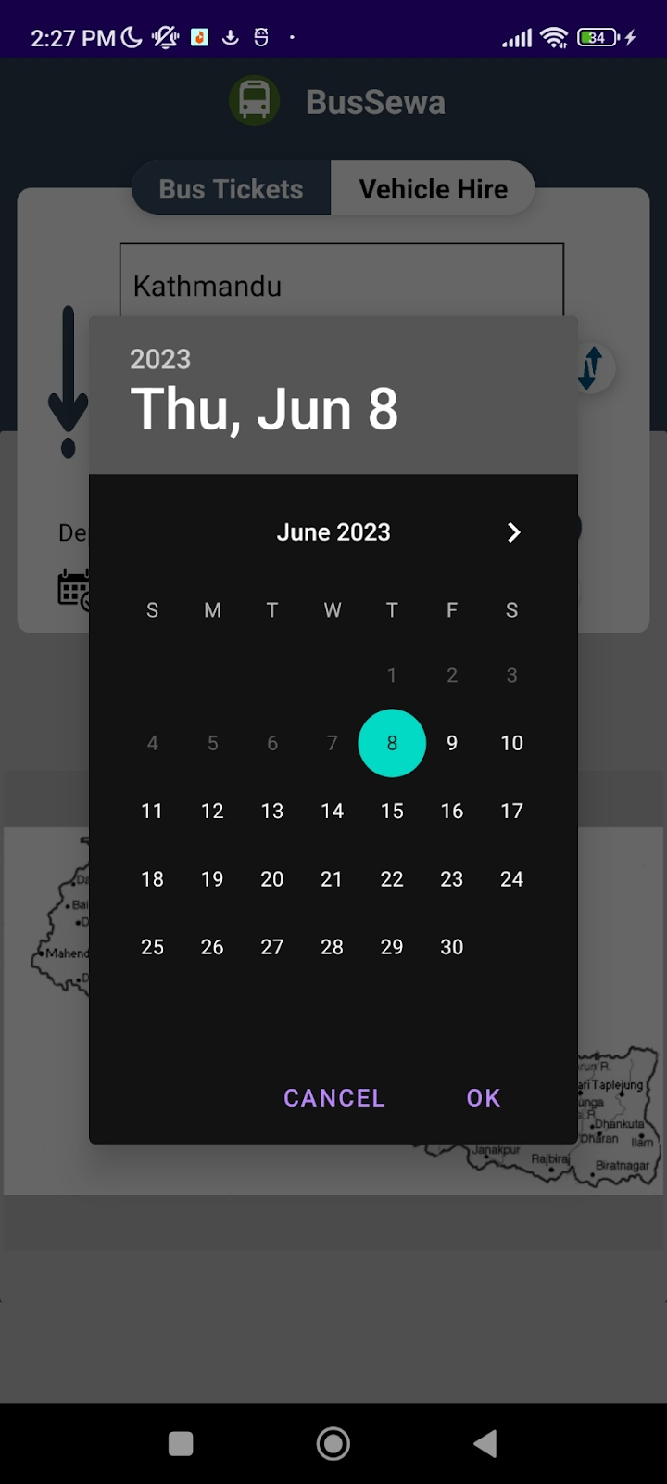

**Fig 5.3: Date Picker**

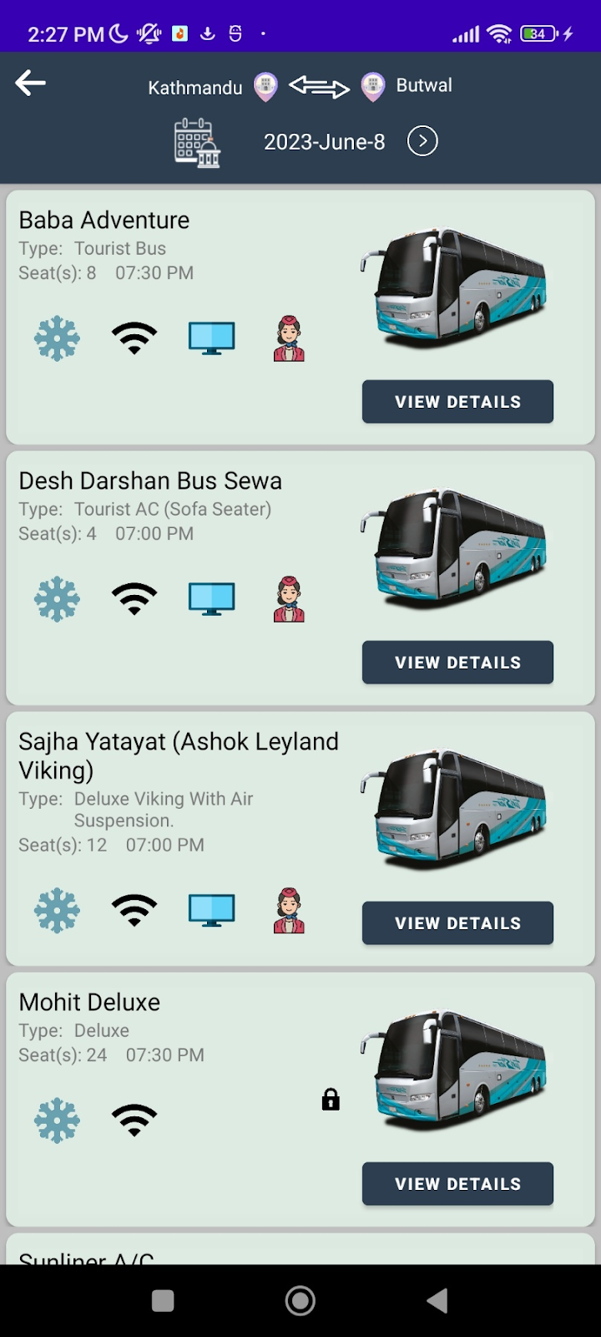

**Fig 5.4: Display buses on provided date and location**

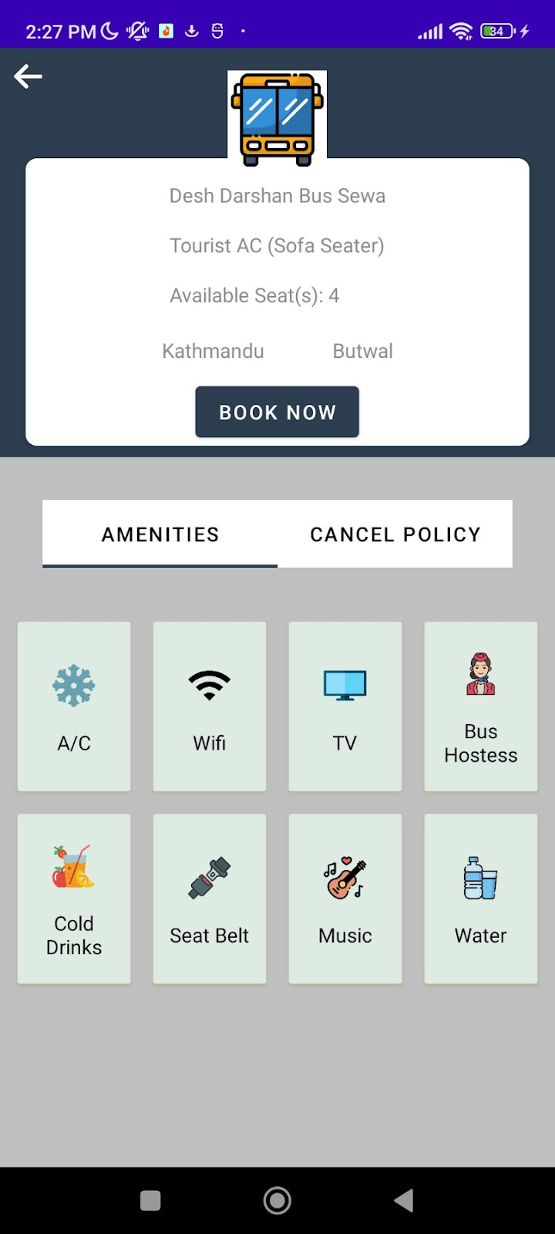

**Fig 5.5: Display facilities**

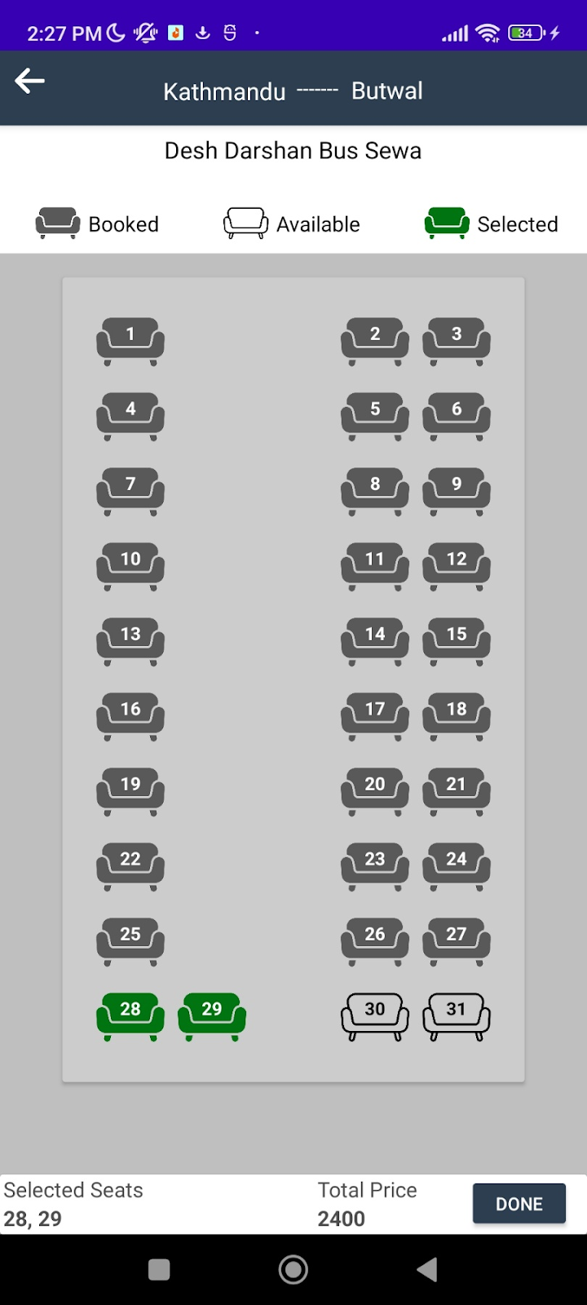

**Fig 5.6: Seat Layout**

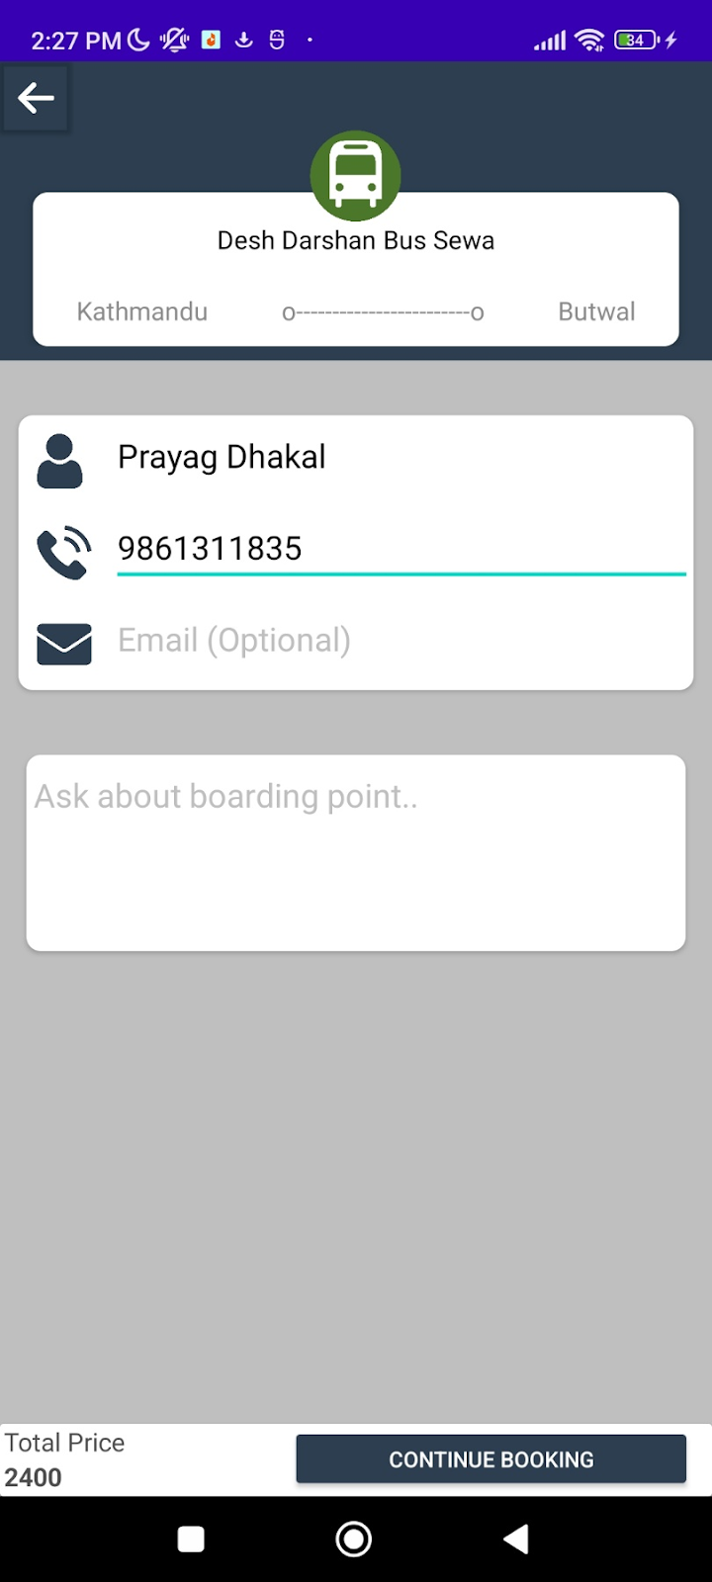

**Fig 5.7: Enter Details for payment**

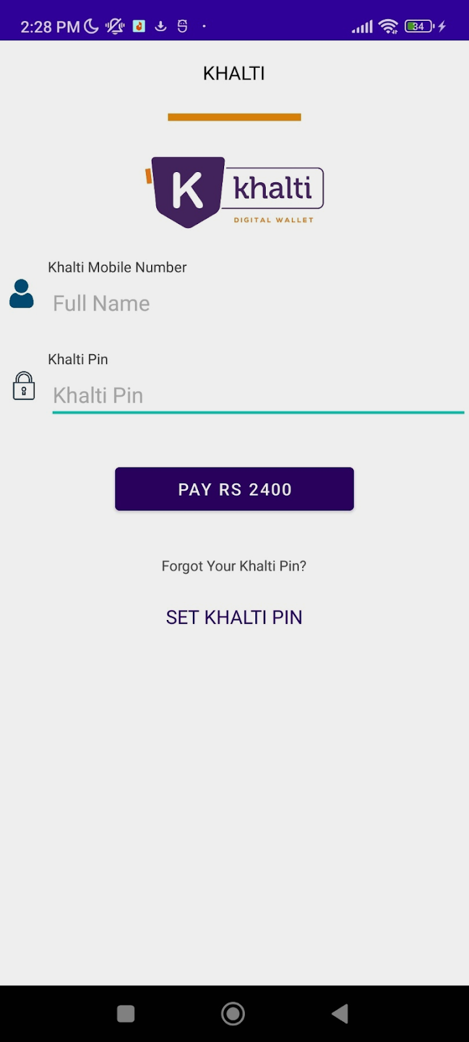

**Fig 5.8: Payment via Khalti**

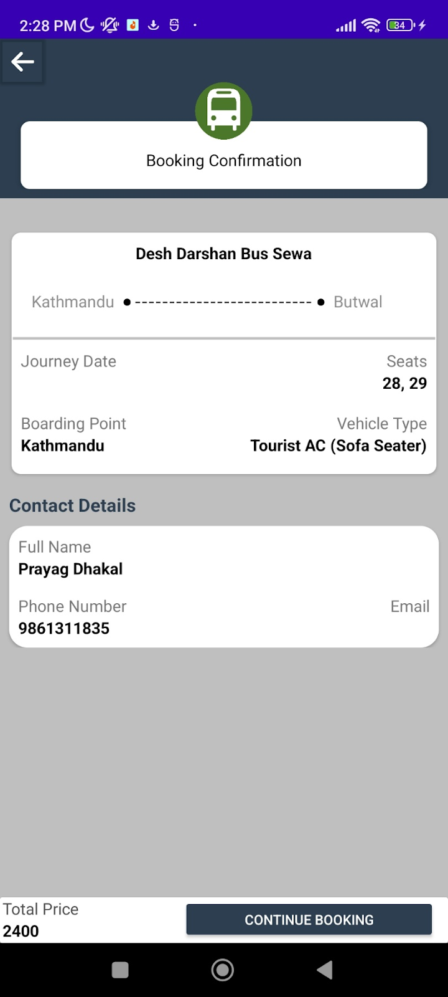

**Fig 5.9: Ticket**