

Project Report

**Bank Management System (ATM Simulator System)**

**Submitted To**

Mr. Sabuj Chandra Paul

Lecturer, Dept. of CSE

North East University Bangladesh

**Submitted By**

Radi Ahmed Chowdhury

ID: 200103020066

**Introduction:**

The Bank Management System (ATM Simulator) is a desktop-based application developed using Java Swing and MySQL. It simulates core ATM functionalities such as user login, deposit, withdrawal, balance enquiry, PIN change, and mini statement. The purpose of this project is to provide a realistic banking experience for users while demonstrating the integration of GUI design with backend database operations. It also serves as a practical implementation of Java programming and JDBC in a real-world context.

**Background of the Project:**

In today’s digital age, managing banking transactions efficiently is crucial for both users and financial institutions. Traditional manual systems are time-consuming, error-prone, and lack user convenience. This project aims to simulate an ATM system that automates basic banking functions like deposits, withdrawals, and balance checks through a user-friendly desktop application.

The motivation behind this project is to gain hands-on experience in developing real-world software using Java and MySQL, while understanding how banking operations can be handled securely through technology.

**Objectives**

* To develop a functional desktop-based ATM simulator using Java Swing and MySQL.
* To provide users with basic banking services like login, deposit, withdrawal, balance enquiry, PIN change, and mini statement.
* To understand and apply database operations using JDBC.
* To implement secure authentication through card number and PIN verification.

**Related Work**

* DBBL Nexus ATM
* BRAC Bank Smart ATM
* bKash Agent Portal
* Visa & Mastercard ATM Networks

**Methodology**

Technologies and Tools Used:

* **Java (Swing)** – for GUI development
* **MySQL** – for storing user data and transaction history
* **JDBC** – to connect Java with the MySQL database
* **NetBeans** – for coding and debugging

Workflow

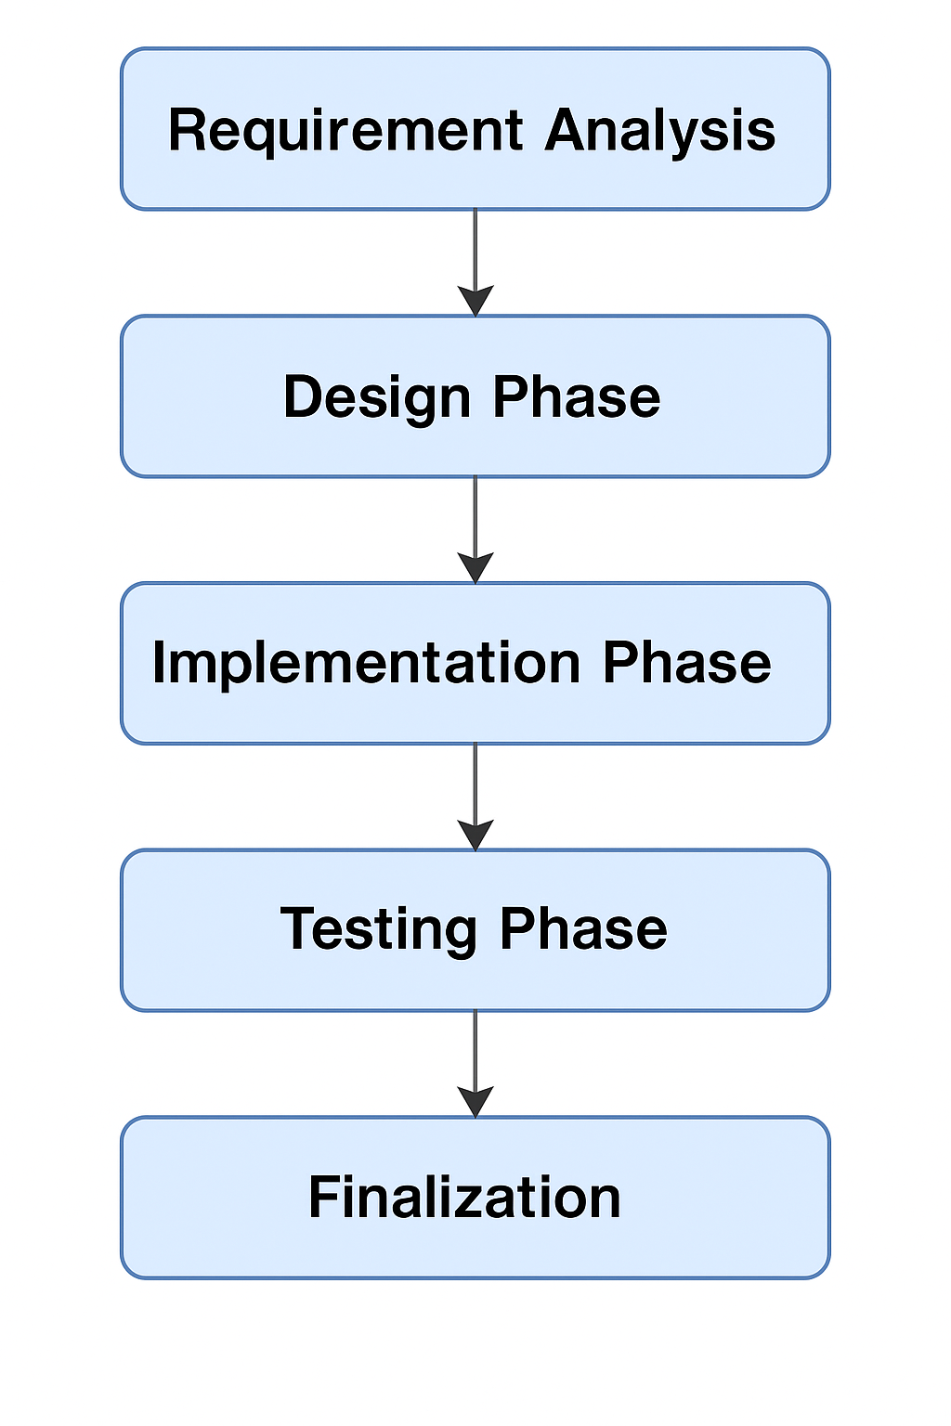

UML Diagram

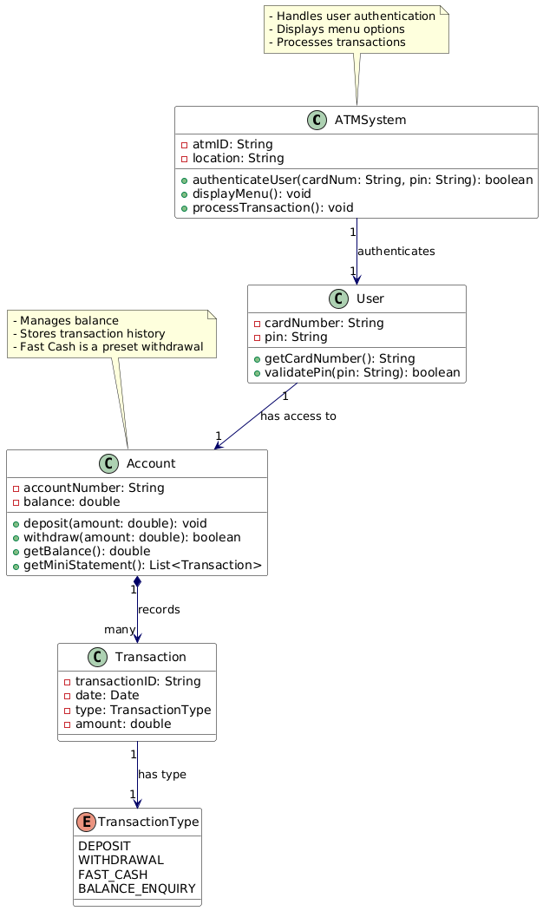

**Implementation / Development**

The Bank Management System (ATM Simulator) was developed using Java with Swing for the GUI and MySQL as the backend database. The application follows a modular design, with separate classes handling login, signup, transactions, deposits, withdrawals, PIN change, and balance inquiry.

Each module was developed following the MVC (Model-View-Controller) pattern to ensure separation of concerns and better maintainability.

Key Features Implemented:

* Login & Sign-up form with input validation
* Transaction interface with multiple services
* Real-time balance check and update via database
* PIN change functionality
* Mini statement generation

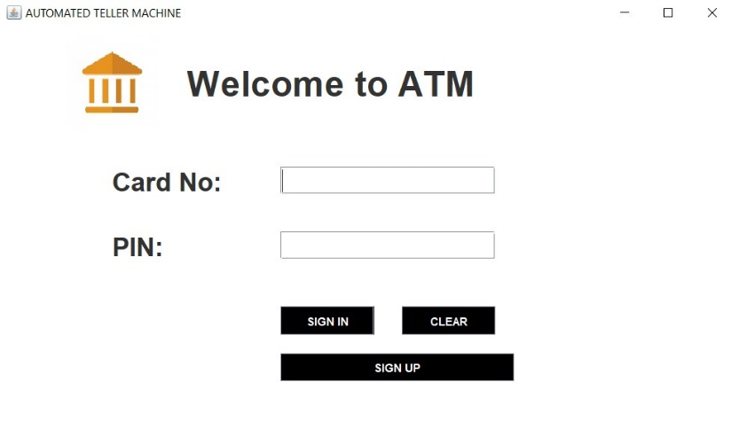

Login Page

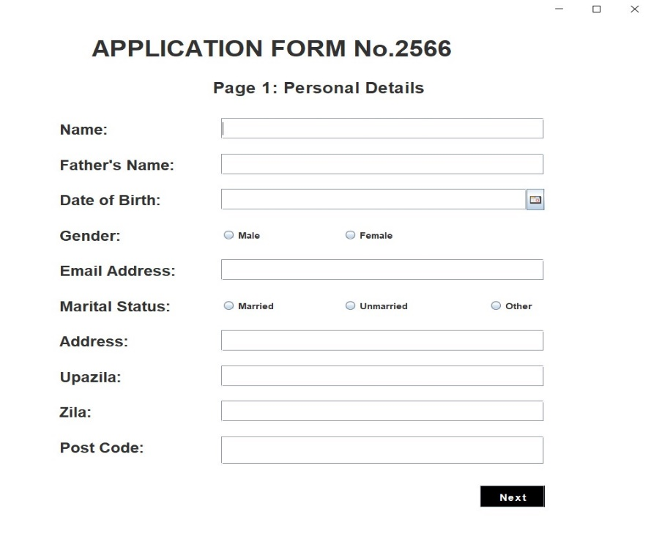

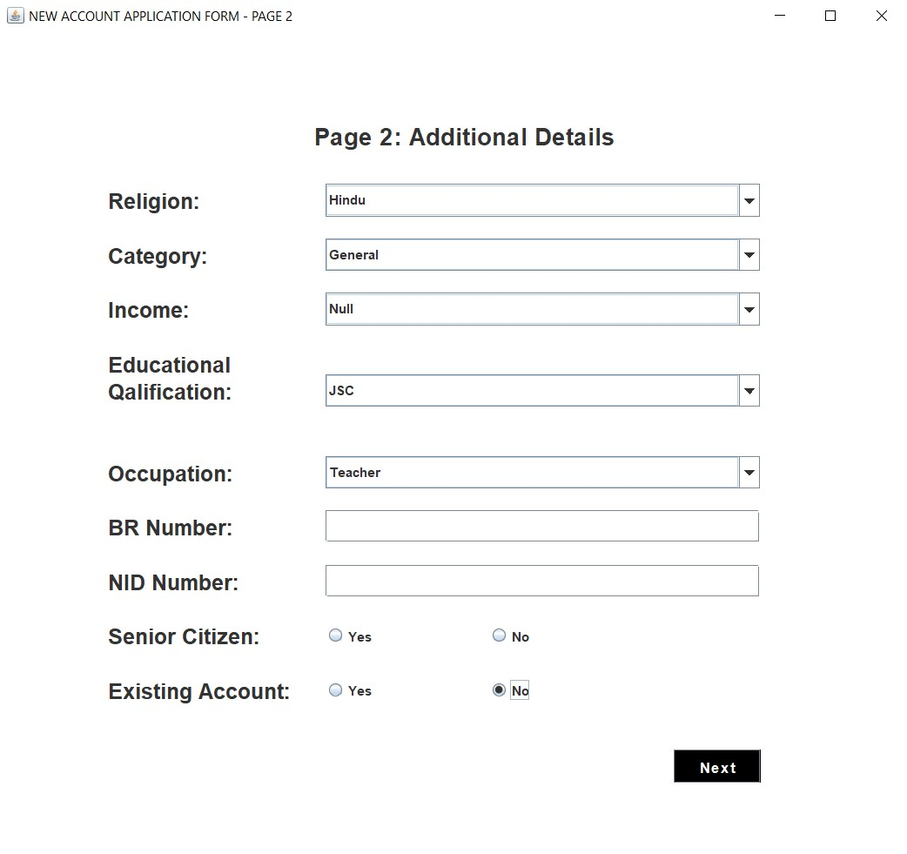

Signup Pages

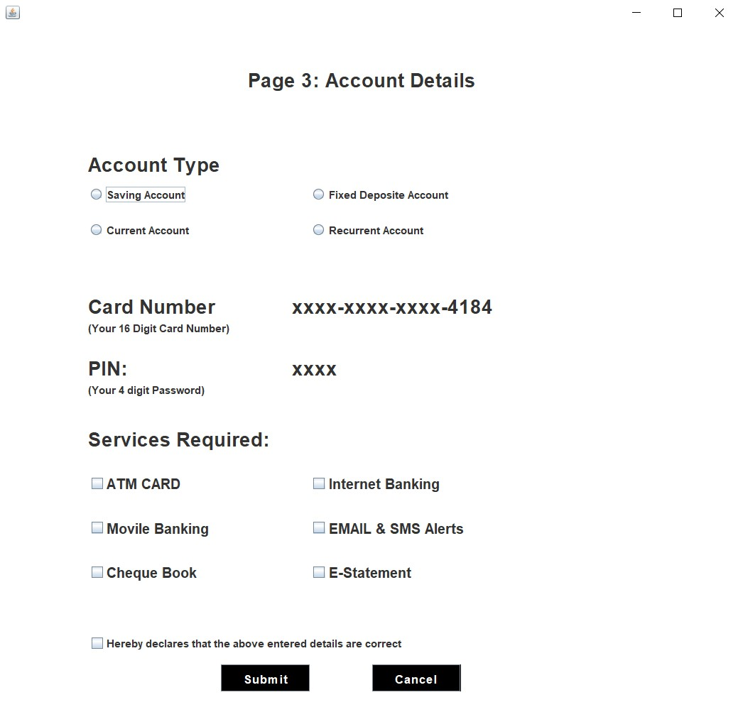

Account Details Page

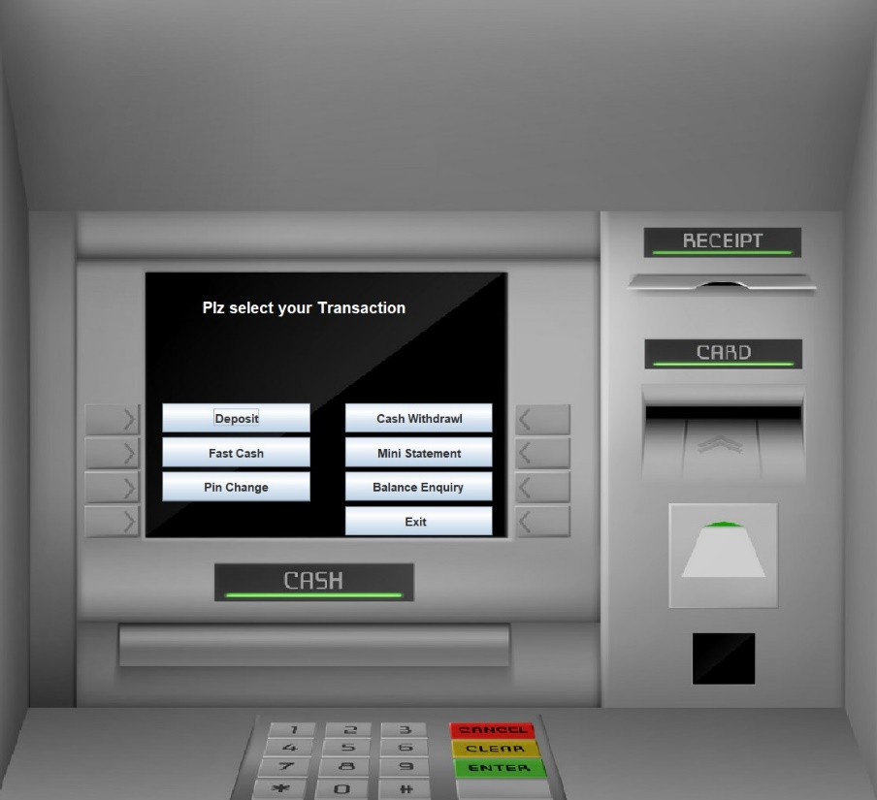

Frontend

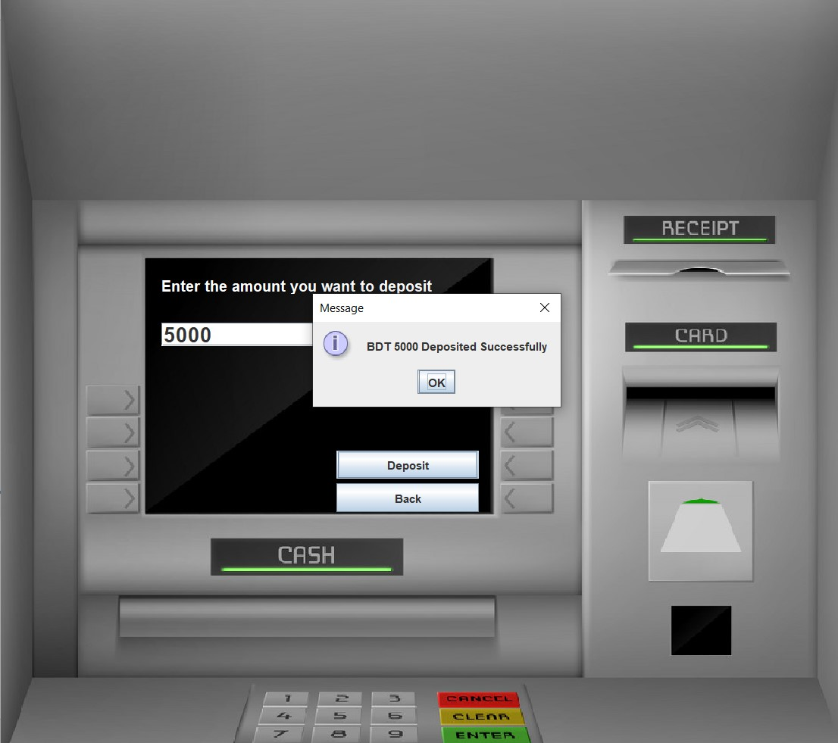

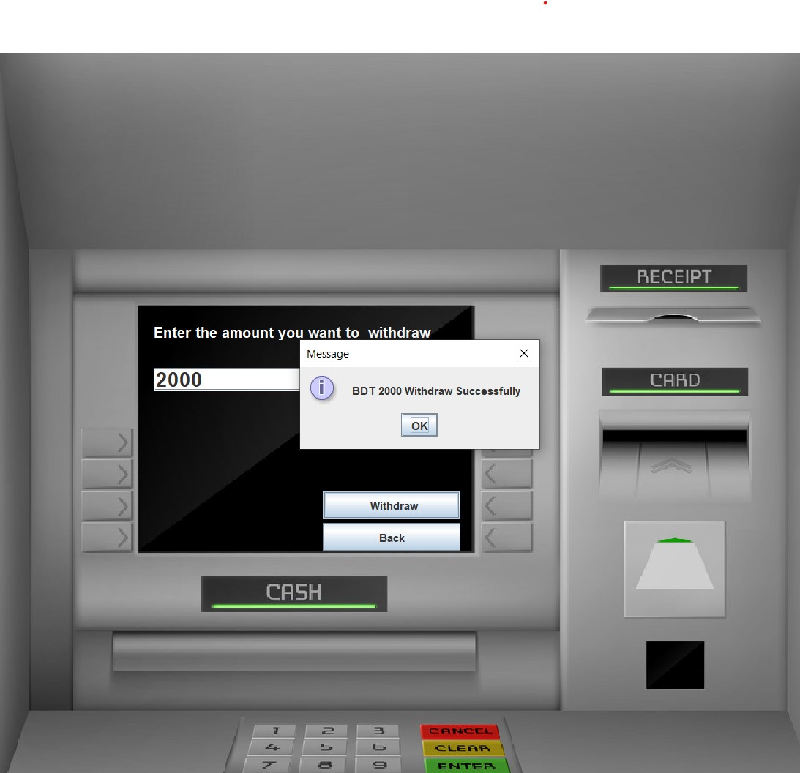

**Results / Analysis**

The Bank Management System (ATM Simulator) was successfully developed and tested as a desktop application. All core banking operations such as login, deposit, withdrawal, fast cash, balance enquiry, mini statement, and PIN change were implemented using Java Swing and connected to a MySQL database via JDBC.

The system provides a smooth user interface, accurate transaction recording, and real-time balance updates. Testing confirmed that transactions are securely stored in the database, and invalid inputs (like incorrect PIN or insufficient balance) are properly handled with clear error messages.

**Challenges Faced**

**JDBC Integration:** Initially faced issues connecting Java with the MySQL database due to driver setup and connection string errors.  
✅ Resolved by configuring the JDBC driver properly and testing connections step by step

**GUI Layout Management**: Designing complex interfaces using Java Swing was difficult without a layout manager.  
✅ Used null layout with manual positioning to control the layout precisely*.*

**Handling User Input**: Validating PINs and preventing invalid or empty inputs required extra logic.  
✅ Implemented input checks and appropriate error dialogs

**Database Logic for Balance Calculation**: Computing the real-time balance based on transaction history was tricky.  
✅ Solved by looping through transactions and calculating net deposits and withdrawals.

**Conclusion**

The Bank Management System (ATM Simulator System) was successfully developed as a desktop-based application using Java and MySQL. It simulates real-world ATM operations such as login, withdrawal, deposit, balance enquiry, and PIN change. Through this project, we gained practical experience in building user interfaces with Java Swing and managing data through JDBC connectivity, enhancing our understanding of both frontend and backend development.

**Future Scope**

The project can be enhanced further by adding the following features:

* **Admin Panel** to manage users and monitor all transactions
* **Fund Transfer** between accounts
* **ATM Receipt Generation** after each transaction
* **Encryption** for PIN and sensitive data to increase security
* **User Profile Management** (update phone, email, etc.)
* **Transaction Limits** and OTP verification for added security