3D equation of the motion

Equation for motion of relativistic charged particle in external electrical and magnetic fields is as follows (formula (3) from [4]):

 (1)

Here are the fields of the RF cavity and is the external magnetic field.

Let come in equation (1) to dimensionless variables:   (again, dot means the differentiation with respect to dimensionless “time” ). Then



Let’s find expression for . Using unit vectors rewrite the vector :



Then

 (2)

But 

Then



so that

(3)

This equation gives (it is necessary to remember, that   and ):

(4)

Special case is as follows: main symmetrical mode of the field in the RF cavity with cylindrical geometry  and. For this case last equations reduce to the following expressions (in the right parts of equations the reverse replacements from coordinates  to  were made):



So, there are the formulas used in *Helleg2D* code (formula (5) from [1], formulas (4) from [2] and formulas (6) – (8) from [3]).

Preparation for comparison results from code Hellweg with code *ASTRA*

Two matlab scripts were written to allow verify the results from Hellweg using code *ASTRA* (A Space charge TRacking Algorithm [5]).

Script *hellwegOutput2ASTRA.m* reads a special file *beam.log*, created by *Hellweg* after initialization of initial data. File beam.log includes data for each generated particle (coordinates and velocities) and rewrites them in file, which is readable by code *ASTRA*.

Script *astraOutputFilesAnalyser.m* allows to analyse any output files created by the code *ASTRA* in the process of the work and to submit the results of analysis in a forms suitable for comparison with the results of the code *Hellweg.*

Comparison of the results from codes *Hellweg* and *ASTRA*

Figure 1 shows the input files to compare results from Hellweg and ASTRA codes.

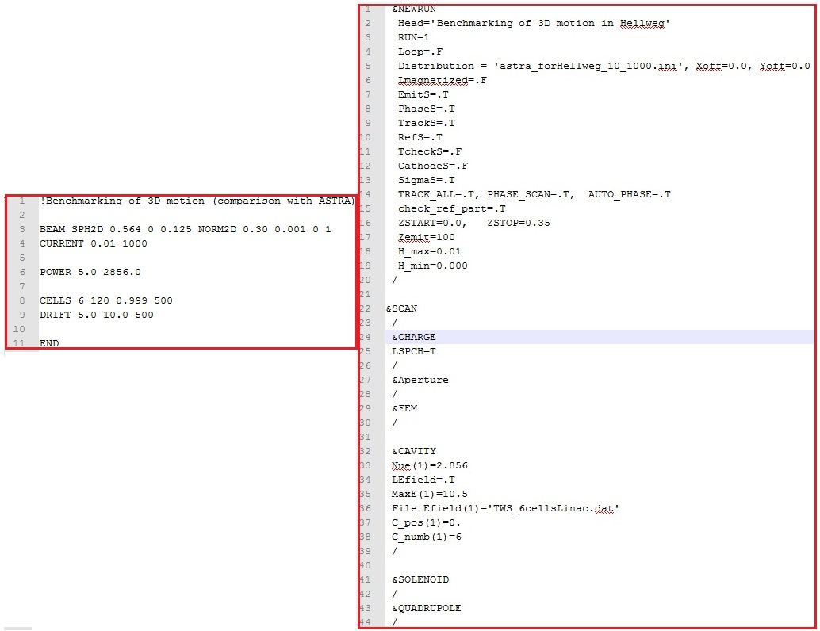

Figure 1. Input files for codes Hellweg (left) and ASTRA (right).

Next Figures show the screenshot of the launching of the code ASTRA and distribution of the longitudinal electric field on the axis of the system, which is used by ASTRA.

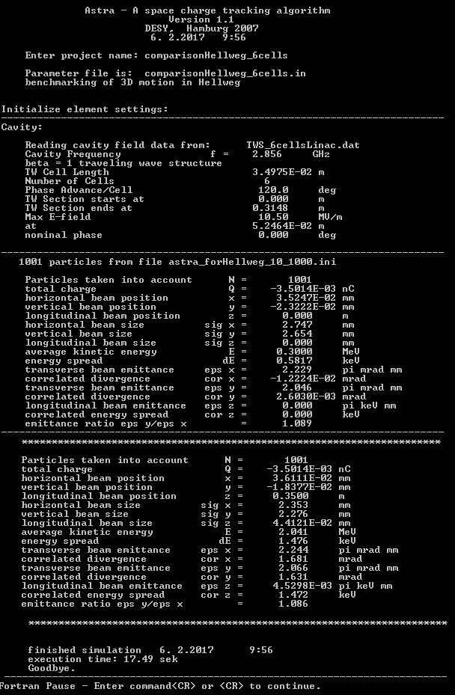

Figure 2. Screenshot of the launching ASTRA.

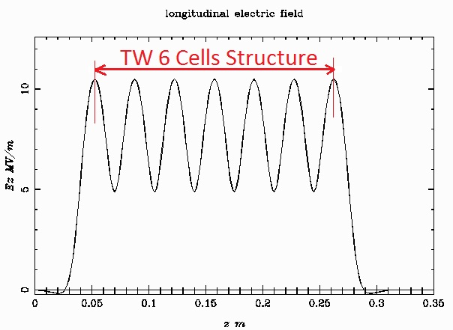

Figure 3. Electric field on the axis of TW 6 cells cavity.

Comparison of the simulation of the beam acceleration on both codes is shown on the Figure 4.

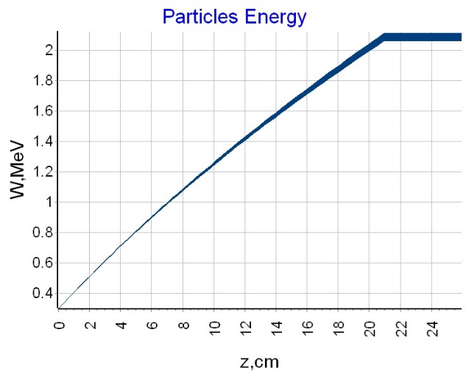 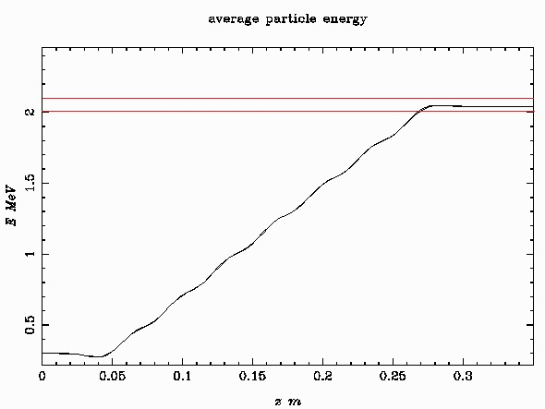

Figure 4. Beam acceleration in Hellweg (left) and ASTRA (right) codes.

Next Figure 5 presents the dependences of normalized transverse emittances along the system.

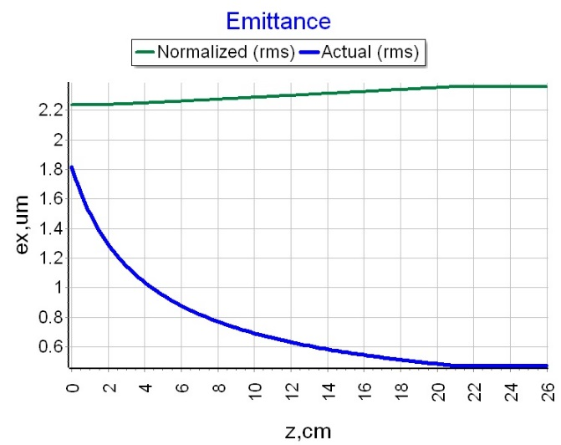 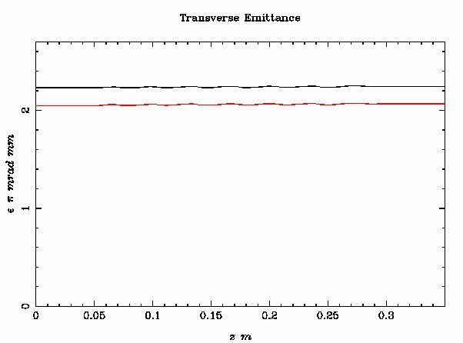

Figure 5. Normalized transverse emittances in Hellweg (left) and ASTRA (right) codes.

Figure 6 shows the transverse phase space distributions after linac for both codes simulations.

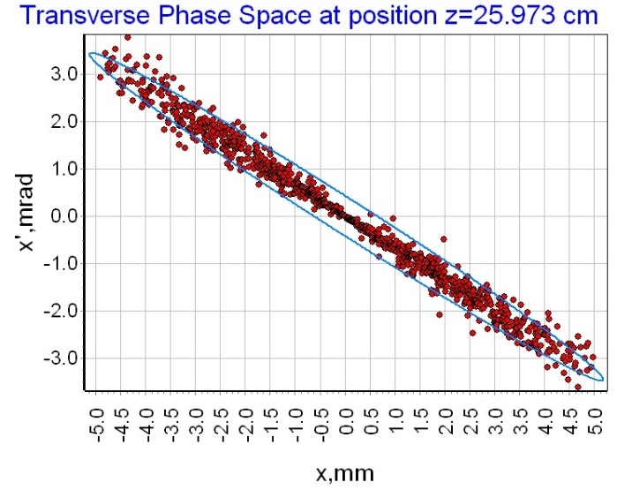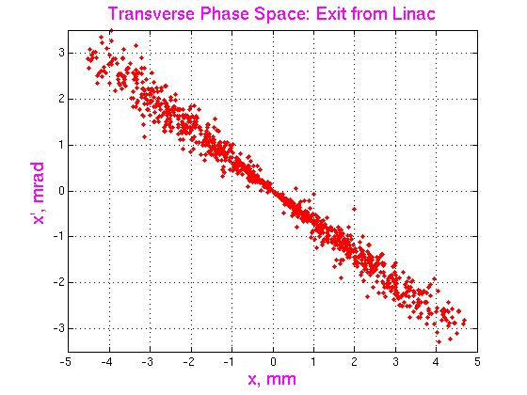

Figure 6. Transverse Phase space at the end of linac in Hellweg (left) and ASTRA (right) codes.

Figures 4 – 6 show quite good agreement between results.

References.

1. E. S. Masunov, B.N. Rastchikov*. Metod rascheta gruppirovki cilnotochnogo puchka v neodnorodnoj volnovodnoj sekcii LUE* (in Russian). “Uskoriteli”, **17** (1979) 78 – 83.
2. S. Kutsaev. *Electron dynamics simulations with Hellweg2D code*. NIM, **A618** (2010) 298-305.
3. D. Bruhwiler. *Cloud-based design of average power travelling wave linac*. DOE FY 2016 (Release 2). Phase I SBIR Proposal, topic 24i.
4. E. S. Masunov, B.N. Rastchikov*. Gruppirovka I samouskorenie cilnotochnogo puchka v volnovodnoj zamedlyayustchej cisteme pri nalichii vheshnego magnitnogo polya* (in Russian). Journal of Technical Physics, **49** (1979) 1462 – 1470.
5. K. Flöttmann, ASTRA – A Space Charge Tracking Algorithm, <http://www.desy.de/~mpyflo/>.