Brillouin Flow in Hellweg2d

1. Beam with zero emittance.

Hellweg2D result is:

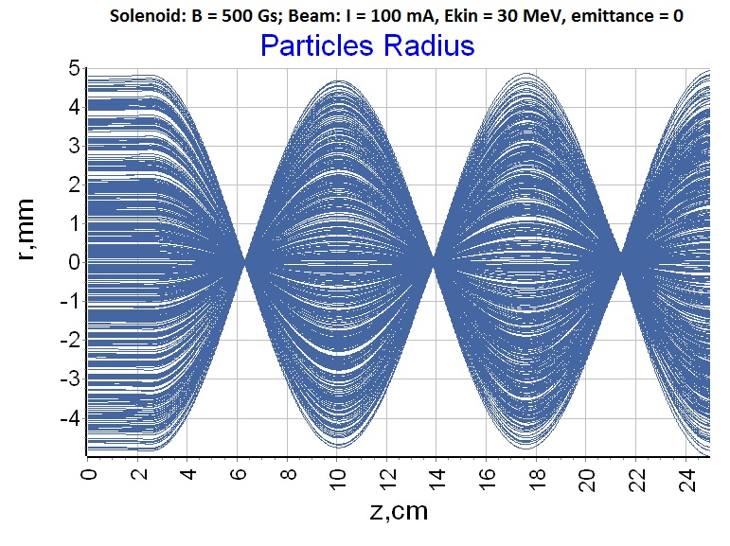

Brillouin wave length is defined from equation (7-19) [1] for periodic fluctuation of the beam radius (nonrelativistic case!):

 (1)

where is the confinement factor. It can be shown (see Appendix), that usually. So, for the electron beam with kinetic energy and solenoid with field  one has in a good agreement with value  from picture.

1. Beam with nonzero emittance.

Firstly let rewrite formula (1), using expression for Larmor radius:

. (2)

It can be shown [2] that for the beam with emittance  expression (2) moves to

. (3)

It is possible again neglect the contribution of the confinement factor. The following distributions are used in Hellweg2D simulation:

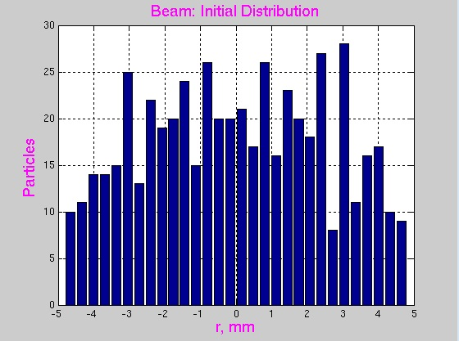 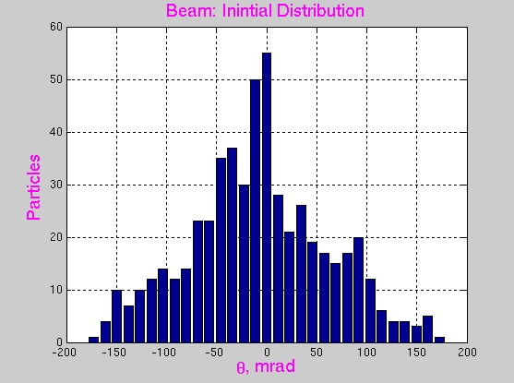

For these distributions and , so that . This emittance value is practically no effect on the length Hellweg2D simulation for this case confirms this conclusion:

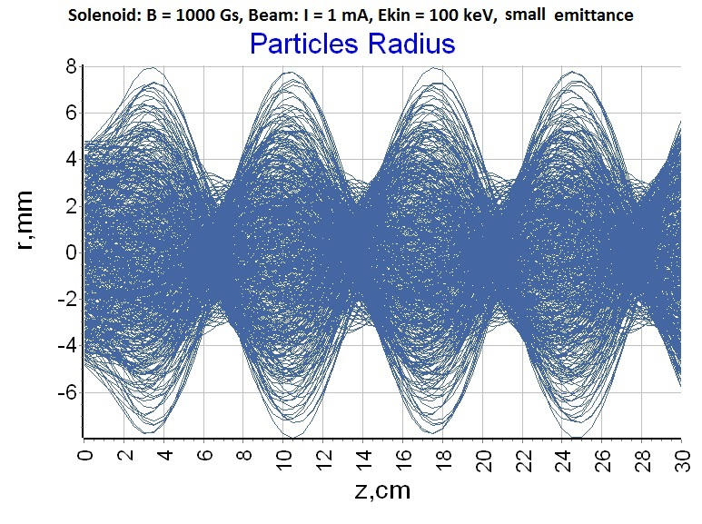

For and  one has in a excellent agreement with value  from picture.

References

1. A.S. Gilmor. *Klystrons, traveling wave tubes, magnetrons, crossed-field amplifiers, and gyrotrons*. Artech House, 2011.
2. I.N. Meshkov. *Transportation of charged particle beams.* (In Russian). Nauka, 1991.

Appendix: confinement Factor

Confinement factor is defined in (7-12) as ratio of the equilibrium radius and parameter( – current of the beam,  – charge, mass, and longitudinal velocity of the electron and  – the speed of light) :

 where (see formula (7-5))  (A1)

Equilibrium radius can be found from equation (7-7):

 (A2)

In this equation are magnetic field and radius of the beam on the cathode. In our case (“cathode” is simply an entrance to the system) and  – the initial radius of the beam. Then instead (A2) one has the following equation for

 (A3)

Solution of this equation is

 (A4)

Next figures show the dependence value of from different parameters of the beam (energy, current and magnetic field).

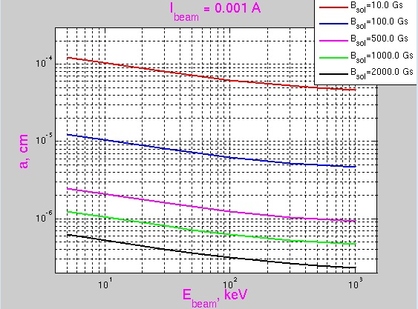 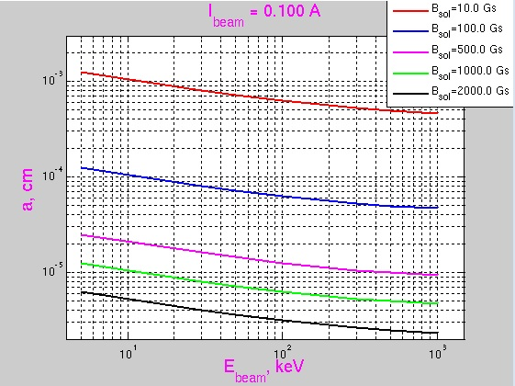

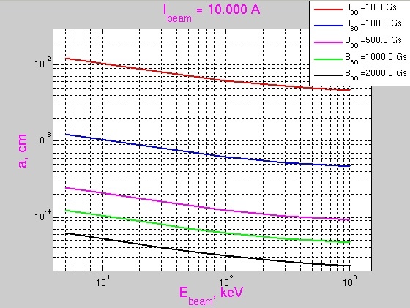 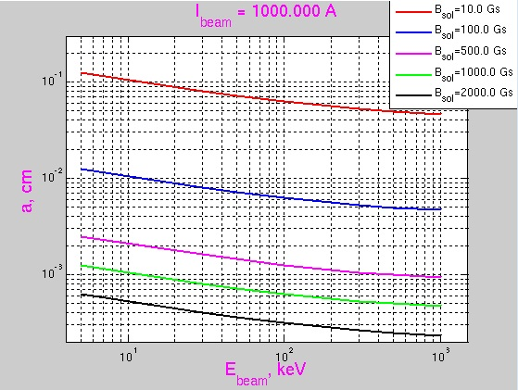

Seen that usually , so that

 (A5)

Returning to the general case instead (A4) one has

 (A6)

and for  instead (A5) one has

 (A7)

so that

 (A8)