“Space-charge calculation for bunched beams with 3-D ellipsoidal symmetry”

R.W. Garnett and T.P. Wangler

**Electric Field** (numeration as in article)

Let calculate electric field in the point  of charge ellipsoid (total charge with azimuthal symmetry, i.e. the semisizes of this ellipsoid are correspondingly  (so that ):

 (5)

where

. (4)

**Calculation of integrals for (5)**

1. For  (from (5)) the following approximation is used:



1. To calculate integrals for (5) the N-points Gauss-method is used:



where

|  |  |  |
| --- | --- | --- |
|  | | |
| Point |  |  |
| 1 | -0.9061798 | 0.2369269 |
| 2 | -0.5384093 | 0.4786287 |
| 3 | 0.0000000 | 0.5688889 |
| 4 | 0.5384093 | 0.4786287 |
| 5 | 0.9061798 | 0.2369269 |

|  |  |  |
| --- | --- | --- |
|  | | |
| Point |  |  |
| 1 | -0.9324695 | 0.1713245 |
| 2 | -0.6612094 | 0.3607616 |
| 3 | -0.2386192 | 0.4679139 |
| 4 | 0.2386192 | 0.4679139 |
| 5 | 0.6612094 | 0.3607616 |
| 6 | 0.9324695 | 0.1713245 |

|  |  |  |
| --- | --- | --- |
|  | | |
| Point |  |  |
| 1 | -0.9491079 | 0.1294850 |
| 2 | -0.7415312 | 0.2797054 |
| 3 | -0.4058452 | 0.3818301 |
| 4 | 0.0000000 | 0.4179592 |
| 5 | 0.4058452 | 0.3818301 |
| 6 | 0.7415312 | 0.2797054 |
| 7 | 0.9491079 | 0.1294850 |

|  |  |  |
| --- | --- | --- |
|  | | |
| Point |  |  |
| 1 | -0.9602899 | 0.1012285 |
| 2 | -0.7966665 | 0.2223810 |
| 3 | -0.5255324 | 0.3137066 |
| 4 | -0.1834346 | 0.3626838 |
| 5 | 0.1834346 | 0.3626838 |
| 6 | 0.5255324 | 0.3137066 |
| 7 | 0.7966665 | 0.2223810 |
| 8 | 0.9602899 | 0.1012285 |

|  |  |  |
| --- | --- | --- |
|  | | |
| Point |  |  |
| 1 | -0.9681602 | 0.0812744 |
| 2 | -0.8360311 | 0.1806482 |
| 3 | -0.6133714 | 0.2606107 |
| 4 | -0.3242534 | 0.3123471 |
| 5 | 0.0000000 | 0.3302394 |
| 6 | 0.3242534 | 0.3123471 |
| 7 | 0.6133714 | 0.2606107 |
| 8 | 0.8360311 | 0.1806482 |
| 9 | 0.9681602 | 0.0812744 |

|  |  |  |
| --- | --- | --- |
|  | | |
| Point |  |  |
| 1 | -0.9739065 | 0.0666713 |
| 2 | -0.8650634 | 0.1494513 |
| 3 | -0.6794096 | 0.2190864 |
| 4 | -0.4333954 | 0.2692602 |
| 5 | -0.1488743 | 0.2955242 |
| 6 | 0.1488743 | 0.2955242 |
| 7 | 0.4333954 | 0.2692602 |
| 8 | 0.6794096 | 0.2190864 |
| 9 | 0.8650634 | 0.1494513 |
| 10 | 0.9739065 | 0.0666713 |

|  |  |  |
| --- | --- | --- |
|  | | |
| Point |  |  |
| 1 | -0.9782287 | 0.0556686 |
| 2 | -0.8870626 | 0.1255804 |
| 3 | -0.7301520 | 0.1862902 |
| 4 | -0.5190961 | 0.2551938 |
| 5 | -0.2695432 | 0.2628045 |
| 6 | 0.0000000 | 0.2729251 |
| 7 | 0.2695432 | 0.2628045 |
| 8 | 0.5190961 | 0.2551938 |
| 9 | 0.7301520 | 0.1862902 |
| 10 | 0.8870626 | 0.1255804 |
| 11 | 0.9782287 | 0.0556686 |

|  |  |  |
| --- | --- | --- |
|  | | |
| Point |  |  |
| 1 | -0.9815606 | 0.0471753 |
| 2 | -0.9041173 | 0.1069393 |
| 3 | -0.7699027 | 0.1600783 |
| 4 | -0.5873180 | 0.2031674 |
| 5 | -0.3678315 | 0.2334925 |
| 6 | -0.1253334 | 0.2491470 |
| 7 | 0.1253334 | 0.2491470 |
| 8 | 0.3678315 | 0.2334925 |
| 9 | 0.5873180 | 0.2031674 |
| 10 | 0.7699027 | 0.1600783 |
| 11 | 0.9041173 | 0.1069393 |
| 12 | 0.9815606 | 0.0471753 |

|  |  |  |
| --- | --- | --- |
|  | | |
| Point |  |  |
| 1 | -0.9894009 | 0.0271525 |
| 2 | -0.9445750 | 0.0622535 |
| 3 | -0.8656312 | 0.0951585 |
| 4 | -0.7554044 | 0.1246290 |
| 5 | -0.6178762 | 0.1495960 |
| 6 | -0.4580168 | 0.1691565 |
| 7 | -0.2816036 | 0.1826034 |
| 8 | -0.0950125 | 0.1894506 |
| 9 | 0.0950125 | 0.1894506 |
| 10 | 0.2816036 | 0.1826034 |
| 11 | 0.4580168 | 0.1691565 |
| 12 | 0.6178762 | 0.1495960 |
| 13 | 0.7554044 | 0.1246290 |
| 14 | 0.8656312 | 0.0951585 |
| 15 | 0.9445750 | 0.0622535 |
| 16 | 0.9894009 | 0.0271525 |

1. The following graphs show that the integration is achieved acceptable accuracy for :

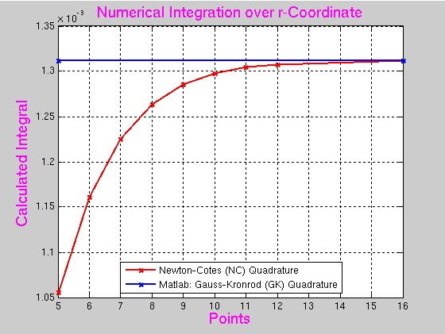 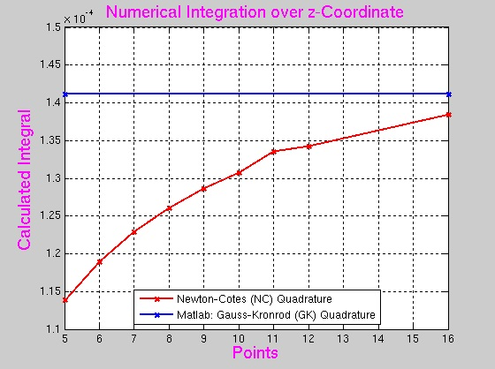

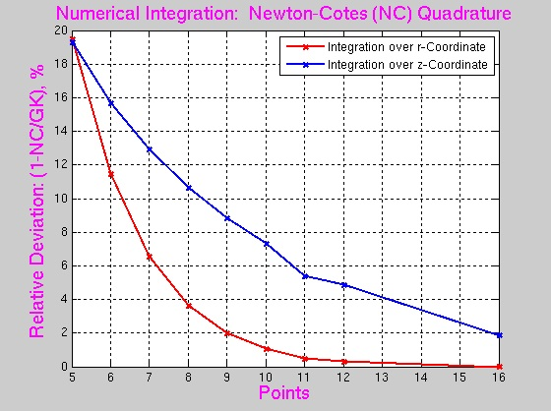

**Comparison for ASTRA and Hellweg2D**

Comparison for ASTRA and Hellweg2D (Lapostolle’s approach) to take into account the space charge effect:

