“Space-charge calculation for bunched beams with 3-D ellipsoidal symmetry”

R.W. Garnett and T.P. Wangler

**Main formulas** (numeration as in article)

Charge density:

 (6)

where

 (7)

After some transformations one has

 (11)

where

 and 

Let input dimensionless values , i.e.  , then

 and .

**Simulation**

1. 
2. 





1. 
2. 
3. 
4. 
5. 

**Results** (compare with solid line from original figure 1 with results for and )

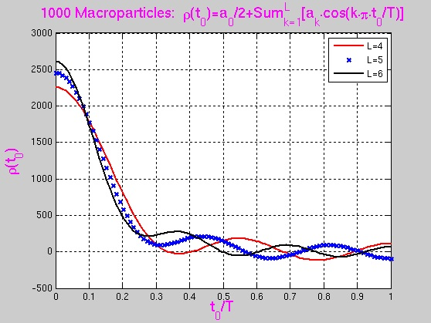 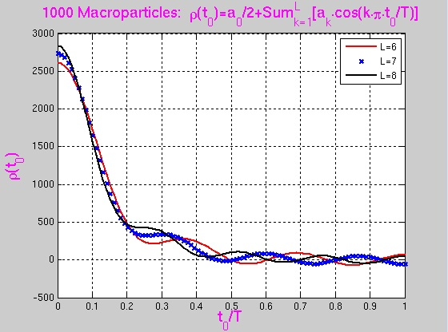

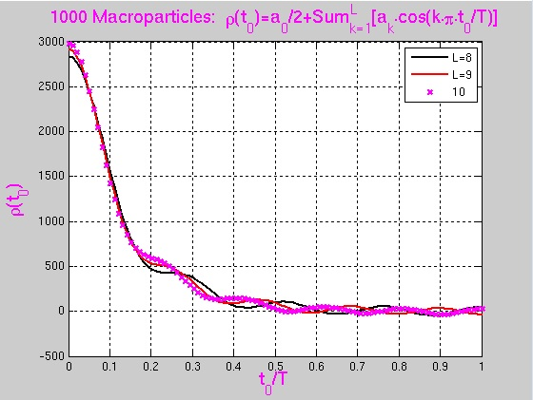

**Electric Field**

Let calculate electric field in the point  of charge ellipsoid (total charge with azimuthal symmetry, i.e. the semisizes of this ellipsoid are correspondingly  (so that ):

 (5)

where

. (4)

**Calculation of integrals for (5)**

To calculate integrals for (5) the 5-points Gauss-method is used:



where

|  |  |  |
| --- | --- | --- |
| Point |  |  |
| 1 |  |  |
| 2 |  |  |
| 3 | 0 |  |
| 4 |  |  |
| 5 |  |  |

For  (from (5)) the following approximation is used:

