**Physics in Hellweg2D**

Physics in Hellweg2D includes three issues:

1. Equation of the motion;
2. Equations of the electromagnetic fields in the cavity;
3. Equations of the space charge effect.

These equations describe the problem in an axially symmetric geometry (2D) and will be presented and verified. This will allow describe the problem in 3D case in further.

Origin formulas [1-8]

1. Equations of the motion (EoM) together with equations of the fields in the cavity (EoF; formulas (5) from [1], formulas (4) from [2] and formulas (6) – (8) from [3]):

 (1)

where (dot means the differentiation with respect to dimensionless “time” )

 (2)

These formulas can be transformed to the following form. Firstly, let take into account that

 (3)

then (1a) is transformed to



or (with )

 (4a)

Similarly, (1b) is transformed to



or (taking into account that )

 (4b)

At last, (1c) is transformed to

 (4c)

Formulas (4) must be compared with the original formulas of Masunov [5; formulas (4)]:

 (5)

Note: equation (5c) is written for case .

The pares of equations (4a), (5a) and (4b),(5b) are the same (!), but the equations (4c) and (5c) are different. Why? Maybe (4c) is integral of (5c) simply?

1. Equations to describe space charge effect (SCE; formulas (6,7) from [1]):

 (6)

where form factor  is

 (7)

These formulas, in turn were borrowed from Chapter 7.0 in the description of the Trace-3D code [6]:

 (8)

where form factor  is a special function on parameter ; this function is tabulated in a special table.

The same formulas were used in [7], where for form factor  an analytical expression was suggested:

 (9)

In turn, these formulas are taken from the original work [8], where the fields of the space charge of the beam were calculated under the following suggestions:

* Beam is presented as a 3D homogeneous charged ellipsoid, charge density, with semi axes  (for 2D case );
* SCE is determined by internal field of ellipsoid.

In these suggestions for charged ellipsoid with  and  the following formulas for the distributions of the potentials of the electric fields of the beam have been received ([8], formulas (5), (6)).

* Oblong ellipsoid with :

 (10a)

* Flattened ellipsoid with :

 (10b)

These expressions allow find the electric field of the beam with current . Indeed, the charge density in this beam is

 (11)

so

 (12)

where form factor  is

 (13)

Verification of the formulas (1)-(5)

Equations (5) were obtained from formula (3) in [4] as equation for motion of relativistic charged particle in external electrical and magnetic fields:

 (14)

Here are the fields of the RF cavity and is the external magnetic field.

Let come in equation (6) to dimensionless variables:   (again, dot means the differentiation with respect to dimensionless “time” ). Then

and



So, for main mode of the field in the RF cavity with cylindrical geometry  and:



Note 1: for mail mode of the fields in the cylindrical cavity.

Note 2: Because th3 equation (5c) was written for case .

Returning in these equations to the dimensional variables we have:



Resume concerning verification of formulas (5): the terms  and  were missed in the right sides of the last second and third expressions. *I think it is my mistake somewhere*.

**So, code Hellweg2D uses correct expressions for equations of motion.**

Verification of the formulas (8), (12)-(13)

To do this, let's consistently reproduce the results obtained in [8].

Let charge is homogeneously distributing with density inside the ellipsoid with semi axes . Then the potential  on the axis (in the point of observation ) equals

.

The equation of ellipsoid is



Then inside of ellipsoid,  potential is



But



i.e.



Then



and



In a special case with round bunch  and then



Let take into account that for 



The elementary integrals are



and



Let input the function :



then



So

So,



where



Being that



then



For this reason

Further, expression for  depend on ratio , i.e. signs of  and .

Case for oblong ellipsoid: . Then



So



then



and





So that



Remembering that



one has the final expression for :



So, for 



Case for Flattened ellipsoid: . Then

Further,



then



and



So that

Remembering that



one has the final expression for  in the case 



So,



For this reason, in case 





or finally for 



Quite similar in case one has





or finally for 



This is original formula (6) from [8], but without factor “2” in denominator again.

At last, for case  on has

So, the final expressions for potential are



Now let’s convert these expressions for the case. Dependence of the potential on these variables can be found as follows. Second terms should be replaced by expressions, which satisfy to Laplace equation:



It means that factor  should be replaced by . Similarly, terms like  should be replaced by expressions which satisfy to Poison equation inside ellipsoid:



i.e.



So, final expression for potential inside ellipsoid is as follows:

 Comparison with formulas (10) (original formulas (5), (6) from [8]) shows that original formulas content extra factor “2” in denominators before variable .

Expressions for potential give the following electric field inside the ellipsoid (with taking into account the connection (11) between charge density  and beam current):



Where form factor  equals

 (14)

Next Figure shows this form factor as function of parameter.

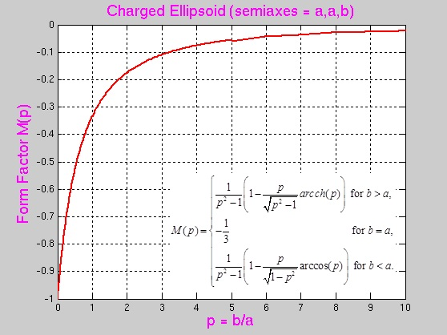

Next Figure shows the comparison of this form factor and form factor, which is used in the code Hellweg2D.

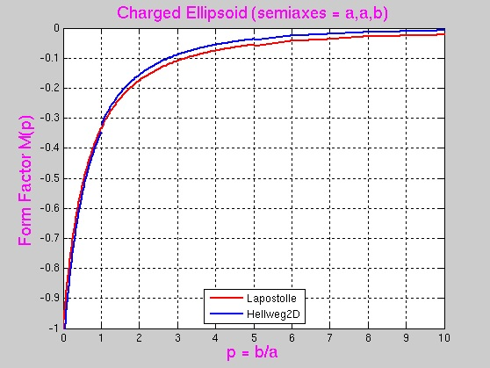

Last expressions for electrical field were found in the coordinate system of the beam. Transverse electric field at the transition to the laboratory frame decreases to  times. So, the final expressions for electrical field which must be used in the code Hellweg2D are as follows:

 (15)

with form factor  from (14).

Next Figures show the comparisons of absolute and relative results in codes ASTRA and Hellweg2D for space charge effect.

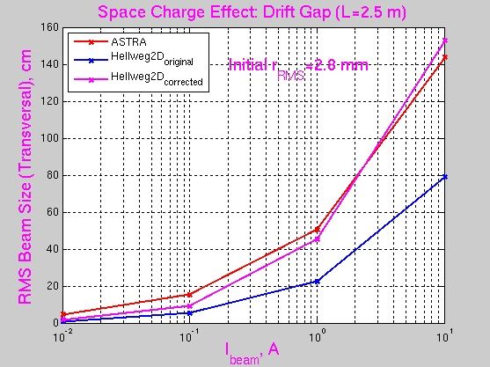

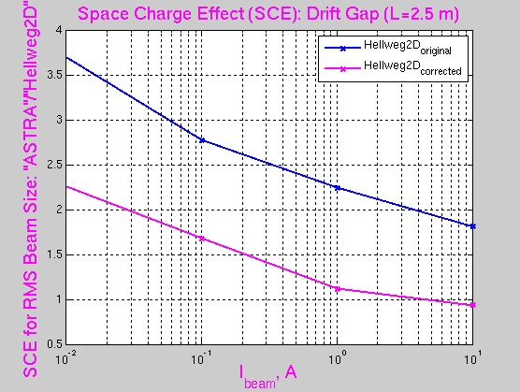

“Идгу” data are described by expressions (8), (13), and "magenta" data are received in accordance with the Lapostolle’s formulas (14), (15) derived above.

References.

1. S. Kutsaev. *Electron dynamics simulations with Hellweg2D code*. NIM, **A618** (2010) 298-305.
2. D. Bruhwiler. *Cloud-based design of average power travelling wave linac*. DOE FY 2016 (Release 2). Phase I SBIR Proposal, topic 24i.
3. E. S. Masunov, B.N. Rastchikov*. Gruppirovka I samouskorenie cilnotochnogo puchka v volnovodnoj zamedlyayustchej cisteme pri nalichii vheshnego magnitnogo polya* (in Russian). Journal of Technical Physics, **49** (1979) 1462 – 1470.
4. E. S. Masunov, B.N. Rastchikov*. Metod rascheta gruppirovki cilnotochnogo puchka v neodnorodnoj volnovodnoj sekcii LUE* (in Russian). “Uskoriteli”, **17** (1979) 78 – 83.
5. E. S. Masunov, B.N. Rastchikov*. Issledovanie nestacionarnoj dinamiki cilnotochnogo relyativistskogo puchka v volnovodnykh sekciyakh LUE* (in Russian). Journal of Technical Physics, **48** (1978) 2533 – 2540.
6. K.R. Crandall, D.P. Rusthoi. *TRACE 3-D Documentation.* Preprint LA-UR-97-886, Los Alamos National Laboratory, 1997. laacg.lanl.gov/laacg/services/traceman.pdf.
7. D. Raparia, J.G. Alessi, Y.Y. Lee, W.T. Weng. *Achromat with linear space charge for bunched beams.* 19 International Conference Linac’98, Report TH4023, Chicago, 1998. <https://accelconf.web.cern.ch/L98/PAPERS/TH4023.PDF>.
8. P.M. Lapostolle. *Effect de la charge d’espace dans un accelerateur lineaire protons.* Preprint CERN AR/Int. SG/65-15, 1965.