
CURRICULUM VITAE
PERSONAL DETAILS
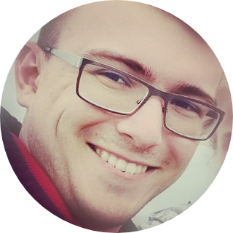
Name: Oleg V. Fedorov
Address: Novogireevskaya str, 17-56, 111399, Moscow, Russia;
Phone: +7 (926) 577 67 46 (Russian);
E-mail o.fedorov@sysbiomed.ru
ofedorov@pharm-sintez.ru,
Date of birth: 02 November 1993
Nationality: Russian
Spoken languages: Russian (native), English (fluent, 105 TOEFL), German (reading)
EDUCATION
2014-2018 | N.D. Zelinsky Institute of Organic Chemistry, Russian Academy of Sciences, Moscow (PhD)
2009-2014 | M.V. Lomonosov Moscow State University, Chemistry Department, chair of organic chemistry (graduation with honours)
2007-2009 | Moscow High School #1303, Moscow Chemical Lyceum (High School)
WORKING HISTORY
2022-currently employed | Scientific Research Institute for Systems Biology and Medicine ⁵, Moscow, Senior Researcher, group leader (Laboratory of Simple Systems, Group of Peptide and Oligonucleotide Synthesis).
2019-2022 | JSC “Pharm-Sintez” (Rus: АО «Фарм-Синтез») ⁴, Moscow, Senior Researcher – Leading Researcher, group leader (group of radiopharmaceutical development).  Fields of expertise – lead-discovery, peptide synthesis, quality control (analytical chemistry – development, validation, transfer of methods).  Group leader of full-cycle development and production of peptide tracers for radiopharmaceutical needs – from SPPS and liquid phase synthesis, purification and quality control to preparation of final formulations for clinical use.
2014-2019 | N.D. Zelinsky Institute of Organic Chemistry, Russian Academy of Sciences, Moscow, laboratory #8 of functional organic compounds, PhD, research assistant (2014-2016) research associate (2016-2019) in the research group of Prof. Dr. A. D. Dilman ¹.  Fields of expertise – organofluorine chemistry, photoredox chemistry, metalloorganics, difluorocarbene and difluorocyclopropane chemistry.
2011-2014 | Lomonosov Moscow State University, Laboratory of Supramolecular Chemistry and Organic Nanomaterials, Master Student, research associate (in the research group of Prof. Sergey Z. Vatsadse) ^{2,3}.  Fields of expertise – supramolecular chemistry, crown-esters, self-organization, material science.

WORK EXPIERIENCE:
few bullet points

Administrative experience:

- Project leader (grant program) during PhD studies
  - Scientific advisement for students;
  - Preparation of scientific publications and grant reports.
- Leader of group of radiopharmaceutical development (JSC “Pharm-Sintez”).
  - Leading a group of research associates (1 – 2 employees);
  - lead-discovery, peptide synthesis, quality control (analytical chemistry – development, validation, transfer of methods).
- Leader of group of peptide and oligonucleotide synthesis (Scientific Research Institute for Systems Biology and Medicine).
  - De-novo establishing technological pipeline for production of peptide standards for proteomics;
  - De-novo establishing technological pipeline for production of oligonucleotide synthesis for gene construction;
  - Leading a group of several research associates (3 employees);
  - Formulating tasks and goals for
    - research projects;
    - technological improvements;
    - maintenance of sustainable production of target compounds.

Medicinal and Pharmaceutical Chemistry:

- Selected APS products I have expertise on (including their preparation, quality control and/or clinical formulations): Atosiban, Reversan, Imatinib, Bortezomib, Pomalidomide, Octreotide, PSMA1007, PSMA617, DOTA-TATE, DOTA-NOC (and corresponding Gallium and Lutecium complexes for analytical standardizations), Mannose Triflate, Zoledronic acid.
- GMP and GLP compliancy expertise.

Peptide Synthesis:

- Experience in liquid-phase peptide synthesis (LPPS), synthesis planning, establishing production pipeline and calculating economic aspects of peptide APS production;
- Manual and automated solid-phase peptide synthesis (SPPS) on various types of solid support resins;
- Rich experience of preparation of high quality peptide standard libraries (mainly, on PurePep Chorus by Gyros Protein) for high throughput proteomics;
- Peptide analytics for quality control and preparative purification (FPLC, HPLC)

Oligonucleotide Synthesis and Gene Construction:

- Preparation of oligonucleotide libraries for gene construction by PCR/LCR and further Gibson assembly
- Quantification (Nanodrop, TECAN) and QC (ESI-MS, MALDI, gel-elecrophoresis)

PUBLICATIONS

- Fedorov, O. V., Scherbinina S.I., Levin, V. V., and Dilman, A. D.; Light-mediated dual phosphine-/copper-catalyzed atom-transfer radical addition reaction.; J. Org. Chem., 2019, 84(17), 11068–11079; [DOI]
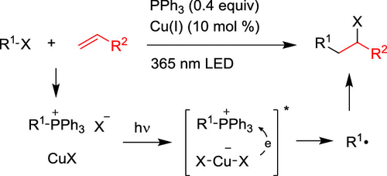
- Scherbinina S.I., Fedorov O. V., Levin, V. V., Kokorekin V. A., Struchkova M. I., and Dilman, A. D.; Synthesis of 3-Fluoropyridines via Photoredox-Mediated Coupling of α,α- Difluoro-β- iodoketones with Silyl Enol Ethers.; J. Org. Chem., 2017, 82 (24), 12967–12974; [DOI]
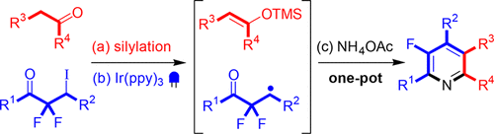
- Fedorov, O. V.; Kosobokov, M. D.; Levin, V. V.; Struchkova, M. I.; Dilman, A. D.; Halogenative Difluorohomologation of Ketones.; J. Org. Chem. 2015, 80, 5870–5876; [DOI]
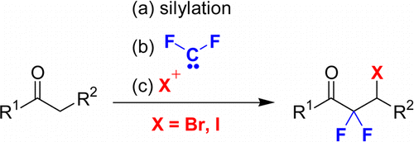
- Fedorov, O. V.; Struchkova, M. I.; Dilman, A. D.; Silicon Reagent with Functionalized Tetrafluoroethylene Fragments: Preparation and Coupling with Aldehydes.; J. Org. Chem. 2016, 81, 9455–9460; [DOI]
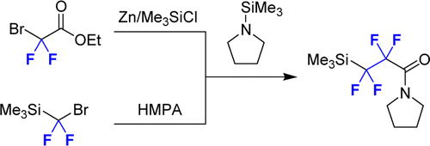
- Fedorov, O. V.; Levin, V. V.; Volodin A. D.; Struchkova M.I.; Korlyukov A.A.; Dilman, A. D.; Synthesis of difluorosubstituted six-membered nitronates via an addition/substitution cascade.; Tetrahedron Letters 2016, 5, 3639–3642; [DOI]
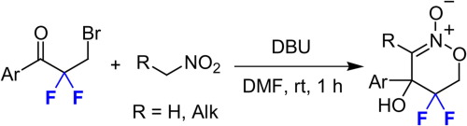
- Fedorov, O. V.; Struchkova, M. I.; Dilman, A. D.; Synthesis of gem-Difluorinated Hydroxypyrrolidines.; J. Org. Chem. 2017, 82 (6), 3270–3275; [DOI]
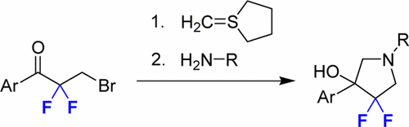
- Kuz’mina N. E.; Yashkir V. A.; Moiseev S. V.; Fedorov O. V.; Rakhmanov E. V.; Baleeva N. S.; Tarakanova A. V.; Anisimov A. V.; Russian J. Org. Chem., 2013, Vol. 49, No. 9, 1386–1396; [DOI]
- Vedernikov A. I.; Nuriev V. N.; Fedorov O. V.; Moiseeva A. A.; Kurchavov N. A.; Kuźmina L. G.; Freidzon A. Ya.; Pod ́yacheva E. S.; Medvedko A. V.; Vatsadze S. Z.; Gromov S. P., Russ.Chem.Bull., Int.Ed., 2016, Vol. 65, No. 11. 2686–2703. [DOI]
- Nuriev, V. N.; Fedorov, O. V.; Moiseeva, A. A.; Freidzon, A. Ya.; Kurchavov, N. A.; Vedernikov, A. I.; Medved'ko, A. V.; Pod'yacheva, E. S.; Vatsadze, S. Z.; Gromov, S. P.; Russian J. Org. Chem., 2017, Vol. 53, No. 11, 1726–1737 [DOI]
- V. M. Petriev, V. K. Tishchenko, E. D. Stepchenkova, O. V. Fedorov, A.A. Fronya; Behavioral Features of Gallium-68 Radionuclide Incorporated in Glucose Derivatives in Laboratory Animals.; Bulletin of the Lebedev Physics Institute. 2020, Vol. 47, No.11, 339–344 [DOI]
- V. M. Petriev, V. K. Tishchenko, E. D. Stepchenkova, O. V. Fedorov, A.A. Fronya; Особенности поведения радионуклида галлия-68 в составе производных глюкозы в организме лабораторных животных.; Краткие сообщ. по физике ФИАН 2020, №11, 19–27

SCIENTIFIC COMMUNITY IDENTIFIERS

Web of Science ResearcherID : | T-6867-2017
SCOPUS authorId : | 7004564086
ORCID : | 0000-0003-3457-4654

INTERNATIONAL CONFERENCES
PhD level (selected list):

The Fourth International Scientific Conference “Advances in Synthesis and Complexing”, 24-28 April 2017 – Moscow, Russia | Oral session: «Synthesis of fluorinated heterocyclic compounds starting from α,α-difluoro-β-halogenketones», Fedorov, O. V., Levin, V. V., Dilman, A. D.
BOSS XV 15th Belgian Organic Synthesis Symposium, July 10-15, 2016 – Antwerp, Belgium | «Difluorohomologation of Carbonyl Compounds», Oleg V. Fedorov, Mikhail D. Kosobokov, Vitalij V. Levin and Alexander D. Dilman;
BOSS XVI 17th Belgian Organic Synthesis Symposium, July 8-13, 2018 – Brussels, Belgium | «Photocatalitic Approach to Fluorinated Heterocycles from Сarbonyl Compounds», Oleg V. Fedorov, Liubov Panferova, Sofya I. Scherbinina, Artem Tsymbal, Vitalij V. Levin and Alexander D. Dilman;
Winter School on Organic Chemistry “Modern Trends in Organic Chemistry” WSOC-2016, 2016 – Moscow, Russia | «Ketone difluorohomologation in synthesis of fluorinated heterocycles», Oleg V. Fedorov, Mikhail D. Kosobokov, Vitalij V. Levin and Alexander D. Dilman;
International Congress on Heterocyclic Chemistry KOST-2015, October 18-23, 2015 – Moscow, Russia | «Synthesis of fluorine-substituted heterocycles using difluorocarbene», Alexander D. Dilman, Oleg V. Fedorov, Mikhail D. Kosobokov, Vitalij V. Levin;
School level (selected list):
OLYMPIADS & CONFERENCES
2009 – Final stage of the 45th Russian National Competition in Chemistry (Russian Olympiad of Senior High School students on Chemistry), Archangelsk, 3rd degree.
2009 – Moscow Olympiad of Senior High School students on Chemistry, 1st degree.
2009 – Regional Stage of the International Science and Engineering Fair, Intel ISEF held in Russia (Intel ISEF junior 2009), 3rd degree.
2009 – XXIII Young Chemists' Conference, 3rd degree.
2009 – Moscow Olympiad of Senior High School students on Art, 2nd degree.
2009 – LXV Moscow Student Academic Competition in Chemistry, 2nd degree.
2008 – LXIV Moscow Student Academic Competition in Chemistry, 2nd degree.
2006 – LVII Moscow Student Academic Competition in Chemistry, 3nd degree.

PATENTS
Nuriev V. N., Fedorov O. V., Podyacheva E. S., Vedernikov A. I., Kurchavov N. A., Vatsadze S. Z., Gromova T. A., Gromov S. P., Russian Federation Patent №2603135 (2016). B.I.Bul. 2016, № 32.
Нуриев В.Н., Федоров О.В., Подъячева Е.С., Ведерников А.И., Курчавов Н.А., Вацадзе С.З., Громова Т.А., Громов С.П., Патент РФ 2603135 (2016). Б.И. Бюл. 2016, № 32.

GRANT PROGRAMS AND FUNDING
My scientific research was supported and funded by Russian Science Foundation (RSF 17-13-01041, employee), Russian Foundation for Basic Research (RFBR 16-29-10661, employee; 16-33-00458 mol_a, project leader and employer – I was solely responsible for obtaining this funding program and for preparing grant project reports).

RESEARCH INTERESTS
Photoredox catalisys, late-stage fluorination, difluorocarbene and difluorocyclopropane chemistry, strain energy promoted transformations, intramolecular reactions, PET-precursors and radiopharmaceutical chemistry, peptide synthesis, new methodologies in peptide bond formation, natural product synthesis, peptide antibiotics, peptide tracers for PET, computer-aided drug-design, PROTACs, LYTACs, antibody-drug conjugates, TAG-assisted peptide synthesis, GAP-peptide synthesis, flow-reactors and applications of flow chemistry in pharmaceutical industry, ML applications in computational chemistry, chemoinformatics and chemical database managing toolkits.
SOFT SKILLS
I have strong presentation and technical writing skills. I use Zettelkasten method to organize my knowledge-base, which helps me prepare short communications and profound reports on any topic I was interested in or worked on - and blazingly fast.
Science communication and popularization skills:
- In 2016-2018 I organized a 1.5- year long science communication club project, (another_link) for young scientists – PhD’s, postdocs and young researchers with hardcore-level lections on their own research.
- I love teamwork, organizing events, planning tasks, managing and inspiring big teams. I believe I am communicative person and I love making contacts and getting to know more about people around me.
Additional leadership experience:
- I organized several extreme-sports festivals and trips, involving freeride, heliski and ski-tour.

ADDITIONAL RELATED SKILLS
Linux administration – Debian, Arch, Ubuntu, AWS. Setting up the remote computational resources and maintaining them operational. Bash scripting, compilation, networking essentials, multi-core parallel computations, openmpi.
Chemoinformatics toolkits – OpenBabel, KNIME, RDKit. Chemoinformatic data-cartridges: Mongo-RDkit, cgrbd (PostgreSQL)
Molecular docking – AutoDock, Schrödinger
Quantum and Computational Chemistry toolkits – ORCA, Avogadro, GAUSSIAN, Multiwfn, XTB package
Python – scripting, data analysis and presentation in Jupyter-Notebook, ML applications in chemistry, python full-stack development. Familiar with git-flow process.
Familiar with full-stack web-development: REST-API, Flask, Django, React, Vue.js, Node.js, Docker, SQLite, MongoDB, PostgreSQL – acquired those skills during the work with my chemoinformatics-related pet-project.
REFERENCES

1. Alexander D. Dilman,  Dr. Sci., prof. RAS, head of the Laboratory #8 of functional organic compounds, https://dilmanlab.ru/, N.D. Zelinsky Institute of Organic Chemistry, Russian Academy of Sciences (ZIOC). | Contacts:  +7 910 405 69 88  E-mail:  adil25@mail.ru  dilman@ioc.ac.ru  website, twitter
2. Sergey Z. Vatsadze  Prof., Dr. Sci., Deputy head of the Laboratory of Supramolecular Chemistry and Nanotechnology of Organic Materials (MSU), Head of the Laboratory of supramolecular chemistry (№2) (ZIOC). | Contacts:  E-mail: zurabych@gmail.com
3. Sergei P. Gromov,  Prof., Dr. Sci., head of the Laboratory of Supramolecular Chemistry and Nanotechnology of Organic Materials, vice director, head of the laboratory at the Photochemistry Center, RAS  Corresponding member of the Russian Academy of Sciences (RAS) | Contacts:  +7 495 935 01 16  E-mail: gromov@photonics.ru  spgromov@mail.ru
4. Alexander N. Balaev,  Ph.D., Principal Researcher, Group leader, head of the “OCTREOTIDE” department of AO “Pharm-Sintez” | Contacts:  E-mail:  abalaev@pharm-sintez.ru
5. Vadim M. Govorun,  Academician, Prof., Dr. Sci., head of the Laboratory of Simple Systems, director of Scientific Research Institute for Systems Biology and Medicine | Contacts:  +7 985 764 11 23  E-mail:  vgovorun@yandex.ru

