CURRICULUM VITAE
PERSONAL DETAILS

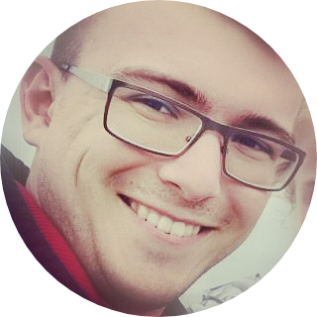
Name: Oleg V. Fedorov
Gender: Male
Marital Status: Engaged
Address: Novogireevskaya str, 17-56, 111399, Moscow, Russia;
Telephone: +7 (926) 577 67 46 (Russian);
E-mail olegvfedorov.orgchem@gmail.com, ofedorov@mail.pharm-sintez.ru
Date of birth: 02 November 1993
Nationality: Russian
Spoken languages: Russian (native), English (fluent, 105 Toefl), Deutsch (reading)
EDUCATION

2014-2018 | N.D. Zelinsky Institute of Organic Chemistry, Russian Academy of Sciences, Moscow (PhD)
2009-2014 | M.V. Lomonosov Moscow State University, Chemistry Department, chair of organic chemistry (graduation with honours)
2007-2009 | Moscow High School #1303, Moscow Chemical Lyceum (High School)

WORKING HISTORY

2019-currently employed | AO “Pharm-Sintez”, Moscow, Leading research associate (group of radiopharmaceutical development).  Fields of expertise – lead-discovery, peptide synthesis, quality control (analytical chemistry – development, validation, transfer of methods).  Group leader of full-cycle development and production of peptide tracers for radiopharmaceutical needs – from SPPS and liquid phase synthesis, purification and quality control to preparation of final formulations for clinical use.
2014-2019 | N.D. Zelinsky Institute of Organic Chemistry, Russian Academy of Sciences, Moscow, laboratory #8 of functional organic compounds, PhD, research assistant (in the research group of Prof. Dr. A. D. Dilman).  Fields of expertise – organofluorine chemistry, photoredox chemistry, metalloorganics, difluorocarbene and difluorocyclopropane chemistry.
2011-2014 | Lomonosov Moscow State University, Laboratory of Supramolecular Chemistry and Organic Nanomaterials, Master Student, research associate (in the research group of Prof. Sergey Z. Vatsadse).  Fields of expertise – supramolecular chemistry, crown-esters, self-organization, material science.
PUBLICATIONS
- Fedorov, O. V., Scherbinina S.I., Levin, V. V., and Dilman, A. D.; Light-mediated dual phosphine-/copper-catalyzed atom-transfer radical addition reaction.; J. Org. Chem., 2019, 84(17), 11068–11079; [DOI]
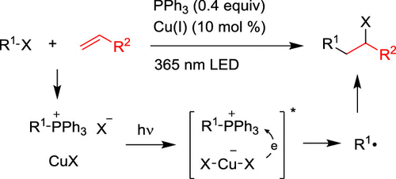
- Scherbinina S.I., Fedorov O. V., Levin, V. V., Kokorekin V. A., Struchkova M. I., and Dilman, A. D.; Synthesis of 3-Fluoropyridines via Photoredox-Mediated Coupling of α,α- Difluoro-β- iodoketones with Silyl Enol Ethers.; J. Org. Chem., 2017, 82 (24), 12967–12974; [DOI]
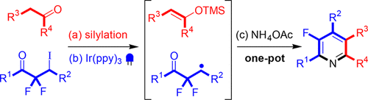
- Fedorov, O. V.; Kosobokov, M. D.; Levin, V. V.; Struchkova, M. I.; Dilman, A. D.; Halogenative Difluorohomologation of Ketones.; J. Org. Chem. 2015, 80, 5870–5876; [DOI]
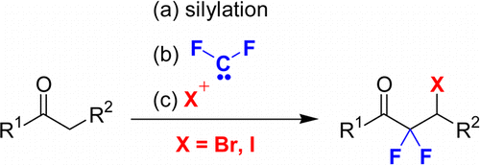
- Fedorov, O. V.; Struchkova, M. I.; Dilman, A. D.; Silicon Reagent with Functionalized Tetrafluoroethylene Fragments: Preparation and Coupling with Aldehydes.; J. Org. Chem. 2016, 81, 9455–9460; [DOI]
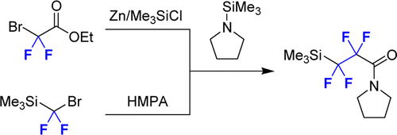
- Fedorov, O. V.; Levin, V. V.; Volodin A. D.; Struchkova M.I.; Korlyukov A.A.; Dilman, A. D.; Synthesis of difluorosubstituted six-membered nitronates via an addition/substitution cascade.; Tetrahedron Letters 2016, 5, 3639–3642; [DOI]
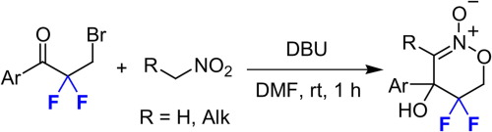
- Fedorov, O. V.; Struchkova, M. I.; Dilman, A. D.; Synthesis of gem-Difluorinated Hydroxypyrrolidines.; J. Org. Chem. 2017, 82 (6), 3270–3275; [DOI]
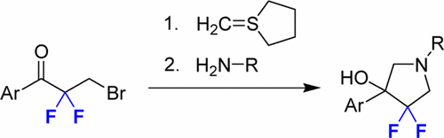
- Kuz’mina N. E.; Yashkir V. A.; Moiseev S. V.; Fedorov O. V.; Rakhmanov E. V.; Baleeva N. S.; Tarakanova A. V.; Anisimov A. V.; Russian Journal of Organic Chemistry, 2013, Vol. 49, No. 9, 1386–1396; [DOI]
- Vedernikov A. I.; Nuriev V. N.; Fedorov O. V.; Moiseeva A. A.; Kurchavov N. A.; Kuźmina L. G.; Freidzon A. Ya.; Pod ́yacheva E. S.; Medvedko A. V.; Vatsadze S. Z.; Gromov S. P., Russ.Chem.Bull., Int.Ed., 2016, Vol. 65, No. 11. 2686—2703. [DOI]
- Nuriev, V. N.; Fedorov, O. V.; Moiseeva, A. A.; Freidzon, A. Ya.; Kurchavov, N. A.; Vedernikov, A. I.; Medved'ko, A. V.; Pod'yacheva, E. S.; Vatsadze, S. Z.; Gromov, S. P.; Russian J. Org. Chem., 2017, Vol. 53 No. 11, 1726-1737 [DOI]
INTERNATIONAL CONFERENCES
PhD level (selected list):

The Fourth International Scientific Conference “Advances in Synthesis and Complexing”, 24-28 April 2017 – Moscow, Russia | Oral session: «Synthesis of fluorinated heterocyclic compounds starting from α,α-difluoro-β-halogenketones», Fedorov, O. V., Levin, V. V., Dilman, A. D.
BOSS XV 15th Belgian Organic Synthesis Symposium, July 10-15, 2016 – Antwerp, Belgium | «Difluorohomologation of Carbonyl Compounds», Oleg V. Fedorov, Mikhail D. Kosobokov, Vitalij V. Levin and Alexander D. Dilman;
BOSS XVI 17th Belgian Organic Synthesis Symposium, July 8-13, 2018 – Brussels, Belgium | «Photocatalitic Approach to Fluorinated Heterocycles from Сarbonyl Compounds», Oleg V. Fedorov, Liubov Panferova, Sofya I. Scherbinina, Artem Tsymbal, Vitalij V. Levin and Alexander D. Dilman;
Winter School on Organic Chemistry “Modern Trends in Organic Chemistry” WSOC-2016, 2016 – Moscow, Russia | «Ketone difluorohomologation in synthesis of fluorinated heterocycles», Oleg V. Fedorov, Mikhail D. Kosobokov, Vitalij V. Levin and Alexander D. Dilman;
International Congress on Heterocyclic Chemistry KOST-2015, October 18-23, 2015 – Moscow, Russia | «Synthesis of fluorine-substituted heterocycles using difluorocarbene», Alexander D. Dilman, Oleg V. Fedorov, Mikhail D. Kosobokov, Vitalij V. Levin;
School level (selected list):
OLYMPIADS & CONFERENCES

2009 – Final stage of the 45th Russian National Competition in Chemistry (Russian Olympiad of Senior High School students on Chemistry), Archangelsk, 3rd degree.
2009 – Moscow Olympiad of Senior High School students on Chemistry, 1st degree.
2009 – Regional Stage of the International Science and Engeneering Fair, Intel ISEF held in Russia (Intel ISEF junior 2009), 3rd degree.
2009 – XXIII Young Chemists' Conference, 3rd degree.
2009 – Moscow Olympiad of Senior High School students on Art, 2nd degree.
2009 – LXV Moscow Student Academic Competition in Chemistry, 2nd degree.
2008 – LXIV Moscow Student Academic Competition in Chemistry, 2nd degree.
2006 – LVII Moscow Student Academic Competition in Chemistry, 3nd degree.

PATENTS
Nuriev V. N., Fedorov O. V., Podyacheva E. S., Vedernikov A. I., Kurchavov N. A., Vatsadze S. Z., Gromova T. A., Gromov S. P., Russian Federation Patent №2603135 (2016). B.I.Bul. 2016, № 32.
НуриевВ.Н., ФедоровО.В., ПодъячеваЕ.С., ВедерниковА.И., КурчавовН.А., ВацадзеС.З., ГромоваТ.А., ГромовС.П., Патент РФ 2603135 (2016). Б.И.Бюл. 2016,№ 32.

GRANT PROGRAMS AND FUNDING

My scientific research was supported and funded by Russian Science Foundation (RSF 17-13-01041, employee), Russian Foundation for Basic Research (RFBR 16-29-10661, employee; 16-33-00458 mol_a, project leader and employer).

RESEARCH INTERESTS

Photoredox catalisys, late-stage fluorination, difluorocarbene and difluorocyclopropane chemistry, strain energy promoted transformations, intramolecular reactions, PET-precursors and radiopharmaceutical chemistry, peptide synthesis, natural product synthesis, computer-aided drug-design.
SOFT SKILLS

Science communication and popularization skills. In 2016-2018 I organized a 1.5- year long science communication club project for young scientists – PhD’s, postdocs and young researchers with hardcore-level lections on their own research. Club was exceptionally popular due to intensive teamwork of organization committee on design, lectors training, scientific redaction policies and thoughtful plotting each one of the club meetings. A lot of locally famous Russian chemists held lections in our club, which boosted their career and media representation, and this is something I am very proud of. I love teamwork, organizing events, planning tasks, managing and inspiring big teams. I believe I am communicative person and I love making contacts and getting to know more about people around me.

ADDITIONAL RELATED SKILLS

Linux administration – Debian, Arch, Ubuntu, AWS
Chemoinformatics – familiar with OpenBabel, KNIME, RDKit.
Molecular docking – AutoDock, Schrödinger.
Quantum and Computational Chemistry – ORCA, Avogadro, GAUSSIAN
Python – scripting, data analysis and presentation in Jupyter-Notebook.
Familiar with full-stack web-development: Flask, Django, React, Vue.js, Node.js, Docker, SQLite, MongoDB – acquired those skills during the work with my chemoinformatics-related pet-project.

REFERENCES

Alexander D. Dilman,  Dr. Sci., prof. RAS, head of the laboratory #8 of functional organic compounds, N.D. Zelinsky Institute of Organic Chemistry, Russian Academy of Sciences. | Contacts:  +7(910)405-69-88  E-mail:  adil25@mail.ru  dilman@ioc.ac.ru  website, twitter
Sergey Z. Vatsadze  Dr. Sci., Prof., Deputy head of the Laboratory of Supramolecular Chemistry and Nanotechnology of Organic Materials | E-mail: zurabych@gmail.com
Sergei P. Gromov,  Dr. Sci., Prof., head of the Laboratory of Supramolecular Chemistry and Nanotechnology of Organic Materials, vice director, head of the laboratory at the Photochemistry Center of the RAS  Corresponding member of the Russian Academy of Sciences (RAS) | +7 495 935 01 16  E-mail: gromov@photonics.ru  spgromov@mail.ru

