Climate signals in mosquito eggs: non-linear thermal optimality and lagged precipitation effects on Aedes albopictus oviposition across Europe
Andrea Radici¹, Francesco Sera², Margo Blaha³, Roberto Rosà³, Daniele Da Re^{4,3}

¹ IRD, Montpellier, France
² University of Florence, Florence, Italy
³ University of Trento, Trento, Italy
⁴ Research and Innovation Center, Edmund Mach Foundation, S. Michele all’Adige, Italy

Abstract
Background: The Asian tiger mosquito Aedes albopictus is one of the most rapidly expanding invasive vectors in Europe, with documented associations between its population dynamics and climatic variability. Despite growing evidence linking temperature and precipitation to mosquito oviposition activity, the temporal structure of these relationships, including the duration and shape of lagged effects, remains poorly characterised. Inconsistent results across studies reflect methodological heterogeneity and the absence of standardised surveillance data spanning multiple climatic zones.
Methods: We used weekly ovitrap egg count data from the VectAbundance standardised surveillance network, covering 170 trap sites across nine regions in Italy, Switzerland, France, and Albania over the period 2018–2023 (31,040 trap-week observations). Distributed lag non-linear models (DLNMs) were fitted within a quasi-Poisson generalised non-linear modelling framework to characterise simultaneous non-linear and lagged effects of weekly mean temperature and cumulative precipitation on egg counts at a maximum lag of eight weeks. Seven model specifications of increasing complexity were compared via 20-replicate random cross-validation, evaluating predictive performance using RMSE, MAE, and RMSLE. The best-performing model was validated on two independent test sets: held-out temporal windows (2010–2017 and 2024) from the calibration regions and geographically distinct held-out regions.
Results: The model including temperature, precipitation, and seasonal spline achieved the best cross-validation performance (median RMSLE = 1.04). Temperature was the dominant driver, with a non-linear cumulative effect peaking at 23–25°C (IRR ~5 relative to 15°C) and primarily short-lag responses (0–2 weeks). Precipitation showed a weaker positive effect above ~12 mm/week, peaking at a 1–2 week lag. The model explained 80.7% of within-trap temporal deviance. Per-trap forward validation yielded a median Pearson r = 0.74 (IQR 0.60–0.82) across 88 trap sites. Spatial extrapolation to held-out regions produced Pearson r values of 0.42–0.78 depending on region.
Conclusions: [To be completed.]
Keywords: Distributed lag non-linear models; DLNM; VectAbundance; invasive mosquito; vector surveillance

Background
Aedes albopictus (Skuse, 1895), commonly known as the Asian tiger mosquito, is among the most invasive mosquito species globally and has become firmly established across large parts of Europe over the past three decades [REFS]. Originally native to Southeast Asia, it has spread to all Mediterranean countries and progressively colonised temperate regions in central and western Europe [REFS]. Beyond its nuisance biting, Ae. albopictus is a competent vector for several arboviruses of public health concern, including dengue, chikungunya, and Zika viruses, and has been directly implicated in autochthonous outbreaks of chikungunya and dengue in Italy and France [REFS].
The population dynamics of Ae. albopictus are tightly coupled to climatic conditions, with temperature governing development rates, adult survival, and gonotrophic cycle duration [REFS]. The thermal biology of the species is relatively well characterised, partly because temperature is easily measured and experimentally manipulated: laboratory and field studies have established non-linear thermal performance curves with optimal oviposition activity at intermediate temperatures and suppression at both cold and heat extremes [REFS]. The effects of precipitation on mosquito population dynamics are considerably less well understood. While rainfall is known to influence larval habitat availability through the filling of container breeding sites [REFS], the direction, magnitude, and temporal structure of precipitation effects on oviposition remain poorly resolved. A recent systematic review found that reported associations between rainfall and Ae. albopictus abundance are highly heterogeneous, with studies reporting positive, negative, and null effects depending on the region, season, and lag window considered (Kern et al., 2026). Previous studies have approached the climate-oviposition relationship using a range of methodologies, including linear regression with manually defined lag windows, machine learning approaches, and mechanistic thermal biology models [REFS], but these efforts have produced similarly inconsistent results. This inconsistency likely reflects both genuine spatial and seasonal context-dependence and significant methodological limitations: the use of different climatic metrics, arbitrarily defined lag windows, and non-standardised surveillance data, combined with the inability of standard regression methods to simultaneously model non-linearity in both the exposure-response and lag dimensions. Characterising the shape and temporal extent of these lagged relationships for both temperature and precipitation within a unified analytical framework is therefore essential for building biologically realistic and generalisable predictive models.
Distributed lag non-linear models (DLNMs) offer a principled solution to this problem. Originally developed for environmental epidemiology [REFS: Gasparrini et al.], DLNMs are designed to simultaneously capture two features of climate-biological relationships that standard regression cannot handle jointly: the non-linearity of the exposure-response curve (e.g., the fact that biological activity often peaks at intermediate environmental conditions and declines at both extremes) and the distributed nature of lagged effects, whereby the biological response to a climate event is not confined to the week of exposure but is distributed across the preceding weeks, reflecting the cumulative influence of recent climatic history. This is achieved through a cross-basis function, a mathematical construct that spans both the exposure and lag dimensions, allowing the shape of the climate effect to vary flexibly depending on the lag at which it is measured. In practice, a DLNM produces a three-dimensional response surface describing how the effect of a given climatic value changes as a function of how long ago that value was recorded. Their application to entomological surveillance data remains limited but methodologically well-motivated, given the biological plausibility of delayed and non-linear climatic effects on insect population dynamics.
In this study, we leverage the VectAbundance dataset, an harmonised resource of ovitrap surveillance programme operating across multiple European countries with explicit information of trap designs, deployment protocols, and data recording procedures [REFS], together with the DLNM framework to characterise the lagged non-linear effects of temperature and precipitation on Ae. albopictus oviposition activity across nine European regions. We compare seven model specifications of increasing complexity through a repeated cross-validation procedure and evaluate the predictive capacity of the best-performing model on temporally and spatially independent test sets. Our aim is to provide a robust, biologically grounded characterisation of climate-oviposition dynamics that can inform both mechanistic understanding and operational early-warning systems for vector surveillance.

Methods

Study area and surveillance data
Oviposition data were obtained from the VectAbundance dataset [REFS]. The dataset comprises weekly egg counts from ovitraps, the standard entomological surveillance tool in many European countries, consisting in black containers equipped with a wooden paddle serving as an oviposition substrate. Observations represent trap-level data aggregated over a 9x9 km lattice grid and by ISO week and year, yielding a panel of weekly egg counts per trap site.
The full dataset spans 2010–2024 and covers 216 unique trap sites across 21 administrative regions in Italy, Switzerland, France, and Albania. For model calibration, we restricted the analysis to nine regions satisfying all of the following criteria within the 2018–2023 calibration window: at least three years of observations, a mean of at least three active traps per year, and a mean non-zero detection rate of at least 20% (Table 1). The 2018 start year was chosen to correspond to the operational maturity phase of the observations gathered by the surveillance network, i.e., when trap density and protocols were most consistent. The nine calibration regions were located in Italy and Switzerland, with Emilia-Romagna, Autonomous Province of Trento, Autonomous Province of Bolzano, Lazio, Veneto, and Puglia for Italy, while Ostschweiz and Canton of Ticino for Switzerland.
Two independent test sets were defined a priori. Test set 1 comprised observations from the same nine calibration regions but outside the 2018–2023 calibration period, covering 2010–2017 and 2024 (24,170 trap-week observations from 101 trap sites). Within this set, 13 trap IDs not present in the calibration set (predominantly new traps entering in 2024) were excluded from quantitative evaluation, leaving 88 traps (23,195 observations). Test set 2 comprised observations from the 12 regions excluded from calibration, covering all available years (4,630 trap-week observations from 35 trap sites across Albania, France, and Switzerland), enabling assessment of spatial extrapolation to unsurveyed areas.
Table 1. Summary of the VectAbundance surveillance dataset used for model calibration and validation.
Region | Country | Role | Years available | Calibration years  (2018–2023) | N traps | Mean traps/year | Mean % non-zero
Emilia-Romagna | Italy | Calibration | 2010–2024 | 6 | 38 | 34.2 | 52.6
Autonomous Province of Trento | Italy | Calibration | 2010–2022 | 5 | 15 | 12.4 | 51.3
Lazio | Italy | Calibration | 2017–2021 | 4 | 42 | 25.5 | 41.7
Tuscany | Italy | Calibration | 2020–2022 | 3 | 16 | 8.3 | 35.7
Autonomous Province of Bolzano | Italy | Calibration | 2013–2024 | 5 | 20 | 17 | 39.5
Veneto | Italy | Calibration | 2018–2022 | 5 | 18 | 11 | 26.8
Puglia | Italy | Calibration | 2010–2022 | 3 | 5 | 5 | 25.2
Ticino | Switzerland | Calibration | 2010–2024 | 6 | 13 | 4.7 | 44
Ostschweiz | Switzerland | Calibration | 2019–2024 | 3 | 17 | 5.3 | 28.3
Sicily | Italy | Test set 2 | 2010–2022 | — | 1 | — | —
Tirane | Albania | Test set 2 | 2014–2022 | — | 3 | — | —
Cote Azur | France | Test set 2 | 2014–2019 | — | 1 | — | —
Nordwestschweiz | Switzerland | Test set 2 | 2019–2024 | — | 9 | — | —
Espace Mittelland | Switzerland | Test set 2 | 2020–2024 | — | 3 | — | —
Région lémanique | Switzerland | Test set 2 | 2022–2024 | — | 10 | — | —
Zentralschweiz | Switzerland | Test set 2 | 2023–2024 | — | 2 | — | —
Zürich | Switzerland | Test set 2 | 2023–2024 | — | 2 | — | —
Fier | Albania | Test set 2 | 2020–2021 | — | 1 | — | —
Lushnje | Albania | Test set 2 | 2020–2021 | — | 1 | — | —
Lezhe | Albania | Test set 2 | 2021 | — | 1 | — | —
Vlore | Albania | Test set 2 | 2020–2021 | — | 2 | — | —

Climatic covariates
Weekly climatic data were obtained from ERA5-Land reanalysis products (REF) at 0.1° × 0.1° spatial resolution. Two covariates were extracted: (i) weekly mean 2-metre air temperature (°C), derived as the mean of daily mean temperature estimates within each ISO week; and (ii) weekly cumulative total precipitation (mm). Data were processed as weekly statistics over 2018–2024 and spatially matched to each trap site by extracting values at the nearest raster grid cell. For trap sites located at raster domain edges where grid cells contained no-data values, i.e. coastal areas, a 5 × 5 grid cell focal mean gap-filling procedure was applied prior to extraction.
Distributed lag non-linear models
DLNMs were implemented using the dlnm package [REFS] in R (version X.X). The response variable was the weekly egg count per ovitrap, floor-transformed to integer values prior to modelling. All models shared a common linear predictor structure on the log scale, combining a trap-specific intercept, absorbed as a nuisance factor via the eliminate argument of the gnm package [REFS] to account for large between-trap variability in absolute egg counts, with cross-basis functions for the climatic covariates and terms describing seasonality or long-term trend depending on the model specification.
The cross-basis matrix for temperature used a B-spline basis of degree 2 with internal knots at the 25th and 75th percentiles of the observed weekly mean temperature distribution in the calibration dataset (Q25 = 6.2°C, Q75 = 18.6°C), spanning a range from below 0°C to above 30°C. The cross-basis for precipitation used a B-spline of degree 2 with knots at the 25th, 75th, and 90th percentiles (Q25 = 3.3 mm, Q75 = 30.2 mm, Q90 = 53.4 mm). The asymmetric knot placement reflects the right-skewed distribution of weekly cumulative precipitation and concentrates additional spline flexibility in the upper tail, where container-filling dynamics are expected to produce the strongest and most non-linear biological response. For both covariates, the lag dimension was modelled using a natural spline with internal knots at lags 1 and 4 weeks. The maximum lag was set to 8 weeks, consistent with the generation time of Ae. albopictus under warm conditions [REFS] and with the constraint that within-season surveillance data do not permit attribution of late-season dynamics to climatic conditions occurring several months prior. Lag continuity was preserved within surveillance regions using the group argument of crossbasis, ensuring that lag series were not artificially bridged across spatially discontinuous monitoring networks.
All models were fitted within a quasi-Poisson generalised non-linear modelling framework. The quasi-Poisson family was selected to account for overdispersion in weekly egg counts, in which the observed variance substantially exceeded the mean, without imposing distributional assumptions on the variance function. Effect estimates are expressed as incidence rate ratios (IRR), representing the multiplicative change in expected weekly egg count associated with a given temperature or precipitation value relative to a reference condition, integrated over the full 8-week lag window for cumulative effects or evaluated at a specific lag for lag-specific effects. For temperature, the reference was set to 15°C, corresponding to the recognised lower activity threshold for Ae. albopictus [Reinhold et al. 2018], such that IRR > 1 indicates higher expected egg counts than at 15°C and IRR < 1 indicates suppression. For precipitation, the reference was set to 0 mm per week.
Model specifications
Seven model specifications of increasing complexity were evaluated and compared via cross-validation to identify the structure that best balanced predictive performance and parsimony:
- Model 1 (seas): seasonality via natural spline of ISO week number (df = 4) plus year as a linear covariate;
- Model 2 (seas.trend): long-term trend via natural spline of cumulative week number (df = 4 per year);
- Model 3 (Temp): temperature cross-basis only;
- Model 4 (T.seas): temperature cross-basis plus seasonal spline and year;
- Model 5 (T.P.seas): temperature and precipitation cross-bases plus seasonal spline and year;
- Model 6 (T.seas.trend): temperature cross-basis plus long-term trend spline;
- Model 7 (T.P.seas.trend): temperature and precipitation cross-bases plus long-term trend spline.
The seasonal spline (df = 4 per year) follows standard practice for weekly time series in DLNM applications [REFS]. All models included the trap-specific intercept via the eliminate argument, ensuring that climatic effects were estimated from within-trap temporal variation only.
Cross-validation procedure
Model selection was performed via 20-replicate repeated random cross-validation. In each replicate, a stratified random sample of 70% of observations was drawn within each trap-year stratum to form the fitting subset, with the remaining 30% constituting the validation subset. Cross-basis matrices were recomputed independently for fitting and validation subsets using identical basis parameterisations. We note that this within-stratum splitting does not constitute a strict temporal hold-out, as training and validation observations from the same trap-year may be temporally adjacent. This limitation is addressed by the independent temporal and spatial test sets described below. Performance was assessed using root mean square error (RMSE), mean absolute error (MAE), and root mean square logarithmic error (RMSLE). RMSLE is computed as the square root of the mean squared difference between the log-transformed predicted and observed values (with a unit offset to handle zeros), and was the primary selection metric. Unlike RMSE, which penalises absolute errors and is therefore dominated by large egg counts during peak season, RMSLE penalises relative errors symmetrically across the full range of the response, making it more appropriate for overdispersed count data with high between-observation variance. Quasi-Poisson overdispersion and residual deviance were recorded as secondary diagnostics of model fit. Performance distributions across 20 replicates were summarised as median and interquartile range.
Predictive validation on independent test sets
The best-performing model was refitted on the full calibration dataset and applied to both independent test sets. Because gnm with eliminate cannot predict for trap IDs lacking calibration intercepts, predictions were computed by manually assembling the fixed-effect linear predictor from the model coefficients and adding trap-specific intercepts back-calculated as the mean residual between the full and fixed-effects linear predictor for each calibration trap. For trap IDs not present in the calibration set (all traps in test set 2 and 13 traps in test set 1 entering the network in 2024), a population-average intercept estimated from the calibration data was used. Pooled RMSLE and Pearson r were computed across all observations, alongside per-trap Pearson’s r for test set 1, which is the more informative metric for panel data given the dominance of between-trap variance in pooled evaluations, and per-region Pearson’s r for test set 2. Model goodness-of-fit on the calibration set was quantified as the proportion of within-trap temporal deviance explained relative to a null model containing only trap-level intercepts, providing a measure of the climatic and seasonal signal attributable to the fixed-effect covariates.

Spatial extrapolation of oviposition seasonality
To characterise the spatial distribution of oviposition seasonality, the best model was applied to a gridded ERA5-Land climate dataset covering the broader Mediterranean and central European domain over 2019–2023. For each grid cell and year, predicted egg counts were generated using the fixed-effect linear predictor plus the population-average intercept. The oviposition season was defined per grid cell per year as the contiguous period during which predicted egg counts exceeded 5 eggs per week, consistent with standard ovitrap activity thresholds [REFS]. Season onset (first week above threshold), offset (last week above threshold), and duration (offset minus onset, expressed in months by dividing by 4) were extracted per grid cell and averaged across years.
Supplementary ecological analyses
To move beyond model validation metrics and characterise the biological content of the DLNM results, four complementary analyses were conducted. First, a thermal trigger temperature for season onset was identified by computing, for each grid cell and year across the spatial prediction domain, the ISO week in which weekly mean temperature first exceeded 17.5°C, a threshold selected from the empirical transition zone in the DLNM two-dimensional lag-response surface where the IRR contour crossed 1.0 across all lag values. The mean threshold-crossing week per grid cell was then correlated with predicted season onset using Pearson correlation, restricted to grid cells with a detectable predicted season in at least one year. Second, to contextualise the weak pooled precipitation signal in the DLNM, the fraction of active-season weeks, defined as weeks in which model-predicted egg counts exceeded 10 eggs per trap per week with weekly cumulative precipitation above 12 mm was computed per calibration region. The 12 mm threshold corresponds to the inflection point in the overall cumulative precipitation-response curve. This analysis was restricted to the calibration dataset to characterise the climatic precipitation regime within which the DLNM effect was estimated. Third, interannual variability in predicted season length was characterised by computing onset, offset, and duration per grid cell and year across 2018–2023 prior to cross-year averaging, and summarising the distribution of season length by year. Fourth, to assess whether spatial extrapolation introduced systematic bias in predicted peak oviposition timing, the week of maximum predicted and observed egg count was extracted for each trap-year combination across the six representative spatial test traps, and the mean difference between predicted and observed peak week was computed per region. Positive values indicate earlier predicted peaks; negative values indicate later predicted peaks relative to observations.

Software
All analyses were performed in R (version ≥ 4.3). Spatial raster extraction used the terra package. DLNMs were constructed using the dlnm package. Data manipulation and visualisation used the tidyverse ecosystem and ggplot2.

Results

Surveillance data and calibration dataset
The full VectAbundance dataset comprised 59,734 trap-week observations from 216 unique trap sites across 21 regions and four countries. After applying the calibration inclusion criteria, nine regions were retained for model fitting, encompassing 170 trap sites and 31,040 trap-week observations over 2018–2023 (Table 1). The number of years of data per trap ranged from 1 to 6 within the calibration window, with 29 traps (17%) having the complete 6-year record. Non-zero detection rates within the calibration set ranged from 20% (Veneto) to 53% (Emilia-Romagna) across regions.

Cross-validation model comparison
Cross-validation RMSLE on the validation subsets identified T.P.seas as the best-performing model specification (median RMSLE = 1.044), followed closely by T.seas (RMSLE = 1.048). The addition of precipitation to the temperature-seasonality model provided a consistent marginal improvement across all 20 replicates. Models incorporating the long-term trend spline (T.P.seas.trend, T.seas.trend) performed slightly worse on validation (RMSLE = 1.066 and 1.072 respectively), indicating that the trend component captured calibration-period variance without improving generalisation. The seasonality-only model (seas) and the temperature-only model (Temp) performed substantially worse (RMSLE = 1.093 and 1.132 respectively), confirming that both climatic forcing and seasonal structure are necessary components. The seas.trend model was the worst performer (RMSLE = 1.194), consistent with overfitting to the temporal trajectory of the calibration period.
RMSE and MAE rankings were consistent with RMSLE for validation subsets. Quasi-Poisson dispersion on the fitting subsets was lowest for the Temp model (median ~28) and highest for the seas model (~2.6 × 10⁸), the latter reflecting numerical instability of the log-linear predictor in the absence of a climate covariate. The T.P.seas model had a fitting dispersion of 533 (IQR 367–688) on the cross-validation fitting subsets, decreasing to 372.6 when refitted on the full calibration dataset. This reduction reflects the stabilising effect of the larger and more balanced full calibration dataset on the dispersion estimate; full-dataset model fit diagnostics are reported in the following section.
Table 2. Predictive performance of seven model specifications evaluated by repeated random cross-validation (20 replicates). Values represent median (interquartile range) computed across replicates on the 30% validation subset of each replicate. Models are ordered left to right by increasing complexity. RMSLE = root mean square logarithmic error (primary selection metric); RMSE = root mean square error; MAE = mean absolute error. Lower values indicate better predictive performance. The best-performing model by RMSLE is T.P.seas (temperature + precipitation + seasonal spline). Seas = seasonal spline + year; seas.trend = long-term trend spline; Temp = temperature cross-basis only; T.seas = temperature + seasonal spline + year; T.P.seas = temperature + precipitation + seasonal spline + year; T.seas.trend = temperature + long-term trend spline; T.P.seas.trend = temperature + precipitation + long-term trend spline.
Metric | seas | seas.trend | Temp | T.seas | T.P.seas | T.seas.trend
RMSLE | 1.093 (1.089–1.106) | 1.194 (1.186–1.200) | 1.132 (1.122–1.141) | 1.048 (1.041–1.062) | 1.044 (1.037–1.057) | 1.072 (1.066–1.087)
RMSE | 54.051 (53.319–54.751) | 54.616 (54.027–55.471) | 54.994 (54.523–56.041) | 53.816 (53.431–54.575) | 53.486 (53.055–54.175) | 53.198 (52.598–54.077)
MAE | 24.876 (24.465–25.307) | 25.852 (25.396–26.335) | 26.433 (25.924–26.629) | 25.320 (24.995–25.517) | 25.086 (24.752–25.355) | 25.339 (24.981–25.649)

Model fit on calibration data
The T.P.seas model fitted on the full calibration dataset converged successfully. The quasi-Poisson dispersion parameter was 372.6, consistent with high overdispersion typical of oviposition count data. The model explained 80.7% of the within-trap temporal deviance relative to a null model containing only trap-level intercepts (null deviance = 2,179,809; residual deviance = 420,802). This indicates that temperature, precipitation, seasonality, and year together account for over four-fifths of the temporal variability in egg counts that is not attributable to baseline between-trap differences in productivity.

Temperature and precipitation lag-response relationships
The overall cumulative temperature effect showed a pronounced non-linear response, with IRR rising steeply from the 15°C reference and peaking at approximately 23–25°C (IRR ~5), followed by a sharp decline toward 30°C (Figure 2A). The confidence interval widened considerably above 25°C, reflecting fewer calibration observations at those temperatures.
Lag profiles at fixed temperatures revealed that the temperature effect was strongest at short lags (0–2 weeks) and decayed over the 8-week window (Figure 2B). At 22°C, the IRR was highest at lag 0 and declined monotonically toward 1.0 by lag 8, consistent with an immediate within-season response to warming. At 6°C, the effect was suppressive at all lags but showed a slight increasing trend with lag, biologically plausible as cold temperatures slow larval development and delay the adult emergence signal. At 14°C — near the lower developmental threshold — the lag profile was essentially flat and near null across all lags. At 30°C, the effect was slightly positive at very short lags before becoming inhibitory and declining below 1.0 by lag 8, consistent with initial stimulation followed by acute heat stress on adult survival and gonotrophic cycle disruption.
The two-dimensional lag-response surface (Figure 2C) integrates these patterns and reveals the joint structure of the temperature-lag relationship. The surface confirms a well-defined zone of enhanced oviposition activity centred approximately on 20–27°C and lags 0–4 weeks, appearing as a broad warm-coloured ridge extending from short to intermediate lags. Conversely, a persistent cool-coloured zone below 15°C spans the full lag range, indicating sustained suppression regardless of the lag at which cold temperatures are experienced. The transition from suppression to enhancement occurs sharply around 17–18°C across all lags, broadly consistent with the recognised lower activity threshold for the species.

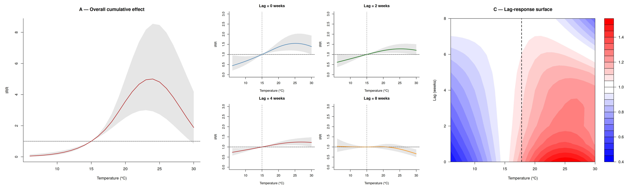

Figure 1. Non-linear lagged effects of temperature on Aedes albopictus weekly egg counts estimated by the best-performing DLNM (T.P.seas, calibration dataset 2018–2023, n = 170 traps). (A) Overall cumulative exposure-response function showing the IRR integrated across the full 8-week lag window, relative to 15°C (dashed reference line). (B) Lag-specific exposure-response curves at four fixed lags (0, 2, 4, and 8 weeks), illustrating the progressive attenuation of the temperature signal with increasing lag; dashed lines indicate IRR = 1 (horizontal) and the 15°C reference temperature (vertical). (C) Two-dimensional lag-response surface with IRR colour-coded across the full temperature × lag space; the dashed vertical line marks the 15°C centering reference. Shaded areas and colour gradients represent 95% confidence intervals. IRR = incidence rate ratio.

Precipitation showed a weaker and more uncertain cumulative effect (Figure 3A). The overall response was non-linear, with a slight suppression below approximately 10 mm/week (IRR < 1 relative to 0 mm) followed by a monotonically positive effect at higher rainfall, reaching IRR ~1.5 at 70 mm/week. The suppression at very low precipitation values is consistent with a threshold effect in which sporadic light rainfall is insufficient to fill container breeding sites and may instead dilute or destabilise small existing water bodies. The transition to a positive effect occurs at approximately 10–12 mm/week, which may represent a biologically meaningful minimum for consistent container filling.
Lag-specific exposure-response curves (Figure 3B) confirmed that the precipitation effect was negligible at lag 0 — where rainfall in the same week shows no clear positive signal — and became weakly positive at lags 2–4 weeks for precipitation above approximately 20 mm, consistent with the time required for larval development and adult emergence following a rainfall event. By lag 8 weeks the effect had dissipated toward null, indicating that the precipitation signal does not persist beyond approximately one month. At all lags and precipitation values the confidence intervals crossed 1, confirming that the precipitation effect, while directionally consistent with a container-filling mechanism, is statistically weak throughout the range of observed values.
The two-dimensional lag-response surface (Figure 3C) makes the temporal structure of the precipitation effect visually explicit. The warm-coloured zone of enhanced oviposition is concentrated between lags 2 and 5 weeks and precipitation values above approximately 15 mm, forming an elongated ridge across the central region of the surface. A distinct cool-coloured zone of mild suppression is visible at lag 0 across most precipitation values, and a secondary suppression zone appears at high lags (6–8 weeks) and low precipitation, consistent with dry-period effects on larval habitat availability. Compared to the temperature surface, the precipitation IRR range is substantially compressed (0.85–1.20 versus 0.4–8.0 for temperature), underscoring that precipitation acts as a secondary modulator of oviposition activity rather than a primary driver.

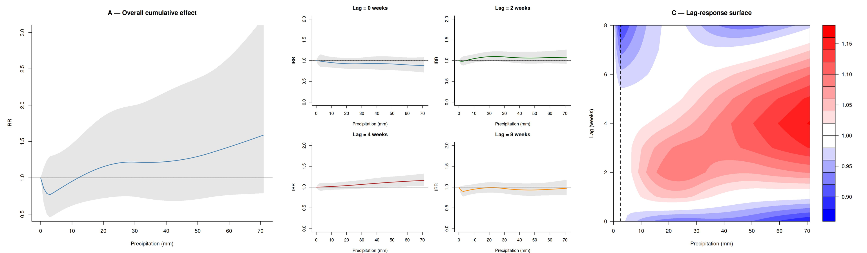

Figure 2. Non-linear lagged effects of weekly cumulative precipitation on Aedes albopictus weekly egg counts estimated by the best-performing DLNM (T.P.seas, calibration dataset 2018–2023, n = 170 traps). (A) Overall cumulative exposure-response function showing the IRR integrated across the full 8-week lag window, relative to 0 mm; the horizontal line marks IRR = 1. A slight suppression below approximately 10 mm/week transitions to a modest positive effect above this threshold. (B) Lag-specific exposure-response curves at four fixed lags (0, 2, 4, and 8 weeks); dashed lines indicate IRR = 1. The strongest positive effect is observed at lags 2–4 weeks for precipitation above approximately 20 mm. (C) Two-dimensional lag-response surface with IRR colour-coded across the precipitation × lag space; the dashed vertical line marks the 0 mm centering reference. Note the compressed IRR scale (0.85–1.20) relative to the temperature figure (0.4–8.0), reflecting the weaker and more uncertain precipitation signal. Shaded areas and colour gradients represent 95% confidence intervals. IRR = incidence rate ratio.

Predictive validation
Per-trap Pearson r on the temporal test set (88 known traps, 2010–2017 and 2024) yielded a median of 0.74 (IQR 0.60–0.82), with 80 of 88 traps (91%) achieving r > 0.5. Performance was strong across all calibration regions, with Ostschweiz (median r = 0.86), Emilia-Romagna (0.81), and Ticino (0.74) performing best. Puglia, despite its marginal data density, achieved median r = 0.53. The Autonomous Province of Bolzano had the highest median RMSLE (2.59), likely reflecting population baseline differences due to a missing calibration year (2018). Pooled per-region Pearson r and RMSLE are reported in Table 3. Pooled metrics across all traps were substantially lower (Pearson r = 0.09–0.15), reflecting the dominance of between-trap variance in absolute egg counts when predictions are evaluated across traps with very different productivity baselines — a known limitation of pooled metrics for panel data with trap-level random effects.
For the spatial test set (12 held-out regions, 35 traps), pooled Pearson r was 0.42 (RMSLE = 1.90; Table 4). Per-region Pearson r ranged from 0.36 (Sicily) to 0.78 (Cote d'Azur), with 9 of 12 regions achieving r > 0.50. Performance was strongest in regions with climatic conditions within the calibration range — Lushnje, Albania (r = 0.69), Espace Mittelland, Switzerland (r = 0.71), and Cote d'Azur, France (r = 0.78) — and weakest in Sicily (r = 0.36) and Vlore, Albania (r = 0.47), which represent the southern and Adriatic margins of the dataset where thermal conditions and species establishment dynamics may differ from the calibration regions. RMSLE values for the spatial test set should be interpreted cautiously, as predictions for these regions used a population-average intercept rather than trap-specific intercepts, making absolute-scale comparisons with the temporal test set unreliable.

Table 3. Per-region predictive performance of the T.P.seas model on the temporal test set (test set 1), comprising observations from the nine calibration regions outside the 2018–2023 calibration period (2010–2017 and 2024). Metrics are computed on pooled trap-week observations within each region. Regions are ordered by ascending RMSLE. Pearson r is reported on the raw count scale; note that pooled metrics are influenced by between-trap variance in absolute egg counts and should be interpreted alongside the per-trap summary (median Pearson r = 0.74, IQR 0.60–0.82, 80/88 traps with r > 0.5). RMSLE = root mean square logarithmic error; n_traps = number of unique trap sites contributing observations; n_trap_weeks = total number of trap-week observations.
Region | Country | n_traps | n_trap_weeks | Pearson_r | RMSLE
Puglia | Italy | 5 | 751 | 0.516 | 1.036
Emilia-Romagna | Italy | 36 | 7669 | 0.73 | 1.037
Lazio | Italy | 2 | 43 | 0.588 | 1.315
Ticino | Switzerland | 8 | 1284 | 0.656 | 1.36
Autonomous Province of Trento | Italy | 11 | 1566 | 0.685 | 1.593
Ostschweiz | Switzerland | 10 | 226 | 0.053 | 2.078
Autonomous Province of Bolzano | Italy | 17 | 2918 | 0.313 | 2.768

Table 4. Per-region predictive performance of the T.P.seas model on the spatial test set (test set 2), comprising observations from 12 regions not included in model calibration, covering all available years. Predictions for these regions used a population-average intercept estimated from the calibration dataset in place of trap-specific intercepts, as no calibration data were available for these locations. Metrics are therefore more reflective of the model's ability to capture the relative temporal pattern of oviposition activity than its absolute abundance. Regions are ordered by ascending RMSLE. RMSLE = root mean square logarithmic error; n_traps = number of unique trap sites; n_trap_weeks = total number of trap-week observations.

Region | Country | n_traps | n_trap_weeks | Pearson_r | RMSLE
Lushnje | Albania | 1 | 48 | 0.694 | 1.438
Région lémanique | Switzerland | 10 | 408 | 0.504 | 1.513
Zentralschweiz | Switzerland | 2 | 28 | 0.484 | 1.54
Tirane | Albania | 3 | 496 | 0.52 | 1.558
Lezhe | Albania | 1 | 19 | 0.479 | 1.582
Espace Mittelland | Switzerland | 3 | 79 | 0.708 | 1.672
Nordwestschweiz | Switzerland | 9 | 473 | 0.618 | 1.821
Cote Azur | France | 1 | 248 | 0.78 | 1.932
Zürich | Switzerland | 2 | 38 | 0.572 | 2.04
Fier | Albania | 1 | 68 | 0.583 | 2.299
Sicily | Italy | 1 | 356 | 0.358 | 2.386
Vlore | Albania | 2 | 132 | 0.468 | 2.731

Spatial distribution of oviposition seasonality
Spatial extrapolation of the T.P.seas model to the gridded ERA5-Land domain revealed a strong latitudinal and altitudinal gradient in predicted oviposition season length (Figure 4A). The longest seasons (6–8 months) were predicted across the Po Valley, the Mediterranean coastlines, and lowland areas of the Balkans, consistent with warm continental summers and mild springs. Season duration declined sharply with altitude in the Alps and Apennines and with latitude north of the Alps, where predicted seasons of 2–3 months were typical. The northern range limit of predicted activity broadly corresponded to the 50°N parallel in lowland areas, with isolated pockets of shorter predicted seasons extending further north along climatically favoured lowland corridors.
Season onset (Figure 4B) showed a similarly strong spatial pattern, with Mediterranean and lowland Po Valley areas initiating the season in weeks 15–18 (mid-April), while northern Swiss and Alpine locations did not cross the 10-egg threshold until weeks 25–30 (June–July), a difference of approximately 10–12 weeks across the latitudinal extent of the study domain. Season offset (Figure 4C) followed a complementary gradient, with southern and coastal areas maintaining activity until weeks 44–48 (October–November), while northern and Alpine areas ceased activity as early as week 33–35 (mid-August).

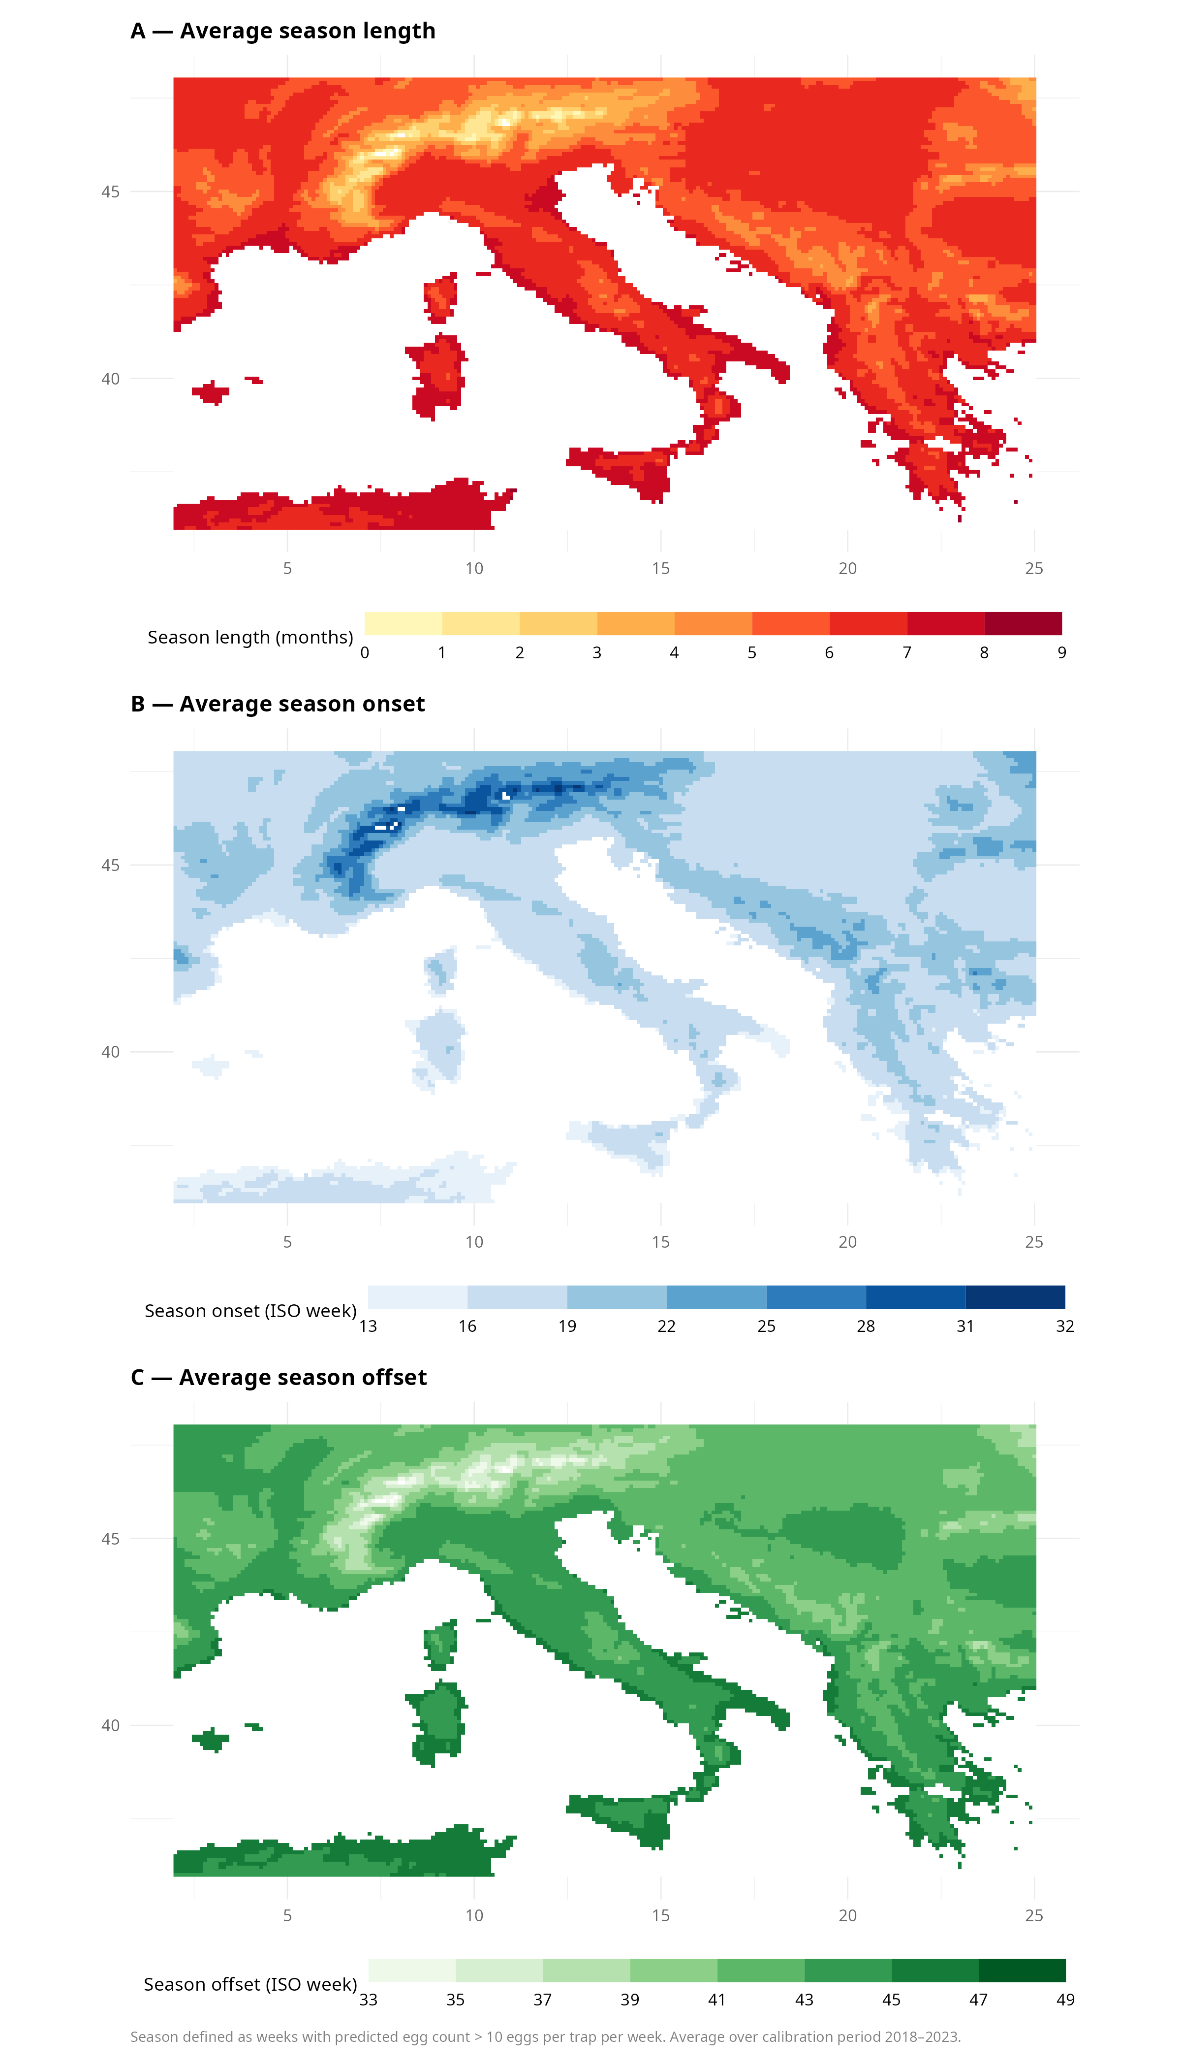
Figure 4. Spatial distribution of predicted Aedes albopictus oviposition seasonality averaged over the calibration period 2018–2023. (A) Average season length in months. (B) Average season onset in ISO week number. (C) Average season offset in ISO week number. The oviposition season is defined as the contiguous period during which predicted weekly egg counts exceed 10 eggs per trap per week. Predictions are based on ERA5-Land gridded climate data (0.1° × 0.1° resolution) using the best-performing T.P.seas model with a population-average trap intercept. White areas indicate grid cells where predicted egg counts did not exceed the 10-egg threshold in any year of the averaging period, corresponding to locations at or beyond the northern and altitudinal range limits of established Ae. albopictus populations.

Supplementary biological analyses
The thermal threshold analysis revealed that the week of 17.5°C temperature crossing explained 86% of the spatial variance in predicted season onset across the study domain (Pearson r = 0.93, 95% CI 0.928–0.932, p < 0.001; Fig. 5A). The fraction of active-season weeks exceeding the 12 mm weekly precipitation threshold varied substantially across calibration regions, revealing a climatic gradient that provides a mechanistic explanation for the weak pooled precipitation effect in the DLNM (Fig. 5B). Northern Alpine regions (Veneto, Autonomous Province of Trento, Autonomous Province of Bolzano, Ostschweiz, Ticino) had 65–83% of active-season weeks above threshold, reflecting wet-summer climates where precipitation is rarely limiting, while Mediterranean regions (Tuscany 39%, Lazio 33%, Puglia 15%) showed substantially lower fractions, consistent with episodic summer-dry precipitation regimes where rainfall events are ecologically meaningful but infrequent. Taken together, these results suggest that precipitation effects on oviposition are climatically context-dependent and likely underestimated by pooled analyses spanning both wet and dry summer regions. Interannual variability in predicted season length was relatively limited across 2019–2023, with median season lengths of approximately 6–6.5 months in most years, with the exception of 2021 which showed a compressed median and greater spatial variance, consistent with the anomalously cool and wet summer conditions recorded across central Europe that year. Northern and high-altitude marginal grid cells exhibited the highest interannual variability, reflecting their position at the thermal limits of species activity where small climatic fluctuations produce disproportionate changes in season duration. Finally, no systematic directional bias in predicted peak oviposition timing was detected across the six representative spatial test regions (mean bias = −1.8 weeks, range −7.0 to +1.0 weeks), with Sicily and the Albanian regions showing delayed predicted peaks of 4–7 weeks relative to observations, and Cote d'Azur and Lushnje showing marginal positive bias of approximately 1 week.

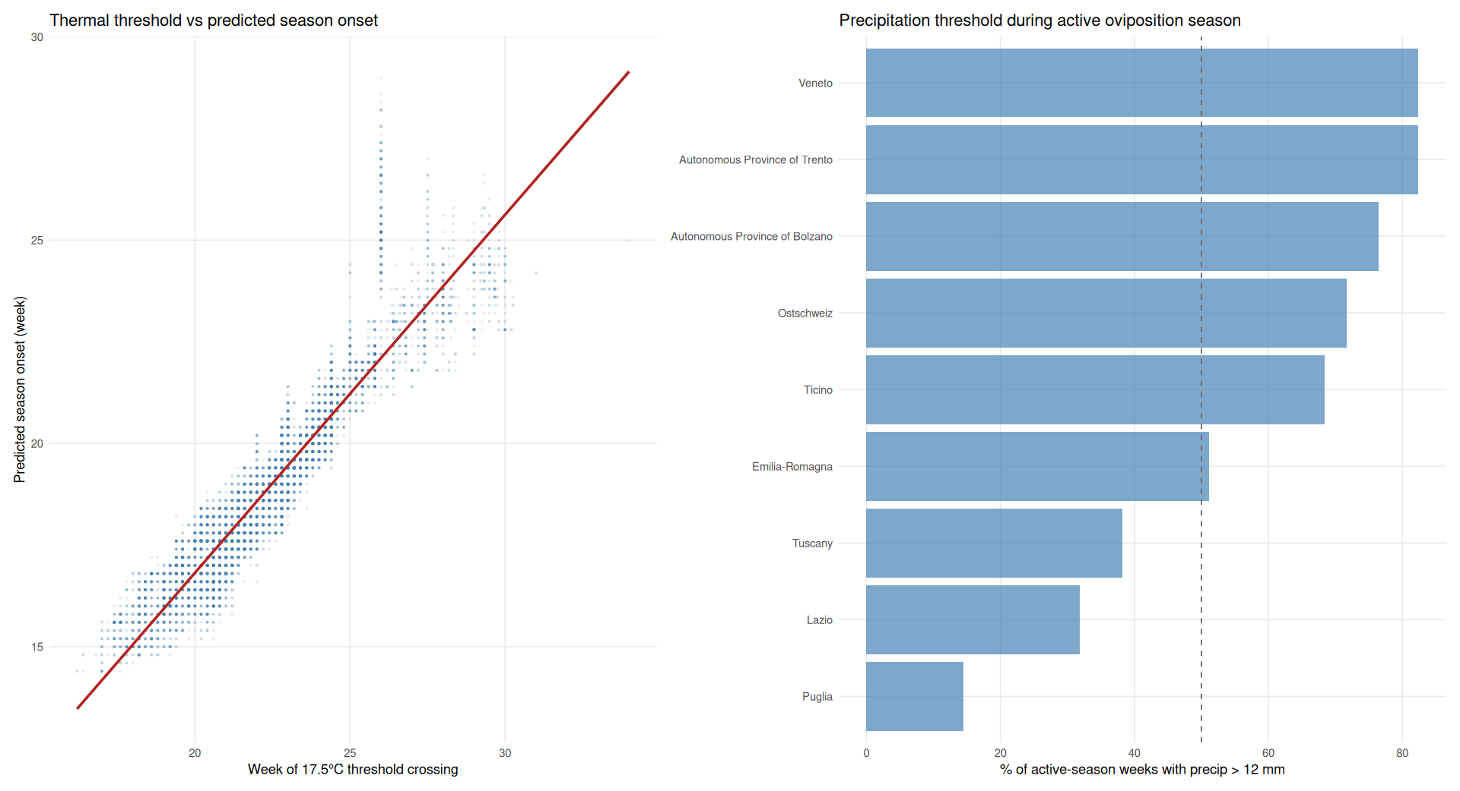
Figure 5. Supplementary biological analyses characterising the thermal trigger and precipitation context of Aedes albopictus oviposition seasonality. (A) Correlation between the predicted season onset (ISO week) and the mean week of 17.5°C temperature crossing across the spatial prediction domain (Pearson r = 0.93, p < 2.2×10⁻¹⁶). Each point represents one grid cell; the red line shows the linear regression fit. The 17.5°C threshold was identified empirically from the DLNM lag-response surface as the transition temperature above which oviposition enhancement consistently exceeds suppression. (B) Fraction of active-season weeks — defined as weeks with predicted egg counts exceeding 10 eggs per trap per week — in which weekly cumulative precipitation exceeded 12 mm, by calibration region. The dashed vertical line marks the 50% level. Regions are ordered by ascending fraction, revealing a gradient from summer-dry Mediterranean climates (Puglia, Lazio, Tuscany) where precipitation rarely exceeds the threshold during the active season, to wet-summer Alpine and pre-Alpine regions (Veneto, Trento, Bolzano, Ostschweiz, Ticino) where it is exceeded in the majority of active weeks.

Discussion
1. Thermal optimum and lag structure The optimal thermal window (23–25°C) and primarily short-lag response (0–2 weeks) is consistent with the known thermal performance curve for Ae. albopictus, with optimal oviposition activity in the 22–26°C range and suppression at both cool and high temperatures. The decay to null by lag 8 supports the use of an 8-week maximum lag. Compare with published thermal performance parameters.
2. The 17.5°C oviposition activity threshold The empirically identified 17.5°C threshold is higher than published laboratory lower developmental thresholds (~10–11°C for larval development), which makes biological sense — oviposition requires not just adult survival but gonotrophic cycle completion, host-seeking, and sufficient adult density, all of which have higher thermal requirements than larval development alone. This distinction between developmental threshold and field oviposition activity threshold is novel and should be discussed in relation to published phenological observations.
3. Precipitation mechanism and regional context The threshold at ~12 mm/week and 1–2 week lag peak is consistent with container-filling dynamics. The absence of a flushing effect at high rainfall distinguishes Ae. albopictus from floodwater breeders. The regional gradient in precipitation limiting frequency is a novel ecological insight: models fitted on pooled multi-regional data will systematically underestimate precipitation effects in summer-dry regions, and future analyses targeting Mediterranean surveillance networks may reveal a stronger precipitation signal. This is a concrete methodological recommendation for future work.
4. Conserved thermal response across the European range in our two stage test, the absence of detectable regional heterogeneity in the thermal response across a latitudinal gradient from Sicily to Ostschweiz suggests that the European range expansion has not been accompanied by local thermal adaptation in oviposition dynamics within the available surveillance timeframe. This is consistent with the hypothesis of a recent genetically narrow founding population but could also reflect phenotypic plasticity. Cite invasion genetics literature.
5. Model selection T.P.seas outperforming T.seas.trend confirms that seasonal structure is more generalisable than long-term trends, which may capture surveillance expansion artefacts rather than true population dynamics. This addresses the stated motivation of inconsistent prior results from prior studies using fixed lag windows and non-standardised data.
6. Validation framework The per-trap Pearson r (median 0.74, 91% of traps r > 0.5) is a more informative metric than pooled r for panel data with trap-level random effects. The distinction should be made explicit. The 2024 forward validation should be presented as the primary performance benchmark, with the 2010–2017 retrospective validation treated as a secondary diagnostic given the different surveillance protocol phase.
7. Non-stationarity and climate change The model is calibrated on 2018–2023 — a relatively warm recent period. The weaker retrospective performance on 2010–2017 compared to forward 2024 validation could reflect non-stationarity in the climate-oviposition relationship as populations adapt to warming, or surveillance protocol differences. Either interpretation has implications for applying the model under future climate scenarios and should be acknowledged explicitly.
8. The 2021 anomaly The compressed predicted season length in 2021 connects to the documented cool and wet European summer of that year and provides empirical evidence that the model captures interannual climate variability, not just mean seasonal patterns. Frame this as evidence of sensitivity to climate anomalies, directly relevant to early warning applications.
9. Spatial extrapolation and surveillance planning The season length map extends phenological quantification to areas without surveillance. Discuss implications for integrated surveillance mapping, prioritisation of new trap deployment, and vector control planning. The finding that local population dynamics introduce peak timing deviations of up to 7 weeks suggests that at least one year of local trap data is required to calibrate absolute timing for operational use.
10. Operational potential The 0–2 week lag window where the temperature signal is strongest aligns with sub-seasonal climate forecast horizons (2–6 weeks). Integration with ECMWF sub-seasonal forecasts or Copernicus Climate Change Service products is feasible. Specify that sub-seasonal rather than seasonal forecasts are the relevant product.
11. Limitations Weekly temporal resolution misses within-week thermal extremes; ERA5-Land may not capture urban heat island effects relevant to container breeders in dense urban environments; the population-average intercept used for spatial prediction does not account for local habitat availability, population density, or surveillance effort; the calibration period (2018–2023) represents a relatively warm recent phase and may not be representative of longer-term climate variability; Bolzano RMSLE anomaly reflects a surveillance data gap rather than a model failure and is noted here rather than in the results.

Conclusions
[To be completed after results discussion.]

Declarations

Availability of data and materials
Training dataset: link al lavoro di Margo per GCB
Script: link alla repo github

Competing interests
The authors declare no competing interests.

Funding
[To be completed.]

Authors' contributions
Andrea Radici: conceptualisation, data analysis, writing
Francesco Sera: data analysis, writing
Margo Blaha: data gathering and harmonisation, writing
Roberto Rosà: conceptualisation, writing
Daniele Da Re: conceptualisation, data analysis, writing

References

Supplementary materials

Supplementary Table S1 caption (fitting diagnostics):
Model fit diagnostics on the fitting subset from repeated random cross-validation (20 replicates). Values represent median (interquartile range) across replicates. RMSLE = root mean square logarithmic error on the fitting subset; ResDev = residual deviance; Dispersion = quasi-Poisson overdispersion parameter. Dispersion values for the seas model are not directly comparable to other models due to numerical instability of the log-linear predictor in the absence of a climatic covariate, which produced extreme fitted values in a subset of replicates. Lower residual deviance and dispersion indicate better model fit to the training data. Note that fitting metrics reflect in-sample performance and should be interpreted alongside the validation metrics in Table 2; models with the lowest fitting deviance (T.P.seas.trend) do not necessarily generalise best to held-out data.

Metric | seas | seas.trend | Temp | T.seas | T.P.seas | T.seas.trend
RMSLE | 8.195 (7.690–8.737) | 5.506 (5.175–6.155) | 8.686 (8.384–8.986) | 9.225 (8.907–9.654) | 9.018 (8.709–9.510) | 9.391 (9.003–9.610)
ResDev | 333,173 (329,543–336,213) | 364,449 (362,904–368,064) | 318,389 (315,362–320,714) | 295,706 (293,445–298,351) | 290,195 (287,421–292,306) | 295,433 (293,389–297,884)
Dispersion† | 261,007,958* | 44.9 (43.7–46.1) | 28.3 (28.0–29.0) | 940 (642–1,559) | 533 (367–688) | 29.5 (28.9–30.2)

