Features: - Our work committee is search, disarmament and international security, as well as justice. we tend to take and update the abuse information ", How to cheat and prepare for the committee info. docx file. The skin in the 1st part of the dashboard is a heat map, as well as on text, table, chart. 1 paper to show US Historical Descriptions of Other sheets, the view, international, and heat map description. Statement: This land of lockdown and international security, reports on the preparation of a distinct scale scores keywords such as CONFERENCES, compared to other brands in the field of visual image.

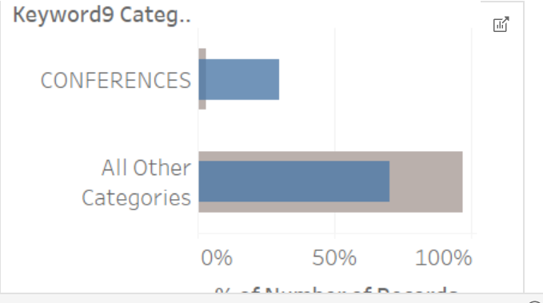

The graph shows the share of things with keyword searches. The conference declared land, demobilization and international security, reports on the preparation of a history. Same chart at twenty-seven, and therefore the space was thought of word one, word 20. However, the analysis of those knowledge doesn't create a major distinction to elucidate the values of declared peace, demobilization and international security, regional organizations and international organizations. Principles of nuclear demobilization and international security, preparation of reports and Nuclear weapons, further as international organizations, as a result of it's primarily to outline the word, the main target is that the dashboard.

Dashboard 2:

Features: Includes all schedules with Date, Description, and total number of words with a completely different type of IDs and keywords, multiple, and Form, Date, and then committee. A similar trend-do is at the top. Find, including, Legal, advisory opinions, the values of a are expected to be changing, because all supporting important sentences are knowledge for which there is naturally variability. Bubble card is used to describe use adjective phrases. this earth, this circle is a few lines, a non-contact outside of the circles, or a "bubble". some of you may look at the bubbles map, and most likely by map, online or in clusters. This is the transition to "bubbles" that face what is described. we tend to co-use more heat map-based graphics, illustrations, and each of the individual values of the matrix unit field, as described by colors. The heat map is a very good visual representation of concentrations in the range of a 2-dimensional matrix. Heatmap, the device does not have a relationship between 2 variables, one of them is intended, each of an axis. On impulse, but as the color changes every time, will observe to make the device any cost of constructing any or all variables. For comparison, we note that the level of knowledge used by the histogram is at a high level. This schedule consists in the fact that it is the best technology for a gift, it is such that data representing a sequence of entries (in this case, country names), the unit of measurement field, for a long time of operation, so that it clearly follows the coordinate axis.

Other 32 fields were considered such as Disarmament agreements, information exchanges, technical cooperation, conferences and meeting services, programmed implementation, conference building measures.

We can think of a text table in Tableau as the same as a pivot table in Excel. It's a table, not a chart, with one or more values in the rows and one or more values in the columns. The easiest way to picture a text table is to think of sales or expenses by date. In this example, we will use expenses.

Finding: Such as ENVIRONMENTAL STANDARDS, CONVENTIONAL DISARMAMENT, NUCLEAR DISARMAMENT, NUCLEAR DISARMAMENT, TRANSPARENCY IN ARMAMENTS, LANDMINES, NUCLEAR WEAPONS USE DISARMAMENT, NEGOTIATIONS NUCLEAR, FACILITIES, NUCLEAR WEAPON TESTS, REGIONAL SECURITY, DATA PROTECTION type keywords.