Lowongan terbaru pelamar error

http://localhost/bursalowker-master/index.php/lowongan/

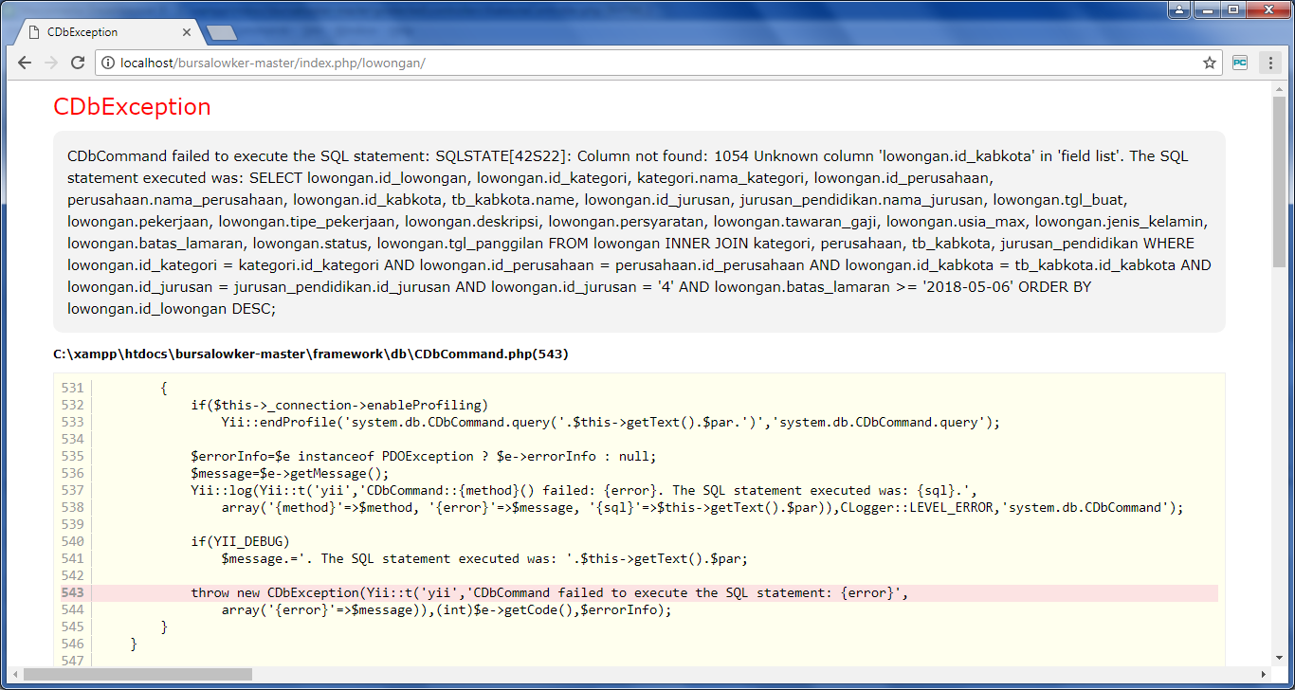

Logout pelamar error

<http://localhost/bursalowker-master/index.php/lowongan/>

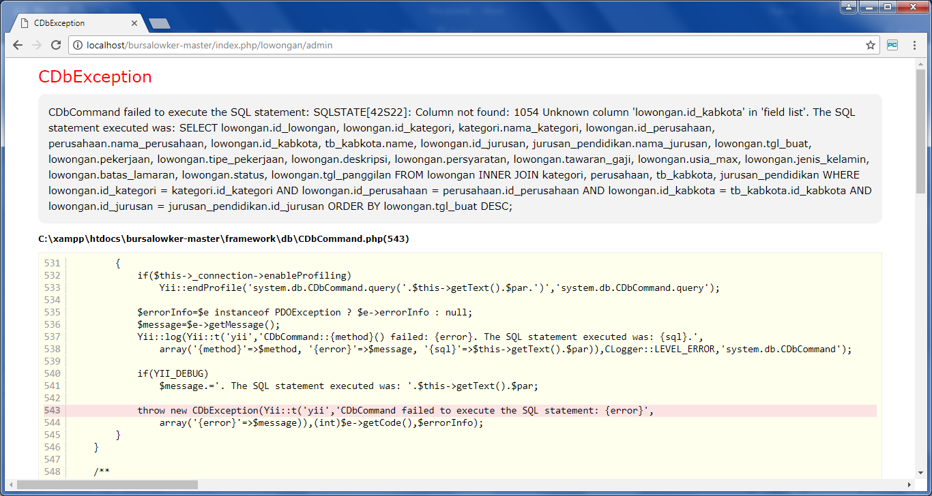

Lowongan pada operator dinas error

http://localhost/bursalowker-master/index.php/lowongan/admin

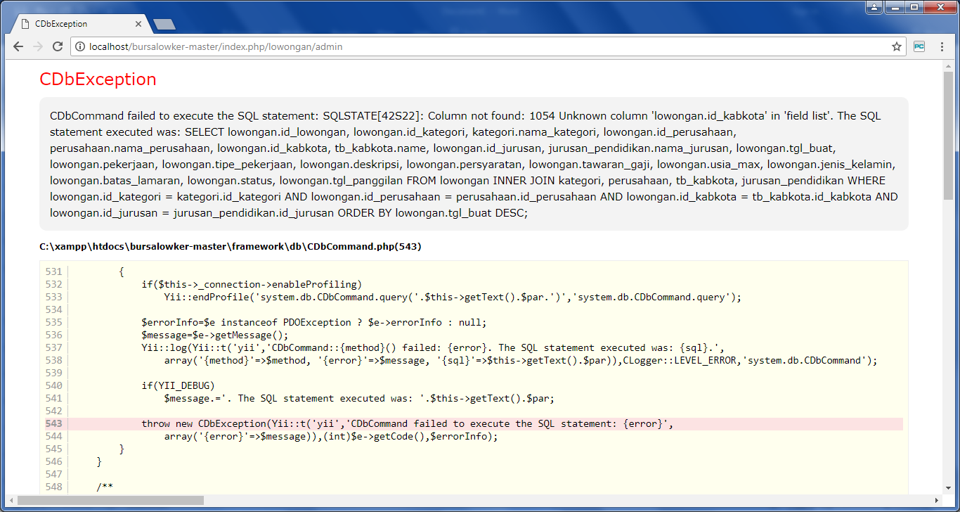

Login perusahaan error

http://localhost/bursalowker-master/index.php/site/loginperusahaan

