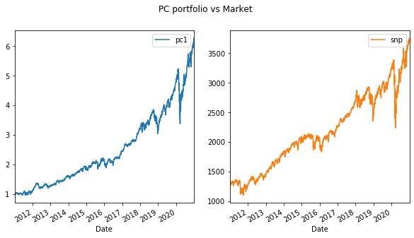

# plot the weights in the PC

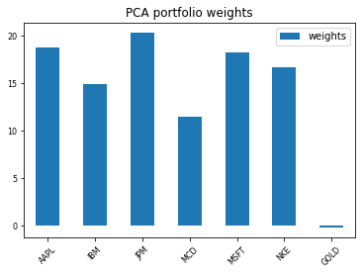

Statistics

array([0.16840541, 0.19414596, 0.86741653])

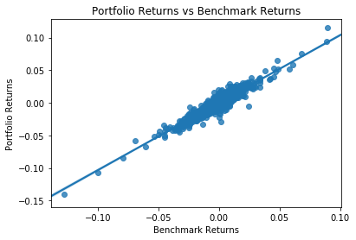

The portfolio beta is 1.0365

The portfolio alpha is 0.00022