Ben Carmona
Homework 8
MATH 380

1. Estimate the value of pi using a Monte Carlo method.

The following results were obtained with MATLAB and the built-in rand function. My random number generator was a + (b-a)*rand(1) which I personally found most satisfactory. Below the table of data is a graph showing the distribution of the points denoted in the first two columns, Xa and Ya (x,y). The zeros and one’s in the fourth column show whether or not the function produced values within the quarter circle: 0 means no and 1 means yes. The fifth column shows the area, the sixth column shows the estimate of pi. After 1000 iterations, pi got pretty close to the actual thing (see n=996). Below the MATLAB plot is Java’s estimate of pi. See graph paper for analytic calculations using integration techniques.

n Xa Ya Yes/No Area pi
-----------------------------------------------------------------
1 | 0.952069 | 0.585333 | 0.000000 | 0.000000 | 0.000000
2 | 0.727276 | 0.263238 | 1.000000 | 0.500000 | 2.000000
3 | 0.199435 | 0.133496 | 1.000000 | 0.666667 | 2.666667
4 | 0.813654 | 0.952980 | 0.000000 | 0.500000 | 2.000000
5 | 0.353294 | 0.905070 | 1.000000 | 0.600000 | 2.400000
6 | 0.874075 | 0.403229 | 1.000000 | 0.666667 | 2.666667
.
.
.
219 | 0.223144 | 0.277806 | 1.000000 | 0.785388 | 3.141553
220 | 0.240135 | 0.264003 | 1.000000 | 0.786364 | 3.145455
221 | 0.174283 | 0.171425 | 1.000000 | 0.787330 | 3.149321
.
.
.
990 | 0.155084 | 0.461849 | 1.000000 | 0.787879 | 3.151515
991 | 0.817086 | 0.959213 | 0.000000 | 0.787084 | 3.148335
992 | 0.306079 | 0.035401 | 1.000000 | 0.787298 | 3.149194
993 | 0.919458 | 0.706457 | 0.000000 | 0.786506 | 3.146022
994 | 0.361995 | 0.805050 | 1.000000 | 0.786720 | 3.146881
995 | 0.500261 | 0.346519 | 1.000000 | 0.786935 | 3.147739
996 | 0.988937 | 0.911882 | 0.000000 | 0.786145 | 3.144578
997 | 0.082724 | 0.258991 | 1.000000 | 0.786359 | 3.145436
998 | 0.959462 | 0.528730 | 0.000000 | 0.785571 | 3.142285
999 | 0.496121 | 0.265192 | 1.000000 | 0.785786 | 3.143143
1000 | 0.305742 | 0.599079 | 1.000000 | 0.786000 | 3.144000
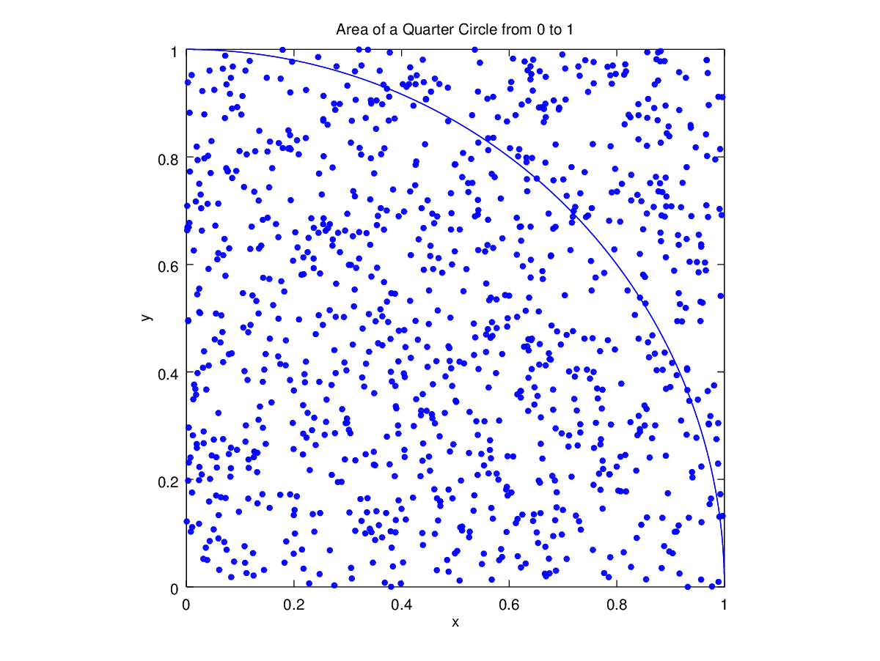
Java output. I imported the Random library into Java: Xa, Ya = rand.nextDouble(). Java’s other built-in Math.random method for some reason did not yield as fine-grained results, at least in my attempt to use it. See below for Java output (notice how off Java is right away, whereas MATLAB is a bit “better”).To me it seems like Java works backward using a more exhaustive method whereas MATLAB works “up” to the answer. The proof is that MATLAB found pi around 220 (shown above), whereas it took Java about twice as long.

n Xa Ya Yes/No Area pi
-----------------------------------------------------------
1 | 0.685390 | 0.709644 | 1.000000 | 1.000000 | 4.000000
2 | 0.852505 | 0.036939 | 1.000000 | 1.000000 | 4.000000
3 | 0.987558 | 0.589705 | 0.000000 | 0.666667 | 2.666667
4 | 0.679584 | 0.074981 | 1.000000 | 0.750000 | 3.000000
.
.
.
451 | 0.161315 | 0.016308 | 1.000000 | 0.787140 | 3.148559
452 | 0.788209 | 0.839157 | 0.000000 | 0.785398 | 3.141593
453 | 0.784402 | 0.606473 | 1.000000 | 0.785872 | 3.143488
.
.
.

995 | 0.074592 | 0.647829 | 1.000000 | 0.782915 | 3.131658
996 | 0.926657 | 0.921547 | 0.000000 | 0.782129 | 3.128514
997 | 0.093696 | 0.086263 | 1.000000 | 0.782347 | 3.129388
998 | 0.616620 | 0.248426 | 1.000000 | 0.782565 | 3.130261
999 | 0.431463 | 0.987061 | 0.000000 | 0.781782 | 3.127127
1000 | 0.616735 | 0.631749 | 1.000000 | 0.782000 | 3.128000
2. Estimate the area trapped between two curves y=x² and y = 6 – x and x-and y-axes.
I used two, almost three, methods to solve this problem. First, I plotted the functions, as seen below. The total area of the rectangle in question is easily evaluated (2*6=12units). The area of the triangle that remains at the top of the graph has an area of 2 units (1/2*2*2=2: formula for area of a triangle). Subtracting that from the total area leaves us with 10 units, which is the area under the curve y = 6 – x. Then we can subtract the area under the parabola, which, using integration, was discovered to be about 2.6. The remaining area is then equal to about 7.3 units. The second method was to solve entirely by integration, which yields exactly the same area of 7.3 units (see graph paper). The third method was to use a Monte Carlo simulation. I found that it was also very close to 7.3333. As was the case with problem 1, MATLAB’s result was slightly more satisfactory (I omitted the Java output for brevity). The more iterations I ran, however, the longer the oscillations. Right around 108 iterations, the answer is spot on. At 1000, it is off by 0.06.

The graph for the area in question is below the table of data and on the next page. For some reason, maybe my lack of RAM, it took entirely too long to generate the plots and the random points, unlike problem 1.

n Xa Ya Yes/No Area pi
-----------------------------------------------------------------
1 | 1.612968 | 3.914599 | 0.482088 | 3.511050 | 12.000000
2 | 1.524431 | 1.455415 | 0.012867 | 2.863047 | 6.000000
3 | 1.906762 | 0.691283 | 0.491291 | 0.113612 | 4.000000
4 | 1.188414 | 5.123059 | 0.226790 | 4.588938 | 6.000000
5 | 0.953845 | 0.902644 | 0.571796 | 2.507900 | 4.800000
.
.
.
105 | 0.616567 | 4.808709 | 0.487198 | 5.523932 | 7.314286
106 | 0.727735 | 4.351789 | 1.532836 | 4.754361 | 7.245283
107 | 0.920332 | 2.833580 | 1.480992 | 2.501897 | 7.289720
108 | 1.073245 | 3.174954 | 0.263688 | 1.337645 | 7.333333
109 | 1.536773 | 2.332853 | 0.940059 | 1.544389 | 7.266055
110 | 0.672883 | 1.027480 | 0.817420 | 2.577785 | 7.309091
.
.
.
995 | 1.082952 | 3.323189 | 0.874523 | 4.414279 | 7.248241
996 | 0.600497 | 1.592812 | 0.050009 | 5.155842 | 7.253012
997 | 0.322289 | 1.968738 | 0.102068 | 1.859436 | 7.257773
998 | 1.584701 | 2.971701 | 0.374137 | 4.723182 | 7.262525
999 | 1.532789 | 3.908694 | 0.677423 | 5.290051 | 7.267267
1000 | 0.073391 | 0.054106 | 1.323098 | 4.386456 | 7.272000
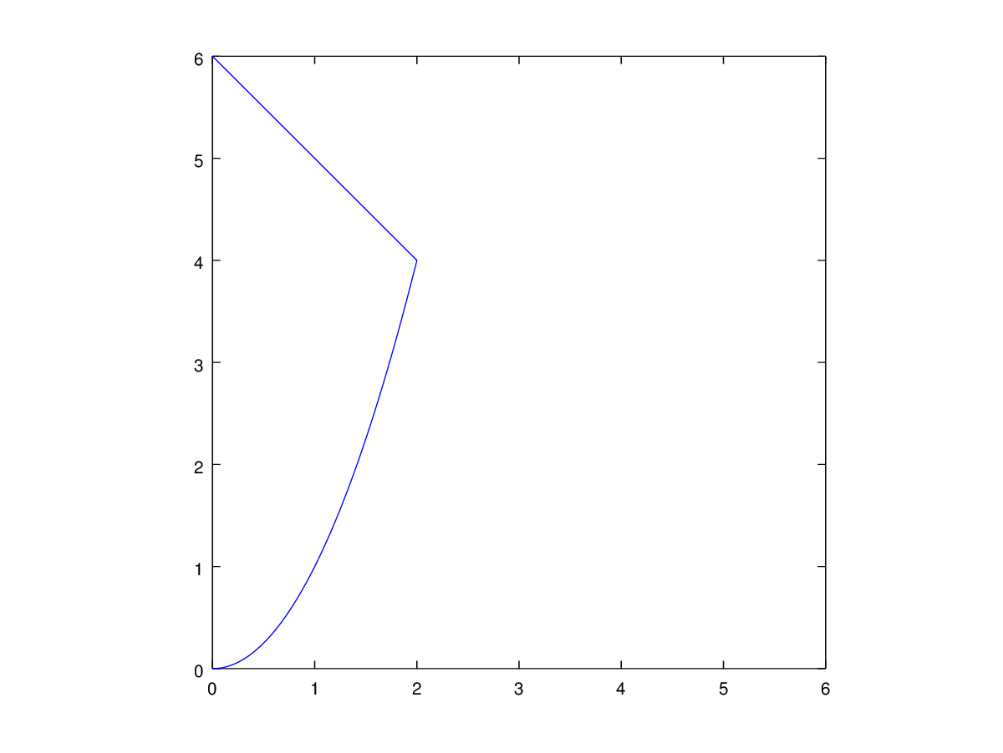
3. Calculate the volume trapped between the two paraboloids.

Z = 8 – x² – y² and z = x² + 3y²

The plots were too difficult for me to plot simultaneously, and even harder to plot with the random points since my Thinkpad isn’t exactly brand new. Using a Monte Carlo simulation, I calculated the area to be between 28 and 29. I used the same random number generator as the previous problems and used MATLAB to execute the simulation. See the table below, and see graph paper for description of algorithm.

n Xa Ya Za Volume
--------------------------------------------------------
1 | 1.021888 | 2.459474 | 4.293360 | 64.000000
2 | 1.216896 | 2.033337 | 1.281050 | 32.000000
3 | 0.204468 | 1.825062 | 3.274304 | 21.333333
4 | 1.525814 | 2.128326 | 0.127334 | 16.000000
5 | 0.871875 | 2.773414 | 5.757110 | 25.600000
.
.
.
990 | 1.832403 | 0.920811 | 3.513964 | 28.703030
991 | 0.571142 | 2.236709 | 4.264987 | 28.738648
992 | 0.485173 | 0.010259 | 5.035760 | 28.645161
993 | 0.522293 | 1.513280 | 2.801576 | 28.616314
994 | 1.409146 | 1.724055 | 7.385498 | 28.651911
995 | 0.273410 | 3.734964 | 3.344747 | 28.687437
996 | 0.967687 | 3.181293 | 2.127650 | 28.722892
997 | 1.764516 | 1.646153 | 2.839504 | 28.758275
998 | 1.278471 | 2.523778 | 3.576851 | 28.793587
999 | 0.145134 | 3.885056 | 7.395037 | 28.828829
1000 | 1.757562 | 1.145318 | 0.207412 | 28.800000
4. Simulate the outcome of a coin flipping game.

Below is my MATLAB code and the table of data below that. I started each player out with $100; I saw runs in my output as well as ups and downs for both players. The runs seemed to last for a while.

i = 1;
a = 0;
b = 1;
coin1 = 0;
coin2 = 0;
score1 = 0;
score2 = 0;
player1 = 0;
player2 = 0;
player1Score = 100; %%each player starts with $100
player2Score = 100;

while( i <= 100 )

coin1 = (a+(b-a)*rand(1)); %% generate random numbers
coin2 = (a+(b-a)*rand(1));

%% assign 0/1 values to random numbers for each coin
if( coin1 > 0.5 )
score1 = 1;
elseif( coin1 < 0.5 )
score1 = 0;
end
if( coin2 > 0.5 )
score2 = 1;
elseif( coin2 < 0.5 )
score2 = 0;
end
%% add and subtract points from each player accordingly
if( score1 == score2 )
player1Score = player1Score + 1;
player2Score = player2Score -1;
elseif( score1 ~= score2 )
%% tally the sums
player1Score = player1Score - 1;
player2Score = player2Score +1;
end
%% print results
fprintf( '%5d | %10d | %10d\n', i, player1Score, player2Score);
i = i + 1;
end

Results on next page
n | Player 1 | Player 2
---------------------------------
1 | 99 | 101
2 | 100 | 100
3 | 101 | 99
4 | 100 | 100
5 | 101 | 99
6 | 100 | 100
7 | 101 | 99
8 | 100 | 100
9 | 99 | 101
10 | 98 | 102
.
.
.
21 | 99 | 101
22 | 98 | 102
23 | 99 | 101
24 | 100 | 100
25 | 101 | 99
26 | 102 | 98
27 | 103 | 97
28 | 104 | 96
29 | 103 | 97
30 | 104 | 96
.
.
.
41 | 103 | 97
42 | 104 | 96
43 | 105 | 95
44 | 104 | 96
45 | 105 | 95
46 | 104 | 96
47 | 103 | 97
48 | 104 | 96
49 | 103 | 97
50 | 104 | 96
.
.
.
61 | 99 | 101
62 | 98 | 102
63 | 97 | 103
64 | 98 | 102
65 | 97 | 103
66 | 98 | 102
67 | 97 | 103
68 | 98 | 102
69 | 99 | 101
70 | 98 | 102
71 | 99 | 101
72 | 100 | 100

In this simulation, the players would be right back where they started at 72 flips.

