- 新建工程项目
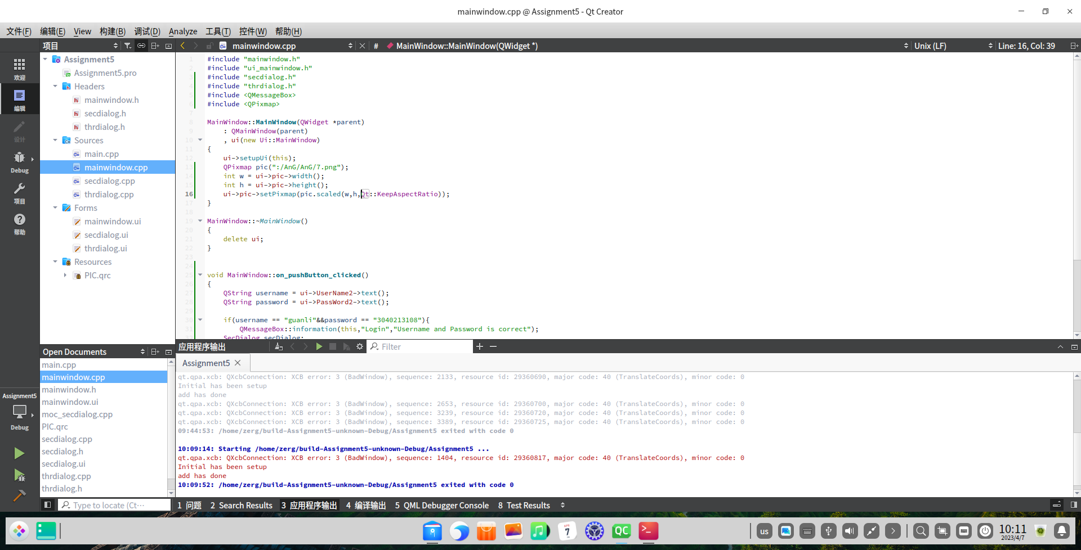
- 主界面ui
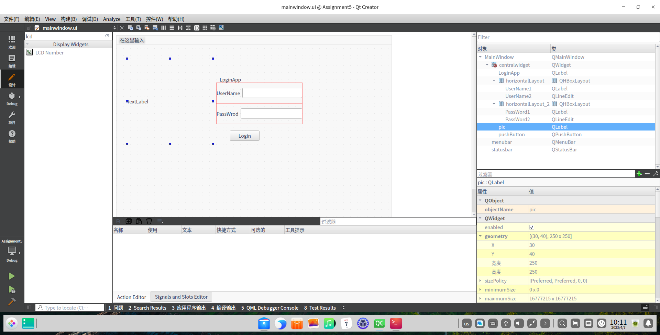
- 第二界面ui
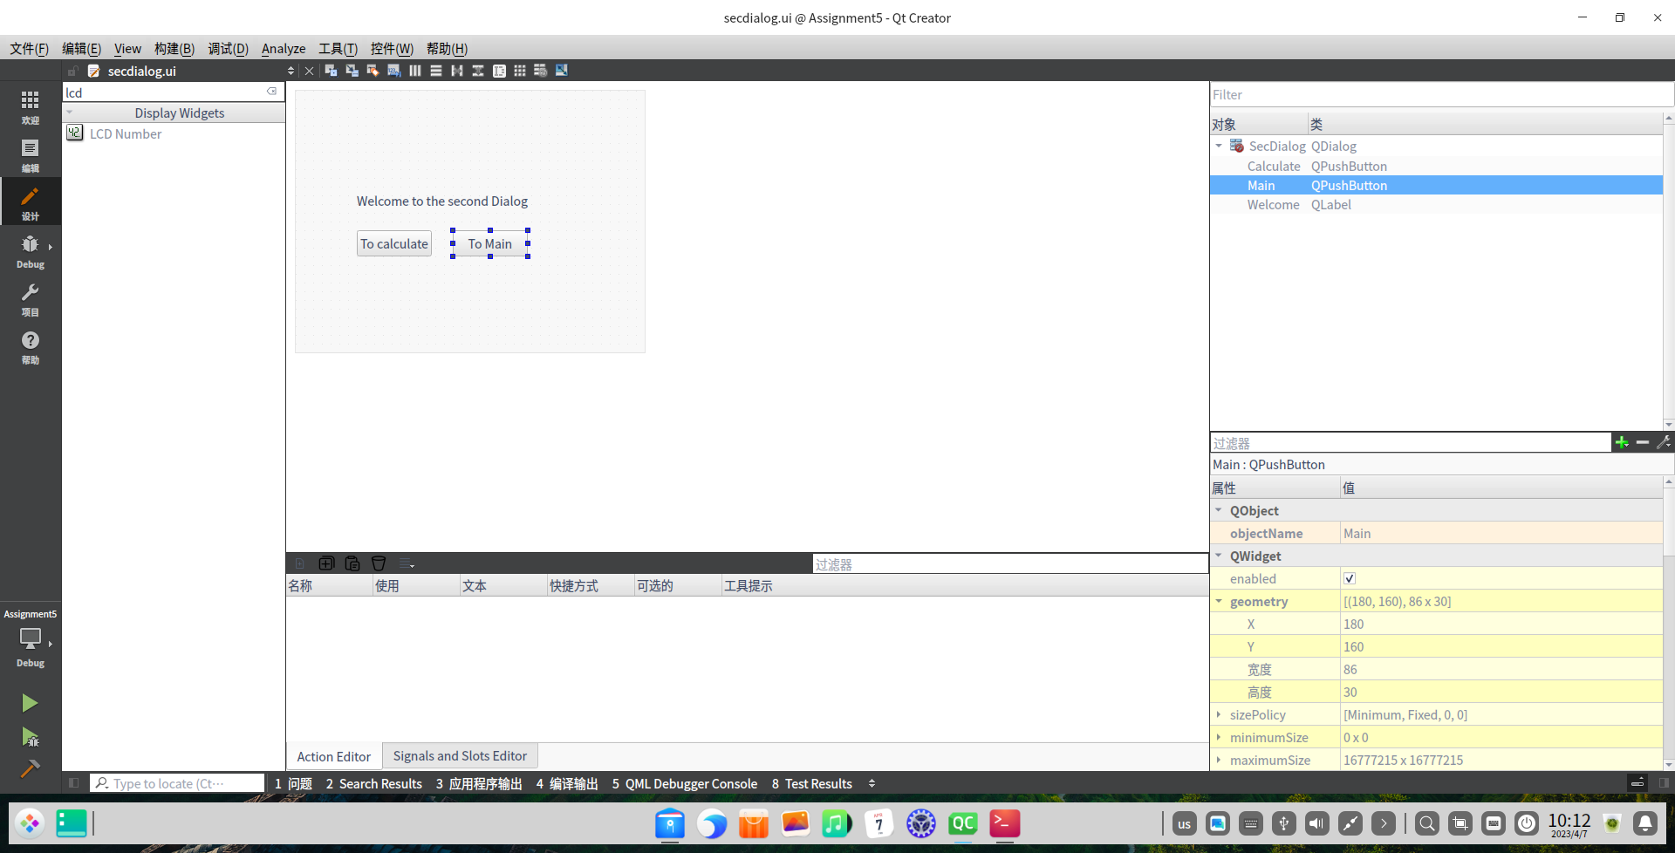
- 计算器ui
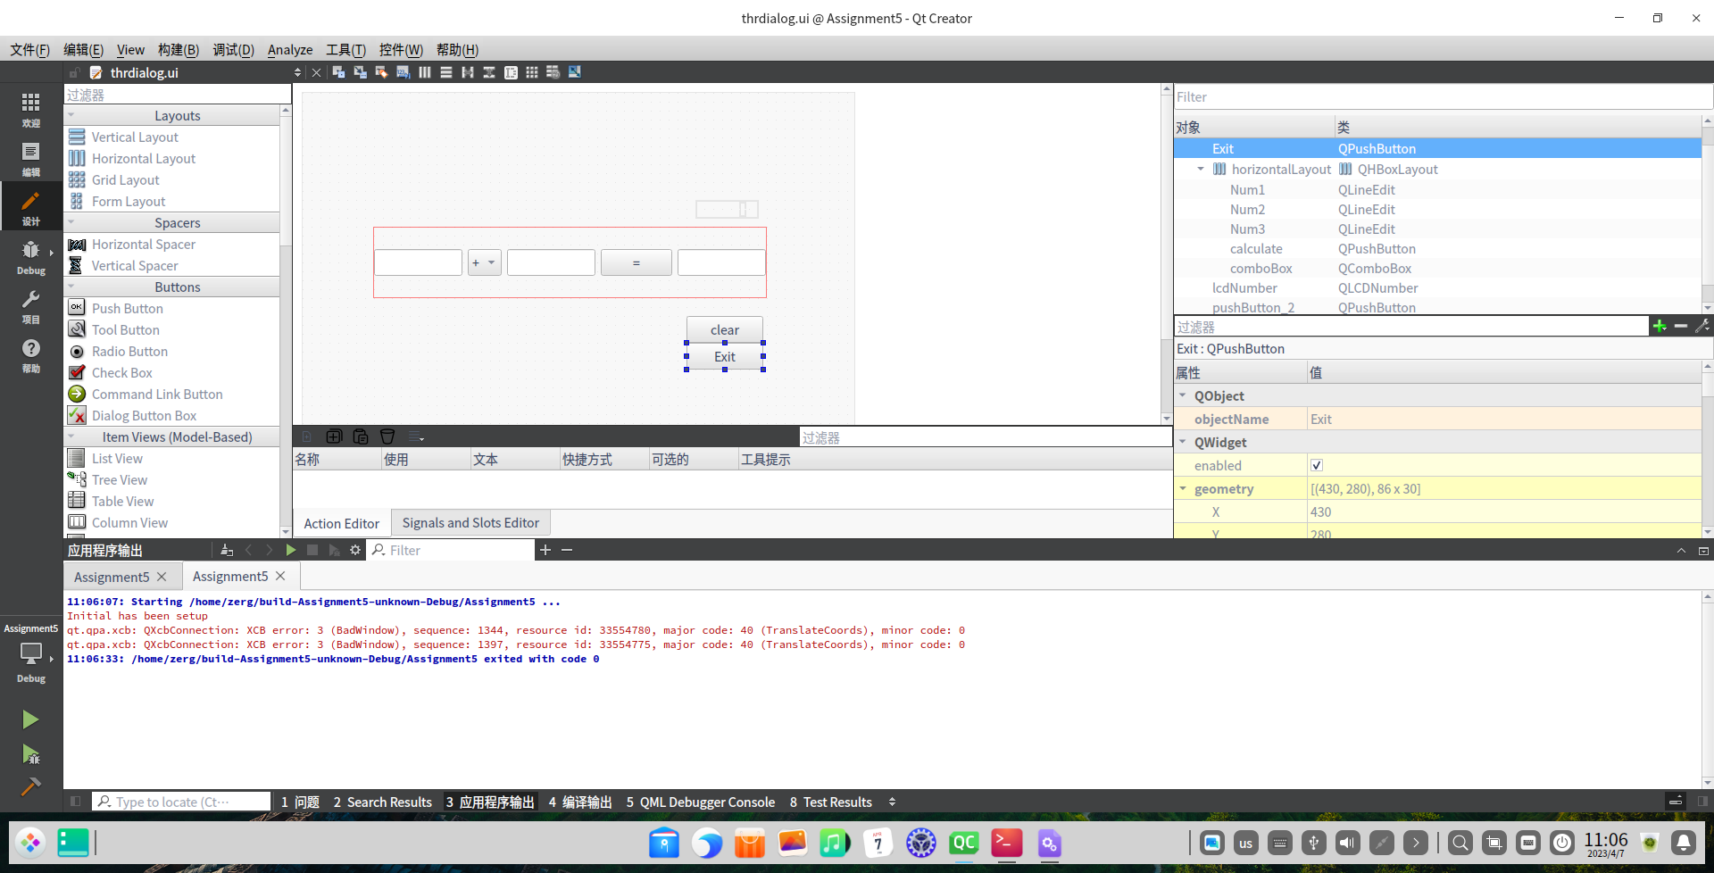
5主界面代码
#include "mainwindow.h"
#include "ui_mainwindow.h"
#include "secdialog.h"
#include "thrdialog.h"
#include <QMessageBox>
#include <QPixmap>

MainWindow::MainWindow(QWidget *parent)
: QMainWindow(parent)
, ui(new Ui::MainWindow)
{
ui->setupUi(this);
QPixmap pic(":/AnG/AnG/7.png");
int w = ui->pic->width();
int h = ui->pic->height();
ui->pic->setPixmap(pic.scaled(w,h,Qt::KeepAspectRatio));
}

MainWindow::~MainWindow()
{
delete ui;
}

void MainWindow::on_pushButton_clicked()
{
QString username = ui->UserName2->text();
QString password = ui->PassWord2->text();

if(username == "guanli"&&password == "3040213108"){
QMessageBox::information(this,"Login","Username and Password is correct");
SecDialog secDialog;
secDialog.setModal(true);
secDialog.exec();
}
else{
QMessageBox::warning(this,"Login","Username and Password is not correct");
}

}
6第二界面代码
#include "secdialog.h"
#include "ui_secdialog.h"
#include "thrdialog.h"
#include "mainwindow.h"

SecDialog::SecDialog(QWidget *parent) :
QDialog(parent),
ui(new Ui::SecDialog)
{
ui->setupUi(this);
}

SecDialog::~SecDialog()
{
delete ui;
}

void SecDialog::on_Calculate_clicked()
{
ThrDialog thrDialog;
thrDialog.setModal(true);
thrDialog.exec();
}

void SecDialog::on_Main_clicked()
{
hide();
//MainWindow mainWindow;
//mainWindow.setModal(true);
//mainWindow.exec();
}
7.计算机代码
#include "thrdialog.h"
#include "ui_thrdialog.h"
#include <QMessageBox>
#include "qdebug.h"

ThrDialog::ThrDialog(QWidget *parent) :
QDialog(parent),
ui(new Ui::ThrDialog)
{
ui->setupUi(this);
ui->lcdNumber->setPalette(Qt::green);
qDebug("Initial has been setup");
}

ThrDialog::~ThrDialog()
{
delete ui;
}

void ThrDialog::on_calculate_clicked()
{
double num1 = ui->Num1->text().toDouble();
double num2 = ui->Num2->text().toDouble();
double num3;
int index = ui->comboBox->currentIndex();
if (index == 0)
{
num3 = num1 +num2;
qDebug("add has done");
}
if(index == 1)
{
num3 = num1- num2;
}
if(index == 2)
{
num3 = num1*num2;
}
if (index ==3 )
{
if(num2==0)
{
qDebug("num2 is 0");
QMessageBox::about(this,"注意","除数不能为0");
return;

}
else{
num3 = num1/num2;
}

}
ui->Num3->setText(QString::number(num3));
ui->lcdNumber->display(num3);
}

void ThrDialog::on_pushButton_2_clicked(bool checked)
{
ui->Num1->clear();
ui->Num2->clear();
ui->Num3->clear();
}

void ThrDialog::on_Exit_clicked()
{
close();
}
8结果展示
