1. 新建qt工程文件
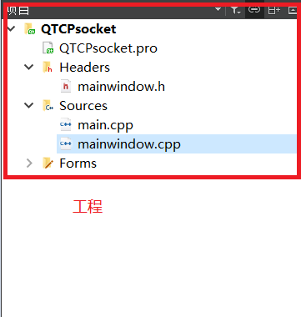
图1
2. *.ui文件中的QWidget对象进行分辨率（geometry参数）的设置
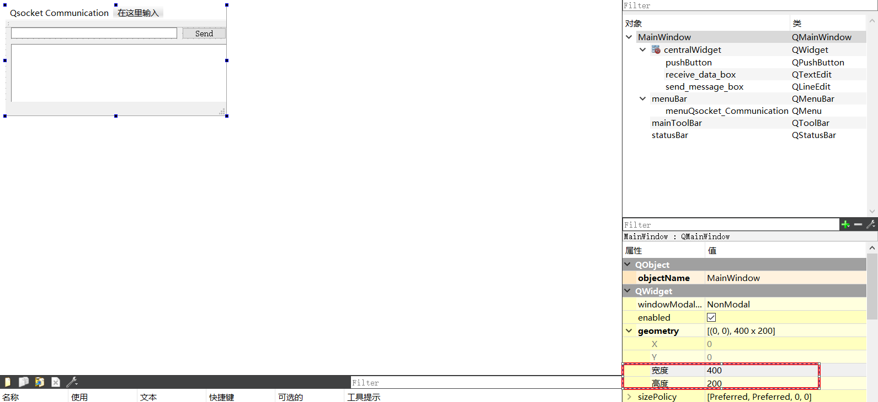
图2
- 添加LineEdit，等控件，并分别增加文字，并修改对象的名称
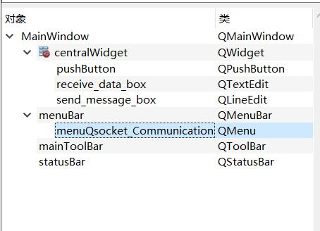
图3
- 在mainwindow.cpp添加相应代码
#include <mainwindow.h>
#include "ui_mainwindow.h"
#include "QString"
#include <QByteArray>

MainWindow::MainWindow(QWidget *parent) :
QMainWindow(parent),
ui(new Ui::MainWindow)
{
ui->setupUi(this);

TCPSocket = new QTcpSocket();
TCPSocket->connectToHost("127.0.0.1",8080);
//TCPSocket->connectToHost(QHostAddress::LocalHost,8080);
TCPSocket->open(QIODevice::ReadWrite);
if(TCPSocket->isOpen())
{
QMessageBox::information(this,"Qt With Mr Ping","Connected To The Server.");
}
else
{
QMessageBox::information(this,"Qt With Mr Ping","Not Connected To The Server.");
}

}

MainWindow::~MainWindow()
{
delete ui;
}

void MainWindow::on_pushButton_clicked()
{
if(TCPSocket)
{
if(TCPSocket->isOpen())
{
QString WriteData = ui->send_message_box->text().append(char(10));

TCPSocket->write(WriteData.toStdString().c_str());
}
else
{
QMessageBox::information(this,"Qt With Mr Ping","Error:"+TCPSocket->errorString());
}
}
else
{
QMessageBox::information(this,"Qt With Mr Ping","Error:"+TCPSocket->errorString());
}

}

void MainWindow::Read_Data_From_Socket()
{
if(TCPSocket){
if(TCPSocket->isOpen()){
QByteArray Data_From_Server = TCPSocket->readAll();
QString MessageString = QString::fromStdString(Data_From_Server.toStdString());
ui->receive_data_box->append(MessageString);
}
}
}

5在mainwindow.h文件
添加代码

private slots:
void on_pushButton_clicked();
void Read_Data_From_Socket();

6 项目检测

