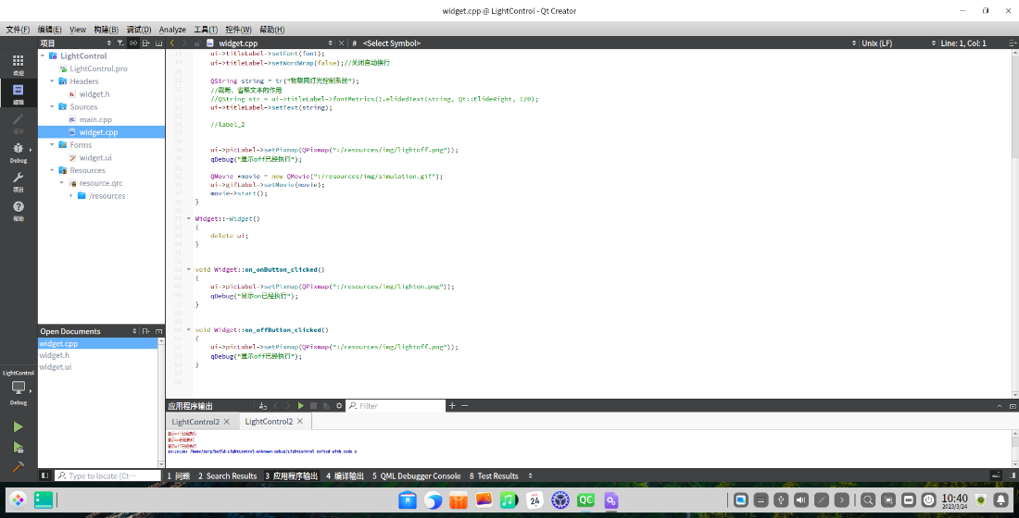

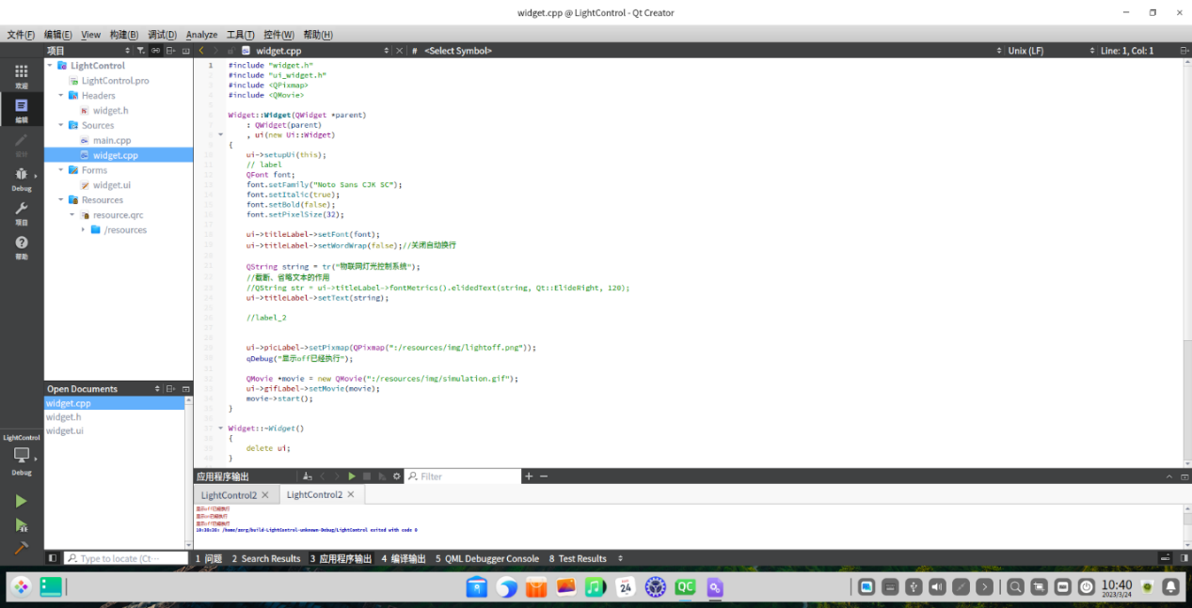

图1 widget.cpp代码

#include "widget.h"

#include "ui_widget.h"

#include <QPixmap>

#include <QMovie>

Widget::**Widget**(QWidget *parent)

: QWidget(parent)

, ui(new Ui::Widget)

{

ui->setupUi(this);

// label

QFont font;

font.setFamily("Noto Sans CJK SC");

font.setItalic(true);

font.setBold(false);

font.setPixelSize(32);

ui->titleLabel->setFont(font);

ui->titleLabel->setWordWrap(false);//关闭自动换行

QString string = tr("物联网灯光控制系统");

//截断、省略文本的作用

//QString str = ui->titleLabel->fontMetrics().elidedText(string, Qt::ElideRight, 120);

ui->titleLabel->setText(string);

//label_2

ui->picLabel->setPixmap(QPixmap(":/resources/img/lightoff.png"));

qDebug("显示off已经执行");

QMovie *movie = new QMovie(":/resources/img/simulation.gif");

ui->gifLabel->setMovie(movie);

movie->start();

}

Widget::~***Widget***()

{

delete ui;

}

void Widget::**on_onButton_clicked**()

{

ui->picLabel->setPixmap(QPixmap(":/resources/img/lighton.png"));

qDebug("显示on已经执行");

}

void Widget::**on_offButton_clicked**()

{

ui->picLabel->setPixmap(QPixmap(":/resources/img/lightoff.png"));

qDebug("显示off已经执行");

}

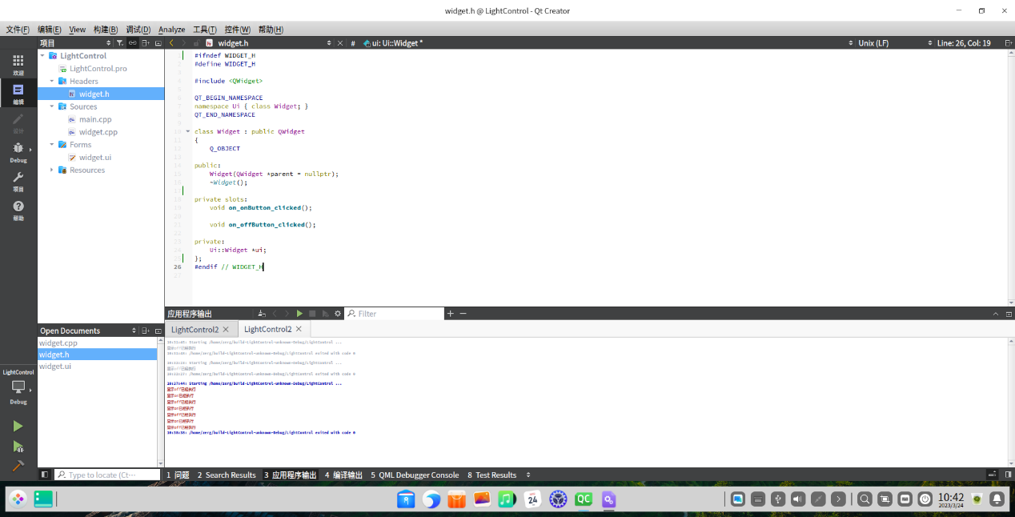

图·2 widget.h代码

#ifndef WIDGET_H

#define WIDGET_H

#include <QWidget>

QT_BEGIN_NAMESPACE

namespace Ui { class Widget; }

QT_END_NAMESPACE

class Widget : public QWidget

{

Q_OBJECT

public:

Widget(QWidget *parent = nullptr);

~***Widget***();

private slots:

void **on_onButton_clicked**();

void **on_offButton_clicked**();

private:

Ui::Widget *ui;

};

#endif // WIDGET_H

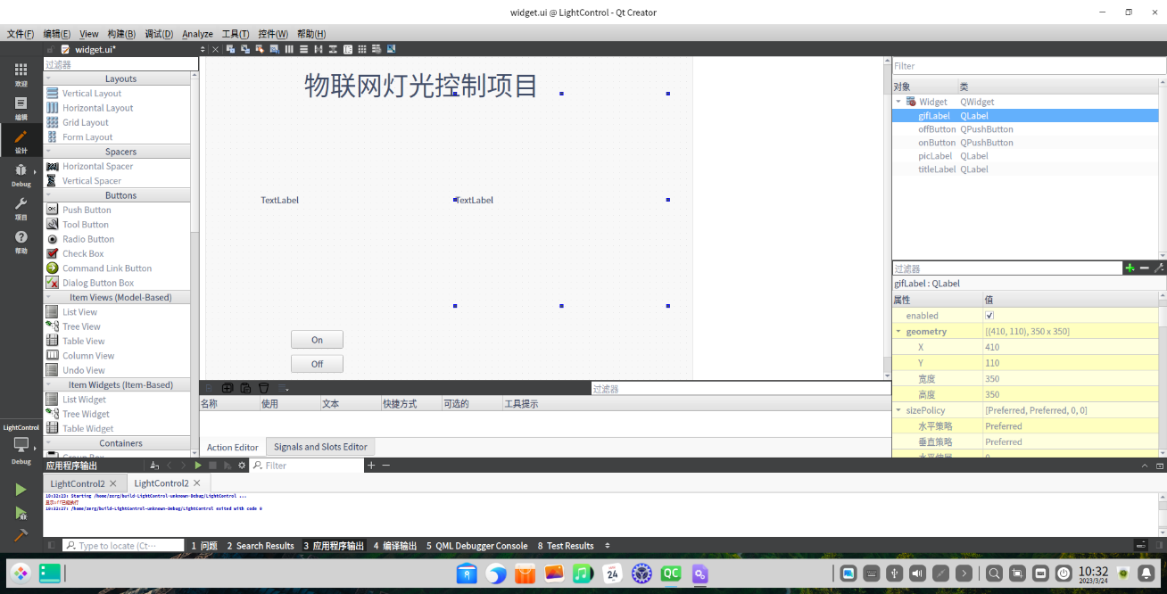

图3 视图界面



图5 运行动态图