1. 新建Qt工程文件

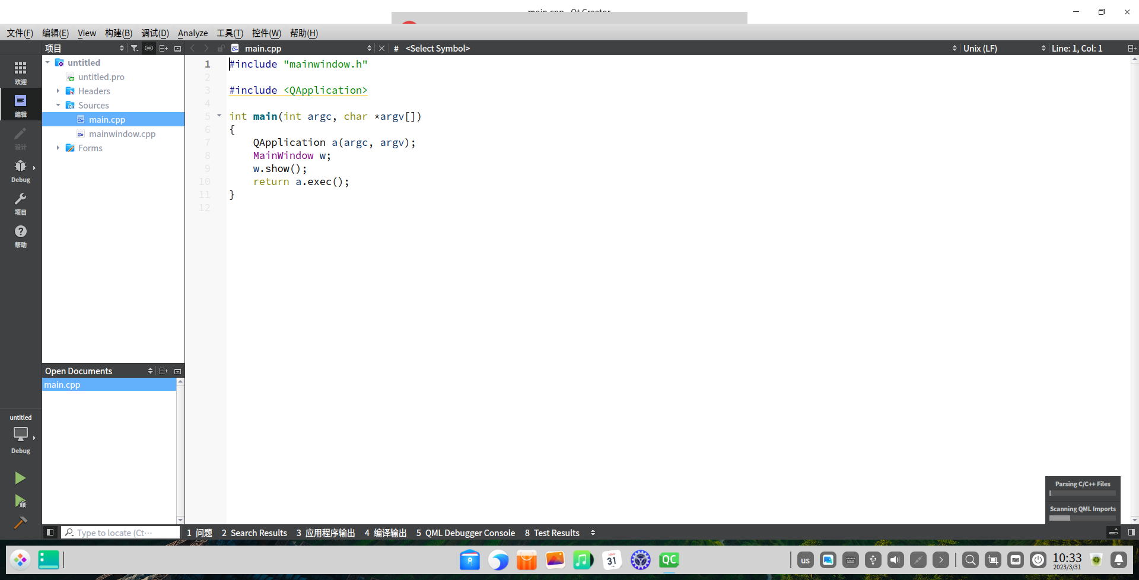

2.添加LineEdit输入框3个，下拉组合框ComboBox1个，按钮Button2个，段位显示LcdNumber1个

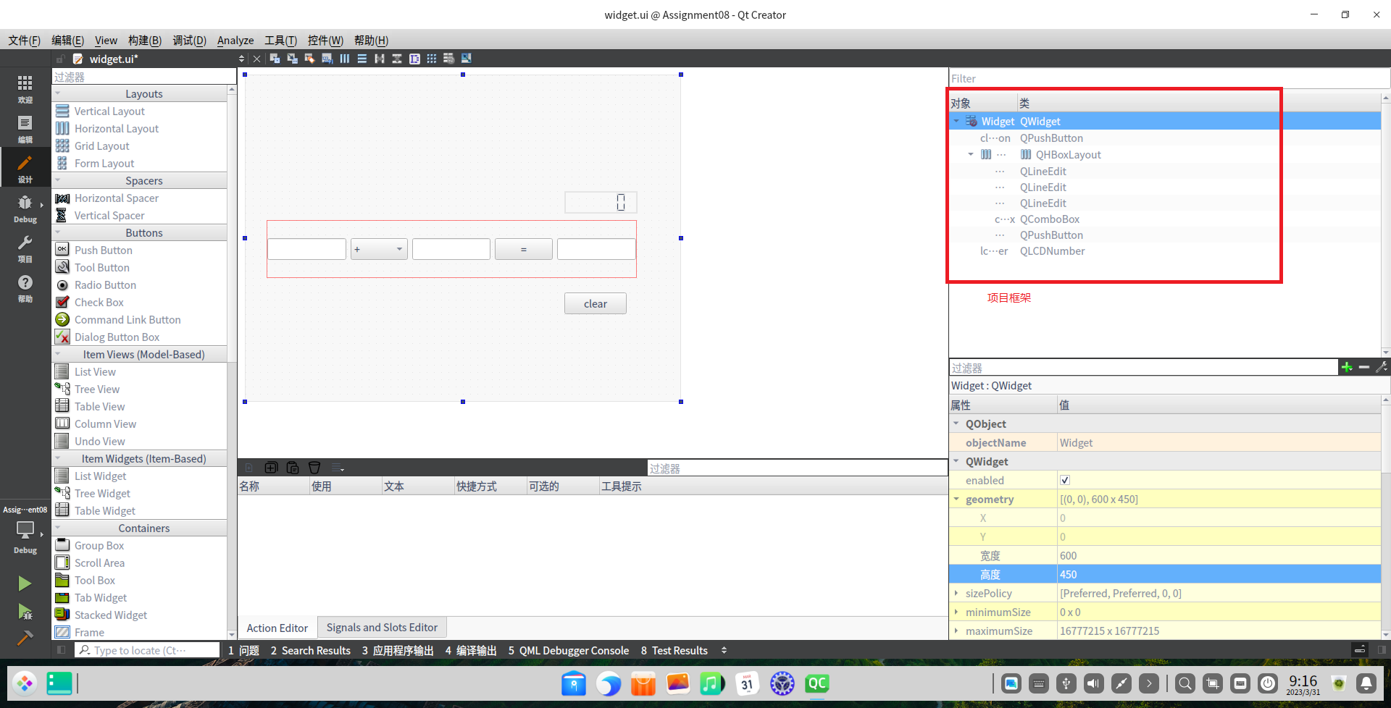

3．添加相应代码

#include "mainwindow.h"

#include "ui_mainwindow.h"

#include<QDebug>

#include<QMessageBox>

MainWindow::MainWindow(QWidget *parent)

: QMainWindow(parent)

, ui(new Ui::MainWindow)

{

ui->setupUi(this);

ui->lcdNumber->setPalette(Qt::green);

}

MainWindow::~MainWindow()

{

delete ui;

}

void MainWindow::on_Calulate_clicked()

{

double num1= ui->lineEdit->text().toDouble();

double num2= ui->lineEdit_2->text().toDouble();

uint8_t index=ui->comboBox->currentIndex();

double result=0.0;

switch (index) {

case 0:

result=num1+num2;

break;

case 1:

result=num1-num2;

break;

case 2:

result=num1*num2;

break;

case 3:

if(num2==0)

{

qDebug("num2 is 0");

QMessageBox::about(this,"注意","除数不能为0");

return;

}

result= num1/num2;

break;

default:

break;

}

ui->Num3->setText(QString::number(result));

ui->lcdNumber->display(result);

}

void MainWindow::on_Clear_clicked()

{

ui->Num1->clear();

ui->Num2->clear();

ui->Num3->clear();

}

4.运行结果

