解答：

1. 新建项目工程文件

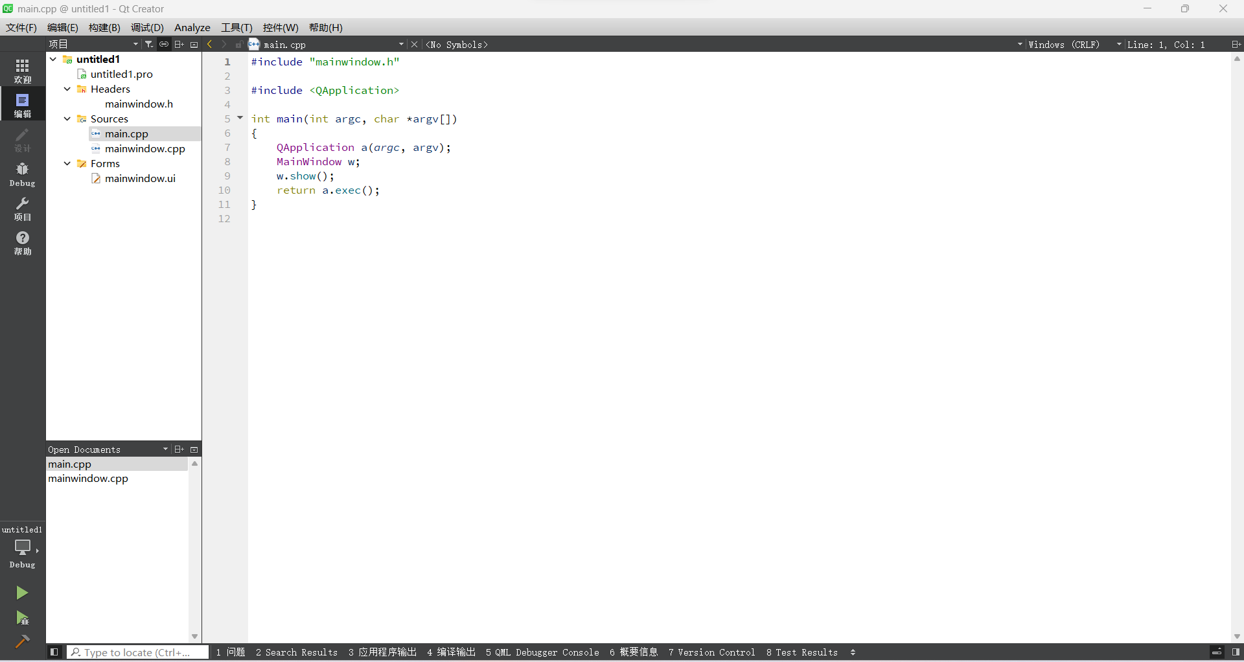

图1 项目工程文件

1. 在ui界面摆放控件，调整分辨率

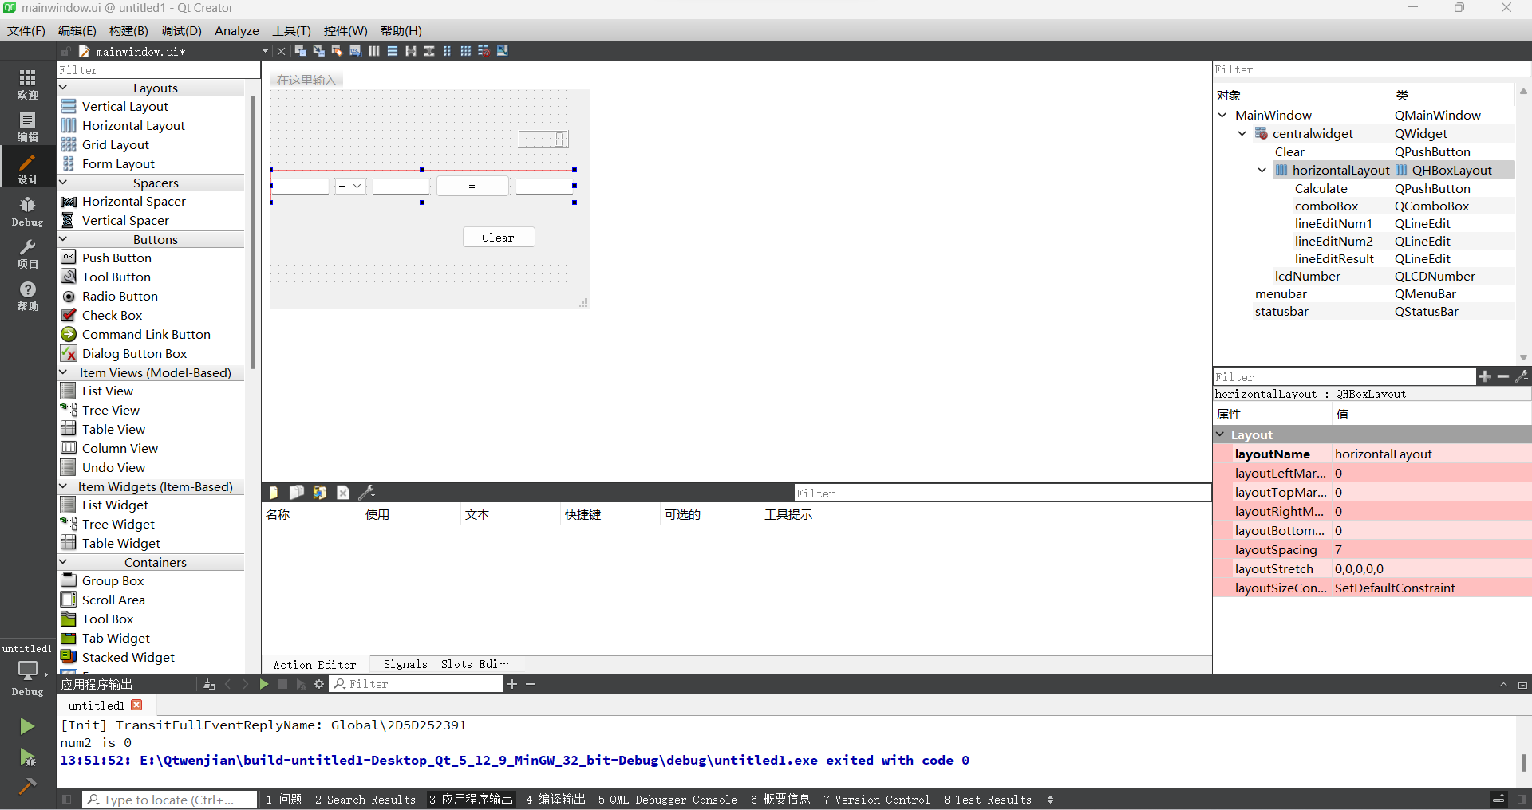

图2 ui界面

1. 编写主文件代码及槽函数

#include "mainwindow.h"

#include "ui_mainwindow.h"

#include <QDebug>

#include <QMessageBox>

MainWindow::**MainWindow**(QWidget *parent)

: QMainWindow(parent)

, ui(new Ui::MainWindow)

{

ui->setupUi(this);

ui->lcdNumber->setPalette(Qt::green);

qDebug("Initial has been setup.");

}

MainWindow::~***MainWindow***()

{

delete ui;

}

void MainWindow::**on_calculate_clicked**()

{

double num1 = ui->lineEditNum1->text().toDouble();

double num2 = ui->lineEditNum2->text().toDouble();

double num3;

int index = ui->comboBox->currentIndex();

if (index == 0)

{

num3 = num1+num2;

qDebug("add has done");

}

if (index == 1)

{

num3 = num1-num2;

}

if (index == 2)

{

num3 = num1*num2;

}

if (index == 3)

{

if (num2 == 0)

{

qDebug("num2 is 0");

QMessageBox::about(this,"注意","除数不能为0");

return;

}

else

{

num3 = num1/num2;

}

}

ui->lineEditNum3->setText(QString::number(num3));

ui->lcdNumber->display(num3);

}

void MainWindow::**on_clear_clicked**()

{

ui->lineEditNum1->clear();

ui->lineEditNum2->clear();

ui->lineEditNum3->clear();

}

1. 添加头文件代码

private slots:

void **on_calculate_clicked**();

void **on_clear_clicked**();

1. 进行项目运行及测试

