1. 一个新建Qt工程文件

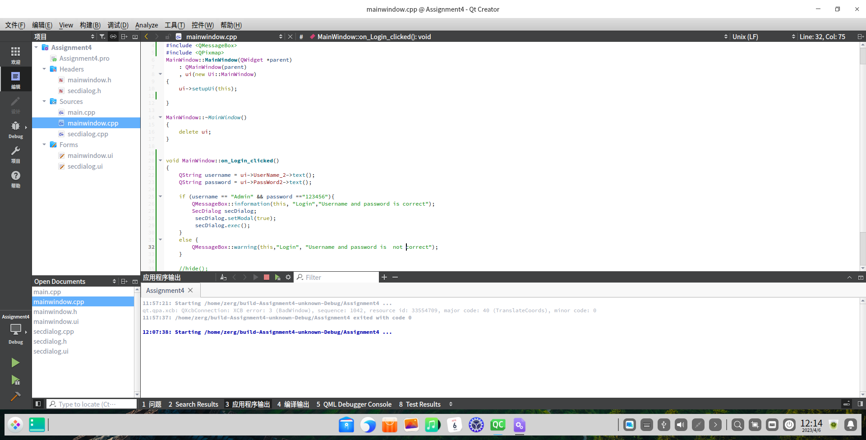

2．Ui文件工程添加LineEdit ，Label ，secdialog

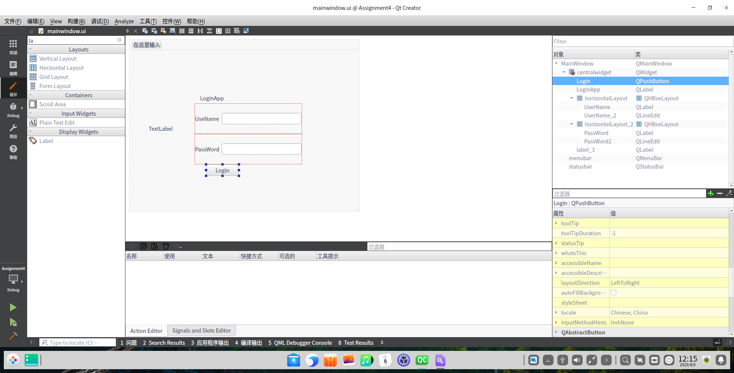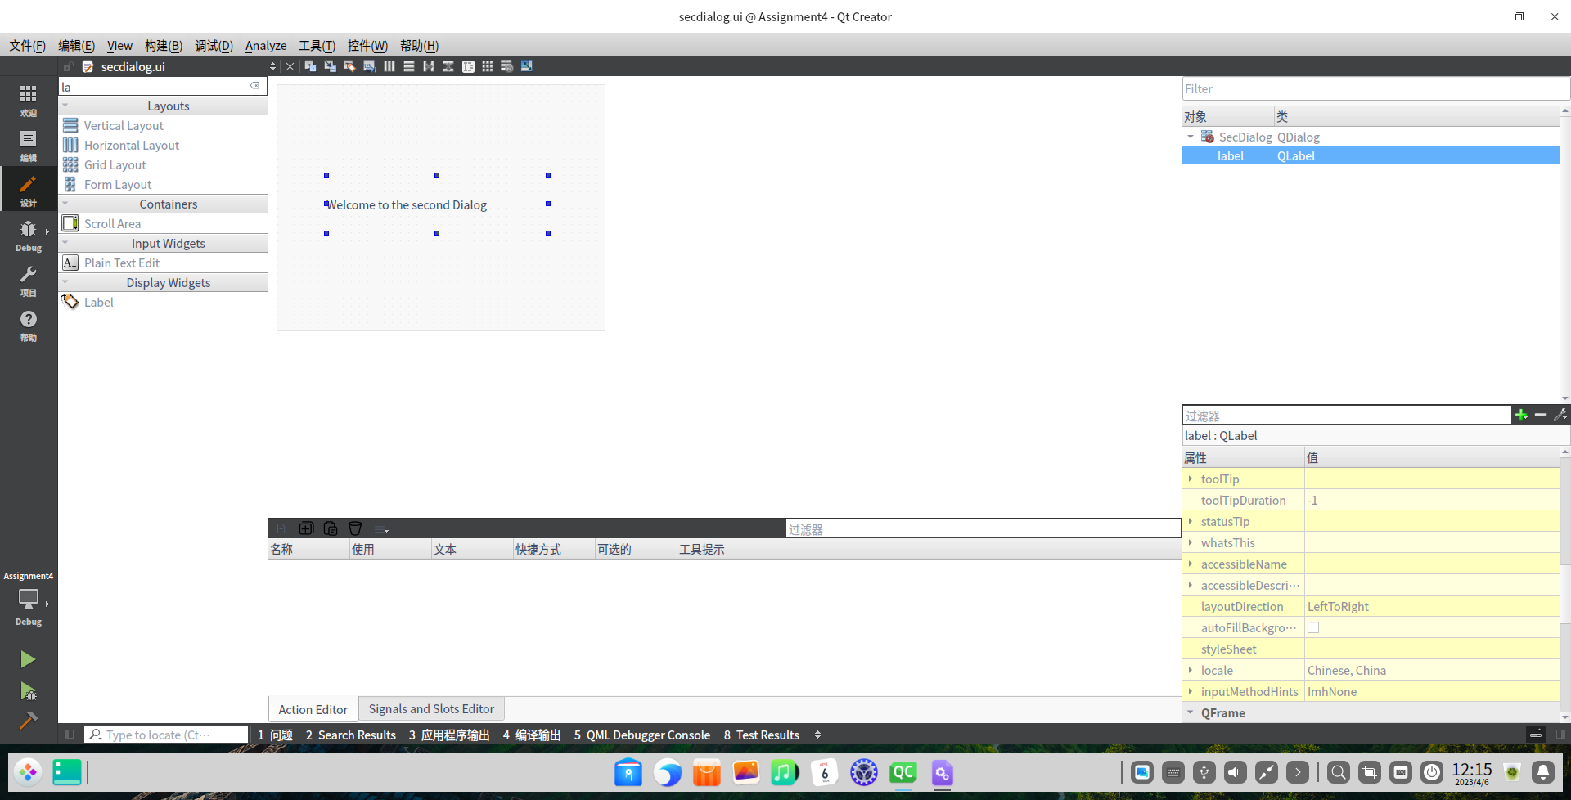

3添加相应代码

#include "mainwindow.h"

#include "ui_mainwindow.h"

#include "secdialog.h"

#include <QMessageBox>

#include <QPixmap>

MainWindow::**MainWindow**(QWidget *parent)

: QMainWindow(parent)

, ui(new Ui::MainWindow)

{

ui->setupUi(this);

}

MainWindow::~***MainWindow***()

{

delete ui;

}

void MainWindow::**on_Login_clicked**()

{

QString username = ui->UserName_2->text();

QString password = ui->PassWord2->text();

if (username == "Admin" && password =="123456"){

SecDialog secDialog;

secDialog.setModal(true);

secDialog.*exec*();

}

else {

QMessageBox::warning(this,"Login", "Username and password is not correct");

}

}

5.结果展示

