**作业5**

Qt Designer Form Class将作业3计算器应用和作业4登录应用结合起来，实现“登录->欢迎->计算器”的三重页面（Multi-Window）应用。

1. **在原工程的基础上新建Qt设计师界面类**

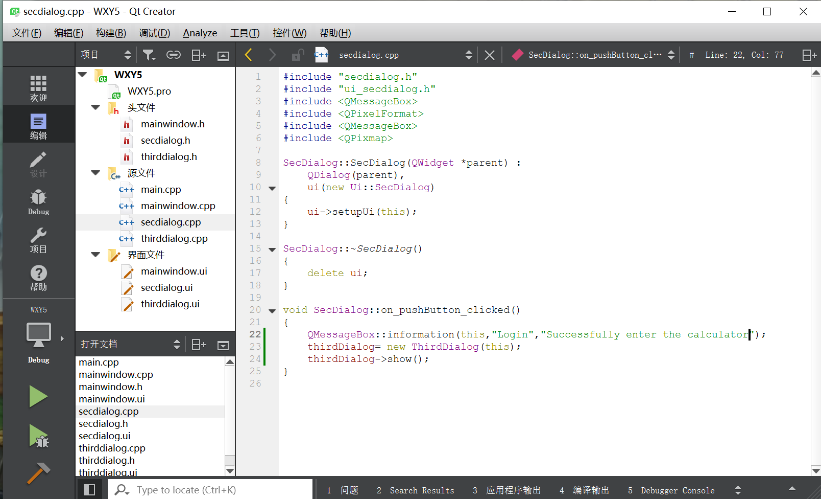

1. （1）在mainwindow界面文件中添加4个label，分别对应图片、UserName、PassWard以及LoginApp，添加pushbutton以及两个lineEdit

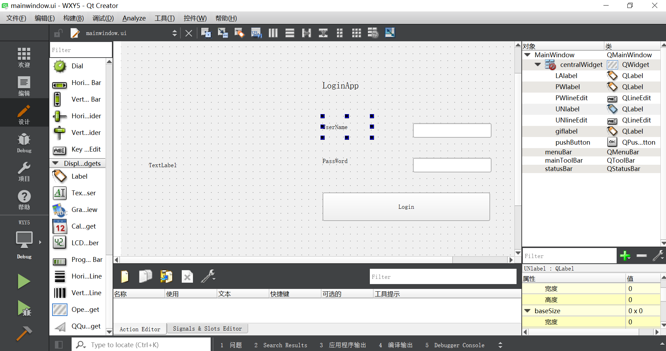

**·添加头文件函数**

#include "secdialog.h"

#include "thirddialog.h"

private slots:

void on_pushButton_clicked();

private:

Ui::MainWindow *ui;

SecDialog *secDialog;

**·添加源文件函数**

#include <QMessageBox>

#include <QPixelFormat>

#include <QPixmap>

MainWindow::MainWindow(QWidget *parent) :

QMainWindow(parent),

ui(new Ui::MainWindow)

{

ui->setupUi(this);

QPixmap pix("C:/Users/WanXY/Desktop/图片/111.jpg");

int w = ui->giflabel->width();

int h = ui->giflabel->height();

ui->giflabel->setPixmap(pix.scaled(w,h,Qt::KeepAspectRatio));

}

MainWindow::~*MainWindow*()

{

delete ui;

}

void MainWindow::on_pushButton_clicked()

{

QString username = ui->UNlineEdit->text();

QString password = ui->PWlineEdit->text();

if(username == "WanXY"&&password == "6534426"){

QMessageBox::information(this,"Login","Username and password is correct");

secDialog= new SecDialog(this);

secDialog->show();

}

else{

QMessageBox::warning(this,"Login","UserName or PassWord is not correct");

}

}

（2）在secdialog界面文件中添加pushbutton并转槽以进入第三窗口

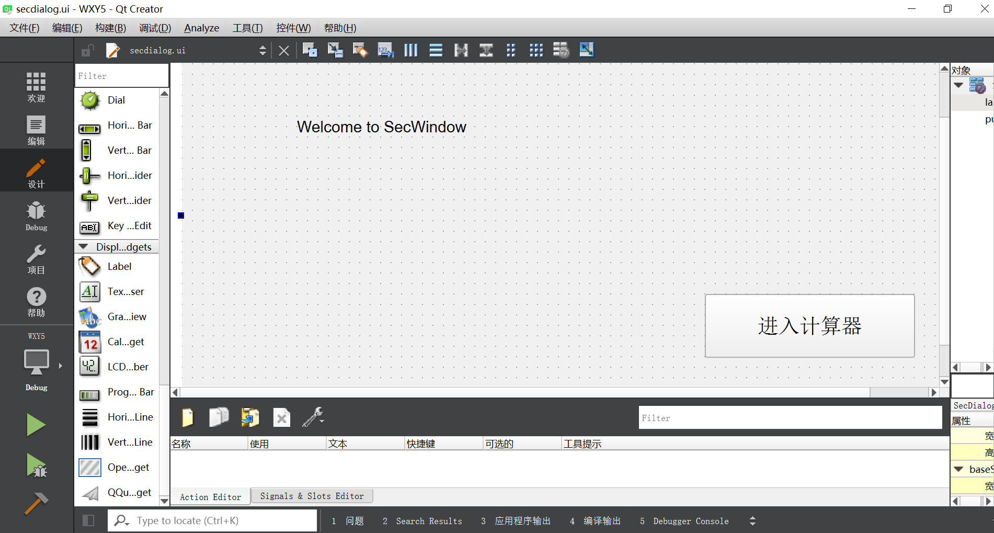

**·在头文件中添加函数**

private slots:

void on_pushButton_clicked();

private:

Ui::SecDialog *ui;

ThirdDialog *thirdDialog;

**·在源文件secdialog中添加函数**

#include <QMessageBox>

#include <QPixelFormat>

#include <QPixmap>

SecDialog::SecDialog(QWidget *parent) :

QDialog(parent),

ui(new Ui::SecDialog)

{

ui->setupUi(this);

}

SecDialog::~*SecDialog*()

{

delete ui;

}

void SecDialog::on_pushButton_clicked()

{

QMessageBox::information(this,"Login","Successfully enter the calculator");

thirdDialog= new ThirdDialog(this);

thirdDialog->show();

}

（3）在thirddialog添加Calculate、Clear、comboBox、lcdNumber、lineEdit、lineEdit_2和lineEdit_3

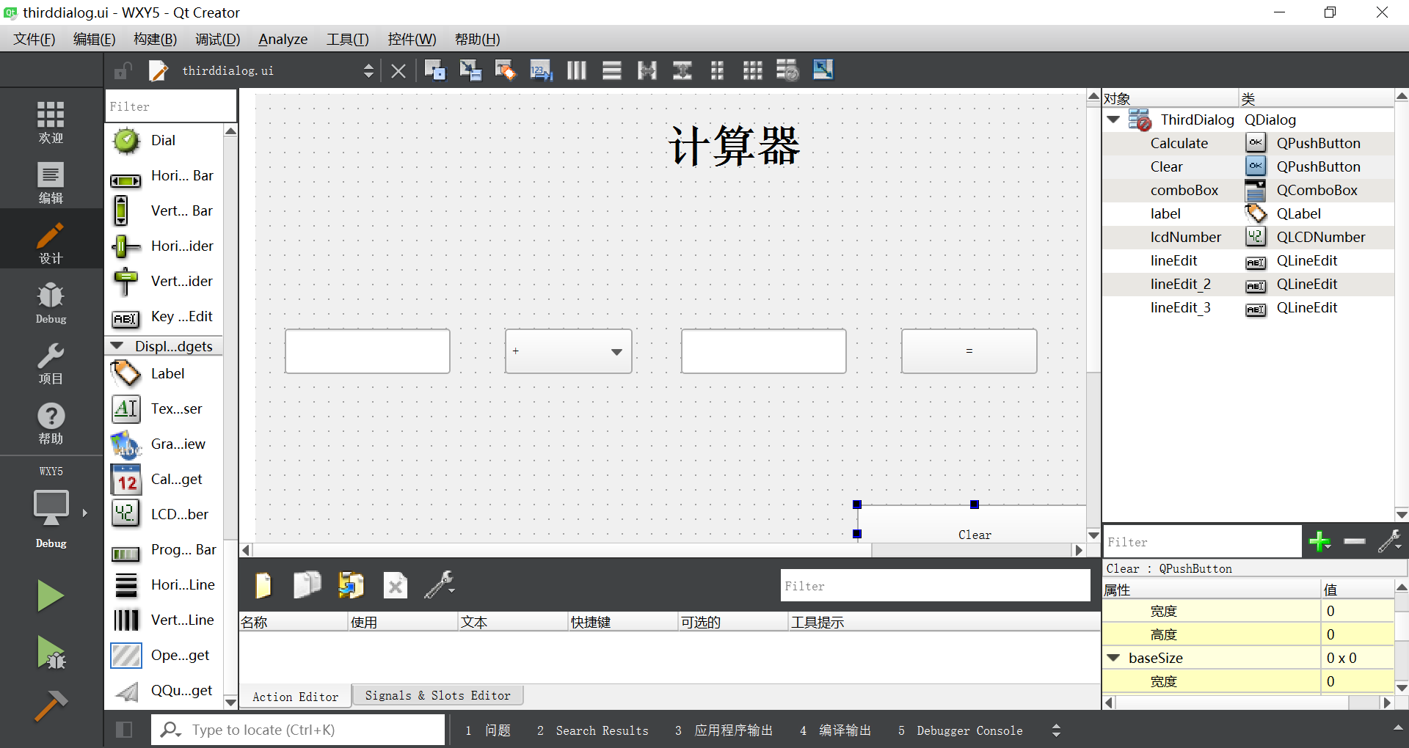**·在thirddialog头文件中添加函数**

private slots:

void on_Clear_clicked();

void on_Calculate_clicked();

**·在thirddialog源文件中添加函数**

ThirdDialog::ThirdDialog(QWidget *parent) :

QDialog(parent),

ui(new Ui::ThirdDialog)

{

ui->setupUi(this);

ui->lcdNumber->setPalette(Qt::green);

}

ThirdDialog::~*ThirdDialog*()

{

delete ui;

}

void ThirdDialog::on_Calculate_clicked()

{

double num1 = ui->lineEdit->text().toDouble();

double num2 = ui->lineEdit_2->text().toDouble();

uint8_t index = ui->comboBox->currentIndex();

double result = 0.0;

switch (index){

case 0:

result = num1 + num2;

break;

case 1:

result = num1 - num2;

break;

case 2:

result = num1 * num2;

break;

case 3:

if(num2 ==0)

{

qDebug("num2 is 0");

QMessageBox::about(this,"注意","除数不能为0");

return;

}

result = num1 / num2;

break;

default:

break;

}

ui->lineEdit_3->setText(QString::number(result));

ui->lcdNumber->display(result);

}

void ThirdDialog::on_Clear_clicked()

{

ui->lineEdit->clear();

ui->lineEdit_2->clear();

ui->lineEdit_3->clear();

}

1. 项目测试

