1. 设置三个界面需要的主窗口，并加入标签

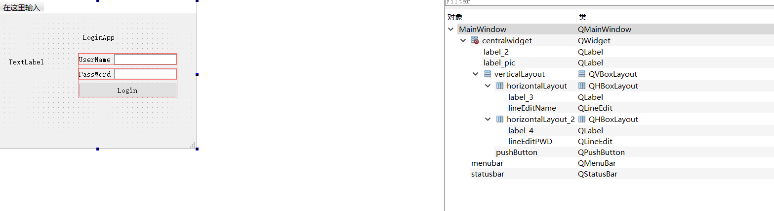

图一

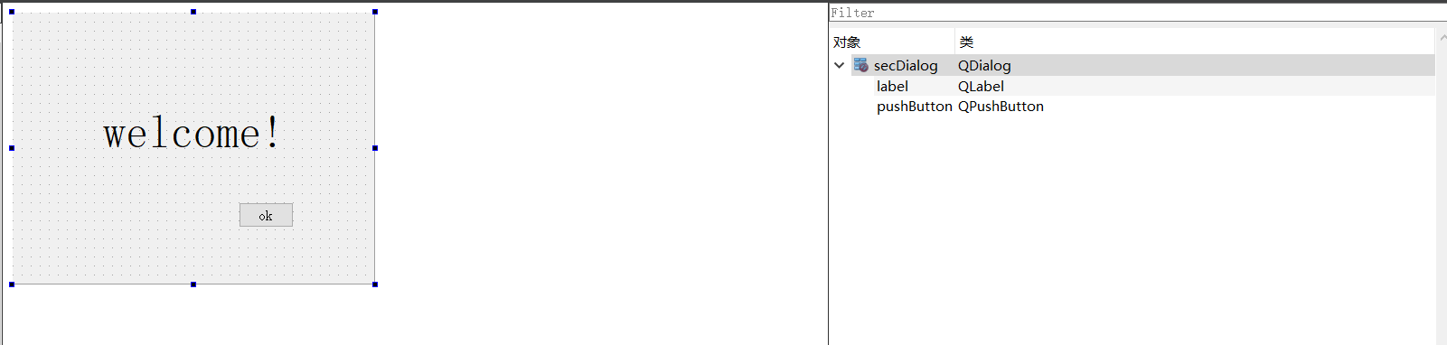

图二

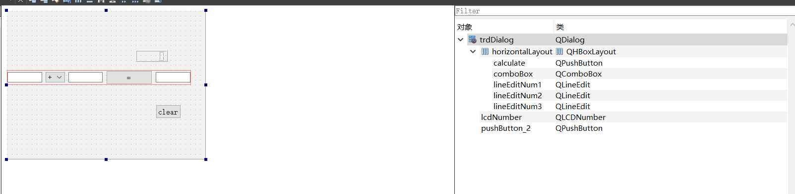

图三

1. 编写各个主窗口的代码

Mainwindow.cpp

#include "mainwindow.h"

#include "ui_mainwindow.h"

#include<QMessageBox>

#include<QPixelFormat>

MainWindow::**MainWindow**(QWidget *parent)

: QMainWindow(parent)

, ui(new Ui::MainWindow)

{

ui->setupUi(this);

// 图标路径

QPixmap pix("D:/qt peoject/demo/ aaa.png");

int w = ui->label_pic->width();

int h = ui->label_pic->height();

ui->label_pic->setPixmap(pix.scaled(w,h,Qt::KeepAspectRatio));

}

MainWindow::~***MainWindow***()

{

delete ui;

}

void MainWindow::**on_pushButton_clicked**()

{

QString username = ui->lineEditName->text();

QString password = ui->lineEditPWD->text();

// 验证用户名和密码是否正确

if(username =="renqinglong"&&password =="123456"){

QMessageBox::information(this,"Login","Username and password is correct");

secdialog = new secDialog(this);

secdialog->show();

}

else

QMessageBox::warning(this,"Login","Username or password is not correct");

}

Secdialog.cpp

#include "secdialog.h"

#include "ui_secdialog.h"

#include "mainwindow.h"

secDialog::**secDialog**(QWidget *parent) :

QDialog(parent),

ui(new Ui::secDialog)

{

ui->setupUi(this);

}

secDialog::~***secDialog***()

{

delete ui;

}

void secDialog::**on_pushButton_clicked**()

{

trddialog = new trdDialog;

trddialog->show();

}

Trddialog.cpp

#include "trddialog.h"

#include "ui_trddialog.h"

#include <QDebug>

#include <QMessageBox>

trdDialog::**trdDialog**(QWidget *parent) :

QDialog(parent),

ui(new Ui::trdDialog)

{

ui->setupUi(this);

ui->lcdNumber->setPalette(Qt::green);

qDebug("Initial has been setup.");

}

trdDialog::~***trdDialog***()

{

delete ui;

}

void trdDialog::**on_calculate_clicked**()

{

double num1 =ui->lineEditNum1->text().toDouble();

double num2 =ui->lineEditNum2->text().toDouble();

double num3;

int index = ui->comboBox->currentIndex();

if (index == 0)

{

num3 = num1+num2;

qDebug("add has done");

}

if (index == 1)

{

num3 = num1-num2;

}

if (index ==2)

{

num3 = num1*num2;

}

if (index ==3)

{

if (num2 == 0)

{

qDebug("num2 is 0");

QMessageBox::about(this,"注意","除数不能为零");

return;

}

else

{

num3 = num1/num2;

}

}

ui->lineEditNum3->setText(QString::number(num3));

ui->lcdNumber->display(num3);

}

void trdDialog::**on_pushButton_2_clicked**()

{

ui->lineEditNum1->clear();

ui->lineEditNum2->clear();

ui->lineEditNum3->clear();

}

1. 运行并调试程序

输入账号和密码

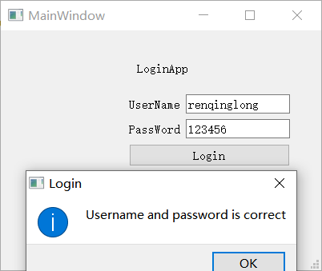

图四

点击OK

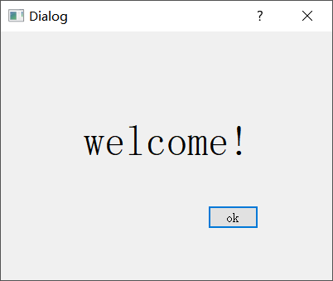

图五

进行计算

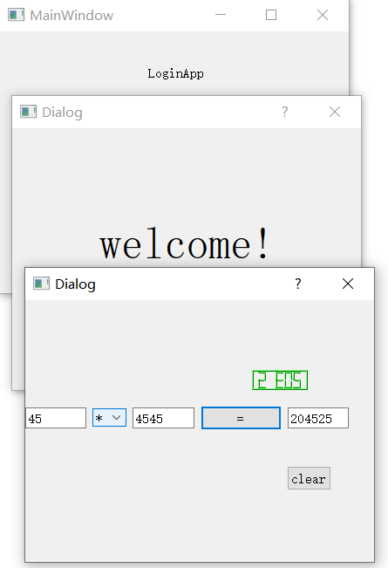

图六