作业5 将作业3与作业4结合

内容：利用QT设计师界面将作业3与作业4相结合

1.QT界面设置（主程序界面与计算器界面）

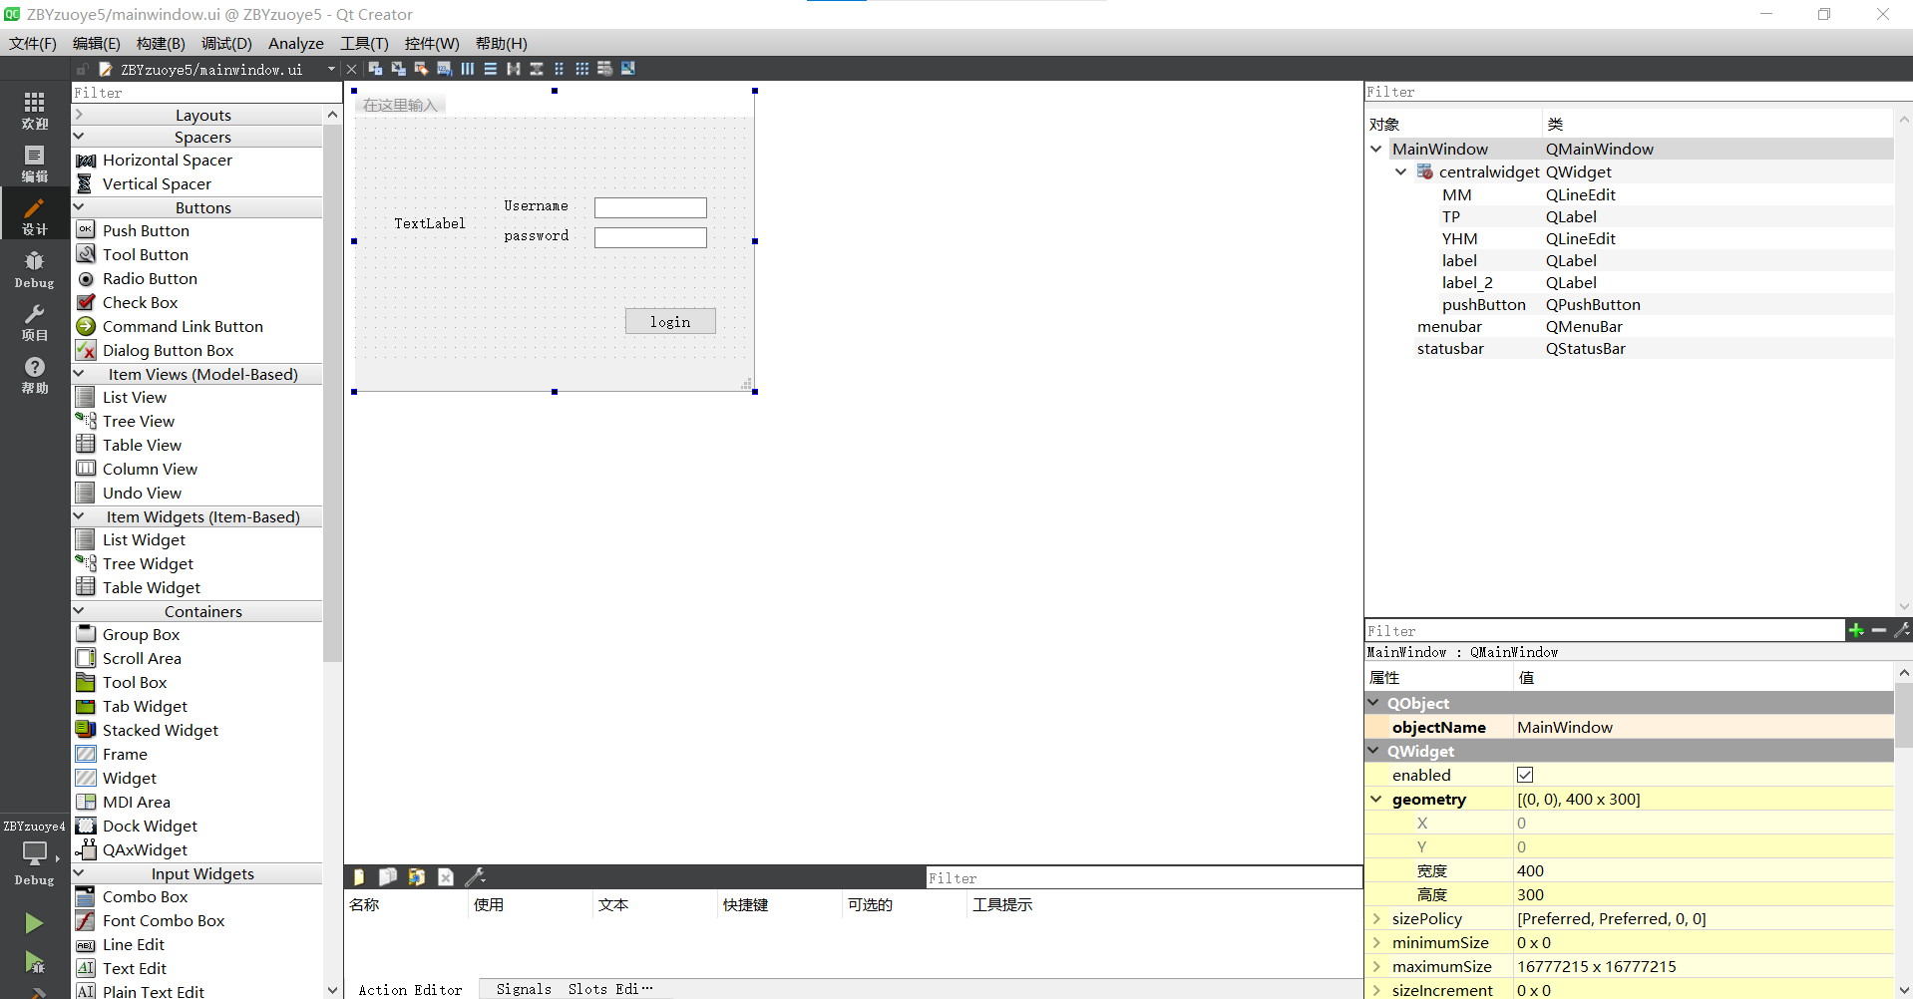

图1 主程序界面设置

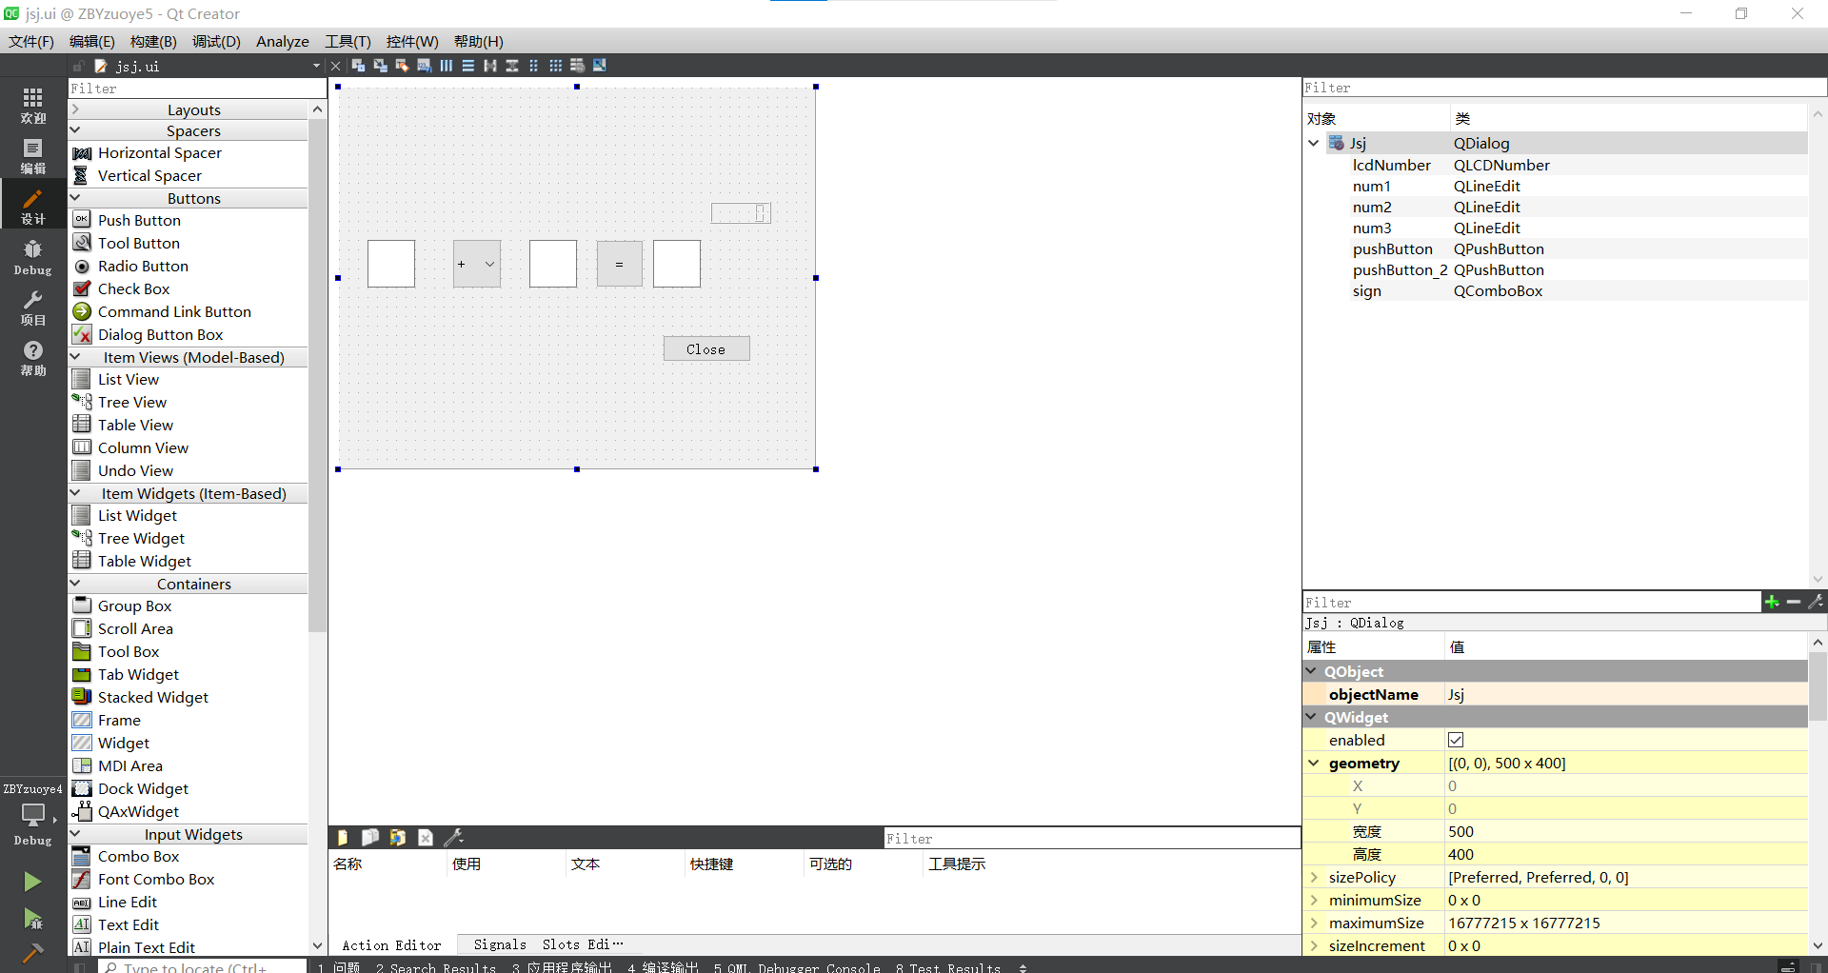

图2 计算器界面设置

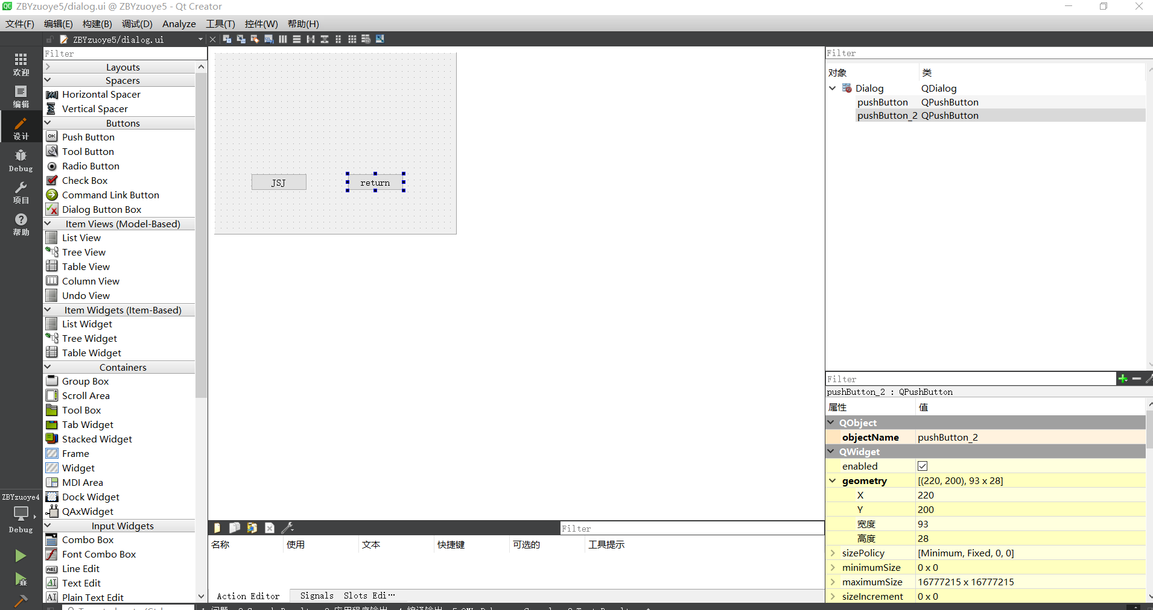

图3计算器跳转界面设置

1. 主程序程序代码

#include "mainwindow.h"

#include "ui_mainwindow.h"

#include "dialog.h"

#include "QDebug"

#include "QMessageBox"

#include "QPixmap"

MainWindow::**MainWindow**(QWidget *parent)

: QMainWindow(parent)

, ui(new Ui::MainWindow)

{

ui->setupUi(this);

ui->TP->setPixmap(QPixmap("E:/qtZY2/denglu.png"));

qDebug();

}

MainWindow::~***MainWindow***()

{

delete ui;

}

void MainWindow::**on_pushButton_clicked**()

{

QString Username = ui->YHM->text();

QString password = ui->MM->text();

if(Username== "Admin" && password== "123456"){

QMessageBox::information(this, "Login", "Username and password is correct");

Dialog secDeialog;

secDeialog.setModal(true);

secDeialog.*exec*();

}

else{

QMessageBox::warning(this,"Login", "Username and password is not correct");

}

}

1. 计算器跳转代码

#include "dialog.h"

#include "ui_dialog.h"

#include "Jsj.h"

Dialog::**Dialog**(QWidget *parent) :

QDialog(parent),

ui(new Ui::Dialog)

{

ui->setupUi(this);

}

Dialog::~***Dialog***()

{

delete ui;

}

void Dialog::**on_pushButton_clicked**()

{

Jsj secJsj;

secJsj.setModal(true);

secJsj.*exec*();

}

void Dialog::**on_pushButton_2_clicked**()

{

this->close();

}

1. 项目测试

