题目：对作业四的完善

1. 创建项目、

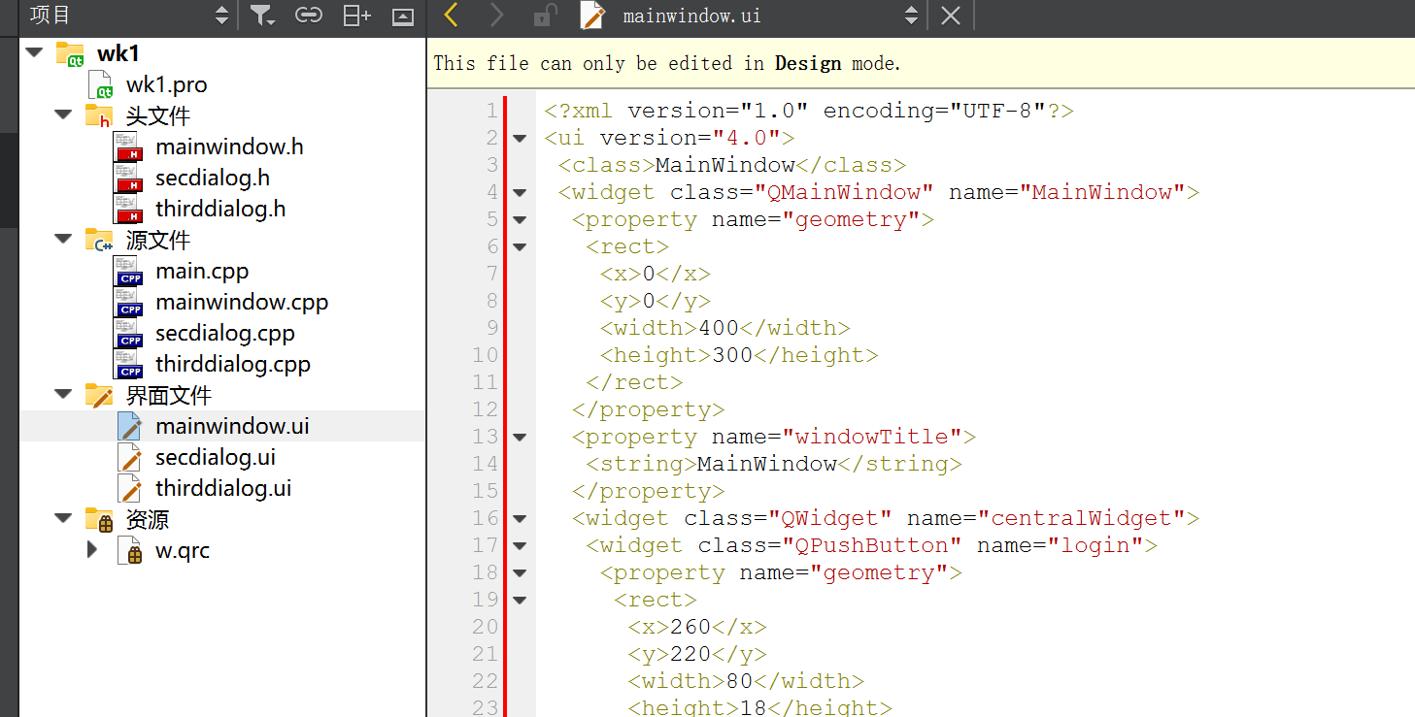

2．对.ui的设置

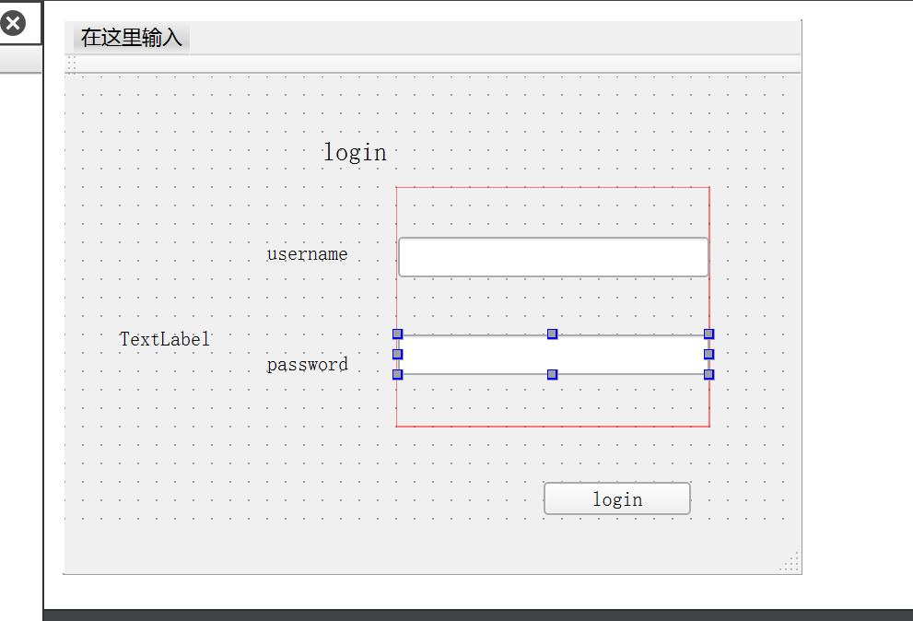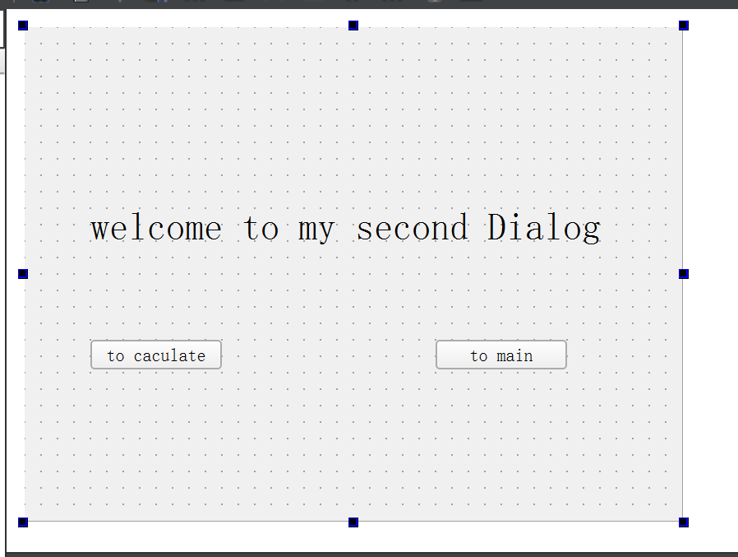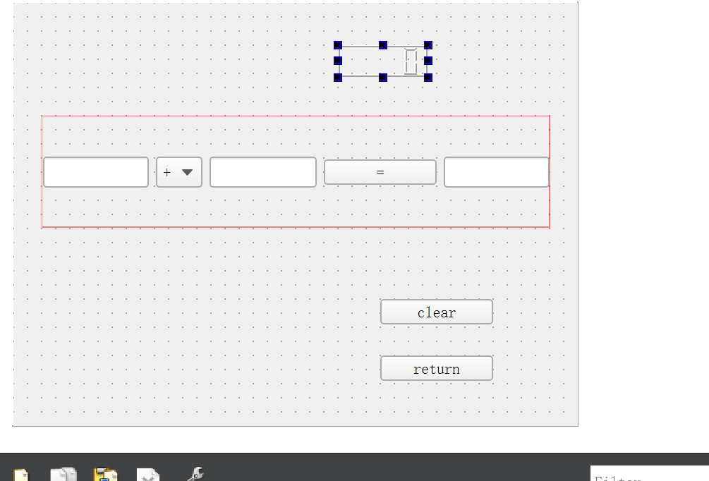

1. 编写代码
2. 1.在mainwindow.h

private slots:

void on_login_clicked();

在mainwindow.cpp中写槽函数

void MainWindow::on_login_clicked()

{

secDialog=new SecDialog(this);

if(ui->lineEdit->text()=="wangke"&&ui->lineEdit_2->text()=="123456")

{

QMessageBox::about(this,"warning ",tr("用户名或密码正确"));

secDialog->show();

}

else

{

QMessageBox::about(this,"warning ",tr("用户名或密码不正确"));

}

}

在lable_3添加图片

ui->label_3->setPixmap(QPixmap(":/image/dd.png"));

ui->label_3->show();

2.增加login按钮跳转secdialog

SecDialog *secDialog;

secDialog=new SecDialog(this);

(2)在secDialog.h中增加caculate 和main 两个按钮的事件

private slots:

void on_caculate_clicked();

void on_main_clicked();

private:

Ui::SecDialog *ui;

ThirdDialog *mythirdDialog;

void SecDialog::on_caculate_clicked()

{

mythirdDialog=new ThirdDialog(this);

mythirdDialog->show();

}

void SecDialog::on_main_clicked()

{

this->hide();

}

(3)在thirdDialog.h中增加按钮事件

private slots:

void on_caculate_a_clicked();

void on_clear_clicked();

void on_return_2_clicked();

void ThirdDialog::on_caculate_a_clicked()

{

double num1=ui->lineEdit->text().toDouble();

double num2=ui->lineEdit_2->text().toDouble();

uint8_t index=ui->comboBox->currentIndex();

double result=0.0;

switch (index) {

case 0:

result=num1+num2;

break;

case 1:

result=num1-num2;

break;

case 2:

result=num1*num2;

break;

case 3:

if(num2==0){

QMessageBox::about(this,"warning ","Divider is not zero.");

}else{

result=num1/num2;

}

break;

default:

break;

}

ui->lineEdit_3->setText(QString::number(result));

ui->lcdNumber->display(result);

}

void ThirdDialog::on_clear_clicked()

{

ui->lineEdit->clear();

ui->lineEdit_2->clear();

ui->lineEdit_3->clear();

ui->lcdNumber->display("");

}

void ThirdDialog::on_return_2_clicked()

{

this->hide();

}

3.运行结果

3.