解答：

1. 创建项目工程文件及第二第三个ui界面

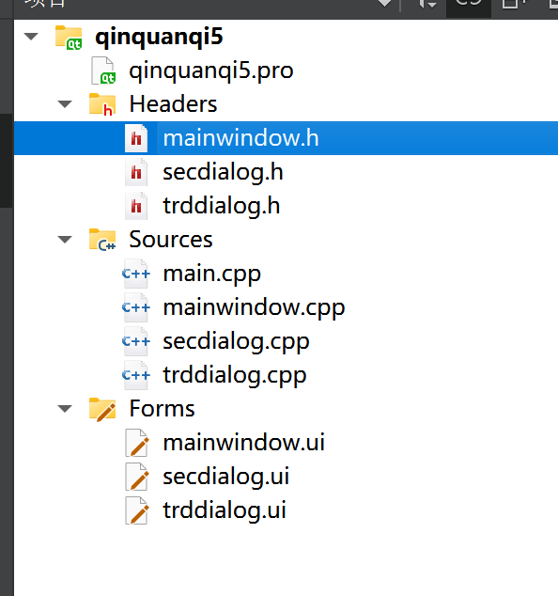

图1 项目文件列表

1. 对ui界面进行控件布局

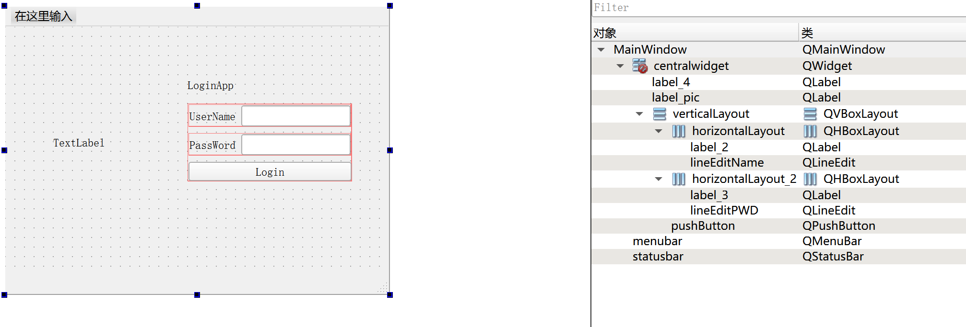

图2 mainwindow界面ui布局

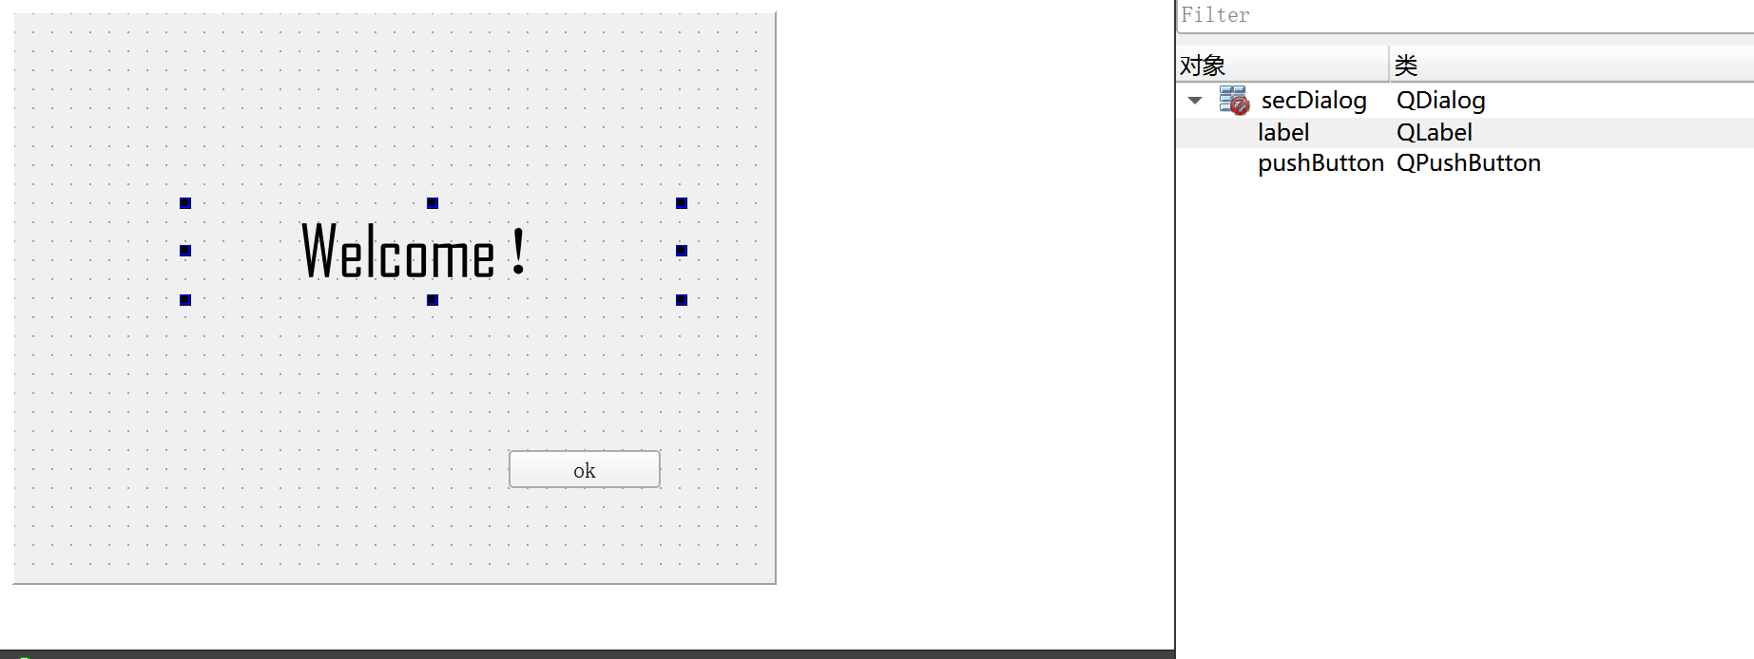

图3 secdialog界面ui布局

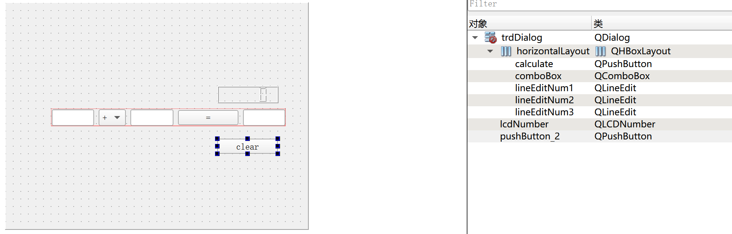

图4 trd界面ui布局

1. 添加include并添加mainwindow.h与secdialog.h头文件代码

private:

Ui::MainWindow *ui;

secDialog *secdialog;

private:

Ui::secDialog *ui;

trdDialog *trddialog;

1. 编写mainwindow代码

#include "mainwindow.h"

#include "ui_mainwindow.h"

#include <QMessageBox>

#include <QPixelFormat>

MainWindow::MainWindow(QWidget *parent)

: QMainWindow(parent)

, ui(new Ui::MainWindow)

{

ui->setupUi(this);

//图标路径

QPixmap pix("E:/qt homework/icon.png");

int w = ui->label_pic->width();

int h = ui->label_pic->height();

ui->label_pic->setPixmap(pix.scaled(w,h,Qt::KeepAspectRatio));

}

MainWindow::~MainWindow()

{

delete ui;

}

void MainWindow::on_pushButton_clicked()

{

QString username = ui->lineEditName->text();

QString password = ui->lineEditPWD->text();

//验证用户名和密码是否正确

if(username == "qinquanqi"&&password == "123456"){

QMessageBox::information(this,"Login","Username and password is correct");

secdialog = new secDialog(this);

secdialog->show();

}

else{

QMessageBox::warning(this,"Login","Username or password is not correct");

}

}

1. 编写secdialog代码

#include "secdialog.h"

#include "ui_secdialog.h"

#include "mainwindow.h"

secDialog::secDialog(QWidget *parent) :

QDialog(parent),

ui(new Ui::secDialog)

{

ui->setupUi(this);

}

secDialog::~secDialog()

{

delete ui;

}

void secDialog::on_pushButton_clicked()

{

trddialog = new trdDialog;

trddialog->show();

}

1. 编写trddialog代码

#include "trddialog.h"

#include "ui_trddialog.h"

#include <QDebug>

#include <QMessageBox>

trdDialog::trdDialog(QWidget *parent) :

QDialog(parent),

ui(new Ui::trdDialog)

{

ui->setupUi(this);

ui->lcdNumber->setPalette(Qt::green);

qDebug("Initial has been setup.");

}

trdDialog::~trdDialog()

{

delete ui;

}

void trdDialog::on_calculate_clicked()

{

double num1 =ui->lineEditNum1->text().toDouble();

double num2 =ui->lineEditNum2->text().toDouble();

double num3;

int index = ui->comboBox->currentIndex();

if (index == 0)

{

num3 = num1+num2;

qDebug("add has done");

}

if (index == 1)

{

num3 = num1-num2;

}

if (index == 2)

{

num3 = num1*num2;

}

if (index == 3)

{

if (num2 == 0)

{

qDebug("num2 is 0");

QMessageBox::about(this,"注意","除数不能为零");

return;

}

else

{

num3 = num1/num2;

}

}

ui->lineEditNum3->setText(QString::number(num3));

ui->lcdNumber->display(num3);

}

void trdDialog::on_pushButton_2_clicked()

{

ui->lineEditNum1->clear();

ui->lineEditNum2->clear();

ui->lineEditNum3->clear();

}

1. 项目运行测试

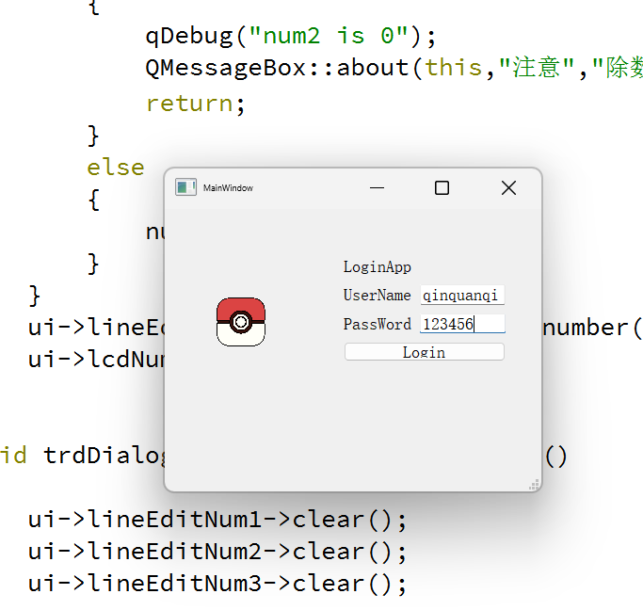

图5 登陆界面

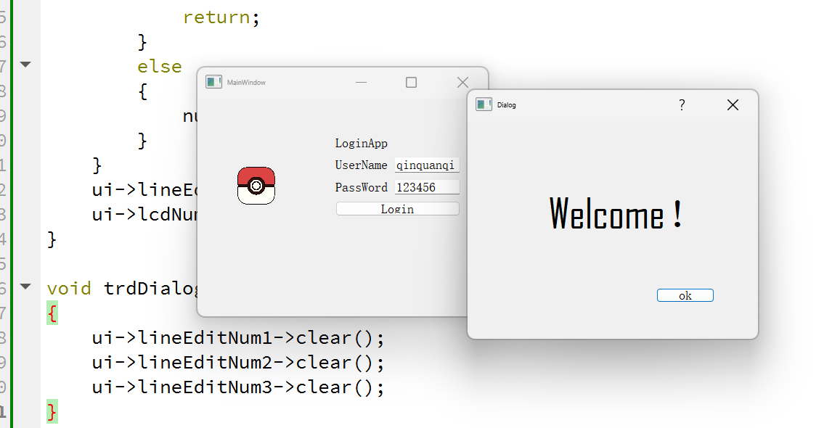

图6 欢迎界面

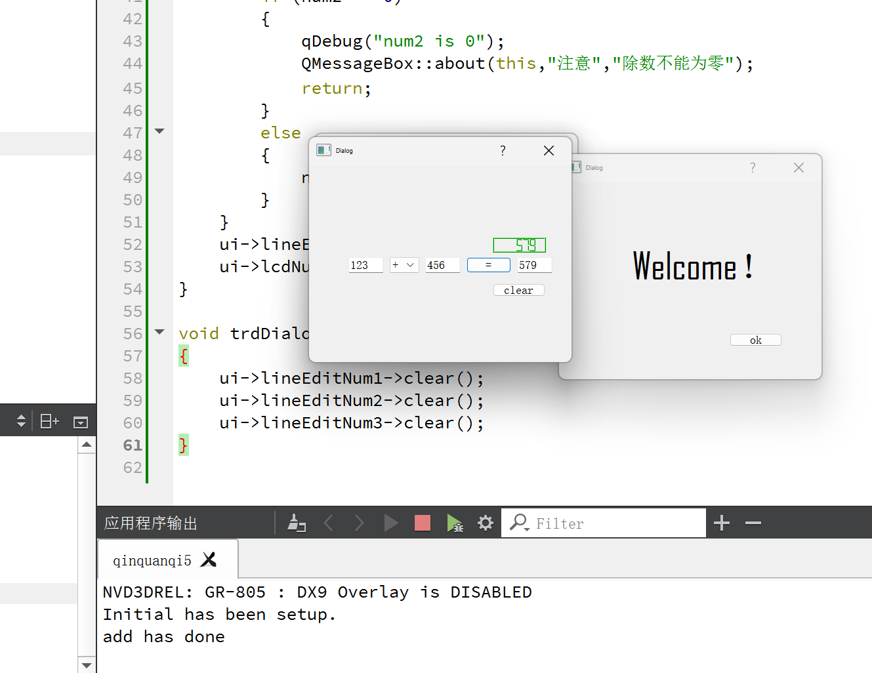

图7 计算器运行

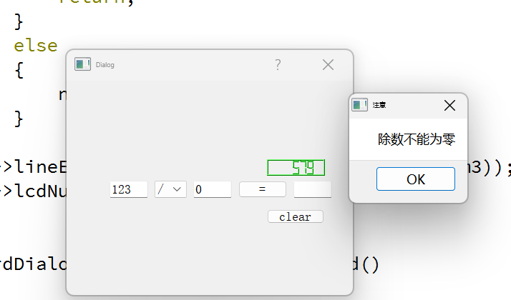

图8 除数为0时报错