**解答：**

**1.创建项目，创建用户登录界面**

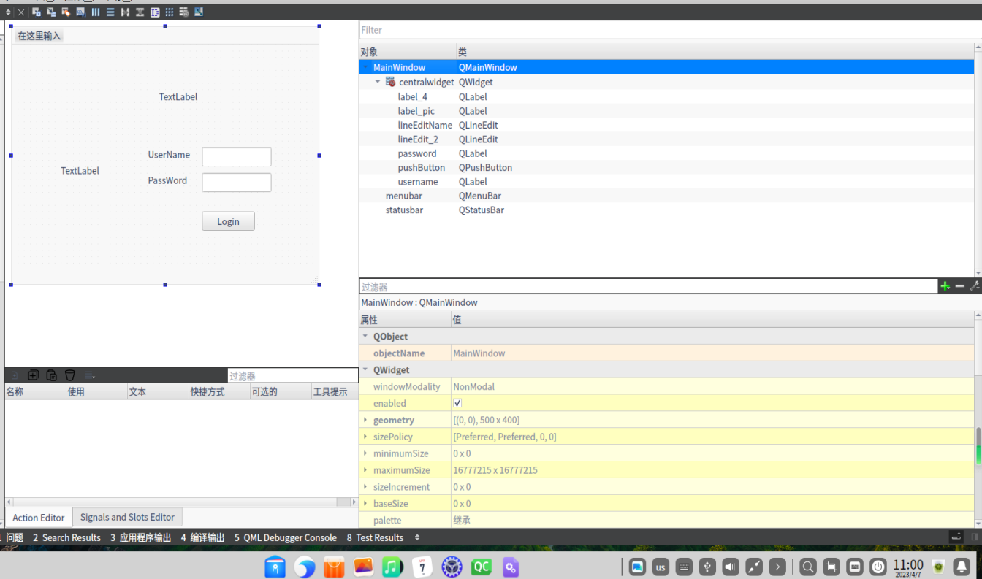

**2.制作欢迎界面**

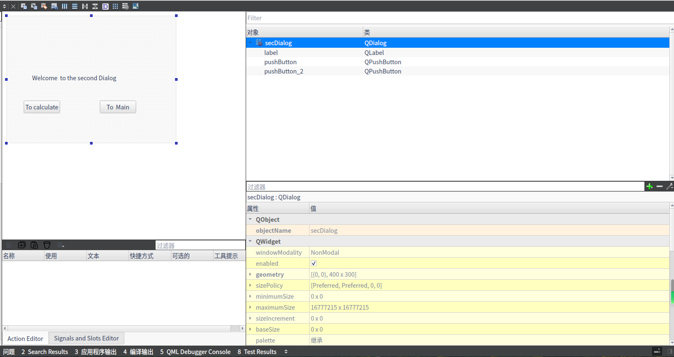

**3.制作计算机界面**

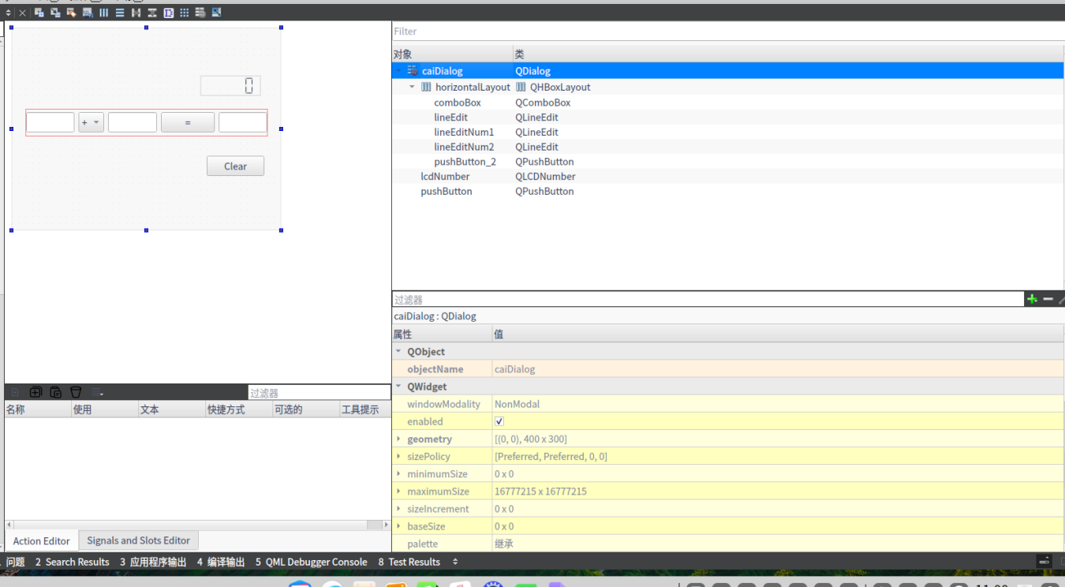

**4.登录页面相关代码**

MainWindow::MainWindow(QWidget *parent)

: QMainWindow(parent)

, ui(new Ui::MainWindow)

{

ui->setupUi(this);

QPixmap logpic(":/new/prefix1/img/2.png");

int w = ui->label_pic->width();

int h = ui->label_pic->height();

ui->label_pic->setPixmap(logpic.scaled(w,h,Qt::KeepAspectRatio));

}

MainWindow::~MainWindow()

{

delete ui;

}

void MainWindow::on_pushButton_clicked()

{

QString username=ui->lineEditName->text();

QString password=ui->lineEdit_2->text();

if(username=="Admin"&&password=="123456"){

secDialog secDialog;

secDialog.setModal(true);

secDialog.exec();

}

else{

QMessageBox::warning(this,"Login","Username and password is correct");

}

}

**5.从欢迎界面转到计算机**

#include "secdialog.h"

#include "ui_secdialog.h"

#include"caidialog.h"

secDialog::secDialog(QWidget *parent) :

QDialog(parent),

ui(new Ui::secDialog)

{

ui->setupUi(this);

}

secDialog::~secDialog()

{

delete ui;

}

void secDialog::on_pushButton_clicked()

{

caiDialog caiDialog;

caiDialog.setModal(true);

caiDialog.exec();

}

void secDialog::on_pushButton_2_clicked()

{

hide();

}

**6.设计计算机中的代码**

#include "caidialog.h"

#include "ui_caidialog.h"

#include <QDebug>

#include <QMessageBox>

caiDialog::caiDialog(QWidget *parent) :

QDialog(parent),

ui(new Ui::caiDialog)

{

ui->setupUi(this);

ui->lcdNumber->setPalette(Qt::green);

}

caiDialog::~caiDialog()

{

delete ui;

}

void caiDialog::on_pushButton_clicked()

{

ui->lineEditNum1->clear();

ui->lineEditNum2->clear();

ui->lineEdit->clear();

ui->lcdNumber->display(0);

}

void caiDialog::on_pushButton_2_clicked()

{

double num1 = ui->lineEditNum1->text().toDouble();

double num2 = ui->lineEditNum2->text().toDouble();

uint8_t index= ui->comboBox->currentIndex();

double result = 0.0;

switch (index) {

case 0:

result = num1 + num2;

break;

case 1:

result = num1 - num2;

break;

case 2:

result = num1 * num2;

break;

case 3:

if(num2 == 0)

{

qDebug("num2 is 0");

QMessageBox::about(this,"注意","除数不能为0");

return;

}

result = num1 / num2;

break;

default:

break;

}

ui->lineEdit->setText(QString::number(result));

ui->lcdNumber->display(result);

}

**6.结果展示**



