1. 新建Qt工程文件

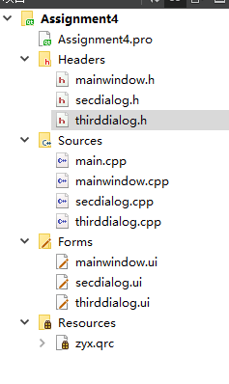

图1 Qt工程文件框架图

2. 在作业四的基础上添加ThirdDialog页面并设置相应参数

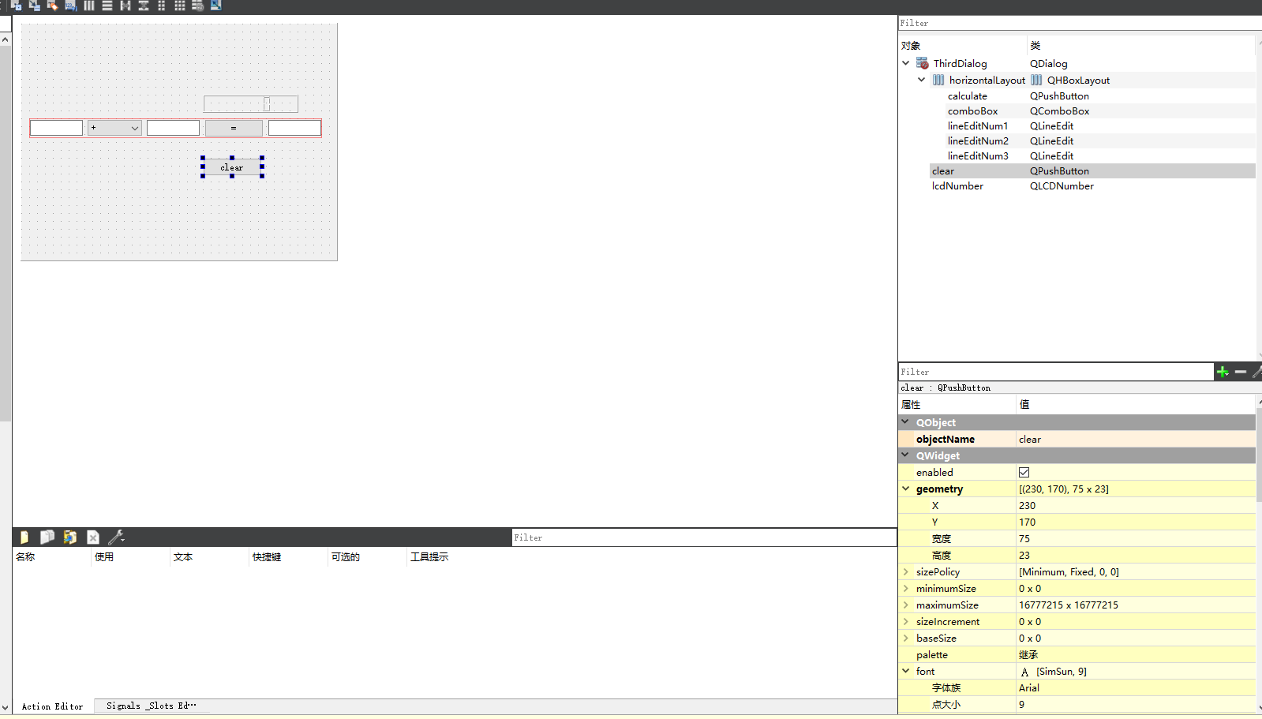

图2 ThirdDialog几何参数设置

3. 添加SecDialog.ui pushbutton的槽函数

void SecDialog::**on_pushButton_clicked**()

{

thirdDialog = new ThirdDialog(this);

thirdDialog->show();

}

4. 添加ThirdDialog计算机对象的槽代码。

void ThirdDialog::**on_calculate_clicked**()

{

double num1 = ui->lineEditNum1->text().toDouble();

double num2 = ui->lineEditNum2->text().toDouble();

double num3;

int index = ui->comboBox->currentIndex();

if(index == 0)

{

num3 = num1+num2;

}

if(index == 1)

{

num3 = num1-num2;

}

if(index == 2)

{

num3 = num1*num2;

}

if(index == 3)

{

if(num2 == 0)

{

qDebug("num2 is 0");

QMessageBox::about(this,"注意","除数不能为0");

return;

}else{

num3 = num1/num2;

}

}

ui->lineEditNum3->setText(QString::number(num3));

ui->lcdNumber->display(num3);

}