答：

#include<QMessageBox>

#include<QPixmap>

#include"dialog.h"

MainWindow::MainWindow(QWidget *parent)

: QMainWindow(parent)

, ui(new Ui::MainWindow)

{

ui->setupUi(this);

QPixmap pix(":/img/img/1.jpg");

int w=ui->label_3->width();

int h=ui->label_3->height();

ui->label_3->setPixmap(pix.scaled(w,h,Qt::KeepAspectRatio));

}

MainWindow::~MainWindow()

{

delete ui;

}

void MainWindow::on_pushButton_clicked()

{

QString username=ui->lineEditName->text();

QString password=ui->lineEditPWD->text();

if(username=="Admin"&&password=="123456"){

secDialog secdialog;

secdialog.setModal(true);

secdialog.exec();

}

else{

QMessageBox::warning(this,"Login","Username and password is correct");

}

}

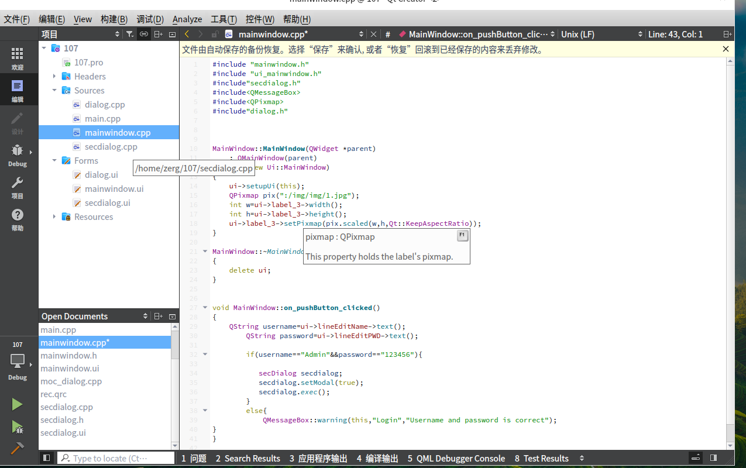

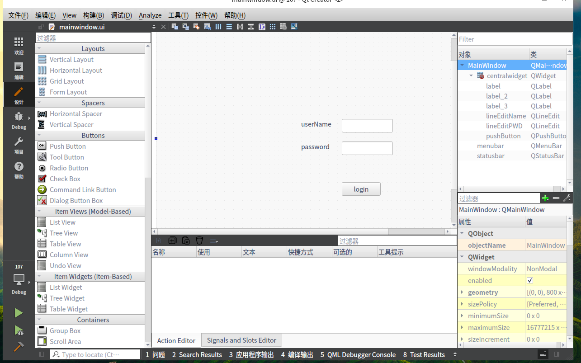

#include "dialog.h"

#include "ui_dialog.h"

#include<QMessageBox>

#include<QDebug>

Dialog::Dialog(QWidget *parent) :

QDialog(parent),

ui(new Ui::Dialog)

{

ui->setupUi(this);

ui->lcdNumber->setPalette(Qt::green);

}

Dialog::~Dialog()

{

delete ui;

}

void Dialog::on_Calculate_clicked()

{

double num1 = ui->lineEdit->text().toDouble();

double num2 = ui->lineEdit_2->text().toDouble();

uint8_t index= ui->comboBox->currentIndex();

double result = 0.0;

switch (index) {

case 0:

result = num1 + num2;

break;

case 1:

result = num1 - num2;

break;

case 2:

result = num1 * num2;

break;

case 3:

if(num2 == 0)

{

qDebug("num2 is 0");

QMessageBox::about(this,"注意","除数不能为0");

return;

}

result = num1 / num2;

break;

default:

break;

}

ui->lineEdit_3->setText(QString::number(result));

ui->lcdNumber->display(result);

}

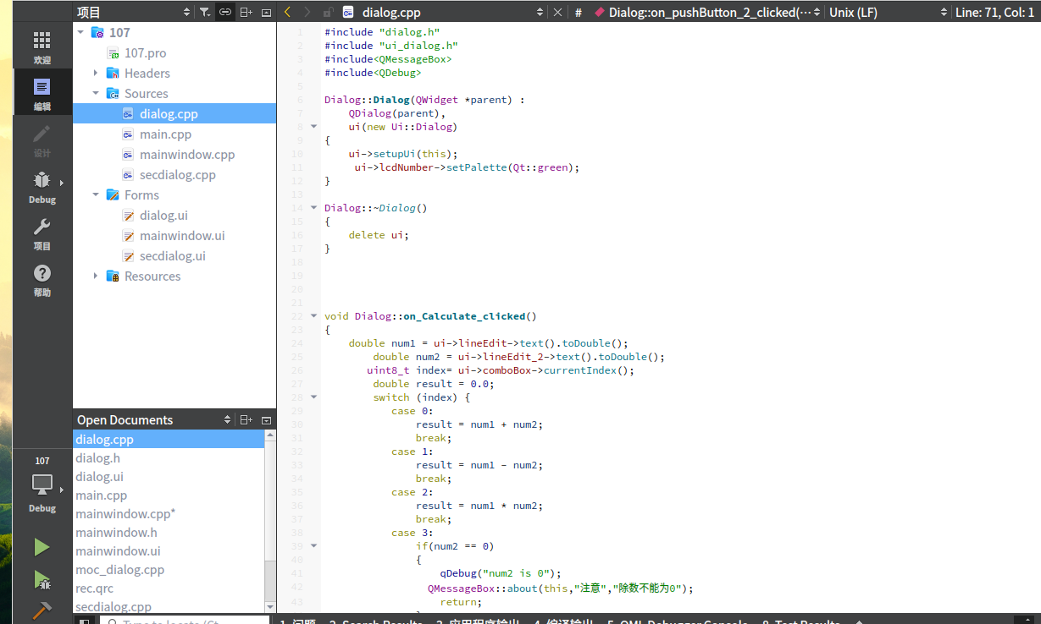

void Dialog::on_pushButton_clicked()

{

ui->lineEdit->clear();

ui->lineEdit_2->clear();

ui->lineEdit_3->clear();

ui->lcdNumber->display(0);

}

void Dialog::on_pushButton_2_clicked()

{

close();

}

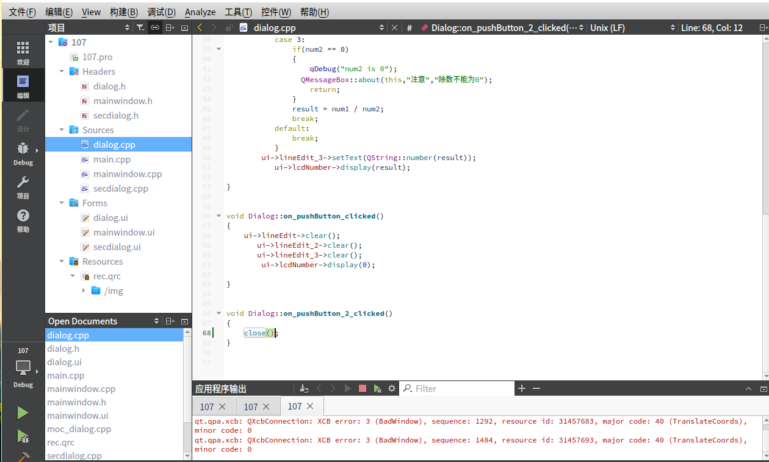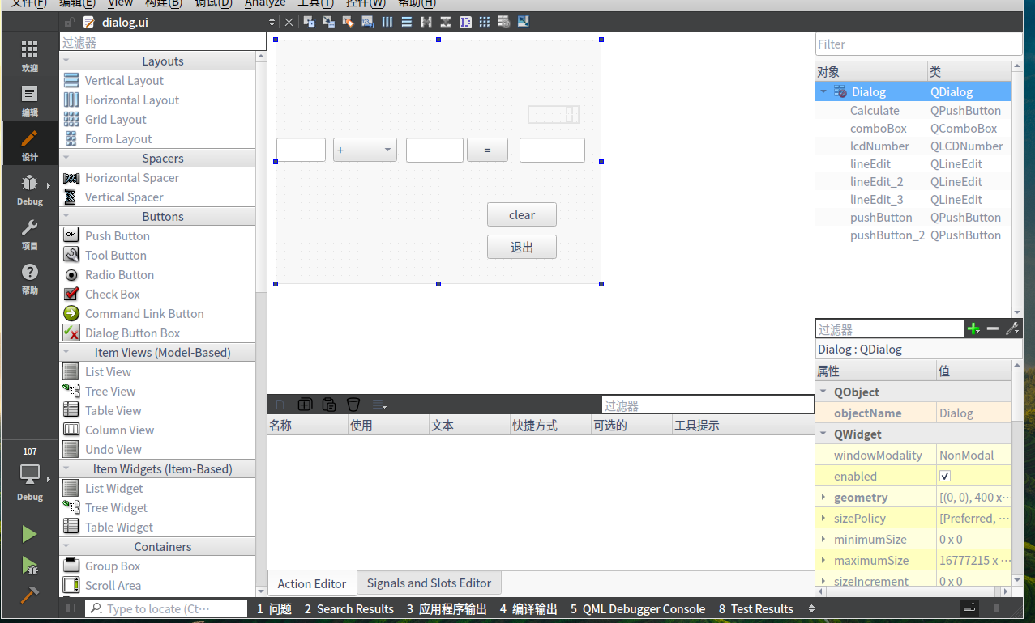

#include "secdialog.h"

#include "ui_secdialog.h"

#include"dialog.h"

secDialog::secDialog(QWidget *parent) :

QDialog(parent),

ui(new Ui::secDialog)

{

ui->setupUi(this);

}

secDialog::~secDialog()

{

delete ui;

}

void secDialog::on_pushButton_clicked()

{

Dialog dialog;

dialog.setModal(true);

dialog.exec();

}

void secDialog::on_pushButton_2_clicked()

{

hide();

}