1.新建qt项目工程文件

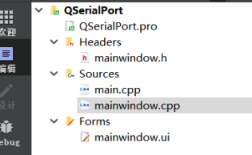

图1 项目工程文件

1. ui界面布局

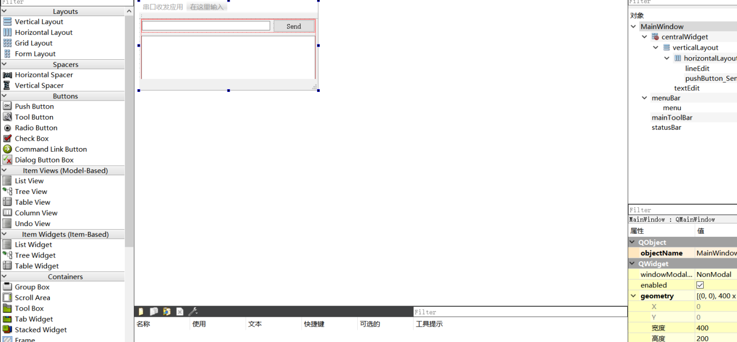

图2 ui界面

1. 编写主函数代码

#include "mainwindow.h"

#include "ui_mainwindow.h"

MainWindow::**MainWindow**(QWidget *parent) :

QMainWindow(parent),

ui(new Ui::MainWindow)

{

ui->setupUi(this);

COMPORT = new QSerialPort();

COMPORT->setPortName("COM2");

COMPORT->setBaudRate(QSerialPort::Baud9600);

COMPORT->setParity(QSerialPort::Parity::NoParity);

COMPORT->setDataBits(QSerialPort::DataBits::Data8);

COMPORT->setStopBits(QSerialPort::StopBits::OneStop);

COMPORT->setFlowControl(QSerialPort::FlowControl::NoFlowControl);

COMPORT->*open*(QIODevice::ReadWrite);

1. 插入槽函数代码

if(COMPORT->isOpen())

{

qDebug()<<"Serial Port is Connected.";

qDebug()<<COMPORT->error();

}

else

{

qDebug()<<"Serial Port is Not Connected.";

qDebug()<<COMPORT->error();

}

connect(COMPORT,SIGNAL(readyRead()),this,SLOT(Read_Serial()));

}

MainWindow::~***MainWindow***()

{

delete ui;

}

void MainWindow::**on_pushButton_Send_Data_clicked**()

{

if(COMPORT->isOpen())

{

COMPORT->write(ui->lineEdit_Send_Data->text().toLatin1()+char(10));

COMPORT->flush();

qDebug()<<"Write Serial";

}

}

void MainWindow::**Read_Serial**()

{

if(COMPORT->isOpen())

{

while(COMPORT->*bytesAvailable*())

{

Data_From_SerialPort += COMPORT->readAll();

}

if(Data_From_SerialPort.at(Data_From_SerialPort.length()-1)==char(10))

{

IS_Data_Received = true;

}

if(IS_Data_Received == true)

{

qDebug()<<"Data From Serial Port: "<<Data_From_SerialPort;

ui->textEdit->append(Data_From_SerialPort);

Data_From_SerialPort = "";

IS_Data_Received = false;

}

}

}

1. 项目运行测试

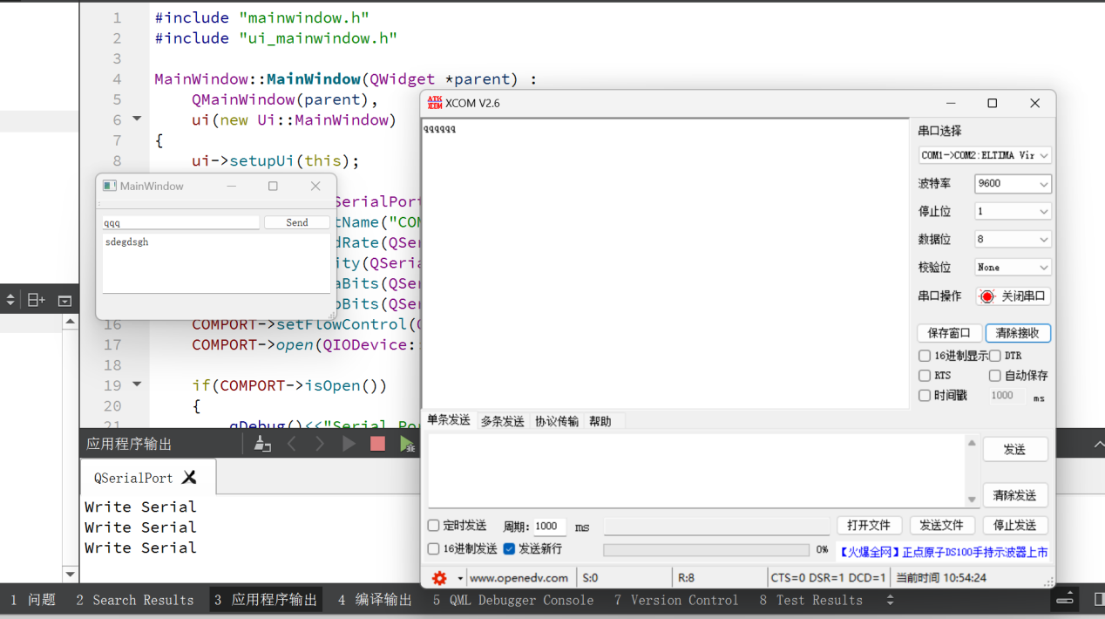

图3 项目运行结果