作业7

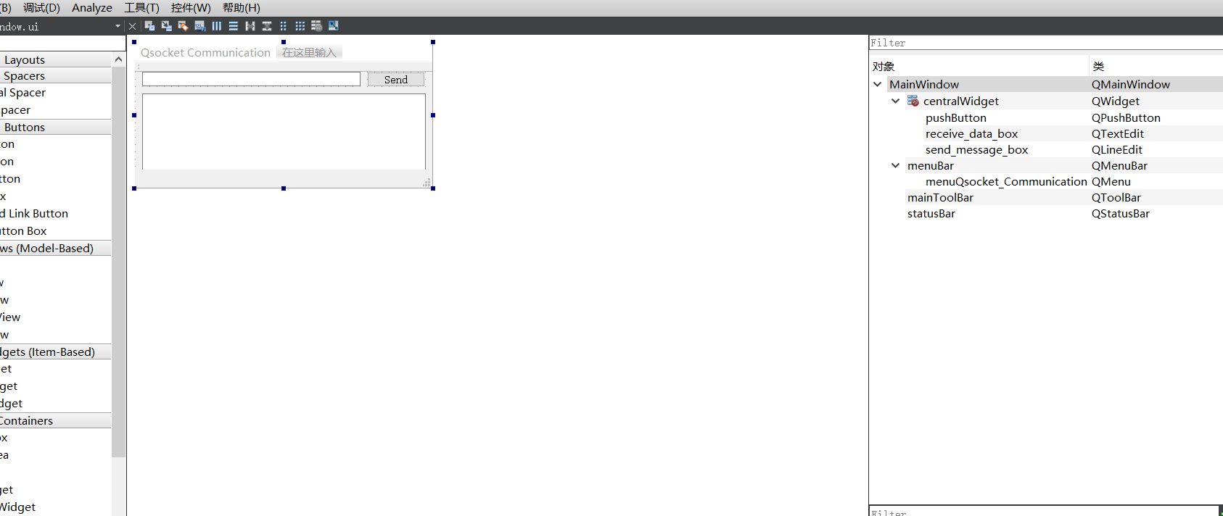

相关代码

**on_pushButton_clicked**()函数

if(TCPSocket)

{

if(TCPSocket->isOpen())

{

QString WriteData = ui->send_message_box->text().append(char(10));

TCPSocket->write(WriteData.toStdString().c_str());

}

else

{

QMessageBox::information(this,"Qt With Mr Ping","Error:"+TCPSocket->errorString());

}

}

else

{

QMessageBox::information(this,"Qt With Mr Ping","Error:"+TCPSocket->errorString());

}

图1 界面布局图



图2 功能实现演示图