1.新建项目：

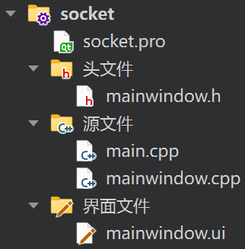

图1 项目框架

2.设置mainwindow.ui中的MainWindow的分辨率：

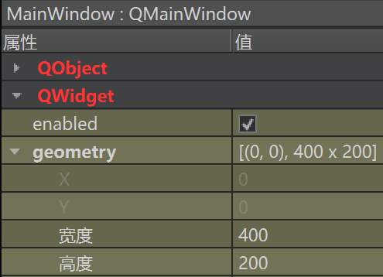

图2 MainWindow分辨率设置

3. 标注应用名称，添加LineEdit，PushButton，TextEdit，输入文字：

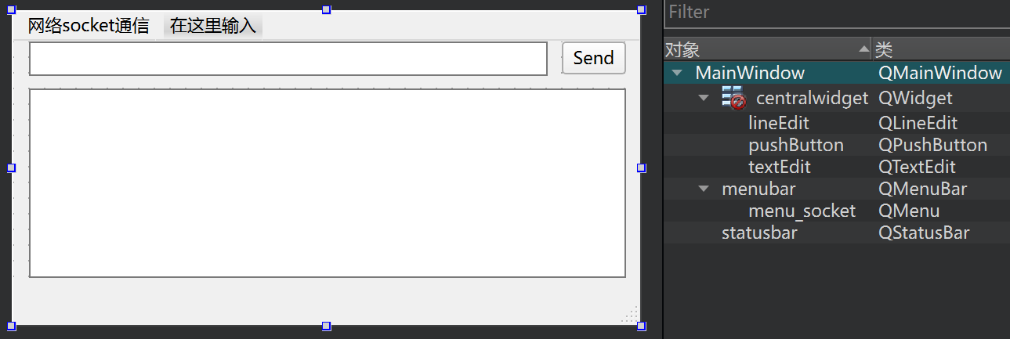

图3 添加控件

4.在socket.pro中添加代码：

QT+=network

5.在mainwindow.h中添加代码：

#include <QByteArray>//字节阵列

#include <QDebug>

#include <QHostAddress>

#include <QMainWindow>

#include <QMessageBox>

#include <QString>

#include <QtNetwork/QTcpSocket>

private slots:

void on_pushButton_clicked();

void Read_Data();

private:

QTcpSocket *TCPSocket;

6.在mainwindow.cpp中添加代码：

//初始化串口属性

TCPSocket=new QTcpSocket();//实例化

TCPSocket->connectToHost(QHostAddress::LocalHost,8080);//连接到主机

connect(TCPSocket,SIGNAL(readyRead()),this,SLOT(Read_Data()));

TCPSocket->open(QIODevice::ReadWrite);

if(TCPSocket->isOpen())

{

QMessageBox::information(this,"Qt with Mr Ping","Connected To The Server");

}else{

QMessageBox::information(this,"Qt with Mr Ping","Not Connected To The Server");

}

//点击按钮发送信息

void MainWindow::on_pushButton_clicked()

{

if(TCPSocket)//判断是否正常打开

{

if(TCPSocket->isOpen())

{

QString WriteData=ui->lineEdit->text().append(char(10));

TCPSocket->write(WriteData.toLocal8Bit(),WriteData.toLocal8Bit ().length());//包容中文信息

}else{

QMessageBox::information(this,"Qt with Mr Ping","Not Connected To The Server");

}

}

}

//接收信息

void MainWindow::Read_Data()

{

if(TCPSocket)

{

if(TCPSocket->isOpen())

{

while (TCPSocket->bytesAvailable())

{

QByteArray Read_Data=TCPSocket->readAll();

QString Message=QString::fromStdString(Read_Data.toStdString());

ui->textEdit->append(Message.toLocal8Bit ());

}

}

}

}

7.运行项目：

构建项目成功，运行项目，收发信息正常。



图4 Qt Creator