1.新建项目工程文件

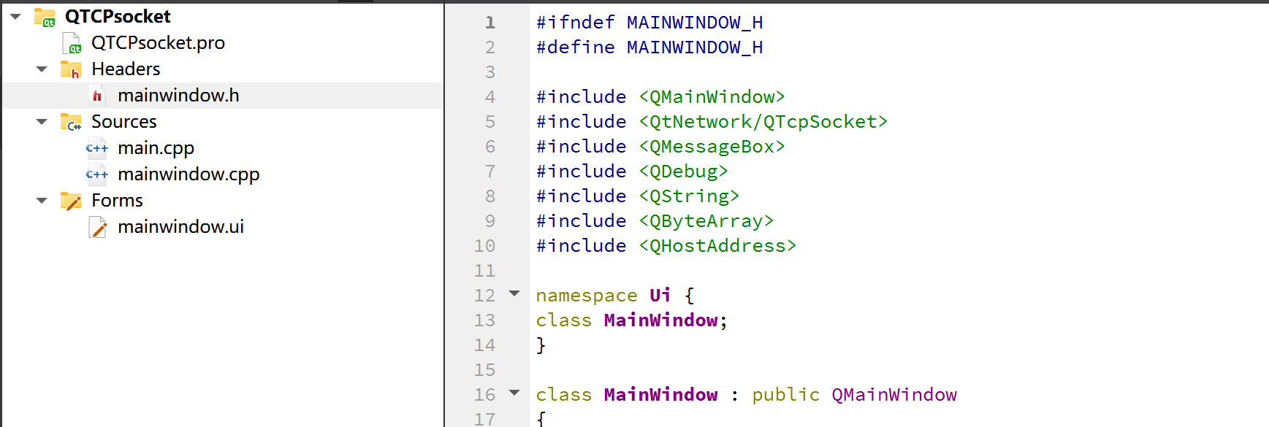

图1.项目工程文件

1. 进行ui界面布局

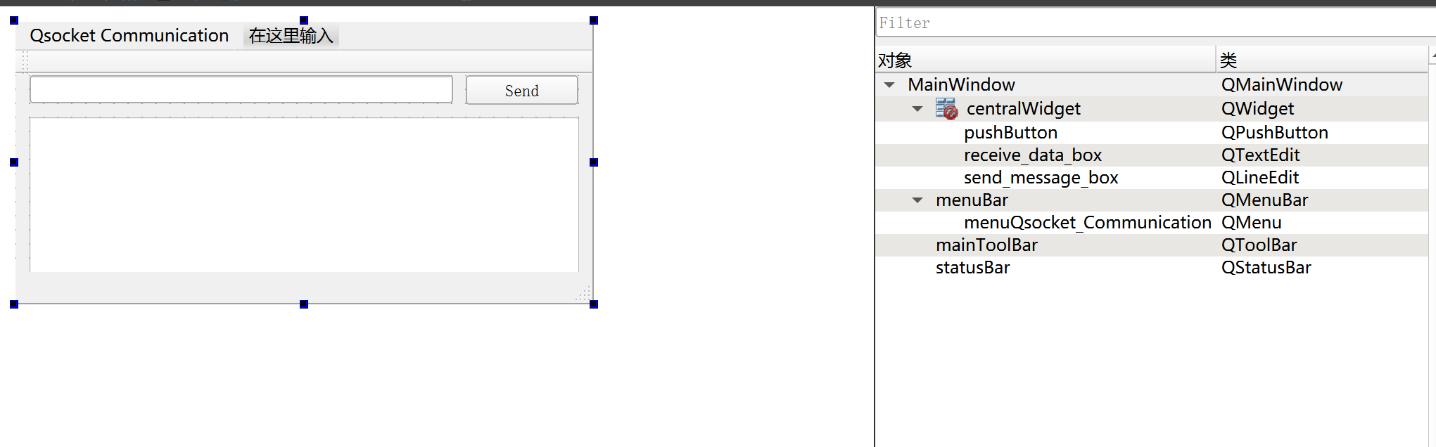

图2 ui界面布局

1. 代码编写

#include "mainwindow.h"

#include "ui_mainwindow.h"

MainWindow::**MainWindow**(QWidget *parent) :

QMainWindow(parent),

ui(new Ui::MainWindow)

{

ui->setupUi(this);

TCPSocket = new QTcpSocket();

TCPSocket->*connectToHost*("127.0.0.1",8080);

//TCPSocket->connectToHost(QHostAddress::LocalHost,8080);

TCPSocket->*open*(QIODevice::ReadWrite);

if(TCPSocket->isOpen())

{

QMessageBox::information(this,"Qt With Mr Ping","Connected To The Server.");

}

else

{

QMessageBox::information(this,"Qt With Mr Ping","Not Connected To The Server.");

}

}

MainWindow::~***MainWindow***()

{

delete ui;

}

1. 槽函数代码

void MainWindow::**on_pushButton_clicked**()

{

if(TCPSocket)

{

if(TCPSocket->isOpen())

{

QString WriteData = ui->send_message_box->text().append(char(10));

TCPSocket->write(WriteData.toStdString().c_str());

}

else

{

QMessageBox::information(this,"Qt With Mr Ping","Error:"+TCPSocket->errorString());

}

}

else

{

QMessageBox::information(this,"Qt With Mr Ping","Error:"+TCPSocket->errorString());

}

}

1. 项目运行测试

、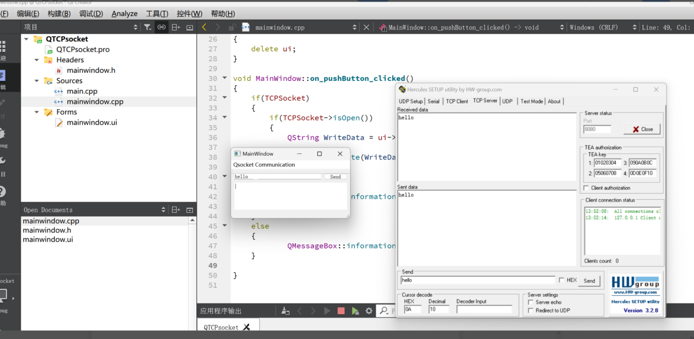

图3 项目运行测试结果