作业 7 网络Socket通信

提交方式：姓名_学号_作业7，如：平毅_2009060707_作业7.doc

解答：

1. 新建Qt工程文件

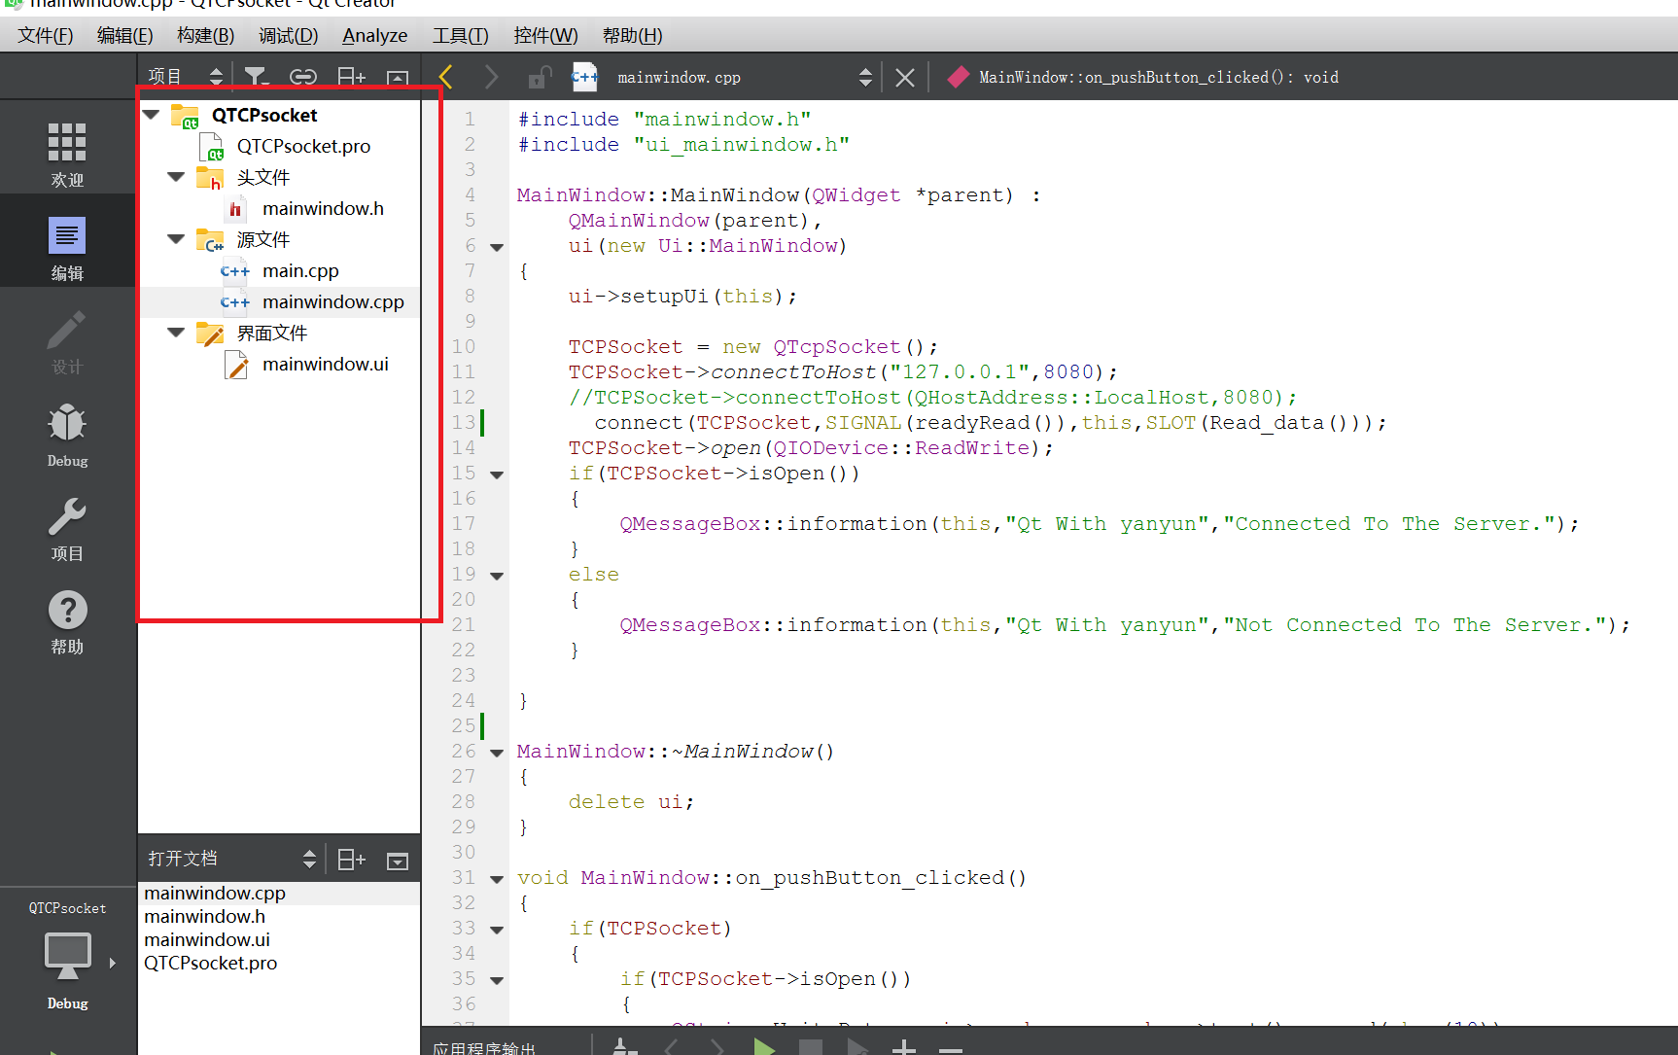

图1 Qt工程文件框架图

1. 在mainwindow界面中添加LineEdit、textEdit和PushButton控件，并分别增加文字，修改（重命名）对象的名称

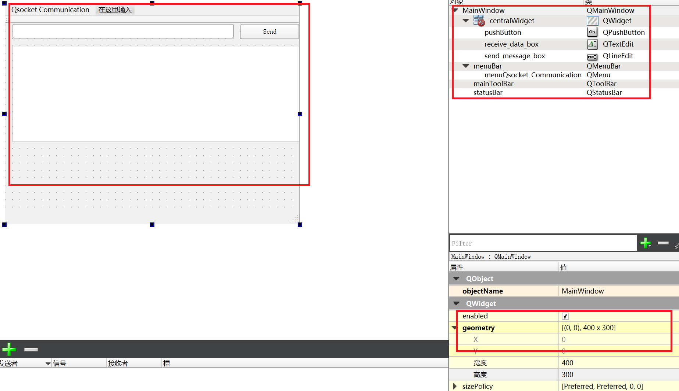

图2 添加控件并修改文字

1. mainwindow:

TCPSocket = new QTcpSocket();

TCPSocket->*connectToHost*("127.0.0.1",8080);

//TCPSocket->connectToHost(QHostAddress::LocalHost,8080);

connect(TCPSocket,SIGNAL(readyRead()),this,SLOT(Read_data()));//连接

TCPSocket->*open*(QIODevice::ReadWrite);

if(TCPSocket->isOpen())

{

QMessageBox::information(this,"Qt With yanyun","Connected To The Server.");

}

else

{

QMessageBox::information(this,"Qt With yanyun","Not Connected To The Server.");

}

转槽函数并判断网口的状态并给出相应的反应

void MainWindow::on_pushButton_clicked()

{

if(TCPSocket)

{

if(TCPSocket->isOpen())

{

QString WriteData = ui->send_message_box->text().append(char(10));

TCPSocket->write(WriteData.toStdString().c_str());

}

else

{

QMessageBox::information(this,"Qt With miss yan","Error:"+TCPSocket->errorString());

}

}

else

{

QMessageBox::information(this,"Qt With Miss yan","Error:"+TCPSocket->errorString());

}

函数可读操作

void MainWindow::Read_data(){

if(TCPSocket)

{

if(TCPSocket->isOpen())

{

QByteArray a=TCPSocket->readAll();

QString Message=QString::fromLocal8Bit(a);

ui->receive_data_box->append(Message);

}

}

}

1. 项目测试

通过构建（Build）检查是否存在error或者warning，在通过构建后点击运行按钮进行测试，经验证实现了点击按钮关闭窗口的功能。



图3 Qt Creator验证测试