Задача 1:
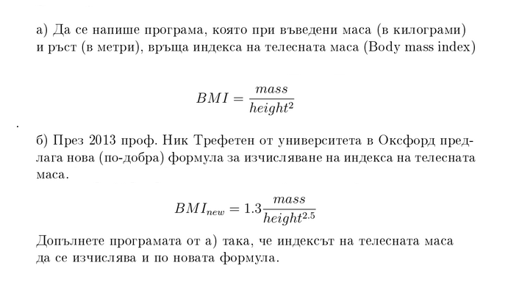￼
Задача 2:

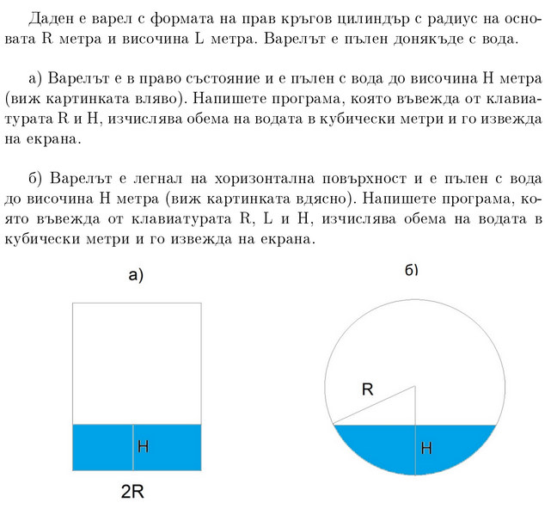
Hint: https://www.mathsisfun.com/geometry/cylinder-horizontal-volume.html

