# Anu Ramanathan, CSM

**US Citizen**, eligible to obtain security clearance

206 992 2323 https://www.linkedin.com/in/AnuRamanathan anur_at_work@outlook.com

Technical- & Programmer-Writer

# WRITING SAMPLES

1. **QSys.co.uk**'s client Bridge Nursery’s Ordering Manuals - from single source (write-once-build-everywhere & single topic authoring with source control for all help files):

For [Desktop](https://orders.bridgenursery.co.uk/img/dropbox/manual/desktop/index.htm) (https://orders.bridgenursery.co.uk/img/dropbox/manual/desktop/index.htm)

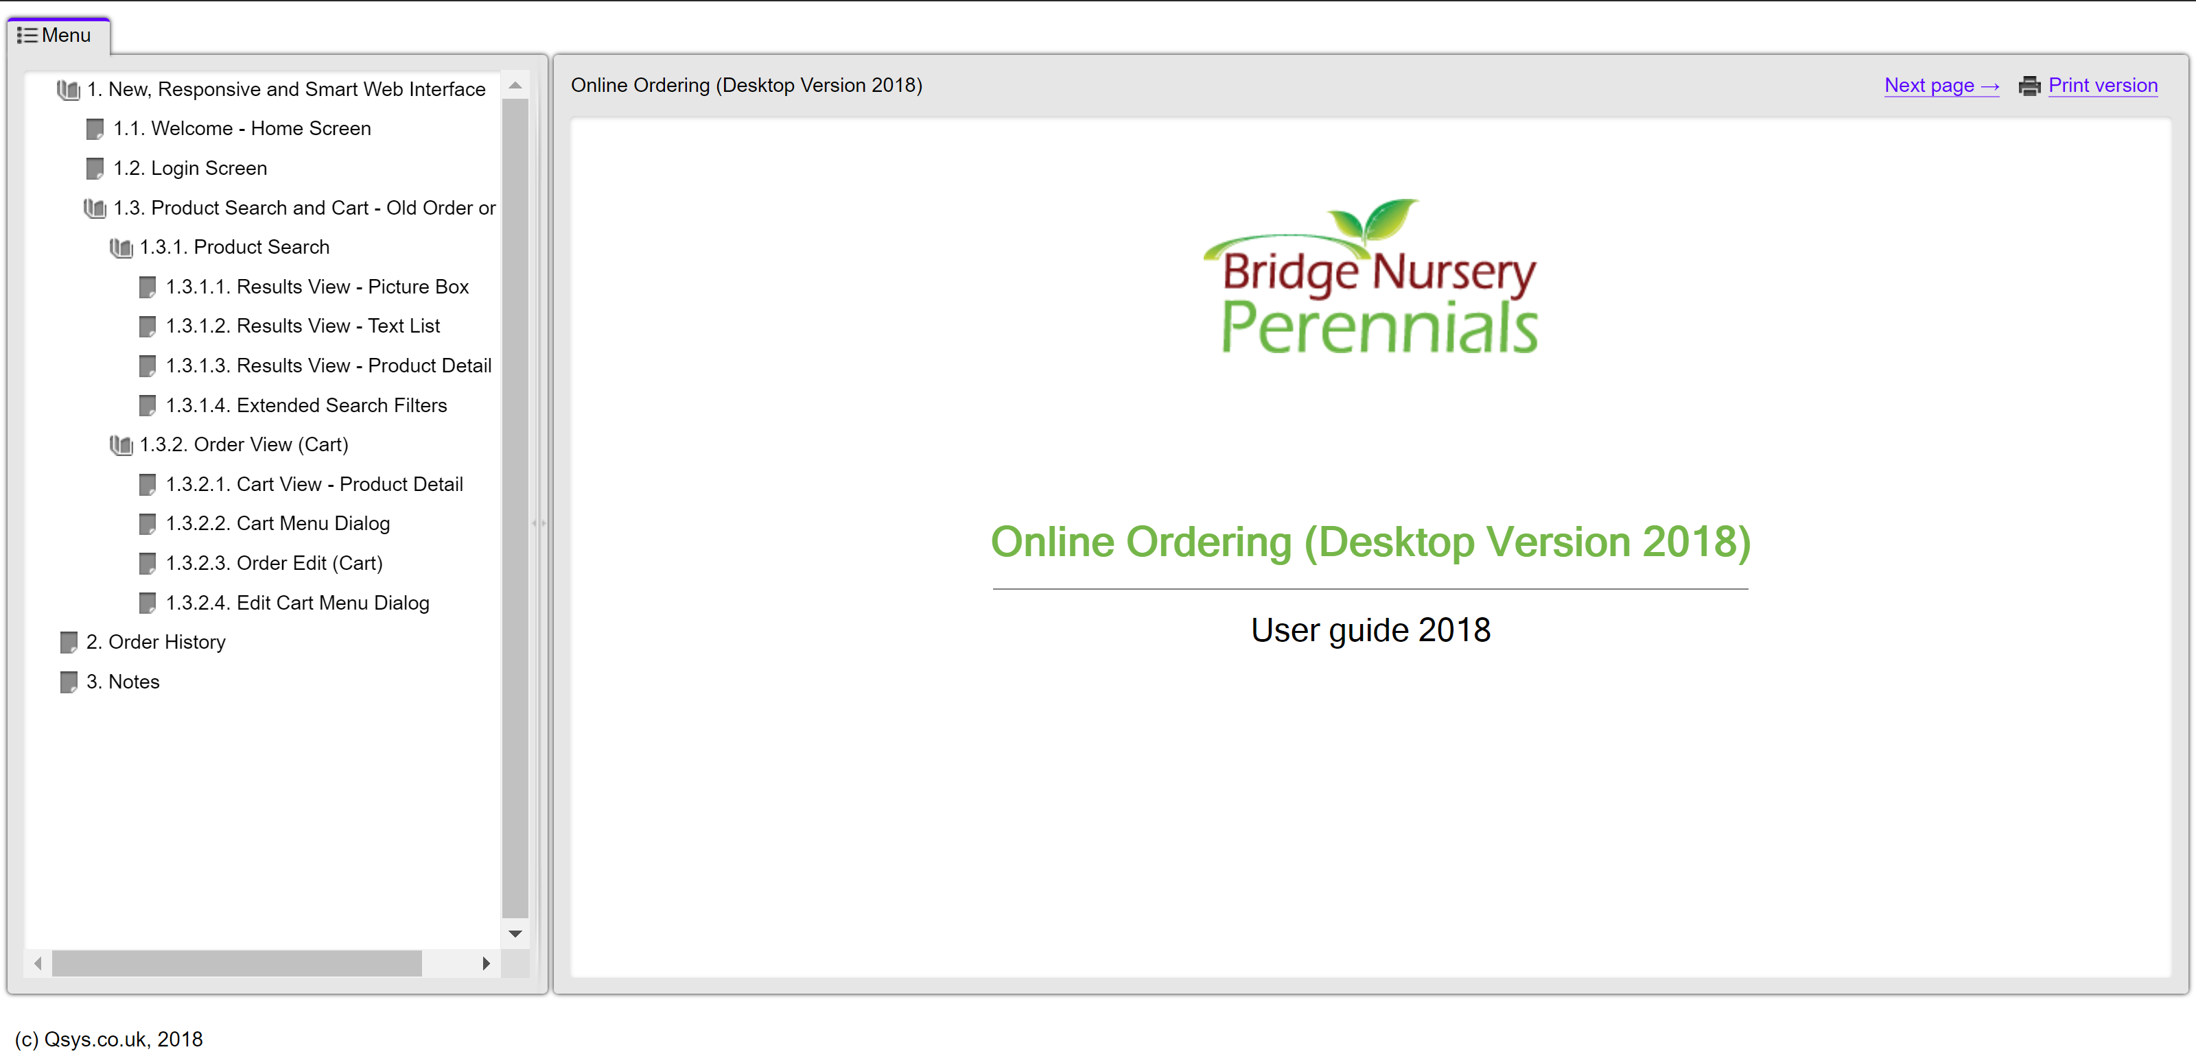

For [Mobile](https://orders.bridgenursery.co.uk/img/dropbox/manual/mobile/index.htm) (https://orders.bridgenursery.co.uk/img/dropbox/manual/mobile/index.htm)

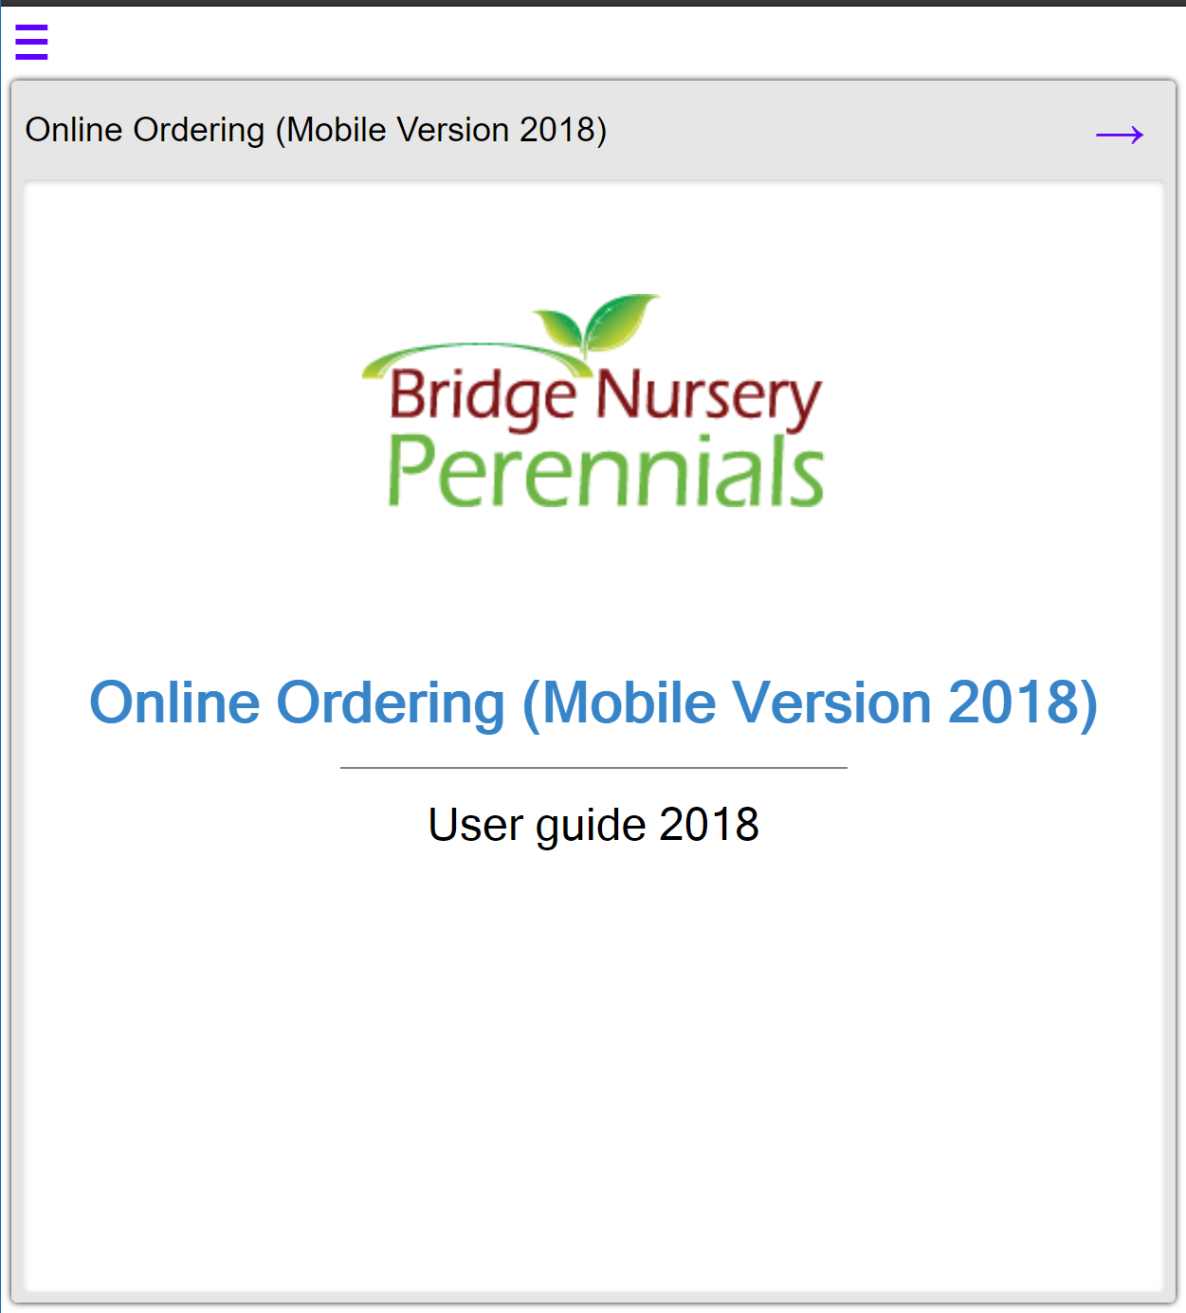 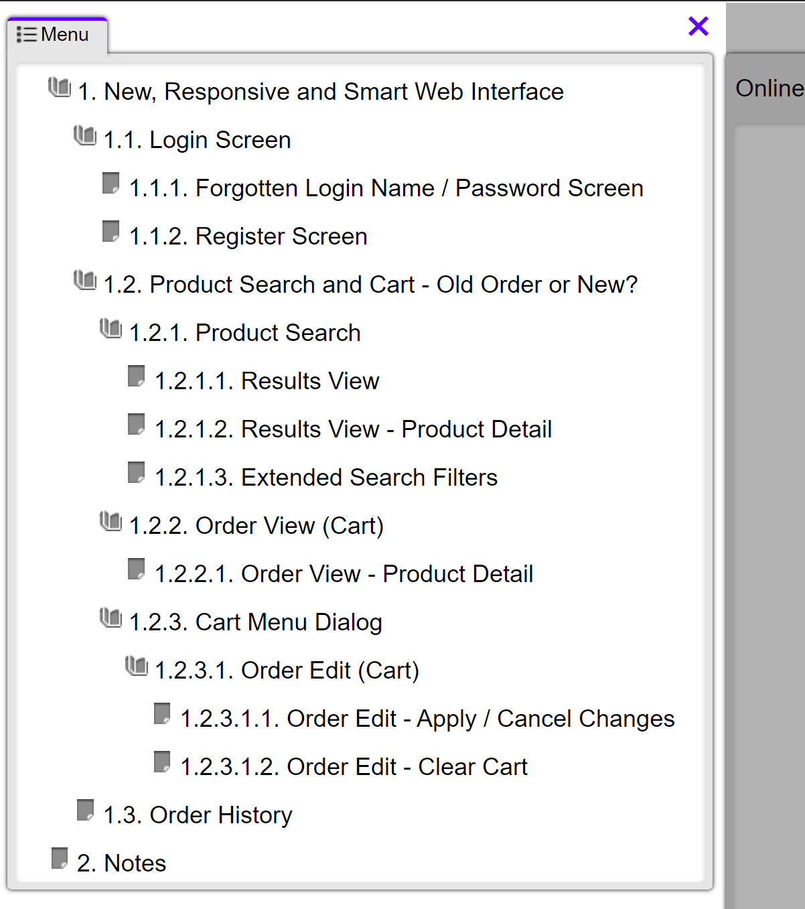

1. As part of my volunteer work as Idiomatic Spoken English Program Facilitator at IAWW.org (Indian Association of Western Washington), this is a document containing a short description of the subject (Thanksgiving), a few pictures and several multi-level questions related to the pictures, and a short list of idioms related to the topic.

*I’ve provided a shrunken version without whitespace in the grey box below so you can easily access the content. The fully formatted version is in the attached file (AnuRamanathan_Philips342797TechnicalWriter_WritingSample_Thanksgiving.docx).*

Thanksgiving

This year, Thanksgiving falls on November 28th, which is the 4th Thursday in the month of November 2019.

Thanksgiving is a harvest festival, and the largest holiday in the United States. It is celebrated by everyone, because we are all free to give thanks to nature, deities and others as we prefer. In fact, more people travel for Thanksgiving than for Christmas!

## Traditional Thanksgiving

The traditional story of Thanksgiving is that:

* English settlers came to North America in 1620 and landed at Plymouth Rock in what is now Massachusetts. But when they landed, it was getting close to winter and they didn’t have enough food to survive the winter.
* The Native American tribe – the Wampanoag Iroquois tribe – who lived in the area generously shared food and knowledge with the Pilgrims, who managed to survive the winter and thrive thereafter.
* The Pilgrims were very thankful, and it is said that the harvest the following year was bountiful with crops of corn, barley, beans and pumpkins.
* The Thanksgiving celebration had deer that the Native Americans brought to roast with the turkeys and other wild game offered by the English colonists. Everyone sat together and feasted.

## Thanksgiving Foods:

A traditional Thanksgiving feast these days includes whole roast turkey with stuffing, corn, cranberry sauce, mashed potatoes with gravy, green bean casserole and finally pumpkin pie for dessert, along with whatever visitors bring with them. In fact, Thanksgiving can be summed up by the 3 Fs – family, food and football.

The meal is traditionally prepared together by family and friends. The turkey is roasted, and the various side dishes prepared. People gather around the dinner table and the meal starts with a prayer, then people take turns giving thanks for their blessings that year, and finally, the eating begins.

## Symbols of Thanksgiving:

Turkey, corn (or maize), pumpkins and cranberries are some of the main symbols which represent Thanksgiving.

## Why Thanksgiving always falls on a Thursday in November:

President John Adams (2nd US president) was the first to make a Thanksgiving proclamation. But this wasn’t an official Federal holiday.

President Abraham Lincoln made Thanksgiving Day the last Thursday in November using a presidential proclamation. Again, he didn’t mean to make this an official Federal holiday.

It was only in 1941 that Congress set the official Thanksgiving Day – to the 4th Thursday in November, and made it into an official Federal holiday. This is because only Congress has the power to do that.

## Other points of view:

When Europeans landed in the Americas, they conquered Native American tribes after more than 100 years of war. The natives, who were called “Indians” suffered greatly, and their population went from more than 100 million in the early 17th century to less than 1 million people today.

Millions died from war, and from diseases to which they had no immunity, like smallpox, tuberculosis and the plague. Successive British colonial, US Federal and State governments have implemented misguided, often racist, policies against Native Americans that still continue to damage their culture, traditions and communities.

This makes some people uncomfortable celebrating Thanksgiving as a victory of Europeans over the Native Americans. Part of the celebration also has very young children playing parts in school plays that show Native Americans in negative or very one-sided stereotypes.

Every year, there are Native American protests on Thanksgiving, which some have declared a “Day of Mourning”.

[How to support indigenous people (Native Americans) on Thanksgiving](https://www.vice.com/en_us/article/zmdmb8/how-to-celebrate-thanksgiving-on-stolen-land) *(*https://www.vice.com/en_us/article/zmdmb8/how-to-celebrate-thanksgiving-on-stolen-land*)*

[Thanksgiving: A Day of Mourning](Thanksgiving:%20A%20Day%20of%20Mourning) (http://americanindiansource.com/mourningday.html)

***Picture #1: Traditional Feast*** 

***Picture #2: Cornucopia*** 

***Picture #3: Porch Decorations*** 

# Questions:

What is the name of some harvest & thanksgiving celebrations where you are from?

Some examples of harvest festivals from India are:

* Pongal (Tamil Nadu), Lohri (Punjab), Onam & Vishu (Kerala),
* Ugadhi (Karnataka, Andhra Pradesh and Telangana),
* Bhogali Bihu (Assam), Holi & Makar Sankranti (all over India), Nabanna (West Bengal),
* Eid-ul-Azha (Muslims all over India), Agera (Catholics in Maharashtra)

What are the traditional foods you eat that day?

How do you decorate your home for harvest or thanksgiving festivals and celebrations?

How do you celebrate family togetherness?

Do you have a day or particular time of year that you celebrate?

What are some unique festivals or celebrations where you live that foster a spirit of togetherness for family, friends, neighborhoods and community?

***Look at Picture #1: Traditional Thanksgiving meal***

Which of the traditional Thanksgiving foods can you identify?

***Look at Picture #2: Cornucopia, or Horn of Plenty***

The Horn of Plenty signifies a never-ending source of food.

Is there a similar concept in your culture, religion or community?

What does this conceptual source of never-ending food look like?

Can you share the story of how it came to be?

***Look at Picture #3: Thanksgiving Porch Decorations***

What are some decoration items that you can name?

Why do you think they are important?

How are they different from the decorations that you put up traditionally for harvest celebrations?

# Common American Idioms

1. **Be stuffed** – To be full and not be able to eat any more.

*The meal was absolutely delicious. I’m afraid I can’t eat one morsel more. I’m stuffed.*

1. **Go cold turkey** – to suffer from suddenly stopping a bad habit (especially addictions)

*Many people who attempt to quit smoking do so by going cold turkey rather than by gradually cutting down.*

1. **Count your blessings** – to be grateful for the good things in your life

*We have a lovely home, healthy children and each other – we should count our blessings.*

1. **Talk turkey** – to discuss a problem in a serious way with a real intention to solve it

*The politicians need to stop messing around and start talking turkey.*

1. **The Rest Is Gravy** - Anything extra is a nice bonus

*Let’s finish up what we’ve promised by the deadline. The rest is gravy.*

1. **Hot Potato** - A difficult situation that nobody wants to handle, so it gets passed from one person to another.

*At Thanksgiving, a hot potato could actually be a hot potato, so be careful (and add butter) before you dig into the   
potato on your plate!*

1. An observational study of Applicant Tracking Systems (ATSs) and their adversarial relationship to job searchers’ resumes.

*I’ve provided a version without whitespace in the grey box below so you can easily access the content. The fully formatted version is in the attached file (AnuRamanathan_Philips342797TechnicalWriter_WritingSample_JobSearchColdWar.docx).*

# The Job Applications Cold War

**An escalating weapons race between applicants and Applicant Tracking Systems (ATS)**

## Disclaimer:

*This document details my job search and application experiences in the IT fields, especially applications programming. It may not precisely apply to other career paths, but the broad outlines remain true.*

## Escalating weapons race between applicants and ATSs

### In the beginning there were *keywords*

And ATSs relied on them.

Naturally, applicants started putting in especially useful keywords into their project descriptions.

* + Advantage: Applicants.

### ATSs started *counting* the number of times keywords appeared in a resume

And they weeded out applicants who’d randomly dropped keywords into their project descriptions with the expectation of gaming the system.

But ingenious minds figured that out and put keyword repetitions in hidden and non-printable text. Resume reviewers of the human persuasion were fooled, and the ATSs gamed.

* + Advantage: Applicants

### And then ATSs tried *discounting* hidden keywords

Wherever there were hidden keywords, ATSs retaliated by discounting them.

But humans gamed the ATSs again, adding keywords in each project description, regardless of relevance.

* + Advantage: Applicants, again

### ATSs looked for *keyphrases*

And applicants countered by adding keyphrases to their project descriptions and wherever else they could.

* + Advantage: Applicants, yet again

### ATSs used a *weighted approach* to ranking *keywords* and *keyphrases*

Weighting keywords & keyphrases by where they occurred in the document (close to the top of the document for paragraphs was more weighted; with lists, within the first two or three bullet points in descending ranking; in terms of tables, closer to the left hand columns of the table and closer to the top row of the tables).

And so applicants followed, putting keywords and keyphrases as close to the top of the document as possible as well as in their project descriptions.

* + Advantage: Applicants, again

### ATSs added *weighted project ranking* to *weighted keyword* and *keyphrase ranking*

ATSs amped up the weapons race by using a weighted ranking of keywords/keyphrases by their projects’ position in the list of projects within a resume. Older projects didn’t receive as many points per keyword/keyphrase.

* + Advantage: ATS. Finally!

Being that humans are generic problem solvers with competencies honed by evolution and experience, applicants reacted by repeating keywords all over the place, for resumes that went into an ATS. But they also kept a resume version that was far more human-readable, without all the unnecessary repetition of keywords and keyphrases.

* + Advantage: Back to applicants

### ATSs countered by requiring recruiters and interviewers *only use resumes stored within*

Applicants upped the ante by crafting resumes that balanced repetition of keywords for ATSs with human readability.

* + Advantage: Applicants, barely

### ATSs *combined weighted project, keyword* and *keyphrase ranking* with *placement*

ATSs checked the keywords’ and keyphrases’ appearances not just within a project’s placement in the document, but also the placement of the keywords and keyphrases within project descriptions. The keywords and keyphrases occurring in the first few lines of a project description were weighted higher than those occurring in the 3rd and lower lines.

Applicants adjusted by putting in as many repetitions as wouldn’t turn off a human reviewer but also worked to repeat enough times for an ATS to possibly put them into the top of a stack to be viewed by a recruiter

* + Advantage: Back to ATS, for now.

*This is as far as my knowledge goes. This was 2017-2018. No doubt other events have occurred in the meantime that have advanced this weapons race further.*

1. A short review of the Jenkins User Handbook to offer review suggestions with justification for each.

*I’ve provided a version without whitespace in the grey box below so you can easily access the content. The fully formatted version is in the attached file (AnuRamanathan_Philips342797TechnicalWriter_WritingSample_JenkinsUserHandbook_Feedback.docx).*

# Anu Ramanathan’s notes on the Jenkins User Handbook:

|  | **Observations** | **Issue Grouping** | **Suggested Corrections** | **Reason(s) for correction** |
| --- | --- | --- | --- | --- |
| 1. | The User Handbook link is lost in the sea of links in the left column | UX  Usability  Presentation  Styling  Content  Architecture  Templates  Standards  Consistency | * Put the User Handbook and its tree of links into its own section in the left hand pane for main TOC * I’d recommend ditching the separate “Overview” page in the TOC and have the “User Handbook” entry be a link that takes you directly into Overview | This makes both the main page of the User Handbook more easily found, as well as allows users to jump directly to their topic of choice without having to read through an entire set of text |
| 2. | The User Handbook Overview page is missing internal links in the right hand pane of the page (non-standard presentation) | * The User Handbook Overview page needs to be structured the same as the pages beneath, with internal links in the page showing as a structured list tree in the right hand pane * Strongly recommend style templates & style guide (both content & presentation) to enforce a consistent look-and-feel * Ideally, have templates for each portion of the page (site/section/page titles, breadcrumbs, left column, right column, content areas, etc.) | * Following a clearly defined standard for content & presentation ensures consistency of look-and-feel across an entire help section (if not the entire site itself) * Important that typography and style remain consistent for the user to learn about the product and how to interact with it, rather than puzzling out why some help pages look one way & others don’t |
| 3. | There is some overlap in content between the main page to the Getting Started with the Guided Tour, and the User Handbook’s overview page. | Content  Maintenance  Architecture  Standards  UX  Usability  Consistency | * Use single-topic authoring style to ensure no overlaps in content * Use page content insertion (“composition”) in the content area to show that said content lives in different pages in the left hand tree, if it is necessary to keep the current look-and-feel of the help content * Text inserted from another source in the TOC could be made into a link to the page in addition * Have a section in the right hand pane of “Related Links” and put the links embedded in the page content there as well | * If content is copied instead of referenced in multiple locations, maintenance becomes a nightmare, since for every single topic, we’d need to ensure that all copies are found and kept updated accurately (consistency of information across the TOC) * Single topic authoring style ensures that for a single topic, there’s only one page where the content lives, and only that topic is covered within that page. * We can have scripting code to control which sections of said topic are displayed based on user permissions and/or where the user is in the page hierarchy and/or for other reasons |
| 4. | Dense paragraphs of text | UX  Usability  Presentation  Styling | * Break up dense blocks of text into paragraphs, use diagrams or other content modes to improve user’s ability to actually want to read & understand the content | * Most people are not used to reading dense blocks of text in today’s hyper-connected world * If users won’t read your documentation, they won’t use your product |
| 5. | No breadcrumbs | UX  Usability  Display Areas  Presentation | * I’d recommend a “where in the TOC are you” and a “back to where you came from” standard set of breadcrumbs be added to the display areas that are available for documentation | * Breadcrumbs can be very helpful for users to get around in documentation – sometimes when they jump away from a page, they have no idea of how to get back and end up wasting time trying to find their way back * Having a “here’s how you get back to where you came from (in the TOC)” be a breadcrumb trail, as well as the standard “here’s where you are in the TOC” especially helps users who are completely new or unfamiliar with the product. |
| 6. | Help presentation | UX  Usability  Presentation  Philosophy of Help Architecture  Write-Once-Compile-Everywhere  Content  Consistency  Architecture  Using build commands  **Security** | * I strongly recommend that the “write-once-compile-everywhere” philosophy be applied to the information architecture and help content * Use build commands to send output to different types of executables (DOCX, PDF, HTML, CHM, etc.) * Following on that, for help presentation, use a single-page-architecture that does not expose your file structure to hackers (especially for the web, but SPA can be adapted for other documentation output streams as well) | * I’m a big supporter of the “Write-once-compile-everywhere” school of writing regardless of if it is code or documentation * Applying this philosophy combined with Single-Topic authoring will ensure that there is one and only one place where any specific piece of knowledge/information resides * Both these approaches – write-once & single-topic authoring – require strrict adherence to metadata tags & standards * Having a common set of metadata tags attached to each unique piece of information will allow for quicker “See Also” links to be found for information residing within this help documentation |
| 7. | Versioning of content files and compiled outputs | Source Control  Continuous Integration (CI) & Continuous Delivery (CD) | * Implement source control to streamline documentation output with the version of the product that is in a CI/CD (DevOps) environment * Keep help source files (content files, project file, build files, etc.) in a source control repository for traceability * Maintain cadence with product development teams to build efficiency and ensure that help versions stay in sync with product versions (simultaneous release) | * Along with write-once & single-topic authoring, source control will streamline documentation output and provide traceability of changes in documentation requirements (maybe in response to feedback from QA & production) * Builds efficiency in an agile environment |