# C2- S6 – PRACTICE- **THE STORE**



We want to implement an online store where customer can give comment on products.

* A product can have feedbacks given by customers
* Each feedback is a comment (a string) and a score (from 0 to 100%)

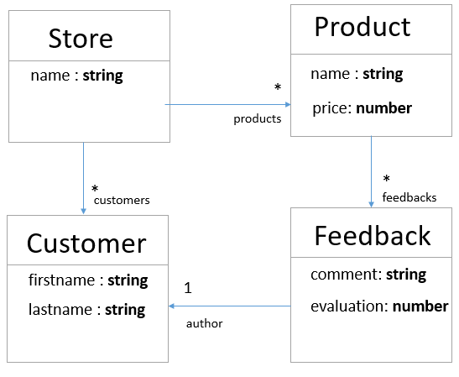

**Q 1**

Implement the model to manage the **Store** and **Products**

* Write methods to
  + Add a product to the store

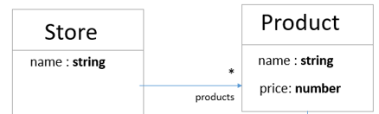

**Q 2**

Implement the model to manage the **Product** and **Feedbacks**

* Write methods to
  + Add a feedback to the product

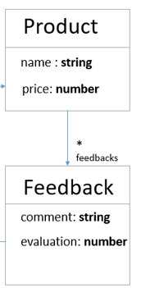

**Q 3**

Implement the model to manage the **Customer** on the store and on the Feedbacks

* Write methods to
  + Add a customer to the store
  + Set the customer of a Feedback

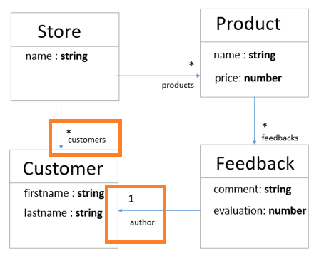

**Q4**

* On **Store** class, implement the method to get all product less than a given price :

getProductLessThan (int price) : Product[]

**Q 5**

* On **Store** class, implement the method to get all feedback (of any product) which contains the given key word :

getFeedbackCOntaining(String keyword) : Feedback[]

**Q 6**

* On **Store** class, implement the method to get all **COMMENTS** from FEEDBACKS of the given customer, from any product

getCustomerComments(Customer customer) : string[]