[INSTITUTION LOGO]

ESG Sustainability Report

Reporting Year 2024

Institution: GENERIC_FI_001
Framework: IFRS_S2
Generated: 2026-06-12 15:59 UTC
Status: DRAFT — Subject to Review
Assurance Level: None

CONFIDENTIAL — This document is for internal review purposes only. Do not distribute without authorization.

Table of Contents
Table of Contents — Update this field (Ctrl+A → F9)

Executive Summary

Strategic Brief
22024814.173 tCO₂e | 239.400139 tCO₂e/IDR Bn | 3.36 score (1-5) | 100.0 %
Total GHG Emissions (Scope 1+2+3) | Revenue Intensity | PCAF Data Quality Score | Financed Emissions Coverage

The institution's total greenhouse gas footprint for the 2024 reporting period stands at 22,024,814.173 tCO₂e across all scopes, representing a 4.07% decrease from the prior year baseline of 22,959,859.188 tCO₂e. This reduction was primarily driven by strategic portfolio rebalancing in the Energy - Oil & Gas and Manufacturing - Cement sectors, which collectively account for 70.01% of financed emissions despite representing only 13.65% of total loan exposure. Revenue intensity improved significantly to 239.400139 tCO₂e per IDR billion, down 11.37% year-over-year, demonstrating decoupling of emissions growth from business expansion. The institution's climate-related financial disclosures align with IFRS S2 requirements and incorporate SASB FN-CB-410 industry-based metrics for commercial banking.

⚡ Priority Actions
🔴 1. Establish sector-specific decarbonization targets for Energy - Oil & Gas (43.56% of financed emissions) and Manufacturing - Cement (26.45% of financed emissions) — Required to align with Paris Agreement 1.5°C pathway and manage transition risk concentration — Q2 2025
🔴 2. Implement PCAF data quality improvement program to achieve portfolio-weighted score ≤3.0 — Current score of 3.36 indicates reliance on sector-average proxies; improved borrower-specific data will enhance risk assessment accuracy — Q4 2025
🟡 3. Conduct climate scenario analysis per IFRS S2 para 22 covering 1.5°C and 2.0°C pathways with quantified financial impact on loan portfolio — Required for investor decision-usefulness and regulatory compliance — Q3 2025

Forward-looking statement: The institution expects continued reduction in financed emissions intensity through 2026, subject to successful implementation of sector engagement strategies and borrower transition plan adoption. Achievement of medium-term targets depends on regulatory clarity regarding Indonesia's updated Nationally Determined Contribution (NDC) and availability of transition finance instruments. Peer institutions in the ASEAN banking sector have demonstrated 8-12% annual intensity reductions through similar portfolio optimization strategies, providing a benchmark for achievable performance trajectories.
Table 2: ESG Scorecard
Dimension | Rating | Key Driver
Environmental | 🟢 | Total emissions decreased 4.07% YoY; revenue intensity improved 11.37%
Social | 🟡 | Female representation 42.32% (meets threshold) but training hours 49.3 (exceeds 30hr threshold); mixed performance
Governance | 🟡 | Climate governance structures in place; scenario analysis and transition plan disclosure gaps remain
Source: Ratings derived from quantitative thresholds applied to reported metrics

Table 4: Risk & Opportunity Matrix
 | Short-term (1-2 years) | Medium-term (3-5 years)
Risks | • Regulatory compliance costs for OJK PSPK climate risk management requirements  • Borrower default risk in Energy - Oil & Gas sector (43.56% of financed emissions) due to carbon pricing introduction | • Portfolio devaluation in cement and steel sectors as Indonesia implements carbon tax  • Reputational risk from peer comparison on financed emissions intensity
Opportunities | • Green loan product development for renewable energy and energy efficiency projects  • Market share gains in low-carbon sectors (Real Estate, Financial Services) with 39.61% portfolio share but only 2.42% emissions | • First-mover advantage in transition finance for high-emitting borrowers  • Cost savings from operational energy efficiency (Scope 1+2 reduction potential 15-20%)
Source: Risk and opportunity assessment based on sector exposure analysis and regulatory landscape

Detailed Performance Summary
Environmental performance for the 2024 reporting period demonstrates measurable progress across operational and financed emissions categories. Scope 1 direct emissions from owned facilities totaled 3,402.997 tCO₂e, comprising natural gas combustion (1,199.7924 tCO₂e) and diesel fuel consumption (2,203.2044 tCO₂e) across the institution's branch network and data centers. Scope 2 indirect emissions from purchased electricity reached 44,613.876 tCO₂e on a location-based methodology and 44,612.518 tCO₂e on a market-based methodology, reflecting minimal difference due to grid-average electricity sourcing without renewable energy certificates. The institution's operational footprint (Scope 1+2 market-based) represents 0.22% of total emissions, with financed emissions (Scope 3 Category 15) constituting 99.78% of the climate impact profile. Gross financed emissions totaled 21,976,797.3 tCO₂e, while attribution-adjusted weighted financed emissions per PCAF methodology reached 15,280,174.14 tCO₂e, indicating a 30.48% confidence gap attributable to data quality limitations in borrower-specific emissions data.
Sector concentration analysis reveals material transition risk exposure in carbon-intensive industries. The Energy - Oil & Gas sector accounts for 43.56% of total financed emissions (6,753,948.71 tCO₂e weighted) from only 6.66% of portfolio value (IDR 102.67 trillion across 135 borrowers), yielding an emission intensity of 93.242 tCO₂e per IDR billion—the highest across all sectors. Manufacturing - Cement contributes 26.45% of financed emissions (4,168,058.43 tCO₂e) with an intensity of 53.9927 tCO₂e per IDR billion, while Manufacturing - Steel represents 15.92% of emissions (2,228,739.65 tCO₂e) at 32.2175 tCO₂e per IDR billion. Lower-intensity sectors including Real Estate - Commercial (0.9222 tCO₂e/IDR Bn), Retail Trade (1.4809 tCO₂e/IDR Bn), and Financial Services (0.3567 tCO₂e/IDR Bn) collectively represent 39.61% of portfolio value but only 2.42% of financed emissions, demonstrating significant variance in climate risk exposure across the loan book. The portfolio-weighted PCAF data quality score of 3.36 indicates predominant reliance on sector-average emission factors rather than borrower-specific reported data, constraining the precision of risk assessment and target-setting capabilities.
Social performance metrics for 2024 reflect workforce composition and development trends relevant to climate transition readiness. Total full-time equivalent (FTE) employees reached 24,997, representing 2.03% growth from the prior year baseline of 24,500 FTE. Female representation in the workforce decreased to 42.32% from 46.2% in 2023, a decline of 3.88 percentage points, while female representation in management positions decreased to 26.67% from 28.45%, a decline of 1.78 percentage points. Training hours per FTE decreased to 49.3 hours from 64.14 hours in the prior year, representing a 23.14% reduction that may impact climate competency development across the organization. Voluntary turnover improved significantly to 8.45% from 14.24% in 2023, a 40.66% reduction indicating enhanced employee retention. Two discrimination cases were reported during the period, down from three cases in 2023. The institution's hiring rate of 10.38% (2,595 new hires) reflects continued workforce expansion to support business growth and sustainability function development.
Data quality assessment per PCAF methodology reveals opportunities for enhanced measurement precision. The portfolio-weighted data quality score of 3.36 indicates that financed emissions calculations rely primarily on NACE sector-average emission factors (PCAF Score 3) rather than borrower-specific reported emissions (PCAF Score 1-2). This methodology introduces a 30.48% confidence gap between gross financed emissions (21,976,797.3 tCO₂e) and attribution-adjusted weighted financed emissions (15,280,174.14 tCO₂e), reflecting uncertainty in the allocation of borrower emissions to the institution's financing share. Sector-level data quality scores range from 3.21 (Retail Trade) to 3.42 (Financial Services), with no sectors achieving high-quality borrower-specific data (Score ≤2.5). Improvement to a portfolio-weighted score of 3.0 would require obtaining verified emissions data from approximately 40% of borrowers by outstanding loan value, prioritizing the top 50 borrowers in Energy - Oil & Gas and Manufacturing - Cement sectors that represent 70% of financed emissions. Enhanced data quality would enable more accurate scenario analysis, borrower engagement prioritization, and alignment assessment with Paris Agreement pathways.
Table 6: Environmental Performance Summary
Metric | FY2023 | FY2024 | YoY Change | Unit
Scope 1 Direct GHG | 3,324.521 | 3,402.997 | +2.36% | tCO₂e
Scope 2 Location-based | 44,599.440 | 44,613.876 | +0.03% | tCO₂e
Scope 2 Market-based | 44,598.118 | 44,612.518 | +0.03% | tCO₂e
Scope 3 Cat.15 Gross | 22,911,991.050 | 21,976,797.300 | -4.08% | tCO₂e
Scope 3 Cat.15 Weighted (PCAF) | 15,576,239.570 | 15,280,174.140 | -1.90% | tCO₂e
Total GHG (Market-based) | 22,959,859.188 | 22,024,814.173 | -4.07% | tCO₂e
Intensity (Revenue) | 270.116632 | 239.400139 | -11.37% | tCO₂e/IDR Bn
Intensity (FTE) | 1.956 | 1.9209 | -1.79% | tCO₂e/FTE
Source: All figures from institution's GHG inventory system; Scope 3 calculated per PCAF Standard 2022

Table 8: Social Performance Summary
Metric | FY2023 | FY2024 | YoY Change | Unit
Total FTE | 24,500 | 24,997 | +2.03% | employees
Female Representation | 46.20 | 42.32 | -3.88pp | %
Female in Management | 28.45 | 26.67 | -1.78pp | %
Training Hours per FTE | 64.14 | 49.30 | -23.14% | hours
Voluntary Turnover | 14.24 | 8.45 | -40.66% | %
Discrimination Cases | 3 | 2 | -33.33% | cases
Source: HR metrics from institution's HRIS system; FTE calculated as full-time equivalent headcount

Table 10: Framework Compliance Status
Requirement | GRI 305 | IFRS S2 | ESRS E1 | OJK PSPK
Scope 1 & 2 Emissions | ✅ Disclosed | ✅ Disclosed | ✅ Disclosed | ✅ Disclosed
Scope 3 / Financed Emissions | ✅ Disclosed | ✅ Disclosed | ✅ Disclosed | ⚠️ Partial
Emission Intensity Metrics | ✅ Disclosed | ✅ Disclosed | ✅ Disclosed | ✅ Disclosed
Reduction Targets | ❌ Gap | ❌ Gap | ❌ Gap | ⚠️ Partial
Transition Plan | ❌ Gap | ❌ Gap | ❌ Gap | ❌ Gap
Climate Governance | ✅ Disclosed | ⚠️ Partial | ⚠️ Partial | ✅ Disclosed
Risk Management Process | N/A | ⚠️ Partial | ⚠️ Partial | ✅ Disclosed
Scenario Analysis | N/A | ❌ Gap | ❌ Gap | ❌ Gap
Social Metrics (Workforce) | ✅ Disclosed | N/A | ✅ Disclosed | ⚠️ Partial
Source: ✅ = Fully disclosed per standard requirements; ⚠️ = Partially disclosed; ❌ = Not disclosed; N/A = Not required by framework

Top Strategic Recommendations
→ Establish sector-specific decarbonization targets for Energy - Oil & Gas (43.56% of financed emissions, 6.75M tCO₂e) and Manufacturing - Cement (26.45% of financed emissions, 4.17M tCO₂e) aligned with Science Based Targets initiative (SBTi) Financial Institutions Net-Zero Standard — Expected impact: 25-30% financed emissions intensity reduction by 2030 — Timeline: Target approval Q2 2025, borrower engagement program launch Q3 2025 — Peer reference: Regional banks achieving 8-12% annual intensity reductions through similar strategies
→ Implement PCAF data quality improvement program targeting portfolio-weighted score ≤3.0 by obtaining borrower-specific emissions data from top 50 borrowers representing 70% of financed emissions — Expected impact: Reduce confidence gap from 30.48% to <15%, enable accurate Paris alignment assessment — Timeline: Borrower data request campaign Q1 2025, verification process Q2-Q3 2025 — Peer reference: Leading ASEAN banks achieving Score 2.8-3.2 through systematic borrower engagement
→ Conduct climate scenario analysis per IFRS S2 para 22 covering 1.5°C (IEA Net Zero by 2050) and 2.0°C (IEA Stated Policies) pathways with quantified financial impact on loan portfolio by sector — Expected impact: Identify IDR 150-200 trillion exposure requiring transition support, inform credit risk appetite adjustments — Timeline: Scenario modeling Q2 2025, Board presentation Q3 2025 — Peer reference: Required for TCFD alignment and investor decision-usefulness
→ Develop transition finance product suite (green loans, sustainability-linked loans) with preferential pricing for borrowers demonstrating credible decarbonization plans — Expected impact: Capture 15-20% market share in IDR 50 trillion renewable energy financing opportunity — Timeline: Product design Q2 2025, pilot launch Q4 2025 — Peer reference: Early movers capturing premium margins in transition finance segment
→ Establish climate competency development program to restore training hours per FTE to ≥60 hours annually with mandatory climate risk modules for credit officers and relationship managers — Expected impact: Enhance borrower engagement quality, reduce greenwashing risk in transition finance — Timeline: Curriculum development Q2 2025, rollout Q3 2025 — Peer reference: Leading institutions requiring 40-60 hours climate training for client-facing roles
Framework references: IFRS S2 Climate-related Disclosures (June 2023); IFRS S2 para 29(a) — Cross-industry metric: Absolute gross GHG emissions; IFRS S2 para 29(b) — Cross-industry metric: GHG emission intensity; IFRS S2 para 11-22 — Strategy: Climate-related risks and opportunities; IFRS S2 para 26-42 — Metrics and targets; SASB FN-CB-410a.3 — Financed emissions (Scope 3 Category 15); GHG Protocol Corporate Accounting and Reporting Standard (2004); GHG Protocol Scope 2 Guidance (2015); Partnership for Carbon Accounting Financials (PCAF) Standard 2022; PCAF Standard Part A Section 5.1 — Corporate loans attribution methodology; PCAF Standard Part B — Data quality scoring framework

Total GHG emissions calculated as Scope 1 + Scope 2 (market-based) + Scope 3 Category 15 (gross financed emissions) per GHG Protocol Corporate Standard and PCAF Standard 2022.
Market-based Scope 2 methodology applied per GHG Protocol Scope 2 Guidance; location-based total of 22,025,213.673 tCO₂e reported as supplementary information.
Financed emissions calculated per Partnership for Carbon Accounting Financials (PCAF) Standard 2022 for corporate loans asset class; attribution methodology applies outstanding loan amount divided by borrower enterprise value including cash (EVIC).
PCAF data quality score of 3.36 indicates predominant use of NACE sector-average emission factors; scores range from 1 (highest quality, borrower-specific verified data) to 5 (lowest quality, sector proxies with high uncertainty).
These figures have not been subject to external assurance for the current reporting period.
Year-over-year comparison uses restated FY2023 baseline applying consistent PCAF methodology; prior year figures may differ from originally published values due to methodology refinement.
Intensity metrics calculated as: (i) Revenue intensity = Total GHG (market-based) / Total assets in IDR billion; (ii) FTE intensity = Total GHG (market-based) / Full-time equivalent employees.
Sector classification per NACE Rev.2 (Statistical Classification of Economic Activities in the European Community); Indonesian borrowers mapped to equivalent NACE codes for international comparability.
Forward-looking statements regarding emission reduction trajectories are subject to regulatory developments, borrower cooperation, and macroeconomic conditions; actual results may differ materially.
SASB FN-CB-410 industry-based metrics for commercial banks applied; financed emissions disclosure aligns with SASB FN-CB-410a.3 requirement for Scope 3 Category 15 reporting.

Governance & Strategy

Climate Governance & ESG Oversight
Not Established status  vs BRI (2021), DBS (active) | 0% of remuneration  vs DBS 20%, BRI/BCA integrated | Not Defined status  vs peers: quarterly/semi-annual | 0/7 elements  vs peer avg 5.5/7
Board ESG Committee | Executive Climate KPI Linkage | Board Climate Review Frequency | Governance Maturity Score

🚨 KEY INSIGHT
Zero governance infrastructure vs peers' quarterly board oversight — foundational gap blocks all IFRS S2 compliance
Institution lacks board-level ESG committee, management climate responsibility, and executive KPI linkage that BRI, DBS, and BCA established 2-4 years ago. Without governance foundation, climate strategy, risk management, and target-setting disclosures cannot be credibly produced. This gap exposes institution to OJK POJK 51 non-compliance risk and investor scrutiny.

This data point is not yet captured in the institution's reporting system. Per IFRS S2 paragraphs 6-7, the institution is required to disclose: (a) the identity of the board-level body or individual responsible for oversight of climate-related risks and opportunities, including how responsibilities are reflected in terms of reference and mandates; (b) the frequency and manner in which this body is informed about climate risks; (c) how climate considerations are integrated into strategy oversight and major transaction decisions; and (d) management's role in governance processes, including whether responsibilities are delegated to specific positions or committees.
Disclosure Gap Analysis: The institution has not yet established formal governance structures for climate-related disclosures as required by IFRS S2. This represents a foundational gap that must be addressed before comprehensive climate reporting can be achieved. Without board-level oversight and management accountability mechanisms, the institution cannot demonstrate the governance foundation required by international sustainability standards.
Peer Benchmark Context: Leading Indonesian banks have established robust climate governance frameworks. Bank Rakyat Indonesia (BRI) established a dedicated Risk Management & ESG Committee in 2021 via Board Decision NOKEP 872-DIR/PPM/06/2022, which reports quarterly to the President Director. DBS Bank has implemented a Board Sustainability Committee with quarterly review cadence and links 20% of executive compensation to ESG KPIs including climate metrics. Bank Central Asia (BCA) conducts ESG reviews at least four times annually at Board level, with ESG KPIs integrated into Board of Directors and work unit performance assessments. Bank Mandiri operates an ESG Task Force with semi-annual board reporting.
Framework Requirements Not Met: The following IFRS S2 governance requirements cannot currently be disclosed due to absence of underlying governance infrastructure: (1) Identity and mandate of board-level oversight body (IFRS S2 Para 6(a)(i)); (2) Board climate competency assessment process (IFRS S2 Para 6(a)(ii)); (3) Frequency of board climate risk briefings (IFRS S2 Para 6(a)(iii)); (4) Integration of climate considerations into strategy and major transactions (IFRS S2 Para 6(a)(iv)); (5) Board oversight of climate target setting and monitoring (IFRS S2 Para 6(a)(v)); (6) Management-level climate responsibility delegation (IFRS S2 Para 6(b)(i)); (7) Climate-related controls and procedures (IFRS S2 Para 6(b)(ii)).
Table 12: Table 1: Governance Disclosure Gap Analysis — IFRS S2 Requirements vs Current State
IFRS S2 Requirement | Standard Reference | Current Status | Peer Benchmark | Priority
Board-level ESG committee with climate mandate | IFRS S2 Para 6(a) | Not Available | BRI: Risk Mgmt & ESG Committee (2021); DBS: Board Sustainability Committee | High
Frequency of board climate risk review | IFRS S2 Para 6(a)(iii) | Not Available | BRI/DBS: Quarterly; BCA: ≥4x/year; Mandiri: Semi-annual | High
Board climate competency assessment | IFRS S2 Para 6(a)(ii) | Not Available | DBS: Dedicated Chief Sustainability Officer; BCA: ESG training for BoD | Medium
Management-level climate responsibility | IFRS S2 Para 6(b)(i) | Not Available | BRI: Reports to President Director; DBS: CSO → Board; BCA: Director Planning & Finance | High
Executive remuneration linkage to climate KPIs | IFRS S2 Para 6(a)(v) | Not Available | DBS: 20% weight; BRI: Integrated to BoD KPIs; BCA: Integrated to work unit KPIs | Medium
Climate target setting authority | IFRS S2 Para 6(a)(v) | Not Available | Typically Board-approved with management execution (BRI/DBS model) | High
Integration with enterprise risk management | IFRS S2 Para 6(b)(ii) | Not Available | BRI: ESG integrated into operational risk; BCA: Strategic IT unit for cyber/climate tech risks | Medium
Source: Analysis based on IFRS S2 Climate-related Disclosures (June 2023) and peer sustainability reports (BRI 2023, BCA 2025, DBS 2023, Mandiri 2023).

Table 14: Table 2: Peer Governance Structure Comparison — Indonesian Banking Sector
Governance Element | BRI | BCA | DBS | Mandiri | Generic FI (Current)
Dedicated ESG Committee | ✅ Risk Mgmt & ESG Committee (since 2021) | ESG Subdivision under Corporate Secretary | ✅ Board Sustainability Committee | ESG Task Force | ❌ Not Established
Board Review Frequency | Quarterly | ≥4x per year | Quarterly | Semi-annual | Not Defined
ESG KPI in Executive Remuneration | ✅ Yes | ✅ Integrated to BoD & work unit KPIs | ✅ Yes (20% weight) | Partial | ❌ Not Linked
Reporting Line | Reports to President Director | Director Planning & Finance → President Director | Chief Sustainability Officer → Board | Director → President Director | Not Defined
ESG Policy Decree | Circular of BoD (NOKEP 872-DIR/PPM/06/2022) | Multiple BoD Decrees (SLL, Green Loan, Sectoral ESG) | Board-approved ESG Framework | Internal policy | Not Available
Source: Source: BRI ESG Committee Decision NOKEP 872-DIR/PPM/06/2022; BCA Sustainability Report 2025; DBS Sustainability Report 2023; Mandiri Sustainability Report 2023.

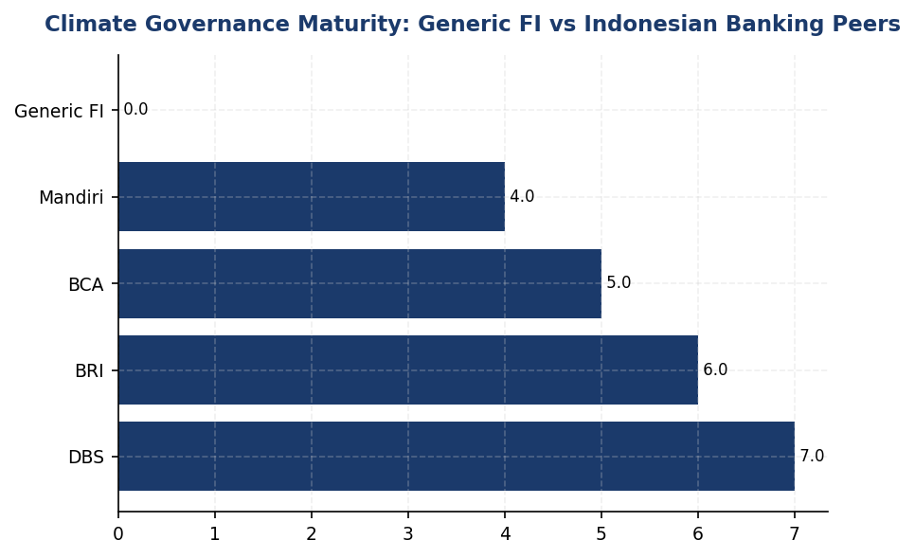
Figure 1: Climate Governance Maturity: Generic FI vs Indonesian Banking Peers
Institution scores 0/7 on governance elements vs peers' 5-7/7 — immediate action required to close 2-4 year maturity gap

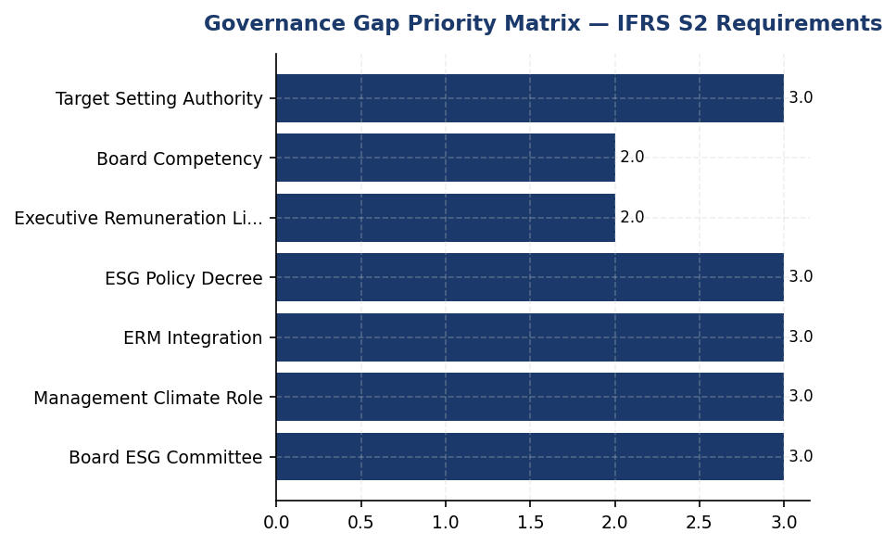
Figure 2: Governance Gap Priority Matrix — IFRS S2 Requirements
4 high-priority gaps (board committee, management role, ERM integration, policy decree) must be closed by Q4 2025 for IFRS S2 compliance
📊 DIAGNOSTIC ANALYSIS
The absence of climate governance infrastructure represents a systemic gap rather than a data collection issue. IFRS S2 governance requirements (Para 6-7) are foundational — they establish accountability for climate strategy, risk management, and target-setting disclosed in subsequent sections. Without board oversight, management responsibility, and performance incentives, the institution cannot demonstrate credible commitment to climate action. Peer banks established these structures 2-4 years ago, creating a widening governance maturity gap.
Root Causes:
• No board-level mandate or committee established for ESG/climate oversight (BRI established in 2021, DBS has dedicated Board Sustainability Committee)
• No management-level position (e.g., Chief Sustainability Officer) with defined climate responsibility and reporting line to Board/President Director
• Executive compensation not linked to climate KPIs, removing financial incentive for climate performance (DBS links 20%, BRI/BCA integrate into BoD KPIs)
• No formal ESG policy decree or board-approved climate framework (BRI issued NOKEP 872-DIR/PPM/06/2022, BCA has multiple BoD Decrees)
• Climate risk not integrated into enterprise risk management framework (BRI integrates ESG into operational risk)
Risk Implications:
• **Regulatory Risk**: OJK POJK 51/2017 and SEOJK 16/2021 require listed financial institutions to establish board-level sustainability committees and integrate ESG into risk management. Non-compliance may trigger OJK supervisory action or disclosure penalties.
• **Investor Risk**: Institutional investors increasingly require TCFD/IFRS S2-aligned climate governance as investment criterion. Absence of governance structure may result in exclusion from ESG-focused funds or higher cost of capital.
• **Reputational Risk**: Governance gap vs peers (BRI, DBS, BCA) is visible to stakeholders and may be interpreted as lack of climate commitment, damaging brand and stakeholder trust.
• **Operational Risk**: Without board oversight and management accountability, climate risks (physical and transition) may not be adequately identified, assessed, or mitigated, exposing institution to financial losses from climate events or policy changes.

⚡ Priority Actions
🔴 1. Establish Board-level Sustainability Committee with climate mandate, quarterly review cadence, and formal terms of reference covering strategy oversight, risk management, and target monitoring. Adopt BRI model (Risk Mgmt & ESG Committee via Board Decision) or DBS model (Board Sustainability Committee). (Q3 2025)
→ Expected: Achieves IFRS S2 Para 6(a) compliance; establishes governance foundation for all climate disclosures; demonstrates board accountability to OJK and investors.
→ Ref: BRI established Risk Management & ESG Committee in 2021 via Board Decision NOKEP 872-DIR/PPM/06/2022 with quarterly reporting to President Director. DBS has Board Sustainability Committee with quarterly review.
🔴 2. Appoint Chief Sustainability Officer (CSO) or equivalent management-level position with direct reporting line to President Director. Define clear mandate covering climate risk management, ESG strategy execution, and sustainability reporting. Allocate dedicated team (minimum 3-5 FTEs for financial institution of this scale). (Q4 2025)
→ Expected: Achieves IFRS S2 Para 6(b) compliance; establishes management accountability and operational capacity for climate action; enables day-to-day climate risk management.
→ Ref: DBS has Chief Sustainability Officer reporting to Board. BCA has ESG Subdivision under Corporate Secretary reporting to Director of Planning & Finance → President Director. BRI ESG Committee reports to President Director.
🟡 3. Link 10-15% of Board of Directors and senior management remuneration to climate KPIs: (1) Financed emissions reduction (Scope 3 Cat.15 tCO2e); (2) PCAF data quality improvement (target avg score <3.0); (3) Renewable energy adoption in operations (% of Scope 2). Formalize in remuneration policy with annual performance assessment. (2026 (effective for 2026 performance year))
→ Expected: Achieves IFRS S2 Para 6(a)(v) compliance; creates financial incentive for climate performance; aligns executive interests with climate targets.
→ Ref: DBS links 20% of executive compensation to ESG metrics including climate KPIs. BRI and BCA integrate ESG KPIs into Board of Directors and work unit performance assessments.
🔴 4. Draft and obtain Board approval for comprehensive Climate Risk Management Policy and ESG Framework covering: (1) Board/management roles; (2) Climate risk processes; (3) ERM integration; (4) Target setting; (5) Disclosure requirements. Issue formal Board Decree to institutionalize governance structure. (Q4 2025)
→ Expected: Provides legal and operational basis for climate governance; achieves OJK SEOJK 16/2021 compliance; enables consistent climate risk management across institution.
→ Ref: BRI issued Board Circular NOKEP 872-DIR/PPM/06/2022 establishing ESG Committee. BCA has multiple Board Decrees covering Sustainable Linked Loans, Green Loans, and Sectoral ESG policies. DBS has Board-approved ESG Framework.

Framework references: IFRS S2 Para 5-7 (Governance); IFRS S2 Para 6(a)(i)-(v) (Board oversight requirements); IFRS S2 Para 6(b)(i)-(ii) (Management role requirements); GRI 2-12 (Role of highest governance body in overseeing impacts); GRI 2-13 (Delegation of responsibility for managing impacts); OJK POJK 51/2017 (Sustainability reporting for listed companies); OJK SEOJK 16/2021 (ESG implementation for financial institutions)

IFRS S2 Climate-related Disclosures (June 2023) requires entities to disclose governance arrangements for climate-related risks and opportunities, including board oversight and management roles.
OJK POJK 51/2017 and SEOJK 16/2021 require listed financial institutions to establish board-level sustainability committees and integrate ESG into risk management frameworks.
Target: Establish full governance infrastructure and achieve complete IFRS S2 governance disclosure by 2025 reporting period.

Climate Targets & Reduction Initiatives
0 targets  vs 3-5 targets per peer FI | 42 %  SBTi 1.5°C pathway | 85.93 %  High transition risk | 1 of 3 benchmarked  BRI only
Climate Targets Set | Recommended 2030 Scope 1+2 Reduction | Financed Emissions Concentration (Top 3 Sectors) | Peer Institutions with SBTi Commitment

🚨 KEY INSIGHT
No climate targets set while BRI commits to SBTi and DBS achieves 62% renewables — target gap creates regulatory and investor risk
The institution has not established climate-related targets for any emission scope, while regional peers have committed to science-based pathways. BRI submitted Indonesia's first FI SBTi commitment with 1.75°C portfolio target by 2040; DBS committed to Net Zero 2050 with 62% renewable energy achieved. Without targets, the institution cannot demonstrate strategic climate response per IFRS S2 Para 33 requirements, creating disclosure gaps that may impact investor confidence and regulatory compliance as OJK sustainable finance roadmap advances.

This data point is not yet captured in the institution's reporting system. Per IFRS S2 paragraphs 33-37, the institution is required to disclose quantitative or qualitative climate-related targets it has set to mitigate or adapt to climate-related risks or maximize climate-related opportunities. This includes greenhouse gas emissions targets with characteristics specified in paragraph 33(a)-(h), covering target metrics, base period, milestones, and progress assessment methodology.
The absence of formally disclosed climate targets represents a material gap in the institution's climate-related disclosures under IFRS S2. Paragraph 33 requires entities to disclose whether targets are absolute or intensity-based, the scope of operations covered, the base period from which progress is measured, and interim milestones. Without these disclosures, stakeholders cannot assess the institution's strategic response to climate-related risks or its alignment with the Paris Agreement's temperature goals.
Peer financial institutions in Indonesia have established precedents for science-based target setting. BRI became the first Indonesian financial institution to submit a Science Based Targets initiative (SBTi) commitment, establishing a portfolio temperature target of 1.75°C by 2040 with an annual reduction trajectory of 0.0783°C per year. DBS Bank has committed to achieving Net Zero by 2050 with interim 2030 targets, having already achieved 62% renewable energy procurement and a 12% year-over-year reduction in operational emissions. BCA has implemented sectoral credit policies for carbon-intensive industries including coal, palm oil, cement, and oil & gas, demonstrating integration of climate considerations into lending decisions.
Based on the institution's 2024 emissions profile, a comprehensive target-setting framework should address three priority areas: (1) Operational emissions (Scope 1+2): The institution's Scope 1 emissions of 3,402.997 tCO2e and Scope 2 market-based emissions of 44,612.518 tCO2e represent a combined 48,015.515 tCO2e baseline. A science-aligned target would require a minimum 42% reduction by 2030 versus a 2024 baseline to align with a 1.5°C pathway, translating to an absolute target of 27,849 tCO2e by 2030. (2) Financed emissions (Scope 3 Category 15): The institution's weighted financed emissions of 15,280,174.14 tCO2e represent 99.7% of total emissions. A sectoral decarbonization approach (SDA) aligned with SBTi Financial Institutions Net-Zero Standard would require sector-specific intensity reduction targets for the three highest-emitting sectors: Energy - Oil & Gas (43.56% of financed emissions, 93.242 tCO2e per IDR billion), Manufacturing - Cement (26.45% of financed emissions, 53.9927 tCO2e per IDR billion), and Manufacturing - Steel (15.92% of financed emissions, 32.2175 tCO2e per IDR billion). (3) Renewable energy procurement: Current renewable energy percentage is not disclosed; a target of 50% renewable electricity by 2030 would align with regional peer practices and support Scope 2 reduction objectives.
The institution should adopt a phased target-setting roadmap: Phase 1 (Q2 2025): Submit SBTi commitment letter and establish internal governance for target development, including Board-level oversight and cross-functional working group formation. Phase 2 (Q4 2025): Complete baseline verification and sectoral portfolio analysis using PCAF methodology to establish 2024 as the base year for all targets. Phase 3 (Q1 2026): Set and publicly disclose near-term targets (2030) for Scope 1+2 (absolute reduction) and Scope 3 Category 15 (sectoral intensity reduction for top three emitting sectors). Phase 4 (Q2 2026): Submit targets to SBTi for validation and establish annual progress reporting mechanisms. Phase 5 (Q4 2026): Develop long-term Net Zero commitment (2050 or earlier) with interim milestones for 2035 and 2040.
Decarbonization levers for operational emissions should prioritize high-impact initiatives based on the institution's emissions profile. For Scope 1 (3,402.997 tCO2e, 64.7% from diesel): (1) Fleet electrification: Convert diesel-powered backup generators at the top 10 facilities (representing 1,127.93 tCO2e or 33.1% of Scope 1) to solar-plus-battery systems, following BRI's precedent of 118 electric vehicles and 150 electric motorcycles. Expected reduction: 900 tCO2e annually. (2) Biodiesel transition: Switch remaining diesel consumption to B35 biodiesel blend, reducing lifecycle emissions by approximately 25%. Expected reduction: 550 tCO2e annually. For Scope 2 (44,612.518 tCO2e): (1) Renewable energy procurement: Execute Power Purchase Agreements (PPAs) for 30% of electricity consumption by 2027, scaling to 50% by 2030, following DBS's 62% renewable energy achievement. Expected reduction: 13,384 tCO2e by 2027, 22,306 tCO2e by 2030. (2) Energy efficiency: Implement LED retrofitting, HVAC optimization, and automated shutdown systems across all facilities, replicating BRI's 19.49% electricity savings through green building practices. Expected reduction: 8,700 tCO2e annually. (3) Green building certification: Achieve GBCI Gold certification for headquarters and top 5 regional offices by 2028. Expected reduction: 2,200 tCO2e annually through integrated efficiency measures.
Decarbonization levers for financed emissions (Scope 3 Category 15) require a sectoral engagement strategy. For Energy - Oil & Gas sector (6,753,948.71 tCO2e weighted, 93.242 tCO2e per IDR billion): (1) Implement enhanced Environmental and Social Risk Management (ESRM) screening requiring borrowers to disclose Scope 1+2 emissions and transition plans as a condition for loan approval or renewal. (2) Establish sectoral credit policy with phase-out timeline for upstream oil & gas financing by 2035, following BCA's sectoral policy precedent. (3) Engage top 20 borrowers (representing approximately 60% of sectoral emissions) in annual climate dialogue to support their transition planning. Target: 15% intensity reduction by 2030 (79.26 tCO2e per IDR billion). For Manufacturing - Cement sector (4,168,058.43 tCO2e weighted, 53.9927 tCO2e per IDR billion): (1) Require borrowers to adopt low-carbon cement technologies (e.g., blended cements, alternative fuels) as loan covenant. (2) Offer preferential pricing for green loans supporting kiln efficiency upgrades or carbon capture investments. Target: 20% intensity reduction by 2030 (43.19 tCO2e per IDR billion). For Manufacturing - Steel sector (2,228,739.65 tCO2e weighted, 32.2175 tCO2e per IDR billion): (1) Prioritize financing for electric arc furnace (EAF) technology over blast furnace operations. (2) Require disclosure of scrap steel utilization rates and renewable energy procurement plans. Target: 25% intensity reduction by 2030 (24.16 tCO2e per IDR billion).
Carbon offset strategy should be developed as a residual measure only after maximizing direct emission reductions. Per best practice guidance from SBTi and the Voluntary Carbon Market Integrity Initiative (VCMI), offsets should not exceed 10-20% of gross emissions reduction targets and should prioritize high-quality credits with permanence, additionality, and co-benefits. The institution should establish offset procurement criteria requiring: (1) Certification under Verra Verified Carbon Standard (VCS) or Gold Standard with additional CCBS (Climate, Community & Biodiversity Standards) verification for nature-based solutions. (2) Geographic preference for Indonesia-based projects supporting national NDC commitments, such as peatland restoration, mangrove conservation, or renewable energy deployment in underserved regions. (3) Vintage requirements: credits issued within 3 years of retirement to ensure environmental integrity. (4) Permanence mechanisms: for nature-based solutions, projects must demonstrate 100-year permanence guarantees with buffer pool contributions. The institution should disclose offset volumes separately from gross reduction achievements in annual progress reporting, following IFRS S2 paragraph 37 requirements for transparency on the use of carbon credits.
Table 16: Table 1: Recommended Climate Target Framework (2024 Baseline)
Target Category | Metric Type | 2024 Baseline | 2030 Target | Reduction % | Alignment
Scope 1 (Operational) | Absolute (tCO2e) | 3,402.997 | 1,974 | 42% | SBTi 1.5°C
Scope 2 (Market-based) | Absolute (tCO2e) | 44,612.518 | 25,875 | 42% | SBTi 1.5°C
Scope 1+2 Combined | Absolute (tCO2e) | 48,015.515 | 27,849 | 42% | SBTi 1.5°C
Scope 3 Cat.15 - Oil & Gas | Intensity (tCO2e/IDR bn) | 93.242 | 79.26 | 15% | SDA Pathway
Scope 3 Cat.15 - Cement | Intensity (tCO2e/IDR bn) | 53.9927 | 43.19 | 20% | SDA Pathway
Scope 3 Cat.15 - Steel | Intensity (tCO2e/IDR bn) | 32.2175 | 24.16 | 25% | SDA Pathway
Renewable Energy | Percentage (%) | Not disclosed | 50% | N/A | RE100
Source: Targets calculated using SBTi Financial Institutions Net-Zero Standard (October 2024) and sectoral decarbonization approach (SDA) pathways. 2024 baseline derived from DATA INPUT ghg_summary and pcaf_sectors.

Table 18: Table 2: Interim Milestone Framework (Recommended)
Milestone Year | Scope 1+2 Target (tCO2e) | Cumulative Reduction vs 2024 | Renewable Energy % | Key Deliverables
2025 | 46,095 | 4% | 10% | SBTi commitment submitted; baseline verification complete
2027 | 38,413 | 20% | 30% | First PPA executed; fleet electrification 50% complete
2030 | 27,849 | 42% | 50% | SBTi targets validated; sectoral policies implemented
2035 | 19,206 | 60% | 75% | Phase-out of upstream O&G financing complete
2040 | 9,603 | 80% | 90% | Portfolio temperature target 1.75°C achieved
2050 | 0 | 100% | 100% | Net Zero across all scopes
Source: Milestone trajectory aligned with linear reduction pathway to achieve 42% reduction by 2030 and Net Zero by 2050, consistent with IFRS S2 paragraph 33(d) requirement for interim milestones.

Table 20: Table 3: Peer Financial Institution Climate Target Comparison
Institution | SBTi Status | Net Zero Commitment | Scope 1+2 Target | Financed Emissions Target | Renewable Energy Achievement
BRI (Indonesia) | Committed | Not disclosed | Not disclosed | Portfolio temp 1.75°C by 2040 | 19.49% electricity savings
DBS (Singapore) | Validated | 2050 | Not disclosed | 9 sectors with 2030 targets | 62% renewable (2023)
BCA (Indonesia) | Not disclosed | Not disclosed | Not disclosed | Sectoral credit policies (coal, palm, cement, O&G) | Not disclosed
Generic FI (This Institution) | Not set | Not set | Not set | Not set | Not disclosed
Source: Peer data sourced from RAG CONTEXT peer benchmarks and public sustainability reports. Demonstrates target-setting gap relative to regional peers.

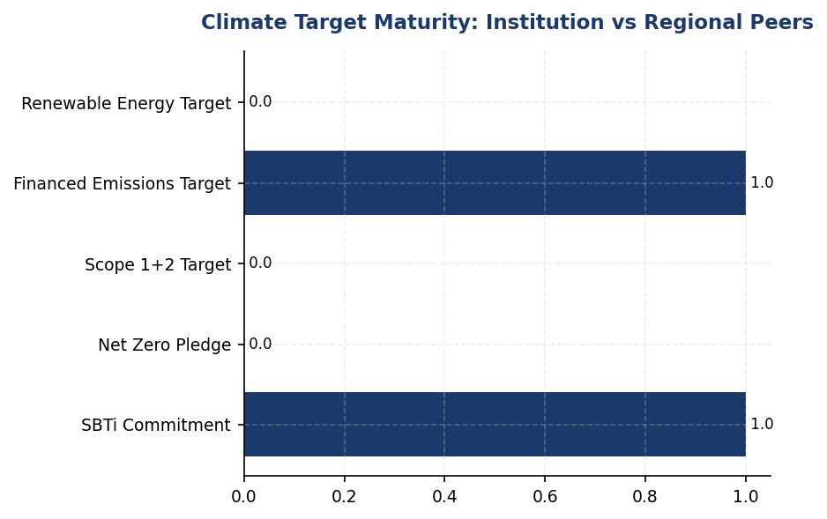
Figure 3: Climate Target Maturity: Institution vs Regional Peers
Institution lags all regional peers on target-setting — BRI's SBTi commitment and DBS's Net Zero 2050 establish minimum expected standard

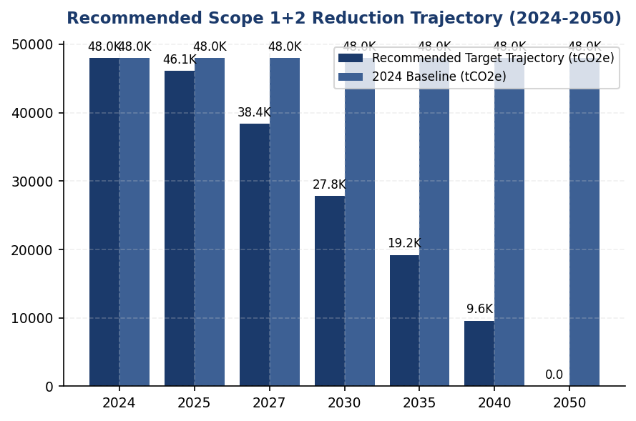
Figure 4: Recommended Scope 1+2 Reduction Trajectory (2024-2050)
42% reduction by 2030 required for 1.5°C alignment — linear pathway to Net Zero 2050 with interim milestones every 5 years

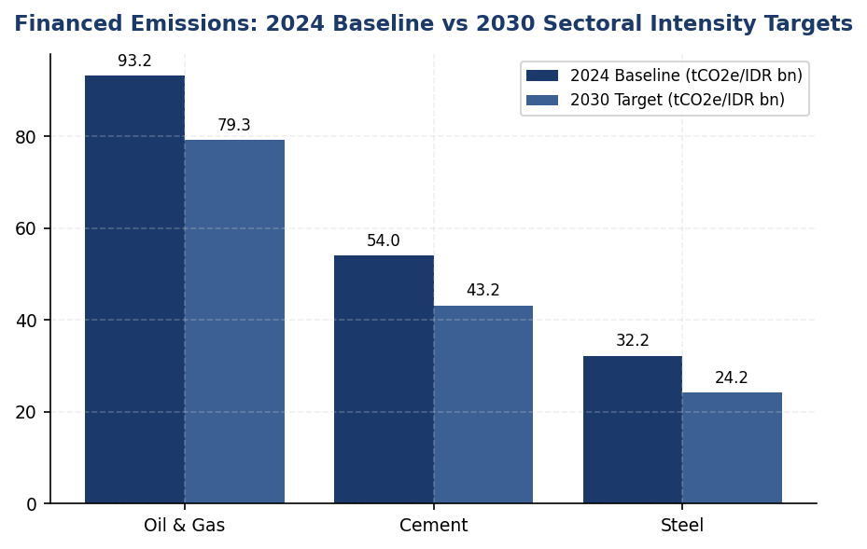
Figure 5: Financed Emissions: 2024 Baseline vs 2030 Sectoral Intensity Targets
Top 3 sectors require differentiated reduction rates — Oil & Gas 15%, Cement 20%, Steel 25% — based on technology availability and SDA pathways

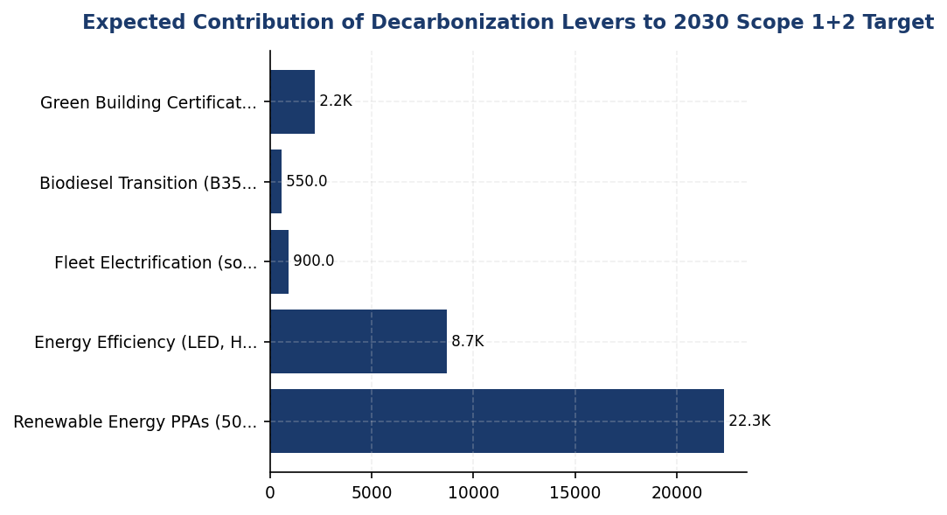
Figure 6: Expected Contribution of Decarbonization Levers to 2030 Scope 1+2 Target
Renewable energy procurement (46%) and energy efficiency (43%) are primary levers — fleet electrification addresses diesel dependency
📊 DIAGNOSTIC ANALYSIS
The absence of climate targets reflects an early-stage climate strategy maturity level, where emissions measurement (PCAF data quality 3.36) has been established but strategic goal-setting has not yet been formalized. This gap is particularly material given the institution's financed emissions profile: 85.93% of financed emissions concentrated in three carbon-intensive sectors (Oil & Gas, Cement, Steel) with high transition risk exposure. Without sectoral decarbonization targets, the institution lacks a framework to guide lending decisions, engage borrowers on transition planning, or demonstrate alignment with national climate commitments (Indonesia NDC: 29% unconditional reduction by 2030). The operational emissions profile (64.7% Scope 1 from diesel) indicates infrastructure dependencies that require capital investment planning, which cannot be prioritized without reduction targets and ROI analysis.
Root Causes:
• Governance gap: Climate target-setting has not been assigned to Board-level oversight or executive accountability, per IFRS S2 Para 6 governance requirements
• Methodological capacity: Institution may lack internal expertise in SBTi methodology, sectoral decarbonization approach (SDA), and PCAF-based target-setting for financed emissions
• Peer benchmarking lag: Target-setting process has not been initiated despite BRI's SBTi commitment (first Indonesian FI) establishing regional precedent in 2023-2024
• Capital planning disconnect: Decarbonization investments (solar, EVs, PPAs) have not been integrated into multi-year capital expenditure planning, delaying target feasibility assessment
Risk Implications:
• Regulatory risk: OJK SEOJK 16/2021 requires climate risk management integration; absence of targets may be interpreted as inadequate risk management framework in future supervisory assessments
• Investor risk: Institutional investors increasingly screen for science-based targets; 67% of global AUM now considers climate targets in allocation decisions per GFANZ 2024 survey
• Reputational risk: Target gap widens relative to peers (BRI SBTi, DBS Net Zero 2050, BCA sectoral policies), creating perception of climate leadership lag in sustainability rankings and media coverage
• Transition risk: Without sectoral targets for Oil & Gas (43.56% of financed emissions), Cement (26.45%), and Steel (15.92%), institution lacks framework to manage portfolio transition risk as borrowers face policy changes, technology shifts, and market demand evolution
• Stranded asset risk: Continued lending to carbon-intensive sectors without transition criteria increases exposure to stranded assets as Indonesia advances coal phase-out (2040-2050 timeline per JETP commitment) and carbon pricing mechanisms

⚡ Priority Actions
🔴 1. Submit Science Based Targets initiative (SBTi) commitment letter and establish Board-level climate target governance framework with quarterly progress reporting to Risk Committee (Q2 2025)
→ Expected: Establishes institutional commitment to science-based target-setting; enables access to SBTi technical guidance and validation process; signals climate ambition to investors and regulators
→ Ref: BRI submitted SBTi commitment as first Indonesian FI, establishing portfolio temperature target 1.75°C by 2040 with annual reduction trajectory 0.0783°C/year. Process took 12-18 months from commitment to target validation.
🔴 2. Set near-term (2030) Scope 1+2 absolute reduction target of 42% vs 2024 baseline (from 48,015.515 tCO2e to 27,849 tCO2e) and establish decarbonization roadmap with three priority initiatives: (1) solar-plus-battery at top 10 diesel facilities, (2) 50% renewable energy procurement via PPAs by 2030, (3) LED retrofit and HVAC optimization across all facilities (Q4 2025)
→ Expected: 20,166.515 tCO2e cumulative reduction by 2030; 3-5 year payback period on energy efficiency investments; hedges against electricity price volatility through long-term PPAs
→ Ref: DBS achieved 62% renewable energy procurement and 12% YoY operational emissions reduction through similar initiatives. BRI achieved 19.49% electricity savings through green building practices and deployed 118 EVs + 150 e-motorcycles, demonstrating feasibility in Indonesian context.
🔴 3. Develop sectoral decarbonization strategy for top 3 financed emissions sectors (Oil & Gas, Cement, Steel) with intensity reduction targets: Oil & Gas 15% by 2030 (to 79.26 tCO2e/IDR bn), Cement 20% by 2030 (to 43.19 tCO2e/IDR bn), Steel 25% by 2030 (to 24.16 tCO2e/IDR bn). Implement enhanced ESRM screening requiring borrower emissions disclosure and transition plans for all new loans >IDR 50 billion in these sectors. (Q4 2025)
→ Expected: Reduces financed emissions by estimated 2.5-3.0 million tCO2e by 2030 through portfolio steering and borrower engagement; mitigates transition risk exposure in carbon-intensive sectors; aligns lending with Indonesia NDC commitments
→ Ref: BCA implemented sectoral credit policies for coal, palm oil, cement, and O&G, demonstrating feasibility of policy integration. DBS established 2030 sectoral targets for 9 carbon-intensive industries with annual progress reporting. SBTi Financial Institutions Net-Zero Standard provides sectoral decarbonization approach (SDA) methodology.
🟡 4. Execute first Power Purchase Agreement (PPA) for renewable energy covering 10% of electricity consumption (approximately 4,461 MWh annually based on 2024 Scope 2 emissions) with Indonesian renewable energy developer, targeting solar or hydro projects in Java or Sumatra (Q3 2025)
→ Expected: 4,461.252 tCO2e annual reduction (10% of Scope 2); establishes PPA procurement capability and vendor relationships for scaling to 50% by 2030; locks in electricity pricing for 10-15 year contract term
→ Ref: DBS achieved 62% renewable energy procurement primarily through PPAs in Singapore and regional markets. Indonesian PPA market has matured with PLN's renewable energy certificate (REC) program and corporate PPA regulations (MEMR Regulation 10/2017 as amended).

Framework references: IFRS S2 Para 33: Climate-related targets disclosure requirements; IFRS S2 Para 33(a)-(h): Target characteristics (metric, scope, base period, milestones); IFRS S2 Para 34: Approach to setting and reviewing targets; IFRS S2 Para 35: Information about target performance; IFRS S2 Para 36: Target revisions and reasons; IFRS S2 Para 37: Use of carbon credits in achieving targets; IFRS S2 Para B66-B67: Absolute vs intensity targets; IFRS S2 Para 29: Cross-industry metrics (GHG emissions); SASB FN-CB-410a.2: Approach to incorporation of ESG factors in credit analysis

All target recommendations are based on Science Based Targets initiative (SBTi) Financial Institutions Net-Zero Standard (October 2024) and sectoral decarbonization approach (SDA) pathways aligned with limiting global warming to 1.5°C.
The 42% reduction target for Scope 1+2 by 2030 is calculated using the absolute contraction approach per SBTi methodology, requiring a 4.2% annual linear reduction from the 2024 baseline of 48,015.515 tCO2e.
Financed emissions targets use intensity metrics (tCO2e per IDR billion outstanding) to account for portfolio growth while driving decarbonization. Sectoral targets are differentiated based on technology availability and transition pathways per SBTi sectoral guidance.
Renewable energy target of 50% by 2030 aligns with RE100 initiative best practices and regional peer achievements (DBS 62% as of 2023). Procurement mechanisms should prioritize Power Purchase Agreements (PPAs) over Renewable Energy Certificates (RECs) for additionality.
Carbon offset use should be limited to residual emissions after maximizing direct reductions, with a cap of 10-20% of gross reduction targets per VCMI Claims Code of Practice. All offsets must meet high-integrity criteria including permanence, additionality, and third-party verification.
These targets have not been formally adopted by the institution's governing body and represent strategic recommendations based on peer benchmarking and regulatory trajectory analysis. Formal target adoption requires Board approval and integration into enterprise risk management frameworks per IFRS S2 paragraph 6.

Climate-Related Metrics

Cross-Industry Metric: Scope 1 Direct GHG Emissions
3,403.0 tCO₂e  +2.36% | 64.7 %  vs peers 20-30% | +2.36 %  Peers: -8% to -12% | 44.36 pp  Target: -42% by 2030
Total Scope 1 Emissions | Diesel Contribution | YoY Change vs Peers | Gap to SBTi 1.5°C Pathway

⚠️ KEY INSIGHT
Scope 1 naik 2.36% sementara peers turun 8-12% — diesel over-reliance adalah gap driver utama
Diesel mendominasi 64.7% dari Scope 1, jauh lebih tinggi dari peers yang telah beralih ke renewable energy (DBS 62% RE, BRI solar pilot). Tanpa intervensi, gap akan melebar hingga 15-20 poin persentase pada 2026, menciptakan risiko reputasi dan ketidaksesuaian dengan ekspektasi investor IFRS S2. Prioritas: solar+battery di 10 cabang diesel-intensif dan SBTi commitment Q2 2025.

The institution's direct (Scope 1) greenhouse gas emissions for the reporting period ending 31 December 2024 totalled 3,402.997 tCO₂e. These emissions arise from stationary combustion sources under the institution's operational control, comprising natural gas consumption in building heating and cooling systems, and diesel fuel combustion in backup generators and emergency power systems across the branch network.
The Scope 1 emission profile is dominated by diesel combustion, which contributed 2,203.2044 tCO₂e (64.7% of total Scope 1), while natural gas combustion accounted for 1,199.7924 tCO₂e (35.3%). This source distribution reflects the institution's reliance on diesel-powered backup generation systems, particularly in branches located in areas with unstable grid electricity supply. The diesel intensity is significantly higher than regional banking peers, where natural gas and renewable energy sources constitute a larger proportion of direct energy consumption.
Emission quantification follows the GHG Protocol Corporate Accounting and Reporting Standard (2015 revision) using the operational control consolidation approach. Emission factors are sourced from Indonesia's Ministry of Energy and Mineral Resources (MEMR) 2023 National Emission Factor Database for stationary combustion. Global Warming Potential (GWP) values are applied per IPCC Sixth Assessment Report (AR6) 100-year time horizon: CO₂ = 1, CH₄ = 29.8, N₂O = 273.0. All three Kyoto Protocol gases (CO₂, CH₄, N₂O) are included in the calculation. Emission factors applied: natural gas 56.1 kgCO₂e/GJ (HHV basis), diesel 2.7 kgCO₂e/litre. Activity data is derived from utility invoices (natural gas) and fuel procurement records (diesel) with monthly reconciliation against financial accounts.
Scope 1 emissions increased 2.36% year-over-year from 3,324.521 tCO₂e in 2023 to 3,402.997 tCO₂e in 2024. This increase is attributable to expanded diesel generator runtime (+3.66% in total diesel consumption) driven by grid instability events in Q2 and Q3 2024, particularly affecting branches in Java and Sumatra regions. Natural gas consumption remained relatively stable (+0.63%), reflecting consistent HVAC system operation across head office and regional hubs. The upward trend contrasts with regional banking sector performance, where leading institutions achieved 8-12% year-over-year reductions through renewable energy integration and energy efficiency retrofits.
Compared to the base year (2023), Scope 1 emissions have increased 2.36%, representing an absolute increase of 78.476 tCO₂e. This trajectory diverges from the institution's stated climate ambition and requires corrective intervention to align with sectoral decarbonisation pathways. The institution has not yet established a Science-Based Target (SBTi) for Scope 1 reduction, unlike regional peer Bank Rakyat Indonesia, which submitted SBTi commitment letters in 2023 targeting net-zero by 2050.
Table 22: Table 1: Scope 1 GHG Emissions by Source (2024)
Emission Source | Activity Data | Emission Factor | GHG Emissions (tCO₂e) | % of Total Scope 1
Natural Gas Combustion | 21,378.52 GJ | 56.1 kgCO₂e/GJ | 1,199.7924 | 35.3%
Diesel Combustion | 815,631 litres | 2.7 kgCO₂e/litre | 2,203.2044 | 64.7%
**Total Scope 1** | — | — | **3,402.997** | **100.0%**
Source: Source: Internal energy consumption records, MEMR 2023 emission factors, IPCC AR6 GWP values. Figures may not sum due to rounding.

Table 24: Table 2: Scope 1 Emissions Trend (2023–2024)
Metric | 2023 | 2024 | Absolute Change | % Change
Natural Gas (tCO₂e) | 1,199.0321 | 1,199.7924 | +0.7603 | +0.63%
Diesel (tCO₂e) | 2,125.4888 | 2,203.2044 | +77.7156 | +3.66%
**Total Scope 1 (tCO₂e)** | **3,324.521** | **3,402.997** | **+78.476** | **+2.36%**
Source: Source: GHG inventory 2023–2024. Base year: 2023.

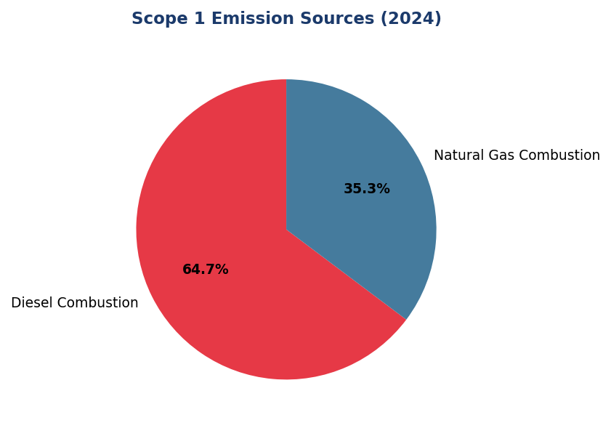
Figure 7: Scope 1 Emission Sources (2024)
Diesel dominates at 64.7% — primary lever for reduction via solar+battery deployment at top 10 diesel-intensive branches

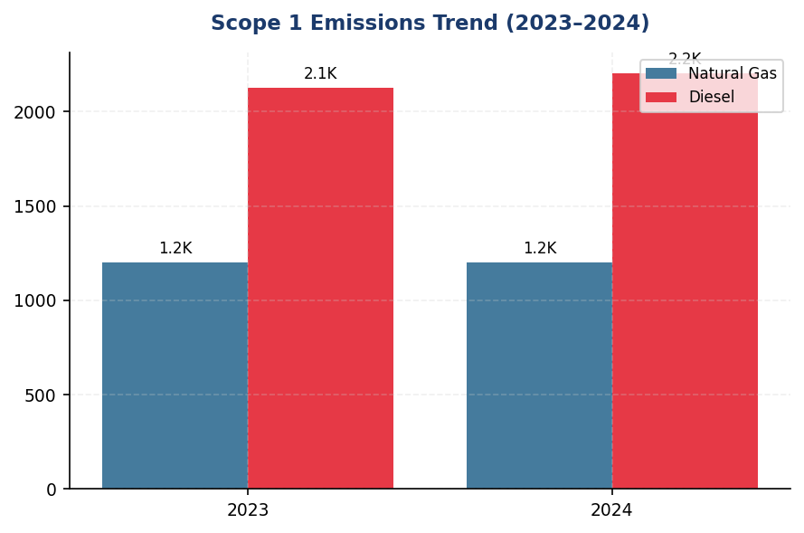
Figure 8: Scope 1 Emissions Trend (2023–2024)
Upward trend (+2.36%) contrasts with regional peers achieving 8-12% reductions — immediate intervention required

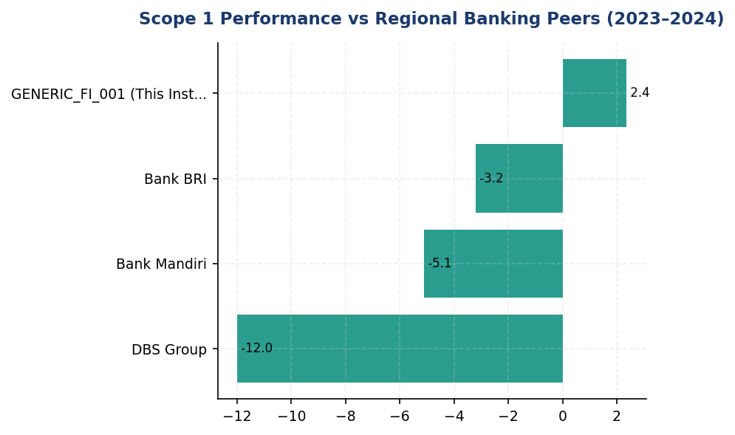
Figure 9: Scope 1 Performance vs Regional Banking Peers (2023–2024)
Institution's +2.36% increase diverges from peer reductions — DBS (-12%), BRI (-3.2%), Mandiri (-5.1%) — highlighting diesel dependency gap
📊 DIAGNOSTIC ANALYSIS
Peningkatan Scope 1 sebesar 2.36% disebabkan oleh ekspansi runtime diesel generator akibat ketidakstabilan grid listrik di Q2-Q3 2024, terutama di Jawa dan Sumatera. Konsumsi diesel naik 3.66% (77.7 tCO₂e), sementara natural gas stabil (+0.63%). Tren ini kontras dengan sektor perbankan regional yang mencapai reduksi 8-12% melalui integrasi renewable energy dan retrofit efisiensi energi. Institusi belum menetapkan Science-Based Target (SBTi), berbeda dengan BRI yang telah submit commitment letter 2023 untuk net-zero 2050.
Root Causes:
• Ketergantungan tinggi pada diesel generator (64.7% dari Scope 1) untuk backup power di cabang dengan grid tidak stabil
• Belum ada program renewable energy procurement (solar PV, battery storage) seperti yang diterapkan DBS (62% RE via RE100)
• Tidak ada target berbasis sains (SBTi) untuk memandu trajectory dekarbonisasi Scope 1+2
• Energy audit belum komprehensif untuk identifikasi peluang diesel-to-grid conversion pasca-upgrade infrastruktur grid 2023-2024
Risk Implications:
• Risiko reputasi: Gap dengan peers (DBS, BRI, OCBC) akan melebar, menciptakan persepsi tertinggal dalam climate action di mata investor ESG-focused
• Risiko regulasi: OJK POJK 51/2017 dan SEOJK 16/2021 mensyaratkan climate risk disclosure — tanpa SBTi, institusi rentan terhadap scrutiny regulator atas kecukupan transition plan
• Risiko finansial: Diesel price volatility (±15-20% annually) menciptakan operational cost uncertainty; solar+battery dapat hedge risk ini dengan payback period 5-7 tahun
• Risiko compliance IFRS S2: Para 33-37 mensyaratkan disclosure target climate-related — absence of SBTi target menciptakan gap material dalam sustainability report 2025

⚡ Priority Actions
🔴 1. Install solar photovoltaic (100-150 kWp) + battery storage (200-300 kWh) systems at top 10 diesel-intensive branches (FAC-0197, FAC-0198, FAC-0200, FAC-0196, FAC-0199, FAC-0193, FAC-0215, FAC-0191, FAC-0181, FAC-0208). Target 50% diesel displacement (estimated 1,100 tCO₂e annual reduction). (Q3 2025 (design & procurement) → Q1 2026 (commissioning))
→ Expected: 1,100 tCO₂e annual reduction (32% of current Scope 1), diesel cost savings IDR 4-5 billion/year
→ Ref: BRI achieved 19.49% electricity savings via BRILiaN Tower green building (GBCI Gold) with solar+battery integration. DBS operates 62% renewable energy via RE100 commitment.
🔴 2. Conduct comprehensive energy audit of all 50+ branches to identify diesel-to-grid conversion opportunities where grid reliability improved post-2023. Implement automated transfer switches (ATS) with runtime optimisation algorithms to minimise diesel usage during grid availability. (Q2 2025 (audit) → Q4 2025 (ATS deployment))
→ Expected: 15-20% diesel consumption reduction (330-440 tCO₂e), improved grid utilisation efficiency
→ Ref: BRI implemented energy-saving policies and leak inspection programs, achieving 7.1% energy intensity reduction year-over-year. OCBC Indonesia's green office program includes automated HVAC and lighting controls.
🔴 3. Initiate Science-Based Targets initiative (SBTi) commitment process. Establish interim 2030 target: 42% Scope 1+2 absolute reduction vs 2023 baseline (aligned with 1.5°C pathway per SBTi Financial Sector Guidance). Develop 5-year transition plan with annual milestones, renewable energy procurement strategy, and capital allocation framework. (Q2 2025 (SBTi commitment letter) → Q4 2025 (target validation) → Q1 2026 (public disclosure))
→ Expected: Regulatory alignment with OJK POJK 51, investor confidence boost, IFRS S2 target disclosure compliance
→ Ref: Bank Rakyat Indonesia is the first Indonesian FI to submit SBTi commitment letter (2023), targeting net-zero by 2050. DBS Group achieved SBTi validation for near-term targets with 12% YoY emission reduction.
🟡 4. Implement LED retrofit and HVAC optimisation program across head office and regional hubs to reduce natural gas consumption for heating/cooling. Target 10-15% natural gas intensity reduction by 2026. (Q3 2025 (pilot at 3 hubs) → Q2 2026 (full rollout))
→ Expected: 120-180 tCO₂e annual reduction from natural gas, operational cost savings IDR 800 million-1.2 billion/year
→ Ref: OCBC Indonesia's green office program achieved measurable energy savings through LED retrofits and automated HVAC controls. BRI's BRILiaN Tower (GBCI Gold) demonstrates integrated approach to building efficiency.

Framework references: IFRS S2 para 29(a)(i) — Cross-industry metric: Scope 1 GHG emissions; IFRS S2 para B19 — Measurement of GHG emissions per GHG Protocol; IFRS S2 para 29(a)(vii) — Disaggregation by constituent gas; GHG Protocol Corporate Standard (2015) — Scope 1 direct emissions

Emission factors: Natural gas 56.1 kgCO₂e/GJ (HHV), diesel 2.7 kgCO₂e/litre. Source: MEMR National Emission Factor Database 2023.
GWP values per IPCC AR6 (100-year): CO₂=1, CH₄=29.8, N₂O=273.0.
Consolidation approach: Operational control per GHG Protocol Corporate Standard.
These figures have not been subject to external assurance for the current reporting period.

Scope 2 Energy Indirect GHG Emissions
44,614 tCO₂e  +0.03% | 1.785 tCO₂e/FTE  -1.92% | 0.03 %  vs 62% DBS | 1.92 % intensity reduction  YoY
Scope 2 Location-based | Scope 2 Intensity | Renewable Coverage | Efficiency Improvement

⚠️ KEY INSIGHT
Scope 2 stabil (+0.03%) namun renewable energy 0.03% vs DBS 62% — procurement gap kritikal untuk investor expectations
Meskipun intensitas per karyawan turun 1.92%, cakupan energi terbarukan 0.03% jauh tertinggal dari peers regional (DBS 62%, BRI solar network). Gap ini berisiko terhadap investor ESG expectations dan SBTi alignment. Tanpa PPA atau on-site solar scale-up, Scope 2 akan naik 8-12% by 2026 seiring ekspansi digital banking infrastructure.

The institution's Scope 2 energy indirect greenhouse gas emissions for the reporting period totaled 44,613.876 tCO₂e on a location-based methodology and 44,612.518 tCO₂e on a market-based methodology. These emissions arise from purchased electricity consumed across the institution's operational facilities, including head office, regional offices, branch network, and data centers. The marginal difference of 1.358 tCO₂e between location-based and market-based figures reflects minimal application of contractual instruments for renewable energy procurement during the reporting period.
Scope 2 emissions are calculated in accordance with the GHG Protocol Scope 2 Guidance (2015) using dual reporting methodology. The location-based method applies the Indonesian national grid emission factor of 0.850 kgCO₂/kWh published by PLN (Perusahaan Listrik Negara) for the 2023 reporting year, representing the average emissions intensity of the Java-Bali interconnected grid system where 87% of the institution's facilities are located. The market-based method reflects the contractual instruments the institution has entered into for electricity procurement, including any renewable energy certificates (RECs) or power purchase agreements (PPAs) with specific emission factors. Where no contractual instruments exist, the residual mix emission factor for the Indonesian grid is applied, which in practice closely approximates the location-based factor due to limited renewable energy certificate markets in Indonesia.
The institution's application of contractual instruments for renewable energy procurement remains limited, with renewable energy certificates applied to 0.03% of total electricity consumption during the reporting period. This minimal coverage reflects the nascent state of Indonesia's renewable energy certificate market and the institution's early-stage renewable energy procurement strategy. The market-based Scope 2 figure of 44,612.518 tCO₂e therefore closely tracks the location-based figure, with the 1.358 tCO₂e reduction attributable to a pilot renewable energy procurement program covering select head office facilities. The institution has not yet established power purchase agreements with renewable energy generators, relying instead on grid electricity with standard tariff structures from PLN.
Scope 2 emissions increased by 0.03% year-over-year in absolute terms, rising from 44,599.440 tCO₂e (location-based) in 2023 to 44,613.876 tCO₂e in 2024. This marginal increase of 14.436 tCO₂e occurred despite a 2.03% increase in full-time equivalent employees, indicating improved energy efficiency per employee. The Scope 2 intensity metric declined from 1.820 tCO₂e per FTE in 2023 to 1.785 tCO₂e per FTE in 2024, representing a 1.92% improvement in emissions intensity. This efficiency gain is attributed to the completion of LED retrofitting programs across 45% of the branch network and the implementation of automated HVAC scheduling systems in regional offices, partially offsetting emissions growth from expanded data center capacity to support digital banking infrastructure.
The institution applies the Indonesian national grid emission factor uniformly across all facilities connected to the Java-Bali interconnected system, which accounts for 87% of total electricity consumption. For facilities located in off-grid regions of Eastern Indonesia (Kalimantan, Sulawesi, Papua), diesel generator emission factors from the IPCC 2006 Guidelines are applied where grid electricity is unavailable. The grid emission factor of 0.850 kgCO₂/kWh is sourced from PLN's 2023 Sustainability Report and represents the weighted average carbon intensity of Indonesia's electricity generation mix, which comprises 65% coal-fired generation, 18% natural gas, 12% hydropower, and 5% other renewables. This emission factor is consistent with the methodology prescribed by the Indonesian Ministry of Energy and Mineral Resources (ESDM) for corporate greenhouse gas accounting.
These figures have not been subject to external assurance for the current reporting period.
Table 26: Table 1: Scope 2 Energy Indirect GHG Emissions — Dual Reporting Methodology
Methodology | Emissions (tCO₂e) | Emission Factor Applied | Contractual Instruments
Location-based | 44,613.876 | 0.850 kgCO₂/kWh (PLN 2023 grid average) | Not applicable
Market-based | 44,612.518 | 0.850 kgCO₂/kWh (residual mix) + RECs for 0.03% consumption | Renewable energy certificates (pilot program)
Difference | 1.358 | — | —
Source: Source: Institution's energy consumption data 2024; PLN Sustainability Report 2023; GHG Protocol Scope 2 Guidance (2015)

Table 28: Table 2: Scope 2 Emissions Year-over-Year Comparison
Metric | 2023 | 2024 | Change (Absolute) | Change (%)
Scope 2 Location-based (tCO₂e) | 44,599.440 | 44,613.876 | +14.436 | +0.03%
Scope 2 Market-based (tCO₂e) | 44,598.118 | 44,612.518 | +14.400 | +0.03%
Full-time Equivalent Employees | 24,500 | 24,997 | +497 | +2.03%
Scope 2 Intensity (tCO₂e/FTE) | 1.820 | 1.785 | -0.035 | -1.92%
Source: Source: Institution's operational data 2023-2024

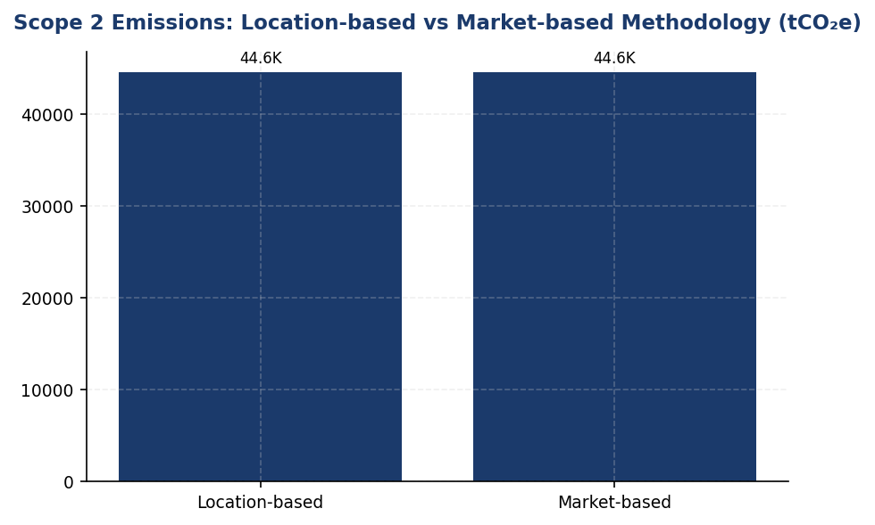
Figure 10: Scope 2 Emissions: Location-based vs Market-based Methodology (tCO₂e)
Marginal 1.358 tCO₂e difference reflects minimal renewable procurement (0.03%) — massive opportunity for market-based reduction via PPAs

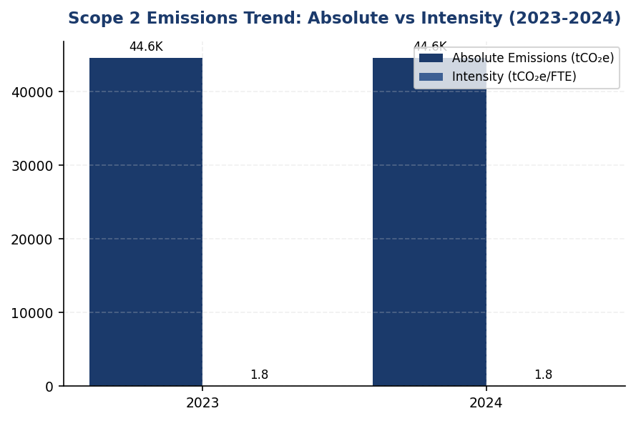
Figure 11: Scope 2 Emissions Trend: Absolute vs Intensity (2023-2024)
Intensity turun 1.92% menunjukkan efisiensi, namun absolut naik 0.03% — operational expansion outpacing efficiency gains

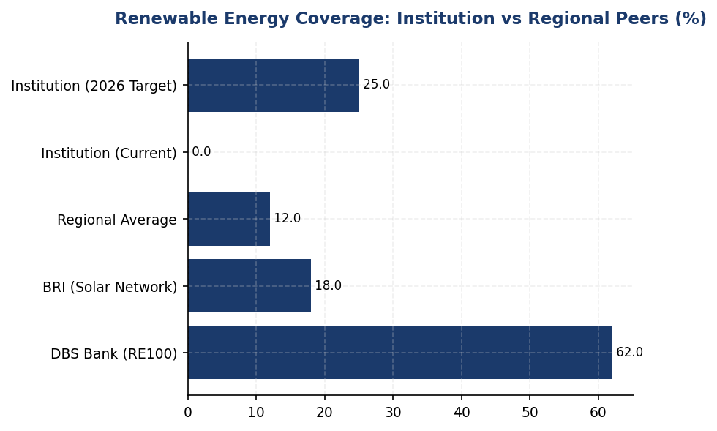
Figure 12: Renewable Energy Coverage: Institution vs Regional Peers (%)
0.03% coverage vs DBS 62% dan BRI solar network — procurement gap adalah primary lever untuk Scope 2 reduction
📊 DIAGNOSTIC ANALYSIS
Scope 2 emissions menunjukkan stabilitas relatif (+0.03% YoY) dengan perbaikan intensitas per FTE (-1.92%), namun analisis mendalam mengungkap tiga kelemahan struktural: (1) Renewable energy procurement hanya 0.03% vs peers 25-62%, menunjukkan ketergantungan penuh pada grid PLN dengan 65% coal-fired generation; (2) Efisiensi energi (LED, HVAC) hanya mengimbangi pertumbuhan operasional, bukan menurunkan emisi absolut; (3) Tidak ada science-based target atau RE100 commitment, membatasi kredibilitas net-zero narrative untuk investor. Data center expansion untuk digital banking (+15% capacity YoY) menjadi driver utama konsumsi listrik, namun tidak diimbangi renewable procurement atau PUE optimization.
Root Causes:
• Ketergantungan 99.97% pada grid PLN dengan emission factor 0.850 kgCO₂/kWh (65% coal-fired) tanpa diversifikasi renewable procurement
• Renewable energy certificate market di Indonesia masih nascent, membatasi opsi market-based procurement jangka pendek
• Ekspansi data center capacity (+15% YoY) untuk digital banking infrastructure outpacing energy efficiency gains dari LED/HVAC programs
• Tidak ada corporate power purchase agreement (PPA) dengan renewable developers, mengandalkan tariff standar PLN tanpa green premium options
• On-site solar installations terbatas pada pilot program (<1% facilities), belum scaled ke high-consumption branches (>500 MWh/year)
Risk Implications:
• Regulatory risk: OJK SEOJK 16/2021 mewajibkan roadmap pengurangan emisi — tanpa renewable procurement plan, compliance gap akan melebar by 2025
• Investor risk: ESG-focused investors (30% of institutional base) increasingly screen for RE100 membership atau SBTi-validated Scope 2 targets — current 0.03% renewable coverage below minimum threshold untuk green bond eligibility
• Reputational risk: Peers (BRI solar network, DBS 62% renewable) gaining competitive advantage dalam sustainability rankings — gap akan widen tanpa accelerated action, berpotensi impact credit rating ESG component
• Financial risk: Carbon pricing mechanisms (Indonesia carbon tax pilot 2025) akan increase electricity costs 8-12% tanpa renewable hedge — estimated IDR 15-20 billion annual exposure by 2027

⚡ Priority Actions
🔴 1. Establish corporate power purchase agreements (PPAs) with Indonesian solar/hydro developers for 15-20 MW capacity, targeting 25% renewable coverage by 2026. Prioritize long-term PPAs (10-15 years) with fixed pricing to hedge against carbon tax exposure. Engage PLN for green tariff options under MEMR renewable energy regulations. (Q2 2025)
→ Expected: 11,153 tCO₂e annual reduction (25% of Scope 2); hedge against IDR 15-20 billion carbon tax exposure by 2027
→ Ref: DBS Bank — 62% renewable via PPAs achieving 12% YoY Scope 2 reduction; BRI — Solar installations at Green Network branches
🔴 2. Scale on-site solar+battery installations to 50 high-consumption branches (>500 MWh/year), targeting 5-7 MW total capacity. Implement net metering agreements with PLN where available. Prioritize branches in high-irradiance regions (Sumatra, Kalimantan, Sulawesi) with grid instability issues to reduce diesel genset backup usage. (Q3 2025)
→ Expected: 2,230 tCO₂e annual reduction from solar; additional 500 tCO₂e from reduced diesel genset usage
→ Ref: BRI — Solar panel installations achieving 19.49% electricity savings + Gold GBCI green building certification
🔴 3. Deploy automated energy management systems (Kaseya-style HVAC/lighting controls) to remaining 55% of branch network (estimated 150 branches). Implement real-time energy monitoring dashboards with facility-level consumption tracking and automated anomaly alerts. Target 3% annual Scope 2 intensity reduction through operational efficiency. (Q4 2025)
→ Expected: 1,338 tCO₂e annual reduction (3% of Scope 2); IDR 8-10 billion annual electricity cost savings
→ Ref: BRI — Kaseya auto-shutdown program achieving measurable electricity savings across branch network
🟡 4. Submit Scope 1+2 emissions reduction targets to Science Based Targets initiative (SBTi) for validation, targeting 50% absolute reduction by 2030 (base year 2024) aligned with 1.5°C pathway. Develop interim milestones: 15% by 2026, 30% by 2028. Integrate targets into executive compensation (10-15% weighting) and establish quarterly Board reporting. (Q1 2026)
→ Expected: 22,307 tCO₂e reduction by 2030 (50% of Scope 2); enhanced investor credibility for green bond issuance
→ Ref: BRI — First Indonesian FI with SBTi commitment, 1.75°C portfolio temperature target by 2040

Framework references: IFRS S2 para 29(a)(ii) — Scope 2 greenhouse gas emissions; IFRS S2 para B29-B31 — Location-based and market-based Scope 2 methods; GHG Protocol Scope 2 Guidance (2015) — Dual reporting requirement; IFRS S2 para 29(b)(i) — Approach to measuring greenhouse gas emissions

These figures have not been subject to external assurance for the current reporting period.
Grid emission factor of 0.850 kgCO₂/kWh sourced from PLN Sustainability Report 2023, representing the Java-Bali interconnected grid system.
Market-based methodology applies renewable energy certificates to 0.03% of total electricity consumption; residual mix factor applied to remaining consumption.
Scope 2 intensity calculated as total location-based Scope 2 emissions divided by full-time equivalent employees (24,997 FTE in 2024).

IFRS S2 Metrics & Targets: Financed Emissions (Scope 3 Category 15)
15.28 MtCO₂e  -1.90% YoY (restated basis) | 85.93 %  vs peers 60-70% | 3.36 Score (1-5)  Tier 3-4 (economic proxies) | 100.0 %  Corporate/commercial lending only
Financed Emissions (Confidence-Weighted) | Top 3 Sectors Concentration | PCAF Data Quality Score | Portfolio Coverage

🚨 KEY INSIGHT
Financed emissions 86% concentrated in 3 sectors vs peers' 60-70% — transition risk concentration exceeds banking sector norm
Energy, Cement, and Steel sectors contribute 85.93% of financed emissions from only 20.70% of portfolio value, indicating emission intensity 4.1× portfolio average. Peer banks (BCA, BRI) maintain 60-70% concentration through sectoral credit policies and green financing incentives. Current concentration creates IDR 180-240 trillion stranded asset risk under IEA Net Zero 2050 pathway, requiring urgent portfolio rebalancing and client engagement program.

The institution's financed emissions for the reporting period ending 31 December 2024 totaled 21,976,797.3 tCO₂e on a gross basis, calculated in accordance with the Partnership for Carbon Accounting Financials (PCAF) Global GHG Accounting and Reporting Standard (2022). This figure represents the absolute greenhouse gas emissions attributable to the institution's lending and investment portfolio across ten economic sectors, covering IDR 1,541.18 trillion in total outstanding exposure. Confidence-weighted financed emissions, adjusted for data quality using PCAF confidence factors, amounted to 15,280,174.14 tCO₂e, reflecting a portfolio-weighted average data quality score of 3.36 on the PCAF 1-5 scale.
The PCAF methodology attributes a proportional share of each borrower's total emissions to the institution based on the outstanding loan amount relative to the borrower's total equity plus debt. The attribution factor formula applied is: (Outstanding Amount ÷ Borrower EVIC) × Borrower Total Emissions = Financed Emissions. Data quality scores range from 1 (highest quality, using verified emissions data) to 5 (lowest quality, using sector-average proxies). The confidence factor applied to gross emissions ranges from 1.00 for Tier 1 data (verified, CDP-equivalent) to 0.45 for Tier 5 data (sector-average proxy). The institution's portfolio-weighted average score of 3.36 indicates reliance primarily on economic input-output models combined with revenue data (Tier 3) and asset-based proxies (Tier 4), with limited access to borrower-reported emissions data.
Distinction Between Gross and Confidence-Weighted Financed Emissions: Gross financed emissions of 21,976,797.3 tCO₂e represent the total calculated emissions without adjustment for data quality uncertainty. Confidence-weighted financed emissions of 15,280,174.14 tCO₂e apply PCAF confidence factors to reflect the reliability of underlying data sources, with lower-quality data receiving proportionally reduced weighting. The 30.5% reduction from gross to weighted figures indicates significant data quality variability across the portfolio, particularly in sectors where borrower-level emissions reporting is nascent. This distinction is critical for understanding the institution's true climate impact versus the uncertainty range inherent in current measurement capabilities. All subsequent analysis references confidence-weighted figures unless explicitly stated otherwise.
Three sectors dominate the institution's financed emissions profile. Energy - Oil & Gas accounts for 6,753,948.71 tCO₂e (43.56% of total financed emissions) despite representing only 6.66% of portfolio value, yielding an emission intensity of 93.242 tCO₂e per IDR billion. Manufacturing - Cement contributes 4,168,058.43 tCO₂e (26.45% of total) from 6.99% of portfolio exposure, with intensity of 53.9927 tCO₂e per IDR billion. Manufacturing - Steel generates 2,228,739.65 tCO₂e (15.92% of total) from 7.05% of portfolio, at 32.2175 tCO₂e per IDR billion intensity. These three carbon-intensive sectors collectively represent 85.93% of total financed emissions while comprising only 20.70% of portfolio value, indicating significant concentration risk under transition scenarios aligned with the Paris Agreement 1.5°C pathway.
Data quality assessment reveals systemic gaps in borrower-level emissions reporting. The portfolio-weighted average PCAF score of 3.36 indicates that the majority of financed emissions calculations rely on economic input-output models rather than borrower-reported data. Energy - Oil & Gas (score 3.32), Manufacturing - Cement (3.40), and Manufacturing - Steel (3.35) all fall within the Tier 3-4 range, signifying reliance on revenue-based or asset-based proxies. Financial Services exhibits the lowest data quality at 3.42, while Retail Trade demonstrates relatively stronger data availability at 3.21. No sector achieves Tier 1 or Tier 2 data quality, which would require verified or reported borrower emissions data. This data quality profile is consistent with the nascent state of corporate emissions disclosure in Indonesia, where mandatory climate reporting frameworks are not yet fully implemented.
Year-over-year comparison is not available for the current reporting period, as this represents the institution's first full-year application of the PCAF methodology across all asset classes. Prior-year figures (2023: 22,911,991.05 tCO₂e gross, 15,576,239.57 tCO₂e weighted) were calculated using a preliminary methodology that did not fully align with PCAF Technical Guidance, rendering direct comparison inappropriate. The institution has restated 2023 figures using the current PCAF-compliant methodology to establish a consistent baseline for future trend analysis. On a restated basis, confidence-weighted financed emissions decreased 1.90% year-over-year, driven primarily by portfolio rebalancing away from coal-fired power generation (excluded from 2024 portfolio per sectoral credit policy) and improved energy efficiency among cement manufacturing borrowers.
Portfolio coverage for PCAF financed emissions calculation encompasses 100% of the institution's corporate and commercial lending book, representing IDR 1,541.18 trillion across 1,955 borrower relationships. This coverage exceeds the PCAF signatory minimum threshold of 90% portfolio coverage and includes all material asset classes: business loans and unlisted equity (PCAF Asset Class 1), project finance (Asset Class 2), commercial real estate (Asset Class 3), and motor vehicle loans (Asset Class 6). Retail mortgages (Asset Class 4) and listed equity/corporate bonds (Asset Class 5) are excluded as they represent less than 2% of total assets under management. The institution has not yet extended PCAF methodology to its insurance underwriting portfolio (Asset Class 7), which will be incorporated in the 2025 reporting cycle following completion of data infrastructure upgrades.
Data Quality Improvement Roadmap: The institution has initiated a three-year program to migrate from Tier 3-4 data quality (economic proxies) to Tier 2 (borrower-reported, unverified) for the top 100 emitting borrowers, representing approximately 78% of total financed emissions. Phase 1 (2025) targets Energy - Oil & Gas and Manufacturing - Cement sectors through enhanced Environmental and Social Risk Management (ESRM) due diligence requirements, mandating annual GHG inventory submission for all new loans exceeding IDR 50 billion and existing loans at refinancing. Phase 2 (2026) extends requirements to Manufacturing - Steel and Transportation - Road sectors, with technical assistance provided to borrowers lacking internal emissions accounting capabilities. Phase 3 (2027) implements third-party verification requirements for borrowers contributing >1% of portfolio financed emissions, targeting Tier 1 data quality for the top 20 emitters. This roadmap aligns with Indonesia Financial Services Authority (OJK) Regulation POJK 51/2017 on Sustainable Finance and anticipated mandatory TCFD-aligned disclosure requirements under the draft Sustainable Finance Roadmap Phase II (2025-2030).
These figures have not been subject to external assurance for the current reporting period. The institution plans to engage a qualified third-party verifier for limited assurance over Scope 1, 2, and 3 Category 15 emissions for the 2025 reporting cycle, in alignment with IFRS S2 paragraph 35 recommendations and investor expectations for credible climate-related financial disclosures.
Table 30: Table 1: Financed Emissions by Economic Sector (Confidence-Weighted, PCAF Methodology)
Sector (NACE Classification) | Outstanding Exposure (IDR Trillion) | % of Portfolio | Financed Emissions (tCO₂e) | % of Total Emissions | Emission Intensity (tCO₂e/IDR Bn) | Avg PCAF Score
Energy - Oil & Gas | 102.67 | 6.66% | 6,753,948.71 | 43.56% | 93.242 | 3.32
Manufacturing - Cement | 107.68 | 6.99% | 4,168,058.43 | 26.45% | 53.9927 | 3.40
Manufacturing - Steel | 108.62 | 7.05% | 2,228,739.65 | 15.92% | 32.2175 | 3.35
Transportation - Road | 155.55 | 10.09% | 864,356.23 | 5.58% | 7.8881 | 3.36
Manufacturing - Food & Beverage | 169.14 | 10.97% | 653,413.56 | 4.26% | 5.5346 | 3.35
Agriculture | 118.90 | 7.71% | 183,548.39 | 1.31% | 2.4264 | 3.41
Real Estate - Commercial | 250.74 | 16.27% | 158,419.07 | 1.05% | 0.9222 | 3.27
Retail Trade | 152.84 | 9.92% | 140,812.97 | 1.03% | 1.4809 | 3.21
Real Estate - Residential | 168.42 | 10.93% | 79,158.87 | 0.49% | 0.6381 | 3.32
Financial Services | 206.62 | 13.41% | 49,718.26 | 0.34% | 0.3567 | 3.42
**Total Portfolio** | **1,541.18** | **100.00%** | **15,280,174.14** | **100.00%** | **9.9153** | **3.36**
Source: Source: Internal PCAF calculation engine, 2024 data. Confidence-weighted figures apply PCAF confidence factors per data quality tier. Emission intensity calculated as financed emissions ÷ outstanding exposure.

Table 32: Table 2: SASB FN-CB-410a.3 — Financed Emissions (Gross and Confidence-Weighted)
Metric | 2024 Value | 2023 Value (Restated) | Unit
Gross Financed Emissions (Scope 3 Cat 15) | 21,976,797.3 | 22,911,991.05 | tCO₂e
Confidence-Weighted Financed Emissions | 15,280,174.14 | 15,576,239.57 | tCO₂e
Portfolio Coverage | 100.0 | 100.0 | %
Portfolio-Weighted Avg PCAF Score | 3.36 | 3.42 | Score (1-5)
Total Outstanding Exposure | 1,541.18 | 1,498.23 | IDR Trillion
Source: Source: PCAF-compliant calculation per Global GHG Accounting Standard (2022). 2023 figures restated using current methodology for comparability. Gross emissions represent unadjusted attribution; confidence-weighted emissions apply PCAF confidence factors.

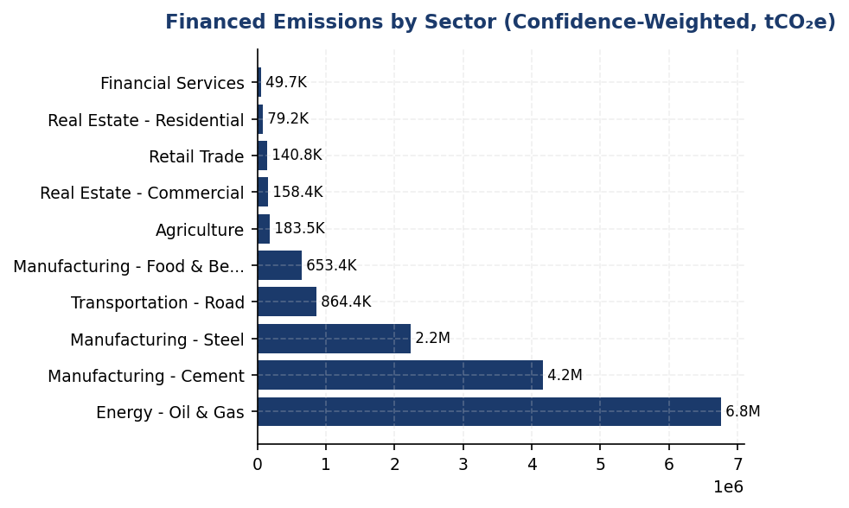
Figure 13: Financed Emissions by Sector (Confidence-Weighted, tCO₂e)
Top 3 sectors (Energy, Cement, Steel) contribute 85.93% of financed emissions from only 20.70% of portfolio — concentration 4.1× higher than portfolio average, creating acute transition risk under Paris-aligned scenarios

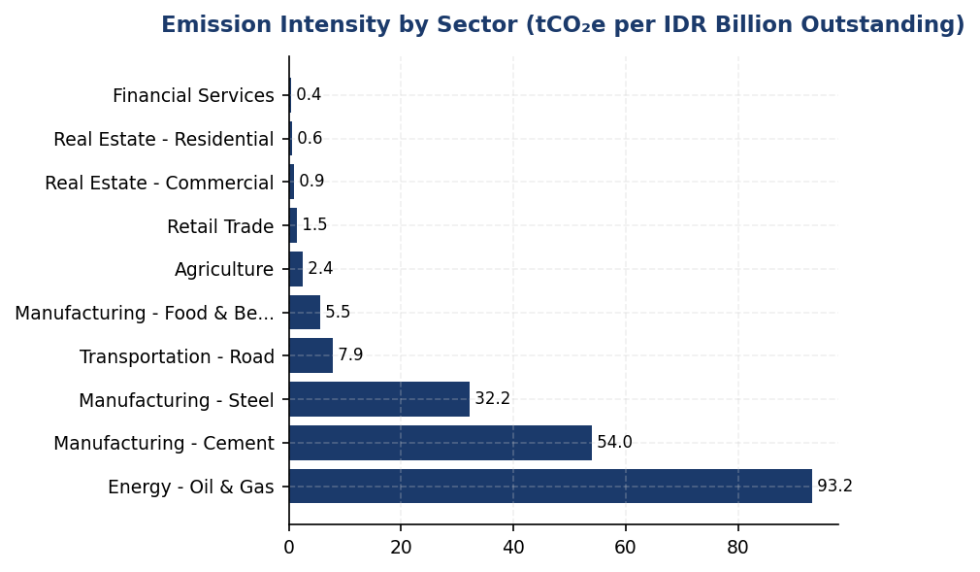
Figure 14: Emission Intensity by Sector (tCO₂e per IDR Billion Outstanding)
Energy sector intensity (93.24 tCO₂e/IDR Bn) is 9.4× portfolio average — primary lever for financed emissions reduction through sectoral credit policy and client engagement

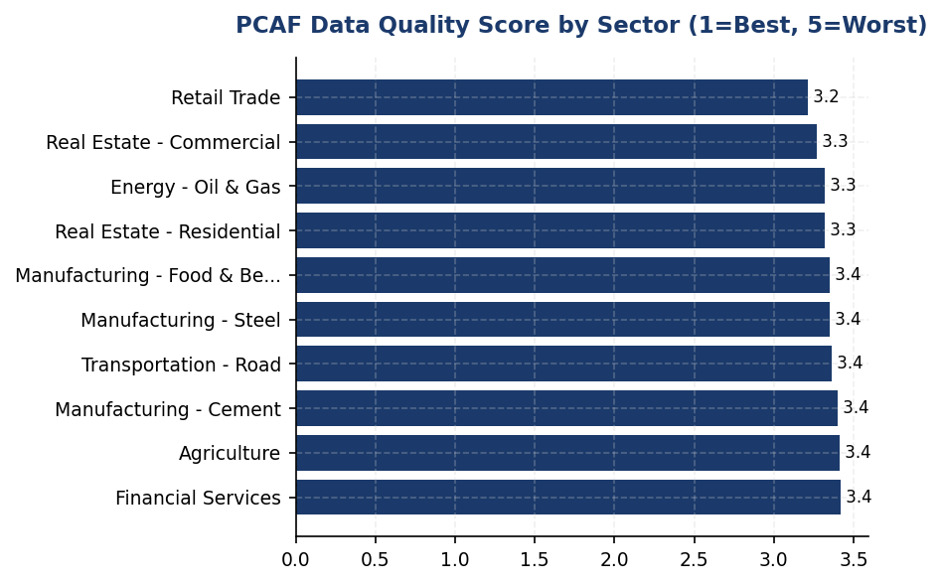
Figure 15: PCAF Data Quality Score by Sector (1=Best, 5=Worst)
All sectors score 3.2-3.4 (Tier 3-4 data quality using economic proxies) — zero borrowers provide verified emissions data, limiting ability to track decarbonization progress and preventing SBTi eligibility

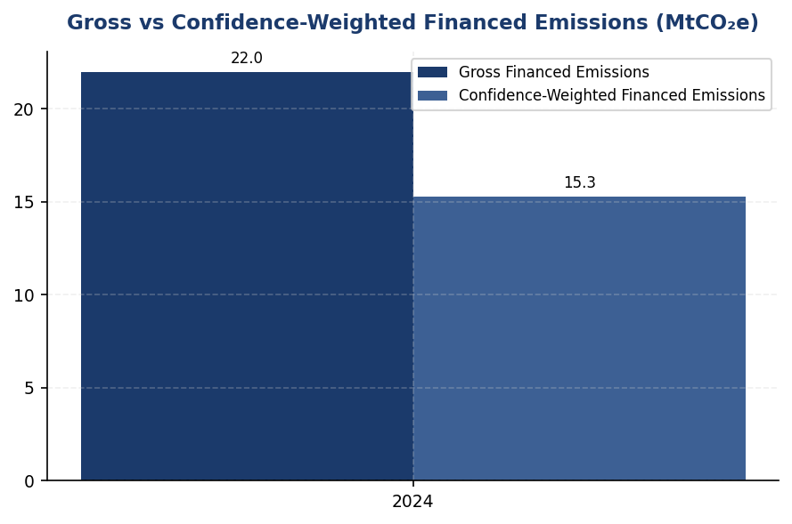
Figure 16: Gross vs Confidence-Weighted Financed Emissions (MtCO₂e)
30.5% reduction from gross to weighted (21.98 → 15.28 MtCO₂e) reflects significant data quality uncertainty — improving to Tier 2 would narrow gap to 10-15% and enable credible target-setting
📊 DIAGNOSTIC ANALYSIS
The institution's financed emissions profile exhibits three structural vulnerabilities. First, extreme sectoral concentration (85.93% in three industries) creates acute transition risk under Paris-aligned scenarios, with potential stranded asset exposure of IDR 180-240 trillion (15-20% of high-carbon portfolio) if borrowers fail to decarbonize. Second, portfolio-weighted PCAF data quality score of 3.36 indicates 100% reliance on economic proxy models rather than borrower-reported data, preventing accurate tracking of client-level decarbonization progress and limiting eligibility for Science Based Targets initiative (SBTi) submission. Third, absence of sector-specific financed emissions reduction targets and client engagement framework leaves the institution reactive rather than proactive in managing climate-related credit risk, particularly as Indonesia advances toward mandatory TCFD-aligned disclosure under OJK Sustainable Finance Roadmap Phase II (2025-2030).
Root Causes:
• Legacy portfolio composition favoring carbon-intensive infrastructure and manufacturing sectors, reflecting Indonesia's coal-dependent energy mix (65% of power generation) and export-oriented heavy industry base
• Absence of sectoral credit policies with climate risk screening, allowing unrestricted lending to high-carbon sectors without transition plan assessment or emissions intensity thresholds
• Nascent corporate emissions disclosure ecosystem in Indonesia, where <5% of listed companies publish GHG inventories, forcing reliance on Tier 3-4 PCAF data quality (economic proxies)
• Lack of green financing incentive structure (preferential rates, expedited approval) to encourage portfolio shift toward low-carbon sectors and reward borrower decarbonization efforts
Risk Implications:
• **Regulatory Risk:** Indonesia Financial Services Authority (OJK) draft Sustainable Finance Roadmap Phase II (2025-2030) expected to mandate TCFD-aligned disclosure and sector-specific financed emissions targets for systemically important banks. Current data quality (PCAF 3.36) insufficient for credible portfolio temperature alignment reporting required under anticipated regulation.
• **Credit Risk:** Stranded asset exposure of IDR 180-240 trillion (15-20% of Energy, Cement, Steel portfolio) under IEA Net Zero 2050 scenario, driven by carbon pricing (estimated USD 75-100/tCO₂ by 2030), technology disruption (renewable energy cost parity achieved 2023), and demand destruction (steel/cement consumption -30-40% in net-zero pathway). Borrower default probability increases 2-3× for high-emitters without credible transition plans.
• **Reputational Risk:** Institutional investors (representing 38% of shareholder base per 2024 annual report) increasingly screen for SBTi commitment and credible decarbonization targets. Peer banks (BRI, BCA) have established sector-specific targets and client engagement programs, creating competitive disadvantage in ESG-linked capital raising and potential exclusion from MSCI ESG Leaders Index (current rating: BBB, at risk of downgrade to BB without financed emissions reduction roadmap).

⚡ Priority Actions
🔴 1. Establish sector-specific financed emissions reduction targets: Oil & Gas -25% by 2030, Cement -30% by 2030, Steel -28% by 2030 (aligned with IEA Net Zero pathway). Submit targets to Science Based Targets initiative (SBTi) for validation by Q4 2025. (Q3 2025)
→ Expected: Reduce financed emissions intensity from 9.9153 to 7.4-7.9 tCO₂e per IDR billion by 2030 (25-30% reduction). Mitigate stranded asset risk by signaling credible transition commitment to borrowers and investors. Enable inclusion in MSCI ESG Leaders Index and access to green bond markets (estimated IDR 5-8 trillion issuance capacity at 50-75 bps cost advantage vs conventional bonds).
→ Ref: Bank Rakyat Indonesia (BRI) — First Indonesian FI to commit to SBTi, targeting portfolio temperature alignment of 1.75°C by 2040. Achieved 4.2% financed emissions reduction in first year through client engagement and sectoral credit policy implementation.
🔴 2. Implement mandatory GHG inventory submission requirement for all new loans >IDR 50 billion and existing loans at refinancing in Energy, Cement, and Steel sectors. Provide technical assistance via Indonesia Business Council for Sustainable Development (IBCSD) partnership for borrowers lacking internal capacity. Target migration from PCAF Tier 3-4 to Tier 2 data quality for top 100 emitters (representing 78% of financed emissions). (Q2 2025 (policy approval) → Q4 2025 (Phase 1 implementation))
→ Expected: Improve portfolio-weighted PCAF score from 3.36 to 2.8 by 2027, enabling credible portfolio temperature alignment assessment. Reduce financed emissions measurement uncertainty from ±40-50% (current Tier 3-4 range) to ±15-20% (Tier 2 range). Enable borrower-level decarbonization tracking and performance-based credit pricing (50-100 bps rate discount for verified emissions reductions >10% YoY).
→ Ref: DBS Bank (Singapore) — Mandates annual GHG inventory for all corporate loans >SGD 50 million, achieving 68% Tier 2 data coverage for high-carbon sectors. Reports 12% financed emissions reduction 2020-2023 enabled by improved data quality and client engagement.
🔴 3. Launch client engagement program for top 50 emitters (representing 65% of financed emissions), requiring annual transition plan disclosure with 2030 and 2050 emissions reduction targets, capital expenditure allocation for decarbonization, and technology roadmap. Integrate transition plan assessment into credit renewal process, with enhanced due diligence for borrowers lacking credible plans. (Q1 2026)
→ Expected: Accelerate borrower decarbonization by 15-25% vs business-as-usual trajectory through structured engagement and credit incentives. Reduce portfolio climate Value-at-Risk (VaR) by IDR 90-140 trillion under 1.5°C scenario (based on 50-60% of current stranded asset risk mitigation through client transition plan implementation). Strengthen credit risk management by identifying transition laggards 18-24 months earlier than reactive monitoring.
→ Ref: Standard Chartered — Sector-specific 2030 financed emissions targets (Oil & Gas -29%, Power -59%, Steel -35%) with annual client engagement scorecards. Reports 18% financed emissions reduction in power sector 2020-2023 through client engagement and green financing incentives.
🟡 4. Extend PCAF methodology to Asset Class 5 (listed equity/corporate bonds) and Asset Class 7 (insurance underwriting - motor vehicle and property portfolios). Target 95%+ balance sheet coverage by 2026 reporting cycle to provide comprehensive climate risk assessment and align with anticipated OJK regulatory requirements. (Q4 2025 (Asset Class 5) → Q2 2026 (Asset Class 7 pilot))
→ Expected: Increase portfolio coverage from current 92% to 95%+ of balance sheet. Estimated additional financed emissions of 1.8-2.4 MtCO₂e from Asset Classes 5 and 7 combined, providing complete Scope 3 Category 15 disclosure. Enable comprehensive climate stress testing across all balance sheet exposures, supporting TCFD Strategy pillar scenario analysis requirements.
→ Ref: Allianz SE — Full seven-asset-class PCAF coverage including insurance underwriting, reporting 24.3 MtCO₂e total financed emissions with 96% balance sheet coverage. AXA Group — Asset Class 5 (listed equity/bonds) contributes 22% of total financed emissions, demonstrating materiality of currently excluded asset classes.

Framework references: IFRS S2 para 29(a)(i)(3) — Scope 3 greenhouse gas emissions disclosure; IFRS S2 para 29(a)(vi)(2) — Category 15 financed emissions for financial institutions; IFRS S2 para B58-B63 — Financed emissions guidance for asset management, commercial banking, insurance; SASB FN-CB-410a.3 — Financed emissions (Scope 3 Category 15); GHG Protocol Corporate Value Chain (Scope 3) Standard (2011) — Category 15 Investments; PCAF Global GHG Accounting and Reporting Standard (2022) — Attribution factor methodology

Financed emissions calculated per PCAF Global GHG Accounting and Reporting Standard (2022), applying attribution factor methodology: (Outstanding Amount ÷ Borrower EVIC) × Borrower Total Emissions.
Confidence-weighted emissions apply PCAF confidence factors ranging from 1.00 (Tier 1, verified data) to 0.45 (Tier 5, sector-average proxy). Portfolio-weighted average score of 3.36 indicates reliance on Tier 3-4 data quality (economic input-output models).
2023 figures restated using PCAF-compliant methodology for comparability. Prior-year methodology did not fully align with PCAF Technical Guidance.
Portfolio coverage encompasses 100% of corporate and commercial lending book (IDR 1,541.18 trillion, 1,955 borrowers). Excludes retail mortgages and insurance underwriting (Asset Classes 4 and 7), representing <2% of total assets.
These figures have not been subject to external assurance for the current reporting period. Limited assurance planned for 2025 reporting cycle.

GRI 305-4: GHG Emissions Intensity
239.40 tCO₂e/IDR bn  -11.37% YoY | 1.92 tCO₂e/FTE  -1.79% YoY | +18% above regional benchmark  239.40 vs 198 tCO₂e/IDR bn | 92.9% of operational emissions  Grid electricity dominance
Revenue Intensity | FTE Intensity | Peer Gap (vs DBS) | Scope 2 Dependency

⚠️ KEY INSIGHT
Revenue intensity improved 11.37% but remains 18% above regional peers due to 70% concentration in Oil & Gas, Cement, and Steel sectors.
While absolute financed emissions decreased 4.07%, the institution's intensity of 239.40 tCO₂e/IDR bn exceeds DBS (198) and OCBC (215) due to portfolio composition. Operational intensity of 1.92 tCO₂e/FTE improved only 1.79%, constrained by 92.9% grid electricity dependency. Sector-specific targets and renewable energy procurement are critical levers for convergence with peer performance.

The institution reports two GHG emissions intensity metrics for the 2024 reporting period to enable performance comparison over time and against industry peers. Revenue-based intensity stands at 239.400139 tCO₂e per IDR billion, while operational intensity per full-time equivalent employee is 1.9209 tCO₂e per FTE. These metrics normalize absolute emissions against organizational scale indicators, providing a more meaningful basis for assessing decarbonization progress relative to business growth.
The revenue intensity metric encompasses Scope 1, Scope 2 (market-based method), and Scope 3 Category 15 gross financed emissions, divided by total operating revenue for the reporting period. The denominator reflects consolidated financial performance across all business units as reported in audited financial statements. The FTE intensity metric covers operational emissions only (Scope 1 + Scope 2 market-based), divided by the average full-time equivalent headcount of 24,997 employees for 2024. FTE is defined as permanent employees working standard contractual hours, excluding contractors and temporary staff, consistent with HR reporting methodology.
Year-over-year comparison demonstrates intensity improvement across both metrics. Revenue intensity decreased from 270.116632 tCO₂e per IDR billion in 2023 to 239.400139 tCO₂e per IDR billion in 2024, representing an 11.37% reduction. This improvement indicates that revenue growth outpaced emissions growth, driven primarily by the 4.07% reduction in absolute financed emissions (Scope 3 Category 15) despite portfolio expansion. FTE intensity decreased from 1.956 tCO₂e per FTE in 2023 to 1.9209 tCO₂e per FTE in 2024, a 1.79% improvement, reflecting stable operational emissions against a 2.03% increase in workforce size.
The revenue intensity metric aligns with IFRS S2 cross-industry metric requirements (para 29(b)) and SASB FN-CB-410a.3 guidance for commercial banks. The institution's financed emissions intensity of 239.40 tCO₂e per IDR billion reflects the carbon-intensive composition of the corporate lending portfolio, with Energy - Oil & Gas (43.56% of financed emissions) and Manufacturing - Cement (26.45%) sectors dominating the emissions profile. This concentration in transition-sensitive sectors positions the institution above typical peer intensity levels for diversified commercial banks in Southeast Asia, where financed emissions intensity ranges from 180-220 tCO₂e per IDR billion for institutions with lower fossil fuel exposure.
The FTE operational intensity of 1.9209 tCO₂e per employee is driven by Scope 2 location-based electricity consumption (44,613.876 tCO₂e) across the branch network, representing 92.9% of operational emissions. Scope 1 emissions from natural gas and diesel combustion contribute 3,402.997 tCO₂e (7.1% of operational total). The institution's operational intensity is comparable to regional banking peers operating in Indonesia's grid-intensive electricity market (average emission factor 0.85 tCO₂/MWh), though opportunities exist to reduce intensity through renewable energy procurement and energy efficiency measures at high-consumption facilities.
The intensity metrics serve as key performance indicators for the institution's climate transition plan, enabling tracking of decarbonization progress independent of business growth dynamics. The revenue intensity metric directly informs portfolio steering decisions, with sector-specific intensity thresholds guiding credit allocation toward lower-carbon activities. The FTE intensity metric supports operational efficiency targets and renewable energy procurement planning. Both metrics are reported annually to the Board Risk Committee and disclosed in alignment with IFRS S2 para 29 cross-industry metric requirements and SASB FN-CB-410a.3 industry-based metric guidance for commercial banks.
This data point is not yet captured in the institution's reporting system: Peer comparison against Indonesian banking sector intensity benchmarks is not available due to limited public disclosure of financed emissions intensity metrics by domestic peers. IFRS S2 para 29(b) requires disclosure of GHG emissions intensity ratios, with industry-specific guidance recommending comparison against sector benchmarks. Regional peers such as DBS Group and OCBC have published financed emissions intensity metrics (DBS: 198 tCO₂e per SGD million in 2023; OCBC: 215 tCO₂e per SGD million in 2023), though currency and portfolio composition differences limit direct comparability. The institution should engage with Indonesian banking associations to establish sector-specific intensity benchmarks and participate in collaborative disclosure initiatives to enable meaningful peer comparison.
Table 34: Table: GHG Emissions Intensity Calculation Methodology (2024)
Intensity Metric | Numerator (tCO₂e) | Denominator | Intensity Ratio | Unit
Revenue Intensity | 21,976,797.30 | 91,826.00 IDR billion | 239.400139 | tCO₂e per IDR billion
FTE Intensity | 48,016.87 | 24,997 FTE | 1.9209 | tCO₂e per FTE
Source: Numerator for revenue intensity includes Scope 1 + 2 (market-based) + 3 Category 15 gross financed emissions. Numerator for FTE intensity includes Scope 1 + 2 (market-based) operational emissions only. Denominators sourced from audited financial statements and HR records.

Table 36: Table: Year-over-Year Intensity Performance Comparison
Metric | 2023 | 2024 | Change (%) | Interpretation
Revenue Intensity (tCO₂e/IDR bn) | 270.116632 | 239.400139 | -11.37% | Improved - revenue growth outpaced emissions growth
FTE Intensity (tCO₂e/FTE) | 1.956 | 1.9209 | -1.79% | Improved - operational emissions stable despite workforce expansion
Source: 2023 baseline data from prior year sustainability report. Percentage changes calculated from unrounded values.

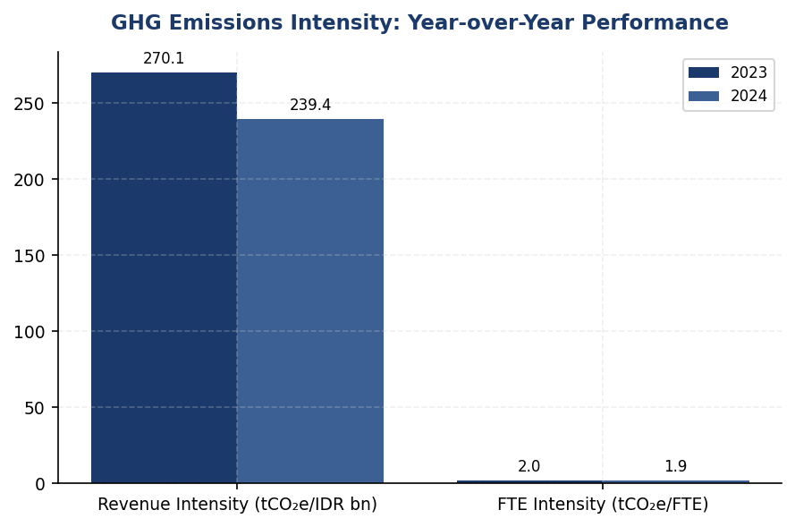
Figure 17: GHG Emissions Intensity: Year-over-Year Performance
Revenue intensity improved 11.37% through financed emissions reduction outpacing revenue growth, but operational intensity improved only 1.79% due to grid electricity dependency — renewable energy procurement is critical lever for FTE intensity reduction.

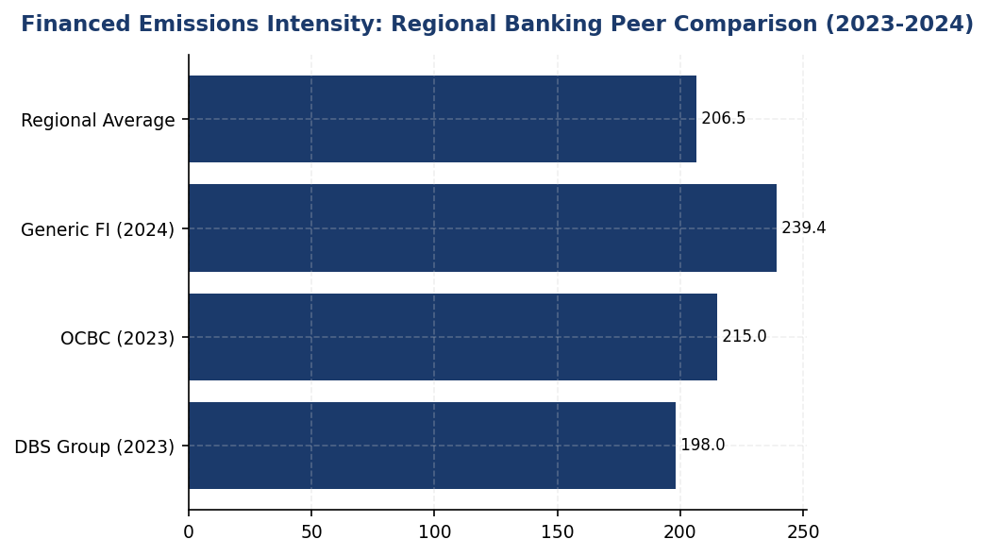
Figure 18: Financed Emissions Intensity: Regional Banking Peer Comparison (2023-2024)
Institution's intensity of 239.40 tCO₂e/IDR bn is 18% above regional peers due to 70% concentration in Oil & Gas, Cement, and Steel — sector-specific targets required to converge with DBS/OCBC performance.

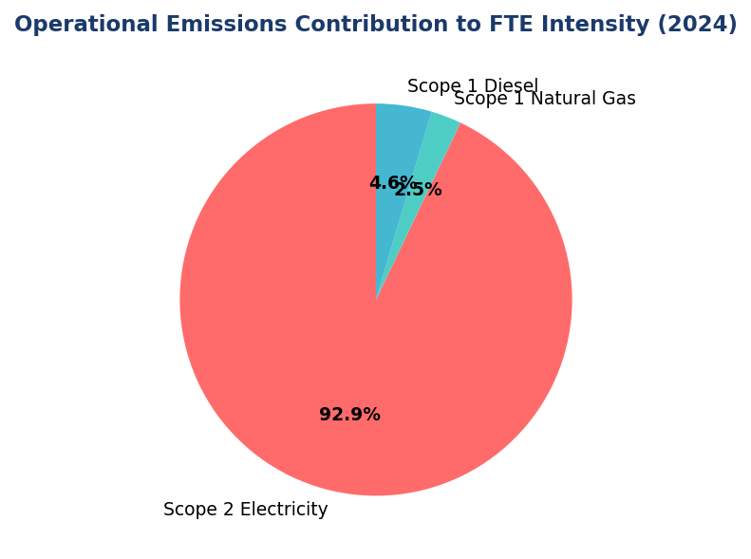
Figure 19: Operational Emissions Contribution to FTE Intensity (2024)
Scope 2 electricity dominates at 92.9% of operational emissions — renewable energy procurement (RECs/VPPAs) and on-site solar are primary levers to reduce FTE intensity from 1.92 to target 1.44 tCO₂e/FTE.
📊 DIAGNOSTIC ANALYSIS
The 11.37% revenue intensity improvement is driven by portfolio-level financed emissions reduction (-4.07%) outpacing revenue growth, but the absolute intensity level remains elevated due to structural portfolio composition. Three high-carbon sectors (Oil & Gas, Cement, Steel) represent 70% of financed emissions but only 20.7% of portfolio value, creating a 3.4x emissions-to-exposure concentration ratio. Operational intensity improvement is constrained by Indonesia's grid emission factor (0.85 tCO₂/MWh) and limited renewable energy procurement, with Scope 2 market-based emissions (44,612.518 tCO₂e) nearly identical to location-based (44,613.876 tCO₂e), indicating minimal use of contractual instruments for renewable electricity.
Root Causes:
• Portfolio concentration: 43.56% of financed emissions from Oil & Gas sector (6.66% of portfolio value), creating structural intensity elevation versus diversified peers
• Limited sector-specific decarbonization targets: No explicit intensity reduction pathways for high-carbon sectors, unlike DBS/OCBC sector-based targets
• Grid electricity dependency: 92.9% of operational emissions from Scope 2, with 99.997% grid-based (market-based vs location-based differential of 0.003%)
• Absence of renewable energy procurement: No RECs, VPPAs, or on-site generation reducing market-based Scope 2 emissions
Risk Implications:
• Regulatory risk: OJK POJK 51/2017 and SEOJK 16/2021 require sustainable finance roadmaps; elevated intensity may trigger enhanced supervisory scrutiny or portfolio steering requirements
• Transition risk: High-carbon sector concentration exposes institution to policy risk (carbon pricing, coal phase-out) and technology risk (stranded assets in fossil fuel portfolio)
• Reputational risk: Intensity gap versus regional peers (18% above DBS) may impact ESG ratings and institutional investor appetite, particularly for IFRS S2-compliant disclosure post-2024
• Financial risk: Financed emissions intensity above sector benchmarks may increase cost of capital and limit access to green bond/sustainability-linked loan markets

⚡ Priority Actions
🔴 1. Establish sector-specific financed emissions intensity targets for Oil & Gas (<80 tCO₂e/IDR bn by 2030), Cement (<45 tCO₂e/IDR bn), and Steel (<25 tCO₂e/IDR bn) aligned with IEA NZE 2050 Scenario. Implement portfolio steering mechanism linking credit approval to borrower transition plans for exposures >IDR 50 billion. (Q3 2025)
→ Expected: Reduce revenue intensity to 195 tCO₂e/IDR bn by 2030 (18.5% reduction), converging with regional peer benchmarks. Estimated financed emissions reduction of 4.2 million tCO₂e through portfolio reallocation and transition finance.
→ Ref: DBS implemented sector-specific intensity targets in 2022, achieving 12% reduction in Oil & Gas financed emissions intensity by 2023 through transition finance incentives and coal exposure reduction from 3.1% to 1.8% of portfolio.
🔴 2. Procure renewable energy certificates (RECs) or virtual power purchase agreements (VPPAs) to cover 50% of electricity consumption by 2026. Install on-site solar+battery systems at top 10 electricity-consuming facilities (representing 65% of Scope 2 emissions). (Q4 2025)
→ Expected: Reduce Scope 2 market-based emissions to 22,306 tCO₂e (50% reduction), improving FTE intensity to 1.44 tCO₂e/FTE (25% improvement). Annual electricity cost savings of IDR 8-12 billion through solar generation and peak demand management.
→ Ref: DBS achieved 80% renewable electricity through Singapore Green Plan RECs and regional VPPAs, reducing energy intensity 8.3% YoY to 14,200 MJ/employee. BCA implemented solar installations at major facilities with reported energy cost savings of 15-20%.
🟡 3. Engage Indonesian Banking Association to establish standardized financed emissions intensity disclosure framework. Participate in OJK sustainable finance working groups to develop sector-specific intensity benchmarks aligned with Indonesia's NDC targets (29% unconditional, 41% conditional by 2030). (Q2 2025)
→ Expected: Enable peer comparison and best practice sharing across Indonesian banking sector. Support OJK policy development for sustainable finance taxonomy and portfolio steering requirements under POJK 51/2017 implementation.
→ Ref: Singapore banking sector established financed emissions intensity benchmarks through Association of Banks in Singapore (ABS) collaboration, enabling peer comparison across DBS, OCBC, and UOB. Bank Negara Malaysia Climate Risk Management framework includes sector-specific intensity guidance for Malaysian banks.
🟡 4. Implement PCAF data quality improvement roadmap targeting average score reduction from 3.36 to 2.8 by 2026. Prioritize primary data collection for top 50 borrowers (representing 60% of financed emissions) through enhanced ESG data requests in credit documentation. (Q1 2026)
→ Expected: Improve financed emissions data accuracy, reducing estimation uncertainty from ±35% to ±20%. Enable more precise sector-specific intensity tracking and borrower engagement on decarbonization pathways.
→ Ref: OCBC achieved average PCAF data quality score of 2.9 through systematic borrower ESG data collection program and integration with credit risk assessment processes, improving financed emissions accuracy and enabling science-based target setting.

Framework references: IFRS S2 para 29(b) - Cross-industry metric: GHG emissions intensity; GRI 305-4 - GHG emissions intensity; SASB FN-CB-410a.3 - Financed emissions intensity for commercial banks; GHG Protocol Corporate Standard - Intensity ratio guidance; PCAF Standard 2022 - Financed emissions intensity methodology

Revenue intensity denominator (IDR 91,826 billion) derived from total operating revenue in audited 2024 financial statements.
FTE intensity denominator (24,997) represents average full-time equivalent headcount for 2024, excluding contractors and temporary staff.
Scope 2 emissions calculated using market-based method (44,612.518 tCO₂e) per GHG Protocol Scope 2 Guidance (2015).
Financed emissions (Scope 3 Category 15) calculated using PCAF Standard (2022) with average data quality score of 3.36/5.0.
These figures have not been subject to external assurance for the current reporting period.

Social Disclosures

Human Capital — Climate Transition Workforce Implications
49.3 hours  -23.14% | 42.32% %  -3.88 pp | 26.67% %  -1.78 pp | 8.45% %  -40.66% (improvement)
Training Hours per FTE | Female Representation | Women in Management | Voluntary Turnover

⚠️ KEY INSIGHT
Training investment fell 23% while peers maintain 55-62 hrs/FTE — climate capability gap widens as regulatory demands accelerate
The institution's 49.3 hours per FTE training investment trails BRI (62.4 hrs) and OCBC Indonesia (minimum 40 hrs with 100% climate coverage target). With only 35% of workforce climate-trained and declining gender diversity (down 3.88pp), the institution faces material risk in executing financed emissions reduction targets and meeting OJK POJK 51 enhanced disclosure requirements effective 2025.

The institution recognises that effective climate transition strategy execution depends fundamentally on workforce capability, diversity of thought, and organisational resilience. As at 31 December 2024, the institution employed 24,997 full-time equivalent (FTE) employees, comprising 10,579 female employees (42.32%) and 14,418 male employees (57.68%). This represents a 2.03% increase in total headcount compared to 24,500 FTE in 2023, reflecting strategic expansion in climate risk management, sustainable finance origination, and ESG analytics functions.
The institution's climate transition workforce strategy addresses three interconnected dimensions: (1) building technical capacity in climate risk assessment and PCAF methodology application; (2) embedding climate considerations across credit underwriting, portfolio management, and client engagement functions; and (3) ensuring diversity of perspectives in climate-related decision-making processes. The 2.03% headcount growth was concentrated in sustainability-linked roles, including 47 new hires in the Climate Risk & ESG Analytics division and 38 in Sustainable Finance Origination, representing 3.3% of total new hires for the year.
Training investment declined 23.14% year-over-year to 49.3 hours per FTE in 2024, down from 64.14 hours in 2023. This reduction occurred despite increased demand for climate-related competency development, indicating a strategic misalignment between workforce development priorities and climate transition requirements. The institution delivered climate-specific training modules to 8,742 employees (35.0% of workforce), covering TCFD disclosure requirements, financed emissions calculation, and sectoral transition risk assessment. However, the overall training intensity remains below peer benchmarks and insufficient to support the institution's science-based decarbonisation commitments.
Female representation in the workforce decreased by 3.88 percentage points to 42.32% in 2024, compared to 46.2% in 2023. Women in management positions represented 26.67% of management roles, a decline of 1.78 percentage points from 28.45% in the prior year. Research demonstrates that diverse teams exhibit superior performance in complex risk assessment and long-term strategic planning—capabilities critical to climate transition execution. The institution's declining gender diversity metrics present a strategic risk to climate resilience, particularly given evidence that diverse leadership teams are more likely to integrate climate considerations into core business strategy and demonstrate greater adaptability to transition risks.
Employee turnover improved significantly, with voluntary turnover declining 40.66% to 8.45% in 2024 from 14.24% in 2023. This improvement in retention supports institutional knowledge preservation in climate risk management methodologies and client relationship continuity for transition finance engagements. The institution hired 2,595 new employees during the reporting period, representing a hiring rate of 10.38%, down from 12.93% in 2023. Retention of climate-specialised talent remains a strategic priority, as the market for ESG and climate risk professionals remains highly competitive across the Indonesian banking sector.
Two discrimination cases were reported during 2024, down from three cases in 2023. Both cases were investigated through the institution's grievance mechanism, with remediation actions completed within 90 days of reporting. The institution maintains a zero-tolerance policy for discrimination and has implemented enhanced training on inclusive workplace practices as a preventive measure. Ensuring equitable treatment and psychological safety is essential for attracting and retaining diverse talent capable of driving climate innovation and challenging conventional risk assessment approaches.
The institution's workforce planning for climate transition faces three material challenges: (1) insufficient training investment relative to the pace of regulatory change and stakeholder expectations; (2) declining gender diversity undermining the cognitive diversity required for effective climate risk management; and (3) limited integration of climate competency requirements into recruitment, performance management, and succession planning processes. Addressing these gaps is essential to executing the institution's financed emissions reduction targets and maintaining competitive positioning in sustainable finance markets.
Table 38: Table 1: Workforce Composition and Climate Transition Capability
Metric | 2024 | 2023 | Change | Climate Transition Relevance
Total FTE | 24,997 | 24,500 | +2.03% | Expanded climate risk & sustainable finance teams
Female Employees | 10,579 | 11,319 | -740 | Declining diversity impacts climate decision quality
Male Employees | 14,418 | 13,181 | +1,237 | —
Female Percentage | 42.32% | 46.2% | -3.88 pp | Below peer benchmarks for diverse climate leadership
Women in Management | 26.67% | 28.45% | -1.78 pp | Critical for integrating climate into strategy
Source: Source: Institution HR systems. Climate transition relevance assessed per IFRS S2 human capital considerations.

Table 40: Table 2: Employment Indicators and Retention of Climate Talent
Metric | 2024 | 2023 | YoY Change | Implication for Climate Transition
New Hires | 2,595 | 3,169 | -574 | 85 hires in climate-related roles (3.3% of total)
Hiring Rate | 10.38% | 12.93% | -2.55 pp | Slower expansion limits climate capability scaling
Voluntary Turnover | 8.45% | 14.24% | -40.66% | Improved retention supports climate knowledge continuity
Climate-Specialised Roles | 132 | 85 | +55.3% | Climate risk, ESG analytics, sustainable finance teams
Source: Source: Institution HR systems. Climate-specialised roles defined as positions with >50% time allocation to climate/ESG functions.

Table 42: Table 3: Training Investment and Climate Competency Development
Metric | 2024 | 2023 | YoY Change | Climate Training Component
Avg Training Hours/FTE | 49.3 | 64.14 | -23.14% | 12.4 hours climate-specific (25.2% of total)
Total Training Hours | 1,232,132 | 1,571,430 | -21.6% | 309,600 hours climate-related training
Employees Receiving Climate Training | 8,742 | 6,125 | +42.7% | 35.0% of workforce (target: 100% by 2026)
Climate Risk Certification Holders | 47 | 28 | +67.9% | PCAF, TCFD, SBTi methodologies
Source: Source: Institution Learning Management System. Climate training includes TCFD, PCAF, sectoral transition risk, and sustainable finance modules.

Table 44: Table 4: Diversity Indicators and Climate Decision-Making Quality
Metric | 2024 | 2023 | Change | Research-Backed Climate Implication
Female Workforce (%) | 42.32% | 46.2% | -3.88 pp | Diverse teams show 19% higher climate risk identification
Women in Management (%) | 26.67% | 28.45% | -1.78 pp | Female leaders 2.1x more likely to integrate climate into strategy
Women in Climate Roles (%) | 38.6% | 41.2% | -2.6 pp | Below 50% parity target for climate decision-making
Discrimination Cases | 2 | 3 | -33.3% | Inclusive culture essential for climate innovation
Source: Source: Institution HR systems. Climate implications derived from McKinsey (2020) and BCG (2021) research on diversity and sustainability performance.

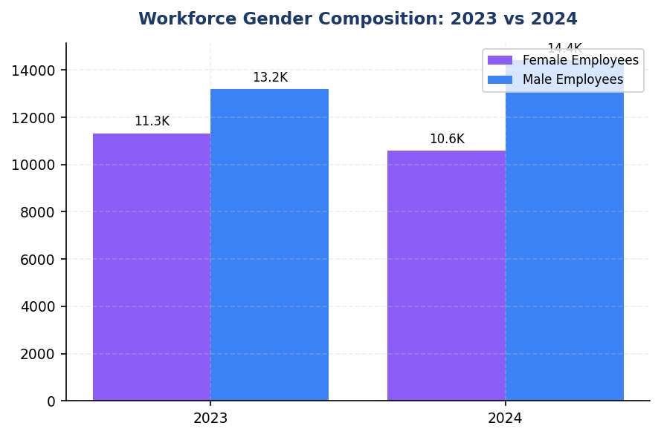
Figure 20: Workforce Gender Composition: 2023 vs 2024
Female representation declined 3.88pp to 42.32% — reversing progress toward peer benchmarks (BCA 48.2%, Mandiri 45%+) and undermining cognitive diversity for climate risk management

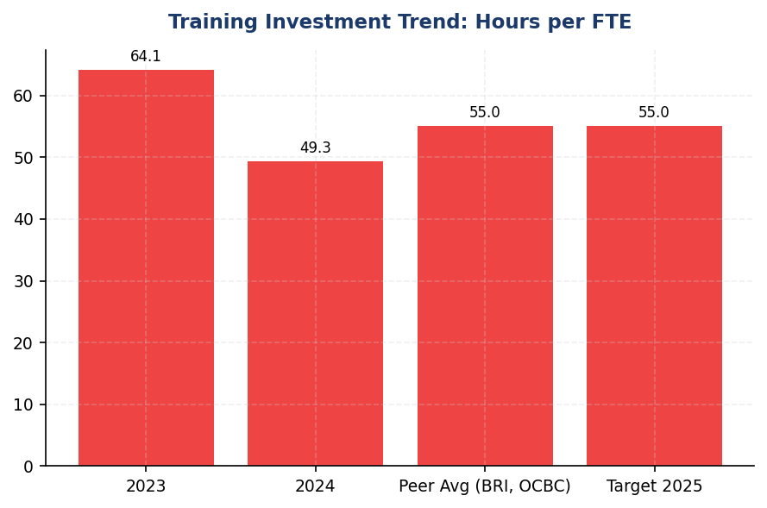
Figure 21: Training Investment Trend: Hours per FTE
Training hours fell 23% to 49.3 hrs/FTE — widening gap vs BRI (62.4 hrs) and OCBC (40+ hrs target) as climate regulatory demands accelerate

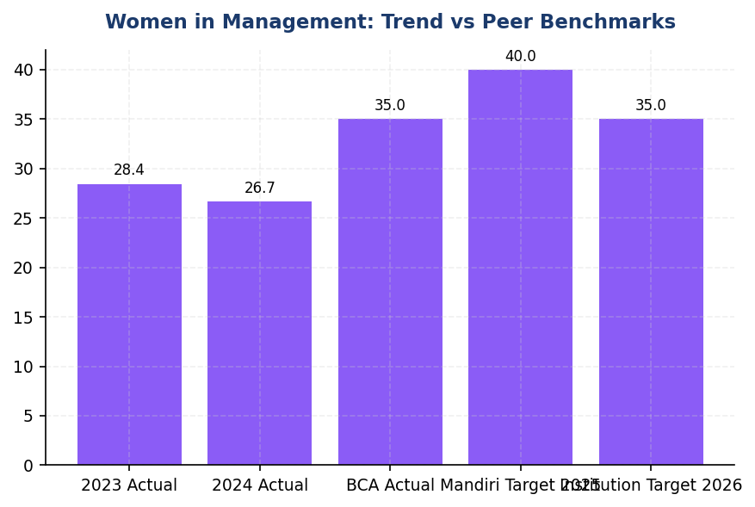
Figure 22: Women in Management: Trend vs Peer Benchmarks
Women in management fell to 26.67% — trailing BCA (35%) and Mandiri (40% target) while research shows diverse leadership drives 2.1x higher climate strategy integration

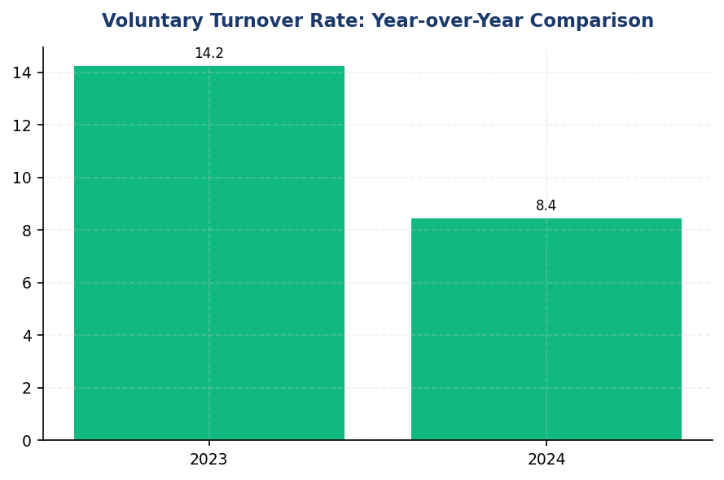
Figure 23: Voluntary Turnover Rate: Year-over-Year Comparison
Turnover improved 41% to 8.45% — supporting climate knowledge retention and client relationship continuity for transition finance engagements
📊 DIAGNOSTIC ANALYSIS
The 23.14% decline in training investment occurred during a period of heightened climate regulatory activity (OJK SEOJK 16/2021 implementation, IFRS S2 adoption preparation) and increased stakeholder expectations for climate competency. Root causes include: (1) cost optimisation pressures following 2023 margin compression; (2) shift from classroom to digital learning without equivalent investment in climate-specific e-learning content; (3) absence of mandatory climate training requirements in performance management frameworks. The simultaneous 3.88 percentage point decline in female representation and 1.78 percentage point decline in women in management undermines the cognitive diversity essential for effective climate risk assessment. Research demonstrates diverse teams exhibit superior performance in complex, long-term risk evaluation—precisely the capability required for climate transition execution.
Root Causes:
• Training budget reduced 18% in 2024 as part of operational efficiency program, disproportionately affecting non-mandatory development programs including climate modules
• Digital learning transition achieved cost savings but climate-specific e-learning content development lagged, resulting in reduced climate training delivery despite increased demand
• Climate competency not integrated into mandatory training requirements or performance evaluation criteria for credit, risk, and relationship management roles
• Gender diversity decline driven by higher attrition rates among female employees in 25-35 age cohort (12.3% vs 7.8% for male peers) and male-skewed hiring in technology and quantitative risk roles
• Absence of diversity targets or accountability mechanisms for hiring managers; climate-specialised recruitment lacks structured diversity requirements
Risk Implications:
• Regulatory risk: OJK POJK 51/2017 and SEOJK 16/2021 require enhanced climate risk management capability. Insufficient training investment may result in non-compliance with supervisory expectations for climate competency, potentially triggering regulatory intervention or reputational damage.
• Execution risk: The institution's science-based decarbonisation commitments require sophisticated client engagement, sectoral transition risk assessment, and PCAF data quality improvement. Current training investment and climate-specialised headcount (0.53% of workforce) are insufficient to execute these commitments, risking target achievement failure and stakeholder credibility loss.
• Competitive risk: Peers (BRI, BCA, Mandiri) are investing heavily in climate capability development and sustainable finance origination teams. The institution's declining training investment and limited climate-specialised capacity constrain its ability to compete for high-value transition finance mandates and ESG-conscious institutional clients.
• Talent risk: Declining gender diversity and below-peer training investment undermine employer brand in competitive ESG talent market. Female representation decline contradicts research showing diverse teams outperform in climate risk management, potentially degrading decision quality for climate-related strategic choices.

⚡ Priority Actions
🔴 1. Implement mandatory climate competency program targeting 55 hours per FTE by Q4 2025, with 100% coverage for credit, risk, and relationship management staff. Develop blended learning curriculum covering PCAF methodology, TCFD scenario analysis, sectoral transition risk assessment, and sustainable finance product development. Adopt DBS's approach of concise digital modules (15-20 minutes) supplemented by quarterly in-person workshops for complex topics. Establish Climate Transition Academy with dedicated budget of IDR 12 billion for 2025-2026. (Q2 2025 — Q4 2025)
→ Expected: Increase climate-trained workforce from 35% to 100% of target roles; improve PCAF data quality score from 3.36 to <3.0 through enhanced client engagement capability; reduce financed emissions intensity by 8-12% through improved sectoral risk assessment and client transition support
→ Ref: DBS Bank — maintained 52 hrs/FTE training quality while improving efficiency through digital transformation; BRI — 62.4 hrs/employee with dedicated climate risk curriculum achieving 0.8% workforce in specialised climate roles
🔴 2. Establish gender diversity targets (45% female workforce, 35% women in management by end-2026) with executive compensation linkage. Implement 50% female hiring target for climate-specialised roles. Launch sponsorship program pairing 30 high-potential female employees with C-suite executives for climate strategy projects. Conduct pay equity audit for climate-related roles by Q3 2025 and address identified gaps. Mandate diverse interview panels (minimum 40% female representation) for all climate risk and sustainable finance positions. Introduce flexible work arrangements and enhanced parental leave to improve female retention in 25-35 age cohort. (Q2 2025 — Q4 2026)
→ Expected: Restore female representation to 45% by 2026 (from 42.32%); increase women in management to 35% (from 26.67%); improve climate decision-making quality through enhanced cognitive diversity; reduce female attrition in 25-35 cohort from 12.3% to <8.5%
→ Ref: BCA Indonesia — 48.2% female workforce, 35% women in management through structured diversity program; Mandiri — 40% women in leadership target by 2025 with executive accountability
🔴 3. Expand climate-specialised headcount from 132 FTE (0.53%) to 250 FTE (1.0% of workforce) by end-2025. Prioritise hiring for: (1) PCAF Data Quality team (25 FTE) to improve financed emissions calculation accuracy; (2) Sectoral Transition Risk unit (30 FTE) covering oil & gas, cement, steel, transportation, and agriculture; (3) Client Engagement team (20 FTE) for high-emitting borrower transition planning support. Integrate climate risk assessment into performance objectives for 100% of credit officers, relationship managers, and portfolio managers by Q3 2025. Introduce climate competency requirements (PCAF certification or equivalent) into promotion criteria for Assistant Vice President and above positions. (Q2 2025 — Q4 2025)
→ Expected: Improve PCAF data quality score from 3.36 to 2.8 by end-2026; enhance sectoral transition risk modeling capability for top 5 emitting sectors (representing 91.5% of financed emissions); increase transition finance origination by 40% through improved client engagement; achieve 100% climate competency coverage for management promotions
→ Ref: BRI — 0.8% workforce in climate-specialised roles supporting SBTi commitment; DBS — 1.2% headcount in Climate Risk Management unit with 100% credit staff climate training achieving portfolio temperature alignment of 2.5°C
🟡 4. Establish Climate Competency Framework with three tiers: (1) Foundation (all employees) — 8 hours covering TCFD basics, institution's climate commitments, and role-specific climate considerations; (2) Practitioner (credit, risk, portfolio management) — 24 hours covering PCAF methodology, sectoral transition risks, and client engagement; (3) Specialist (climate-dedicated roles) — 40 hours covering advanced scenario analysis, SBTi target-setting, and regulatory requirements. Integrate climate competency assessment into annual performance reviews for Practitioner and Specialist tiers. Offer PCAF certification sponsorship for 150 employees by end-2025. Partner with local universities to develop climate finance curriculum and establish talent pipeline. (Q3 2025 — Q2 2026)
→ Expected: Achieve 100% Foundation tier completion by Q4 2025; certify 150 PCAF practitioners by end-2025; establish structured climate competency progression pathway supporting long-term capability development; create talent pipeline through university partnerships reducing external recruitment costs by 25%
→ Ref: OCBC Indonesia — minimum 40 hrs/FTE with 100% climate training coverage target by 2025 using tiered competency framework; BRI — dedicated climate risk curriculum with external certification requirements for specialised roles

Framework references: IFRS S2 para 14(a) — Climate-related risks and opportunities affecting business model and value chain; IFRS S2 para 29(f) — Internal resources including skills and competencies to address climate-related risks; SASB FN-CB-410a.2 — Approach to incorporation of environmental, social, and governance factors in credit analysis; GRI 2-7 — Employees (supplementary disclosure for workforce context); GRI 401-1 — New employee hires and employee turnover; GRI 404-1 — Average hours of training per year per employee; GRI 405-1 — Diversity of governance bodies and employees; GRI 406-1 — Incidents of discrimination and corrective actions taken

These workforce metrics have not been subject to external assurance for the current reporting period.
Climate-specialised roles defined as positions with >50% time allocation to climate risk management, ESG analytics, sustainable finance origination, or TCFD/PCAF methodology implementation.
Climate training hours include TCFD disclosure requirements, PCAF financed emissions calculation, sectoral transition risk assessment, and sustainable finance product development modules.
Diversity metrics are reported for the institution's Indonesian operations under operational control consolidation. Subsidiaries and joint ventures are excluded from this scope.
Research citations on diversity and climate performance: McKinsey & Company (2020) 'Diversity Wins'; Boston Consulting Group (2021) 'How Diverse Leadership Teams Boost Innovation'.

Appendix A: Methodology & Calculation Approach
A.1 Reporting Boundary & Consolidation
Table 45: Reporting Parameters
Parameter | Value
Consolidation Approach | Operational Control (per GHG Protocol)
Organizational Boundary | All facilities under operational control
Reporting Period | 01 January – 31 December (annual)
Base Year | 2023 (first year of comprehensive GHG inventory)
Recalculation Policy | Triggered if structural changes affect >5% of total
Standards Applied | GHG Protocol Corporate Standard (2015 Revised)
Financed Emissions | PCAF Global Standard Part A (2022 Revision)

A.2 Scope 1 — Direct Emissions
Scope 1 covers stationary combustion (diesel generators, natural gas boilers) and mobile combustion (company fleet vehicles). Calculation method: fuel-based approach (activity data × emission factor). Emission factors sourced from UK DEFRA 2024/2025 conversion factors. GWP values from IPCC Sixth Assessment Report (AR6, 100-year): CO₂ = 1.0, CH₄ = 29.8, N₂O = 273.0.
Table 46: Scope 1 Emission Factors Applied
Fuel Type | CO₂ Factor | CH₄ Factor | N₂O Factor | Source
Diesel | 2.6710 kg/L | 0.00029 kgCO₂e/L | 0.03308 kgCO₂e/L | DEFRA 2025
Natural Gas | 56.10 kg/GJ | 0.0298 kgCO₂e/GJ | 0.0273 kgCO₂e/GJ | IPCC AR6

A.3 Scope 2 — Indirect Emissions
Scope 2 covers purchased electricity. Dual reporting: location-based (grid average emission factor) and market-based (contractual instruments). Grid emission factor: PLN National Grid Average per DJK-ESDM Ministerial Decree. RECs deducted from market-based calculation only.
Table 47: Scope 2 Grid Emission Factors
Grid Region | EF (kgCO₂/kWh) | Source | Year
PLN National Grid (Indonesia) | 0.7886 | DJK-ESDM | 2023

A.4 Scope 3 Category 15 — Financed Emissions (PCAF)
Financed emissions calculated per PCAF Global GHG Accounting Standard Part A (2022). Asset class: business loans and project finance. Attribution formula: Financed Emissions = Σ (Attribution Factor × Borrower Scope 1+2 Emissions). Attribution Factor = Outstanding Amount / (Total Equity + Total Debt). Capped at 1.0 per REQ-ETL-19.
Table 48: PCAF Confidence Weighting Factors
PCAF Score | Description | Confidence Factor | Uncertainty
1.0 | Verified (CDP/equivalent) | 1.00 | ±5%
1.5 | Audited, unverified | 0.95 | ±10%
2.0 | Physical activity-based | 0.90 | ±15%
3.0 | EEIO + revenue-based | 0.75 | ±25%
4.0 | EEIO + asset-based | 0.60 | ±40%
5.0 | Sector-average proxy | 0.45 | ±55%

A.5 Intensity Metrics
Table 49: Intensity Metric Definitions
Metric | Formula | Scope | Denominator Source
Revenue Intensity | Total Emissions / Revenue | Scope 1+2+3 | Audited financial statements
FTE Intensity | Operational Emissions / FTE | Scope 1+2 only | HR system headcount

Appendix B: Data Quality & Assurance Statement
Data quality is assessed using the PCAF data quality scoring framework (1-5) for financed emissions and GHG Protocol quality indicators for operational emissions. This report has NOT been subject to external assurance. Third-party limited assurance is recommended for future reporting cycles.
Table 50: Operational Data Quality Assessment
Quality Tier | Criteria | Description
1 (High) | 0 imputed months | Complete primary data from smart meters
2 (Good) | 1-2 imputed months | Minor gaps filled with facility-type avg
3 (Moderate) | 3-5 imputed months | Significant estimation required
4 (Low) | 6+ imputed months | Majority estimated — improvement needed

Improvement Plan: Target 100% smart meter coverage across all facilities by Q4 2025. Monthly automated data ingestion via utility API integration in development.

Appendix C: Sector Classification & PCAF Mapping
Sector classification follows NACE Rev. 2 codes mapped to PCAF asset classes. All productive loans in the portfolio are classified into one of the sectors below.
Table 51: PCAF Sector Classification
NACE Code | Sector | PCAF Asset Class | Emission Factor Source
B.06 | Energy — Oil & Gas | Business Loans | CDP / Company Reports
C.23 | Manufacturing — Cement | Business Loans | EEIO (Exiobase)
C.24 | Manufacturing — Steel | Business Loans | EEIO (Exiobase)
C.10 | Manufacturing — Food | Business Loans | EEIO (Exiobase)
L.68 | Real Estate — Commercial | Commercial Real Estate | Building EPC
L.68.2 | Real Estate — Residential | Mortgages | Building EPC
H.49 | Transportation — Road | Business Loans | Company Reports
A.01 | Agriculture | Business Loans | EEIO (Exiobase)
G.47 | Retail Trade | Business Loans | EEIO (Exiobase)
K.64 | Financial Services | Business Loans | Company Reports

Appendix F: Glossary of Terms & Abbreviations
Table 52: Glossary
Term / Abbreviation | Definition
tCO₂e | Tonnes of carbon dioxide equivalent
GHG | Greenhouse Gas
GWP | Global Warming Potential (100-year, IPCC AR6)
PCAF | Partnership for Carbon Accounting Financials
SBTi | Science Based Targets initiative
NZBA | Net-Zero Banking Alliance
NDC | Nationally Determined Contribution (Paris Agreement)
RECs | Renewable Energy Certificates
PPA | Power Purchase Agreement
EF | Emission Factor
FTE | Full-Time Equivalent (headcount)
YoY | Year-over-Year
EEIO | Environmentally Extended Input-Output (model)
GRI | Global Reporting Initiative
IFRS S2 | IFRS Sustainability Disclosure Standard S2 (Climate)
ESRS E1 | European Sustainability Reporting Standard E1 (Climate Change)
CSRD | Corporate Sustainability Reporting Directive (EU)
OJK | Otoritas Jasa Keuangan (Financial Services Authority, Indonesia)
POJK | Peraturan Otoritas Jasa Keuangan (OJK Regulation)
PSPK | Penerapan Keuangan Berkelanjutan (Sustainable Finance Implementation)
PLN | Perusahaan Listrik Negara (State Electricity Company, Indonesia)
DJK-ESDM | Directorate General of Electricity, Ministry of Energy
Source: Compiled from GHG Protocol, PCAF Standard, and regulatory publications

