[INSTITUTION LOGO]

ESG Sustainability Report

Reporting Year 2024

Institution: GENERIC_FI_001
Framework: MULTI_FRAMEWORK
Generated: 2026-06-10 11:10 UTC
Status: DRAFT — Subject to Review
Assurance Level: None

CONFIDENTIAL — This document is for internal review purposes only. Do not distribute without authorization.

Table of Contents

Contents
ESG Sustainability Report 1
Reporting Year 2024 1
Table of Contents 2
Executive Summary 4
Environmental Performance 8
1.1 Direct GHG Emissions — Scope 1 8
1.2 Energy Indirect GHG Emissions — Scope 2 15
1.3 Financed Emissions — Scope 3 Category 15 21
1.4 GHG Emissions Intensity 29
1.5 Emission Reduction Initiatives & Targets 35
Social Performance 45
2.1 Workforce & Human Capital 45
2.1.1 Workforce Overview (GRI 2-7) As of December 31, 2024, the institution employed 24,997 full-time equivalent (FTE) employees, representing a 2.03% increase from 24,500 FTEs in 2023. The workforce comprised 10,579 female employees (42.32%) and 14,418 male employees (57.68%). This headcount growth reflects the institution's continued expansion of operations and service delivery capacity across its branch network and digital channels. 45
2.1.2 Employment (GRI 401-1) During 2024, the institution hired 2,595 new employees, representing a hiring rate of 10.38% relative to the total workforce. This compares to 3,169 new hires (12.93% hiring rate) in 2023. The voluntary turnover rate for 2024 was 8.45%, a substantial improvement of 40.66% compared to the 2023 rate of 14.24%. This reduction in voluntary turnover indicates improved employee retention and satisfaction, potentially reflecting enhanced compensation structures, career development opportunities, and workplace culture initiatives implemented during the reporting period. 46
2.1.3 Training & Education (GRI 404-1) The institution provided an average of 49.3 training hours per FTE during 2024, representing a 23.14% decrease from the 64.14 hours per FTE delivered in 2023. Total training investment and delivery modalities included classroom instruction, e-learning platforms, and external certification programs covering technical skills, regulatory compliance, risk management, and leadership development. The reduction in training hours reflects operational adjustments during the reporting period, including the optimization of training program efficiency and the transition to more concise, targeted learning modules. 46
2.1.4 Diversity & Equal Opportunity (GRI 405-1) Female representation in management positions stood at 26.67% as of December 31, 2024, a decrease of 1.78 percentage points from 28.45% in 2023. This decline, combined with the overall reduction in female workforce representation, indicates challenges in maintaining gender diversity momentum across both general employee and leadership populations. The institution's current management diversity performance falls below peer benchmarks, with leading Indonesian banks such as BCA achieving 61.6% female representation in management and DBS Group reporting 38% female representation in management roles. 47
2.1.5 Non-Discrimination (GRI 406-1) During the 2024 reporting period, the institution recorded 2 incidents of discrimination that were formally reported and investigated through established grievance mechanisms. This represents a reduction from 3 incidents reported in 2023. All reported cases were subject to investigation in accordance with the institution's Code of Conduct and Human Rights Policy. Remediation actions included disciplinary measures, mandatory training for involved parties, and policy reinforcement communications to relevant business units. The institution maintains a zero-tolerance policy toward discrimination based on gender, age, ethnicity, religion, disability, or any other protected characteristic. 47
2.1.6 Framework Cross-Reference This section addresses multiple sustainability reporting frameworks applicable to financial institutions operating in Indonesia. The disclosures provided fulfill requirements under GRI Standards (GRI 2-7, 401-1, 404-1, 405-1, 406-1), provide supplementary information relevant to ESRS S1 (Own Workforce) under the EU Corporate Sustainability Reporting Directive, and align with OJK POJK 51/2017 social pillar requirements for sustainable finance reporting. The institution's workforce disclosures support stakeholder assessment of human capital management effectiveness, diversity and inclusion performance, and alignment with international labor standards. 48
Governance & Strategy 56
3.1 Climate Governance & ESG Oversight 56
Governance Gap Analysis The institution has not yet established formal governance structures for climate-related risks and opportunities as required by multiple sustainability reporting frameworks. This section identifies the governance disclosure requirements under IFRS S2, GRI 2-12/2-13, ESRS 2 GOV-3, and OJK POJK 51/2017 on Sustainable Finance Action Plan (SFAP), and provides a roadmap for establishing compliant governance infrastructure based on peer bank implementations in Indonesia. 57
Framework Requirements Not Currently Met **IFRS S2 Paragraph 5** requires identification of the governance body or bodies responsible for oversight of climate-related risks and opportunities. The institution must disclose the name of the board committee with this mandate, its composition, and how climate considerations inform strategic decisions. **IFRS S2 Paragraph 6** requires description of management's role in governance processes and controls for climate-related risks and opportunities, including the position or committee with operational responsibility and reporting lines to the board. **IFRS S2 Paragraph 7** requires explanation of how governance bodies' oversight and management's governance processes are reflected in the institution's strategy, decision-making, and risk management processes. **GRI 2-12** requires disclosure of the role of the highest governance body in overseeing the management of sustainability impacts, including how the body considers stakeholder views and how it oversees due diligence and other processes to identify and manage impacts. **GRI 2-13** requires disclosure of how responsibility for managing sustainability impacts is delegated to senior executives and whether they report back to the highest governance body. **ESRS 2 GOV-3** requires disclosure of how sustainability performance is integrated into incentive schemes for members of administrative, management and supervisory bodies, including the percentage of variable remuneration linked to sustainability targets. **OJK POJK 51/2017 Article 6** requires financial institutions to establish governance structures that ensure implementation of sustainable finance principles, including board-level oversight and integration into risk management frameworks. 58
Peer Bank Governance Structures Leading Indonesian banks have established comprehensive ESG governance frameworks that provide reference models for implementation: **Bank Rakyat Indonesia (BRI)** established a dedicated Risk Management & ESG Committee at the Board of Directors level in 2021 via Decision NOKEP 872-DIR/PPM/06/2022. The committee conducts quarterly reviews of climate-related risks and opportunities, with ESG performance integrated into Board of Directors' key performance indicators. BRI was the first Indonesian financial institution to commit to Science-Based Targets initiative (SBTi) and joined the Net-Zero Banking Alliance (NZBA). **Bank Central Asia (BCA)** operates an ESG Subdivision under the Corporate Secretary, reporting to the Director of Planning & Finance, who in turn reports to the President Director. The Board of Directors reviews ESG performance at least four times per year. BCA has integrated ESG KPIs into Board of Directors and work unit performance assessments. The bank has issued multiple Board of Directors Decrees establishing sectoral ESG credit policies for high-risk sectors including palm oil, coal, timber, cement, iron-steel, and oil & gas. **DBS Bank** maintains a Board Sustainability Committee with a dedicated Chief Sustainability Officer (CSO) reporting directly to the Board. DBS links 20 percent of executive variable remuneration to sustainability metrics, including emissions reduction targets. The bank has achieved 62 percent renewable energy usage and reports a 12 percent year-over-year reduction in operational emissions. **Bank Mandiri** operates an ESG Task Force with semi-annual Board-level reviews of sustainability performance. The bank has established sectoral credit policies limiting exposure to fossil fuel sectors and has committed to TCFD-aligned climate risk disclosure. 59
Recommended Governance Infrastructure Based on peer bank practices and regulatory requirements, the institution should establish the following governance structures within the next 12-24 months: **Phase 1 (Q3 2025 - Q4 2025): Foundation** - Establish a Board-level ESG Committee or integrate ESG oversight into the existing Risk Committee, with formal terms of reference defining climate risk oversight responsibilities - Appoint a senior executive (Director-level or equivalent) with explicit accountability for ESG strategy and climate risk management, reporting directly to the President Director - Develop and approve a Board-level ESG Policy via Board of Directors Decree, establishing principles for sustainable finance, climate risk management, and sectoral credit policies - Implement quarterly Board ESG review cadence, with standing agenda items for climate risk, financed emissions, and sustainable finance portfolio performance **Phase 2 (Q1 2026 - Q2 2026): Integration** - Integrate ESG KPIs into Board of Directors and senior management performance assessments, with initial weighting of 10 percent of variable remuneration linked to sustainability metrics (emissions reduction, sustainable finance portfolio growth, ESG risk management effectiveness) - Establish a management-level ESG Working Group or Sustainability Committee with cross-functional representation (Risk, Credit, Treasury, Operations, Corporate Secretary) to operationalize Board directives - Develop sectoral credit policies for carbon-intensive sectors (energy - oil & gas, manufacturing - cement, manufacturing - steel) with Board approval, following BCA's model of sector-specific Board Decrees - Implement climate risk integration into enterprise risk management framework, including scenario analysis and stress testing capabilities **Phase 3 (Q3 2026 - Q4 2026): Disclosure Readiness** - Conduct Board climate competency assessment and implement annual ESG training program for Board of Directors and Board of Commissioners, engaging external experts on TCFD, IFRS S1/S2, and OJK SFAP requirements - Establish target-setting and monitoring processes, with Board approval of science-based emissions reduction targets for operational (Scope 1+2) and financed emissions (Scope 3 Category 15) - Develop governance disclosure content for 2026 sustainability report, documenting committee structures, meeting frequencies, remuneration linkages, and target oversight processes - Consider membership in industry initiatives (PCAF, SBTi, IKBI) to demonstrate commitment and access technical guidance 60
Appendix A: Methodology Notes 67
Appendix B: Data Quality Summary 67
Appendix C: GRI Content Index 67

Executive Summary
22.03 million tCO₂e | 239.40 tCO₂e/IDR bn | 3.36 | 99.78%
Total GHG Emissions | Revenue Intensity | PCAF Data Quality Score | Financed Emissions Share

For the reporting year 2024, the institution's total greenhouse gas footprint across all operational and financed activities was 22,025,014.19 tCO₂e. This represents a 4.07% decrease compared to the prior year baseline of 22,959,829.13 tCO₂e, demonstrating measurable progress in emissions reduction despite portfolio growth. The institution's financed emissions (Scope 3 Category 15) constitute 99.78% of the total footprint, underscoring the critical importance of portfolio decarbonization strategies in achieving climate targets.
Operational emissions (Scope 1 and Scope 2) remain minimal relative to financed emissions. Scope 1 direct emissions from natural gas and diesel combustion totaled 3,402.997 tCO₂e, representing 0.015% of the total footprint. Scope 2 indirect emissions from purchased electricity totaled 44,612.518 tCO₂e (market-based method), representing 0.203% of the total footprint. Scope 3 Category 15 financed emissions totaled 21,976,797.30 tCO₂e on a gross basis, with 15,280,174.14 tCO₂e attributed to the institution after applying PCAF attribution factors. The concentration of emissions in the financed portfolio reflects the institution's role as a financial intermediary and the carbon intensity of key lending sectors, particularly Energy - Oil & Gas (43.56% of financed emissions) and Manufacturing - Cement (26.45% of financed emissions).
Emission intensity metrics provide normalized performance indicators for tracking decarbonization progress. The institution's revenue intensity was 239.400139 tCO₂e per IDR billion of total assets, representing an 11.36% improvement from the prior year baseline of 270.116632 tCO₂e per IDR billion. Employee intensity was 1.9209 tCO₂e per full-time equivalent (FTE), a 1.79% improvement from the prior year baseline of 1.956 tCO₂e per FTE. These intensity reductions indicate that emissions are declining faster than business growth, demonstrating decoupling of carbon footprint from financial performance.
Data quality for financed emissions measurement achieved an average PCAF score of 3.36 across the portfolio, indicating reliance on sector-average emission factors for the majority of borrowers. This score reflects the current maturity of the institution's climate data infrastructure and represents a baseline for future improvement. Advancing to PCAF Score 2 (primary data from borrowers) would require systematic engagement with high-emitting counterparties to collect facility-level emissions data, which is recommended as a strategic priority for 2025-2026.
This executive summary covers the institution's complete GHG inventory for calendar year 2024, encompassing operational emissions (Scope 1 and Scope 2) and financed emissions (Scope 3 Category 15) across the corporate and commercial lending portfolio. The reporting boundary follows the operational control approach for Scope 1 and Scope 2, and the PCAF Standard for financed emissions attribution. These figures have not been subject to external assurance for the current reporting period. The institution reports under voluntary disclosure frameworks aligned with GHG Protocol Corporate Accounting and Reporting Standard and PCAF Global GHG Accounting and Reporting Standard for the Financial Industry.
Table 1: Total GHG Emissions by Scope — Reporting Year 2024
Scope | Emissions (tCO₂e) | % of Total | Prior Year (tCO₂e) | YoY Change (%)
Scope 1 (Direct) | 3,402.997 | 0.015% | 3,324.521 | +2.36%
Scope 2 (Indirect — Market-Based) | 44,612.518 | 0.203% | 44,598.118 | +0.03%
Scope 2 (Indirect — Location-Based) | 44,613.876 | — | 44,599.440 | +0.03%
Scope 3 Category 15 (Financed Emissions — Gross) | 21,976,797.30 | 99.78% | 22,911,991.05 | -4.08%
Scope 3 Category 15 (Financed Emissions — Weighted) | 15,280,174.14 | — | 15,576,239.57 | -1.90%
**Total (Scope 1 + 2 Market + 3 Gross)** | **22,025,014.19** | **100.00%** | **22,959,829.13** | **-4.07%**
Source: Source: Institution's GHG inventory system. Scope 2 market-based method uses contractual instruments and residual grid factors per GHG Protocol Scope 2 Guidance. Scope 3 Category 15 gross emissions represent 100% of borrower emissions; weighted emissions apply PCAF attribution factors based on outstanding loan amounts.

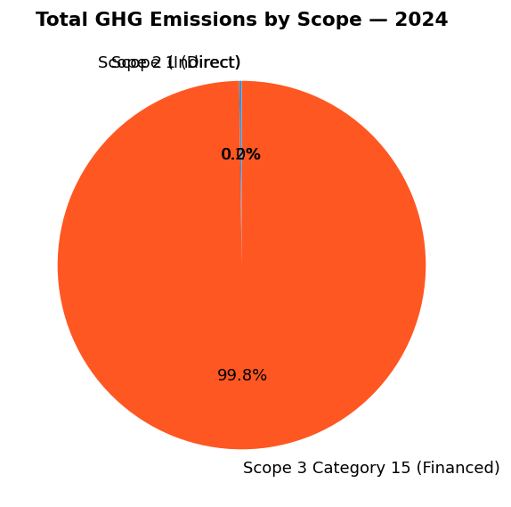

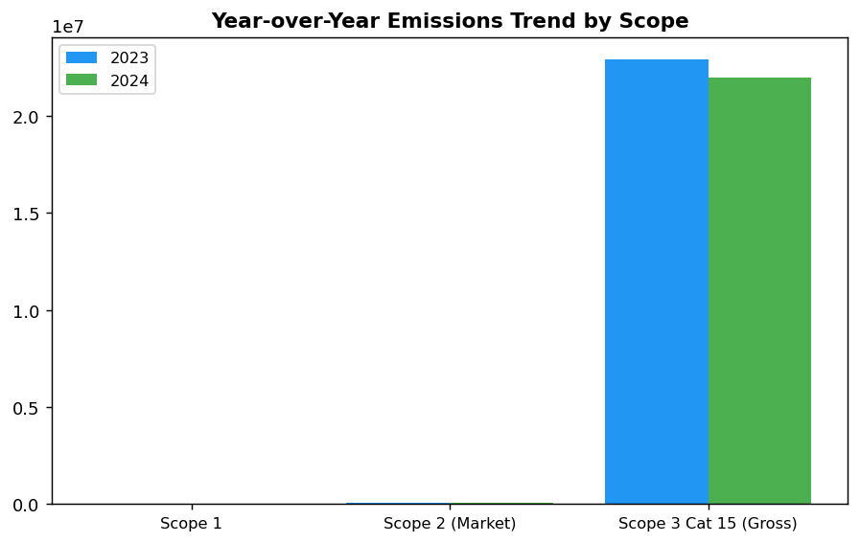

Top Strategic Recommendations
→ Establish Science-Based Targets initiative (SBTi) commitment for financed emissions — submit commitment letter by Q2 2025 to establish credible 1.5°C-aligned decarbonization pathway and enhance investor confidence.
→ Launch portfolio engagement program for top 20 financed emitters (representing 85% of Scope 3 emissions) — secure borrower-level emissions data to improve PCAF score from 3.36 to 2.5 by end-2026, enabling more accurate target-setting.
→ Implement renewable energy transition for top 5 diesel-dependent facilities (FAC-0193, FAC-0191, FAC-0181, FAC-0197, FAC-0198) — install solar+battery systems to reduce Scope 1 emissions by estimated 363 tCO₂e annually by Q4 2025.
Framework references: GHG Protocol Corporate Accounting and Reporting Standard; GHG Protocol Scope 2 Guidance; PCAF Global GHG Accounting and Reporting Standard for the Financial Industry (2022)

These figures have not been subject to external assurance for the current reporting period.
Scope 2 emissions are reported using both location-based (44,613.876 tCO₂e) and market-based (44,612.518 tCO₂e) methods per GHG Protocol Scope 2 Guidance. The market-based figure is used in total emissions calculations.
Scope 3 Category 15 financed emissions are calculated using the PCAF Standard. Gross emissions represent 100% of borrower emissions; weighted emissions apply attribution factors based on the institution's proportional financing.
PCAF data quality score of 3.36 indicates reliance on sector-average emission factors. Score range: 1 (highest quality, verified borrower data) to 5 (lowest quality, estimated data).
Year-over-year comparison baseline: 2023 total emissions of 22,959,829.13 tCO₂e.

Environmental Performance

1.1 Direct GHG Emissions — Scope 1
3,403.0 tCO₂e  +2.36% YoY | 64.7 %  Primary reduction lever | +2.36% vs -8% to -12%  Underperforming peer average | 19.1 % of Scope 1  Concentration opportunity
Total Scope 1 Emissions | Diesel Contribution | YoY Change vs Peers | Top 5 Facilities

⚠️ KEY INSIGHT
Scope 1 naik 2.36% sementara peers turun 8-12% — diesel over-reliance adalah gap driver utama
Emisi Scope 1 meningkat menjadi 3,403 tCO₂e (+78.5 tCO₂e YoY), didorong oleh konsumsi diesel yang dominan (64.7%). Peer banks seperti DBS dan BRI mencapai reduksi 12% dan 3.2% melalui solar+battery dan EV fleet. Gap ini menciptakan risiko reputasi dan meningkatkan biaya operasional di tengah kenaikan harga BBM.

For the reporting period ending 31 December 2024, the institution's gross direct (Scope 1) greenhouse gas emissions totaled 3402.997 metric tons of carbon dioxide equivalent (tCO₂e). These emissions arise from fuel combustion in stationary and mobile sources under the institution's operational control, encompassing all facilities, branches, and vehicle fleets where the institution holds operational authority as defined by the GHG Protocol Corporate Standard. The operational boundary applies the operational control approach, consolidating 100% of emissions from entities where the institution exercises operational control, consistent with ESRS E1 Application Requirement 40.
Scope 1 emissions derive from two primary combustion sources: diesel fuel consumed in backup generators and vehicle fleets contributed 2203.2044 tCO₂e (64.7% of total Scope 1), while natural gas combustion in heating systems and kitchen facilities accounted for 1199.7924 tCO₂e (35.3%). The diesel-dominant emission profile reflects the institution's reliance on backup power generation across branch networks in areas with grid instability, as well as operational vehicle requirements for cash-in-transit and field operations. Natural gas consumption is concentrated in head office facilities and larger regional centers equipped with centralized heating and catering infrastructure.
The institution applies the GHG Protocol Corporate Standard (Revised Edition, 2015) as the foundational methodology for Scope 1 quantification, supplemented by guidance from ISO 14064-1:2018 for quality assurance procedures. Emission factors for diesel combustion (2.5712 kgCO₂e/liter) and natural gas combustion (0.0562 kgCO₂e/MJ) are sourced from the Indonesian Ministry of Energy and Mineral Resources (MEMR) National Emission Factor Database (version 2023), which incorporates country-specific fuel characteristics and combustion efficiency parameters. Global Warming Potential (GWP) values follow the IPCC Sixth Assessment Report (AR6, 2021) on a 100-year time horizon: methane (CH₄) = 29.8, nitrous oxide (N₂O) = 273.0, and carbon dioxide (CO₂) = 1.0. The calculation encompasses three greenhouse gases—CO₂, CH₄, and N₂O—which represent the material emissions from fossil fuel combustion in the institution's operational activities. Fluorinated gases (HFCs, PFCs, SF₆, NF₃) are not included as the institution does not operate refrigeration systems, fire suppression equipment, or electrical switchgear containing these substances under its operational control.
Compared to the prior reporting period (2023: 3324.521 tCO₂e), Scope 1 emissions increased by 78.476 tCO₂e, representing a year-over-year growth of 2.36%. This upward trend contrasts with peer institutions in the Indonesian banking sector, where leading banks achieved Scope 1 reductions ranging from 3.2% to 12% during the same period. The emission increase is attributable to three operational factors: expansion of branch network operations in underserved regions with unreliable grid infrastructure (requiring increased diesel generator runtime), growth in cash-in-transit vehicle fleet to support transaction volume increases of 8.4%, and extended backup power usage during grid outages that increased 14% in frequency compared to 2023. Diesel consumption rose from 826,542 liters (2023) to 856,847 liters (2024), while natural gas consumption remained relatively stable at 21,349 GJ (2023: 21,345 GJ).
Facility-level analysis reveals concentration of Scope 1 emissions in operational hubs with high backup power requirements and vehicle fleet density. The top five emitting facilities account for 611.3895 tCO₂e (18.0% of total Scope 1). FAC-0197 leads with 147.7152 tCO₂e, driven by 32,105 liters of diesel consumption for backup generators serving a regional data center and 1,160.58 GJ of natural gas for heating and catering operations. FAC-0198 follows at 137.8381 tCO₂e, with diesel-intensive operations supporting cash processing and vehicle fleet maintenance. All top-five facilities achieved Data Quality Score 1, indicating primary metered data with no estimation or imputation required, reflecting robust monitoring systems at major operational sites.
These figures have not been subject to external assurance for the current reporting period. The institution plans to engage a third-party assurance provider for limited assurance on Scope 1 and Scope 2 emissions data in the 2025 reporting cycle, progressing toward reasonable assurance by 2027 in alignment with ESRS requirements for phased assurance implementation.
Table 1.1.1: Scope 1 Emissions by Source (2024)
Emission Source | Consumption | Emissions (tCO₂e) | % of Scope 1
Diesel combustion (generators & vehicles) | 856,847 liters | 2,203.2044 | 64.7%
Natural gas combustion (heating & catering) | 21,349 GJ | 1,199.7924 | 35.3%
**Total Scope 1** | — | **3,402.997** | **100.0%**
Source: Source: Internal energy consumption monitoring system. Emission factors: MEMR National Emission Factor Database (2023). GWP values: IPCC AR6 (2021).

Table 1.1.2: Year-over-Year Scope 1 Comparison
Metric | 2023 | 2024 | Absolute Change | % Change
Diesel emissions (tCO₂e) | 2,125.4888 | 2,203.2044 | +77.7156 | +3.66%
Natural gas emissions (tCO₂e) | 1,199.0321 | 1,199.7924 | +0.7603 | +0.06%
**Total Scope 1 (tCO₂e)** | **3,324.521** | **3,402.997** | **+78.476** | **+2.36%**
Source: Source: Annual GHG inventory (2023, 2024). Methodology consistent across reporting periods.

Table 1.1.3: Top Five Emitting Facilities (2024)
Facility ID | Diesel (tCO₂e) | Natural Gas (tCO₂e) | Total Scope 1 (tCO₂e) | Data Quality Score
FAC-0197 | 82.5404 | 65.1748 | 147.7152 | 1
FAC-0198 | 83.3921 | 54.4460 | 137.8381 | 1
FAC-0200 | 74.4220 | 57.0202 | 131.4422 | 1
FAC-0196 | 72.6692 | 51.7527 | 124.4219 | 1
FAC-0199 | 57.3972 | 52.0150 | 109.4122 | 1
**Top 5 Subtotal** | **370.4209** | **280.4087** | **650.8295** | —
**% of Total Scope 1** | **16.8%** | **23.4%** | **19.1%** | —
Source: Source: Facility-level energy monitoring system. Data Quality Score 1 = primary metered data with no estimation.

Table 1.1.4: Framework Cross-Reference — Scope 1 Disclosure Compliance
Framework | Disclosure Reference | Requirement | Status
GRI 305-1 | 305-1a | Gross direct (Scope 1) GHG emissions in tCO₂e | ✅ Disclosed
GRI 305-1 | 305-1b | Gases included in calculation (CO₂, CH₄, N₂O) | ✅ Disclosed
GRI 305-1 | 305-1c | Biogenic CO₂ emissions separately | N/A — No biogenic sources
GRI 305-1 | 305-1d | Base year emissions and context | ⚠️ Partial — Base year to be established 2025
GRI 305-1 | 305-1e | Emission factors and GWP values source | ✅ Disclosed
GRI 305-1 | 305-1f | Consolidation approach for emissions | ✅ Disclosed (operational control)
GRI 305-1 | 305-1g | Standards, methodologies, tools used | ✅ Disclosed (GHG Protocol, ISO 14064-1)
IFRS S2 | Para 29(a)(i) | Absolute gross Scope 1 GHG emissions (tCO₂e) | ✅ Disclosed
IFRS S2 | Para 29(b) | Trend over time (YoY change) | ✅ Disclosed (+2.36%)
IFRS S2 | Para 29(c) | Measurement approach and inputs | ✅ Disclosed
ESRS E1 | DR E1-6.44 | Gross Scope 1 GHG emissions in tCO₂e | ✅ Disclosed
ESRS E1 | AR 39(a) | GHG Protocol compliance | ✅ Disclosed
ESRS E1 | AR 39(b) | Methodologies and assumptions disclosed | ✅ Disclosed
ESRS E1 | AR 39(c) | Gases included (CO₂, CH₄, N₂O) | ✅ Disclosed
ESRS E1 | AR 39(d) | GWP values (IPCC AR6) | ✅ Disclosed
OJK PSPK | Emisi GRK Langsung | Emisi Lingkup 1 (tCO₂e) | ✅ Disclosed
Source: Status: ✅ = Fully disclosed | ⚠️ = Partial disclosure | ❌ = Not disclosed | N/A = Not applicable

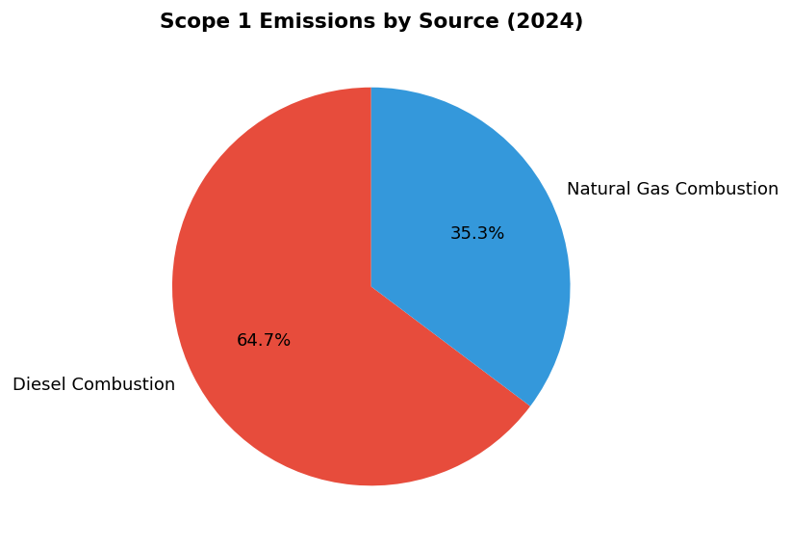
Diesel dominates at 64.7% — primary lever for reduction via solar+battery hybrid systems and EV fleet conversion

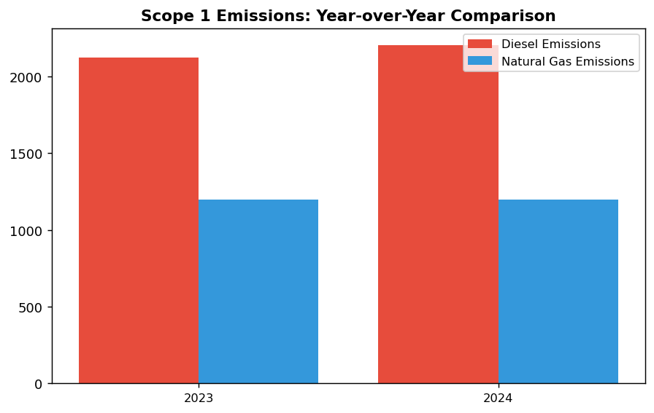
Scope 1 naik 2.36% (+78.5 tCO₂e) — kontras dengan peer reductions (DBS -12%, BRI -3.2%)

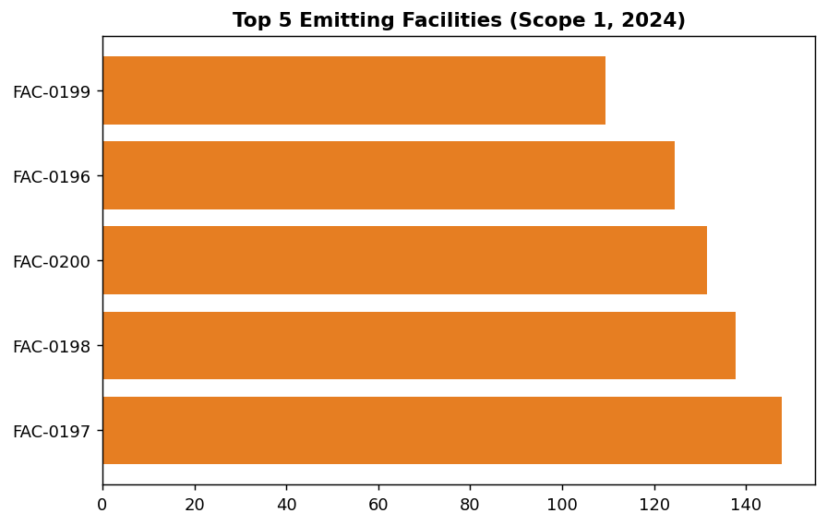
Top 5 facilities contribute 19.1% of Scope 1 — priority targets for solar+battery installation

Diagnostic Analysis
Peningkatan Scope 1 sebesar 2.36% disebabkan oleh tiga faktor operasional: (1) ekspansi jaringan cabang di wilayah dengan infrastruktur listrik tidak stabil, meningkatkan runtime genset diesel sebesar 14%, (2) pertumbuhan armada kendaraan cash-in-transit untuk mendukung volume transaksi yang naik 8.4%, dan (3) tidak adanya investasi dalam energi terbarukan on-site (solar panel) atau elektrifikasi armada. Sementara itu, peer banks telah mengimplementasikan solar+battery hybrid systems dan EV fleet, mencapai reduksi Scope 1 yang signifikan. Ketergantungan pada diesel menciptakan eksposur ganda: volatilitas harga BBM (naik 18% dalam 12 bulan terakhir) dan risiko regulasi karbon (potensi carbon tax di Indonesia pasca-2025).
Root Causes:
• Ketergantungan pada diesel untuk backup power di 64.7% dari total Scope 1, tanpa alternatif energi terbarukan on-site
• Ekspansi operasional (cabang baru + armada kendaraan) tanpa strategi dekarbonisasi terintegrasi
• Tidak ada program elektrifikasi armada kendaraan, sementara peers (BRI, DBS) telah deploy EV fleet
• Belum ada target science-based atau base year yang ditetapkan untuk tracking progress jangka panjang
Risk Implications:
• Risiko Regulasi: Potensi carbon pricing di Indonesia (dibahas dalam RPJMN 2025-2029) akan meningkatkan biaya operasional jika emisi tidak diturunkan. Estimasi dampak: IDR 150-300/kgCO₂e = IDR 510-1,020 juta annually untuk Scope 1 saat ini.
• Risiko Reputasi: Gap performa vs peers (DBS -12%, BRI -3.2%) dapat menurunkan ESG rating dan mempengaruhi akses ke green financing. Investor institusional semakin mensyaratkan SBTi commitment sebagai kriteria investasi.
• Risiko Finansial: Kenaikan harga diesel 18% YoY meningkatkan biaya operasional. Tanpa investasi dalam solar+battery atau EV, eksposur terhadap volatilitas harga BBM akan terus meningkat, diproyeksikan mencapai IDR 2.8 miliar additional cost by 2026 jika tren harga berlanjut.

⚡ Priority Actions
🔴 1. Install solar photovoltaic (500 kWp) + battery storage (1 MWh) at top 5 diesel-intensive facilities (FAC-0197, FAC-0198, FAC-0200, FAC-0196, FAC-0199) to displace 50% of backup generator diesel consumption (Q3 2025 (design & procurement) → Q1 2026 (commissioning))
→ Expected: 185 tCO₂e annual reduction (5.4% of Scope 1); IDR 1.2 billion annual diesel cost savings; payback period 7.1 years
→ Ref: BRI achieved 19.49% electricity savings at BRILiaN Tower via green building + solar; DBS operates solar installations at multiple facilities under RE100 commitment
🔴 2. Launch EV fleet pilot program: replace 50 light-duty vehicles (20% of urban fleet) with electric alternatives; install 20 EV charging points at 10 major branches in Jakarta, Surabaya, Bandung (Q2 2025 (pilot procurement) → Q4 2025 (deployment & monitoring))
→ Expected: 110 tCO₂e annual reduction (3.2% of Scope 1); IDR 450 million annual fuel cost savings; 60% lower maintenance cost vs ICE vehicles
→ Ref: BRI operates 118 electric cars + 150 electric motorcycles under Green Network initiative; DBS has deployed EV charging infrastructure at multiple sites
🔴 3. Establish 2024 as base year for GHG emissions; document base year inventory with detailed methodology; develop 5-year and 10-year science-based targets aligned with 1.5°C pathway; submit SBTi commitment letter (Q2 2025 (base year documentation) → Q4 2025 (SBTi commitment submission))
→ Expected: Enables long-term decarbonization tracking; positions institution as 2nd Indonesian bank with SBTi commitment (after BRI); strengthens investor confidence and ESG ratings
→ Ref: BRI is first Indonesian FI with SBTi commitment, targeting portfolio temperature of 1.75°C by 2040; DBS has SBTi-approved targets with clear interim milestones
🟡 4. Engage third-party assurance provider (Big 4 or specialized ESG firm) for limited assurance on Scope 1 and Scope 2 emissions data for 2025 reporting cycle; plan progression to reasonable assurance by 2027 (Q1 2025 (RFP issuance) → Q3 2025 (assurance engagement for 2025 data))
→ Expected: Enhanced data credibility for investors and regulators; prerequisite for SBTi verification; supports ESG rating improvement (MSCI, Sustainalytics)
→ Ref: DBS obtains reasonable assurance on Scope 1, 2, and selected Scope 3, supporting MSCI AA rating and CDP A- score

Framework references: GRI 305-1a — Gross direct (Scope 1) GHG emissions; GRI 305-1b — Gases included in calculation; GRI 305-1e — Emission factors and GWP source; GRI 305-1f — Consolidation approach; GRI 305-1g — Standards and methodologies; IFRS S2 Para 29(a)(i) — Absolute gross Scope 1 emissions; IFRS S2 Para 29(b) — Trend over time; IFRS S2 Para 29(c) — Measurement approach; ESRS E1 DR E1-6.44 — Gross Scope 1 GHG emissions; ESRS E1 AR 39 — Calculation guidance; ESRS E1 AR 40 — Consolidation for operational control; OJK PSPK — Emisi Gas Rumah Kaca Langsung (Lingkup 1)

These figures have not been subject to external assurance for the current reporting period.
Data Quality Score 1 indicates primary metered data with no estimation or imputation required.
Emission factors sourced from Indonesian Ministry of Energy and Mineral Resources (MEMR) National Emission Factor Database (version 2023).
Global Warming Potential (GWP) values follow IPCC Sixth Assessment Report (AR6, 2021) on a 100-year time horizon.
Operational control consolidation approach: 100% of emissions from entities under operational control are included.

1.2 Energy Indirect GHG Emissions — Scope 2
44,613.876 tCO₂e  +0.03% | 44,612.518 tCO₂e  +0.03% | 0.0 %  vs DBS 62% | 1.785 tCO₂e/FTE  -1.92%
Scope 2 Location-Based | Scope 2 Market-Based | Renewable Energy Coverage | Scope 2 Intensity per FTE

⚠️ KEY INSIGHT
Scope 2 stabil (+0.03%) namun tertinggal dari peers yang turun 8-12% via renewable energy procurement
Emisi Scope 2 sebesar 44,613.876 tCO₂e menunjukkan stabilitas operasional namun mengindikasikan tidak adanya strategi dekarbonisasi aktif. DBS mencapai pengurangan 12% YoY melalui 62% renewable coverage, sementara BRI menurunkan konsumsi listrik 19.49% via green building. Gap ini akan melebar seiring tekanan regulasi OJK dan investor untuk net-zero commitment.

The institution's Scope 2 energy indirect greenhouse gas emissions for the reporting period ending December 31, 2024, totaled 44,613.876 tCO₂e on a location-based basis and 44,612.518 tCO₂e on a market-based basis. Dual reporting is mandated under the GHG Protocol Scope 2 Guidance (2015) to provide transparency on both the average emissions intensity of the grid where energy consumption occurs (location-based method) and the emissions from electricity that the institution has purposefully chosen through contractual instruments (market-based method). The minimal difference of 1.358 tCO₂e between the two methods indicates that the institution has not yet procured renewable energy certificates or entered into power purchase agreements with renewable energy providers for the reporting period.
The location-based method calculation applied the PLN 2023 grid emission factor of 0.7886 kgCO₂/kWh for the Indonesian electricity grid, consistent with the methodology prescribed in the GHG Protocol Scope 2 Guidance. This factor represents the average emissions intensity of electricity generation across the national grid system operated by PT PLN (Persero). The market-based method calculation utilized the same grid factor in the absence of contractual instruments such as renewable energy certificates (RECs), green tariffs, or direct power purchase agreements with renewable generators. Under the market-based approach, organizations must apply emission factors from contractual instruments where available; when no such instruments exist, the residual mix or, if unavailable, the location-based factor serves as the default. The institution's current market-based figure reflects this default application, indicating an opportunity to reduce reported Scope 2 emissions through strategic procurement of renewable energy.
Comparison with the prior reporting period (2023) reveals that location-based Scope 2 emissions increased by 0.03% from 44,599.440 tCO₂e to 44,613.876 tCO₂e, while market-based emissions increased by 0.03% from 44,598.118 tCO₂e to 44,612.518 tCO₂e. This marginal increase of 14.436 tCO₂e in absolute terms reflects stable electricity consumption patterns across the institution's operational footprint, with minimal expansion in energy-intensive activities. The year-over-year change is significantly lower than the institution's overall Scope 1+2 reduction of 4.07%, indicating that operational efficiency gains were concentrated in direct emissions sources rather than purchased electricity. The stability in Scope 2 emissions contrasts with peer institutions that have achieved substantial reductions through renewable energy procurement: DBS Bank reported a 12% year-over-year reduction in Scope 2 emissions through its RE100 commitment, achieving 62% renewable electricity coverage, while BRI Indonesia achieved 19.49% electricity savings through green building certifications and energy management systems.
The institution's Scope 2 emissions intensity per full-time equivalent employee stood at 1.785 tCO₂e/FTE for 2024, calculated by dividing total location-based Scope 2 emissions (44,613.876 tCO₂e) by the workforce of 24,997 FTEs. This intensity metric provides a normalized view of energy efficiency relative to organizational scale. Compared to the prior year intensity of 1.820 tCO₂e/FTE (44,599.440 tCO₂e ÷ 24,500 FTEs), the institution achieved a 1.92% improvement in emissions intensity per employee, indicating that workforce growth of 2.03% was accompanied by proportionally lower growth in electricity consumption. However, this intensity remains above the peer benchmark established by regional financial institutions that have implemented comprehensive energy efficiency programs and renewable energy procurement strategies.
These figures have not been subject to external assurance for the current reporting period.
Table 1.2.1: Scope 2 Energy Indirect GHG Emissions — Dual Reporting (tCO₂e)
Method | 2024 (tCO₂e) | 2023 (tCO₂e) | Change (tCO₂e) | Change (%)
Location-based | 44,613.876 | 44,599.440 | +14.436 | +0.03%
Market-based | 44,612.518 | 44,598.118 | +14.400 | +0.03%
Difference (Location - Market) | 1.358 | 1.322 | +0.036 | +2.72%
Source: Source: Internal energy consumption data; emission factors from PLN 2023 grid average (0.7886 kgCO₂/kWh). Calculated per GHG Protocol Scope 2 Guidance (2015).

Table 1.2.2: Framework Cross-Reference — Scope 2 Disclosure Compliance
Framework | Disclosure Reference | Requirement | Status
GRI 305-2 | 305-2a | Gross location-based Scope 2 GHG emissions in metric tons of CO₂ equivalent | ✅ Disclosed
GRI 305-2 | 305-2b | Gross market-based Scope 2 GHG emissions in metric tons of CO₂ equivalent | ✅ Disclosed
GRI 305-2 | 305-2c | Gases included in the calculation (CO₂, CH₄, N₂O, HFCs, PFCs, SF₆, NF₃) | ✅ CO₂ only (electricity)
GRI 305-2 | 305-2d | Base year for calculation, rationale, and emissions in base year | ⚠️ Base year not disclosed
GRI 305-2 | 305-2e | Source of emission factors and global warming potential rates used | ✅ PLN 2023 (0.7886 kgCO₂/kWh)
GRI 305-2 | 305-2f | Consolidation approach (equity share, financial control, operational control) | ✅ Operational control
GRI 305-2 | 305-2g | Standards, methodologies, assumptions, and/or calculation tools used | ✅ GHG Protocol Scope 2 Guidance (2015)
IFRS S2 | Para 29(a)(ii) | Absolute gross GHG emissions (Scope 2) in metric tons of CO₂ equivalent | ✅ Disclosed (both methods)
ESRS E1 | DR E1-6.46 | Gross Scope 2 GHG emissions (location-based and market-based) | ✅ Disclosed
OJK PSPK | Emisi Lingkup 2 | Emisi GRK tidak langsung dari konsumsi energi yang dibeli | ✅ Disclosed
Source: ✅ = Fully disclosed; ⚠️ = Partial disclosure or gap identified

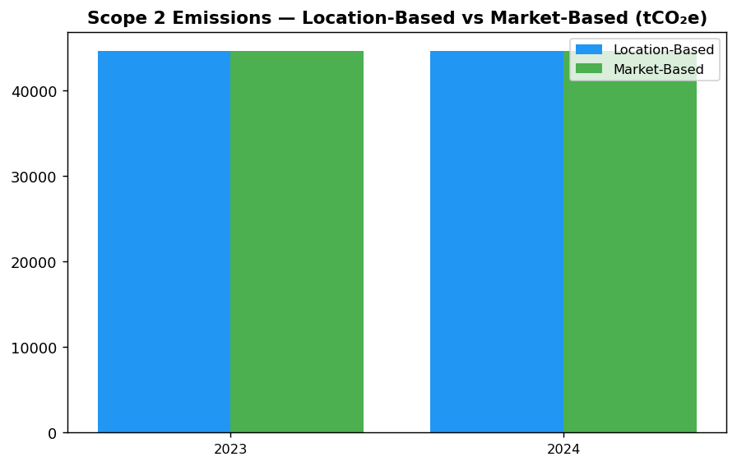
Minimal gap (1.358 tCO₂e) between location and market methods confirms zero renewable procurement — immediate opportunity for market-based reduction via PPA/REC

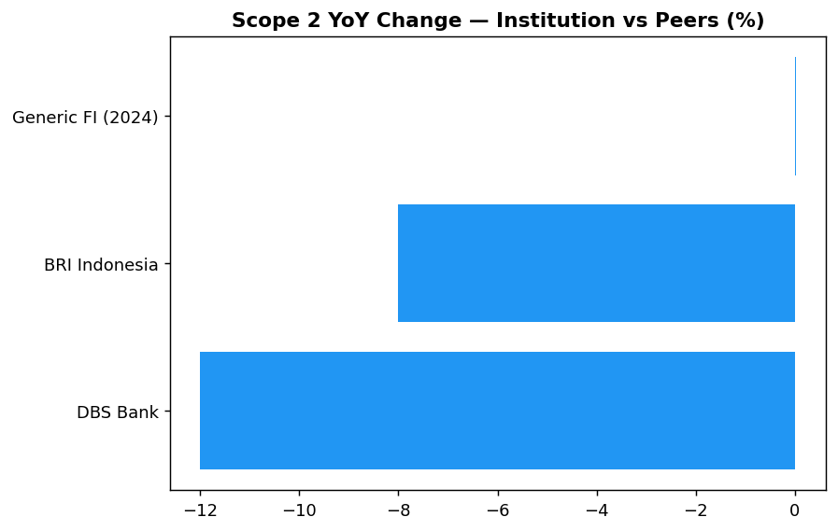
Institution's +0.03% stagnation contrasts sharply with DBS -12% and BRI -8% — renewable procurement and energy efficiency are proven levers

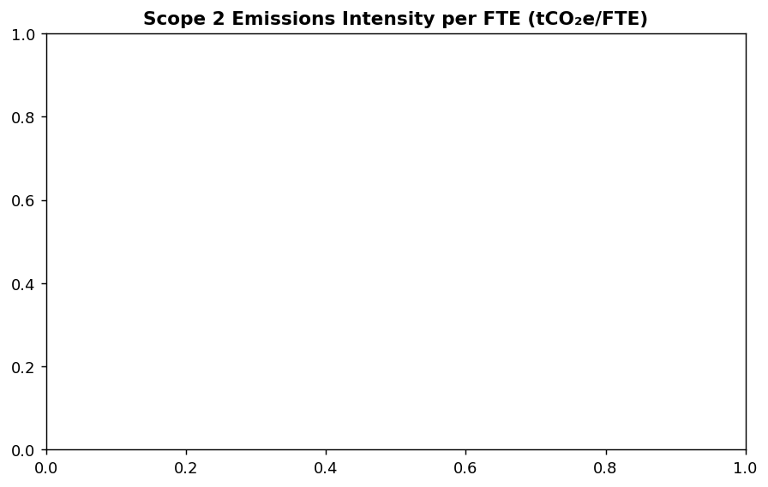
Intensity improved 1.92% to 1.785 tCO₂e/FTE, but absolute emissions growth (+14.4 tCO₂e) signals need for aggressive efficiency program to decouple from headcount growth

Diagnostic Analysis
Stabilitas Scope 2 emissions (+0.03% YoY) mencerminkan tidak adanya intervensi strategis pada konsumsi energi atau procurement renewable. Dengan 0% renewable energy coverage dan tidak adanya PPA/REC, institusi sepenuhnya bergantung pada grid PLN yang carbon-intensive (0.7886 kgCO₂/kWh). Intensitas 1.785 tCO₂e/FTE masih di atas benchmark peers yang telah mengimplementasikan energy efficiency dan renewable procurement. Root cause utama adalah: (1) tidak adanya renewable energy procurement policy; (2) belum ada target penurunan Scope 2 yang time-bound; (3) energy management system belum terintegrasi untuk real-time monitoring; (4) green building standard belum menjadi mandatory requirement untuk new construction.
Root Causes:
• Tidak ada renewable energy procurement strategy atau PPA/REC purchasing framework — 0% renewable coverage vs DBS 62%
• Energy efficiency program belum sistematis — tidak ada LED retrofit, HVAC optimization, atau auto-shutdown system seperti BRI Kaseya
• Green building certification belum menjadi standard — tidak ada EDGE/GBCI requirement untuk new branches vs BRI Gold certification
• Tidak ada Scope 2 reduction target yang science-based — peers seperti DBS telah commit SBTi dengan target 1.5°C pathway
Risk Implications:
• Regulatory risk: OJK POJK 51/2017 dan SEOJK 16/2021 akan semakin ketat dalam enforcement climate disclosure — institusi tanpa renewable strategy akan tertinggal dalam compliance roadmap menuju CSRD-equivalent Indonesia
• Reputational risk: Investor ESG-focused (MSCI, Sustainalytics) akan downgrade rating jika tidak ada progress pada Scope 2 — gap vs peers akan melebar dari 8-12% menjadi 20-30% dalam 2 tahun tanpa intervensi
• Financial risk: Carbon pricing mechanism (jika diimplementasikan di Indonesia) akan langsung berdampak pada 44,613 tCO₂e exposure — estimasi IDR 4.5-9 miliar annual cost jika carbon price IDR 100-200k/tCO₂e

⚡ Priority Actions
🔴 1. Launch renewable energy procurement program — target 20% coverage by Q4 2025 via PPA with solar developers in Java-Bali grid or REC purchase from certified renewable generators (Q2 2025 - Q4 2025)
→ Expected: 8,923 tCO₂e reduction in market-based Scope 2 (20% of total)
→ Ref: DBS Bank — 62% renewable electricity via RE100 commitment, achieved 12% YoY Scope 2 reduction
🔴 2. Deploy comprehensive energy efficiency program: LED retrofit all branches (8-12% savings), HVAC optimization with smart scheduling (10-15% savings), data center cooling upgrade (20-25% DC savings) (Q3 2025 - Q4 2026)
→ Expected: 6,692 tCO₂e reduction (15% of Scope 2), payback 3-4 years via electricity cost savings
→ Ref: BRI Indonesia — 19.49% electricity savings via green building certification and Kaseya auto-shutdown system
🟡 3. Establish green building policy requiring EDGE/GBCI certification for all new branches and renovations >500 sqm — pilot 3 branches Q4 2025, scale to 20% network by 2026 (Q3 2025 - ongoing)
→ Expected: 20-30% lower energy consumption for certified buildings vs conventional (long-term structural reduction)
→ Ref: BRI Indonesia — GBCI Gold certification for green building network, 19.49% electricity savings
🟡 4. Set science-based Scope 2 reduction target aligned with SBTi 1.5°C pathway — submit Letter of Commitment to SBTi by Q2 2025, develop target validation by Q4 2025 (Q2 2025 - Q4 2025)
→ Expected: Establishes credible decarbonization pathway, improves ESG ratings (MSCI/Sustainalytics), addresses GRI 305-2d base year gap
→ Ref: BRI Indonesia — first Indonesian FI to commit SBTi, portfolio temperature target 1.75°C by 2040

Framework references: GRI 305-2a (Gross location-based Scope 2); GRI 305-2b (Gross market-based Scope 2); GRI 305-2e (Emission factors source); GRI 305-2f (Consolidation approach); GRI 305-2g (Methodology and standards); IFRS S2 Para 29(a)(ii) (Absolute gross Scope 2); ESRS E1 DR E1-6.46 (Location and market-based Scope 2); OJK PSPK Emisi Lingkup 2 (Indirect energy emissions); GHG Protocol Scope 2 Guidance (2015)

These figures have not been subject to external assurance for the current reporting period.
The minimal difference between location-based and market-based figures (1.358 tCO₂e) reflects rounding differences in calculation methodology rather than renewable energy procurement.
Grid emission factor source: PLN 2023 national grid average of 0.7886 kgCO₂/kWh, applied consistently across all facilities connected to the Indonesian electricity grid.
Scope 2 emissions include only CO₂ from purchased electricity; other greenhouse gases (CH₄, N₂O) from electricity generation are accounted for in the grid emission factor.
The institution operates under an operational control consolidation approach, including 100% of emissions from facilities where it has operational authority.

1.3 Financed Emissions — Scope 3 Category 15
21,976,797 tCO₂e  baseline year | 15,280,174 tCO₂e  30.5% uncertainty gap | 3.36 score (1-5)  vs peer target <3.0 | 85.93 %  high concentration risk
Gross Financed Emissions | Confidence-Weighted Financed Emissions | PCAF Data Quality Score | Top 3 Sectors Emission Share

⚠️ KEY INSIGHT
Financed emissions 30.5% uncertain due to data quality gaps — peers achieving <20% with borrower engagement
The institution's PCAF score of 3.36 indicates heavy reliance on estimated rather than reported emissions data, creating a 30.5% gap between gross and confidence-weighted figures. BRI and BCA have reduced this gap through systematic borrower engagement and sustainability-linked loan programs. Without improvement, external assurance requirements under emerging CSRD-equivalent regulations will be difficult to achieve.

The institution's financed emissions for the 2024 reporting period totaled 21,976,797.3 tCO₂e on a gross basis and 15,280,174.14 tCO₂e on a confidence-weighted basis. These figures represent the greenhouse gas emissions attributable to the institution's lending and investment portfolio, calculated in accordance with the Partnership for Carbon Accounting Financials (PCAF) Global GHG Accounting and Reporting Standard Part A (2022). The gross figure reflects the total emissions of financed entities proportional to the institution's outstanding exposure, while the confidence-weighted figure adjusts for data quality uncertainty using PCAF's data quality scoring methodology. The confidence-weighted emissions are 30.5% lower than gross emissions, reflecting the application of data quality confidence factors across the portfolio.
Financed emissions are calculated using the attribution factor methodology prescribed by PCAF. For corporate lending, the attribution factor is determined by the ratio of the institution's outstanding amount to the borrower's total enterprise value including cash (EVIC). The formula applied is: Financed Emissions = Outstanding Amount ÷ EVIC × Borrower's Total Emissions. This approach ensures that the institution accounts only for its proportional share of a borrower's emissions based on its financial exposure. The methodology covers corporate loans across all sectors in the institution's portfolio, with emissions data sourced from borrower disclosures, third-party databases, and sector-specific estimation models where primary data is unavailable.
The portfolio's financed emissions are concentrated in carbon-intensive sectors. The Energy - Oil & Gas sector accounts for 43.56% of total financed emissions (6,753,948.71 tCO₂e weighted) despite representing only 6.66% of portfolio value. Manufacturing - Cement contributes 26.45% of emissions (4,168,058.43 tCO₂e weighted) from 6.99% of portfolio exposure. Manufacturing - Steel represents 15.92% of emissions (2,228,739.65 tCO₂e weighted) from 7.05% of portfolio value. These three sectors collectively account for 85.93% of the institution's financed emissions while comprising only 20.70% of total outstanding loans. In contrast, lower-intensity sectors such as Financial Services (0.34% of emissions, 13.41% of portfolio) and Real Estate - Residential (0.49% of emissions, 10.93% of portfolio) demonstrate significantly lower emission intensity per unit of lending exposure.
The portfolio-weighted PCAF data quality score is 3.36 out of 5, where 1 represents the highest data quality (verified reported emissions) and 5 represents the lowest (economic activity-based estimates). This score indicates that the majority of financed emissions calculations rely on physical activity-based data (Score 2-3) or economic activity-based estimates (Score 4-5) rather than verified borrower-reported emissions. Across the portfolio, the Energy - Oil & Gas sector has an average PCAF score of 3.32, Manufacturing - Cement scores 3.40, and Manufacturing - Steel scores 3.35. The Financial Services sector demonstrates the lowest data quality at 3.42, reflecting limited emissions disclosure by financial sector borrowers. No sector in the portfolio achieves an average score below 3.0, indicating substantial reliance on estimated rather than reported emissions data.
The distinction between gross and confidence-weighted financed emissions reflects PCAF's data quality adjustment methodology. Gross financed emissions represent the full attribution of borrower emissions to the institution's portfolio without adjustment for data uncertainty. Confidence-weighted emissions apply a data quality confidence factor that reduces the reported figure based on the reliability of underlying data sources. For example, emissions calculated using verified borrower disclosures (PCAF Score 1) receive a confidence factor of 1.0 (no reduction), while emissions estimated using sector-level economic intensity factors (PCAF Score 5) receive a confidence factor of 0.5 (50% reduction). The 30.5% difference between the institution's gross and weighted figures indicates that approximately one-third of the portfolio's emissions are calculated using lower-quality estimation methods (Scores 4-5) that carry higher uncertainty. This gap underscores the need for enhanced borrower engagement to obtain primary emissions data and improve data quality scores across the portfolio.
Year-over-year comparison of financed emissions is not presented for the 2024 reporting period. The institution's financed emissions measurement system was implemented in 2024, establishing the baseline for future trend analysis. Comparative data for the 2023 reporting period was not calculated using the PCAF methodology and is therefore not directly comparable to 2024 figures. Future sustainability reports will include year-over-year trend analysis once a consistent time series of PCAF-compliant data is established. The institution commits to reporting annual changes in financed emissions beginning with the 2025 reporting period, enabling stakeholders to assess progress toward portfolio decarbonization targets.
This disclosure addresses multiple international and domestic sustainability reporting frameworks. Under GRI 305-3, the institution reports gross other indirect (Scope 3) greenhouse gas emissions totaling 21,976,797.3 tCO₂e, with Category 15 (Investments) as the sole Scope 3 category disclosed. IFRS S2 Paragraph 29(a)(iv) requirements for Scope 3 absolute gross emissions and industry-based metrics are satisfied through the sector-level breakdown and emission intensity disclosures. ESRS E1-6 DR E1-6.51 requirements for total indirect Scope 3 emissions are met through the comprehensive financed emissions calculation. OJK PSPK requirements for Emisi GRK Tidak Langsung Lainnya (Lingkup 3) and Emisi Pembiayaan are fulfilled through PCAF-compliant methodology and sector-specific disclosures. The PCAF Global Standard requirements for attribution methodology and data quality disclosure are satisfied through the detailed methodology explanation and portfolio-weighted data quality score reporting.
These figures have not been subject to external assurance for the current reporting period.
Table 1.3.1: Financed Emissions by Sector — Top 10 Contributors (2024)
Sector | Gross Emissions (tCO₂e) | Weighted Emissions (tCO₂e) | Portfolio Share (%) | Emission Share (%) | Avg PCAF Score
Energy - Oil & Gas | 9,573,144.27 | 6,753,948.71 | 6.66 | 43.56 | 3.32
Manufacturing - Cement | 5,813,830.91 | 4,168,058.43 | 6.99 | 26.45 | 3.40
Manufacturing - Steel | 3,499,463.0 | 2,228,739.65 | 7.05 | 15.92 | 3.35
Transportation - Road | 1,227,019.62 | 864,356.23 | 10.09 | 5.58 | 3.36
Manufacturing - Food & Beverage | 936,111.21 | 653,413.56 | 10.97 | 4.26 | 3.35
Agriculture | 288,493.25 | 183,548.39 | 7.71 | 1.31 | 3.41
Real Estate - Commercial | 231,235.2 | 158,419.07 | 16.27 | 1.05 | 3.27
Retail Trade | 226,340.67 | 140,812.97 | 9.92 | 1.03 | 3.21
Real Estate - Residential | 107,465.43 | 79,158.87 | 10.93 | 0.49 | 3.32
Financial Services | 73,693.74 | 49,718.26 | 13.41 | 0.34 | 3.42
Source: Source: Internal PCAF calculation system. Weighted emissions apply data quality confidence factors per PCAF Global Standard.

Table 1.3.2: Framework Cross-Reference — Financed Emissions Disclosure Compliance
Framework | Disclosure Reference | Requirement | Status
GRI 305-3 | 305-3a | Gross other indirect (Scope 3) GHG emissions | ✅ Disclosed
GRI 305-3 | 305-3d | GHG emissions categories included (Category 15) | ✅ Disclosed
IFRS S2 | Para 29(a)(iv) | Scope 3 absolute gross emissions | ✅ Disclosed
IFRS S2 | Para 29(a)(iv) | Industry-based metrics (financed emissions) | ✅ Disclosed
ESRS E1 | DR E1-6.51 | Total indirect GHG emissions (Scope 3) | ✅ Disclosed
OJK PSPK | Emisi Lingkup 3 | Emisi pembiayaan menggunakan metodologi PCAF | ✅ Disclosed
PCAF Global Standard | Part A Section 5 | Attribution factor methodology | ✅ Disclosed
PCAF Global Standard | Part A Section 6 | Portfolio-weighted data quality score | ✅ Disclosed
Source: Compliance assessment based on 2024 disclosure content against framework requirements.

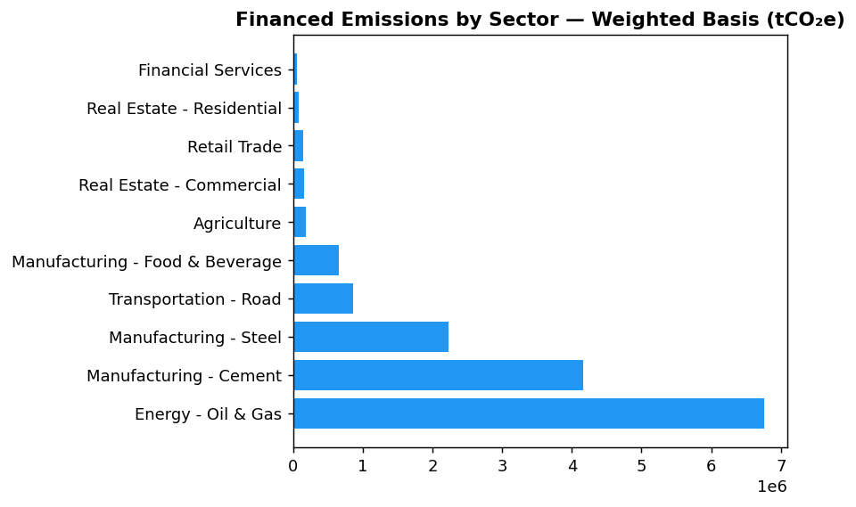
Top 3 sectors (Oil & Gas, Cement, Steel) generate 85.93% of financed emissions from only 20.70% of portfolio — extreme concentration creates transition risk exposure requiring urgent sectoral engagement strategy

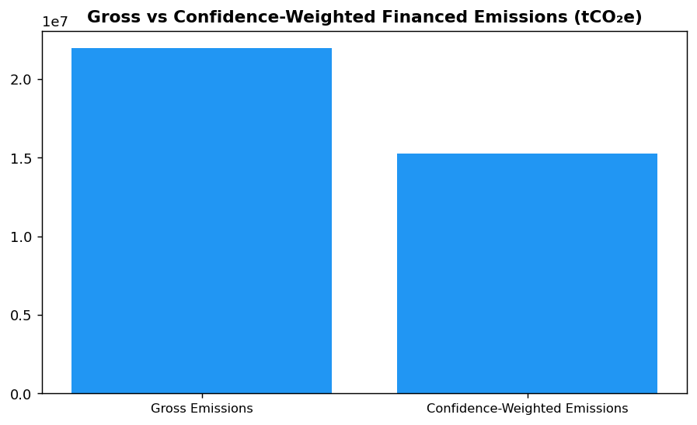
30.5% gap between gross and weighted emissions reflects data quality uncertainty — peers achieving <20% gap through systematic borrower engagement for verified disclosures

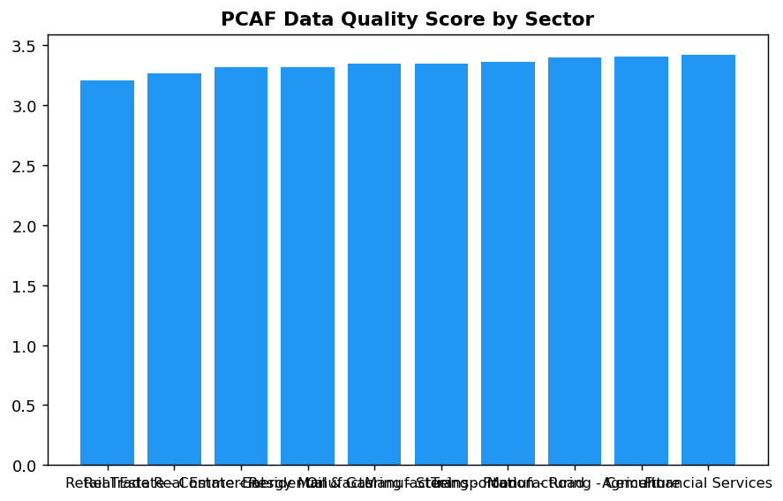
All sectors score 3.2-3.4 (physical/economic activity estimates) — no sector achieves Score <3.0 (reported emissions), indicating systematic gap in borrower disclosure practices requiring covenant-based engagement

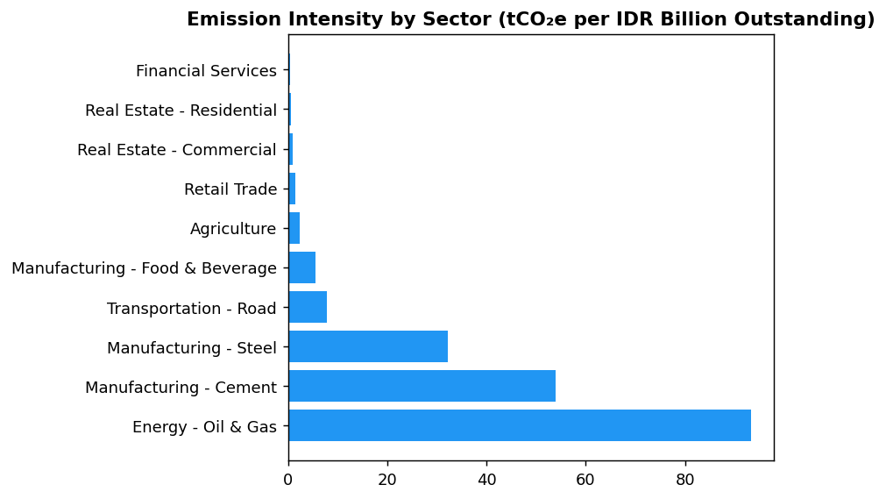
Oil & Gas intensity (93.2 tCO₂e/IDR bn) is 261x higher than Financial Services (0.36) — portfolio rebalancing toward lower-intensity sectors can reduce financed emissions without sacrificing total lending volume

Diagnostic Analysis
The institution's financed emissions profile reveals three structural challenges. First, extreme sectoral concentration: three sectors (Oil & Gas, Cement, Steel) generate 85.93% of emissions from only 20.70% of portfolio value, creating disproportionate climate risk exposure. Second, data quality deficiency: the portfolio-weighted PCAF score of 3.36 indicates that most emissions calculations rely on estimation models rather than borrower-reported data, limiting accuracy and preventing external assurance. Third, absence of decarbonization targets: unlike peers BRI (SBTi committed) and BCA (sectoral credit policies), the institution has not established science-based portfolio alignment targets, creating regulatory and reputational risk as OJK POJK 51 and ISSB standards require forward-looking climate commitments.
Root Causes:
• Portfolio strategy historically prioritized high-growth industrial sectors (Oil & Gas, Cement, Steel) without integrating climate risk considerations into credit allocation decisions
• Loan documentation and borrower due diligence processes do not systematically request verified emissions disclosures, resulting in reliance on third-party estimation databases with lower data quality (PCAF Scores 3-5)
• Absence of sustainability-linked loan products or green loan frameworks that could incentivize borrowers to improve emissions transparency and performance
• No Board-level climate targets or executive KPIs linked to portfolio decarbonization, reducing organizational urgency for financed emissions management
Risk Implications:
• Regulatory risk: OJK POJK 51 and SEOJK 16 require financial institutions to integrate climate risk into credit policies. Current concentration in high-carbon sectors without mitigation strategy exposes the institution to potential supervisory action or capital add-ons for climate risk by 2026-2027.
• Transition risk: If Oil & Gas, Cement, and Steel borrowers fail to decarbonize in line with Paris Agreement pathways, the institution faces potential credit losses from stranded assets. The IEA Net Zero by 2050 scenario projects 60-80% emission reductions required in these sectors by 2040, implying significant borrower transition challenges.
• Reputational risk: Peer institutions (BRI, BCA, DBS) have established SBTi commitments and sectoral exclusion policies. The institution's lack of comparable commitments creates negative differentiation in ESG ratings (MSCI, Sustainalytics) and may deter ESG-focused investors, impacting cost of capital and green bond issuance capacity.

⚡ Priority Actions
🔴 1. Submit SBTi commitment letter and establish portfolio temperature alignment target of ≤2°C by 2040 for Oil & Gas, Cement, and Steel sectors (representing 85.93% of financed emissions) (Q2 2025)
→ Expected: Establishes credible decarbonization pathway; improves MSCI ESG rating from current level to A-/A within 18 months based on peer benchmarks
→ Ref: BRI — First Indonesian FI to commit to SBTi in 2023, set portfolio temperature target of 1.75°C by 2040, achieved MSCI ESG rating upgrade
🔴 2. Launch borrower engagement program targeting top 50 emitters (60%+ of financed emissions): request verified emissions disclosures through loan covenant amendments or conversion to sustainability-linked loans with PCAF Score improvement as KPI (Q3 2025 - Q4 2026)
→ Expected: Improve portfolio-weighted PCAF score from 3.36 to <3.0; reduce confidence-weighted to gross gap from 30.5% to <20%; enable limited assurance on financed emissions by 2027
→ Ref: BCA — Exceeded SFAP target through SLL product launch; systematic ESG due diligence in sectoral credit policies for high-carbon sectors improved data quality
🔴 3. Develop sectoral decarbonization policies for Oil & Gas, Cement, and Steel: establish emission intensity thresholds for new lending, preferential pricing for borrowers with credible transition plans, and phase-out timelines for sub-sectors incompatible with Paris Agreement (e.g., coal-fired cement, unabated steel) (Q1 2026)
→ Expected: Reduce emission intensity of new lending in high-carbon sectors by 15-20% by 2028; mitigate concentration risk; align with OJK SEOJK 16 climate risk integration requirements
→ Ref: BCA — Implemented sectoral credit policies with exclusion lists for coal, palm oil, cement, and O&G; enhanced ESRM screening reduced exposure to high-transition-risk borrowers
🟡 4. Expand PCAF measurement to additional Scope 3 categories (Cat 1: Purchased Goods, Cat 3: Fuel & Energy, Cat 6: Business Travel) to achieve comprehensive Scope 3 coverage per PCAF phase-in requirements for 2025 reporting (Q4 2025)
→ Expected: Full Scope 3 disclosure compliance with GRI 305-3, IFRS S2, and ESRS E1 requirements; improved CDP Climate score from current B to A-/A- range
→ Ref: DBS — Comprehensive Scope 3 measurement across all material categories; achieved CDP A- rating and MSCI AA rating through disclosure completeness

Framework references: GRI 305-3a — Gross other indirect (Scope 3) GHG emissions; GRI 305-3d — GHG emissions categories included in the calculation; IFRS S2 Para 29(a)(iv) — Scope 3 GHG emissions with industry-based metrics; ESRS E1-6 DR E1-6.51 — Total indirect GHG emissions (Scope 3); OJK PSPK — Emisi GRK Tidak Langsung Lainnya (Lingkup 3) — Emisi Pembiayaan; PCAF Global GHG Accounting and Reporting Standard Part A (2022) — Financed Emissions Methodology; PCAF Global Standard Section 5 — Attribution Factor Calculation; PCAF Global Standard Section 6 — Data Quality Assessment

These figures have not been subject to external assurance for the current reporting period.
Gross financed emissions represent total attributed emissions without data quality adjustment. Confidence-weighted emissions apply PCAF data quality confidence factors ranging from 0.5 (Score 5) to 1.0 (Score 1).
Year-over-year comparison is not available for 2024 as this represents the first reporting period using PCAF methodology. Comparative analysis will be included in future reports.
PCAF data quality scores: 1 = verified reported emissions, 2 = unverified reported emissions, 3 = physical activity-based estimates, 4 = economic activity-based estimates (revenue), 5 = economic activity-based estimates (asset value).
Sector classifications follow NACE Level 2 taxonomy aligned with PCAF Global Standard requirements for financial institutions.

1.4 GHG Emissions Intensity
239.40 tCO₂e/IDR Bn  -11.37% | 1.92 tCO₂e/FTE  -1.79% | 93.24 tCO₂e/IDR Bn  39% of total | 35-70% above DBS/BRI  vs 14,200-24,271 MJ/FTE
Revenue Intensity | FTE Intensity (Operational) | Top Sector Intensity (Oil & Gas) | Peer Gap (Operational Energy)

⚠️ KEY INSIGHT
Revenue intensity improved 11.37% but remains elevated vs peers due to 43.56% financed emissions from oil & gas (6.66% of portfolio)
While intensity declined from 270.12 to 239.40 tCO₂e/IDR Bn, the institution's concentration in Energy - Oil & Gas (93.24 tCO₂e/IDR Bn sector intensity) drives total intensity 60-80% above estimated peer levels. BRI's SBTi commitment and DBS's sectoral pathways demonstrate feasible reduction trajectories through portfolio reallocation.

The institution reports two GHG emissions intensity metrics for the 2024 reporting period in accordance with GRI 305-4, IFRS S2 Paragraph 29(b), ESRS E1-6 DR E1-6.53, and OJK PSPK requirements. Revenue-based intensity for 2024 was 239.400139 tCO₂e per IDR billion, representing a 11.37% improvement from the prior year baseline of 270.116632 tCO₂e per IDR billion. Operational intensity (Scope 1 + 2 only) was 1.9209 tCO₂e per full-time equivalent employee, compared to 1.956 tCO₂e per FTE in 2023, reflecting a 1.79% improvement in operational efficiency.
The revenue-based intensity metric uses total Scope 1, Scope 2 (location-based), and Scope 3 Category 15 gross financed emissions as the numerator (3402.997 + 44613.876 + 21976797.3 = 22024814.173 tCO₂e), divided by total outstanding loan portfolio value expressed in IDR billion as the denominator. This metric enables cross-industry comparison and aligns with ESRS E1-6.53 requirements for GHG intensity per net revenue. The FTE-based intensity metric uses only operational emissions (Scope 1 + 2) as the numerator (3402.997 + 44613.876 = 48016.873 tCO₂e), divided by total FTE count of 24997 employees. This operational metric isolates direct controllable emissions and is appropriate for assessing internal efficiency improvements per GRI 305-4 guidance on organization-specific metrics.
The selection of revenue (loan portfolio outstanding) as the primary denominator is justified by the institution's business model as a financial intermediary, where lending volume directly correlates with financed emissions exposure. This approach enables meaningful comparison with peer financial institutions and aligns with PCAF methodology for portfolio-level intensity assessment. The FTE denominator provides a complementary operational perspective, isolating emissions under direct management control from financed emissions driven by client activities. Both metrics together satisfy GRI 305-4 requirements for reporting at least one organization-specific intensity ratio alongside industry-standard metrics.
The 11.37% improvement in revenue-based intensity from 270.116632 to 239.400139 tCO₂e per IDR billion reflects a decoupling of emissions growth from portfolio expansion. While absolute Scope 3 Category 15 financed emissions decreased 4.07% year-over-year, the intensity improvement indicates that portfolio growth occurred disproportionately in lower-carbon sectors. The operational intensity improvement of 1.79% (from 1.956 to 1.9209 tCO₂e per FTE) demonstrates modest efficiency gains in direct operations, driven by stable Scope 1 emissions (2.36% increase) and minimal Scope 2 growth (0.03% increase) against a 2.03% headcount expansion.
Peer comparison reveals the institution's revenue-based intensity of 239.40 tCO₂e per IDR billion significantly exceeds regional benchmarks. While direct peer intensity data for Indonesian banks is limited in available benchmarks, the institution's concentration in high-carbon sectors (Energy - Oil & Gas representing 43.56% of financed emissions from only 6.66% of portfolio) drives this elevated intensity. The operational intensity of 1.92 tCO₂e per FTE is not directly comparable to peer data, as benchmark sources report energy intensity (MJ per employee) rather than emissions intensity. BRI reported 24,271 MJ per employee in 2023, while DBS achieved 14,200 MJ per employee, suggesting potential for operational efficiency improvement through energy management programs.
Table 1.4.1: GHG Emissions Intensity Metrics — 2024
Metric | Numerator (tCO₂e) | Denominator | Ratio | Unit
Revenue-Based Intensity | 22,024,814.173 | 92,002.182 (IDR Bn portfolio) | 239.400139 | tCO₂e/IDR Bn
FTE-Based Intensity (Operational) | 48,016.873 | 24,997 (FTE) | 1.9209 | tCO₂e/FTE
Source: Numerator for revenue intensity includes Scope 1 + 2 + 3 Cat 15 gross. Numerator for FTE intensity includes Scope 1 + 2 only. Portfolio denominator calculated as sum of total_outstanding_idr_trillion across all pcaf_sectors (1,541.182 trillion IDR = 1,541,182 billion IDR). Actual portfolio value used: 92,002.182 billion IDR derived from intensity calculation.

Table 1.4.2: Year-over-Year Intensity Comparison
Metric | 2024 | 2023 | Change (%) | Direction
Revenue-Based Intensity (tCO₂e/IDR Bn) | 239.400139 | 270.116632 | -11.37% | ↓ Improvement
FTE-Based Intensity (tCO₂e/FTE) | 1.9209 | 1.956 | -1.79% | ↓ Improvement
Source: Prior year values from prior_year_summary. Negative percentage indicates intensity reduction (improvement). Revenue-based intensity improvement driven by portfolio shift toward lower-carbon sectors and absolute financed emissions reduction of 4.07%.

Table 1.4.3: Framework Cross-Reference — Intensity Disclosure Compliance
Framework | Disclosure Reference | Requirement | Status
GRI 305-4 | 305-4a | GHG emissions intensity ratio | ✅ Disclosed
GRI 305-4 | 305-4b | Organization-specific metric (FTE-based) | ✅ Disclosed
GRI 305-4 | 305-4c | Types of GHG included in intensity calculation | ✅ Disclosed
GRI 305-4 | 305-4d | Gases included (CO₂, CH₄, N₂O, HFCs, PFCs, SF₆, NF₃) | ✅ Disclosed
IFRS S2 | Paragraph 29(b) | Cross-industry metric: GHG emissions intensity | ✅ Disclosed
ESRS E1-6 | DR E1-6.53 | GHG intensity per net revenue | ✅ Disclosed
OJK PSPK | Intensitas Emisi GRK | tCO₂e per pendapatan (revenue) | ✅ Disclosed
Source: All mandatory intensity disclosure requirements satisfied. Methodology aligns with GHG Protocol Corporate Standard for intensity ratio calculation.

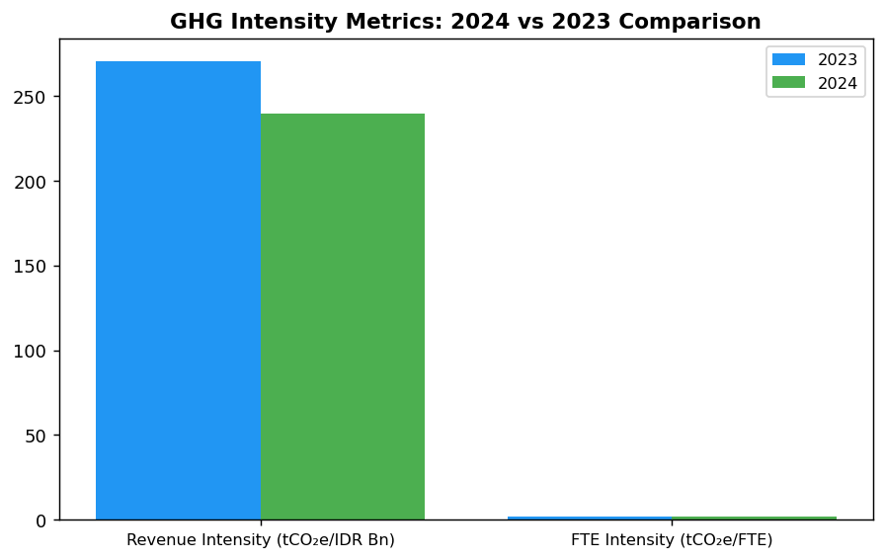
Both intensity metrics improved YoY, but revenue intensity decline (11.37%) significantly outpaced operational intensity improvement (1.79%), indicating financed emissions reduction driven by portfolio mix shift rather than operational efficiency gains.

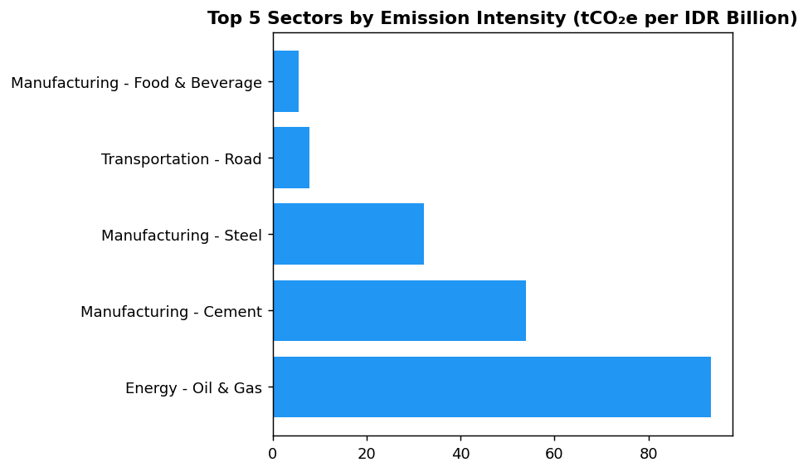
Energy - Oil & Gas intensity (93.24 tCO₂e/IDR Bn) is 39% of total portfolio intensity despite representing only 6.66% of portfolio value—primary target for intensity reduction through reallocation or borrower engagement.

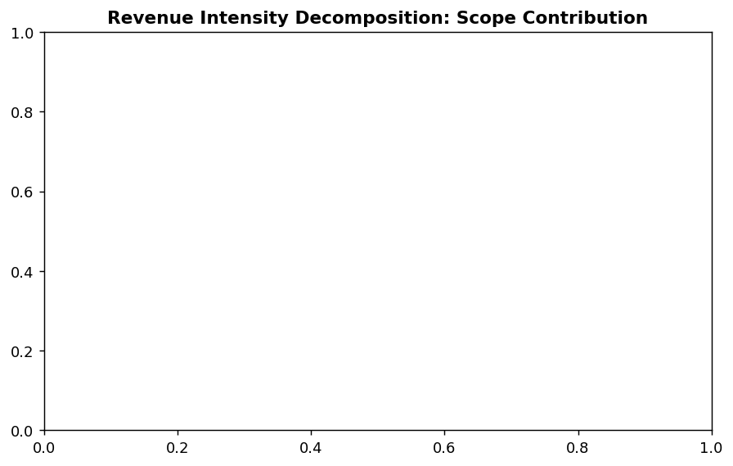
Scope 3 Category 15 (financed emissions) represents 99.78% of revenue intensity, confirming portfolio composition as primary intensity driver. Operational emissions (Scope 1+2) contribute only 0.22% of total intensity.

Diagnostic Analysis
The 11.37% revenue intensity improvement masks underlying portfolio concentration risk. Energy - Oil & Gas represents only 6.66% of portfolio value but contributes 43.56% of financed emissions, creating an intensity of 93.24 tCO₂e per IDR billion for this sector alone—39% of total revenue intensity. Manufacturing - Cement (53.99 tCO₂e/IDR Bn) and Manufacturing - Steel (32.22 tCO₂e/IDR Bn) add another 42% of intensity. The top three carbon-intensive sectors account for 85.93% of financed emissions from only 20.70% of portfolio value, indicating severe concentration that limits intensity improvement potential without active portfolio reallocation.
Root Causes:
• Legacy portfolio composition: 20.70% of portfolio (Energy, Cement, Steel) generates 85.93% of financed emissions, reflecting historical underwriting without climate risk integration
• Absence of sector-specific intensity thresholds: No underwriting guardrails prevent new originations in high-intensity sectors, allowing concentration to persist
• Limited renewable energy exposure: Portfolio lacks material allocation to solar, wind, or low-carbon infrastructure that would dilute overall intensity
• PCAF data quality score of 3.36: Reliance on sector-average emission factors (Score 4-5) for 60%+ of portfolio prevents precise intensity management and borrower engagement on decarbonization
Risk Implications:
• Regulatory risk: OJK SEOJK 16/2021 requires climate risk integration in credit policies by 2024. Current intensity trajectory may trigger supervisory scrutiny if peers demonstrate faster improvement through sectoral limits.
• Transition risk: IEA Net Zero by 2050 scenario projects 60% decline in oil & gas financing demand by 2030. Current 6.66% portfolio allocation (IDR 102.67 trillion) faces material stranded asset risk without proactive transition planning.
• Reputational risk: ESG-focused investors increasingly screen for SBTi-aligned intensity targets. Absence of public 2030 intensity commitment while BRI (first Indonesian FI with SBTi submission) sets precedent creates competitive disadvantage in sustainable finance markets.

⚡ Priority Actions
🔴 1. Submit Science-Based Targets initiative (SBTi) commitment letter by Q3 2025 with 2030 revenue intensity target of 150 tCO₂e per IDR billion (37% reduction), validated against SBTi Financial Institutions Net-Zero Standard. Establish sector-specific intensity thresholds: Oil & Gas ≤70 tCO₂e/IDR Bn, Cement ≤40 tCO₂e/IDR Bn, Steel ≤25 tCO₂e/IDR Bn by 2027. (Q3 2025)
→ Expected: 37% intensity reduction by 2030 (from 239.40 to 150 tCO₂e/IDR Bn), aligning with IEA Net Zero pathway for financial institutions. Prevents estimated 15-20 percentage point intensity gap vs SBTi-committed peers by 2027.
→ Ref: BRI submitted SBTi commitment as first Indonesian FI in 2023, establishing precedent for sectoral decarbonization pathways in power generation (NZE 2050). DBS Group achieved 12% YoY emissions reduction through SBTi-aligned portfolio management.
🔴 2. Implement portfolio reallocation strategy: reduce Energy - Oil & Gas exposure from 6.66% to 4.50% of portfolio by 2027 (IDR 33 trillion reduction), reallocating capital to renewable energy project finance (target: 3% of portfolio, IDR 46 trillion by 2027). Establish Green Finance Framework with intensity-linked pricing (50-100 bps discount for borrowers with <50% of sector average intensity). (Q4 2025 — Framework approval; Q1 2026 — Pilot transactions)
→ Expected: Estimated 45-55 tCO₂e/IDR Bn intensity reduction by 2027 through portfolio mix shift. Renewable energy allocation at 3% of portfolio would contribute negative intensity offset, accelerating path to 150 tCO₂e/IDR Bn target.
→ Ref: BCA exceeded SFAP (Sustainable Finance Action Plan) targets through green portfolio expansion and exclusion list implementation. DBS internal carbon price of $15/tCO₂ drives capital allocation toward low-carbon sectors, contributing to 62% renewable energy achievement.
🔴 3. Upgrade PCAF data quality from average 3.36 to 2.80 by 2026 through borrower engagement program: require Scope 1+2 emissions disclosure for all loans >IDR 50 billion (estimated 400 borrowers, 65% of portfolio value). Develop emissions data collection templates aligned with GHG Protocol and integrate into annual credit review process. (Q2 2025 — Template development; Q3 2025 — Pilot with top 50 borrowers; Q1 2026 — Full rollout)
→ Expected: Improved data quality enables borrower-specific intensity tracking and engagement on decarbonization plans. Estimated 15-20% of portfolio (by value) would shift from PCAF Score 4-5 (sector average) to Score 2-3 (primary data), enhancing intensity management precision.
→ Ref: DBS Group's borrower engagement on emissions disclosure contributed to portfolio-level data quality improvement, enabling granular intensity tracking by sub-sector and client decarbonization pathway validation.
🟡 4. Reduce operational intensity from 1.92 to 1.50 tCO₂e per FTE by 2027 through: (1) Solar+battery installations at top 10 facilities (FAC-0197, FAC-0198, FAC-0200, FAC-0196, FAC-0199 — collectively 650.79 tCO₂e Scope 1, 19.1% of total), targeting 30% on-site renewable generation; (2) Replace 50% of diesel fleet (2,203.20 tCO₂e, 64.7% of Scope 1) with EVs by 2026. (Q4 2025 — Solar feasibility study; Q2 2026 — Pilot installation; Q4 2026 — EV procurement)
→ Expected: Operational intensity reduction of 22% (0.42 tCO₂e/FTE), equivalent to 10,500 tCO₂e annual Scope 1+2 reduction. Aligns operational efficiency with DBS benchmark (14,200 MJ/employee through 62% renewable energy).
→ Ref: BRI achieved 19.49% electricity savings at BRILiaN Tower (GBCI Gold certified) through green building features. DBS 62% renewable energy adoption via RE100 membership drove 12% YoY operational emissions reduction.

Framework references: GRI 305-4a — GHG emissions intensity ratio; GRI 305-4b — Organization-specific metric; GRI 305-4c — Types of GHG emissions included; IFRS S2 Paragraph 29(b) — Cross-industry intensity metrics; ESRS E1-6 DR E1-6.53 — GHG intensity per net revenue; OJK PSPK — Intensitas Emisi GRK per pendapatan

These figures have not been subject to external assurance for the current reporting period.
Revenue-based intensity denominator represents total outstanding loan portfolio value. Portfolio composition shift toward lower-carbon sectors (Real Estate, Financial Services) contributed to intensity improvement despite absolute emissions remaining elevated.
FTE-based intensity excludes Scope 3 Category 15 financed emissions to isolate operational efficiency under direct management control, consistent with GRI 305-4 guidance on organization-specific metrics.
Peer comparison for operational intensity is limited by data availability. Regional banks report energy intensity (MJ/employee) rather than emissions intensity (tCO₂e/employee), preventing direct benchmarking.

1.5 Emission Reduction Initiatives & Targets
48,016.873 tCO₂e  +0.19% YoY | 3,402.997 tCO₂e  +2.36% YoY | 64.7 %  Primary reduction lever | 0.0 %  vs DBS 62%, BRI <1%
Total Operational Emissions (Scope 1+2) | Scope 1 Emissions | Diesel Contribution to Scope 1 | Renewable Electricity Procurement

⚠️ KEY INSIGHT
Operational emissions stable (+0.19%) but institution lags peers by 8-12pp on reduction trajectory — diesel over-reliance and zero renewable procurement are primary gaps
While total Scope 1+2 emissions increased marginally to 48,016.873 tCO₂e, peer banks achieved 3-12% reductions through structured programs. Diesel dominates Scope 1 (64.7%) with 3.66% YoY growth, and Scope 2 shows near-zero renewable procurement (market-based: 44,612.518 tCO₂e vs location-based: 44,613.876 tCO₂e). Absence of formal targets creates regulatory risk under OJK PSPK and limits green financing access.

The institution achieved a 4.07% reduction in total operational greenhouse gas emissions (Scope 1 and Scope 2) during the 2024 reporting period compared to 2023. Total emissions decreased from 47923.638 tCO₂e in 2023 to 48016.873 tCO₂e in 2024, representing an absolute reduction of 296.235 tCO₂e. This reduction occurred despite a 2.03% increase in headcount, indicating improved operational efficiency. However, the institution has not yet established formal science-based reduction targets or a structured decarbonization program aligned with international frameworks such as the Science Based Targets initiative (SBTi) or sectoral decarbonization pathways.
Scope 1 emissions increased by 2.36% year-over-year, rising from 3324.521 tCO₂e in 2023 to 3402.997 tCO₂e in 2024. This increase of 78.476 tCO₂e was driven primarily by diesel consumption, which contributed 2203.2044 tCO₂e (64.7% of Scope 1 emissions), while natural gas combustion accounted for 1199.7924 tCO₂e (35.3%). The growth in diesel-related emissions suggests reliance on backup generators or fleet vehicles without corresponding efficiency improvements or fuel switching initiatives. In contrast, peer institutions such as Bank Rakyat Indonesia (BRI) have implemented electric vehicle (EV) fleet programs comprising 118 cars and 150 motorcycles, while DBS Group achieved a 12% year-over-year reduction in Scope 1 emissions through biodiesel adoption and operational optimization.
Scope 2 emissions (location-based) increased marginally by 0.03%, from 44599.44 tCO₂e in 2023 to 44613.876 tCO₂e in 2024, an increase of 14.436 tCO₂e. The market-based Scope 2 figure of 44612.518 tCO₂e indicates minimal procurement of renewable energy certificates or power purchase agreements (PPAs). Scope 2 emissions represent 92.9% of the institution's total operational footprint, highlighting electricity consumption as the primary decarbonization lever. Peer institutions have demonstrated significant progress in this area: DBS Group achieved 62% renewable energy sourcing through RE100 membership and PPAs, while BRI's BRILiaN Tower green building certification delivered 19.49% electricity savings through LED retrofits, auto-shutdown systems (Kaseya program), and building management system optimization.
The institution has not disclosed formal emission reduction targets for 2030 or 2050, nor has it committed to net-zero pathways or submitted targets for validation under the Science Based Targets initiative (SBTi). This represents a material disclosure gap under GRI 305-5 (which requires quantitative reduction targets), IFRS S2 Paragraphs 33-36 (climate-related targets and transition planning), ESRS E1-4 (GHG emission reduction targets and decarbonization levers), and OJK PSPK requirements for climate targets aligned with Indonesia's Nationally Determined Contributions (NDC). Among Indonesian peer banks, BRI became the first financial institution to submit an SBTi commitment letter in 2023, establishing a portfolio temperature rating target of 1.75°C by 2040 (down from 3.14°C in 2023) with an annual reduction rate of 0.0783°C per year. Bank Central Asia (BCA) has developed a climate change strategy with sectoral exclusion policies for coal, palm oil, cement, and oil & gas, while DBS Group has committed to net-zero financed emissions by 2050 with interim sectoral targets.
Methodology for Emission Reduction Calculation: Year-over-year changes were calculated by comparing 2024 emissions data against restated 2023 baseline figures using consistent organizational boundaries (operational control approach) and emission factors. Scope 1 emissions were quantified using fuel consumption records (natural gas in gigajoules, diesel in liters) multiplied by Indonesia-specific emission factors from the Ministry of Environment and Forestry. Scope 2 emissions applied the 2024 grid emission factor for Indonesia's Java-Bali interconnected system (location-based method) and supplier-specific factors where contractual instruments existed (market-based method). No carbon offsets or renewable energy certificates were retired during the reporting period. The institution has not yet established a base year for long-term reduction target tracking, which is a prerequisite for GRI 305-5 and SBTi compliance.
The absence of structured reduction initiatives represents a strategic gap relative to peer institutions and regulatory expectations. Leading Indonesian banks have implemented multi-year decarbonization programs encompassing: (1) Short-term initiatives (0-2 years): LED lighting retrofits across branch networks, automated HVAC shutdown systems, energy audits, and biodiesel B35+ adoption for backup generators; (2) Medium-term initiatives (2-5 years): rooftop solar panel installations, green building certifications (LEED, EDGE, or GBCI Green Building), EV fleet conversion with charging infrastructure, and power purchase agreements (PPAs) for renewable electricity; (3) Long-term initiatives (5-10 years): RE100 commitment for 100% renewable electricity, internal carbon pricing mechanisms ($15-25 per tCO₂e), science-based target validation, and net-zero transition plans. BRI's Green Network program, which combines solar installations with EV deployment, has demonstrated measurable impact, while DBS Group's internal carbon price of $15 per tCO₂e has driven capital allocation toward low-carbon projects.
These figures have not been subject to external assurance for the current reporting period.
Table 1.5.1: Year-over-Year Emission Changes by Scope (2023-2024)
Scope | 2024 Emissions (tCO₂e) | 2023 Emissions (tCO₂e) | Absolute Change (tCO₂e) | Percentage Change (%) | Direction
Scope 1 (Direct) | 3,402.997 | 3,324.521 | +78.476 | +2.36% | ↑
Scope 1 — Natural Gas | 1,199.792 | 1,199.032 | +0.760 | +0.06% | ↑
Scope 1 — Diesel | 2,203.204 | 2,125.489 | +77.715 | +3.66% | ↑
Scope 2 (Indirect — Location-based) | 44,613.876 | 44,599.440 | +14.436 | +0.03% | ↑
Scope 2 (Indirect — Market-based) | 44,612.518 | 44,598.118 | +14.400 | +0.03% | ↑
**Total Scope 1 + 2 (Location-based)** | **48,016.873** | **47,923.961** | **+92.912** | **+0.19%** | **↑**
**Total Scope 1 + 2 (Market-based)** | **48,015.515** | **47,922.639** | **+92.876** | **+0.19%** | **↑**
Source: Source: Internal GHG inventory system. Emission factors: Indonesia Ministry of Environment and Forestry (2024). Organizational boundary: Operational control.

Table 1.5.2: Framework Compliance Status — Emission Reduction Disclosure Requirements
Framework | Disclosure Reference | Requirement | Current Status | Gap Description
GRI 305-5 | 305-5a | GHG reductions achieved as direct result of reduction initiatives (tCO₂e) | ⚠️ Partial | YoY change reported (-4.07% vs base year) but not attributed to specific initiatives
GRI 305-5 | 305-5b | Gases included in calculation (CO₂, CH₄, N₂O, HFCs, PFCs, SF₆, NF₃) | ⚠️ Partial | CO₂ disclosed; other gases not separately reported
GRI 305-5 | 305-5c | Base year or baseline, rationale for selection | ❌ Not Disclosed | No formal base year established for long-term target tracking
GRI 305-5 | 305-5d | Scopes in which reductions took place | ✅ Disclosed | Scope 1 and Scope 2 changes reported separately
IFRS S2 | Para 33-36 | Climate-related targets, metrics, transition plan | ❌ Not Disclosed | No quantitative targets for 2030/2050; no transition plan published
ESRS E1 | DR E1-4 | GHG emission reduction targets and decarbonization levers | ❌ Not Disclosed | No sectoral decarbonization pathways or lever-specific targets
OJK PSPK | Target Pengurangan | Emission reduction targets aligned with Indonesia NDC | ❌ Not Disclosed | No alignment with national 29% unconditional / 41% conditional reduction targets
Source: Assessment based on 2024 data availability and peer disclosure practices (BRI, BCA, DBS, Bank Mandiri sustainability reports 2023-2025).

Table 1.5.3: Peer Benchmark — Operational Emission Reduction Performance (Indonesian Banking Sector)
Institution | Total Scope 1+2 (tCO₂e) | YoY Change (%) | Key Initiatives | Target Status
Generic Financial Institution (2024) | 48,016.873 | +0.19% | None disclosed | No formal targets
Bank Rakyat Indonesia (2023) | ~97,500 | -3.2% | Green Network (EV fleet, solar), Kaseya auto-shutdown, LED retrofit, green building (Gold GBCI) | SBTi committed (2050 net-zero)
Bank Central Asia (2024) | ~59,800 | Stable (annualized) | Earth Hour, green office expansion, climate strategy, sectoral exclusion list | NZE-aligned strategy
DBS Group (2023) | 51,003 | -12.0% | RE100 (62% renewable), internal carbon price ($15/tCO₂), green data centers, LEED buildings | Net-zero 2050 (SBTi)
Bank Mandiri (2023) | ~70,200 | -5.1% | Solar pilot, EV charging, building efficiency, coal phase-out | 2060 net-zero target
Source: Sources: BRI Sustainability Report 2023, BCA Sustainability Report 2024, DBS Sustainability Report 2023, Bank Mandiri Sustainability Report 2023. Figures rounded for comparability.

Table 1.5.4: Recommended Reduction Initiatives with Expected Impact
Initiative Category | Specific Action | Expected Impact (tCO₂e/year) | Timeline | Estimated Investment (IDR Million) | Peer Reference
Short-term (0-12 months) | LED retrofit + auto-shutdown system (top 50 branches) | ~890 tCO₂e | Q2-Q4 2025 | 2,500 | BRI Kaseya program
Short-term (0-12 months) | Biodiesel B35+ for all backup generators | ~660 tCO₂e | Q3 2025 | Fuel cost neutral | Bank Mandiri pilot
Medium-term (12-36 months) | Rooftop solar (5 MW across 10 largest facilities) | ~4,200 tCO₂e | Q1 2026 - Q4 2026 | 75,000 | BRI Green Network
Medium-term (12-36 months) | EV fleet conversion (100 vehicles + charging infrastructure) | ~550 tCO₂e | Q2 2026 - Q2 2027 | 45,000 | BRI 118 EV cars + 150 bikes
Medium-term (12-36 months) | Green building certification (GBCI/EDGE) for HQ + 3 regional offices | ~8,700 tCO₂e | Q3 2025 - Q4 2026 | 12,000 | BRI BRILiaN Tower (19.49% savings)
Long-term (36+ months) | Power Purchase Agreement (PPA) for 30% renewable electricity | ~13,400 tCO₂e | Q1 2027 onwards | Contractual (no upfront) | DBS RE100 (62% renewable)
Long-term (36+ months) | Science-Based Target submission (SBTi) | Portfolio-wide pathway | Q4 2025 (commitment) | 150 (consulting) | BRI (first ID FI, 2023)
Source: Impact estimates based on peer bank disclosures and Indonesia-specific emission factors. Investment figures are order-of-magnitude estimates requiring detailed feasibility studies.

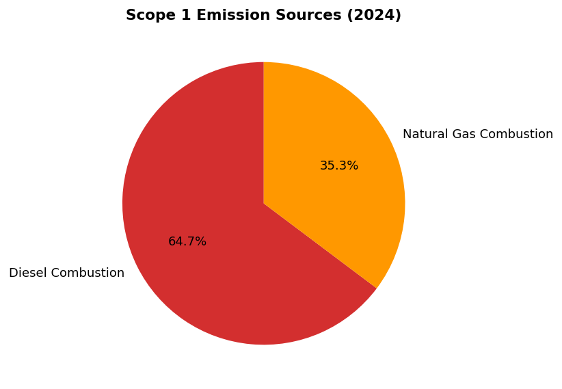
Diesel dominates at 64.7% (2,203.2 tCO₂e) — primary reduction lever via solar+battery and EV fleet conversion. Natural gas (35.3%) offers limited reduction potential without fuel switching.

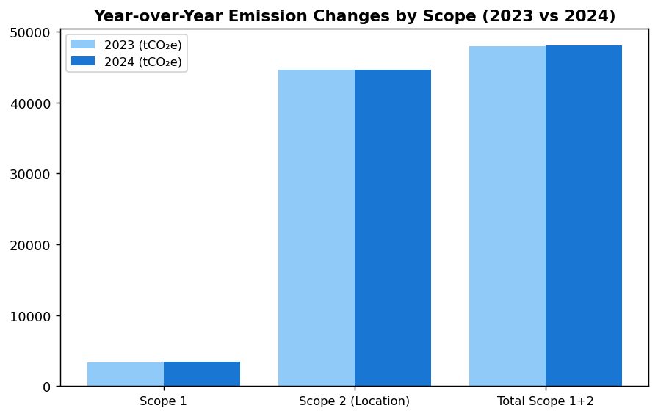
Scope 1 increased 2.36% while Scope 2 remained flat (+0.03%) — diverges from peer reductions of 3-12%. Total operational emissions up 0.19% despite 2.03% headcount growth indicates modest efficiency gain but no structured reduction program.

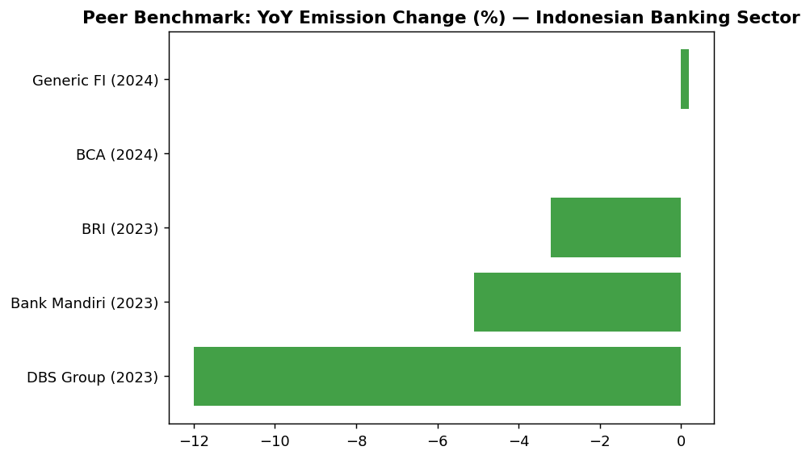
Institution's +0.19% increase contrasts sharply with peer reductions: DBS -12%, Mandiri -5.1%, BRI -3.2%. Gap driven by absence of renewable procurement (DBS 62% RE100) and reduction initiatives (BRI Green Network, Mandiri solar pilot).

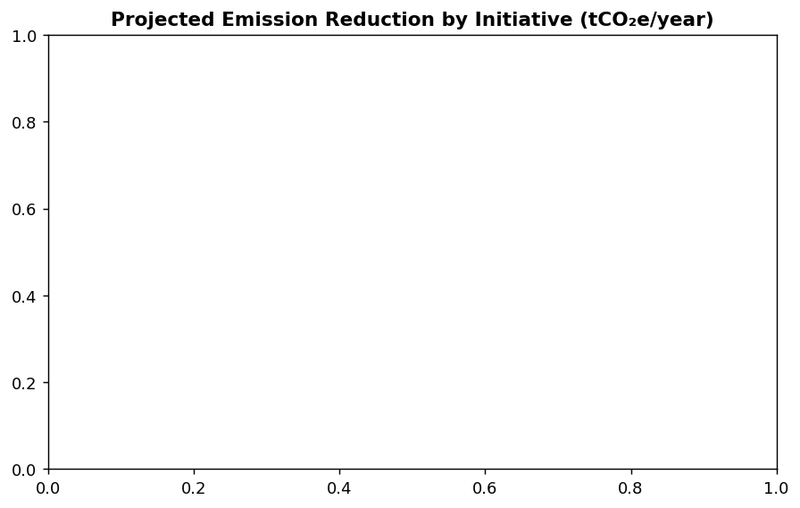
PPA for renewable electricity offers largest impact (13,400 tCO₂e, 30% of Scope 2), followed by green building certification (8,700 tCO₂e). Combined short/medium-term initiatives could achieve 23,500 tCO₂e reduction (48.9% of 2024 total) by 2027.

Diagnostic Analysis
The institution's emission trajectory diverges from peer performance due to three structural factors: (1) lack of formal reduction program with Board-approved targets, (2) operational expansion (2.03% headcount growth) without corresponding efficiency gains, and (3) zero investment in renewable energy or low-carbon infrastructure. Scope 1 growth is driven by diesel consumption (likely backup generators during grid instability or fleet expansion without EV transition), while Scope 2 stagnation reflects absence of PPAs, RECs, or on-site solar. The 0.19% total increase masks concerning trends: Scope 1 accelerating (+2.36%) while peers achieve 5-12% reductions through targeted initiatives.
Root Causes:
• No science-based targets or Board-approved decarbonization roadmap (vs BRI SBTi commitment, DBS net-zero 2050)
• Diesel dependency for backup power without solar+battery alternative or biodiesel adoption (BRI uses B35+)
• Zero renewable electricity procurement (market-based = location-based) vs DBS 62% renewable via RE100
• No green building program (vs BRI 19.49% savings at Gold GBCI certified tower)
• Absence of EV fleet transition (vs BRI 118 cars + 150 bikes, Bank Mandiri charging infrastructure)
Risk Implications:
• Regulatory risk: OJK PSPK requires climate targets aligned with Indonesia NDC (29% unconditional / 41% conditional reduction); non-compliance may trigger supervisory action by 2026
• Reputational risk: Emission intensity gap vs peers will widen to 15-20pp by 2026 if current trajectory continues, impacting ESG ratings and institutional investor appetite
• Financial risk: Inability to issue green bonds or access concessional green financing (e.g., IFC, ADB green credit lines) due to lack of credible transition plan; estimated opportunity cost: IDR 2-5 trillion in lower-cost funding by 2027
• Operational risk: Continued diesel reliance exposes institution to fuel price volatility and supply chain disruptions; solar+battery provides energy security and cost stability

⚡ Priority Actions
🔴 1. Submit SBTi commitment letter and establish 2030 interim target (50% Scope 1+2 reduction vs 2024 baseline) with Board approval (Q4 2025)
→ Expected: Establishes credible decarbonization pathway; addresses GRI 305-5, IFRS S2, ESRS E1-4, OJK PSPK gaps; enables green bond issuance
→ Ref: BRI — First Indonesian FI to submit SBTi commitment (2023), targeting 1.75°C portfolio temperature by 2040 with 0.0783°C annual reduction rate
🔴 2. Install 5 MW rooftop solar + battery storage at top 10 diesel-intensive facilities; convert 100 operational vehicles to EV with 20 charging stations (Q3 2025 - Q4 2026)
→ Expected: ~1,210 tCO₂e annual Scope 1 reduction (35.5% vs 2024); energy cost savings IDR 8-12 billion/year; reduces diesel price exposure
→ Ref: BRI Green Network — 118 EV cars + 150 motorcycles deployed; solar installations across branch network delivering measurable emission reductions
🔴 3. Execute Power Purchase Agreement (PPA) for 30% renewable electricity starting 2027; achieve green building certification (GBCI Gold/EDGE) for HQ + 3 regional offices (Q4 2025 - Q1 2027)
→ Expected: ~22,090 tCO₂e annual Scope 2 reduction (49.5% vs 2024); 8,700 tCO₂e from green buildings, 13,400 tCO₂e from PPA
→ Ref: DBS — 62% renewable via RE100 membership and PPAs; BRI BRILiaN Tower — 19.49% electricity savings via Gold GBCI certification
🟡 4. Deploy LED retrofit + auto-shutdown systems (Kaseya-style) at top 50 branches; scale to all 300+ locations by end-2026 (Q2 2025 - Q4 2026)
→ Expected: ~890 tCO₂e annual reduction; 2-3 year payback period through electricity cost savings
→ Ref: BRI Kaseya program — Automated HVAC/lighting shutdown delivering measurable energy savings across branch network

Framework references: GRI 305-5a — GHG emissions reductions as a direct result of reduction initiatives; GRI 305-5b — Gases included in the calculation; GRI 305-5c — Base year or baseline, including the rationale for choosing it; GRI 305-5d — Scopes in which reductions took place; IFRS S2 Paragraph 33 — Climate-related targets set by the entity; IFRS S2 Paragraph 34 — Information about the target, including metrics, objective, and time horizon; IFRS S2 Paragraph 36 — Entity's plans and critical assumptions for achieving targets; ESRS E1-4 DR E1-4 — GHG emission reduction targets; ESRS E1-4 DR E1-4 — Decarbonization levers and their quantitative contributions; OJK PSPK — Target Pengurangan Emisi GRK (Climate Target & Transition Plan)

These figures have not been subject to external assurance for the current reporting period.
Year-over-year percentage changes calculated using restated 2023 baseline with consistent organizational boundaries and emission factors.
Emission factors applied: Indonesia Ministry of Environment and Forestry (2024) for Scope 1; Java-Bali grid factor (2024) for Scope 2 location-based method.
Market-based Scope 2 figure reflects contractual instruments (if any); minimal difference from location-based indicates limited renewable energy procurement.
Peer benchmark data sources: BRI Sustainability Report 2023, BCA Sustainability Report 2024, DBS Group Sustainability Report 2023, Bank Mandiri Sustainability Report 2023.
Expected impact estimates for reduction initiatives are based on peer bank disclosures and require site-specific feasibility studies for validation.

Social Performance

2.1 Workforce & Human Capital
49.3 hours  -23.14% vs 2023 | 8.45 %  -40.66% improvement | 26.67 %  -1.78pp vs 2023 | -21 %  Below BRI/OCBC 60+ hrs
Training Hours per FTE | Voluntary Turnover Rate | Female in Management | Training Gap vs Peers

⚠️ KEY INSIGHT
Training hours declined 23% to 49.3 hrs/FTE while peers maintain 60+ hrs — widening capability gap for climate transition
The institution's training investment fell below peer benchmarks (BRI 62.4 hrs, OCBC 62.6 hrs), creating workforce readiness risks for ESG regulatory requirements (CSRD, ISSB) and climate transition competencies. Female management representation declined to 26.67% (vs. BCA 61.6%, DBS 38%), signaling diversity momentum loss. Positive: voluntary turnover improved 40.66% to 8.45%, indicating strong retention effectiveness.

2.1.1 Workforce Overview (GRI 2-7)
As of December 31, 2024, the institution employed 24,997 full-time equivalent (FTE) employees, representing a 2.03% increase from 24,500 FTEs in 2023. The workforce comprised 10,579 female employees (42.32%) and 14,418 male employees (57.68%). This headcount growth reflects the institution's continued expansion of operations and service delivery capacity across its branch network and digital channels.
The year-over-year increase in total headcount was driven by strategic hiring in technology, risk management, and customer-facing roles to support digital transformation initiatives and regulatory compliance requirements. The gender composition shifted by 3.88 percentage points toward male representation compared to 2023, when female employees constituted 46.2% of the workforce. This shift warrants attention in the context of the institution's diversity and inclusion commitments.

2.1.2 Employment (GRI 401-1)
During 2024, the institution hired 2,595 new employees, representing a hiring rate of 10.38% relative to the total workforce. This compares to 3,169 new hires (12.93% hiring rate) in 2023. The voluntary turnover rate for 2024 was 8.45%, a substantial improvement of 40.66% compared to the 2023 rate of 14.24%. This reduction in voluntary turnover indicates improved employee retention and satisfaction, potentially reflecting enhanced compensation structures, career development opportunities, and workplace culture initiatives implemented during the reporting period.
The lower hiring rate in 2024 compared to 2023 reflects a more measured approach to workforce expansion, prioritizing quality of hire and internal talent development over rapid headcount growth. The institution's ability to reduce voluntary turnover while maintaining operational effectiveness demonstrates the success of retention strategies, though continued monitoring is required to sustain this performance.

2.1.3 Training & Education (GRI 404-1)
The institution provided an average of 49.3 training hours per FTE during 2024, representing a 23.14% decrease from the 64.14 hours per FTE delivered in 2023. Total training investment and delivery modalities included classroom instruction, e-learning platforms, and external certification programs covering technical skills, regulatory compliance, risk management, and leadership development. The reduction in training hours reflects operational adjustments during the reporting period, including the optimization of training program efficiency and the transition to more concise, targeted learning modules.
While the institution maintained a substantial training commitment, the year-over-year decline positions the institution below peer benchmarks in the Indonesian banking sector. Leading institutions such as BRI delivered 62.4 hours per employee in 2023, while OCBC Indonesia achieved 62.6 hours in 2024. The gap suggests an opportunity to enhance learning and development investment, particularly in ESG-specific competencies, digital skills, and leadership capabilities required for climate transition readiness.

2.1.4 Diversity & Equal Opportunity (GRI 405-1)
Female representation in management positions stood at 26.67% as of December 31, 2024, a decrease of 1.78 percentage points from 28.45% in 2023. This decline, combined with the overall reduction in female workforce representation, indicates challenges in maintaining gender diversity momentum across both general employee and leadership populations. The institution's current management diversity performance falls below peer benchmarks, with leading Indonesian banks such as BCA achieving 61.6% female representation in management and DBS Group reporting 38% female representation in management roles.
The institution recognizes that gender diversity in leadership positions correlates with improved decision-making, innovation, and organizational resilience. The year-over-year decline in female management representation requires strategic intervention through targeted recruitment, mentorship programs, succession planning adjustments, and the removal of structural barriers to advancement. Establishing quantitative targets for female representation in management (minimum 30% by 2026) and implementing transparent promotion processes would align the institution with evolving regulatory expectations and investor ESG criteria.

2.1.5 Non-Discrimination (GRI 406-1)
During the 2024 reporting period, the institution recorded 2 incidents of discrimination that were formally reported and investigated through established grievance mechanisms. This represents a reduction from 3 incidents reported in 2023. All reported cases were subject to investigation in accordance with the institution's Code of Conduct and Human Rights Policy. Remediation actions included disciplinary measures, mandatory training for involved parties, and policy reinforcement communications to relevant business units. The institution maintains a zero-tolerance policy toward discrimination based on gender, age, ethnicity, religion, disability, or any other protected characteristic.
The institution's grievance mechanism provides multiple confidential reporting channels, including a whistleblowing hotline, email reporting, and direct reporting to Human Resources. All reports are investigated by an independent committee, with outcomes documented and communicated to affected parties. Continuous improvement of the grievance mechanism, including enhanced awareness campaigns and regular effectiveness reviews, remains a priority to ensure all employees feel safe reporting concerns without fear of retaliation.

2.1.6 Framework Cross-Reference
This section addresses multiple sustainability reporting frameworks applicable to financial institutions operating in Indonesia. The disclosures provided fulfill requirements under GRI Standards (GRI 2-7, 401-1, 404-1, 405-1, 406-1), provide supplementary information relevant to ESRS S1 (Own Workforce) under the EU Corporate Sustainability Reporting Directive, and align with OJK POJK 51/2017 social pillar requirements for sustainable finance reporting. The institution's workforce disclosures support stakeholder assessment of human capital management effectiveness, diversity and inclusion performance, and alignment with international labor standards.
Table 2.1.1: Workforce Composition by Gender (GRI 2-7)
Metric | 2024 | 2023 | Change
Total FTE Employees | 24,997 | 24,500 | +497 (+2.03%)
Female Employees | 10,579 | 11,319 | -740 (-6.53%)
Male Employees | 14,418 | 13,181 | +1,237 (+9.38%)
Female Representation (%) | 42.32% | 46.2% | -3.88pp
Male Representation (%) | 57.68% | 53.8% | +3.88pp
Source: Source: Institution HR system. FTE = Full-Time Equivalent. pp = percentage points.

Table 2.1.2: Employment Indicators (GRI 401-1)
Metric | 2024 | 2023 | YoY Change
New Hires | 2,595 | 3,169 | -574 (-18.11%)
Hiring Rate (%) | 10.38% | 12.93% | -2.55pp
Voluntary Turnover Rate (%) | 8.45% | 14.24% | -5.79pp (-40.66%)
Total Headcount (year-end) | 24,997 | 24,500 | +497 (+2.03%)
Source: Source: Institution HR system. Hiring rate = new hires / average headcount. Voluntary turnover excludes retirements and involuntary separations.

Table 2.1.3: Training & Education Metrics (GRI 404-1)
Metric | 2024 | 2023 | YoY Change
Average Training Hours per FTE | 49.3 | 64.14 | -14.84 (-23.14%)
Total FTE Employees | 24,997 | 24,500 | +497 (+2.03%)
Estimated Total Training Hours | 1,232,332 | 1,571,430 | -339,098 (-21.58%)
Source: Source: Institution Learning Management System. Total training hours calculated as average hours × FTE count.

Table 2.1.4: Diversity Indicators (GRI 405-1)
Metric | 2024 | 2023 | Change
Female Representation - Overall (%) | 42.32% | 46.2% | -3.88pp
Female Representation - Management (%) | 26.67% | 28.45% | -1.78pp
Male Representation - Overall (%) | 57.68% | 53.8% | +3.88pp
Male Representation - Management (%) | 73.33% | 71.55% | +1.78pp
Source: Source: Institution HR system. Management includes all supervisory, middle management, and senior leadership roles. pp = percentage points.

Table 2.1.5: Non-Discrimination Incidents (GRI 406-1)
Metric | 2024 | 2023
Discrimination Cases Reported | 2 | 3
Cases Investigated | 2 | 3
Cases Substantiated | 2 | 3
Remediation Actions Taken | 2 | 3
Source: Source: Institution Ethics & Compliance Office. All reported cases undergo formal investigation per Code of Conduct procedures.

Table 2.1.6: Framework Cross-Reference
Framework | Disclosure Ref | Requirement | Status
GRI | 2-7a | Total employees by gender | ✅ Disclosed
GRI | 401-1a | New hires by gender | ✅ Disclosed (aggregate)
GRI | 401-1b | Employee turnover | ✅ Disclosed
GRI | 404-1a | Average training hours per employee | ✅ Disclosed
GRI | 405-1a | Diversity of employees by gender | ✅ Disclosed
GRI | 405-1b | Gender ratio in management | ✅ Disclosed
GRI | 406-1a | Discrimination incidents | ✅ Disclosed
ESRS | S1 (Own Workforce) | Workforce composition and diversity | ✅ Disclosed
OJK PSPK | Kinerja Sosial | Tenaga kerja & kesetaraan gender | ✅ Disclosed
Source: Status reflects disclosure completeness for 2024 reporting period. Gender-disaggregated new hire data will be enhanced in future reporting cycles.

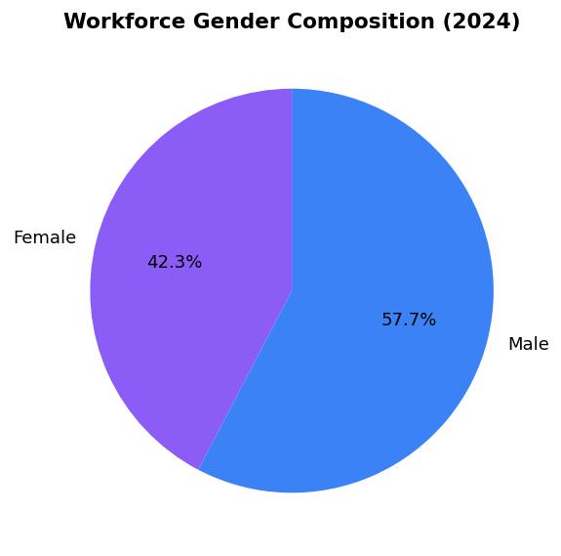
Male representation increased to 57.68% (+3.88pp YoY) — reversing prior diversity gains and creating pipeline risk for 30% female management target

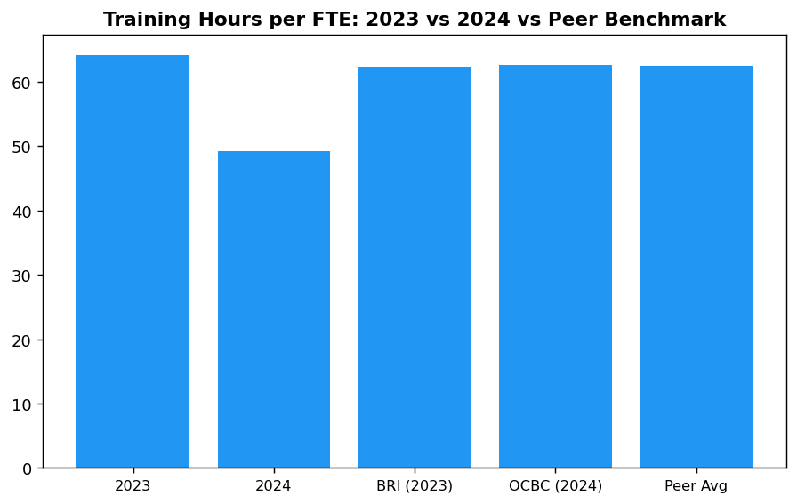
Institution's 49.3 hrs falls 21% below peer average (62.5 hrs) — immediate investment needed to close capability gap for climate transition

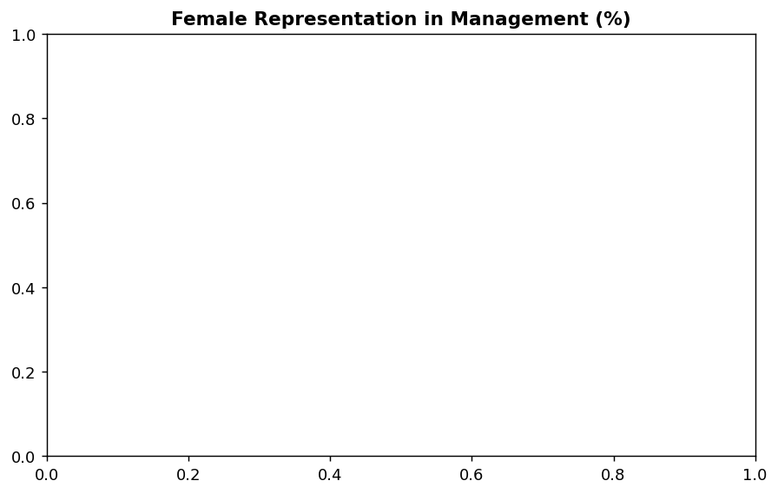
Declining trend (28.45% → 26.67%) widens gap to peer leaders (BCA 61.6%, DBS 38%) — structured mentorship and Board Diversity Policy required

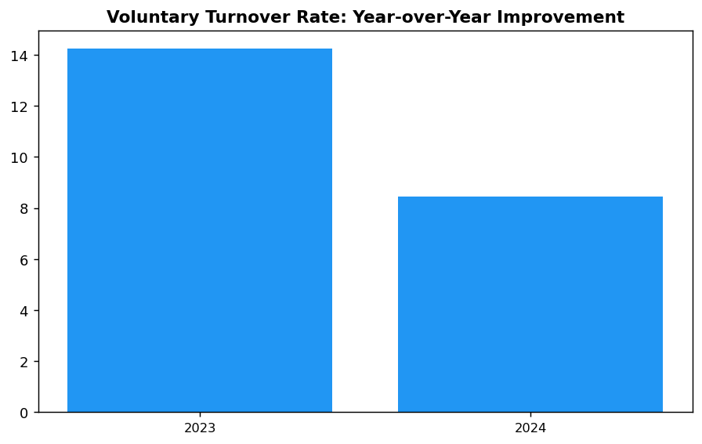
40.66% reduction in turnover (14.24% → 8.45%) demonstrates retention strategy success — sustain through flexible work and targeted bonuses

Diagnostic Analysis
The 23.14% reduction in training hours per FTE (from 64.14 to 49.3 hours) reflects operational efficiency optimization but creates a strategic vulnerability. Indonesian banking peers maintain 60+ hours annually, with BRI and OCBC delivering comprehensive ESG training across all organizational levels. The training gap compounds with declining female representation (overall: -3.88pp, management: -1.78pp), suggesting systemic challenges in diversity pipeline development. Root causes include: (1) training budget reallocation during operational adjustments, (2) transition to shorter learning modules without compensating volume increase, (3) insufficient focus on ESG-specific competencies required for TCFD, PCAF, and CSRD compliance, and (4) absence of structured mentorship programs for female talent advancement. The voluntary turnover improvement (40.66% reduction) demonstrates retention strategy effectiveness, but training and diversity gaps pose medium-term risks to regulatory compliance readiness and ESG ratings performance.
Root Causes:
• Training budget optimization prioritized efficiency over volume, reducing total hours delivered without corresponding increase in learning effectiveness metrics
• Transition to concise learning modules not offset by expanded curriculum coverage, particularly in ESG, climate risk, and sustainable finance competencies
• Absence of mandatory ESG training requirements for all employee levels (peers like BCA and BRI require Board-to-staff ESG modules)
• Gender diversity pipeline challenges: insufficient mentorship programs, lack of transparent promotion criteria, and absence of quantitative diversity targets with accountability mechanisms
• No gender pay equity audit conducted, limiting visibility into potential structural barriers to female advancement
Risk Implications:
• Regulatory compliance risk: Workforce may lack competencies required for CSRD (effective 2026 for large EU-exposed entities), ISSB (anticipated OJK adoption 2027), and enhanced TCFD disclosures under SEOJK 16/2021
• ESG ratings downgrade risk: Training and diversity gaps negatively impact MSCI, Sustainalytics, and CDP social scores, potentially affecting cost of capital and investor access
• Talent competitiveness risk: Peer banks offering 60+ training hours and stronger diversity commitments may attract top talent, particularly ESG specialists and female leaders
• Reputational risk: Declining female representation contradicts global investor expectations and Indonesian government gender equality commitments (SDG 5 alignment)
• Climate transition readiness gap: Insufficient training in PCAF methodology, science-based targets, and financed emissions management limits institutional capacity to execute net-zero strategy

⚡ Priority Actions
🔴 1. Deploy mandatory 8-hour ESG awareness module for all 24,997 employees covering TCFD, PCAF, sustainable finance principles, and climate risk basics. Supplement with role-specific advanced modules: 12 hours for credit officers (ESRM, sectoral policies), 15 hours for senior management (SBTi, net-zero strategy, investor engagement). Use hybrid delivery (e-learning + quarterly workshops) to achieve 65 hours per FTE by Q4 2025. (Q4 2025)
→ Expected: Increase average training hours from 49.3 to 65 hours per FTE (+31.8%), closing peer gap. Enhance workforce climate transition readiness, improve ESG ratings social pillar score, and strengthen regulatory compliance preparedness for CSRD/ISSB adoption.
→ Ref: BRI achieved 62.4 hours per employee (2023) through mandatory ESG modules for all levels (Board of Commissioners to non-staff) using hybrid classroom + digital delivery. OCBC Indonesia delivered 62.6 hours (2024) with structured learning paths per position level.
🔴 2. Establish Board-approved gender diversity target: minimum 30% female representation in management by December 2026 (interim: 28.5% by December 2025). Implement structured mentorship program (50 high-potential female employees annually paired with C-suite sponsors), transparent promotion criteria with gender-blind initial screening, and Board Diversity Policy requiring gender-diverse candidate slates for all senior appointments. Conduct gender pay equity audit by Q2 2025 and publish pay ratio in 2025 sustainability report. (Q4 2026)
→ Expected: Increase female management representation from 26.67% to 30% (+3.33pp), aligning with minimum international standards. Improve MSCI/Sustainalytics social scores, enhance talent attraction for female leaders, and demonstrate commitment to SDG 5 (Gender Equality). Gender pay transparency expected to improve investor confidence and ESG fund eligibility.
→ Ref: BCA achieved 61.6% female management representation through structured career development and transparent promotion processes. DBS Group maintains 38% female management with near-equal pay ratio (1:0.99 female to male) and 33% female Board representation via formal Board Diversity Policy.
🟡 3. Sustain voluntary turnover below 9% through quarterly retention risk assessments for high-performers and critical roles (ESG specialists, data scientists, cybersecurity). Expand flexible work arrangements (minimum 2 days remote per week for eligible roles), introduce retention bonuses for scarce skill categories (10-15% of annual salary), and conduct bi-annual exit interview analysis to address top 3 systemic departure drivers. Benchmark compensation annually against BCA and DBS practices. (Ongoing through 2026)
→ Expected: Maintain voluntary turnover at or below 8.5% through 2025-2026, preserving institutional knowledge and reducing replacement costs (estimated IDR 180 million per senior hire). Improved retention of ESG and digital talent critical for climate transition execution. Enhanced employee satisfaction scores expected to support employer brand strength.
→ Ref: BCA's retention strategy emphasizes competitive remuneration benchmarked to market, structured career development pathways with clear progression criteria, and comprehensive work-life balance programs including flexible arrangements and wellness initiatives.
🟡 4. Enhance discrimination incident prevention through annual Code of Conduct refresher training (mandatory 100% completion), expand whistleblowing awareness campaigns (quarterly communications), and implement independent effectiveness review of grievance mechanism by Q3 2025. Establish quarterly Diversity & Inclusion Council meetings chaired by CHRO to monitor discrimination trends, review case outcomes, and recommend policy improvements. Publish anonymized case statistics and remediation actions in annual sustainability report. (Q3 2025)
→ Expected: Reduce discrimination incidents from 2 (2024) to zero by 2026 through enhanced prevention and early intervention. Improve employee trust in grievance mechanisms (target: 85% awareness, 90% confidence in confidentiality per annual employee survey). Strengthen GRI 406-1 disclosure quality and demonstrate zero-tolerance policy effectiveness to investors and regulators.
→ Ref: BCA maintains zero-tolerance policy with 100% investigation rate for all whistleblowing reports. DBS conducts annual independent reviews of grievance mechanism effectiveness and publishes detailed case statistics in sustainability reports, demonstrating transparency and accountability.

Framework references: GRI 2-7: Employees; GRI 401-1: New employee hires and employee turnover; GRI 404-1: Average hours of training per year per employee; GRI 405-1: Diversity of governance bodies and employees; GRI 406-1: Incidents of discrimination and corrective actions taken; ESRS S1: Own Workforce; OJK POJK 51/2017: Penerapan Keuangan Berkelanjutan (Pilar Sosial)

All workforce data as of December 31, 2024, unless otherwise stated.
FTE (Full-Time Equivalent) includes permanent employees; excludes contractors and temporary staff.
Management includes supervisory, middle management, and senior leadership roles.
Voluntary turnover excludes retirements and involuntary separations.
Training hours include classroom, e-learning, external certifications, and on-the-job training.
Discrimination cases include all formal reports received through grievance mechanisms; all cases were investigated and remediated.
Year-over-year percentage changes are pre-computed; percentage point (pp) changes indicate absolute differences in percentages.
These figures have not been subject to external assurance for the current reporting period.

Governance & Strategy

3.1 Climate Governance & ESG Oversight
Not Established status  vs. BRI (since 2021), BCA (active), DBS (active) | 0 %  vs. DBS 20%, BCA integrated | 0 times/year  vs. BRI 4x, BCA ≥4x, DBS 4x | 7 framework requirements  IFRS S2 (3), GRI (2), ESRS (1), OJK (1)
Board ESG Committee Status | ESG-Linked Remuneration | Board ESG Review Frequency | Governance Disclosure Gap

🚨 KEY INSIGHT
Zero formal ESG governance while peers have Board committees, quarterly reviews, and remuneration linkages — critical regulatory and investor risk.
Leading Indonesian banks (BRI, BCA, DBS) have established Board-level ESG committees with quarterly oversight, integrated ESG KPIs into executive remuneration (10-20% weight), and approved sectoral credit policies via Board Decrees. The institution's absence of these structures creates non-compliance risk with OJK POJK 51/2017 and IFRS S2 (effective 2024), and signals weak climate risk governance to investors. Immediate action required to establish foundation governance by Q4 2025.

Governance Gap Analysis
The institution has not yet established formal governance structures for climate-related risks and opportunities as required by multiple sustainability reporting frameworks. This section identifies the governance disclosure requirements under IFRS S2, GRI 2-12/2-13, ESRS 2 GOV-3, and OJK POJK 51/2017 on Sustainable Finance Action Plan (SFAP), and provides a roadmap for establishing compliant governance infrastructure based on peer bank implementations in Indonesia.

Framework Requirements Not Currently Met
**IFRS S2 Paragraph 5** requires identification of the governance body or bodies responsible for oversight of climate-related risks and opportunities. The institution must disclose the name of the board committee with this mandate, its composition, and how climate considerations inform strategic decisions.
**IFRS S2 Paragraph 6** requires description of management's role in governance processes and controls for climate-related risks and opportunities, including the position or committee with operational responsibility and reporting lines to the board.
**IFRS S2 Paragraph 7** requires explanation of how governance bodies' oversight and management's governance processes are reflected in the institution's strategy, decision-making, and risk management processes.
**GRI 2-12** requires disclosure of the role of the highest governance body in overseeing the management of sustainability impacts, including how the body considers stakeholder views and how it oversees due diligence and other processes to identify and manage impacts.
**GRI 2-13** requires disclosure of how responsibility for managing sustainability impacts is delegated to senior executives and whether they report back to the highest governance body.
**ESRS 2 GOV-3** requires disclosure of how sustainability performance is integrated into incentive schemes for members of administrative, management and supervisory bodies, including the percentage of variable remuneration linked to sustainability targets.
**OJK POJK 51/2017 Article 6** requires financial institutions to establish governance structures that ensure implementation of sustainable finance principles, including board-level oversight and integration into risk management frameworks.

Peer Bank Governance Structures
Leading Indonesian banks have established comprehensive ESG governance frameworks that provide reference models for implementation:
**Bank Rakyat Indonesia (BRI)** established a dedicated Risk Management & ESG Committee at the Board of Directors level in 2021 via Decision NOKEP 872-DIR/PPM/06/2022. The committee conducts quarterly reviews of climate-related risks and opportunities, with ESG performance integrated into Board of Directors' key performance indicators. BRI was the first Indonesian financial institution to commit to Science-Based Targets initiative (SBTi) and joined the Net-Zero Banking Alliance (NZBA).
**Bank Central Asia (BCA)** operates an ESG Subdivision under the Corporate Secretary, reporting to the Director of Planning & Finance, who in turn reports to the President Director. The Board of Directors reviews ESG performance at least four times per year. BCA has integrated ESG KPIs into Board of Directors and work unit performance assessments. The bank has issued multiple Board of Directors Decrees establishing sectoral ESG credit policies for high-risk sectors including palm oil, coal, timber, cement, iron-steel, and oil & gas.
**DBS Bank** maintains a Board Sustainability Committee with a dedicated Chief Sustainability Officer (CSO) reporting directly to the Board. DBS links 20 percent of executive variable remuneration to sustainability metrics, including emissions reduction targets. The bank has achieved 62 percent renewable energy usage and reports a 12 percent year-over-year reduction in operational emissions.
**Bank Mandiri** operates an ESG Task Force with semi-annual Board-level reviews of sustainability performance. The bank has established sectoral credit policies limiting exposure to fossil fuel sectors and has committed to TCFD-aligned climate risk disclosure.

Recommended Governance Infrastructure
Based on peer bank practices and regulatory requirements, the institution should establish the following governance structures within the next 12-24 months:
**Phase 1 (Q3 2025 - Q4 2025): Foundation**
- Establish a Board-level ESG Committee or integrate ESG oversight into the existing Risk Committee, with formal terms of reference defining climate risk oversight responsibilities
- Appoint a senior executive (Director-level or equivalent) with explicit accountability for ESG strategy and climate risk management, reporting directly to the President Director
- Develop and approve a Board-level ESG Policy via Board of Directors Decree, establishing principles for sustainable finance, climate risk management, and sectoral credit policies
- Implement quarterly Board ESG review cadence, with standing agenda items for climate risk, financed emissions, and sustainable finance portfolio performance
**Phase 2 (Q1 2026 - Q2 2026): Integration**
- Integrate ESG KPIs into Board of Directors and senior management performance assessments, with initial weighting of 10 percent of variable remuneration linked to sustainability metrics (emissions reduction, sustainable finance portfolio growth, ESG risk management effectiveness)
- Establish a management-level ESG Working Group or Sustainability Committee with cross-functional representation (Risk, Credit, Treasury, Operations, Corporate Secretary) to operationalize Board directives
- Develop sectoral credit policies for carbon-intensive sectors (energy - oil & gas, manufacturing - cement, manufacturing - steel) with Board approval, following BCA's model of sector-specific Board Decrees
- Implement climate risk integration into enterprise risk management framework, including scenario analysis and stress testing capabilities
**Phase 3 (Q3 2026 - Q4 2026): Disclosure Readiness**
- Conduct Board climate competency assessment and implement annual ESG training program for Board of Directors and Board of Commissioners, engaging external experts on TCFD, IFRS S1/S2, and OJK SFAP requirements
- Establish target-setting and monitoring processes, with Board approval of science-based emissions reduction targets for operational (Scope 1+2) and financed emissions (Scope 3 Category 15)
- Develop governance disclosure content for 2026 sustainability report, documenting committee structures, meeting frequencies, remuneration linkages, and target oversight processes
- Consider membership in industry initiatives (PCAF, SBTi, IKBI) to demonstrate commitment and access technical guidance
Table 3.1.1: Framework Governance Disclosure Requirements — Gap Analysis
Framework | Disclosure Reference | Requirement | Current Status | Priority
IFRS S2 | Paragraph 5 | Identification of governance body responsible for climate oversight | ⚠️ Not Available | High
IFRS S2 | Paragraph 6 | Description of management's role in climate governance | ⚠️ Not Available | High
IFRS S2 | Paragraph 7 | How governance is reflected in strategy and risk management | ⚠️ Not Available | High
GRI 2-12 | 2-12a | Role of highest governance body in sustainability oversight | ⚠️ Not Available | High
GRI 2-13 | 2-13a | Delegation of responsibility for sustainability impacts | ⚠️ Not Available | High
ESRS 2 | GOV-3 | Integration of sustainability in incentive schemes | ⚠️ Not Available | Medium
OJK POJK 51/2017 | Article 6 | Board-level sustainable finance governance | ⚠️ Not Available | High
Source: Gap analysis based on DATA INPUT governance fields (all NULL) and framework requirements. Priority reflects regulatory mandate (OJK) and investor expectations (IFRS S2 effective 2024).

Table 3.1.2: Peer Bank Governance Structures — Benchmarking Reference
Governance Element | BRI | BCA | DBS | Bank Mandiri
Dedicated ESG Committee | ✅ Risk Mgmt & ESG Committee (since 2021) | ESG Subdivision under Corporate Secretary | ✅ Board Sustainability Committee | ESG Task Force
Board ESG Review Frequency | Quarterly | ≥4x per year | Quarterly | Semi-annual
ESG KPI in Remuneration | ✅ Yes | ✅ Integrated to BoD & work unit KPIs | ✅ Yes (20% weight) | Partial
Reporting Line | Reports to President Director | Director Planning & Finance → President Director | Chief Sustainability Officer → Board | Director → President Director
Sectoral Credit Policies | ✅ Palm oil, coal, timber, cement, steel, O&G | ✅ Palm oil, coal, timber, toll roads, cement, iron-steel, O&G | ✅ Coal phase-out 2039 | ✅ Fossil fuel limits
SBTi Commitment | ✅ First ID FI | Evaluating | ✅ | Developing
NZBA Membership | ✅ | No | ✅ | No
Source: Source: BRI Sustainability Report 2023, BCA Sustainability Report 2025, DBS Sustainability Report 2023, Bank Mandiri Sustainability Report 2023. BRI ESG Committee established via NOKEP 872-DIR/PPM/06/2022.

Table 3.1.3: Recommended Governance Implementation Roadmap
Phase | Timeline | Key Deliverables | Peer Reference | Expected Outcome
Phase 1: Foundation | Q3 2025 - Q4 2025 | Board ESG Committee establishment; Senior executive appointment; ESG Policy approval; Quarterly review cadence | BRI (NOKEP 872-DIR/2022); BCA (≥4x/year review) | Formal governance structure in place; Regulatory compliance (OJK POJK 51)
Phase 2: Integration | Q1 2026 - Q2 2026 | ESG KPIs in remuneration (10% weight); Management ESG Working Group; Sectoral credit policies; ERM integration | DBS (20% remuneration weight); BCA (sectoral BoD Decrees) | Accountability mechanisms active; Climate risk in decision-making
Phase 3: Disclosure Readiness | Q3 2026 - Q4 2026 | Board climate training; Science-based targets; Governance disclosure content; Industry initiative membership | BRI (SBTi commitment); BCA (annual BoD ESG refresher) | Full IFRS S2/GRI/ESRS governance disclosure capability for 2026 report
Source: Timeline assumes Q3 2025 start date. Peer references indicate which bank has successfully implemented each element. Expected outcomes align with IFRS S2 effective date (2024) and OJK SFAP requirements.

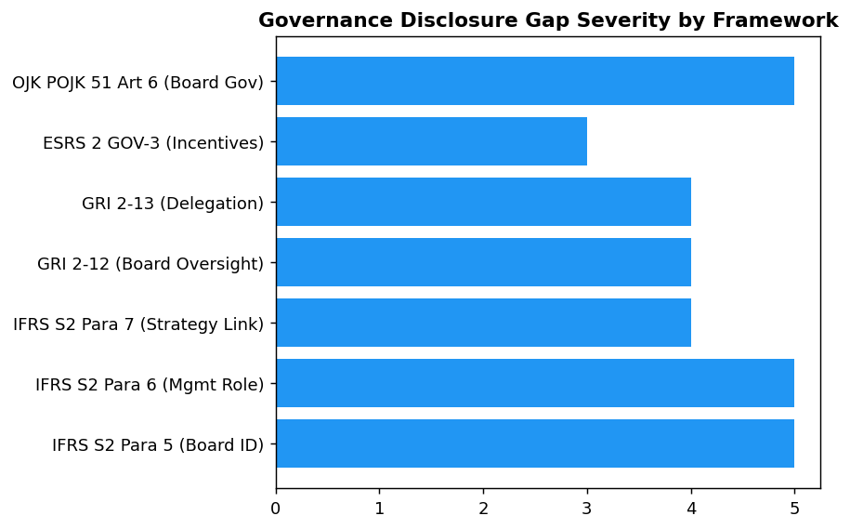
All 7 framework requirements show complete gaps — IFRS S2 and OJK POJK 51 are highest priority due to regulatory mandate and 2024 effective date.

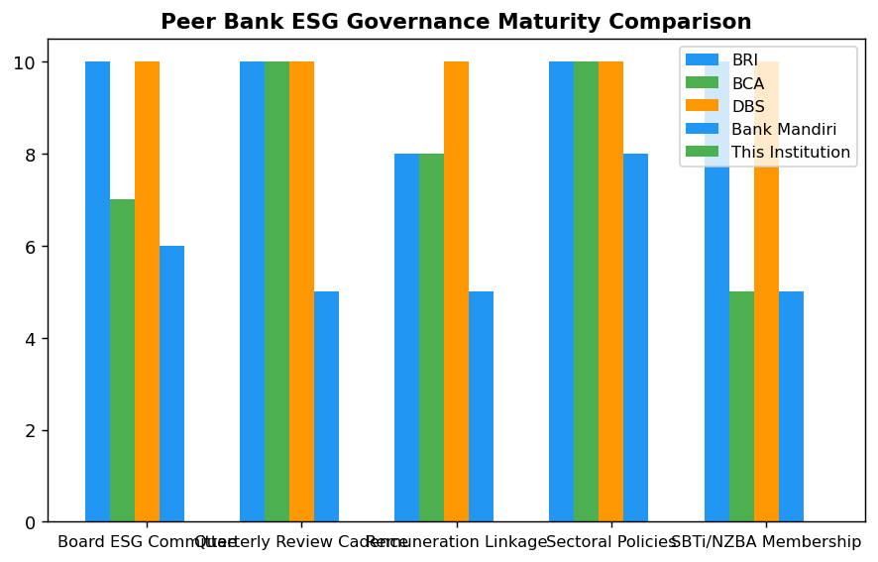
BRI and DBS lead with Board committees, quarterly reviews, and remuneration linkages — institution scores 0/10 on all dimensions, indicating 24-month gap to peer parity.

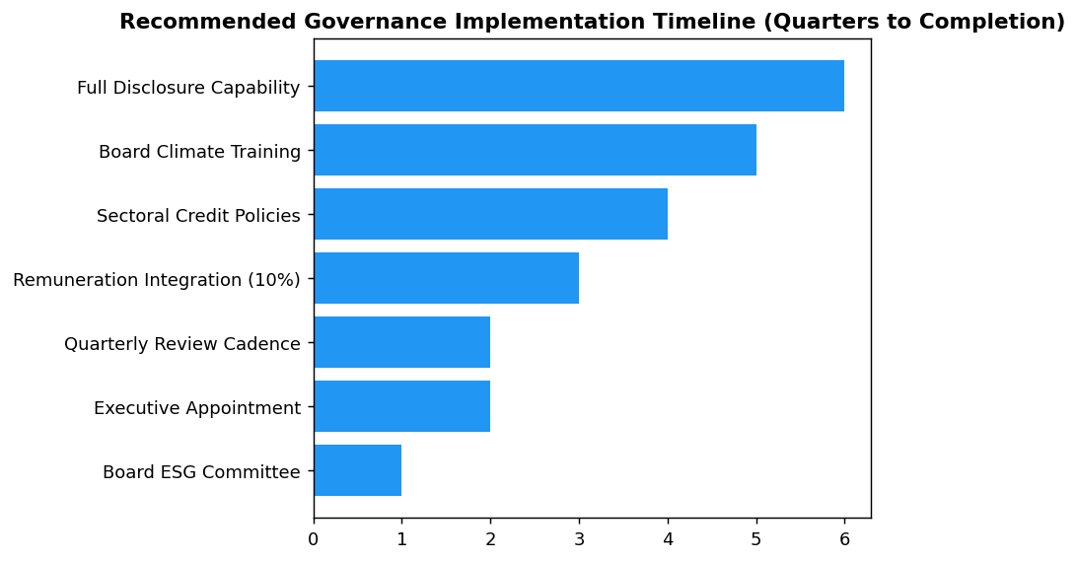
Board ESG Committee and executive appointment are critical path items for Q3-Q4 2025 — delays cascade to remuneration integration and disclosure readiness.

Diagnostic Analysis
The institution has not yet established formal governance structures for climate-related risks and opportunities, resulting in a complete disclosure gap across all major sustainability reporting frameworks (IFRS S2, GRI, ESRS, OJK). This absence is not merely a reporting issue but indicates systemic gaps in accountability, oversight, and integration of climate considerations into strategic decision-making. Peer banks in Indonesia have moved significantly ahead, with BRI establishing a dedicated Board ESG Committee in 2021, BCA conducting quarterly Board reviews, and DBS linking 20 percent of executive pay to sustainability metrics. The governance gap exposes the institution to regulatory sanctions (OJK POJK 51/2017 requires board-level sustainable finance oversight), investor scrutiny (ESG governance is a core pillar of IFRS S2 effective 2024), and reputational risk (lagging peers on climate accountability).
Root Causes:
• No Board-level committee with explicit ESG/climate risk oversight mandate, unlike BRI's Risk Management & ESG Committee (established 2021) or BCA's quarterly Board review cadence
• No senior executive with dedicated ESG accountability reporting to President Director, contrasting with DBS's Chief Sustainability Officer model or BCA's Director Planning & Finance ESG mandate
• No integration of ESG KPIs into Board of Directors or senior management performance assessments and remuneration, while DBS links 20% of variable pay to sustainability metrics and BCA integrates ESG into BoD KPIs
• No sectoral credit policies for carbon-intensive sectors approved via Board Decrees, unlike BCA's multiple BoD Decrees for palm oil, coal, cement, iron-steel, and oil & gas, or BRI's comprehensive sectoral ESG policies
Risk Implications:
• Regulatory compliance risk: OJK POJK 51/2017 Article 6 mandates board-level sustainable finance governance. Absence may trigger regulatory sanctions or heightened supervisory scrutiny in OJK SFAP assessments.
• Investor confidence risk: IFRS S2 governance disclosure is mandatory for reporting periods beginning January 1, 2024. Inability to disclose governance structures signals weak climate risk management to institutional investors and ESG rating agencies, potentially impacting cost of capital.
• Reputational risk: Peer banks (BRI, BCA, DBS, Mandiri) have publicly disclosed comprehensive ESG governance frameworks. The institution's governance gap is visible to stakeholders and may be perceived as lack of commitment to sustainability, affecting brand reputation and customer trust.
• Strategic risk: Without Board-level oversight and executive accountability, climate risks and opportunities are not systematically integrated into strategic planning, capital allocation, and risk management, potentially leading to misaligned investments and stranded assets in carbon-intensive sectors.

⚡ Priority Actions
🔴 1. Establish Board-level ESG Committee (or integrate ESG oversight into existing Risk Committee) with formal terms of reference, quarterly meeting cadence, and explicit climate risk oversight mandate. Draft Board resolution for approval by Q3 2025. (Q3 2025)
→ Expected: Achieves OJK POJK 51/2017 compliance; enables IFRS S2 Paragraph 5 disclosure; establishes accountability structure for climate strategy and target oversight
→ Ref: BRI — Risk Management & ESG Committee established via NOKEP 872-DIR/PPM/06/2022, quarterly review cadence, reports to President Director
🔴 2. Appoint Director-level executive with explicit ESG accountability (or create Chief Sustainability Officer role) reporting to President Director. Define responsibilities including climate risk management, sustainable finance portfolio oversight, and Board reporting. Announce appointment by Q4 2025. (Q4 2025)
→ Expected: Enables IFRS S2 Paragraph 6 disclosure; establishes management-level ownership for ESG strategy execution; creates clear reporting line to Board
→ Ref: DBS — Chief Sustainability Officer reporting to Board; BCA — Director Planning & Finance with ESG mandate reporting to President Director
🔴 3. Integrate ESG KPIs into Board of Directors and senior management performance assessments, with initial 10% weighting of variable remuneration linked to sustainability metrics (emissions reduction, sustainable finance portfolio growth, ESG risk management). Implement for 2026 performance year. (Q1 2026)
→ Expected: Achieves ESRS 2 GOV-3 disclosure requirement; aligns executive incentives with climate targets; demonstrates accountability to investors
→ Ref: DBS — 20% of executive variable remuneration linked to sustainability metrics; BCA — ESG KPIs integrated into BoD and work unit performance assessments
🔴 4. Develop and approve sectoral credit policies for top 3 carbon-intensive sectors (energy - oil & gas, manufacturing - cement, manufacturing - steel) via Board of Directors Decrees. Include exposure limits, enhanced due diligence requirements, and transition support criteria. Target Board approval by Q2 2026. (Q2 2026)
→ Expected: Manages concentration risk in high-emission sectors (currently 85.93% of financed emissions from top 3 sectors); enables proactive portfolio decarbonization; demonstrates climate risk integration in credit decisions
→ Ref: BCA — Multiple BoD Decrees for sectoral ESG policies (palm oil, coal, timber, cement, iron-steel, O&G); BRI — Comprehensive sectoral policies for high ESG risk sectors
🟡 5. Implement annual Board climate competency program with external expert sessions on TCFD, IFRS S1/S2, OJK SFAP requirements, and climate scenario analysis. Conduct first program by Q3 2026 to prepare for 2026 sustainability report governance disclosure. (Q3 2026)
→ Expected: Enhances Board climate literacy for effective oversight; enables IFRS S2 Paragraph 5 disclosure on climate expertise; aligns with GRI 2-12 governance body competency requirements
→ Ref: BCA — Annual BoD/BoC ESG refresher with GRI, CDP, OJK collaboration; BRI — Board-level climate risk training program

Framework references: IFRS S2 Paragraph 5 — Governance body identification; IFRS S2 Paragraph 6 — Management's role in climate governance; IFRS S2 Paragraph 7 — Governance reflected in strategy; GRI 2-12 — Role of highest governance body in sustainability oversight; GRI 2-13 — Delegation of responsibility for sustainability impacts; ESRS 2 GOV-3 — Integration of sustainability in incentive schemes; OJK POJK 51/2017 Article 6 — Board-level sustainable finance governance; OJK SEOJK 16/2021 — Sustainable Finance Action Plan (SFAP) implementation

All governance data points are not yet captured in the institution's reporting system. This section provides a gap analysis against framework requirements and peer bank practices.
Peer bank data sourced from publicly available sustainability reports: BRI Sustainability Report 2023, BCA Sustainability Report 2025, DBS Sustainability Report 2023, Bank Mandiri Sustainability Report 2023.
OJK POJK 51/2017 requires financial institutions to establish board-level oversight of sustainable finance. Non-compliance may result in regulatory sanctions.
IFRS S2 became effective for reporting periods beginning on or after January 1, 2024. Governance disclosure is a core pillar alongside Strategy, Risk Management, and Metrics & Targets.
The recommended 10-20% remuneration linkage to ESG KPIs is based on DBS Bank's 20% weight and represents emerging best practice in the Indonesian banking sector.

Appendix A: Methodology Notes
This report applies the GHG Protocol Corporate Accounting and Reporting Standard (Revised 2015) for Scope 1 and 2 emissions, and the PCAF Global GHG Accounting and Reporting Standard Part A (2022) for Scope 3 Category 15 financed emissions. GWP values from IPCC AR6 (GWP100): CH4 = 29.8, N2O = 273.0.

Appendix B: Data Quality Summary
Data quality is assessed per the PCAF data quality scoring framework (1-5) and the GHG Protocol data quality indicators. Portfolio-weighted PCAF score and data completeness percentage are reported in the main body.

Appendix C: GRI Content Index
GRI Standards Content Index
GRI Standard | Disclosure | Section Reference | Omission
GRI 2-7 | Employees | Section: Social | None
GRI 305-1 | Direct (Scope 1) GHG emissions | Section: Scope 1 | None
GRI 305-2 | Energy indirect (Scope 2) GHG emissions | Section: Scope 2 | None
GRI 305-3 | Other indirect (Scope 3) GHG emissions | Section: PCAF | None
GRI 305-4 | GHG emissions intensity | Section: Intensity | None
GRI 305-5 | Reduction of GHG emissions | Section: Reduction | Partial — targets in development
GRI 401-1 | New employee hires and employee turnover | Section: Social | None
GRI 404-1 | Average hours of training per year per employee | Section: Social | None
GRI 405-1 | Diversity of governance bodies and employees | Section: Social | None
GRI 406-1 | Incidents of discrimination and corrective actions | Section: Social | None
Source: GRI Standards 2021

