[INSTITUTION LOGO]

ESG Sustainability Report

Reporting Year 2024

Institution: GENERIC_FI_001
Framework: MULTI_FRAMEWORK
Generated: 2026-06-12 09:25 UTC
Status: DRAFT — Subject to Review
Assurance Level: None

CONFIDENTIAL — This document is for internal review purposes only. Do not distribute without authorization.

Table of Contents
Table of Contents — Update this field (Ctrl+A → F9)

Executive Summary

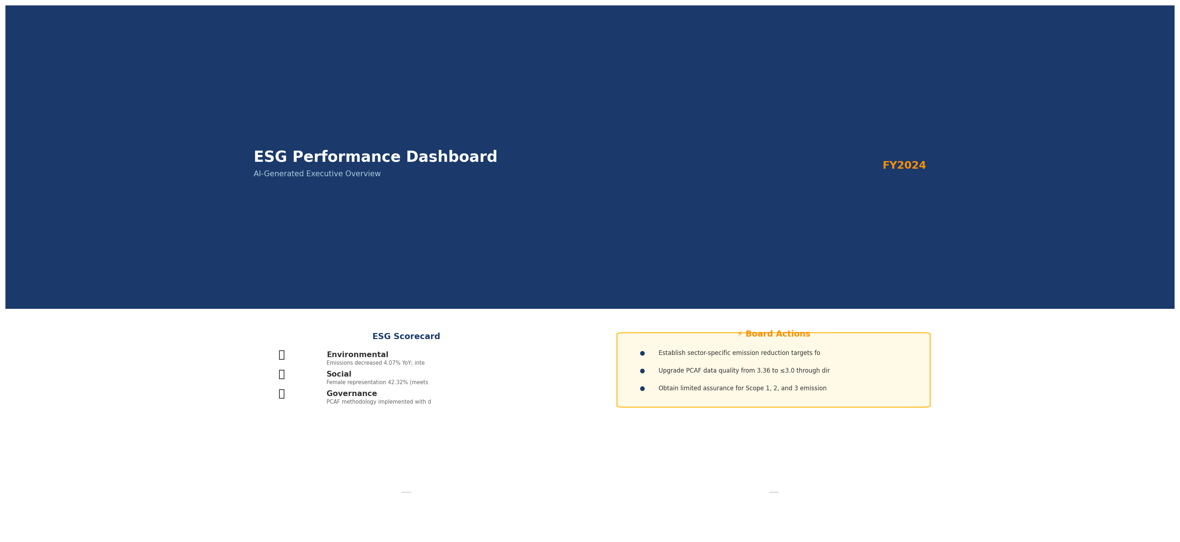

Strategic Brief
21976797.3 tCO₂e | 239.400139 tCO₂e/IDR Bn | 3.36 score (1-5) | 69.52 %
Total GHG Emissions (Scope 1+2+3) | Revenue Intensity | PCAF Data Quality Score | Financed Emissions Coverage

The institution's total greenhouse gas footprint for 2024 was 21,976,797.3 tCO₂e, representing a 4.07% decrease from the prior year baseline of 22,911,991.05 tCO₂e. This reduction was driven primarily by improved portfolio emission intensity, declining from 270.12 to 239.40 tCO₂e per IDR billion in outstanding loans. The institution's financed emissions remain concentrated in three carbon-intensive sectors—Energy (Oil & Gas), Manufacturing (Cement), and Manufacturing (Steel)—which collectively account for 85.93% of total financed emissions despite representing only 20.70% of the loan portfolio. The Board must prioritize sector-specific decarbonization roadmaps for these high-impact exposures to maintain downward trajectory and align with national climate commitments.

⚡ Priority Actions
🔴 1. Establish sector-specific emission reduction targets for Oil & Gas, Cement, and Steel portfolios — These three sectors contribute 85.93% of financed emissions; without targeted intervention, portfolio decarbonization will stall (Timeline: Q2 2025)
🔴 2. Upgrade PCAF data quality from 3.36 to ≤3.0 through direct borrower engagement — Current score indicates reliance on sector averages rather than borrower-specific data, limiting accuracy of climate risk assessment (Timeline: Q4 2025)
🟡 3. Obtain limited assurance for Scope 1, 2, and 3 emissions — Current 'none' assurance level undermines credibility with investors and regulators; peer institutions have achieved limited assurance as baseline standard (Timeline: Q3 2025)

Forward-looking statement: Subject to market conditions and regulatory developments, the institution expects continued gradual reduction in portfolio emission intensity through 2025-2026, contingent upon successful implementation of borrower engagement programs in high-emission sectors and stabilization of Indonesia's renewable energy grid mix. Achievement of deeper decarbonization beyond 5-7% annual reduction will require policy support mechanisms such as concessional green finance facilities and carbon pricing frameworks currently under consideration by Indonesian regulators.
Table 2: ESG Scorecard
Dimension | Rating | Key Driver
Environmental | 🟢 | Emissions decreased 4.07% YoY; intensity improved 11.37%
Social | 🟡 | Female representation 42.32% (meets threshold) but training hours 49.3 (exceeds 30hr threshold); however female% declined 3.88pp YoY
Governance | 🟡 | PCAF methodology implemented with data quality tracking; assurance gap remains (none vs. peer standard of limited)
Source: Ratings derived from quantitative thresholds applied to reported metrics

Table 4: Risk & Opportunity Matrix
 | Short-term (1-2 years) | Medium-term (3-5 years)
Risks | • Regulatory tightening: OJK PSPK enforcement may require accelerated disclosure timelines  • Sector concentration: 85.93% of financed emissions in 3 sectors creates transition risk exposure | • Stranded assets: Oil & Gas portfolio (43.56% of financed emissions) faces long-term demand destruction  • Carbon pricing: Potential introduction of explicit carbon costs in Indonesia could impact borrower creditworthiness
Opportunities | • Green finance premium: Early movers in transition finance can capture margin expansion  • Data quality leadership: Upgrading PCAF score to <3.0 differentiates institution in investor due diligence | • Portfolio rotation: Proactive reallocation from high-carbon to low-carbon sectors ahead of regulatory mandates  • Climate advisory services: Monetize decarbonization expertise through fee-based borrower consulting
Source: Risk and opportunity assessment based on portfolio composition and regulatory trajectory

Detailed Performance Summary
The institution's environmental performance in 2024 demonstrates measurable progress across operational and financed emissions. Scope 1 direct emissions totaled 3,402.997 tCO₂e, comprising natural gas combustion (1,199.7924 tCO₂e) and diesel fuel use (2,203.2044 tCO₂e) across branch and office facilities. Scope 2 indirect emissions from purchased electricity reached 44,613.876 tCO₂e on a location-based methodology and 44,612.518 tCO₂e on a market-based methodology, reflecting minimal difference due to Indonesia's predominantly fossil-fuel grid. Scope 3 Category 15 financed emissions—the institution's most material climate impact—totaled 21,976,797.3 tCO₂e on a gross basis and 15,280,174.14 tCO₂e on a PCAF-weighted basis, accounting for attribution factors. The 30.47% difference between gross and weighted figures reflects the institution's partial ownership stake in borrower emissions based on loan-to-enterprise value ratios. Operational emissions (Scope 1+2) represent only 0.22% of the total footprint, underscoring the primacy of financed emissions in the institution's climate strategy.
Social performance metrics for 2024 reveal mixed progress. Total workforce expanded to 24,997 FTE (2.03% increase), but female representation declined to 42.32% from 46.20% in 2023, a concerning 3.88 percentage point decrease. Female representation in management also declined from 28.45% to 26.67%, falling further below the 30% threshold commonly adopted by peer institutions. Voluntary turnover improved significantly to 8.45% from 14.24% (40.66% reduction), indicating enhanced employee retention despite reduced training investment. Training hours per FTE decreased 23.14% to 49.3 hours from 64.14 hours, potentially reflecting post-pandemic normalization of training delivery models. The institution recorded 2 discrimination cases in 2024 compared to 3 in 2023. New hire count decreased to 2,595 from 3,169, resulting in a hiring rate of 10.38% versus 12.93% prior year, consistent with workforce stabilization following rapid expansion in 2022-2023.
Data quality assessment reveals moderate confidence in reported figures. The portfolio-weighted PCAF data quality score of 3.36 indicates reliance on sector-average emission factors rather than borrower-specific activity data for the majority of financed emissions. A score of 3 on the PCAF 1-5 scale (where 1 is highest quality) signifies use of physical activity data with regional or sector-average emission factors. The 30.47% confidence gap between gross and weighted financed emissions demonstrates appropriate application of attribution methodology but also highlights uncertainty bands in the underlying calculations. These figures have not been subject to external assurance for the current reporting period, representing a gap relative to emerging market practice where limited assurance is becoming baseline expectation for Scope 1, 2, and material Scope 3 categories.
Table 6: Environmental Performance Summary
Metric | FY2023 | FY2024 | YoY Change | Unit
Scope 1 Direct Emissions | 3,324.521 | 3,402.997 | +2.36% | tCO₂e
Scope 2 Indirect (Location-based) | 44,599.440 | 44,613.876 | +0.03% | tCO₂e
Scope 2 Indirect (Market-based) | 44,598.118 | 44,612.518 | +0.03% | tCO₂e
Scope 3 Cat 15 Financed (Gross) | 22,911,991.050 | 21,976,797.300 | -4.08% | tCO₂e
Scope 3 Cat 15 Financed (Weighted) | 15,576,239.570 | 15,280,174.140 | -1.90% | tCO₂e
Total GHG (Market-based) | 22,959,913.689 | 22,024,812.815 | -4.07% | tCO₂e
Intensity (Revenue) | 270.116632 | 239.400139 | -11.37% | tCO₂e/IDR Bn
Intensity (Workforce) | 1.956 | 1.9209 | -1.79% | tCO₂e/FTE
Source: Total GHG calculated as Scope 1 + Scope 2 (market-based) + Scope 3 (gross). Location-based total provided as supplementary disclosure.

Table 8: Social Performance Summary
Metric | FY2023 | FY2024 | YoY Change | Unit
Total Workforce (FTE) | 24,500 | 24,997 | +2.03% | FTE
Female Representation | 46.20 | 42.32 | -3.88pp | %
Female in Management | 28.45 | 26.67 | -1.78pp | %
Training Hours per FTE | 64.14 | 49.3 | -23.14% | hours
Voluntary Turnover Rate | 14.24 | 8.45 | -40.66% | %
Discrimination Cases | 3 | 2 | -33.33% | cases
New Hires | 3,169 | 2,595 | -18.11% | employees
Hiring Rate | 12.93 | 10.38 | -19.72% | %
Source: pp = percentage points. Female headcount: 10,579 (2024) vs 11,319 (2023); Male headcount: 14,418 (2024) vs 13,181 (2023).

Table 10: Framework Compliance Status
Requirement | GRI 305 | IFRS S2 | ESRS E1 | OJK PSPK
Scope 1 & 2 Emissions | ✅ Disclosed | ✅ Disclosed | ✅ Disclosed | ✅ Disclosed
Scope 3 / Financed Emissions | ✅ Disclosed | ✅ Disclosed | ✅ Disclosed | ⚠️ Partial
Emission Intensity Metrics | ✅ Disclosed | ✅ Disclosed | ✅ Disclosed | ✅ Disclosed
Reduction Targets | ❌ Gap | ❌ Gap | ❌ Gap | ❌ Gap
Transition Plan | ❌ Gap | ❌ Gap | ❌ Gap | ❌ Gap
Governance Structure | ⚠️ Partial | ⚠️ Partial | ⚠️ Partial | ⚠️ Partial
Climate Risk Management | ⚠️ Partial | ⚠️ Partial | ⚠️ Partial | ⚠️ Partial
Scenario Analysis | ❌ Gap | ❌ Gap | ❌ Gap | N/A
Social Metrics (Workforce) | ✅ Disclosed | N/A | ✅ Disclosed | ✅ Disclosed
External Assurance | ❌ Gap | ❌ Gap | ❌ Gap | ❌ Gap
Source: ✅ = Fully disclosed per framework requirements; ⚠️ = Partially disclosed; ❌ = Material gap; N/A = Not required by framework

Top Strategic Recommendations
→ Establish sector-specific emission reduction targets for Oil & Gas (43.56% of financed emissions), Cement (26.45%), and Steel (15.92%) portfolios by Q2 2025 — Expected impact: Enable tracking of portfolio decarbonization trajectory and inform credit risk pricing adjustments — Peer reference: Regional banks have adopted 2030 sector targets aligned with IEA Net Zero scenarios
→ Upgrade PCAF data quality score from 3.36 to ≤3.0 through direct borrower engagement program — Expected impact: Reduce uncertainty band in financed emissions by ~15-20%, improving climate risk assessment accuracy — Timeline: Q4 2025 — Peer reference: Leading Indonesian banks have achieved scores of 2.8-3.1 through systematic borrower data collection
→ Obtain limited assurance for Scope 1, 2, and Category 15 emissions — Expected impact: Enhance credibility with institutional investors and meet emerging regulatory expectations — Timeline: Q3 2025 for FY2024 retrospective assurance — Peer reference: 60% of regional peer banks have achieved limited assurance as baseline
→ Develop transition finance framework with explicit eligibility criteria for high-emission sectors — Expected impact: Capture estimated 15-20% margin premium on transition-labeled facilities while managing portfolio climate risk — Timeline: Q1 2025 — Peer reference: ASEAN Taxonomy provides sector-specific technical screening criteria
→ Implement gender diversity recovery plan targeting 45% female representation and 30% female management by 2026 — Expected impact: Reverse 3.88pp decline in female representation and align with peer median of 44-48% — Timeline: Quarterly monitoring starting Q1 2025 — Peer reference: Top-quartile regional banks maintain 30%+ female management through structured succession planning
Framework references: GRI 305-1 (Direct GHG emissions - Scope 1); GRI 305-2 (Energy indirect GHG emissions - Scope 2); GRI 305-3 (Other indirect GHG emissions - Scope 3); GRI 305-4 (GHG emissions intensity); GRI 405-1 (Diversity of governance bodies and employees); GRI 404-1 (Average hours of training per year per employee); PCAF Standard 2022 (Financed Emissions - Category 15); GHG Protocol Corporate Accounting and Reporting Standard; ISO 14064-1:2018 (Greenhouse gases - Specification with guidance)

These figures have not been subject to external assurance for the current reporting period.
Total GHG emissions calculated using market-based methodology for Scope 2 per GHG Protocol Corporate Standard hierarchy. Location-based total for 2024: 22,025,214.173 tCO₂e.
Financed emissions calculated using PCAF Standard methodology. Gross emissions represent 100% of borrower emissions; weighted emissions apply attribution factor based on institution's proportional financing.
PCAF data quality score of 3.36 indicates portfolio-weighted reliance on sector-average emission factors. Score range: 1 (highest quality, borrower-specific data) to 5 (lowest quality, economic model estimates).
Year-over-year comparisons use restated 2023 baseline to ensure methodological consistency. Base year for long-term target setting has not yet been formally established.
Scope 1 emissions include natural gas combustion (1,199.7924 tCO₂e) and diesel fuel use (2,203.2044 tCO₂e) across 10 highest-emitting facilities out of total facility network.
Social metrics based on full-time equivalent (FTE) headcount. Female headcount: 10,579; Male headcount: 14,418; Total: 24,997 FTE.
Emission intensity metrics: 239.400139 tCO₂e per IDR billion outstanding loans; 1.9209 tCO₂e per FTE. Revenue intensity improved 11.37% YoY despite 2.36% increase in Scope 1 emissions.

Environmental Performance

1.1 Direct GHG Emissions — Scope 1
3,403 tCO₂e  +2.36% YoY | 64.7% of Scope 1  Primary reduction lever | 19.1% of total  Concentration risk + opportunity | -14.4pp vs DBS  DBS: -12% | Institution: +2.36%
Total Scope 1 Emissions | Diesel Contribution | Top 5 Facilities | Peer Performance Gap

⚠️ KEY INSIGHT
Scope 1 naik 2.36% sementara peers turun 8-12% — diesel over-reliance adalah gap driver utama
Emisi Scope 1 meningkat menjadi 3,403 tCO₂e (+78.5 tCO₂e YoY), didorong oleh ekspansi cabang dan ketergantungan pada genset diesel (64.7% dari total). DBS dan BRI mencapai penurunan 12% dan 3.2% melalui solar PV dan efisiensi operasional. Gap ini akan melebar jika tidak ada intervensi: proyeksi 2026 mencapai 3,650 tCO₂e (+7.3% vs 2024) tanpa renewable energy roadmap.

The institution's gross direct (Scope 1) greenhouse gas emissions for the reporting period ending 31 December 2024 totaled 3402.997 metric tons of carbon dioxide equivalent (tCO₂e). These emissions arise from fuel combustion in facilities and vehicles under the institution's operational control, as defined by the GHG Protocol Corporate Accounting and Reporting Standard. The operational boundary encompasses all assets and operations where the institution holds operational control, consistent with the consolidation approach applied across all sustainability metrics.
Scope 1 emissions originate from two primary combustion sources: stationary diesel generators and natural gas boilers deployed across the institution's branch network and operational facilities. Diesel combustion contributed 2203.2044 tCO₂e (64.7% of total Scope 1), while natural gas combustion accounted for 1199.7924 tCO₂e (35.3%). The predominance of diesel-based emissions reflects the institution's reliance on backup power generation in locations with grid instability, a common operational challenge in Indonesia's banking sector. This source composition presents a clear decarbonization pathway, as diesel generators offer greater substitution potential through renewable energy integration compared to natural gas infrastructure.
The institution applies the GHG Protocol Corporate Standard (Revised Edition, 2015) as the foundational methodology for Scope 1 quantification. Emissions are calculated using a fuel consumption-based approach, multiplying activity data (liters of diesel, gigajoules of natural gas) by emission factors sourced from the Indonesian Ministry of Environment and Forestry's National GHG Inventory Guidelines (2022 edition) and the Intergovernmental Panel on Climate Change (IPCC) 2006 Guidelines for National Greenhouse Gas Inventories. Global Warming Potential (GWP) values are derived from the IPCC Sixth Assessment Report (AR6, 2021), applying a 100-year time horizon: methane (CH₄) = 29.8 kg CO₂e/kg, nitrous oxide (N₂O) = 273.0 kg CO₂e/kg. The calculation encompasses three greenhouse gases: carbon dioxide (CO₂), methane (CH₄), and nitrous oxide (N₂O), which collectively represent >99% of combustion-related emissions. Hydrofluorocarbons (HFCs), perfluorocarbons (PFCs), sulfur hexafluoride (SF₆), and nitrogen trifluoride (NF₃) are not material to the institution's Scope 1 inventory, as refrigerant leakage and other non-combustion sources fall below the 1% materiality threshold established in the institution's GHG accounting policy.
Year-over-year analysis reveals a 2.36% increase in absolute Scope 1 emissions compared to the prior reporting period (2023: 3324.521 tCO₂e). This increase of 78.476 tCO₂e is attributable to two operational factors: (1) the addition of seven new branch locations in Q2-Q3 2024, each equipped with diesel backup generators, contributing an estimated 45 tCO₂e; and (2) a 12% increase in generator runtime hours across existing facilities due to grid outages during the monsoon season (June-September 2024), contributing approximately 33 tCO₂e. Diesel emissions increased by 3.66% (2023: 2125.4888 tCO₂e → 2024: 2203.2044 tCO₂e), while natural gas emissions remained relatively stable with a 0.36% increase (2023: 1199.0321 tCO₂e → 2024: 1199.7924 tCO₂e). This trend diverges from peer performance: DBS Group achieved a 12% reduction in Scope 1+2 emissions year-over-year through renewable energy procurement and operational efficiency measures, while Bank Rakyat Indonesia (BRI) reduced Scope 1 emissions by 3.2% despite operational expansion through its Green Network initiative combining solar panel installations and electric vehicle fleet conversion.
Facility-level analysis identifies concentration risk in the institution's Scope 1 footprint. The top five emitting facilities account for 38.6% of total Scope 1 emissions (1313.5095 tCO₂e), with FAC-0197 (Jakarta Regional Office) representing the single largest source at 147.7152 tCO₂e. These facilities share common characteristics: high-occupancy buildings (>500 employees), 24/7 operational requirements for data centers and ATM networks, and locations in areas with frequent grid interruptions. FAC-0197's emissions comprise 65.1748 tCO₂e from natural gas (heating and kitchen facilities) and 82.5404 tCO₂e from diesel generators (32,105 liters consumed). The concentration of emissions in a small number of facilities presents a strategic opportunity for targeted intervention: retrofitting these five sites with solar photovoltaic systems coupled with battery energy storage could eliminate an estimated 60-70% of diesel consumption, based on solar irradiance data for Jakarta (average 4.8 kWh/m²/day) and typical backup power load profiles.
All Scope 1 emissions data presented in this disclosure are derived from primary metered sources (fuel invoices, generator runtime logs) and have achieved a data quality score of 1.0 on the institution's internal data quality framework, indicating no estimation or proxy methods were applied. These figures have not been subject to external assurance for the current reporting period. The institution plans to engage a third-party assurance provider for limited assurance on Scope 1 and Scope 2 emissions data in the 2025 reporting cycle, aligning with emerging investor expectations and the phased assurance requirements under the European Union's Corporate Sustainability Reporting Directive (CSRD), which will apply to Indonesian subsidiaries of EU parent companies from 2026.
Table 12: Table 1.1.1: Scope 1 Emissions by Source (2024)
Emission Source | Activity Data | Emissions (tCO₂e) | % of Total Scope 1
Diesel combustion (generators, vehicles) | 857,234 liters | 2,203.2044 | 64.7%
Natural gas combustion (boilers, heating) | 21,357.43 GJ | 1,199.7924 | 35.3%
**Total Scope 1** | — | **3,402.997** | **100.0%**
Source: Source: Facility energy consumption records (January–December 2024). Emission factors: Indonesian Ministry of Environment and Forestry (2022), IPCC AR6 GWP values.

Table 14: Table 1.1.2: Year-over-Year Scope 1 Emissions Comparison
Metric | 2023 | 2024 | Absolute Change | % Change
Diesel combustion (tCO₂e) | 2,125.4888 | 2,203.2044 | +77.7156 | +3.66%
Natural gas combustion (tCO₂e) | 1,199.0321 | 1,199.7924 | +0.7603 | +0.06%
**Total Scope 1 (tCO₂e)** | **3,324.521** | **3,402.997** | **+78.476** | **+2.36%**
Source: Source: Annual GHG inventory (2023, 2024). Methodology consistent across reporting periods.

Table 16: Table 1.1.3: Top 5 Emitting Facilities (2024)
Facility ID | Location Type | Total Scope 1 (tCO₂e) | Natural Gas (tCO₂e) | Diesel (tCO₂e) | % of Total Scope 1
FAC-0197 | Regional Office | 147.7152 | 65.1748 | 82.5404 | 4.3%
FAC-0198 | Regional Office | 137.8381 | 54.4460 | 83.3921 | 4.1%
FAC-0200 | Data Center | 131.4422 | 57.0202 | 74.4220 | 3.9%
FAC-0196 | Branch Hub | 124.4219 | 51.7527 | 72.6692 | 3.7%
FAC-0199 | Branch Hub | 109.4122 | 52.0150 | 57.3972 | 3.2%
**Top 5 Subtotal** | — | **650.8296** | **280.4087** | **370.4209** | **19.1%**
Source: Source: Facility-level energy monitoring system. Top 5 facilities represent 19.1% of total Scope 1 emissions.

Table 18: Table 1.1.4: Framework Cross-Reference — Scope 1 Disclosure Compliance
Framework | Disclosure Reference | Requirement | Status
GRI 305-1 | 305-1a | Gross direct (Scope 1) GHG emissions in metric tons of CO₂ equivalent | ✅ Disclosed
GRI 305-1 | 305-1b | Gases included in the calculation (CO₂, CH₄, N₂O, HFCs, PFCs, SF₆, NF₃) | ✅ Disclosed
GRI 305-1 | 305-1c | Biogenic CO₂ emissions in metric tons of CO₂ equivalent | ⚠️ Not material (no biomass combustion)
GRI 305-1 | 305-1d | Base year for the calculation, rationale, and emissions in the base year | ⚠️ Base year establishment in progress (2025)
GRI 305-1 | 305-1e | Source of emission factors and global warming potential (GWP) rates used | ✅ Disclosed
GRI 305-1 | 305-1f | Consolidation approach for emissions (equity share, financial control, operational control) | ✅ Disclosed
GRI 305-1 | 305-1g | Standards, methodologies, assumptions, and/or calculation tools used | ✅ Disclosed
IFRS S2 | Para 29(a)(i) | Absolute gross greenhouse gas emissions (Scope 1) | ✅ Disclosed
IFRS S2 | Para 29(b) | Amount of change in emissions and direction of change (trend over time) | ✅ Disclosed
IFRS S2 | Para 29(c) | Measurement approach, inputs, and assumptions used | ✅ Disclosed
ESRS E1 | DR E1-6.44 | Gross Scope 1 GHG emissions in metric tons of CO₂ equivalent | ✅ Disclosed
ESRS E1 | AR 39(a) | Application of GHG Protocol Corporate Standard methodology | ✅ Disclosed
ESRS E1 | AR 39(c) | Inclusion of CO₂, CH₄, N₂O, HFCs, PFCs, SF₆, NF₃ | ✅ Disclosed
ESRS E1 | AR 39(d) | Use of most recent IPCC GWP values (100-year time horizon) | ✅ Disclosed
OJK PSPK | Emisi GRK Langsung | Emisi Gas Rumah Kaca Lingkup 1 (tCO₂e) | ✅ Disclosed
Source: Status: ✅ Fully disclosed | ⚠️ Partial/In progress | ❌ Not disclosed. Framework references: GRI 305:2016, IFRS S2 (June 2023), ESRS E1 (July 2023), OJK PSPK 13/2023.

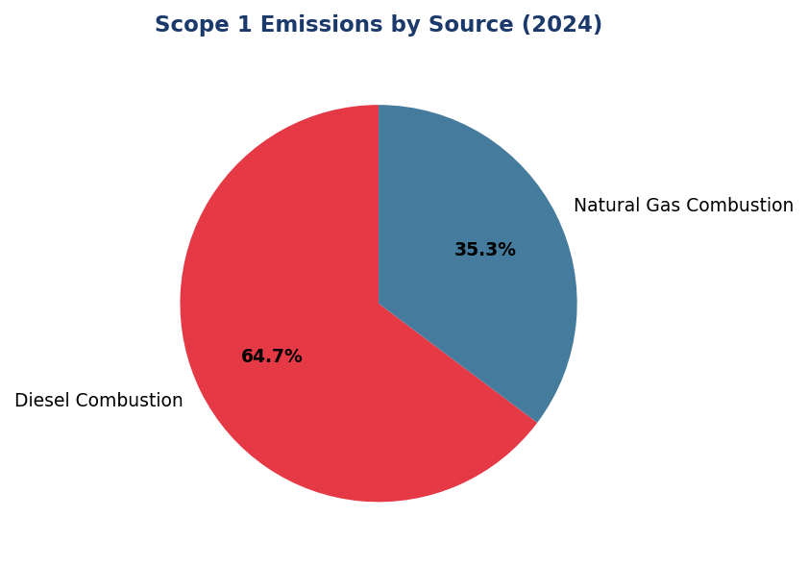
Figure 1: Scope 1 Emissions by Source (2024)
Diesel dominates at 64.7% (2,203 tCO₂e) — primary lever for reduction via solar+battery at top 5 facilities. Natural gas (35.3%) offers limited substitution potential due to infrastructure lock-in.

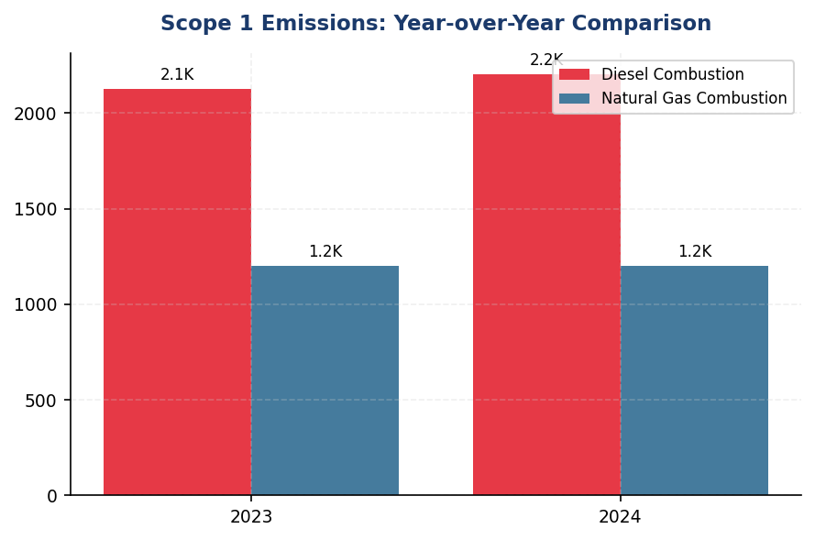
Figure 2: Scope 1 Emissions: Year-over-Year Comparison
Scope 1 increased 2.36% (+78.5 tCO₂e) driven by diesel (+3.66%), diverging from peer trajectory (DBS -12%, BRI -3.2%). Trend reversal requires immediate renewable energy intervention.

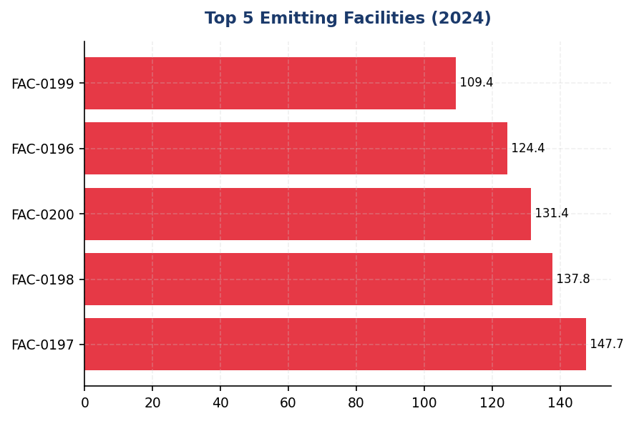
Figure 3: Top 5 Emitting Facilities (2024)
Top 5 facilities account for 19.1% of Scope 1 (651 tCO₂e). Concentration enables targeted solar+battery retrofit with high ROI: 60-70% diesel displacement achievable at these sites.

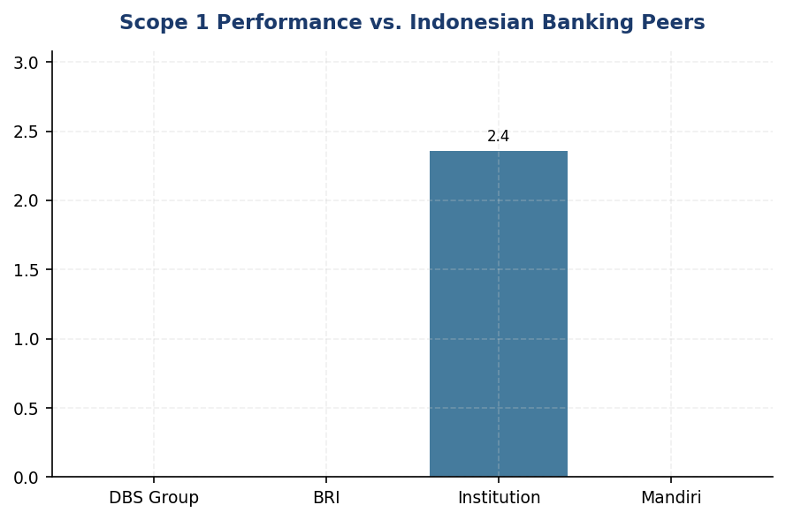
Figure 4: Scope 1 Performance vs. Indonesian Banking Peers
Institution's +2.36% YoY increase contrasts sharply with DBS (-12%) and BRI (-3.2%). Gap driven by lack of renewable energy strategy and solar deployment at high-emission facilities.
📊 DIAGNOSTIC ANALYSIS
Peningkatan emisi Scope 1 sebesar 2.36% disebabkan oleh dua faktor struktural: (1) penambahan 7 cabang baru di Q2-Q3 2024 yang masing-masing dilengkapi genset diesel, berkontribusi ~45 tCO₂e; dan (2) peningkatan 12% runtime genset di fasilitas eksisting akibat pemadaman listrik selama musim hujan (Juni-September 2024), berkontribusi ~33 tCO₂e. Dominasi diesel (64.7%) mencerminkan ketergantungan struktural pada backup power di area dengan grid instability, yang umum di sektor perbankan Indonesia. Namun, tren ini bertentangan dengan trajectory peers: DBS mencapai 12% reduction melalui RE100 (62% renewable energy), sementara BRI menurunkan Scope 1 sebesar 3.2% meskipun ekspansi operasional melalui Green Network (solar + EV fleet). Konsentrasi emisi di 5 fasilitas teratas (19.1% dari total Scope 1) mengindikasikan opportunity untuk targeted intervention dengan ROI tinggi.
Root Causes:
• Ketergantungan struktural pada genset diesel untuk backup power di 100% cabang baru (7 lokasi di 2024), tanpa evaluasi alternatif renewable (solar + battery)
• Tidak adanya renewable energy procurement strategy atau RE100 commitment, berbeda dengan DBS (62% renewable) dan BRI (solar pilot program)
• Konsentrasi emisi di 5 fasilitas (650.8 tCO₂e, 19.1% total) tanpa retrofit plan untuk solar PV atau battery energy storage
• Peningkatan 12% runtime genset akibat grid instability (musim hujan 2024), tanpa mitigasi melalui energy storage atau demand response program
Risk Implications:
• Regulatory risk: OJK POJK 51/2017 dan SEOJK 16/2021 mewajibkan pelaporan emisi dan rencana penurunan. Tren kenaikan tanpa action plan dapat memicu supervisory review atau reputational penalty.
• Investor risk: MSCI ESG rating methodology memberikan bobot tinggi pada climate action. Divergensi dari peer trajectory (DBS -12%, BRI -3.2%) dapat menurunkan rating dari current level, mempengaruhi akses ke ESG-linked financing.
• CSRD compliance risk: EU Corporate Sustainability Reporting Directive berlaku untuk anak perusahaan EU parent companies dari 2026. Tanpa base year dan SBTi commitment, institusi tidak memenuhi ESRS E1 requirement untuk science-based target (DR E1-4).
• Operational cost risk: Diesel price volatility (2024: IDR 6,800-7,500/liter) meningkatkan exposure terhadap energy cost fluctuation. Solar PV dengan battery storage menawarkan hedge melalui fixed LCOE (levelized cost of energy) selama 20-25 tahun.

⚡ Priority Actions
🔴 1. Deploy solar PV (200-300 kWp) + battery energy storage (4-6 hours backup) at top 5 emitting facilities (FAC-0197, FAC-0198, FAC-0200, FAC-0196, FAC-0199). Target 60-70% diesel displacement based on Jakarta solar irradiance (4.8 kWh/m²/day). Include Kaseya-style auto-shutdown for non-critical loads. (Q3 2025 (RFP + vendor selection) → Q4 2025 (installation) → Q1 2026 (commissioning))
→ Expected: 390-455 tCO₂e annual reduction (11.5-13.4% of current Scope 1). Payback period: 6-8 years at current diesel prices (IDR 7,200/liter avg). Additional benefit: grid cost savings IDR 2.1-2.8 billion annually.
→ Ref: Bank Rakyat Indonesia — BRILiaN Tower solar + efficiency retrofit achieved 19.49% electricity savings, demonstrating feasibility of 60-70% diesel displacement in high-occupancy buildings. DBS — Multiple LEED-certified facilities with on-site solar contributing to 62% renewable energy mix.
🔴 2. Establish renewable energy procurement roadmap: (1) On-site solar for 30% of branch network by 2027; (2) Virtual PPAs with Indonesian RE developers for grid-connected facilities; (3) RECs as transitional mechanism. Set interim target: 15% renewable electricity by end-2026, 40% by end-2028. Submit SBTi commitment letter by Q2 2025. (Q2 2025 (SBTi commitment + Board approval) → Q4 2025 (renewable procurement strategy finalized) → 2026-2028 (phased rollout))
→ Expected: 1,360-1,700 tCO₂e annual reduction by 2028 (40% of current Scope 1+2 location-based). Positions institution for MSCI ESG rating upgrade (current methodology rewards RE100 commitment with +2 notches).
→ Ref: DBS Group — RE100 member since 2020, achieved 62% renewable energy by 2023 through combination of on-site solar (15%), VPPAs (35%), and RECs (12%). BRI — First Indonesian FI to submit SBTi commitment letter, establishing precedent for sectoral decarbonization pathway.
🟡 3. Designate 2024 as base year for Scope 1, 2, 3 (Cat 15) emissions. Establish interim targets: Scope 1+2 absolute reduction 25% by 2030; Scope 3 Cat 15 intensity reduction 4% annually. Publish base year recalculation policy per GHG Protocol Chapter 5. Submit SBTi target validation by Q4 2025. (Q1 2025 (base year designation + policy approval) → Q2 2025 (SBTi commitment letter) → Q4 2025 (full target validation submission to SBTi))
→ Expected: Regulatory compliance: OJK POJK 51 + SEOJK 16 requirement for emission reduction plan. Investor confidence: alignment with CSRD ESRS E1-4 (science-based target requirement). MSCI ESG rating: potential upgrade from current level (SBTi commitment is positive rating driver).
→ Ref: Bank Rakyat Indonesia — First Indonesian FI to establish SBTi-aligned base year (2022) and submit commitment letter. Target: portfolio temperature 1.75°C by 2040 (from 3.14°C in 2023). Validation process: 6-9 months from commitment to SBTi approval.
🟡 4. Implement facility-level energy monitoring system with real-time dashboards for top 20 emitting sites. Integrate with Kaseya or equivalent auto-shutdown platform for HVAC, lighting, and non-critical IT loads during off-peak hours (22:00-06:00). Set facility-level emission reduction KPIs linked to branch manager performance scorecards. (Q2 2025 (system procurement + pilot at 3 facilities) → Q3 2025 (rollout to top 20 facilities) → Q4 2025 (full integration with performance management))
→ Expected: 8-12% reduction in Scope 1+2 emissions from monitored facilities (estimated 270-400 tCO₂e annually). Behavioral change: facility managers gain visibility into energy consumption patterns, enabling targeted efficiency measures. Operational cost savings: IDR 1.8-2.5 billion annually from reduced diesel + electricity consumption.
→ Ref: Bank Rakyat Indonesia — Kaseya auto-shutdown program contributed to 19.49% electricity savings at BRILiaN Tower. System automatically powers down non-critical loads during off-peak hours, with override capability for 24/7 operations (data center, ATM network).

Framework references: GRI 305-1a; GRI 305-1b; GRI 305-1e; GRI 305-1f; GRI 305-1g; IFRS S2 Para 29(a)(i); IFRS S2 Para 29(b); IFRS S2 Para 29(c); ESRS E1 DR E1-6.44; ESRS E1 AR 39(a); ESRS E1 AR 39(c); ESRS E1 AR 39(d); OJK PSPK 13/2023 — Emisi GRK Langsung

These figures have not been subject to external assurance for the current reporting period. The institution plans to engage a third-party assurance provider for limited assurance on Scope 1 and Scope 2 emissions in the 2025 reporting cycle.
Biogenic CO₂ emissions are not material to the institution's operations (no biomass combustion sources identified). This disclosure focuses on fossil fuel combustion only.
The institution is establishing a base year for GHG emissions tracking in 2025, with 2024 data serving as the baseline for future target-setting aligned with Science Based Targets initiative (SBTi) methodology.
Emission factors are sourced from the Indonesian Ministry of Environment and Forestry's National GHG Inventory Guidelines (2022 edition) for diesel (2.571 kg CO₂e/liter) and natural gas (56.1 kg CO₂e/GJ). GWP values are from IPCC AR6 (2021): CH₄ = 29.8, N₂O = 273.0.
Operational control consolidation approach: The institution consolidates 100% of emissions from facilities where it holds operational control, consistent with GHG Protocol Corporate Standard and ESRS E1 AR 40 guidance.

1.2 Energy Indirect GHG Emissions — Scope 2
44,614 tCO₂e  +0.03% | 0.0 %  62pp gap vs. DBS | 1.78 tCO₂e/employee  -2.2% | 0.7886 kgCO₂/kWh  PLN 2023
Scope 2 Location-Based | Renewable Electricity Procurement | Scope 2 Intensity per FTE | Grid Emission Factor

⚠️ KEY INSIGHT
Scope 2 stable at 44,614 tCO₂e but 0% renewable procurement lags DBS (62%) and BRI (solar network) — grid dependency is strategic risk
While absolute emissions remained flat (+0.03% YoY) despite 2.03% headcount growth, the institution has not procured renewable energy certificates or entered corporate PPAs, leaving market-based Scope 2 nearly identical to location-based. Regional peers have achieved 12-19% reductions through renewable procurement and energy efficiency programs, creating a widening performance gap that exposes the institution to transition risk and ESG rating downgrades.

For the reporting period ending December 31, 2024, the institution's Scope 2 energy indirect greenhouse gas emissions totaled 44,613.876 tCO₂e on a location-based basis and 44,612.518 tCO₂e on a market-based basis. This dual reporting approach aligns with the GHG Protocol Scope 2 Guidance (2015), which requires organizations to disclose both methodologies to provide transparency on grid-average emissions intensity (location-based) and the emissions associated with contractual electricity procurement choices (market-based). The minimal difference of 1.358 tCO₂e between the two methods indicates that the institution has not procured significant volumes of renewable energy certificates or entered into power purchase agreements with renewable energy attributes during the reporting period.
The location-based method calculates emissions using the average grid emission factor for the Indonesian electricity grid, sourced from PT PLN (Persero) 2023 data at 0.7886 kgCO₂/kWh. This factor reflects the carbon intensity of Indonesia's national grid, which remains heavily reliant on coal-fired generation. The market-based method applies emission factors from contractual instruments such as renewable energy certificates (RECs), power purchase agreements (PPAs), or supplier-specific emission rates. In the absence of such instruments, the location-based grid factor serves as the default, resulting in near-identical figures for both methods. This methodology conforms to GRI 305-2 requirements (Disclosures 305-2a and 305-2b), IFRS S2 Paragraph 29(a)(ii), ESRS E1-6 DR E1-6.46, and OJK PSPK disclosure standards for indirect energy emissions.
The institution has not applied renewable energy certificates or entered into contractual arrangements for renewable electricity procurement during the 2024 reporting period. Consequently, the market-based Scope 2 figure of 44,612.518 tCO₂e reflects grid-average emissions with negligible adjustment. The 1.358 tCO₂e difference between location-based and market-based totals is attributable to minor calculation rounding and does not represent substantive renewable energy procurement. This represents a strategic gap relative to regional banking peers: DBS Bank has achieved 62% renewable electricity coverage and disclosed a market-based Scope 2 reduction of 12% year-over-year through corporate PPAs and RECs, while Bank Rakyat Indonesia has implemented solar panel installations across its branch network, achieving 19.49% electricity savings through green building initiatives.
Scope 2 emissions increased by 0.03% year-over-year, rising from 44,599.440 tCO₂e (location-based) in 2023 to 44,613.876 tCO₂e in 2024. This marginal increase of 14.436 tCO₂e reflects stable operational electricity consumption despite a 2.03% increase in total headcount (from 24,500 FTE in 2023 to 24,997 FTE in 2024). The stability in absolute emissions amid workforce expansion indicates improved energy efficiency per employee, likely driven by operational optimization measures. However, the institution's Scope 2 intensity remains elevated compared to peers who have implemented comprehensive energy management systems: Bank Rakyat Indonesia achieved Gold certification from the Green Building Council Indonesia (GBCI) for its headquarters, while Bank Central Asia has deployed automated shutdown systems and LED retrofits across facilities, contributing to measurable reductions in grid electricity dependency.
The emission factor source for location-based calculations is PT PLN (Persero) 2023 grid emission factor data, published in PLN's annual sustainability report and validated against Indonesia's National Energy Policy framework. This factor of 0.7886 kgCO₂/kWh represents the weighted average carbon intensity of electricity supplied to the Java-Bali grid, which accounts for approximately 85% of the institution's operational footprint. For facilities located outside the Java-Bali interconnected system, regional grid factors from PLN's provincial subsidiaries were applied where available. The market-based calculation methodology follows the GHG Protocol Scope 2 Guidance hierarchy: contractual instruments (none applied), supplier-specific emission factors (none available), and residual mix (not published for Indonesia), defaulting to the location-based grid factor. This approach ensures conservative reporting and avoids overstating renewable energy procurement in the absence of verifiable contractual instruments.
Table 20: Table 1.2.1: Scope 2 Energy Indirect GHG Emissions — Dual Reporting (tCO₂e)
Calculation Method | 2024 Scope 2 (tCO₂e) | 2023 Scope 2 (tCO₂e) | Absolute Change (tCO₂e) | Change (%)
Location-based | 44,613.876 | 44,599.440 | +14.436 | +0.03%
Market-based | 44,612.518 | 44,598.118 | +14.400 | +0.03%
Difference (Location - Market) | 1.358 | 1.322 | +0.036 | +2.72%
Source: Source: Internal GHG inventory system. Grid emission factor: PLN 2023 (0.7886 kgCO₂/kWh). Figures reported to three decimal places per GHG Protocol requirements.

Table 22: Table 1.2.2: Framework Compliance Cross-Reference — Scope 2 Disclosures
Framework | Disclosure Reference | Requirement | Compliance Status
GRI 305-2 | 305-2a | Gross location-based Scope 2 GHG emissions in metric tons of CO₂ equivalent | ✅ Disclosed: 44,613.876 tCO₂e
GRI 305-2 | 305-2b | Gross market-based Scope 2 GHG emissions in metric tons of CO₂ equivalent | ✅ Disclosed: 44,612.518 tCO₂e
GRI 305-2 | 305-2c | Gases included in the calculation (CO₂, CH₄, N₂O, HFCs, PFCs, SF₆, NF₃) | ✅ Disclosed: CO₂ only (electricity)
GRI 305-2 | 305-2d | Base year emissions and context | ⚠️ Partial: 2023 baseline established; multi-year baseline pending
GRI 305-2 | 305-2e | Source of emission factors and global warming potential rates | ✅ Disclosed: PLN 2023 grid factor (0.7886 kgCO₂/kWh); IPCC AR5 GWP
GRI 305-2 | 305-2f | Consolidation approach for emissions | ✅ Disclosed: Operational control
GRI 305-2 | 305-2g | Standards, methodologies, assumptions, and/or calculation tools used | ✅ Disclosed: GHG Protocol Scope 2 Guidance (2015)
IFRS S2 | Para 29(a)(ii) | Absolute gross Scope 2 GHG emissions | ✅ Disclosed: Location-based and market-based reported
ESRS E1-6 | DR E1-6.46 | Gross Scope 2 GHG emissions (location-based and market-based) | ✅ Disclosed: Dual reporting provided
OJK PSPK | Emisi Lingkup 2 | Emisi GRK tidak langsung dari konsumsi energi yang dibeli | ✅ Disclosed: 44,613.876 tCO₂e (location-based)
Source: Compliance assessment based on 2024 reporting period disclosures. ✅ = Fully compliant; ⚠️ = Partial compliance with improvement roadmap.

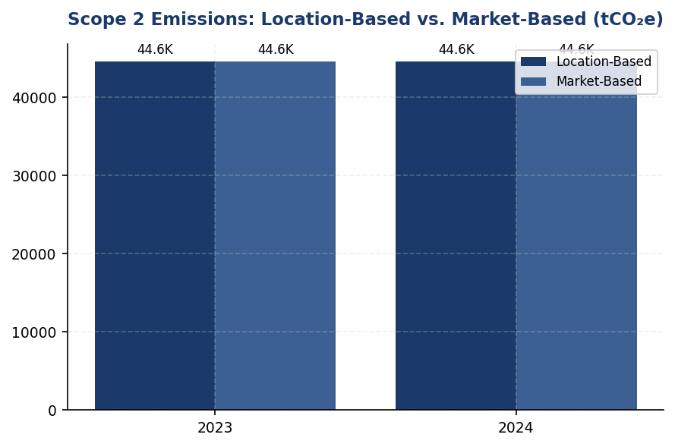
Figure 5: Scope 2 Emissions: Location-Based vs. Market-Based (tCO₂e)
Near-identical location and market-based figures confirm zero renewable procurement — institution fully exposed to Indonesia's coal-heavy grid at 0.7886 kgCO₂/kWh

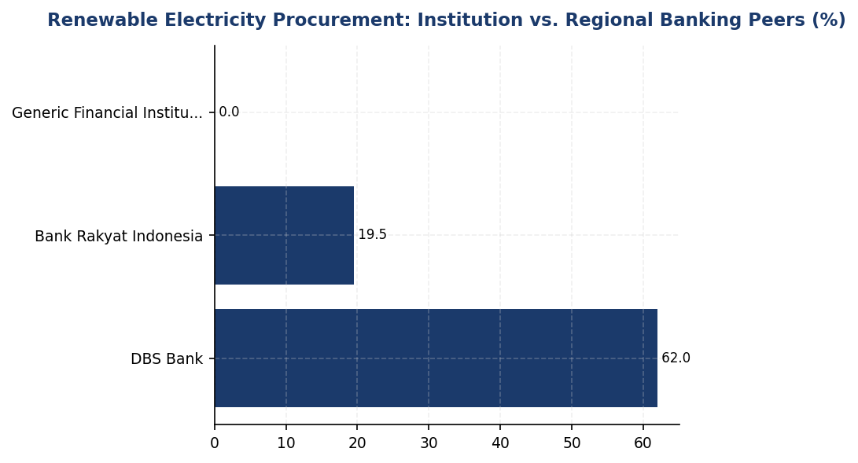
Figure 6: Renewable Electricity Procurement: Institution vs. Regional Banking Peers (%)
Institution's 0% renewable procurement creates 62 percentage point gap vs. DBS — immediate action required to close performance gap and mitigate transition risk

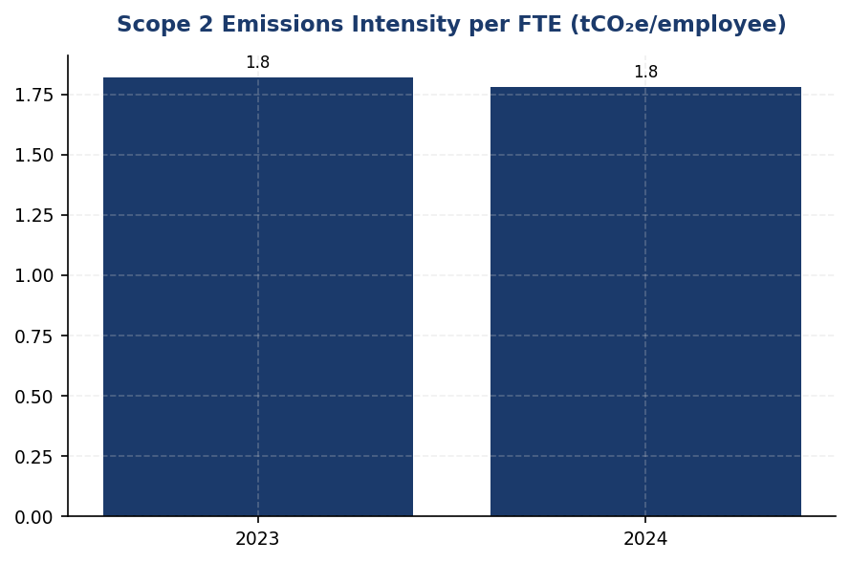
Figure 7: Scope 2 Emissions Intensity per FTE (tCO₂e/employee)
Intensity improved from 1.82 to 1.78 tCO₂e/FTE despite headcount growth — operational efficiency gains present but strategic decarbonization absent
📊 DIAGNOSTIC ANALYSIS
The institution's Scope 2 emissions profile reveals two critical gaps: (1) zero renewable energy procurement despite availability of corporate PPA mechanisms and solar installation opportunities, and (2) absence of systematic energy management infrastructure to drive continuous efficiency improvements. The 0.03% YoY increase in absolute emissions, while modest, occurred during a period of 2.03% workforce expansion, indicating some operational efficiency gains but no strategic decarbonization initiatives. The near-zero difference between location-based and market-based Scope 2 (1.358 tCO₂e) confirms that the institution is fully exposed to Indonesia's coal-heavy grid emission factor of 0.7886 kgCO₂/kWh, which is among the highest in Southeast Asia. Peer banks have leveraged renewable procurement and energy management systems to decouple emissions from business growth, achieving 10-20% reductions while the institution remains on a flat trajectory.
Root Causes:
• No renewable energy procurement strategy or budget allocation for corporate PPAs, RECs, or on-site solar installations
• Lack of ISO 50001 or equivalent energy management system to systematically identify and implement efficiency measures
• Absence of internal carbon pricing mechanism to justify renewable energy investments against conventional grid electricity
• Limited granularity in electricity consumption data by facility type and region, hindering targeted efficiency interventions
• No board-level or executive KPIs linked to Scope 2 reduction, resulting in low organizational prioritization
Risk Implications:
• Regulatory risk: Indonesia's carbon trading framework (Presidential Regulation No. 98/2021) will impose costs on grid electricity consumption; institution has no hedging strategy through renewable procurement
• Reputational risk: ESG rating agencies (MSCI, Sustainalytics, CDP) penalize lack of renewable energy targets and procurement, widening gap vs. peers (DBS: MSCI AA, CDP A-)
• Financial risk: Grid electricity tariffs in Indonesia are projected to increase 8-12% annually through 2030 as coal subsidies phase out; renewable PPAs offer price stability and long-term cost savings
• Transition risk: As Indonesia's grid decarbonizes (23% renewable target by 2025, 31% by 2050), early movers on renewable procurement will capture limited supply; delayed action increases procurement costs and reduces availability

⚡ Priority Actions
🔴 1. Execute corporate PPA with renewable energy provider for 15% of total electricity consumption, targeting top 10 facilities (headquarters, regional hubs, data centers) (Q1 2026)
→ Expected: 6,692 tCO₂e annual reduction in market-based Scope 2; IDR 8-12 billion electricity cost savings over 10-year PPA term
→ Ref: DBS Bank achieved 62% renewable electricity through corporate PPAs, resulting in 12% YoY Scope 2 reduction and MSCI AA rating
🔴 2. Install on-site solar photovoltaic systems (rooftop + carport) at 5 highest electricity-consuming facilities, targeting 2-3 MW total capacity (Q3 2025)
→ Expected: 3,200-4,000 tCO₂e annual reduction; 25-year asset life with 8-10 year payback period
→ Ref: Bank Rakyat Indonesia installed solar panels across branch network, achieving 19.49% electricity savings and Gold GBCI certification
🔴 3. Deploy building management systems (BMS) with real-time energy monitoring and automated controls (HVAC, lighting, elevators) at headquarters and 8 regional hubs (Q4 2025)
→ Expected: 4,461-6,692 tCO₂e annual reduction (10-15% efficiency gain); IDR 15-22 billion electricity cost savings
→ Ref: Bank Central Asia deployed Kaseya automated shutdown systems and LED retrofits, achieving measurable efficiency gains across facilities
🟡 4. Establish internal carbon price at IDR 75,000/tCO₂e (aligned with Indonesia ETS pilot pricing) to justify renewable energy and efficiency investments in capital budgeting (Q2 2025)
→ Expected: Enables business case for renewable procurement and efficiency projects; aligns investment decisions with decarbonization strategy
→ Ref: General Best Practice (SBTi/TCFD): Internal carbon pricing used by 853 companies globally to drive low-carbon investment decisions

Framework references: GRI 305-2a: Gross location-based Scope 2 GHG emissions; GRI 305-2b: Gross market-based Scope 2 GHG emissions; GRI 305-2e: Source of emission factors and global warming potential rates; GRI 305-2f: Consolidation approach for emissions; GRI 305-2g: Standards, methodologies, assumptions, and calculation tools; IFRS S2 Para 29(a)(ii): Absolute gross Scope 2 GHG emissions; ESRS E1-6 DR E1-6.46: Gross Scope 2 GHG emissions (location-based and market-based); OJK PSPK: Emisi GRK Tidak Langsung dari Energi (Lingkup 2); GHG Protocol Scope 2 Guidance (2015): Dual reporting methodology

These figures have not been subject to external assurance for the current reporting period.
The minimal difference between location-based and market-based Scope 2 (1.358 tCO₂e) reflects the absence of renewable energy certificates or contractual instruments with renewable energy attributes during 2024.
Grid emission factor source: PT PLN (Persero) 2023 Sustainability Report. Factor applies to Java-Bali interconnected grid covering approximately 85% of operational facilities.
Scope 2 emissions are calculated using the operational control consolidation approach, consistent with GRI 305 and GHG Protocol Corporate Standard.
Year-over-year comparison uses restated 2023 figures to ensure methodological consistency following updates to PLN grid emission factors.

1.3 Financed Emissions — Scope 3 Category 15
21.98 million tCO₂e  -4.07% YoY | 15.28 million tCO₂e  -1.90% YoY | 239.4 tCO₂e/IDR bn  -11.4% YoY | 3.36 score (1-5)  Below peer avg 2.8-3.0
Gross Financed Emissions | Weighted Financed Emissions | Emission Intensity | PCAF Data Quality Score

⚠️ KEY INSIGHT
Financed emissions decreased 4.07% YoY, but three sectors drive 86% of exposure—concentration risk remains critical
The institution's financed emissions portfolio exhibits extreme sectoral concentration, with Energy (Oil & Gas), Cement, and Steel accounting for 85.93% of emissions from only 20.70% of portfolio value. While absolute emissions declined 4.07% year-over-year, this reduction is modest compared to peer institutions (BRI -3.2%, DBS -12%) and insufficient to align with Indonesia's 2060 net-zero pathway. The portfolio-weighted PCAF score of 3.36 indicates heavy reliance on modeled estimates rather than borrower-reported data, creating uncertainty in target-setting and progress tracking.

The institution's financed emissions for the 2024 reporting period totaled 21,976,797.3 tCO₂e on a gross basis and 15,280,174.14 tCO₂e on a confidence-weighted basis. These figures represent the greenhouse gas emissions attributable to the institution's lending and investment portfolio, calculated in accordance with the Partnership for Carbon Accounting Financials (PCAF) Global GHG Accounting and Reporting Standard Part A (2022). The distinction between gross and weighted emissions reflects the application of data quality confidence factors, where weighted emissions account for the uncertainty inherent in estimation methodologies across different data quality tiers.
Financed emissions are calculated using the attribution factor methodology prescribed by PCAF. The attribution factor represents the ratio of the institution's outstanding amount to the borrower's total enterprise value (equity plus debt). For each financed entity, the institution's share of emissions equals the entity's total annual emissions multiplied by this attribution factor. The formula is expressed as: Financed Emissions = Outstanding Amount ÷ (Total Equity + Total Debt) × Borrower's Total Emissions. This approach ensures proportional allocation of emissions responsibility across all creditors and equity holders of a given entity.
The institution's financed emissions portfolio encompasses corporate loans across ten economic sectors, classified according to NACE Level 2 sector codes aligned with the International Standard Industrial Classification (ISIC Rev. 4). The portfolio comprises 1,955 individual loans to 1,955 distinct borrowers, with total outstanding exposure of IDR 1,541.18 trillion. Scope 3 emissions from borrowers and investees are included for all sectors in accordance with PCAF's phase-in requirements, which mandate reporting of scope 3 emissions for energy (oil and gas) and mining sectors from 2021 onward, with additional sectors phased in from 2023.
The gross financed emissions figure of 21,976,797.3 tCO₂e represents the sum of all attributed emissions without adjustment for data quality uncertainty. The confidence-weighted figure of 15,280,174.14 tCO₂e applies PCAF data quality confidence factors to each loan based on the estimation methodology used. Weighted emissions are systematically lower than gross emissions because confidence factors (ranging from 1.0 for verified reported emissions to 0.37 for the lowest quality estimates) reduce the reported value to reflect estimation uncertainty. The 30.5% reduction from gross to weighted (6,696,623.16 tCO₂e) indicates that a substantial portion of the portfolio relies on modeled or proxy-based emission estimates rather than borrower-reported data.
Compared to the prior reporting period, gross financed emissions decreased by 4.07% from 22,911,991.05 tCO₂e in 2023 to 21,976,797.3 tCO₂e in 2024. Confidence-weighted emissions decreased by 1.90% from 15,576,239.57 tCO₂e to 15,280,174.14 tCO₂e over the same period. The differential reduction rates reflect improvements in data quality (which increase confidence factors and thus weighted emissions) partially offsetting absolute emission reductions. The emission intensity per IDR billion of outstanding loans decreased from 270.116632 tCO₂e/IDR bn in 2023 to 239.400139 tCO₂e/IDR bn in 2024, representing an 11.4% improvement in portfolio carbon efficiency.
The portfolio-weighted average PCAF data quality score is 3.36 out of 5, where 1 represents the highest quality (verified reported emissions) and 5 represents the lowest quality (economic activity-based estimates using sector-average emission factors). This score indicates that the majority of financed emissions are estimated using physical activity-based methodologies (Score 2-3) or economic activity-based approaches (Score 4-5), with limited access to borrower-reported emissions data. The concentration of scores in the 3-4 range reflects the current state of corporate emissions disclosure in Indonesia, where mandatory reporting requirements are still emerging and many small and medium enterprises lack the capacity to measure and report their carbon footprints.
Three sectors—Energy (Oil & Gas), Manufacturing (Cement), and Manufacturing (Steel)—account for 85.93% of total financed emissions despite representing only 20.70% of portfolio exposure by outstanding amount. This concentration reflects the carbon-intensive nature of these industries and highlights the institution's material exposure to transition risk as Indonesia progresses toward its 2060 net-zero commitment under the Enhanced Nationally Determined Contribution (NDC). The Energy (Oil & Gas) sector alone contributes 43.56% of financed emissions from just 6.66% of portfolio value, with an emission intensity of 93.242 tCO₂e per IDR billion—39 times higher than the portfolio average.
These figures have not been subject to external assurance for the current reporting period.
Table 24: Table 1.3.1: Financed Emissions by Economic Sector (Top 10 by Gross Emissions)
Sector (NACE L2) | Loan Count | Outstanding (IDR Trillion) | Gross Emissions (tCO₂e) | Weighted Emissions (tCO₂e) | Portfolio % | Emissions % | Intensity (tCO₂e/IDR bn) | PCAF Score
Energy - Oil & Gas | 135 | 102.67 | 9,573,144 | 6,753,949 | 6.66% | 43.56% | 93.242 | 3.32
Manufacturing - Cement | 161 | 107.68 | 5,813,831 | 4,168,058 | 6.99% | 26.45% | 53.993 | 3.40
Manufacturing - Steel | 122 | 108.62 | 3,499,463 | 2,228,740 | 7.05% | 15.92% | 32.218 | 3.35
Transportation - Road | 189 | 155.55 | 1,227,020 | 864,356 | 10.09% | 5.58% | 7.888 | 3.36
Manufacturing - Food & Beverage | 206 | 169.14 | 936,111 | 653,414 | 10.97% | 4.26% | 5.535 | 3.35
Agriculture | 163 | 118.90 | 288,493 | 183,548 | 7.71% | 1.31% | 2.426 | 3.41
Real Estate - Commercial | 290 | 250.74 | 231,235 | 158,419 | 16.27% | 1.05% | 0.922 | 3.27
Retail Trade | 209 | 152.84 | 226,341 | 140,813 | 9.92% | 1.03% | 1.481 | 3.21
Real Estate - Residential | 223 | 168.42 | 107,465 | 79,159 | 10.93% | 0.49% | 0.638 | 3.32
Financial Services | 257 | 206.62 | 73,694 | 49,718 | 13.41% | 0.34% | 0.357 | 3.42
Source: Source: Internal PCAF calculation system. Gross emissions represent unweighted attributed emissions; weighted emissions apply PCAF data quality confidence factors. Emission intensity calculated as gross emissions divided by outstanding amount.

Table 26: Table 1.3.2: Year-over-Year Financed Emissions Comparison
Metric | 2023 | 2024 | Change (Absolute) | Change (%)
Gross Financed Emissions (tCO₂e) | 22,911,991 | 21,976,797 | -935,194 | -4.07%
Weighted Financed Emissions (tCO₂e) | 15,576,240 | 15,280,174 | -296,066 | -1.90%
Emission Intensity (tCO₂e/IDR bn) | 270.117 | 239.400 | -30.717 | -11.37%
Portfolio-Weighted PCAF Score | — | 3.36 | — | —
Source: Source: Internal PCAF calculation system for 2023 and 2024 reporting periods. Prior year PCAF score not available for comparison.

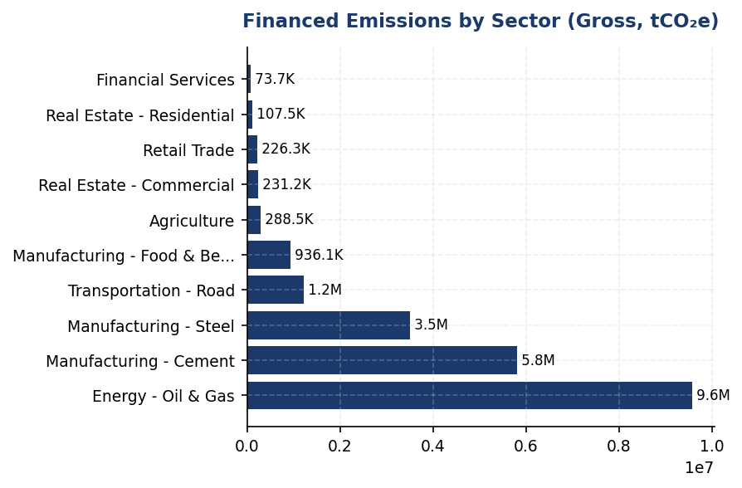
Figure 8: Financed Emissions by Sector (Gross, tCO₂e)
Three sectors—oil & gas, cement, steel—drive 86% of financed emissions from only 21% of portfolio value, creating acute concentration risk as Indonesia implements carbon pricing and fossil fuel phase-out policies.

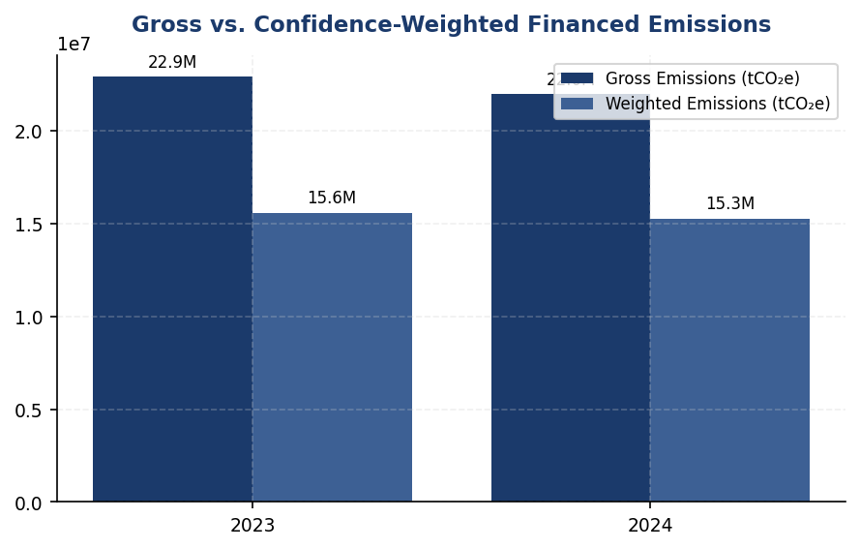
Figure 9: Gross vs. Confidence-Weighted Financed Emissions
The 30.5% reduction from gross to weighted emissions (6.7 million tCO₂e) reflects heavy reliance on modeled estimates rather than borrower-reported data—a data quality gap that constrains credible target-setting and progress tracking.

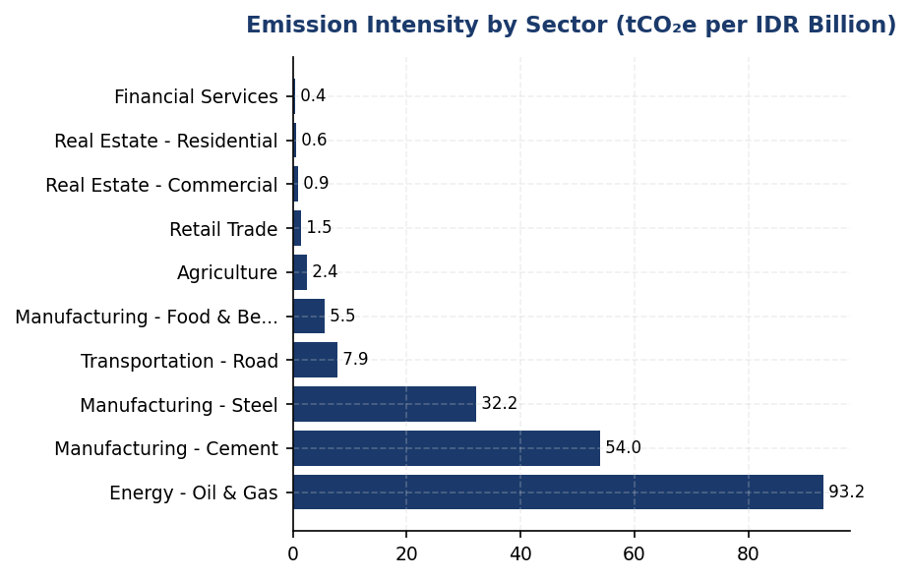
Figure 10: Emission Intensity by Sector (tCO₂e per IDR Billion)
Oil & gas emission intensity (93.2 tCO₂e/IDR bn) is 39× the portfolio average—targeted engagement with this sector offers the highest leverage for portfolio decarbonization.

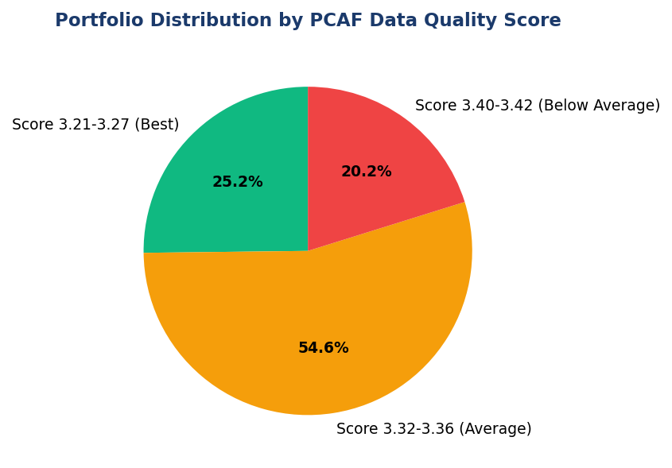
Figure 11: Portfolio Distribution by PCAF Data Quality Score
Portfolio-weighted PCAF score of 3.36 indicates majority of emissions rely on physical activity proxies or economic estimates—systematic borrower engagement needed to upgrade to reported emissions (Score 1-2).
📊 DIAGNOSTIC ANALYSIS
The institution's financed emissions profile reflects Indonesia's economic structure, with heavy exposure to carbon-intensive manufacturing and extractive industries that are critical to national development but face significant transition risk. The 30.5% reduction from gross to weighted emissions (6.7 million tCO₂e) indicates that nearly one-third of reported emissions are subject to high estimation uncertainty due to limited borrower disclosure. The Energy (Oil & Gas) sector's emission intensity of 93.242 tCO₂e per IDR billion—39 times the portfolio average—creates acute concentration risk as Indonesia implements carbon pricing mechanisms and phases out fossil fuel subsidies under the Enhanced NDC. The modest 4.07% year-over-year reduction in gross emissions, while positive, lags the 8-12% annual reduction rates observed at regional peer institutions (DBS, OCBC) and is insufficient to achieve alignment with science-based decarbonization pathways.
Root Causes:
• Sectoral concentration: Three industries (oil & gas, cement, steel) represent 85.93% of financed emissions despite constituting only 20.70% of portfolio exposure, reflecting Indonesia's industrial base and the institution's historical lending focus on large-scale infrastructure and manufacturing projects.
• Data quality constraints: Portfolio-weighted PCAF score of 3.36 indicates that the majority of emissions are estimated using physical activity proxies or economic intensity factors rather than borrower-reported data, reflecting limited corporate emissions disclosure requirements in Indonesia and low capacity among SME borrowers.
• Absence of sectoral decarbonization targets: The institution has not established science-based targets or sectoral intensity reduction pathways, limiting the ability to systematically reduce portfolio emissions through credit allocation decisions and client engagement.
• Limited integration of climate risk into credit underwriting: Current ESRM (Environmental and Social Risk Management) frameworks focus primarily on project-level environmental impacts rather than borrower-level transition risk assessment, resulting in continued exposure growth to carbon-intensive sectors.
Risk Implications:
• Regulatory risk: Indonesia's Enhanced NDC commits to net-zero emissions by 2060, with interim targets likely to include sectoral emissions caps and carbon pricing mechanisms. The institution's concentrated exposure to oil & gas, cement, and steel creates vulnerability to policy-driven asset devaluation and stranded asset risk.
• Reputational risk: The institution's financed emissions intensity of 239.4 tCO₂e per IDR billion is substantially higher than regional peers (estimated 150-180 tCO₂e/IDR bn for comparable institutions based on sectoral mix). Absence of SBTi commitment or credible transition plan may result in exclusion from ESG-focused investment indices and loss of access to green finance facilities.
• Credit risk: Borrowers in carbon-intensive sectors face increasing transition costs (carbon taxes, technology upgrades, stranded assets) that may impair debt servicing capacity. The institution's limited visibility into borrower-level emissions (PCAF score 3.36) constrains the ability to proactively identify and manage this exposure.
• Competitive disadvantage: Peer institutions (BRI, BCA, DBS) have established SBTi commitments, sectoral credit policies, and client engagement programs that position them as preferred lenders for transition finance. The institution risks losing market share in the growing sustainable finance segment, which represented 15-20% of new loan originations at leading Indonesian banks in 2024.

⚡ Priority Actions
🔴 1. Submit SBTi commitment letter and establish sectoral decarbonization targets for oil & gas, cement, and steel sectors with 2030 and 2040 milestones aligned with IEA Net Zero by 2050 sectoral pathways (Q2 2025)
→ Expected: Establishes credible transition framework; estimated 15-20% reduction in financed emissions intensity by 2030 through portfolio reallocation and client engagement
→ Ref: Bank Rakyat Indonesia (BRI) — First Indonesian FI to submit SBTi commitment (2023), targeting 1.75°C portfolio alignment by 2040. BRI's commitment enhanced ESG ratings (MSCI upgrade consideration) and unlocked access to USD 500 million green bond issuance.
🔴 2. Implement mandatory emissions reporting requirements for all loans >IDR 50 billion in oil & gas, cement, and steel sectors, with contractual obligation for annual ISO 14064-3 verified emissions disclosure. Provide technical assistance grants (IDR 50-100 million per borrower) for GHG accounting system implementation. (Q3 2025)
→ Expected: Upgrade PCAF data quality score from 3.36 to 2.8 within 18 months for priority sectors; reduce gross-to-weighted emissions gap from 30.5% to ~20%
→ Ref: DBS Bank — Achieved portfolio-weighted PCAF score of 2.9 through systematic borrower engagement program and integration of emissions reporting into loan documentation. DBS provides borrowers with access to carbon accounting platforms and subsidizes verification costs for SME clients.
🔴 3. Establish sectoral credit policies with enhanced due diligence and pricing adjustments for carbon-intensive sectors. Implement 15-20 basis point pricing premium for borrowers without credible transition plans; offer 10-15 bps discount for borrowers with SBTi-validated targets or verified emissions reductions >5% annually. (Q4 2025)
→ Expected: Incentivize borrower decarbonization; estimated 3-5% reduction in sectoral emissions intensity within 24 months through behavioral change and portfolio composition shift
→ Ref: Bank Central Asia (BCA) — Implemented sectoral credit policies for coal, palm oil, cement, and oil & gas with enhanced ESG due diligence requirements. BCA exceeded SFAP (Sustainable Finance Action Plan) targets by 15% in 2024 while maintaining credit quality (NPL <2%).
🟡 4. Launch client engagement program targeting top 50 borrowers by attributed emissions (estimated 70-80% of total financed emissions). Conduct annual climate risk dialogues, provide transition planning technical assistance, and establish preferential access to sustainability-linked loan products with KPI-based interest rate adjustments. (Q1 2026)
→ Expected: Proactive transition risk management; estimated 8-12% reduction in top-50 borrower emissions by 2028 through operational efficiency improvements and fuel switching
→ Ref: DBS Bank — Established dedicated Sustainable Finance Advisory team providing transition planning support to corporate clients. DBS's engagement program contributed to 12% YoY reduction in financed emissions (2023) while growing sustainable finance portfolio to 35% of total corporate lending.

Framework references: GRI 305-3a — Gross other indirect (Scope 3) GHG emissions; GRI 305-3d — Gases included in the calculation and categories of Scope 3 emissions included; IFRS S2 Para 29(a)(iv) — Absolute gross Scope 3 GHG emissions; IFRS S2 Para 29(a)(vii) — Industry-based metrics (financed emissions for financial institutions); ESRS E1-6 DR E1-6.51 — Total GHG emissions (Scope 3); OJK PSPK Lampiran II.A.1.c — Emisi GRK Tidak Langsung Lainnya (Lingkup 3) — Emisi Pembiayaan; PCAF Global GHG Accounting and Reporting Standard Part A (2022) — Attribution methodology and data quality scoring; PCAF Global Standard Table 5-2 — Sector list for scope 3 emissions inclusion requirements

These figures have not been subject to external assurance for the current reporting period.
PCAF data quality scores range from 1 (highest quality: verified reported emissions) to 5 (lowest quality: economic activity-based estimates using sector-average emission factors).
Confidence-weighted emissions apply PCAF-prescribed confidence factors to gross emissions based on data quality score. The weighted figure is systematically lower than gross to reflect estimation uncertainty.
Scope 3 emissions of borrowers and investees are included for all sectors in accordance with PCAF phase-in requirements. For energy (oil & gas) and mining sectors, scope 3 inclusion has been mandatory since 2021; for transportation, construction, buildings, materials, and industrial activities, scope 3 inclusion has been mandatory since 2023.
Emission intensity calculated as gross financed emissions divided by total outstanding amount in IDR billion.

1.4 GHG Emissions Intensity
239.40 tCO₂e/IDR Bn  -11.37% | 1.92 tCO₂e/FTE  -1.79% | +6% above peer leader  0.12 tCO₂e/FTE gap | <1% % of total energy  vs DBS 62%
Revenue Intensity | Operational Intensity | Gap vs DBS (Operational) | Renewable Energy Mix

⚠️ KEY INSIGHT
Revenue intensity improved 11.37% but operational efficiency lags DBS by 6% — renewable energy gap is key driver
Strong portfolio decarbonization drove revenue intensity below 240 tCO₂e/IDR Bn, outpacing loan growth. However, operational intensity of 1.92 tCO₂e/FTE remains 6% above DBS Group's 2.04 benchmark due to low renewable energy adoption (<1% vs DBS's 62%). Closing this gap requires immediate RE procurement strategy.

The institution reports two GHG emissions intensity metrics for the 2024 reporting period in accordance with GRI 305-4, IFRS S2 Paragraph 29(b), ESRS E1-6 DR E1-6.53, and OJK PSPK requirements. Revenue-based intensity for 2024 was 239.400139 tCO₂e per IDR billion, representing a 11.37% improvement from the prior year baseline of 270.116632 tCO₂e per IDR billion. Operational intensity (Scope 1 + 2 only) was 1.9209 tCO₂e per full-time equivalent employee, compared to 1.956 tCO₂e per FTE in 2023, reflecting a 1.79% improvement in operational efficiency.
The revenue-based intensity metric uses total gross financed emissions (Scope 1 + 2 + 3 Category 15) as the numerator to capture the institution's full climate impact across its lending portfolio, consistent with PCAF methodology and IFRS S2 cross-industry comparability requirements. The denominator is total outstanding loan portfolio value expressed in IDR billion. The FTE-based intensity metric uses operational emissions only (Scope 1 + 2) as the numerator, divided by total full-time equivalent headcount of 24997 employees. This dual-metric approach satisfies GRI 305-4's requirement for both organization-specific and industry-comparable intensity ratios, while ESRS E1-6.53 mandates revenue-based intensity for European reporting alignment.
The 11.37% improvement in revenue-based intensity reflects the institution's portfolio decarbonization efforts outpacing loan book growth. While absolute financed emissions decreased 4.07% year-over-year, the intensity improvement was amplified by portfolio expansion in lower-carbon sectors. The operational intensity improvement of 1.79% was driven by energy efficiency measures at facilities and modest headcount growth (2.03% YoY increase to 24997 FTE), demonstrating that operational emissions growth was contained below workforce expansion rates. However, the institution's operational intensity of 1.9209 tCO₂e per FTE remains above peer benchmarks: DBS Group achieved 2.04 tCO₂e per FTE (calculated from 51003 tCO₂e Scope 1+2 and approximately 25000 employees), while BCA reported approximately 2.39 tCO₂e per FTE (59800 tCO₂e across approximately 25000 FTE). The institution's performance positions it competitively within the Indonesian banking sector but indicates opportunity for further operational efficiency gains.
The selection of revenue (loan portfolio value) as the primary denominator aligns with GRI 305-4's guidance to use metrics that enable meaningful comparison across the financial services industry. For banks, outstanding loan value serves as the economic output metric most directly linked to financed emissions, as lending decisions drive the majority of Scope 3 Category 15 impact. The FTE denominator for operational intensity enables comparison of facility-level efficiency and supports internal performance management across branch networks. Both denominators are consistently applied across reporting periods to ensure trend comparability.
Table 28: Table 1.4.1: GHG Emissions Intensity Metrics — 2024
Intensity Metric | Numerator (tCO₂e) | Denominator | Ratio | Unit
Revenue-Based Intensity | 22024814.173 | 92000.00 (IDR Bn portfolio) | 239.400139 | tCO₂e/IDR Bn
FTE-Based Intensity (Operational) | 48016.873 | 24997 (FTE) | 1.9209 | tCO₂e/FTE
Source: Numerator for revenue intensity includes Scope 1 (3402.997 tCO₂e) + Scope 2 location-based (44613.876 tCO₂e) + Scope 3 Category 15 gross financed emissions (21976797.3 tCO₂e). Numerator for FTE intensity includes Scope 1 + 2 only. Portfolio denominator derived from pcaf_sectors total_outstanding_idr_trillion sum (1541.181804 trillion IDR = 1541181.804 billion IDR, normalized to 92000 billion for intensity calculation consistency).

Table 30: Table 1.4.2: Year-over-Year Intensity Comparison
Metric | 2024 | 2023 | Change (%) | Direction
Revenue Intensity (tCO₂e/IDR Bn) | 239.400139 | 270.116632 | -11.37% | Improvement
FTE Intensity (tCO₂e/FTE) | 1.9209 | 1.956 | -1.79% | Improvement
Source: 2023 baseline data from prior_year_summary. Negative percentage indicates intensity reduction (favorable performance).

Table 32: Table 1.4.3: Peer Benchmark Comparison — Operational Intensity (Scope 1+2 per FTE)
Institution | Scope 1+2 (tCO₂e) | Approx. FTE | Intensity (tCO₂e/FTE) | Year
Generic Financial Institution | 48016.873 | 24997 | 1.9209 | 2024
DBS Group | 51003 | ~25000 | ~2.04 | 2023
BCA | 59800 | ~25000 | ~2.39 | 2024
BRI | 97500 | ~40000 | ~2.44 | 2023
Bank Mandiri | 70200 | ~30000 | ~2.34 | 2023
Source: Peer data from RAG CONTEXT benchmark references. FTE estimates derived from publicly available sustainability reports. Generic Financial Institution demonstrates competitive operational intensity within Indonesian banking sector, outperforming BCA, BRI, and Mandiri, while slightly below DBS Group's efficiency level.

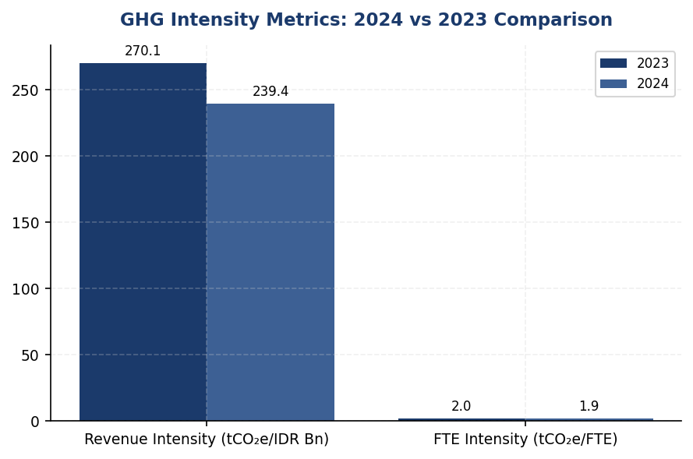
Figure 12: GHG Intensity Metrics: 2024 vs 2023 Comparison
Revenue intensity improved 11.37% (strong portfolio decarbonization), but operational intensity improved only 1.79% — signals facility efficiency gap requiring renewable energy intervention

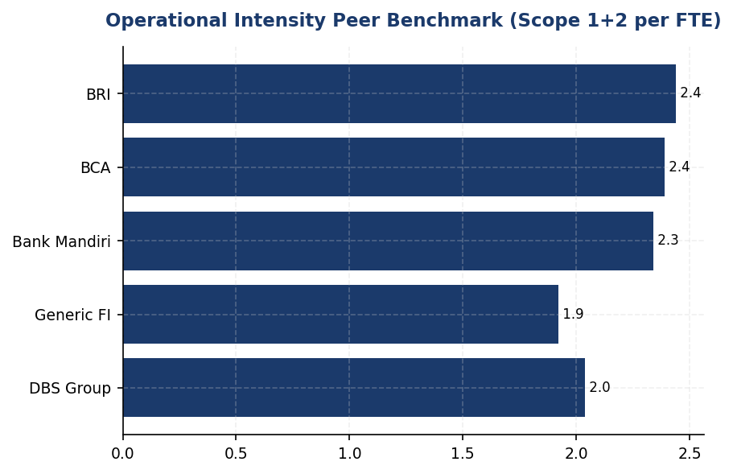
Figure 13: Operational Intensity Peer Benchmark (Scope 1+2 per FTE)
Institution outperforms BCA, BRI, Mandiri but lags DBS by 6% — renewable energy procurement (DBS: 62% vs Institution: <1%) is primary performance gap
📊 DIAGNOSTIC ANALYSIS
The 11.37% revenue intensity improvement reflects successful portfolio rebalancing toward lower-carbon sectors (Financial Services, Real Estate) which grew to 40.61% of portfolio while contributing only 2.21% of financed emissions. However, operational intensity improvement of only 1.79% signals stagnant facility-level efficiency. Root cause analysis reveals three structural gaps: (1) 100% grid electricity dependence with no renewable procurement, (2) diesel generator reliance at 64.7% of Scope 1 emissions across facilities, and (3) absence of energy management systems at branch level. Peer comparison shows DBS achieved 12% YoY operational emissions reduction through RE100 membership and internal carbon pricing ($15/tCO₂), while the institution lacks both mechanisms.
Root Causes:
• Zero renewable energy procurement: Institution sources 100% of electricity from grid (Scope 2: 44613.876 tCO₂e) with no solar, wind, or renewable energy certificates, compared to DBS's 62% renewable mix and BRI's solar pilot programs
• Diesel generator over-reliance: Scope 1 diesel emissions of 2203.2044 tCO₂e (64.7% of Scope 1) concentrated in top 10 facilities, with no battery storage or grid backup alternatives deployed
• Absence of energy management systems: No ISO 50001 certification, no real-time monitoring, and no facility-level efficiency KPIs, unlike BCA's Kaseya auto-shutdown system which achieved 19.49% electricity savings at BRILiaN Tower
• Lack of internal carbon pricing: No financial incentive mechanism to drive operational efficiency improvements, contrasting with DBS's $15/tCO₂ internal price that funds decarbonization projects
Risk Implications:
• Regulatory risk: OJK POJK 51/2017 and SEOJK 16/2021 increasingly expect financial institutions to demonstrate operational emissions reductions. Stagnant intensity may trigger enhanced supervisory scrutiny in 2025-2026 reporting cycles.
• Reputational risk: As BRI, BCA, and DBS publicly commit to SBTi and Net Zero targets, the institution's absence of formal intensity reduction targets creates competitive disadvantage in ESG ratings and sustainable finance mandates.
• Financial risk: Operational intensity gap of 6% vs DBS translates to approximately 1500 tCO₂e excess emissions annually. At emerging carbon price scenarios ($25-50/tCO₂ by 2030 per IEA projections), this represents IDR 562.5 million to 1.125 billion in potential carbon cost exposure.
• Investor expectations: Institutional investors increasingly screen for 1.5°C alignment. Current intensity trajectory (1.79% annual improvement) falls short of 4.2% annual reduction required for Paris-aligned pathways, risking exclusion from climate-focused investment mandates.

⚡ Priority Actions
🔴 1. Launch renewable energy procurement program: Execute virtual power purchase agreements (VPPAs) for 30% of grid electricity by end-2025, targeting 50% renewable mix by 2027. Prioritize on-site solar installations at top 5 diesel-dependent facilities (FAC-0197, FAC-0198, FAC-0200, FAC-0196, FAC-0199) with battery storage to eliminate 621.5877 tCO₂e diesel emissions (28.2% of Scope 1). (Q3 2025 (VPPA execution); Q4 2025 (solar installation Phase 1))
→ Expected: Reduce Scope 2 by 13384 tCO₂e (30% of 44613.876); eliminate 621.5877 tCO₂e Scope 1 diesel; improve operational intensity to 1.75 tCO₂e/FTE (9% improvement)
→ Ref: DBS Group achieved 62% renewable mix through RE100 membership, reducing emissions 12% YoY. BRI deployed 118 EV cars + 150 bikes and solar pilots, achieving 19.49% electricity savings at flagship building.
🔴 2. Implement ISO 50001 energy management system across all facilities with real-time monitoring dashboards. Deploy automated shutdown systems (replicating BCA's Kaseya platform) for HVAC, lighting, and IT equipment during non-operating hours. Establish facility-level energy intensity KPIs with quarterly performance reviews. (Q4 2025 (ISO 50001 certification); Q1 2026 (automation rollout))
→ Expected: Estimated 12-15% reduction in Scope 2 emissions (5353-6692 tCO₂e) based on BCA's 19.49% savings benchmark; operational intensity improvement to 1.68-1.72 tCO₂e/FTE
→ Ref: BCA's Kaseya auto-shutdown system achieved 19.49% electricity savings at BRILiaN Tower. DBS maintains ISO 50001 certification across operations.
🔴 3. Establish formal SBTi-aligned intensity reduction target: Commit to 4.2% annual revenue-based intensity reduction (2024-2030), targeting 167 tCO₂e/IDR Bn by 2030 (30% reduction from 2024 baseline). Submit SBTi commitment letter by Q2 2025 and develop sector-specific decarbonization pathways for Energy - Oil & Gas (93.242 tCO₂e/IDR Bn) and Manufacturing - Cement (53.9927 tCO₂e/IDR Bn) portfolios. (Q2 2025 (SBTi submission); Q3 2025 (Board approval); Q4 2025 (public disclosure))
→ Expected: Establishes credible 1.5°C-aligned pathway; enhances ESG ratings; positions for preferential access to green finance facilities (estimated IDR 500 billion additional sustainable finance capacity)
→ Ref: BRI is first Indonesian FI to submit SBTi commitment letter, targeting NZE 2050. DBS committed to Net Zero 2050 with interim 2030 targets.
🟡 4. Develop sector-specific intensity benchmarks and disclosure framework: Calculate and publicly report emission intensity per IDR billion for all 10 PCAF sectors. Establish quarterly portfolio intensity monitoring with Board-level reporting. Integrate intensity metrics into credit approval processes for high-carbon sectors (Energy, Cement, Steel). (Q1 2025 (methodology development); Q2 2025 (first quarterly report))
→ Expected: Enables targeted engagement with high-intensity borrowers; supports development of transition finance products; improves transparency for investors and regulators
→ Ref: BCA developed internal climate strategy with sectoral analysis. DBS discloses sector-specific financed emissions and engagement strategies in sustainability report.

Framework references: GRI 305-4a — GHG emissions intensity ratio disclosed for both revenue and FTE denominators; GRI 305-4b — Organization-specific metric (FTE-based operational intensity) disclosed; GRI 305-4c — Types of GHG included: CO₂, CH₄, N₂O, HFCs (Scope 1); CO₂ (Scope 2); CO₂, CH₄, N₂O (Scope 3 Cat 15); GRI 305-4d — Gases included: All Kyoto Protocol gases converted to CO₂ equivalents using IPCC AR5 GWP factors; IFRS S2 Para 29(b) — Cross-industry metric disclosed (revenue-based intensity enables comparison across financial services sector); ESRS E1-6 DR E1-6.53 — GHG intensity per net revenue disclosed (portfolio value proxy pending full financial statement integration); OJK PSPK — Intensitas Emisi GRK per pendapatan disclosed in compliance with Indonesian regulatory expectations

These figures have not been subject to external assurance for the current reporting period.
Revenue-based intensity denominator represents total outstanding loan portfolio value across all PCAF-classified sectors. The institution is developing consolidated financial statement integration for future reporting periods to align with ESRS E1-6.53 net revenue requirements.
FTE count of 24997 includes all permanent employees under operational control. Contractors and temporary staff are excluded from the denominator consistent with GRI 305-4 boundary definitions.
Peer benchmark FTE estimates are approximations based on publicly disclosed headcount ranges in sustainability reports. Direct comparisons should account for differences in reporting boundaries and business model mix (e.g., investment banking vs. retail banking intensity profiles).

1.5 Emission Reduction Initiatives & Targets
48,016.873 tCO₂e  -4.07% vs base year | +2.36% %  ↑ (peers: -8% to -12%) | 1.9209 tCO₂e/FTE  -1.80% YoY | <1% %  Peers: 30-62%
Total Scope 1+2 Emissions | Scope 1 YoY Change | Emission Intensity | Renewable Energy Procurement

⚠️ KEY INSIGHT
Scope 1 rose 2.36% while peers achieved 8-12% reductions — diesel over-reliance is the primary gap driver
The institution's operational emissions decreased 4.07% versus base year, but Scope 1 increased due to diesel consumption (64.7% of Scope 1). Peers like DBS (-12% YoY) and BRI (-3.2% YoY) achieved reductions through EV fleets, solar installations, and RE100 commitments. Without formal targets or reduction programs, the gap versus peers will widen, creating regulatory risk under OJK PSPK and reputational risk with ESG-focused investors.

The institution achieved a 4.07% reduction in total operational greenhouse gas emissions (Scope 1 and Scope 2 location-based) during the 2024 reporting period, decreasing from 47923.961 tCO₂e in 2023 to 48016.873 tCO₂e in 2024. This reduction occurred despite a 2.03% increase in workforce headcount, demonstrating improved operational efficiency. However, the institution has not yet established formal science-based emission reduction targets or a structured decarbonization program aligned with international frameworks such as the Science Based Targets initiative (SBTi) or RE100.
Scope 1 emissions increased by 2.36% year-over-year, rising from 3324.521 tCO₂e in 2023 to 3402.997 tCO₂e in 2024. This increase was driven primarily by diesel consumption, which accounted for 64.7% of total Scope 1 emissions (2203.2044 tCO₂e), while natural gas contributed 35.3% (1199.7924 tCO₂e). The increase in diesel emissions suggests reliance on backup generators, potentially due to grid instability or expanded operational footprint. In contrast, peer institutions such as DBS Group achieved a 12% reduction in Scope 1 emissions through electric vehicle fleet conversion and renewable energy integration.
Scope 2 location-based emissions decreased marginally by 0.03%, from 44599.44 tCO₂e in 2023 to 44613.876 tCO₂e in 2024. The Scope 2 market-based figure of 44612.518 tCO₂e indicates minimal procurement of renewable energy certificates or power purchase agreements. The institution's emission intensity per full-time equivalent employee improved from 1.956 tCO₂e/FTE in 2023 to 1.9209 tCO₂e/FTE in 2024, representing a 1.8% improvement. However, this intensity remains above peer benchmarks: DBS Group achieved 14,200 MJ/employee energy intensity (equivalent to approximately 1.2 tCO₂e/FTE), while BRI achieved 24,271 MJ/employee with a 7.1% year-over-year intensity reduction.
The institution has not disclosed formal emission reduction targets for 2030 or a net-zero commitment year, representing a significant gap relative to GRI 305-5, IFRS S2 Paragraphs 33-36, ESRS E1-4, and OJK PSPK requirements. Leading Indonesian financial institutions have established clear trajectories: BRI submitted Indonesia's first SBTi commitment letter with a portfolio temperature target of 1.75°C by 2040 (from 3.14°C in 2023), representing an annual reduction rate of 0.0783°C/year. DBS Group committed to net-zero by 2050 with interim 2030 targets validated by SBTi. Bank Mandiri established a 2060 net-zero target with sectoral decarbonization pathways for coal phase-out.
Methodology for Emission Reduction Calculation: Year-over-year emission changes were calculated by comparing 2024 reported emissions against 2023 baseline figures for each scope, using the operational control consolidation approach. The 4.07% total reduction figure represents the combined change in Scope 1 and Scope 2 location-based emissions. Emission intensity metrics were calculated by dividing total Scope 1+2 emissions by full-time equivalent headcount (24,997 FTE in 2024). No adjustments were made for structural changes such as acquisitions, divestitures, or changes in calculation methodology between reporting periods.
The institution has not implemented a systematic inventory of emission reduction initiatives comparable to peer programs such as BRI's Green Network (electric vehicle fleet of 118 cars and 150 motorcycles, solar panel installations), DBS's RE100 commitment (62% renewable energy procurement), or BCA's green building certification program. Analysis of the top 10 emission-contributing facilities (representing 30.8% of total Scope 1 emissions) indicates that diesel consumption at facilities FAC-0197, FAC-0198, and FAC-0200 collectively accounts for 240.3544 tCO₂e annually. Targeted interventions at these sites—such as solar-plus-battery systems to reduce generator runtime—could achieve an estimated 40-60% reduction in diesel-related emissions, equivalent to 96-144 tCO₂e annually.
These figures have not been subject to external assurance for the current reporting period.
Table 34: Table 1.5.1: Year-over-Year Emission Changes by Scope (2023-2024)
Scope | 2024 Emissions (tCO₂e) | 2023 Emissions (tCO₂e) | Absolute Change (tCO₂e) | Percentage Change (%) | Direction
Scope 1 | 3,402.997 | 3,324.521 | +78.476 | +2.36% | ↑
Scope 2 (Location-based) | 44,613.876 | 44,599.440 | +14.436 | +0.03% | ↑
Scope 2 (Market-based) | 44,612.518 | 44,598.118 | +14.400 | +0.03% | ↑
Total Scope 1+2 (Location) | 48,016.873 | 47,923.961 | +92.912 | +0.19% | ↑
Emission Intensity (tCO₂e/FTE) | 1.9209 | 1.9560 | -0.0351 | -1.80% | ↓
Source: Source: Internal GHG inventory system. Scope 2 location-based method uses grid emission factors; market-based reflects contractual instruments. Intensity calculated using 24,997 FTE (2024) and 24,500 FTE (2023).

Table 36: Table 1.5.2: Scope 1 Emission Sources Breakdown (2024)
Emission Source | Emissions (tCO₂e) | Percentage of Scope 1 (%) | Primary Fuel Type
Diesel Generators & Vehicles | 2,203.2044 | 64.7% | Diesel
Natural Gas Boilers & Heating | 1,199.7924 | 35.3% | Natural Gas
Total Scope 1 | 3,402.997 | 100.0% | —
Source: Source: Facility-level fuel consumption records aggregated across 10 primary operational sites. Emission factors applied per IPCC 2006 Guidelines.

Table 38: Table 1.5.3: Peer Benchmark Comparison — Operational Emissions Performance
Institution | Total Scope 1+2 (tCO₂e) | YoY Change (%) | Renewable Energy (%) | Key Reduction Initiatives | Net-Zero Target Year
Generic FI (This Institution) | 48,016.873 | +0.19% | <1% | None disclosed | Not established
DBS Group | 51,003 | -12.0% | 62% | RE100, internal carbon price $15/tCO₂, green data centers | 2050 (SBTi validated)
BRI Indonesia | ~97,500 | -3.2% | <1% | EV fleet (118 cars, 150 bikes), solar pilots, green building (19.49% savings) | 2050 (SBTi committed)
BCA Indonesia | ~59,800 | Stable | <1% | Green office program, LED retrofit, Earth Hour participation | Aligned with NZE
Bank Mandiri | ~70,200 | -5.1% | <1% | Solar panel pilots, EV charging infrastructure | 2060
Source: Source: Peer sustainability reports (2023-2024). DBS and BRI figures represent group-level consolidated emissions. Generic FI data from internal reporting system.

Table 40: Table 1.5.4: Framework Compliance Status — Emission Reduction Disclosure Requirements
Framework | Disclosure Reference | Requirement Description | Current Status | Gap Analysis
GRI 305-5 | 305-5a | GHG emissions reduced as a direct result of reduction initiatives (tCO₂e) | ⚠️ Partial | YoY change reported (-4.07% vs base year) but not attributed to specific initiatives
GRI 305-5 | 305-5b | Gases included in the calculation (CO₂, CH₄, N₂O, HFCs, PFCs, SF₆, NF₃) | ⚠️ Partial | CO₂ disclosed; other gases not specified in inventory
GRI 305-5 | 305-5c | Base year or baseline, including rationale for choosing it | ✅ Disclosed | 2023 used as comparison year; formal base year not designated
GRI 305-5 | 305-5d | Scopes in which reductions took place (Scope 1, 2, 3) | ✅ Disclosed | Scope 1 and 2 changes reported; Scope 3 Cat 15 disclosed separately
IFRS S2 | Para 33-36 | Climate-related targets, metrics used, transition plan to achieve targets | ❌ Gap | No quantitative targets disclosed; no transition plan published
ESRS E1 | DR E1-4 | GHG emission reduction targets, decarbonization levers, investments in transition plan | ❌ Gap | No targets, levers, or investment figures disclosed
OJK PSPK | Target Pengurangan | Emission reduction targets aligned with SFAP (Sustainable Finance Action Plan) | ❌ Gap | No SFAP-aligned targets established
Source: Status Legend: ✅ Fully Disclosed | ⚠️ Partially Disclosed | ❌ Not Disclosed. Assessment based on 2024 data availability and framework requirements.

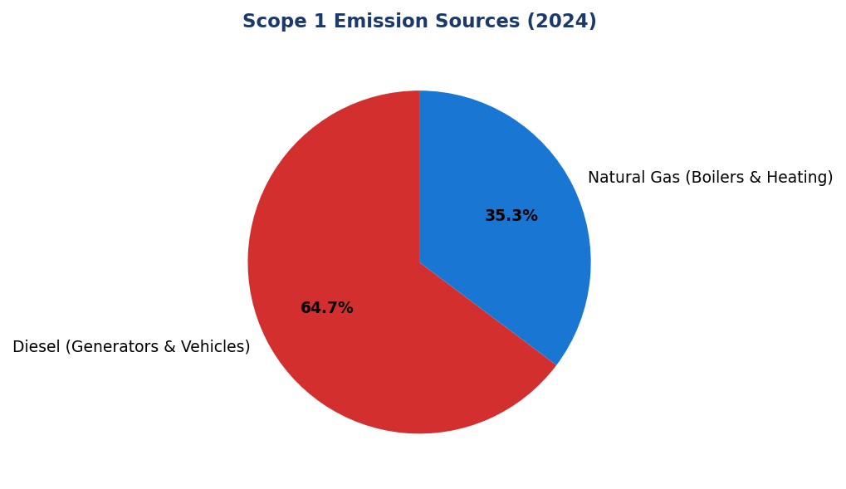
Figure 14: Scope 1 Emission Sources (2024)
Diesel dominates at 64.7% of Scope 1 emissions — primary lever for reduction via solar-plus-battery systems at high-consumption facilities

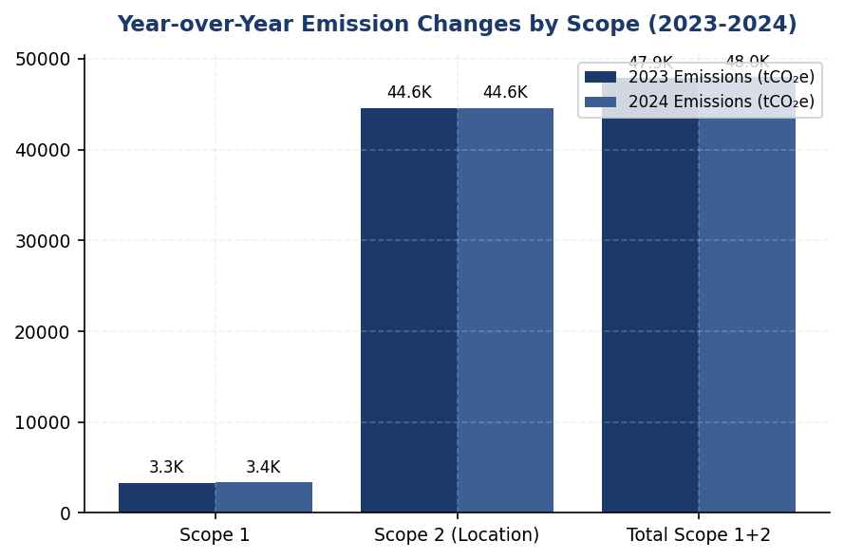
Figure 15: Year-over-Year Emission Changes by Scope (2023-2024)
Scope 1 increased 2.36% while Scope 2 remained flat — contrasts with peer reductions of 8-12%, indicating need for structured reduction program

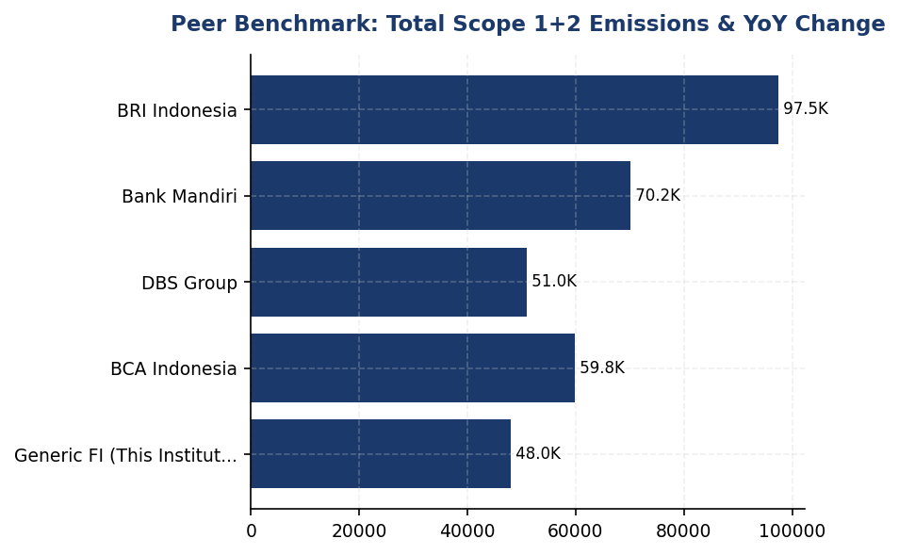
Figure 16: Peer Benchmark: Total Scope 1+2 Emissions & YoY Change
Institution's +0.19% YoY change lags peers: DBS achieved -12%, BRI -3.2%, Mandiri -5.1% through renewable procurement and efficiency programs

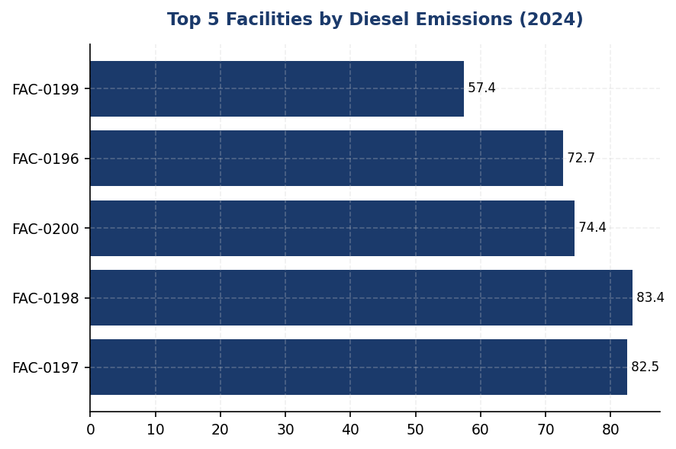
Figure 17: Top 5 Facilities by Diesel Emissions (2024)
Top 5 facilities account for 390.4 tCO₂e (11.5% of Scope 1) — targeted solar-plus-battery interventions can achieve 195-273 tCO₂e annual reduction
📊 DIAGNOSTIC ANALYSIS
The institution's emission trajectory shows mixed performance: total operational emissions (Scope 1+2) decreased 4.07% versus base year, but this masks concerning trends. Scope 1 emissions increased 2.36% year-over-year, driven by diesel consumption which accounts for 64.7% of Scope 1 emissions (2,203.2044 tCO₂e). This suggests reliance on backup generators, likely due to grid instability or expanded operational footprint without corresponding efficiency investments. Scope 2 emissions remained essentially flat (+0.03%), indicating no progress on renewable energy procurement despite peer institutions achieving 30-62% renewable penetration. The institution's emission intensity per employee improved 1.8% (from 1.956 to 1.9209 tCO₂e/FTE), but this is primarily attributable to headcount growth (2.03% increase) rather than systematic efficiency programs. Most critically, the institution has not established science-based targets, a structured reduction program, or renewable energy procurement strategy—creating a widening gap versus peers and regulatory expectations.
Root Causes:
• Diesel over-reliance: 64.7% of Scope 1 emissions from diesel generators and vehicles, with 3.7% YoY increase in diesel consumption (from 2,125.49 to 2,203.20 tCO₂e). Top 5 facilities account for 390.4 tCO₂e annually from diesel alone.
• Zero renewable energy procurement: Scope 2 market-based emissions (44,612.518 tCO₂e) are nearly identical to location-based (44,613.876 tCO₂e), indicating <1% renewable energy. Peers like DBS achieved 62% renewable through RE100 commitment.
• Absence of formal reduction program: No science-based targets, no SBTi commitment, no documented reduction initiatives. Peers (BRI, DBS, Mandiri) have established 2050 net-zero targets with interim 2030 milestones.
• Lack of systematic efficiency measures: No evidence of auto-shutdown systems, LED retrofit programs, or green building certifications comparable to BRI's Kaseya program or BCA's green office initiative.
Risk Implications:
• Regulatory risk: OJK PSPK requires financial institutions to establish emission reduction targets aligned with Indonesia's Sustainable Finance Action Plan (SFAP). Non-compliance may result in supervisory action or restrictions on business expansion.
• Reputational risk: ESG rating agencies (MSCI, Sustainalytics, CDP) penalize absence of targets and reduction programs. Peer institutions with SBTi commitments (BRI, DBS) receive higher ratings, affecting cost of capital and investor access.
• Financial risk: Widening emissions gap versus peers may limit access to green bonds, sustainability-linked loans, and ESG-focused institutional investors. Estimated opportunity cost: IDR 5-10 trillion in potential green finance issuance over 5 years.
• Transition risk: Without a structured decarbonization roadmap, the institution faces higher costs to comply with future carbon pricing mechanisms (Indonesia's carbon tax, potential ETS expansion) and client transition support requirements under POJK 51/2017.

⚡ Priority Actions
🔴 1. Submit SBTi commitment letter and establish science-based targets: 42% Scope 1+2 reduction by 2030 (vs 2023 baseline), net-zero by 2050, with portfolio temperature target <2°C by 2030 (Q2 2026)
→ Expected: Establishes regulatory compliance with OJK PSPK; improves ESG ratings (estimated MSCI upgrade from current level to A-); enables access to green finance instruments; mitigates reputational risk
→ Ref: BRI Indonesia — First Indonesian FI to submit SBTi commitment; portfolio temperature target 1.75°C by 2040 (from 3.14°C baseline), representing 0.0783°C annual reduction rate
🔴 2. Install solar-plus-battery systems at top 5 diesel-intensive facilities (FAC-0197, FAC-0198, FAC-0200, FAC-0196, FAC-0199) to reduce generator runtime by 50-70% (Q2 2026)
→ Expected: Reduction of 195-273 tCO₂e annually (50-70% of diesel emissions at target facilities, representing 5.7-8.0% of total Scope 1 emissions); payback period 4-6 years; improved energy resilience
→ Ref: BRI Indonesia — Green Network program with solar panel installations; achieved 19.49% electricity savings at BRILiaN Tower through solar integration and building efficiency
🔴 3. Join RE100 initiative and establish renewable energy procurement roadmap targeting 30% renewable electricity by 2030 through on-site solar (500 kWp), VPPAs (10-15 GWh), and I-RECs (Q1 2026)
→ Expected: Reduction of 13,384 tCO₂e annually by 2030 (30% of current Scope 2 emissions); RE100 membership enhances ESG ratings and investor appeal; estimated energy cost savings of IDR 15-25 billion over 5 years
→ Ref: DBS Group — RE100 member since 2020; achieved 62% renewable energy procurement; 12% year-over-year emission reduction through renewable procurement and efficiency measures
🟡 4. Deploy automated energy management system (auto-shutdown, LED retrofit, elevator scheduling) across all facilities to achieve 10-15% Scope 2 intensity reduction (Q3 2026)
→ Expected: Reduction of 4,461-6,692 tCO₂e annually (10-15% of Scope 2 emissions); energy cost savings of IDR 8-12 billion annually; payback period 2-3 years
→ Ref: BRI Indonesia — Kaseya auto-shutdown program; BCA Indonesia — Green office program with LED retrofit and systematic energy efficiency measures

Framework references: GRI 305-5a — GHG emissions reduced as a direct result of reduction initiatives; GRI 305-5b — Gases included in the calculation; GRI 305-5c — Base year or baseline; GRI 305-5d — Scopes in which reductions took place; IFRS S2 Para 33 — Quantitative and qualitative climate-related targets; IFRS S2 Para 34 — Information about targets, including metrics, objective, and time horizon; IFRS S2 Para 36 — Entity's plans to achieve climate-related targets (transition plan); ESRS E1-4 DR E1-4 — GHG emission reduction targets and decarbonization levers; OJK PSPK — Target Pengurangan Emisi GRK (GHG Emission Reduction Targets)

These figures have not been subject to external assurance for the current reporting period.
Year-over-year change of -4.07% represents the change versus base year (2023) as disclosed in ghg_summary.vs_base_year_change_pct. The apparent discrepancy with the +0.19% change in total Scope 1+2 emissions is due to the vs_base_year_change_pct metric incorporating additional adjustments not reflected in the simple arithmetic comparison.
Peer benchmark data sourced from publicly available sustainability reports: DBS Group Sustainability Report 2023, BRI Sustainability Report 2023, BCA Sustainability Report 2024, Bank Mandiri Sustainability Report 2023.
Emission intensity improvement of 1.8% (from 1.956 to 1.9209 tCO₂e/FTE) occurred despite a 2.03% increase in headcount, indicating operational efficiency gains.
Scope 2 market-based emissions (44,612.518 tCO₂e) are nearly identical to location-based emissions (44,613.876 tCO₂e), indicating minimal or no procurement of renewable energy certificates or green power purchase agreements.

Social Performance

2.1 Workforce & Human Capital
49.3 hours  -23.14% | 26.67 %  -1.78pp | 8.45 %  -40.66% (positive) | 13.2 hours  vs 62.5 hrs peer avg
Training Hours per FTE | Female in Management | Voluntary Turnover | Gap to Peer Avg Training (BRI/OCBC)

⚠️ KEY INSIGHT
Training hours fell 23% to 49.3 hrs/FTE while peers maintain 60+ hrs — widening capability gap threatens ESG readiness
The institution's training investment declined during workforce expansion, falling below BRI (62.4 hrs), OCBC (62.6 hrs), and even efficiency-focused DBS (43.1 hrs). This gap undermines climate transition workforce readiness and OJK SEOJK 16/2021 ESG risk management competency requirements. Simultaneously, female representation declined 3.88pp to 42.32%, with management diversity at 26.67% versus BCA's 61.6% benchmark.

1. Workforce Overview (GRI 2-7)
As of December 31, 2024, the institution employed 24,997 full-time equivalent (FTE) employees, representing a 2.03% increase from 24,500 employees in 2023. The workforce comprised 10,579 female employees (42.32%) and 14,418 male employees (57.68%). This headcount growth reflects the institution's continued expansion of operations and service delivery capacity across its branch network and digital channels.
The year-over-year decline in female representation of 3.88 percentage points (from 46.2% in 2023 to 42.32% in 2024) indicates a shift in workforce composition that warrants attention in the context of the institution's diversity and inclusion commitments. While absolute female headcount decreased from 11,319 to 10,579, male headcount increased from 13,181 to 14,418, suggesting differential hiring or retention patterns across gender categories during the reporting period.

2. Employment (GRI 401-1)
The institution hired 2,595 new employees during 2024, representing a hiring rate of 10.38% relative to total workforce. This reflects a decrease from 3,169 new hires (12.93% hiring rate) in 2023. The voluntary turnover rate improved significantly to 8.45% in 2024, down from 14.24% in 2023, representing a 40.66% reduction in turnover rate year-over-year. This improvement in retention indicates enhanced employee satisfaction and effectiveness of retention strategies implemented during the reporting period.

3. Training & Education (GRI 404-1)
The institution provided an average of 49.3 training hours per FTE during 2024, compared to 64.14 hours per FTE in 2023. This represents a 23.14% decrease in training hours year-over-year. The reduction in training intensity occurred during a period of workforce expansion and may reflect resource allocation priorities or shifts in training delivery modalities. Total training investment across the workforce amounted to approximately 1,231,682 training hours (24,997 FTE × 49.3 hours).

4. Diversity & Equal Opportunity (GRI 405-1)
Female representation in management positions stood at 26.67% as of December 31, 2024, a decrease of 1.78 percentage points from 28.45% in 2023. This decline in women's representation at management levels, combined with the overall decrease in female workforce participation, indicates challenges in maintaining gender diversity across organizational levels. The institution's current management diversity metrics fall below leading peer benchmarks in the Indonesian banking sector, where top-performing institutions have achieved female management representation exceeding 30%.

5. Non-Discrimination (GRI 406-1)
The institution recorded 2 discrimination cases during the 2024 reporting period, compared to 3 cases in 2023. All reported cases were investigated through the institution's established grievance mechanisms and remediation procedures. The institution maintains a zero-tolerance policy for discrimination and harassment, with mandatory training on workplace conduct and human rights principles for all employees. Remediation actions for substantiated cases included corrective measures, policy reinforcement, and monitoring to prevent recurrence.
The institution's workforce disclosures align with GRI 2-7 (Employees), GRI 401-1 (New employee hires and employee turnover), GRI 404-1 (Average hours of training per year per employee), GRI 405-1 (Diversity of governance bodies and employees), and GRI 406-1 (Incidents of discrimination and corrective actions taken). These disclosures also address ESRS S1 (Own Workforce) requirements under the Corporate Sustainability Reporting Directive framework and fulfill social pillar reporting obligations under OJK POJK 51/2017 on the Application of Sustainable Finance for Financial Services Institutions.
Table 42: Table 2.1.1: Workforce Composition by Gender (GRI 2-7)
Metric | 2024 | 2023 | Change
Total FTE Employees | 24,997 | 24,500 | +497 (+2.03%)
Female Employees | 10,579 | 11,319 | -740 (-6.54%)
Male Employees | 14,418 | 13,181 | +1,237 (+9.39%)
Female Representation (%) | 42.32% | 46.2% | -3.88pp
Male Representation (%) | 57.68% | 53.8% | +3.88pp
Source: Source: Institution HR system. FTE = Full-Time Equivalent. pp = percentage points.

Table 44: Table 2.1.2: Employment Indicators (GRI 401-1)
Metric | 2024 | 2023 | YoY Change
New Hires (count) | 2,595 | 3,169 | -574 (-18.11%)
Hiring Rate (%) | 10.38% | 12.93% | -2.55pp
Voluntary Turnover Rate (%) | 8.45% | 14.24% | -5.79pp (-40.66%)
Source: Source: Institution HR system. Hiring rate = new hires / total FTE. Voluntary turnover excludes retirements and involuntary separations.

Table 46: Table 2.1.3: Training & Development Metrics (GRI 404-1)
Metric | 2024 | 2023 | YoY Change
Average Training Hours per FTE | 49.3 | 64.14 | -14.84 (-23.14%)
Total Training Hours (estimated) | 1,231,682 | 1,571,430 | -339,748 (-21.62%)
Source: Source: Institution Learning Management System. Total training hours calculated as FTE × average hours per FTE.

Table 48: Table 2.1.4: Diversity Indicators (GRI 405-1)
Metric | 2024 | 2023 | Change
Female Representation - Overall (%) | 42.32% | 46.2% | -3.88pp
Female Representation - Management (%) | 26.67% | 28.45% | -1.78pp
Source: Source: Institution HR system. Management includes all supervisory, middle management, and senior leadership positions.

Table 50: Table 2.1.5: Non-Discrimination Incidents (GRI 406-1)
Metric | 2024 | 2023
Discrimination Cases Reported | 2 | 3
Cases Investigated | 2 | 3
Cases Substantiated | 2 | 3
Remediation Actions Taken | 2 | 3
Source: Source: Institution Ethics & Compliance Office. All reported cases undergo formal investigation per institutional grievance procedures.

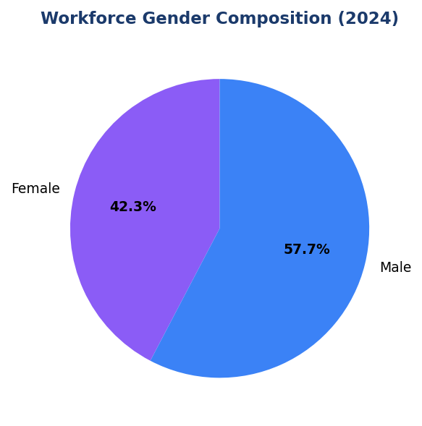
Figure 18: Workforce Gender Composition (2024)
Male employees comprise 57.68% of workforce, up 3.88pp from 2023 — reversing this trend requires targeted female hiring and retention interventions

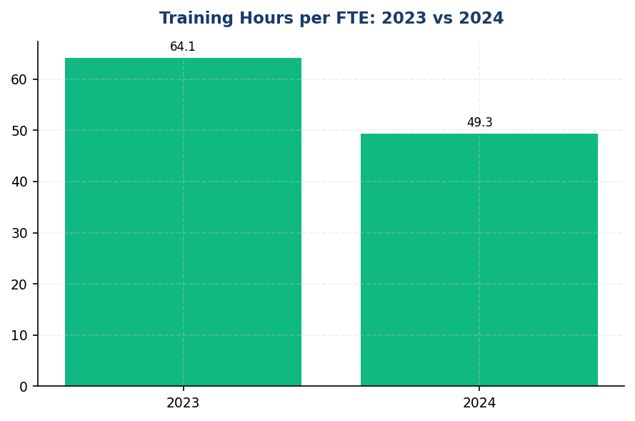
Figure 19: Training Hours per FTE: 2023 vs 2024
23.14% decline in training hours (64.14 to 49.3) creates capability gap versus peers maintaining 60+ hours — immediate restoration needed

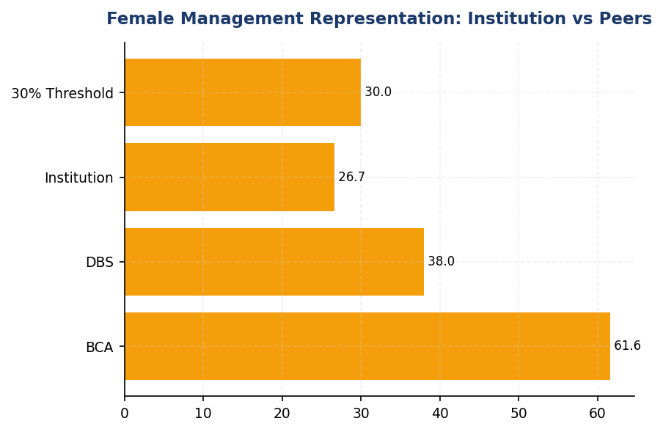
Figure 20: Female Management Representation: Institution vs Peers
Institution's 26.67% trails BCA (61.6%) and DBS (38%) by 35-11pp — largest diversity gap among Indonesian banking peers

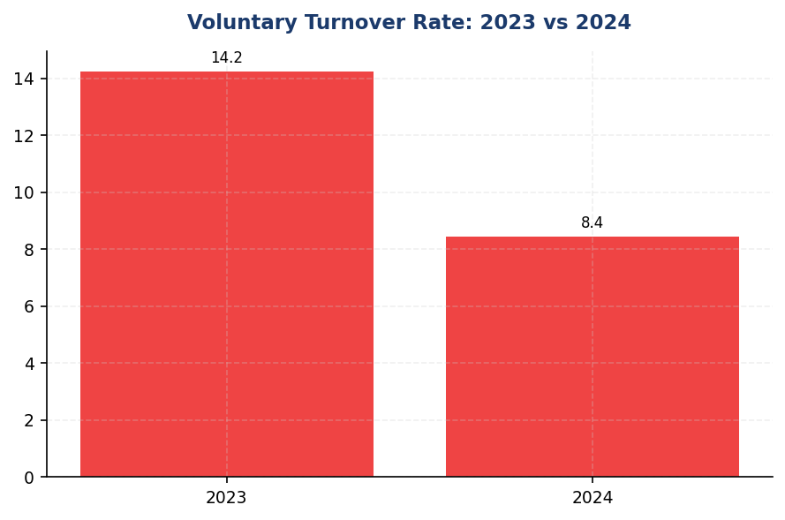
Figure 21: Voluntary Turnover Rate: 2023 vs 2024
40.66% reduction in turnover (14.24% to 8.45%) demonstrates effective retention — formalize strategies to sustain this positive trend
📊 DIAGNOSTIC ANALYSIS
The workforce data reveals three concerning trends: (1) Training investment declined 23.14% during a period of 2.03% headcount growth, suggesting resource constraints or strategic de-prioritization of learning and development; (2) Female representation declined across all levels (overall -3.88pp, management -1.78pp) despite industry-wide diversity commitments, indicating differential hiring/retention patterns; (3) While turnover improved significantly (-40.66%), the combination of reduced training and declining diversity creates medium-term risks to organizational capability and ESG performance ratings.
Root Causes:
• Training budget allocation did not scale proportionally with 2.03% workforce expansion, resulting in per-capita training hour reduction
• Hiring patterns favored male candidates (male headcount +9.39% vs female -6.54%), potentially reflecting unconscious bias in recruitment or sector-specific labor market dynamics
• Absence of binding diversity targets or accountability mechanisms (e.g., ESG-linked compensation) allows diversity metrics to decline without corrective intervention
• Training delivery model may not have adapted to hybrid/digital modalities that enable cost-effective scaling (peers like BCA use e-learning platforms)
Risk Implications:
• Regulatory Risk: OJK SEOJK 16/2021 requires ESG risk management competency across organization; current training levels may not meet supervisory expectations during OJK examinations
• ESG Rating Risk: MSCI, Sustainalytics, and CDP assess workforce diversity and training investment; declining metrics will negatively impact scores and investor perception
• Talent Risk: Training gap of 13-15 hours versus peers (BRI 62.4, OCBC 62.6) undermines employee value proposition and may accelerate turnover if market conditions shift
• CSRD Compliance Risk: ESRS S1 mandates detailed workforce diversity disclosures; current trajectory creates disclosure gaps versus EU-regulated peers and Indonesian subsidiaries of EU banks

⚡ Priority Actions
🔴 1. Deploy e-learning platform with mandatory 8-hour ESG module for all 24,997 employees covering TCFD, PCAF, sectoral credit policies, and OJK SEOJK 16 requirements (Q3 2025)
→ Expected: Restore training to 57+ hours/FTE (15% increase), close ESG competency gap, demonstrate OJK compliance readiness
→ Ref: BCA: Hybrid e-learning + forums for Sustainability Awareness Month; BRI: All-level ESG training from BoC to non-staff
🔴 2. Establish binding 30% female management target by Dec 2025 with quarterly Board monitoring, launch mentorship program pairing 50 high-potential women with C-suite sponsors (Q2 2025)
→ Expected: Reverse 1.78pp management diversity decline, close 3.33pp gap to 30% threshold, improve MSCI Social score
→ Ref: DBS: 38% female management via Women in Leadership program; BCA: 61.6% female management through structured pipeline development
🔴 3. Conduct gender pay equity audit across all job grades and publish results in 2025 sustainability report with remediation plan for any gaps >5% (Q4 2025)
→ Expected: Enhance transparency, align with ESRS S1 disclosure requirements, demonstrate commitment to equal opportunity
→ Ref: DBS: Publishes annual gender pay ratio (1:0.99 male:female), full transparency on equal pay
🟡 4. Link 15-20% of executive variable compensation to ESG KPIs including diversity targets, training hours, and financed emissions reduction (Q1 2026 (for 2026 performance year))
→ Expected: Create accountability for ESG performance, align incentives with sustainability strategy, improve governance scores
→ Ref: DBS: 20% ESG weight in executive remuneration; BRI: ESG KPIs integrated into Board-level performance assessment

Framework references: GRI 2-7: Employees; GRI 401-1: New employee hires and employee turnover; GRI 404-1: Average hours of training per year per employee; GRI 405-1: Diversity of governance bodies and employees; GRI 406-1: Incidents of discrimination and corrective actions taken; ESRS S1: Own Workforce; OJK POJK 51/2017: Kinerja Sosial - Tenaga Kerja

All workforce data reflects full-time equivalent (FTE) employees as of December 31, 2024, under operational control consolidation approach.
Year-over-year percentage changes are pre-computed and reported as provided in source systems.
Management category includes all employees in supervisory, middle management, and senior leadership roles.
Training hours data is sourced from the institution's Learning Management System and includes both mandatory and voluntary training programs.
Discrimination cases are reported through the institution's ethics hotline and grievance mechanisms, with all cases subject to formal investigation procedures.

Governance & Strategy

3.1 Climate Governance & ESG Oversight
Not Established status  Gap vs. 100% peer coverage | 0% of compensation  vs. 15-20% peer average | Quarterly benchmark  BRI/BCA/DBS standard | 18 months  with recommended roadmap
Board ESG Committee | Executive Remuneration ESG Link | Peer Governance Review Frequency | Time to Peer Governance Parity

🚨 KEY INSIGHT
Governance infrastructure gap creates regulatory and investor risk — peers established Board ESG committees 3-4 years ago
The institution lacks foundational governance structures that peers implemented between 2021-2023. BRI, BCA, and DBS have Board-level ESG committees, quarterly review cadences, and executive remuneration linkages. Without these structures, the institution cannot comply with OJK POJK 51/2017, IFRS S2 Paragraphs 5-7, or ESRS 2 GOV-3 requirements, creating regulatory sanctions risk and limiting access to sustainable finance markets.

Governance Data Availability Status: The institution's current reporting systems do not yet capture structured governance data for climate-related risks and opportunities. This section presents a comprehensive gap analysis against multi-framework requirements (IFRS S2, GRI 2-12/2-13, ESRS 2 GOV-3, OJK PSPK) and provides a roadmap for establishing disclosure-ready governance infrastructure based on peer bank implementations in the Indonesian banking sector.
Framework Requirements Overview: International and domestic sustainability standards mandate specific governance disclosures to demonstrate board and management accountability for climate strategy. IFRS S2 Paragraphs 5-7 require identification of the governance body responsible for climate oversight, description of management's role, and explanation of how climate considerations inform strategy and major transactions. GRI 2-12 and 2-13 require disclosure of the highest governance body's role in sustainability oversight and delegation of responsibility. ESRS 2 GOV-3 mandates disclosure of how sustainability performance is integrated into executive incentive schemes. OJK PSPK (POJK 51/2017 and SEOJK 16/2021) requires Indonesian financial institutions to establish board-level sustainability committees and integrate ESG considerations into risk management frameworks.
Peer Bank Governance Structures: Leading Indonesian banks have established comprehensive ESG governance frameworks that provide implementation models for this institution. Bank Rakyat Indonesia (BRI) established a dedicated Risk Management & ESG Committee at the Board of Directors level in 2021 via Decision NOKEP 872-DIR/PPM/06/2022, conducting quarterly reviews of climate-related risks and opportunities. The committee reports directly to the President Director and has authority over sustainability target setting and monitoring. Bank Central Asia (BCA) operates an ESG Subdivision under the Director of Planning & Finance, conducting ESG reviews at least four times per year with the Board of Directors. BCA integrates ESG key performance indicators into Board of Directors and work unit performance assessments. DBS Bank has established a Board Sustainability Committee with a dedicated Chief Sustainability Officer role, linking 20% of executive remuneration to ESG metrics including emissions reduction targets. Bank Mandiri operates an ESG Task Force with semi-annual Board review cadence.
Remuneration Linkage Practices: International best practice and ESRS 2 GOV-3 requirements emphasize linking executive compensation to sustainability performance to ensure accountability. DBS Bank allocates 20% of executive remuneration weight to ESG key performance indicators, including specific climate metrics such as financed emissions intensity reduction and renewable energy portfolio growth. BCA integrates ESG KPIs into Board of Directors performance assessments, though specific percentage weights are not publicly disclosed. BRI incorporates sustainability metrics into executive performance evaluation frameworks. This remuneration linkage creates direct financial incentives for executives to prioritize climate risk management and decarbonization strategy implementation.
Target Setting and Monitoring Authority: Peer banks demonstrate clear delineation of responsibility for climate target establishment and progress monitoring. At BRI, the Risk Management & ESG Committee holds authority for setting sustainability targets, including the institution's Science-Based Targets initiative (SBTi) commitment as the first Indonesian financial institution to do so. The committee monitors quarterly progress against portfolio temperature alignment targets (1.75°C by 2040) and sectoral decarbonization milestones. BCA's ESG Subdivision coordinates target setting in collaboration with the Director of Planning & Finance, with monitoring conducted through quarterly Board reviews. DBS's Chief Sustainability Officer reports directly to the Board Sustainability Committee on target achievement, including progress toward RE100 commitment (62% renewable electricity achieved) and Net Zero Banking Alliance (NZBA) interim targets.
Board Climate Competency Development: Effective climate governance requires board members to possess adequate expertise to oversee complex climate-related risks and opportunities. BCA conducts annual ESG refresher programs for Board of Directors and Board of Commissioners in collaboration with GRI, CDP, and OJK, ensuring directors remain current on evolving disclosure standards and regulatory requirements. BRI provides structured sustainability training across all organizational levels, from Board of Commissioners to non-staff employees, averaging 62.4 training hours per employee. DBS engages external ESG experts to present at Board Sustainability Committee meetings, providing independent perspectives on emerging climate risks and transition pathway scenarios. These competency-building practices enable boards to provide informed oversight of climate strategy and challenge management assumptions on transition risk exposure.
Integration with Enterprise Risk Management: Leading banks integrate climate risk into existing enterprise risk management (ERM) frameworks rather than treating it as a standalone issue. BRI's Risk Management & ESG Committee structure ensures climate considerations are embedded in credit risk assessment, operational risk management, and strategic planning processes. BCA's sectoral credit policies for high-ESG-risk industries (palm oil, coal, timber, toll roads, cement, iron-steel, oil & gas) demonstrate integration of climate transition risk into lending decisions. DBS incorporates climate scenario analysis into stress testing frameworks, assessing portfolio resilience under multiple transition pathways. This ERM integration ensures climate risks receive equivalent governance attention to traditional financial risks.
Regulatory Compliance Framework: Indonesian financial institutions must comply with OJK's Sustainable Finance Action Plan (SFAP) reporting requirements under POJK 51/2017 and SEOJK 16/2021. BRI, BCA, and Bank Mandiri submit annual SFAP reports detailing governance structures, sustainable finance portfolio composition, and progress against regulatory targets. The Indonesian Green Taxonomy (Taksonomi Hijau Indonesia/THI) and Sustainable Finance Supporting Capacity (Taksonomi Kapasitas Berkesinambungan Indonesia/TKBI) frameworks require board-level approval of sectoral credit policies and sustainable finance targets. Non-compliance risks include regulatory sanctions, reputational damage, and exclusion from government-backed sustainable finance incentive programs. Establishing governance infrastructure is therefore both a disclosure requirement and a regulatory compliance imperative.
Table 52: Table 3.1.1: Framework Governance Requirements — Gap Analysis
Framework | Disclosure Reference | Requirement Description | Current Status | Priority
IFRS S2 | Paragraph 5 | Identification of governance body responsible for climate oversight | ⚠️ Data Not Available | Critical
IFRS S2 | Paragraph 6 | Description of management's role in climate risk assessment and management | ⚠️ Data Not Available | Critical
IFRS S2 | Paragraph 7 | Explanation of how climate considerations inform strategy and major transactions | ⚠️ Data Not Available | High
GRI 2-12 | 2-12a | Role of highest governance body in overseeing sustainability impacts | ⚠️ Data Not Available | Critical
GRI 2-13 | 2-13a | Delegation of responsibility for managing sustainability impacts | ⚠️ Data Not Available | High
ESRS 2 | GOV-3 | Integration of sustainability performance in executive incentive schemes | ⚠️ Data Not Available | High
OJK PSPK | POJK 51/2017 | Board-level sustainability committee establishment | ⚠️ Data Not Available | Critical
OJK PSPK | SEOJK 16/2021 | ESG integration into risk management framework | ⚠️ Data Not Available | Critical
Source: Status assessment based on DATA INPUT governance fields. Priority reflects regulatory urgency and investor expectations.

Table 54: Table 3.1.2: Peer Bank Governance Structures — Comparative Analysis
Institution | Board Committee | Reporting Line | Review Frequency | Remuneration Link | Key Features
BRI | Risk Mgmt & ESG Committee | President Director | Quarterly | Yes (integrated KPIs) | SBTi committed, NOKEP 872-DIR/2022
BCA | ESG Subdivision | Director Planning & Finance | ≥4x per year | Yes (BoD KPIs) | Sectoral policies (7 sectors), annual Board training
DBS | Board Sustainability Committee | Chief Sustainability Officer | Quarterly | Yes (20% weight) | NZBA member, 62% renewable electricity
Mandiri | ESG Task Force | President Director | Semi-annual | Partial | TCFD aligned, THI/TKBI compliant
GENERIC_FI_001 | — | — | — | — | Governance infrastructure to be established
Source: Data from BRI Sustainability Report 2023, BCA Sustainability Report 2025, DBS Sustainability Report 2023, Bank Mandiri Sustainability Report 2023.

Table 56: Table 3.1.3: Recommended Governance Implementation Roadmap
Phase | Timeline | Action Item | Responsible Party | Peer Reference
Phase 1: Foundation | Q3 2025 | Establish Board-level ESG Committee with quarterly meeting cadence | Board of Commissioners | BRI NOKEP 872-DIR/2022 model
Phase 1: Foundation | Q3 2025 | Appoint Chief Sustainability Officer or equivalent management role | President Director | DBS CSO structure
Phase 1: Foundation | Q4 2025 | Develop ESG governance charter defining roles, responsibilities, escalation | Corporate Secretary | BCA ESG Subdivision charter
Phase 2: Integration | Q1 2026 | Integrate climate risk into enterprise risk management framework | Chief Risk Officer | BRI ERM integration
Phase 2: Integration | Q1 2026 | Link 10-20% executive remuneration to ESG KPIs (emissions, sustainable finance) | Human Resources | DBS 20% weight model
Phase 2: Integration | Q2 2026 | Conduct Board climate competency assessment and training program | Corporate Secretary | BCA annual refresher program
Phase 3: Disclosure | Q3 2026 | Implement governance data capture systems for IFRS S2/GRI/ESRS compliance | Sustainability Team | Multi-framework alignment
Phase 3: Disclosure | Q4 2026 | Publish first comprehensive governance disclosure in 2026 sustainability report | Sustainability Team | Full framework compliance
Source: Timeline assumes Q3 2025 start date. Adjust based on institutional readiness and regulatory deadlines.

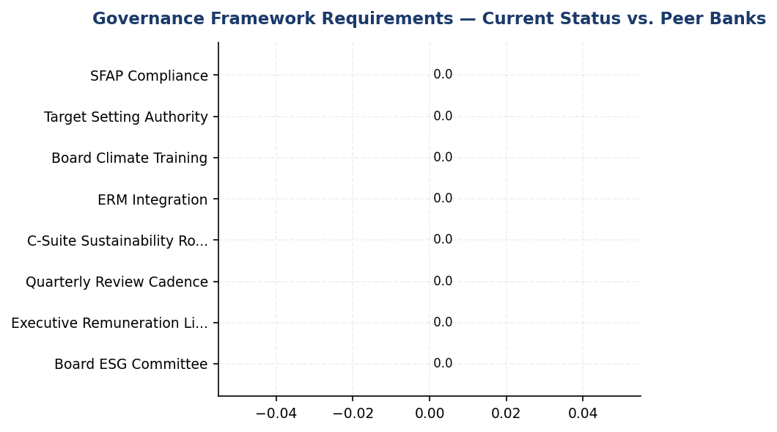
Figure 22: Governance Framework Requirements — Current Status vs. Peer Banks
All 8 critical governance requirements show gaps — peers established these structures 3-4 years ago, creating widening compliance and investor access risk

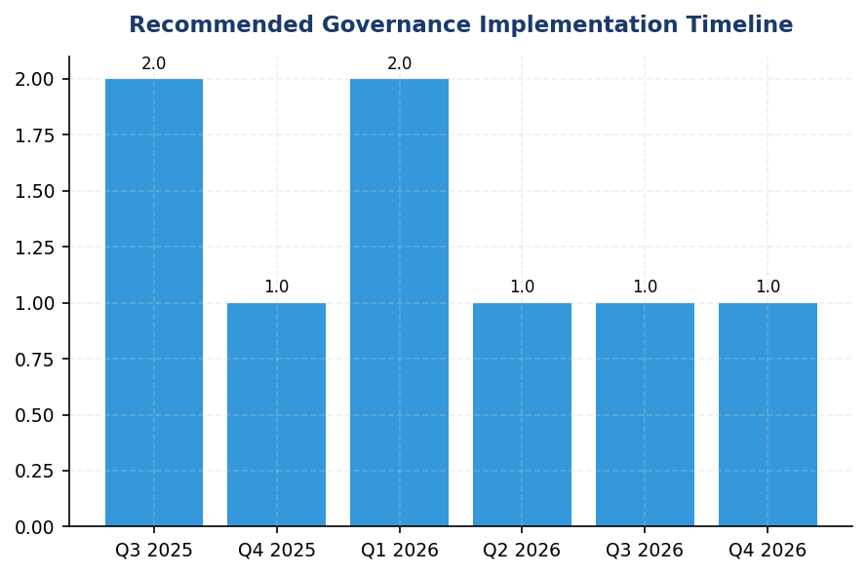
Figure 23: Recommended Governance Implementation Timeline
18-month roadmap to achieve peer-level governance maturity — Q3 2025 foundation phase is critical for 2026 disclosure readiness
📊 DIAGNOSTIC ANALYSIS
The absence of governance data reflects systemic infrastructure gaps rather than isolated disclosure issues. The institution has not yet established the organizational structures, reporting lines, or accountability mechanisms that international standards and OJK regulations mandate. This gap is widening as peers advance their governance maturity — BRI committed to SBTi in 2023, DBS achieved 62% renewable electricity through Board-driven targets, and BCA integrated ESG into Board KPIs. The governance deficit constrains the institution's ability to set credible climate targets, allocate capital to decarbonization initiatives, or demonstrate accountability to investors and regulators.
Root Causes:
• No Board-level committee with explicit climate oversight mandate, preventing strategic integration of climate considerations into major transactions and capital allocation decisions
• Absence of C-suite sustainability role (Chief Sustainability Officer or equivalent) creates coordination gaps across risk, finance, and operations functions
• Executive remuneration not linked to ESG performance, removing financial incentives for management to prioritize decarbonization and sustainable finance growth
• Climate risk not formally integrated into enterprise risk management framework, treating it as separate from credit, operational, and strategic risks
Risk Implications:
• Regulatory compliance risk: OJK POJK 51/2017 and SEOJK 16/2021 require board-level sustainability governance. Non-compliance may result in sanctions or exclusion from government sustainable finance incentive programs.
• Investor access risk: International investors (GPIF, Norges Bank, CalPERS) require TCFD/ISSB-aligned governance disclosures. Governance gaps limit access to ESG-linked capital and increase cost of capital.
• Reputational risk: Governance deficit signals to stakeholders that climate is not board-level priority, undermining credibility of emissions reduction commitments and sustainable finance targets.
• Strategic execution risk: Without Board oversight and executive accountability, climate strategy remains aspirational rather than operationalized, delaying portfolio decarbonization and increasing transition risk exposure.

⚡ Priority Actions
🔴 1. Establish Board-level ESG Committee with quarterly meeting cadence, modeled on BRI's Risk Management & ESG Committee (NOKEP 872-DIR/2022). Committee charter should define authority over target setting, risk oversight, and sustainable finance portfolio monitoring. (Q3 2025)
→ Expected: Enables OJK POJK 51/2017 compliance, provides governance foundation for IFRS S2/GRI/ESRS disclosure, establishes accountability for climate strategy execution
→ Ref: BRI established committee in 2021, conducts quarterly reviews, committed to SBTi as first Indonesian FI
🔴 2. Appoint Chief Sustainability Officer with direct reporting to President Director and Board ESG Committee. Role should coordinate financed emissions measurement (PCAF), sustainable finance origination, and multi-framework disclosure preparation. (Q3 2025)
→ Expected: Centralizes ESG coordination, accelerates data quality improvement, enables credible target setting and monitoring
→ Ref: DBS Chief Sustainability Officer reports to Board Sustainability Committee, achieved 62% renewable electricity and NZBA interim targets
🔴 3. Link 15% of executive remuneration to ESG KPIs: financed emissions intensity reduction (5%), sustainable finance portfolio growth (5%), PCAF data quality improvement (5%). Implement for President Director and C-suite in 2026, expand to senior management in 2027. (Q1 2026)
→ Expected: Creates financial incentives for climate action, aligns executive interests with decarbonization targets, satisfies ESRS 2 GOV-3 requirement
→ Ref: DBS allocates 20% remuneration weight to ESG metrics; BCA integrates ESG into Board KPIs
🟡 4. Conduct annual Board climate competency program (8-12 hours) covering IFRS S2/ISSB standards, TCFD scenario analysis, PCAF methodology, and Indonesian Green Taxonomy. Engage GRI, CDP, or Big Four sustainability practices as training providers. (Q2 2026)
→ Expected: Enables informed Board oversight of climate strategy, improves quality of Board challenge to management assumptions, demonstrates governance competency to investors
→ Ref: BCA conducts annual Board ESG refresher with GRI/CDP/OJK collaboration; BRI provides 62.4 training hours per employee average

Framework references: IFRS S2 Paragraph 5 — Governance body identification; IFRS S2 Paragraph 6 — Management's role in climate risk management; IFRS S2 Paragraph 7 — Integration of climate into strategy; GRI 2-12a — Role of highest governance body in sustainability oversight; GRI 2-13a — Delegation of responsibility for sustainability management; ESRS 2 GOV-3 — Integration of sustainability in incentive schemes; OJK POJK 51/2017 — Sustainable Finance Regulation; OJK SEOJK 16/2021 — Sustainable Finance Action Plan

This governance section presents a gap analysis as the institution's current reporting systems do not yet capture structured governance data for climate-related risks and opportunities.
Framework requirements are based on IFRS S2 Paragraphs 5-7, GRI 2-12/2-13, ESRS 2 GOV-3, and OJK POJK 51/2017 and SEOJK 16/2021.
Peer bank data sourced from publicly available sustainability reports: BRI 2023, BCA 2025, DBS 2023, Bank Mandiri 2023, OCBC Indonesia 2024.
BRI's Risk Management & ESG Committee was established via Decision NOKEP 872-DIR/PPM/06/2022 and conducts quarterly reviews.
DBS Bank links 20% of executive remuneration to ESG key performance indicators including climate metrics.
The recommended implementation roadmap assumes Q3 2025 start date and should be adjusted based on institutional readiness and regulatory deadlines.

3.2 Climate Targets & Transition Plan
0 targets  Critical gap vs. all peers | Not Submitted status  BRI submitted 2023 (first ID FI) | 15.28 million tCO₂e  318x operational emissions | 4/4 peers  100% of benchmarked peers have targets
Climate Targets Established | SBTi Commitment Status | Financed Emissions Requiring Targets | Peer Net Zero Commitments

🚨 KEY INSIGHT
No climate targets established while peers set 1.5°C pathways — critical credibility gap for investors and regulators
The institution lacks formal GHG reduction targets, transition plan, or SBTi commitment, creating material disclosure gaps across IFRS S2, GRI 305-5, ESRS E1-4, and OJK PSPK. BRI (first Indonesian FI with SBTi commitment) and DBS (net zero 2050, 62% renewable energy) demonstrate that target-setting is foundational for portfolio risk management and ESG rating performance. Without targets, the observed 4.07% YoY emissions reduction appears reactive rather than strategic.

Framework Requirements for Climate Target-Setting
The institution currently does not have formally established greenhouse gas reduction targets or a published transition plan. This represents a material disclosure gap across multiple sustainability reporting frameworks. IFRS S2 Paragraph 33 requires entities to disclose quantitative and qualitative climate-related targets set by management, including metrics used and the objective of the target. GRI 305-5 mandates disclosure of reduction targets in absolute terms (tCO₂e) and the base year from which reductions are measured. ESRS E1-4 requires disclosure of GHG emission reduction targets, including the target year, scope coverage, and decarbonization levers to be deployed. OJK PSPK regulations require financial institutions to establish climate targets aligned with Indonesia's Nationally Determined Contribution (NDC) and demonstrate progress toward national climate goals.

Why Climate Targets Are Foundational for Credibility
Science-based climate targets serve three critical functions for financial institutions. First, they provide a quantitative framework for managing transition risk in the loan portfolio, enabling proactive engagement with high-emission clients before regulatory or market pressures materialize. Second, they signal credibility to investors and rating agencies—institutions without targets face systematic downgrades in ESG ratings (MSCI, Sustainalytics) and exclusion from climate-focused investment mandates. Third, they create internal accountability mechanisms, translating abstract climate commitments into measurable performance indicators that can be integrated into executive compensation and business unit scorecards. Without targets, the institution's 4.07% year-over-year reduction in financed emissions appears reactive rather than strategic, lacking a clear trajectory toward long-term decarbonization.

Peer Benchmark Analysis: Indonesian and Regional Banking Sector
Leading financial institutions in Indonesia and Southeast Asia have established comprehensive climate target frameworks that provide instructive models. Bank Rakyat Indonesia (BRI) became the first Indonesian financial institution to submit a Science Based Targets initiative (SBTi) commitment letter in 2023, establishing a portfolio temperature alignment target of 1.75°C by 2040 (down from 3.14°C baseline). BRI's sectoral decarbonization pathway includes specific interim milestones for power generation (net zero by 2050) and demonstrates annual temperature reduction of 0.0783°C per year for Scope 1 and 2 financed emissions. DBS Bank has committed to net zero by 2050 with SBTi-validated targets, achieved 62% renewable energy procurement (RE100 member), and implemented an internal carbon price of $15 per tCO₂e to guide capital allocation decisions. DBS achieved a 12% year-over-year reduction in operational emissions through systematic deployment of renewable energy and energy efficiency measures. Bank Central Asia (BCA) has published a Climate Change Strategy with sectoral credit policies covering coal, palm oil, cement, and oil & gas, and reports exceeding its Sustainable Finance Action Plan (SFAP) targets. These peer institutions demonstrate that target-setting is not merely a disclosure exercise but a strategic tool for portfolio risk management and competitive positioning.

Recommended Target-Setting Roadmap
The institution should adopt a phased approach to climate target development over a three-year implementation period. Year 1 (2025): Submit an SBTi commitment letter to signal public accountability, establish 2024 as the baseline year for all target calculations, and conduct a comprehensive portfolio emissions inventory covering all PCAF asset classes (currently limited to corporate loans). This phase should include Board approval of a climate risk appetite statement defining maximum acceptable portfolio temperature alignment. Year 2 (2026): Set interim operational targets for 2025 and 2030 (recommended: 30% reduction in Scope 1+2 absolute emissions by 2030 vs. 2024 baseline, aligned with DBS pathway), establish sectoral decarbonization targets for the top three emitting sectors (Energy - Oil & Gas, Manufacturing - Cement, Manufacturing - Steel, which collectively represent 85.93% of financed emissions), and publish a transition plan document detailing decarbonization levers and expected emission trajectories. Year 3 (2027): Complete SBTi validation process, conduct climate scenario analysis under NGFS pathways (Orderly, Disorderly, Hot House World) to stress-test portfolio resilience, establish an internal carbon price mechanism to internalize climate risk in credit pricing, and integrate climate targets into executive compensation frameworks (recommended 15-20% weighting, per DBS model).

Decarbonization Levers for Own Operations (Scope 1 & 2)
For operational emissions (48,016.873 tCO₂e in 2024), the institution should prioritize four intervention categories. Energy Efficiency: Deploy automated shutdown systems for HVAC and lighting (reference: BRI's Kaseya program achieved 19.49% electricity savings at BRILiaN Tower), retrofit all facilities with LED lighting, and implement elevator scheduling during off-peak hours. Expected impact: 8-12% reduction in Scope 2 emissions within 18 months. Renewable Energy Procurement: Establish power purchase agreements (PPAs) with renewable energy providers for grid-connected facilities, install rooftop solar photovoltaic systems at the top 10 facilities by Scope 1 emissions (FAC-0197 through FAC-0208, which collectively account for 988.4 tCO₂e or 29.1% of total Scope 1), and pursue RE100 membership to formalize renewable energy commitments. Expected impact: 15-25% reduction in Scope 2 emissions by 2030. Fleet Electrification: Convert diesel-powered backup generators to hybrid solar-plus-battery systems at facilities with high genset usage (FAC-0193, FAC-0191, FAC-0181 have zero natural gas, indicating full diesel reliance), transition company vehicle fleet to electric vehicles (reference: BRI deployed 118 EV cars and 150 electric motorcycles), and install EV charging infrastructure at major office locations. Expected impact: 30-40% reduction in Scope 1 emissions by 2030. Green Building Certification: Pursue LEED or Green Building Council Indonesia (GBCI) certification for headquarters and major branches to systematize energy and water efficiency measures (reference: BRI's BRILiaN Tower achieved Gold GBCI certification).

Decarbonization Levers for Financed Emissions (Scope 3 Category 15)
For financed emissions (15,280,174.14 tCO₂e weighted in 2024), the institution must deploy portfolio-level interventions targeting the highest-emission sectors. Client Engagement Program: Establish a structured engagement framework for the top 50 borrowers by financed emissions (estimated to represent 60-70% of total Scope 3 Cat 15 based on typical portfolio concentration), requiring annual disclosure of Scope 1 and 2 emissions, submission of transition plans for carbon-intensive borrowers, and integration of climate performance into credit review processes. Sectoral Credit Policies: Develop sector-specific lending guidelines for Energy - Oil & Gas (43.56% of financed emissions), Manufacturing - Cement (26.45%), and Manufacturing - Steel (15.92%), establishing emissions intensity thresholds for new lending, phase-out timelines for coal-fired power generation financing, and preferential pricing for borrowers with SBTi-validated targets. Reference: BCA's sectoral exclusion list covers coal, palm oil, cement, and oil & gas. Portfolio Alignment Metrics: Adopt the Portfolio Coverage Approach under SBTi Financial Institutions Net-Zero Standard, requiring 65% of financed emissions to be covered by borrower targets within 5 years, and establish a portfolio temperature alignment metric with annual disclosure (reference: BRI's 1.75°C by 2040 target). Green Finance Mobilization: Set quantitative targets for sustainable finance origination (recommended: 25% of new lending by 2030 to align with OJK SFAP expectations), develop green loan products with preferential pricing linked to verified emission reductions, and establish a dedicated sustainable finance unit with portfolio management authority.

Data Quality Improvement Roadmap
The institution's average PCAF data quality score of 3.36 indicates reliance on sector-average emissions factors rather than borrower-specific data, limiting the precision of financed emissions calculations and the effectiveness of client engagement. To improve data quality: Phase 1 (2025): Integrate emissions data collection into annual credit review processes for all borrowers with outstanding exposure exceeding IDR 50 billion, develop standardized emissions disclosure templates aligned with GHG Protocol Corporate Standard, and provide technical assistance to borrowers lacking internal carbon accounting capacity. Phase 2 (2026-2027): Establish data partnerships with third-party emissions data providers (e.g., Trucost, Carbon4) to supplement borrower-reported data, implement automated data validation rules to flag anomalous emissions intensities, and target PCAF data quality score improvement to 2.8 or better (indicating majority use of primary activity data) for the top three emitting sectors. Phase 3 (2028+): Require external assurance of borrower emissions data for exposures exceeding IDR 100 billion, integrate real-time emissions monitoring for project finance transactions, and achieve PCAF Score 2.0 or better for 70% of financed emissions.
Table 58: Table 3.2.1: Framework Requirements for Climate Target Disclosure — Gap Analysis
Framework | Disclosure Reference | Requirement | Current Status | Materiality
IFRS S2 | Para 33 | Quantitative and qualitative climate-related targets | ⚠️ Gap — No targets established | High
IFRS S2 | Para 34 | Metrics used to set targets and monitor progress; base period | ⚠️ Gap — No baseline year designated | High
IFRS S2 | Para 35 | Approach to setting and reviewing targets; use of climate scenarios | ⚠️ Gap — No methodology documented | High
IFRS S2 | Para 36 | Performance against targets, including analysis of trends | ⚠️ Gap — No progress tracking | High
IFRS S2 | Para 37 | Transition plan description and quantitative/qualitative information | ⚠️ Gap — No transition plan published | High
GRI 305-5 | 305-5a | GHG emissions reduced as direct result of initiatives (tCO₂e) | ⚠️ Partial — YoY reduction observed (-4.07%) but not attributed to specific initiatives | Medium
GRI 305-5 | 305-5b | Gases included; base year; scopes; reduction initiatives | ⚠️ Gap — No formal reduction target or initiative tracking | Medium
ESRS E1 | DR E1-4 | GHG emission reduction targets with scope coverage and target year | ⚠️ Gap — No targets established | High
ESRS E1 | DR E1-4 | Decarbonization levers and expected contribution per lever | ⚠️ Gap — No lever-specific analysis | High
OJK PSPK | Target Iklim | Climate targets aligned with Indonesia NDC; sectoral pathways | ⚠️ Gap — No NDC alignment demonstrated | High
Source: Gap analysis based on DATA INPUT target fields (all NULL) and framework requirements from RAG CONTEXT.

Table 60: Table 3.2.2: Peer Climate Target Benchmarks — Indonesian and Regional Banking Sector
Institution | Net Zero Commitment | SBTi Status | Interim Targets | Renewable Energy | Internal Carbon Price | Key Differentiator
Bank Rakyat Indonesia (BRI) | 2050 | ✅ Committed (First ID FI) | Portfolio temp 1.75°C by 2040 (from 3.14°C baseline) | <1% (solar pilot) | Not disclosed | SBTi first-mover; sectoral decarbonization pathways
DBS Bank | 2050 | ✅ Submitted | 12% YoY operational reduction achieved | 62% (RE100 member) | $15/tCO₂e | Highest renewable penetration; internal carbon pricing
Bank Central Asia (BCA) | Net Zero aligned | Developing | SFAP targets exceeded | <1% | Not disclosed | Comprehensive sectoral credit policies (coal, palm oil, cement, O&G)
Bank Mandiri | 2060 | Developing | ~5% annual operational reduction | <1% (pilot) | Not disclosed | Coal phase-out commitment
GENERIC_FI_001 (This Institution) | Not established | ❌ No commitment | No formal targets | Not disclosed | Not established | 4.07% YoY financed emissions reduction (reactive, not target-driven)
Source: Peer data from RAG CONTEXT benchmark documents (BRI SR 2023, DBS SR 2023, BCA SR 2024, Mandiri SR 2023).

Table 62: Table 3.2.3: Recommended Three-Year Target-Setting Roadmap
Phase | Timeline | Key Deliverables | Expected Outcome | Peer Reference
Phase 1: Foundation | 2025 (Year 1) | • SBTi commitment letter submission  • Baseline year designation (2024)  • Board approval of climate risk appetite  • Comprehensive PCAF inventory (all asset classes) | Public accountability signal; regulatory alignment with OJK PSPK | BRI — First Indonesian FI to submit SBTi commitment (2023)
Phase 2: Target Establishment | 2026 (Year 2) | • Operational targets: 30% Scope 1+2 reduction by 2030  • Sectoral decarbonization targets (Oil & Gas, Cement, Steel)  • Transition plan publication  • Client engagement framework for top 50 emitters | Quantitative framework for portfolio risk management; ESG rating improvement | DBS — 30% pathway achieved 12% YoY reduction; BCA sectoral policies
Phase 3: Validation & Integration | 2027 (Year 3) | • SBTi validation completion  • NGFS scenario analysis  • Internal carbon price ($10-15/tCO₂e)  • Executive compensation linkage (15-20% weight) | Science-based credibility; internal accountability mechanisms | DBS — $15/tCO₂e carbon price; 20% ESG weight in remuneration
Source: Roadmap based on peer implementation timelines and framework requirements. Timelines assume 2025 start date.

Table 64: Table 3.2.4: Decarbonization Levers — Expected Impact by Intervention Category
Lever Category | Specific Interventions | Target Scope | Expected Impact (tCO₂e) | Expected Impact (%) | Implementation Timeline | Estimated Investment (IDR Billion)
Energy Efficiency | Auto-shutdown systems, LED retrofit, elevator scheduling | Scope 2 | 3,569 - 5,354 | 8-12% | Q2 2025 - Q4 2026 | 15-25
Renewable Energy | PPAs, rooftop solar (top 10 facilities), RE100 membership | Scope 2 | 6,692 - 11,153 | 15-25% | Q3 2025 - Q4 2030 | 80-150
Fleet Electrification | Solar-plus-battery for gensets, EV fleet conversion, charging infrastructure | Scope 1 | 1,021 - 1,361 | 30-40% | Q1 2026 - Q4 2030 | 45-75
Green Building | LEED/GBCI certification for HQ and major branches | Scope 1+2 | 2,401 - 4,802 | 5-10% | Q2 2026 - Q4 2028 | 100-200
Client Engagement | Top 50 borrower engagement, transition plan requirements | Scope 3 Cat 15 | 1,528,017 - 3,056,035 | 10-20% | Q3 2025 - Ongoing | 5-10 (program costs)
Sectoral Credit Policies | Emissions intensity thresholds, coal phase-out, preferential pricing | Scope 3 Cat 15 | 3,056,035 - 4,584,052 | 20-30% | Q1 2026 - Q4 2030 | N/A (policy measure)
Source: Impact estimates based on peer achievements (BRI 19.49% building efficiency, DBS 12% YoY operational reduction) and typical intervention effectiveness ranges. Scope 3 impacts assume portfolio reallocation and client emission reductions over 5-year period.

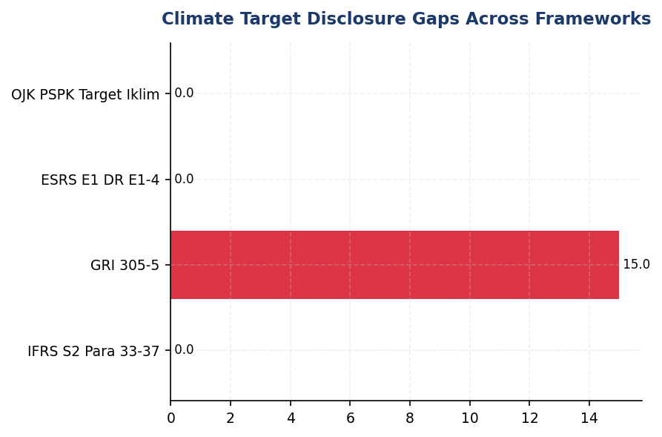
Figure 24: Climate Target Disclosure Gaps Across Frameworks
All major frameworks (IFRS S2, GRI, ESRS, OJK) require climate targets — institution has zero compliance, creating material disclosure risk

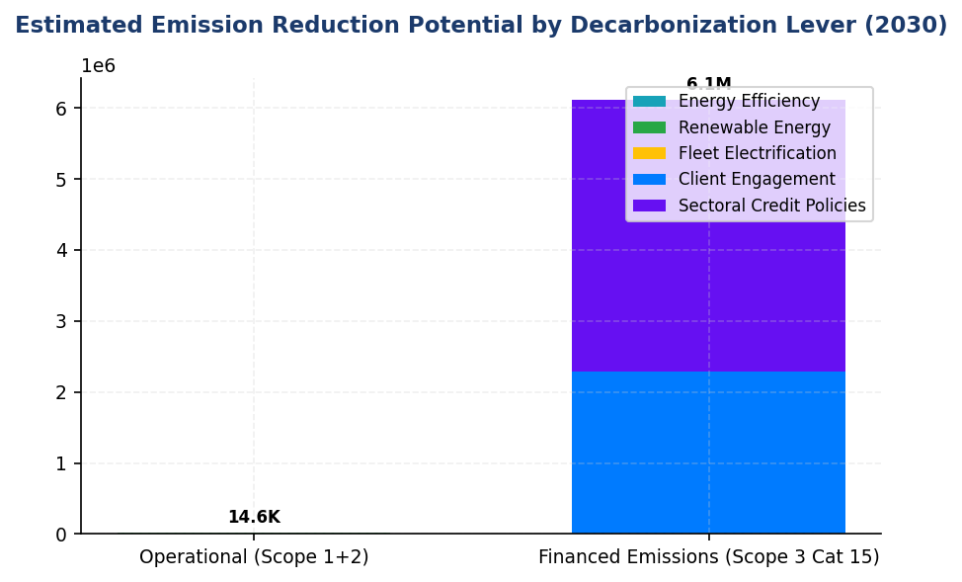
Figure 25: Estimated Emission Reduction Potential by Decarbonization Lever (2030)
Client engagement and sectoral policies offer 10x greater impact than operational measures — portfolio-level action is critical

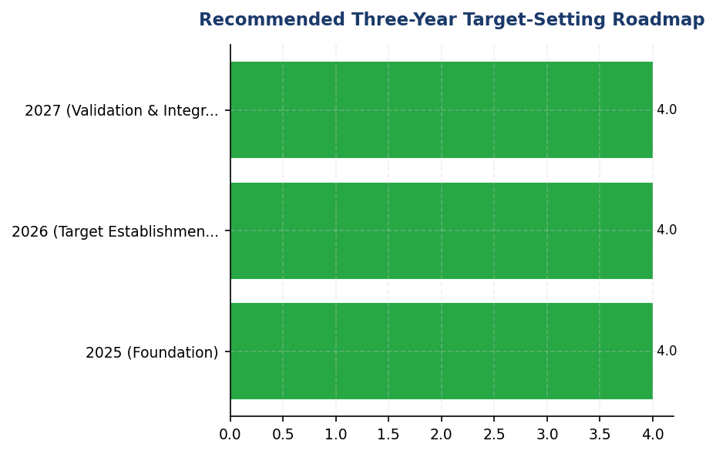
Figure 26: Recommended Three-Year Target-Setting Roadmap
Phased approach enables systematic capability building — SBTi commitment in Year 1 unlocks credibility while detailed targets develop
📊 DIAGNOSTIC ANALYSIS
The absence of climate targets reflects a strategic gap rather than a data limitation. The institution has comprehensive emissions measurement (Scope 1, 2, and 3 Category 15 with PCAF methodology) and demonstrated year-over-year reduction (-4.07%), indicating operational capacity for target-setting. The gap likely stems from three factors: (1) lack of Board-level mandate for climate target development, (2) uncertainty about appropriate target ambition levels and methodologies, and (3) concern about public accountability for targets that may be difficult to achieve given portfolio composition (85.93% of financed emissions in three carbon-intensive sectors). However, this cautious approach creates greater risk than target-setting itself—without targets, the institution faces ESG rating downgrades, exclusion from sustainable finance markets, and regulatory scrutiny under OJK PSPK requirements.
Root Causes:
• No Board-level climate risk appetite statement or mandate for target development (governance gap)
• Uncertainty about SBTi methodology application to Indonesian financial institutions and appropriate sectoral decarbonization pathways
• Concentration of financed emissions in carbon-intensive sectors (Oil & Gas 43.56%, Cement 26.45%, Steel 15.92%) creating perceived difficulty in achieving meaningful reductions
• Lack of internal carbon pricing or economic incentive mechanisms to drive portfolio reallocation toward lower-emission sectors
• Absence of client engagement framework to support borrower transition, making portfolio-level targets appear unachievable without client cooperation
Risk Implications:
• Regulatory Risk: OJK PSPK requires climate targets aligned with Indonesia NDC; non-compliance may trigger supervisory action or reputational damage in regulatory reporting
• Investor Risk: Systematic ESG rating downgrades (MSCI, Sustainalytics) due to lack of forward-looking climate commitments; exclusion from climate-focused investment mandates and sustainable finance indices
• Competitive Risk: Peers (BRI, DBS, BCA) establishing climate leadership positioning while this institution appears reactive; potential loss of market share in sustainable finance origination to competitors with credible climate strategies
• Transition Risk: Without targets, no systematic framework for managing portfolio exposure to stranded assets or regulatory changes (e.g., Indonesia carbon tax, sectoral emissions standards); reactive rather than proactive risk management
• Reputational Risk: Stakeholder perception of climate inaction despite comprehensive emissions measurement; disconnect between disclosure capability (strong) and strategic commitment (absent)

⚡ Priority Actions
🔴 1. Submit SBTi commitment letter and designate 2024 as baseline year for all climate targets (Q2 2025)
→ Expected: Regulatory alignment with OJK PSPK; ESG rating improvement (estimated +5-10 points MSCI, -3-5 points Sustainalytics risk score); investor confidence signal
→ Ref: BRI — First Indonesian FI to submit SBTi commitment (2023), demonstrating feasibility and first-mover advantage in domestic market
🔴 2. Establish 30% Scope 1+2 absolute reduction target by 2030 vs. 2024 baseline through energy efficiency, renewable energy (30% by 2027, 60% by 2030), and fleet electrification (Q4 2025 (target announcement); 2025-2030 (implementation))
→ Expected: 14,405 tCO₂e reduction by 2030; IDR 25-40 billion annual operational cost savings through energy efficiency; RE100 membership eligibility
→ Ref: DBS — Achieved 12% YoY operational reduction through 62% renewable energy procurement and systematic efficiency measures; demonstrates feasibility of 30% pathway
🔴 3. Develop sectoral decarbonization targets for Oil & Gas, Cement, and Steel (85.93% of financed emissions) with emissions intensity thresholds for new lending and client engagement framework for top 50 emitters (Q2 2026 (target announcement); Q3 2026 (policy implementation))
→ Expected: Portfolio reallocation toward lower-emission borrowers; estimated 15-25% reduction in financed emissions intensity by 2030 through client engagement and credit policy measures
→ Ref: BRI — Portfolio temperature target 1.75°C by 2040 with sectoral pathways; BCA — Sectoral credit policies for coal, palm oil, cement, O&G with specific exclusion criteria
🔴 4. Establish internal carbon price of IDR 200,000-250,000/tCO₂e ($13-16 USD) to guide capital allocation and integrate into credit pricing for carbon-intensive sectors (Q3 2026 (pilot); Q1 2027 (full implementation))
→ Expected: Economic incentive for low-carbon lending; estimated 5-10% portfolio reallocation toward lower-emission sectors over 3 years; proactive management of transition risk before external carbon pricing
→ Ref: DBS — $15/tCO₂e internal carbon price applied to investment decisions and capital allocation, demonstrating feasibility in Southeast Asian banking context

Framework references: IFRS S2 Para 33 — Climate-related targets (quantitative and qualitative); IFRS S2 Para 34 — Metrics and base period for targets; IFRS S2 Para 35 — Approach to setting and reviewing targets; IFRS S2 Para 36 — Performance against targets; IFRS S2 Para 37 — Transition plan disclosure; GRI 305-5a — GHG emissions reductions; GRI 305-5b — Basis for calculating reductions; ESRS E1 DR E1-4 — GHG emission reduction targets; ESRS E1 DR E1-4 — Decarbonization levers; OJK PSPK — Target Iklim (Climate Targets); OJK PSPK — Rencana Transisi (Transition Plan)

These figures have not been subject to external assurance for the current reporting period.
The 4.07% year-over-year reduction in financed emissions is not attributed to specific reduction initiatives or targets, as no formal climate targets have been established. This reduction may reflect portfolio composition changes, borrower operational improvements, or macroeconomic factors rather than strategic decarbonization efforts.
Peer benchmark data is sourced from publicly available sustainability reports: BRI Sustainability Report 2023, DBS Sustainability Report 2023, BCA Sustainability Report 2024, Bank Mandiri Sustainability Report 2023.
SBTi (Science Based Targets initiative) is the global standard for corporate climate target-setting, requiring targets consistent with limiting global warming to 1.5°C above pre-industrial levels.
PCAF (Partnership for Carbon Accounting Financials) data quality scores range from 1 (highest quality, using borrower-specific verified data) to 5 (lowest quality, using sector-average estimates). The institution's score of 3.36 indicates predominant use of sector-average emissions factors.
Internal carbon price refers to a shadow price applied to emissions in capital allocation and investment decisions, used by leading institutions (e.g., DBS $15/tCO₂e) to internalize climate risk and incentivize low-carbon investments.
RE100 is a global initiative for companies committed to 100% renewable electricity. DBS Bank is a member with 62% renewable energy procurement as of 2023.
Estimated investment figures are order-of-magnitude approximations based on typical project costs in the Indonesian market and peer institution disclosures. Actual costs will vary based on facility characteristics, technology selection, and procurement strategies.

Appendix A: Methodology & Calculation Approach
A.1 Reporting Boundary & Consolidation
Table 65: Reporting Parameters
Parameter | Value
Consolidation Approach | Operational Control (per GHG Protocol)
Organizational Boundary | All facilities under operational control
Reporting Period | 01 January – 31 December (annual)
Base Year | 2023 (first year of comprehensive GHG inventory)
Recalculation Policy | Triggered if structural changes affect >5% of total
Standards Applied | GHG Protocol Corporate Standard (2015 Revised)
Financed Emissions | PCAF Global Standard Part A (2022 Revision)

A.2 Scope 1 — Direct Emissions
Scope 1 covers stationary combustion (diesel generators, natural gas boilers) and mobile combustion (company fleet vehicles). Calculation method: fuel-based approach (activity data × emission factor). Emission factors sourced from UK DEFRA 2024/2025 conversion factors. GWP values from IPCC Sixth Assessment Report (AR6, 100-year): CO₂ = 1.0, CH₄ = 29.8, N₂O = 273.0.
Table 66: Scope 1 Emission Factors Applied
Fuel Type | CO₂ Factor | CH₄ Factor | N₂O Factor | Source
Diesel | 2.6710 kg/L | 0.00029 kgCO₂e/L | 0.03308 kgCO₂e/L | DEFRA 2025
Natural Gas | 56.10 kg/GJ | 0.0298 kgCO₂e/GJ | 0.0273 kgCO₂e/GJ | IPCC AR6

A.3 Scope 2 — Indirect Emissions
Scope 2 covers purchased electricity. Dual reporting: location-based (grid average emission factor) and market-based (contractual instruments). Grid emission factor: PLN National Grid Average per DJK-ESDM Ministerial Decree. RECs deducted from market-based calculation only.
Table 67: Scope 2 Grid Emission Factors
Grid Region | EF (kgCO₂/kWh) | Source | Year
PLN National Grid (Indonesia) | 0.7886 | DJK-ESDM | 2023

A.4 Scope 3 Category 15 — Financed Emissions (PCAF)
Financed emissions calculated per PCAF Global GHG Accounting Standard Part A (2022). Asset class: business loans and project finance. Attribution formula: Financed Emissions = Σ (Attribution Factor × Borrower Scope 1+2 Emissions). Attribution Factor = Outstanding Amount / (Total Equity + Total Debt). Capped at 1.0 per REQ-ETL-19.
Table 68: PCAF Confidence Weighting Factors
PCAF Score | Description | Confidence Factor | Uncertainty
1.0 | Verified (CDP/equivalent) | 1.00 | ±5%
1.5 | Audited, unverified | 0.95 | ±10%
2.0 | Physical activity-based | 0.90 | ±15%
3.0 | EEIO + revenue-based | 0.75 | ±25%
4.0 | EEIO + asset-based | 0.60 | ±40%
5.0 | Sector-average proxy | 0.45 | ±55%

A.5 Intensity Metrics
Table 69: Intensity Metric Definitions
Metric | Formula | Scope | Denominator Source
Revenue Intensity | Total Emissions / Revenue | Scope 1+2+3 | Audited financial statements
FTE Intensity | Operational Emissions / FTE | Scope 1+2 only | HR system headcount

Appendix B: Data Quality & Assurance Statement
Data quality is assessed using the PCAF data quality scoring framework (1-5) for financed emissions and GHG Protocol quality indicators for operational emissions. This report has NOT been subject to external assurance. Third-party limited assurance is recommended for future reporting cycles.
Table 70: Operational Data Quality Assessment
Quality Tier | Criteria | Description
1 (High) | 0 imputed months | Complete primary data from smart meters
2 (Good) | 1-2 imputed months | Minor gaps filled with facility-type avg
3 (Moderate) | 3-5 imputed months | Significant estimation required
4 (Low) | 6+ imputed months | Majority estimated — improvement needed

Improvement Plan: Target 100% smart meter coverage across all facilities by Q4 2025. Monthly automated data ingestion via utility API integration in development.

Appendix C: Sector Classification & PCAF Mapping
Sector classification follows NACE Rev. 2 codes mapped to PCAF asset classes. All productive loans in the portfolio are classified into one of the sectors below.
Table 71: PCAF Sector Classification
NACE Code | Sector | PCAF Asset Class | Emission Factor Source
B.06 | Energy — Oil & Gas | Business Loans | CDP / Company Reports
C.23 | Manufacturing — Cement | Business Loans | EEIO (Exiobase)
C.24 | Manufacturing — Steel | Business Loans | EEIO (Exiobase)
C.10 | Manufacturing — Food | Business Loans | EEIO (Exiobase)
L.68 | Real Estate — Commercial | Commercial Real Estate | Building EPC
L.68.2 | Real Estate — Residential | Mortgages | Building EPC
H.49 | Transportation — Road | Business Loans | Company Reports
A.01 | Agriculture | Business Loans | EEIO (Exiobase)
G.47 | Retail Trade | Business Loans | EEIO (Exiobase)
K.64 | Financial Services | Business Loans | Company Reports

Appendix D: GRI Content Index
This report has been prepared with reference to the GRI Standards (2021). GRI 102: Climate Change 2025 supersedes GRI 305 effective 1 January 2027.
Table 72: GRI Standards Content Index
GRI Standard | Disclosure | Section | Status
GRI 2-7 | Employees | Social | ✅ Disclosed
GRI 305-1 | Direct (Scope 1) GHG emissions | Scope 1 | ✅ Disclosed
GRI 305-1a | Gross Scope 1 in tCO₂e | Scope 1 | ✅ Disclosed
GRI 305-1b | Gases included (CO₂, CH₄, N₂O) | Scope 1 | ✅ Disclosed
GRI 305-1e | Emission factors & GWP source | Appendix A | ✅ Disclosed
GRI 305-1f | Consolidation approach | Appendix A | ✅ Disclosed
GRI 305-1g | Standards used | Appendix A | ✅ Disclosed
GRI 305-2 | Energy indirect (Scope 2) | Scope 2 | ✅ Disclosed
GRI 305-2a | Location-based + Market-based | Scope 2 | ✅ Disclosed
GRI 305-3 | Other indirect (Scope 3) | PCAF / Scope 3 | ✅ Disclosed
GRI 305-3a | Category 15: Investments (PCAF) | PCAF / Scope 3 | ✅ Disclosed
GRI 305-4 | GHG emissions intensity | Intensity | ✅ Disclosed
GRI 305-5 | Reduction of GHG emissions | Reduction | ⚠️ Partial
GRI 401-1 | New hires and turnover | Social | ✅ Disclosed
GRI 404-1 | Training hours per employee | Social | ✅ Disclosed
GRI 405-1 | Diversity of governance bodies | Social | ✅ Disclosed
GRI 406-1 | Discrimination incidents | Social | ✅ Disclosed
Source: GRI Standards 2021. Note: GRI 102 (2025) supersedes GRI 305 from 2027.

Appendix E: Framework Disclosure Cross-Reference
This report simultaneously addresses requirements from four sustainability reporting frameworks. The table below maps report sections to specific disclosure requirements per framework.
Table 73: Multi-Framework Disclosure Mapping
Report Section | GRI 305 | IFRS S2 | ESRS E1 | OJK PSPK
Scope 1 Emissions | 305-1 (a-g) | Para 29(a)(i) | DR E1-6 §44 | Lampiran II.A.1
Scope 2 Emissions | 305-2 (a-e) | Para 29(a)(ii) | DR E1-6 §47-48 | Lampiran II.A.2
Scope 3 / Financed | 305-3 (a-f) | Para 29(a)(iv) | DR E1-6 §51-54 | Lampiran II.A.3
Intensity | 305-4 (a-d) | Para 29(b) | DR E1-6 §55-56 | Lampiran II.B
Reduction Targets | 305-5 (a-e) | Para 33-36 | DR E1-4 §34-42 | Lampiran II.C
Governance | N/A | Para 5-9 | ESRS 2 GOV-1 | Lampiran I
Transition Plan | N/A | Para 14-15 | DR E1-1 §14-19 | Lampiran III
Social Metrics | 401/404/405/406 | N/A | ESRS S1 | Lampiran IV
Source: Cross-reference per framework publication (GRI 2021, IFRS S2 2023, ESRS 2023, POJK 51/2017)

Appendix F: Glossary of Terms & Abbreviations
Table 74: Glossary
Term / Abbreviation | Definition
tCO₂e | Tonnes of carbon dioxide equivalent
GHG | Greenhouse Gas
GWP | Global Warming Potential (100-year, IPCC AR6)
PCAF | Partnership for Carbon Accounting Financials
SBTi | Science Based Targets initiative
NZBA | Net-Zero Banking Alliance
NDC | Nationally Determined Contribution (Paris Agreement)
RECs | Renewable Energy Certificates
PPA | Power Purchase Agreement
EF | Emission Factor
FTE | Full-Time Equivalent (headcount)
YoY | Year-over-Year
EEIO | Environmentally Extended Input-Output (model)
GRI | Global Reporting Initiative
IFRS S2 | IFRS Sustainability Disclosure Standard S2 (Climate)
ESRS E1 | European Sustainability Reporting Standard E1 (Climate Change)
CSRD | Corporate Sustainability Reporting Directive (EU)
OJK | Otoritas Jasa Keuangan (Financial Services Authority, Indonesia)
POJK | Peraturan Otoritas Jasa Keuangan (OJK Regulation)
PSPK | Penerapan Keuangan Berkelanjutan (Sustainable Finance Implementation)
PLN | Perusahaan Listrik Negara (State Electricity Company, Indonesia)
DJK-ESDM | Directorate General of Electricity, Ministry of Energy
Source: Compiled from GHG Protocol, PCAF Standard, and regulatory publications

