Topological Intelligence for Dual-Gantry Quad-Arm Ceiling Robot System
in Trailer Living Lab

Raditya Artha Rochmanto, Naoyuki Takesue, and Naoyuki Kubota
Department of Mechanical Systems Engineering, Tokyo Metropolitan University
6-6 Asahigaoka, Hino, Tokyo 191-0065, Japan

Abstract:
Recently, various types of robots have been developed for everyday household tasks. Although mobile manipulators and human-like robots are useful, they are difficult to use in Japanese houses due to space limitations. Therefore, we have developed a ceiling robot system composed of a quad-arm on a dual-gantry. Since each gantry has a dual-arm like a human-like robot, the ceiling robot system can perform various tasks done by two people. Internal deadlock may occur in the quad-arm in as well as external deadlock with objects surrounding the ceiling robot system. This paper proposes how to use topological intelligence to specify the movable range with topological twin built into the configuration space. The proposed method uses a method of multi-scale batch-learning growing neural gas to build a perceptual map, and growing cell structure is used to build an action map for each arm. The movable range is specified by a topology-based map update. This paper applied the proposed method to the dual-arm at the simulation level. The simulation results show that the proposed method can identify the possibility of the internal deadlock between the dual-arm. Finally, this paper discusses the applicability of topological intelligence to dual-gantry quad-arm ceiling robot systems.

1. Introduction

Recently, various types of robots have been developed for everyday household tasks thanks to the rapid progress of artificial intelligence (AI) and embedded systems technology [13]. Although mobile manipulators and human-like robots are useful, they are difficult to use in Japanese houses due to space limitations. Therefore, we have developed a ceiling robot system composed of a quad-arm on a dual-gantry [12]. Since each gantry has a dual-arm like a human-like robot, the ceiling robot system can perform various tasks done by two people. If the person performs a task with the ceiling robot system, the total number of arms becomes 6. As a result, we can expect the ceiling robot system is helpful for elderly people and disable people.
Ceiling mounting itself is not new. Inverted-mount industrial robots such as the FANUC R-2000iC/220U hang a six-axis arm from an overhead base so that the floor is left free and several robots can work in close proximity, but they handle heavy workpieces in a fenced cell rather than serve a person [15]. Toyota Research Institute brought the idea into the home with a dual-arm robot that travels on ceiling rails and descends to perform household chores such as loading a dishwasher and wiping surfaces, at the cost of requiring a house purpose-built with the overhead infrastructure [16]. In both cases, however, the arms are carried by a single overhead base, so they cannot be placed independently and only one region of the room can be served at a time. In contrast, the ceiling robot system in our trailer living lab (TLL) distributes four arms over two independently actuated gantries, each gantry contributing a linear and a rotational axis shared by its pair of arms. The system can therefore serve two separate tasks in different parts of the room at the same time, or bring all four arms to a single task, without occupying the floor space that a mobile manipulator would require.
Collision and deadlock avoidance has been surveyed extensively for multi-robot systems, and deadlock is repeatedly identified as an open issue that reactive and receding-horizon schemes do not fully resolve [17]. Those studies, however, address mobile robots that are free to reposition themselves, whereas the arms of a ceiling robot system are attached to a shared gantry and cannot escape each other by moving away. This paper focuses on the collision avoidance of the ceiling robots, because internal deadlock may occur in the quad-arm in as well as external deadlock with objects surrounding the ceiling robot system. Here, we assume that internal deadlock includes both the deadlock state within each arm on the configuration space, and collisions between two or more arms. This is a crucial issue when using four arms simultaneously. Therefore, this paper proposes how to use topological intelligence [7] to specify the movable range with a topological twin built into the configuration space [2]. Basically, topological intelligence includes two primary approaches: topological mapping, which extracts the topological structure hidden in the environment and in the robot itself [1][3][5][6] and topological utilization, which uses the built map for attention, posture selection, inference, and prediction [7][8].
The proposed method uses multi-scale batch-learning growing neural gas as a topological mapping method to build a perceptual map. Furthermore, growing cell structure is used to build an action map for each arm. [4]. The movable range is specified by a topology-based map update between two or more action maps. Furthermore, this paper applies the proposed method to the quad-arm at the simulation level. We will discuss the effectiveness of the proposed method through preliminary simulation results. Finally, this paper discusses the applicability of topological intelligence to dual-gantry quad-arm ceiling robot systems.
This paper is organized as follows: Section 2 explains the hardware architecture of the ceiling robot system and its application examples in the Trailer Living Lab. Section 3 explains the basic concept of topological intelligence and how to build action maps. Section 4 demonstrates a simulation result of a hand-over task with a person. Section 5 concludes this paper and discusses the future direction of topological intelligence for the ceiling robot system.

2. A Dual-Gantry Quad-Arm Ceiling Robot System

We have developed trailer house based mobile living lab (hereafter, TLL) to provide vulnerable people with user experiences on the latest AI and robot technology (Fig.1(a)). We can measure physical ability based on the activities of daily living (ADL) and instrumental ADL (IADL) in the first floor (inside) of the TLL. Various types of sensors to measure human activities are attached to the walls, ceilings, and poles. Furthermore, ceiling robots are equipped for the service from the upper side (Fig.1 (b)).
The ceiling robot uses Kinova Gen3 Lite manipulators: lightweight 6-DOF arms (approximately 0.76 m reach, 5.4 kg, 0.5 kg payload) with a two-finger gripper [14], whose low mass and limited payload make them safe to operate near a person. Two arms are mounted on each motorized gantry, which adds a linear axis along the ceiling rail and a rotational axis, so that each arm forms an 8-DOF chain relative to the room. Four arms on two gantries allow the system to serve the resident from above without occupying floor space.
The ceiling robot system can perform various tasks done by two people. Fig.2 shows several examples of tasks which the ceiling robot system can conduct.

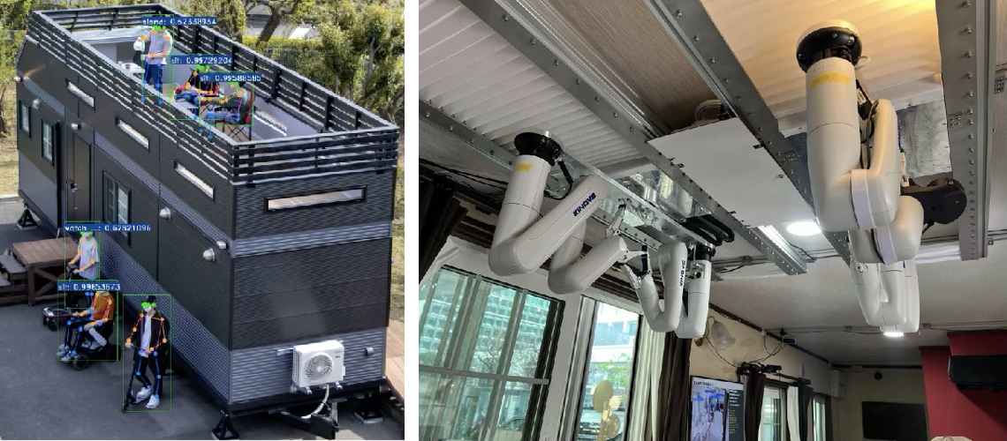
(a) Outside of TLL (b) A ceiling robot system
Fig.1. Trailer living lab (TLL)

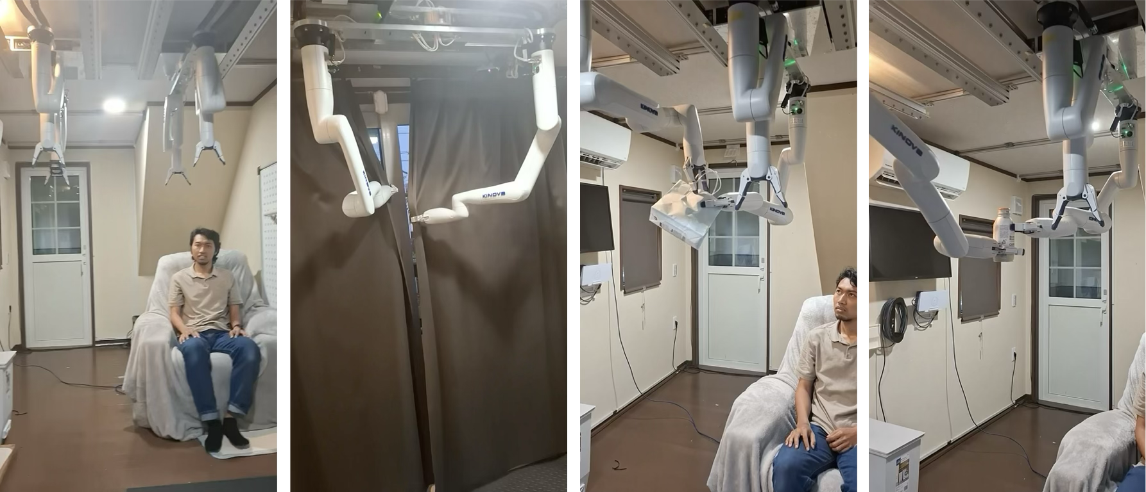
(a) (b) (c) (d)
Fig.2. Taks examples of the ceiling robot system in TLL ((a) Initial position; (b) Opening and closing curtains; (c) and (d) handover task of a bag and bottle)

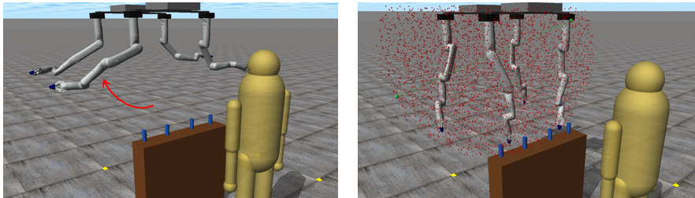
(a) Forward kinematics (b) A training data set
Fig.3. Training data generation based on kinematics

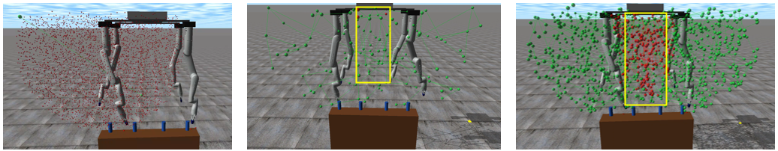
- (b) (c)
Fig.4. Action map building by multi-scale batch-learning growing cell structure

3. Topological Intelligence

We proposed the concepts of topological twins and topological intelligence. The goal of a topological twin is threefold: (1) to extract topological structures that are implicitly hidden in the real world, (2) to reproduce them in the cyber world, and (3) to simulate and analyze real-world phenomena in the cyber world. Topological twins are built using topological mapping methods such as self-organizing maps (SOM) [9] for topology preserving dimensionality reduction, growing cell structures (GCS) [10] for topology preserving incremental learning, and growing neural gas (GNG) for incremental topological clustering [11]. Topological The built topological map is used for inference, learning, search, and prediction.
Fig.3 shows an example of the ceiling robot system, where the joint variables are represented by (q₁, q₂, …, q_{n}) and the relative robot hand position is represented by (x, y, z). The relative position of the robot hand is simply calculated by the forward kinematics. First, we generate a dataset of forward kinematics from the joint values to the relative robot hand position (Fig.3). Next, we build a topological action (effectivity) map by using the relationship (inverse kinematics) from the relative robot hand position to joint values at the microscopic level (Fig.4).
Each node contains information about the position of the hand and the corresponding joint angles. Therefore, when the robot refers to the nearest node in the action map, it can obtain the posture information of that node. Consequently, inverse kinematics does not need to be solved in the trajectory planning. On the other hand, the four arms are close together. The possible collision areas, which are considered internal deadlock, are shown in light blue in Figs. 4 (b) and 4 (c). When a single robot arm is used primarily for a given task, the other arm does not enter that area.

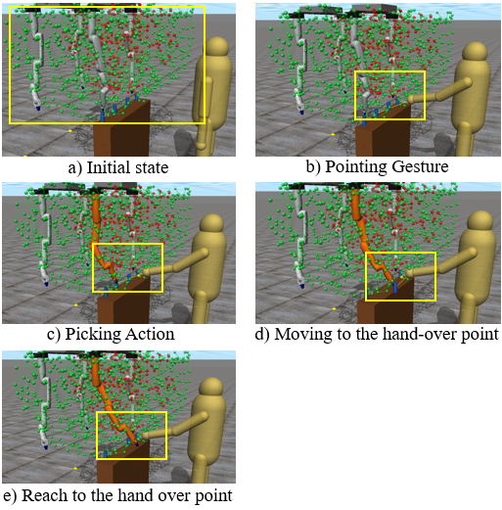
Fig.5. A simulation result of hand-over task

4. Simulation Results

This paper shows an example of hand-over task by the ceiling robot system as a preliminary simulation.
Fig.5 show a simulation result of hand-over task. First, the person points out a target object (Fig.5 (b)), and the right-frontal arm is selected in this example owing to the triangle distance between human and robot through the target object (Fig.5 (c)). The arm is moving to the hand-over point (Fig.5 (d)) and reached the target point (Fig.5 (e)).
Basically, the continuity in three-dimensional task space does not guarantee task achievability or a deadlock-free property of robot arms. On the other hand, continuity in the n-dimensional configuration space can guarantee both properties. The above action map is built in the three-dimensional task space, but the edge connectivity represents the continuity between two postures. Therefore, the trajectory generation on the action map guarantees both task achievability and deadlock-free property within the configuration space of each arm. However, the internal deadlock between two or more arms and the external deadlock with other objects cannot be completely identified on the built action map and perception map. Therefore, we will use the action map in the n-dimensional configuration as a future work.

5. Summary

This paper proposed the method of topological intelligence to specify the movable range of a dual-gantry quad-arm ceiling robot system with a topological twin built into its configuration space. Topological intelligence includes two primary approaches: topological mapping and topological utilization. The topological twin, represented as action maps, can specify the movable range of each arm and the collision possibilities of two or more arms in inverse kinematics. Preliminary simulation results demonstrated the effectiveness of topological intelligence for the dual-gantry quad-arm ceiling robot system.
Future work will involve applying the proposed method to more complicated tasks and discussing the applicability of topological intelligence to cooperative tasks with people.

References

[1] F.Ardilla, M.Yani, A.A.Saputra, W.Chin, N.Kubota, Topological mapping based on perceiving-acting cycle in sharing cognitive environments for robot partners, Communications in Information and Systems Vol.22, No.4, pp.431-458, 2022.
[2] N.Kubota, Multiscopic Topological Twin in Robotics, The 28th International Conference on Neural Information Processing, Bali, Indonesia, Online, December 8-12, 2021.
[3] W.H.Chin, N.Kubota, C.K.Loo, An Episodic-Procedural Semantic Memory Model for Continuous Topological Sensorimotor Map Building, Cognitive Robotics and Adaptive Behaviors, 2022.
[4] N.Doteguchi, N.Kubota, Topological Tracking for Mobility Support Robots Based on Multi-scale Batch-Learning Growing Neural Gas, 10th International Conference on MOBILe Wireless MiddleWARE, Operating Systems and Applications, 2021
[5] M.Watanabe, T.Obo, C.Z.Siow, N.Kubota, Topological Mapping based on Multi-Layer Growing Neural Gas for Topological Twin, In Proc. of the 2025 International Joint Conference on Neural Networks, 2025.
[6] T.Obo, N.Kubota, Y.Toda, N.Masuyama, Fast Multi-scale Batch-Learning Growing Neural Gas, Recent Advances in Intelligent Engineering (edited by L.Kovács, T.Haidegger, A.Szakál), Springer, pp. 1-12, 2024.
[7] N.Kubota, T.Miya, T.Obo, Attention and Posture in Perceiving-acting Cycle based on Topological Intelligence for Reaching Tasks of Robot Partners, 36th International Symposium on Micro-Nano Mechatronics and Human Science, 2025.
[8] N.Kubota, C.Z.Siow, T.Obo, Multiscopic Topological Twin for Cyber-physical Systems, In AI-Driven Smart Industrial Technologies (Ed. Maki K. Habib), IGI Global, pp. 151-174, 2026.
[9] T. Kohonen: Self-Organizing Maps; Springer, 2000.
[10] B. Fritzke: Unsupervised clustering with growing cell structures; Neural Networks, Vol. 2, 1991, pp 531-536.
[11] B. Fritzke: A growing neural gas network learns topologies; Advances in Neural Information Processing Systems, Vol. 7, 1995, pp. 625-632.
[12] S. A. Rahmah, M. R. H. Setyawan, T. Obo, N. Takesue, and N. Kubota, "Modeling Human–Robot Proxemics Based on Human Communication Theory: A Behavior–Interaction–Object-Dependent Approach," Appl. Sci., vol. 15, no. 23, art. no. 12516, 2025, doi: 10.3390/app152312516
[13] R. Firoozi, J. Tucker, S. Tian, A. Majumdar, J. Sun, W. Liu, Y. Zhu, S. Song, A. Kapoor, K. Hausman, B. Ichter, D. Driess, J. Wu, C. Lu, and M. Schwager, "Foundation Models in Robotics: Applications, Challenges, and the Future," arXiv preprint arXiv:2312.07843, 2023
[14] Kinova Robotics, "Gen3 lite robot — user guide/product specifications," Kinova Robotics, Boisbriand, QC, Canada, 2021. [Online]. Available: https://www.kinovarobotics.com. [Accessed: Aug. 4, 2026].
[15] FANUC Europe Corporation, "R-2000iC/220U robot." [Online]. Available: https://www.fanuc.eu/eu-en/product/robot/r-2000ic220u. [Accessed: Aug. 4, 2026].
[16] E. Ackerman, "Toyota research demonstrates ceiling-mounted home robot," IEEE Spectrum, Sep. 30, 2020. [Online]. Available: https://spectrum.ieee.org/toyota-research-ceiling-mounted-home-robot. [Accessed: Aug. 4, 2026].
[17] G. Yang, L. An, and C. Zhao, "Collision/obstacle avoidance coordination of multi-robot systems: A survey," Actuators, vol. 14, no. 2, art. no. 85, 2025, doi: 10.3390/act14020085.

