Auditing Deep Learning for Cardiac MRI Through Semantic Transitions and Conflict-Aware Production Rules⋆
Pavlo Radiuk^{1,∗,†}, Oleksander Barmak^{1,†} and Iurii Krak^{2,3,†}
¹ Khmelnytskyi National University, 11, Institutes str., Khmelnytskyi, 29016, Ukraine
² Taras Shevchenko National University of Kyiv, 64/13, Volodymyrska str., Kyiv, 01601, Ukraine
³ V.M. Glushkov Institute of Cybernetics, 40, Glushkov Ave., Kyiv, 03187, Ukraine

Abstract
Cardiac magnetic resonance (CMR) automation can accelerate ventricular analysis, but model outputs often fail to expose recognizable measurements and auditable decision logic under domain shift. In this work, we introduce a post-hoc audit framework that maps image-derived representations to 28 CMR variables through a regularized transition matrix and converts supported semantics into conflict-aware production rules. The evaluated formal representation is a deterministic 128-dimensional image-mask descriptor baseline with training-only tertile discretization. Experimental evaluation used 150 Automated Cardiac Diagnosis Challenge (ACDC) cases and an untouched 100-case Multi-Centre, Multi-Vendor and Multi-Disease cohort. On held-out ACDC, mean training-SD-normalized root-mean-square error (RMSE) was 0.767 ± 0.246; correlations for global end-diastolic wall thickness, left ventricular ejection fraction, right ventricular ejection fraction, and left ventricular end-diastolic volume were 0.928, 0.863, 0.815, and 0.710, respectively. A measured-semantic classifier achieved 0.860 accuracy and 0.861 macro-F1. The 200-rule layer achieved 0.640 coverage, 0.360 abstention, and 0.644 non-abstained balanced accuracy. External SD-normalized RMSE increased 2.25-fold to 1.726 ± 1.177. The results support semantic auditing while identifying domain shift, rule sparsity, orientation sensitivity, and the need for prospective expert validation.
Keywords
explainable artificial intelligence, cardiac magnetic resonance (CMR), transition matrix, semantic reconstruction, rough sets, production rules, abstention

Introduction
Cardiovascular magnetic resonance (CMR) provides reproducible quantitative information on ventricular anatomy and function, but clinically valid interpretation remains dependent on acquisition quality, segmentation, post-processing conventions, and measurement definitions. Artificial intelligence (AI) can accelerate acquisition and image analysis and may extend CMR toward richer phenotyping [1]. A recent translational review nevertheless identifies dataset design, external validation, deployment, multidisciplinary oversight, and regulation as persistent barriers to routine CMR AI [2]. These requirements are reinforced by standardized CMR acquisition protocols [3] and post-processing recommendations that formalize ventricular volumes, ejection fractions, myocardial mass, and related indices [4].
Public benchmarks have established strong technical foundations. ACDC demonstrated that deep models can jointly support cardiac structure segmentation and disease classification, while also exposing residual variability across structures and diagnoses [5]. The Multi-Centre, Multi-Vendor and Multi-Disease (M&Ms) challenge subsequently showed that scanner, vendor, center, and disease heterogeneity remains a major source of domain shift [6]. However, predictive performance alone does not provide an auditable account of how image-derived evidence corresponds to recognizable clinical measurements. A systematic review of cardiovascular imaging XAI found substantial methodological diversity but continuing limitations in clinically meaningful validation [7]. Human-centered analysis further shows that transparency must be defined relative to intended users and evaluated in context rather than assumed from an explanation visualization [8].
The problem under consideration is therefore the absence of a reproducible chain connecting formal image-derived representations, clinician-facing CMR semantics, and explicit symbolic evidence. Human-in-the-loop healthcare research supports exposing domain knowledge as intermediate evidence [9], whereas calibration studies show that confidence values from modern neural networks cannot be treated automatically as reliable probabilities [10]. Early-stage clinical-AI reporting guidance accordingly requires intended-use boundaries, validation evidence, uncertainty, and human oversight [11]. This requirement is consistent with the broader argument that high-stakes systems should use inspectable reasoning components whenever their assumptions are adequate [12].
The goal of this study is to improve the auditability of CMR analysis by translating fixed image-derived representations into clinician-facing semantic measurements and conflict-aware production rules. The objective of the study is to construct and evaluate a leakage-controlled post-hoc audit pipeline on internal ACDC data and an untouched external M&Ms cohort while explicitly separating audit-layer validity from deep-feature validity. The major contributions are:
- A patient-aligned formal–semantic interface with feature-level quality control, provenance tracking, and explicit exclusion of unsupported semantic targets.
- A regularized transition from 128 deterministic image–mask descriptors to 28 CMR variables, evaluated by feature-specific reconstruction error, association, and external-domain degradation.
- A conservative rough-set-style rule layer that records exact evidence, conflicting consequents, missing prerequisites, physician-predicate alignment, and reason-coded abstention.
The remainder of this paper reviews related work in Section 2, presents the methodology in Section 3, reports the experimental findings in Section 4, discusses their implications and limitations in Section 5, and concludes the study in Section 6.

Related Works
Automated CMR analysis depends first on reliable segmentation and quality control (QC). nnU-Net established a strong self-configuring biomedical segmentation baseline by adapting preprocessing, architecture, training, and post-processing to each dataset [13]; however, segmentation performance alone does not expose downstream clinical reasoning. Gonzales et al. integrated predicted segmentation quality into a deep ensemble for accountable cardiac MRI processing [14], directly motivating QC gates but not a semantic-to-symbolic audit chain. Janik et al. analyzed learned concepts in an ACDC segmentation model [15], showing that internal representations can be interrogated without producing patient-level rules. MiMICRI generates domain-centered counterfactual cardiac images by manipulating segmented structures and evaluates them with medical experts [16]; this improves semantic relevance but remains case-specific.
Medical-imaging XAI reviews provide a broader methodological context. Van der Velden et al. distinguish multiple XAI families and emphasize evaluating explanation behavior rather than visual appearance alone [17]. Borys et al. provide a clinically oriented analysis of saliency methods and their limitations [18]; such maps localize influence but do not directly quantify CMR semantics. Nauta et al. show that XAI evaluation has often relied on anecdotal evidence and argue for explicit quantitative criteria [19]. Bienefeld et al. identify systematic differences between clinician and developer mental models of explainability [20], supporting physician-facing representations rather than developer-defined latent explanations. Jin et al. report that commonly used heatmap methods did not reliably satisfy clinical requirements in a multimodal imaging task [21], further motivating auditable evidence beyond saliency.
Concept-based methods move explanations closer to human semantics. Concept bottleneck models introduce an explicit intermediate concept layer that supports intervention and inspection [22], but they generally require concept supervision and architectural integration. TCAV provides a post-hoc alternative by measuring model sensitivity to user-defined concept directions [23]. TCAV quantifies conceptual relevance without yielding a global symbolic decision policy.
The present framework follows a transition-matrix lineage. Our original work on this topic introduced transition matrices as visual-analytics mappings between formal and interpretable feature spaces [24]. Barmak et al. adapted this mapping to healthcare features understandable to domain experts [25]. SEMTRA subsequently combined global semantic transition with discretization and rough-set rule induction [26]; the current CMR study narrows that framework to patient-level auditability and uses training-only tertiles of full WEDD.
Rough-set theory supplies lower approximations and boundary regions for inconsistent decision tables [27], while reject-option theory formalizes withholding a decision when evidence is insufficient [28]. For transition evaluation, Mean absolute error (MAE) provides a directly interpretable absolute-error summary and complements root-mean-square error (RMSE) [29]. Pearson correlation measures linear association [30], but association alone cannot establish agreement and should be reported with absolute error, bias, and uncertainty.
In summary, the literature leaves a specific gap: existing CMR pipelines address segmentation, QC, local explanation, concepts, or counterfactuals, whereas transition-based work provides semantic mappings without a CMR-specific externally tested audit protocol. The proposed contributions address these omissions by combining patient-level provenance, measured CMR semantics, leakage-controlled transition fitting, feature-level QC, conflict-aware rough rules, explicit abstention, physician-style predicate alignment, and external-domain assessment in one reproducible research pipeline.

Methods
The method is a post-hoc audit layer that preserves a patient-level chain from native cine images and masks to a fixed formal representation, reconstructed measurements, symbolic states, rule provenance, conflict, and reason-coded abstention. The methodological outline is organized as follows: Section 3.1 defines the representation interface and scope; Section 3.2 specifies cohorts, splits, and QC; Section 3.3 formalizes the transition; Section 3.4 defines discretization and rule inference; Section 3.5 specifies predicate alignment; and Section 3.6 defines the evaluation protocol.

Approach Structure and Scope
In the reported experiments, the formal matrix is not produced by a trained deep encoder. It is generated deterministically from end-diastolic (ED) and end-systolic (ES) cine images and masks. For background, left-ventricular (LV) blood pool, right-ventricular (RV) blood pool, and LV myocardium, the extractor computes phase-specific intensity statistics and occupancy; for the three cardiac labels it also retains ED occupancy, ES occupancy, and their difference. The resulting 57 descriptors are mapped to 128 coordinates by a fixed Gaussian projection seeded by 20260611, with the first 32 coordinates preserving direct channels. This baseline was chosen to isolate the audit layer; the same interface can accept a frozen learned encoder in future work. No orientation normalization or rotational augmentation was applied in the reported descriptor extraction.
The measured semantic matrix contains LV/RV end-diastolic volume (EDV), end-systolic volume (ESV), stroke volume (SV), ejection fraction (EF), LV myocardial volumes and mass, LV–RV SV discrepancy, ED/ES wall thickness and wall thickening, chamber areas, compactness, eccentricity, and LV long-axis length. Accordingly, left-ventricular ejection fraction (LVEF), right-ventricular ejection fraction (RVEF), left-ventricular end-diastolic volume (LVEDV), and right-ventricular end-diastolic volume (RVEDV) denote the corresponding chamber-specific measures used below. The transition reconstructs ; eligible semantics are discretized into , and the rulebook returns one auditable consequent or a typed abstention. Transition coefficients are regularized associations, not causal effects or diagnostic criteria.
Figure 1 summarizes the audit architecture.
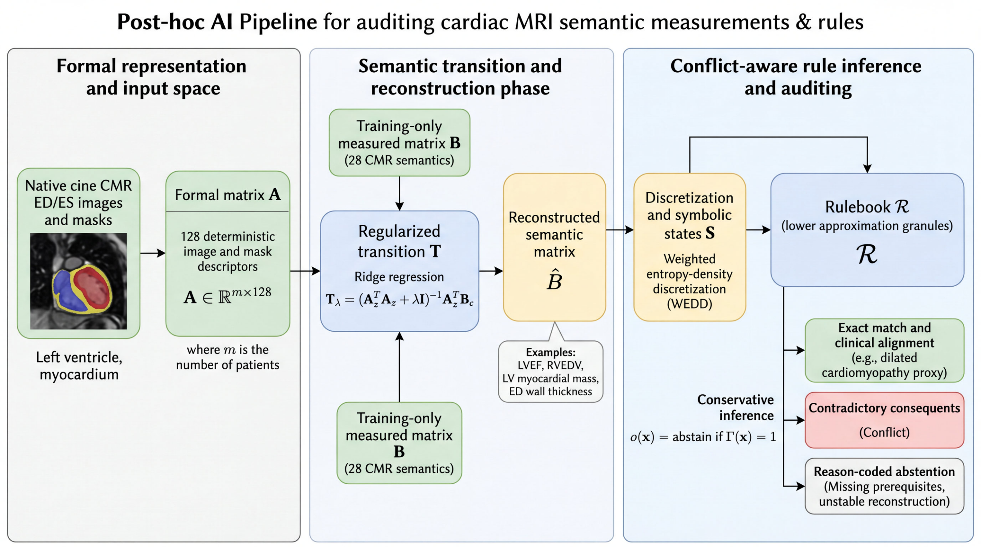
Figure 1: Post-hoc CMR audit architecture. Training-only measured semantics supervise the transition; held-out inference exposes reconstructed semantics, rule provenance, conflict, and abstention without refitting.

Datasets, Splits, and Quality Control
ACDC supplied 150 annotated studies in five balanced categories. A fixed patient-disjoint split assigned 85 cases to training, 15 to validation, and 50 to final testing. The external branch contained 100 M&Ms cases selected once with seed 20260611. Validation, test, and external rows were excluded from every fitted imputation statistic, clipping limit, scaler, regularization choice, transition coefficient, discretization cut, classifier parameter, and rule. Stable `sample_id` values linked each matrix row to its source image, mask, metadata, and label. QC checked readability, ED/ES pairing, label domains, voxel spacing, nonempty LV/RV/myocardial masks, plausible volume/EF ranges, finite features, and exact – row identity. Feature-level failures blocked only dependent semantics and predicates; high/moderate findings entered manual-review triage with basal, mid-ventricular, and apical overlays. Automated triage identifies cases requiring review but does not constitute expert adjudication. The use of explicit quality prediction is consistent with recent accountable CMR segmentation work [14].

Phase 1: Formal-to-Semantic Transition
All preprocessing was learned from the 85 training rows: semantic missing values were median-imputed, targets were clipped to their training 1st–99th percentiles, formal columns were standardized, and semantic columns were centered. With standardized , centered , and ridge penalty λ, the transition minimizes the objective in Equation (1):
(1)
The implementation uses the standard closed-form ridge solution in Equation (2):
(2)
For a held-out standardized row , reconstruction is defined in Equation (3):
(3)
Five-fold stratified cross-validation was restricted to training data and searched ; each fold refitted all preprocessing. Candidates were ranked by validation RMSE and then MAE, with solutions within 0.1 % of the minimum favoring the larger penalty. The selected λ = 3, feature order, projection checksum, preprocessing state, and transition were frozen before validation, test, and external inference.

Phase 2: Discretization, Rough Granulation, and Inference
The current experimental release does not implement the full Weighted Entropy–Density Discretization (WEDD) optimizer. Instead, each eligible semantic feature j is discretized by training-only tertiles and , frozen before held-out inference according to Equation (4):
(4)
This quantile scheme is a documented approximation to the WEDD stage described in the parent framework [26]; consequently, no result in this paper is claimed to validate full WEDD or to show superiority over alternative discretizers.
The discretized training table is treated as a rough-set decision system [27]. Cases sharing the same eligible condition states form an indiscernibility granule; a granule enters the lower approximation only when its members share one consequent. Rules have the form shown in Equation (5):
(5)
The release retains at most three antecedents, support of at least three training cases, and confidence of at least 0.60. Exact compatible rules fire at inference. If severe QC, unstable reconstruction, a missing prerequisite, no match, or contradictory consequents are present, the output follows Equation (6):
(6)
where records the reason; soft similarity never overrides this guard.

Physician-Style Predicates and Similarity
The predicate library represents cine-supported proxies for dilated and hypertrophic cardiomyopathy, abnormal RV or arrhythmogenic right ventricular cardiomyopathy (ARVC)-like morphology/function, myocardial-infarction remodeling, conservative normality, and review triggers. Tissue characterization, noncompaction, inflammatory or infiltrative disease, flow-dependent valvular disease, and complex congenital anatomy remain unsupported when required sequences or measurements are absent. For physician predicate and eligible rule , similarity is defined in Equation (7):
(7)
where is feature compatibility, is clinical weight, and encode conflict, missing evidence, instability, and safe abstention.
The best match is the maximum-similarity rule satisfying support, confidence, prerequisite, and validity gates; no missing prerequisite can be compensated by a high similarity score.

Outcomes and Statistical Protocol
MAE and RMSE use standard definitions [29]; Pearson correlation follows the conventional product-moment definition [30]. To compare targets measured in mL, percentage points, mm, g, and dimensionless units, RMSE was normalized by the ACDC-training standard deviation , as defined in Equation (8):
(8)
Equation (8) is used only for across-target aggregation; mixed-unit MAE/RMSE means are descriptive. Feature-level reporting included Pearson/Spearman correlations, signed bias, Bland–Altman limits, 1,000-resample bias-corrected and accelerated (BCa) 95 % confidence intervals (CIs) for MAE, and Benjamini–Hochberg false-discovery-rate control at 0.05.
A median-imputed, standardized multinomial logistic regression trained on measured served as a transparent comparator. Expected calibration error (ECE) used ten equal-mass confidence bins as in Guo et al. [10]. Rule evaluation reported coverage (at least one fired consequent), typed-abstention rate, conflict among covered cases, and balanced accuracy plus macro-F1 on non-abstained cases; coverage and abstention were always reported with selective accuracy to avoid inflated interpretation. Fixed seeds governed partitioning, external-case selection, projection, bootstrapping, and perturbation sampling.
For perturbation τ on the fixed 12-case set Q, the relative formal-space change is defined as follows:
(9)
Equation (9) normalizes descriptor drift by the unperturbed formal-vector magnitude for each case. The corresponding mean absolute semantic change across the 28 reconstructed targets is defined as follows:
(10)
Equation (10) measures aggregate semantic drift after the frozen transition. The exploratory transformations were 5 % intensity scaling, one-pixel translations on each in-plane axis, and a 2° rotation. Because in Equation (10) mixes units, it ranks sensitivity only. The reported release deliberately leaves images in their dataset-native orientation; based on the perturbation test, prospective implementations should canonicalize image orientation from spatial metadata before descriptor extraction and, when learned encoders are used, evaluate small-angle rotational augmentation on training data only.
Overall, Algorithm 1 specifies the semantic-transition and conflict-aware CMR audit pipeline.
Algorithm 1: Semantic-transition and conflict-aware CMR audit pipeline.
Input: Patient-disjoint ACDC training/validation/test partitions; external M&Ms cohort; paired ED/ES cine images, masks, metadata, and labels.
- Validate and lock cohorts. Verify data integrity, patient independence, QC conditions, and – row alignment; then freeze all held-out cohorts.
- Fit the semantic transition. Learn preprocessing and on training data only, estimate using Equations (1) and (2), and reconstruct held-out semantics using Equation (3).
- Discretize eligible semantics. Map valid semantic features to symbolic states using the frozen training tertiles defined in Equation (4).
- Induce production rules. Form rough-set granules and retain compact rules satisfying the support and confidence constraints in Equation (5).
- Perform guarded inference. Fire compatible rules and apply Equation (6) to return either a single admissible consequent or a reason-coded abstention.
- Align clinical predicates. Match supported physician-style predicates to eligible rules using Equation (7) and the required evidence checks.
- Evaluate semantic fidelity. Report feature-wise errors and the normalized error defined in Equation (8), together with correlation, bias, uncertainty, and external-shift evidence.
- Assess perturbation robustness. Measure formal-space and semantic drift on the fixed perturbation subset using Equations (9) and (10).
Output: Frozen transition , reconstructed semantics , symbolic states , rulebook , audit reports, and reason-coded outputs .

Results
Results follow the audit chain: cohort/QC integrity in Section 4.1, semantic reconstruction in Section 4.2, transparent classification and rule behavior in Section 4.3, predicate alignment in Section 4.4, perturbation sensitivity in Section 4.5, and comparison with published ACDC systems in Section 4.6.

Cohort and QC Evidence
All 250 records retained stable identifiers and exact – order. ACDC contained 85 training cases (56.7 %), 15 validation cases (10.0 %), and 50 test cases (33.3 %); all 100 M&Ms cases were external only. All 20 programmed semantic-matrix gates passed. The workflow generated 53 ACDC and 65 M&Ms overlay panels. Manual-review triage contained 92 cases across the combined 250-case cohort; this is unresolved review workload, not 92 confirmed segmentation errors or completed expert validation. Table 1 summarizes the cohort and release-level QC evidence.
Table 1
Cohort and release-level QC evidence for the experiments. The final two rows explicitly state whether values are per cohort or combined.
Audit item | ACDC | M&Ms | Scope / interpretation
Patient-level cases | 150 | 100 | ACDC: 85/15/50 train/validation/test; M&Ms: external only.
Semantic validation checks | 10/10 | 10/10 | All programmed gates passed.
Native overlay panels | 53 | 65 | ED/ES image–mask panels generated.
Semantic targets per case | 28 | 28 | Same semantic schema evaluated in each cohort.
Pending manual-review cases | – | – | 92 total across ACDC + M&Ms; dataset-specific split was not used.

Semantic Reconstruction Across Datasets
Across 28 targets, mean training-SD-normalized RMSE was 0.510 ± 0.148 in training, 0.814 ± 0.409 in validation, 0.767 ± 0.246 on held-out ACDC, and 1.726 ± 1.177 on external M&Ms. Table 2 summarizes these unit-normalized aggregate errors. External NRMSE was 2.25 times the ACDC-test value, demonstrating substantial domain shift.
Table 2
Aggregate transition reconstruction over 28 targets. RMSE and MAE means combine units and are descriptive only.
Dataset | Split | SD-NRMSE | RMSE mean | MAE mean
ACDC | train | 0.510 ± 0.148 | 33.18 | 26.49
ACDC | validation | 0.814 ± 0.409 | 58.42 | 46.49
ACDC | test | 0.767 ± 0.246 | 51.65 | 38.64
M&Ms | external | 1.726 ± 1.177 | 85.35 | 69.81

Figure 2 shows the descriptive mixed-unit MAE/RMSE means; only NRMSE supports across-target comparisons.
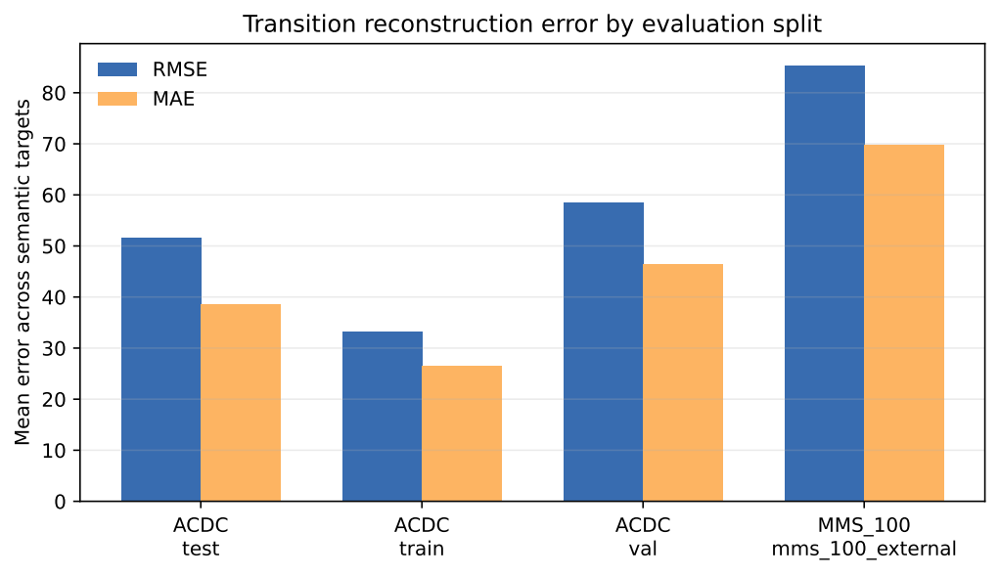
Figure 2: Transition reconstruction error by split. Bars are descriptive mixed-unit means.
Held-out ACDC fidelity was strongly target-dependent. Global ED wall thickness had r = 0.928, LVEF 0.863, RVEF 0.815, RVEDV 0.766, and LVEDV 0.710, whereas LV myocardial mass was 0.517. Table 3 reports the corresponding feature-level errors, correlations, and uncertainty.
Table 3
Held-out ACDC transition results (n = 50); intervals are 1,000-resample BCa 95 % CIs for MAE.
Target | RMSE | MAE (95 % CI) | Pearson r | Bias
Global ED wall thickness (mm) | 0.83 | 0.59 (0.46–0.79) | 0.928 | –0.11
LVEF (percentage points) | 11.38 | 9.17 (7.52–11.16) | 0.863 | –1.93
RVEF (percentage points) | 8.87 | 7.52 (6.33–8.91) | 0.815 | 3.56
LVEDV (mL) | 5.86 | 4.88 (4.02–5.75) | 0.710 | –2.12
RVEDV (mL) | 9.75 | 6.37 (4.89–9.19) | 0.766 | –3.13
LV myocardial mass ED (g) | 4.60 | 3.83 (3.17–4.58) | 0.517 | –1.46

Figure 3 visualizes the high-impact correlations. LVEF MAE was 9.17 percentage points despite high correlation, so threshold-near rule antecedents require guarding. LVEDV had MAE 4.88 mL and bias –2.12 mL, illustrating that low mean bias does not guarantee patient-level fidelity.
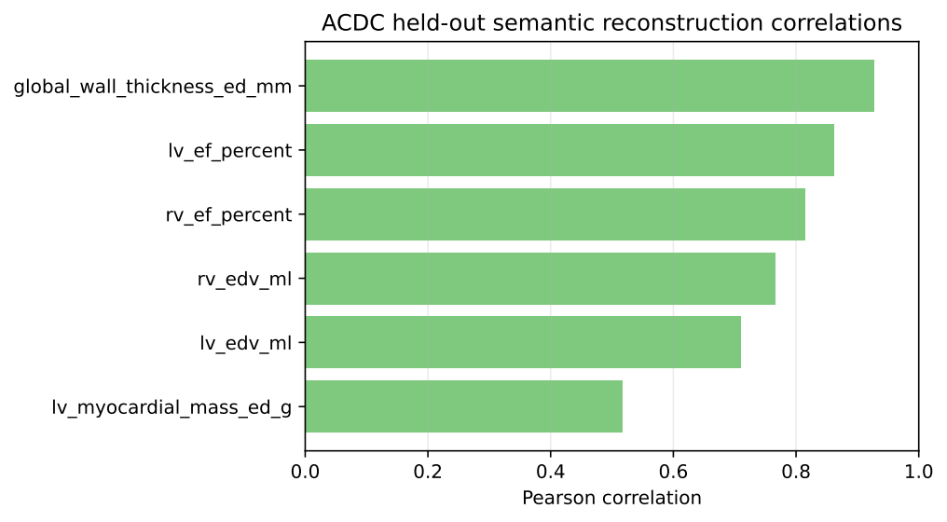
Figure 3: Held-out ACDC Pearson correlations for clinically high-impact semantic targets.
External failure was concentrated in scale-sensitive targets. M&Ms wall thickness remained comparatively stable (r = 0.816, RMSE 0.99 mm), whereas LVEF and RVEF correlations fell to 0.670 and 0.584. LVEDV bias changed from –2.12 to –136.0 mL and myocardial-mass bias from –1.46 to –96.6 g. These targets therefore require external recalibration or exclusion before rule inference.

Transparent Classification and Symbolic Audit
The measured-semantic comparator classified 43 of 50 held-out ACDC cases correctly (accuracy and balanced accuracy 0.860), with macro-F1 0.861 and one-vs-rest macro area under the receiver operating characteristic curve (AUROC) 0.973. Table 4 reports the comparator metrics and row-bootstrap uncertainty.
Table 4
Transparent classifier performance on measured ACDC semantics. ECE uses ten equal-mass bins.
Split | Accuracy | Bal. acc. | Macro-F1 | AUROC | ECE | n
Validation | 0.933 | 0.933 | 0.931 | 1.000 | 0.103 | 15
Test | 0.860 | 0.860 | 0.861 | 0.973 | 0.179 | 50

The 95 % CIs were 0.76–0.94 for accuracy, 0.75–0.95 for balanced accuracy, 0.75–0.94 for macro-F1, and 0.947–0.993 for AUROC. ECE increased from 0.103 in validation to 0.179 on test data. The 200-rule layer covered 32 of 50 test cases (0.640) and abstained on 18 (0.360). On non-abstained cases, balanced accuracy was 0.644 and macro-F1 0.612; covered-case conflict was 0.313, and 0.560 of all test cases encountered at least one conflicting rule during resolution. Table 5 reports the selective rulebook metrics.
Table 5
Rulebook performance. Balanced accuracy and macro-F1 are computed over non-abstained cases.
Split | Coverage | Abstain | Bal. acc. | Macro-F1 | Conflict | Conf. seen | n
Train | 0.565 | 0.435 | 1.000 | 1.000 | 0.229 | 0.565 | 85
Validation | 0.667 | 0.333 | 1.000 | 1.000 | 0.300 | 0.533 | 15
Test | 0.640 | 0.360 | 0.644 | 0.612 | 0.313 | 0.560 | 50

Figure 4 contrasts the semantic comparator with rulebook outcomes.
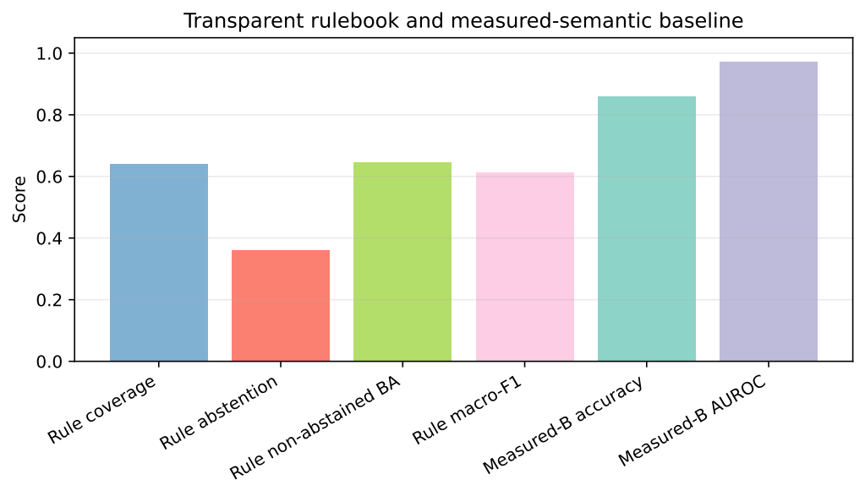
Figure 4: Held-out classifier and rulebook outcomes. Coverage and abstention accompany rule accuracy to prevent selective-performance inflation.
These values materially limit practical utility: the rulebook is not a standalone classifier and is not suitable for clinical deployment. Its present value is selective auditability—showing exactly where sparse antecedents agree, conflict, or fail to support a decision. The perfect training/validation non-abstained scores therefore reflect selective, over-specific granules rather than reliable generalization.

Predicate Alignment and Unsupported Evidence
The strongest admissible similarity was 0.9008 for abnormal RV/ARVC-like morphology or function, followed by hypertrophic cardiomyopathy (0.8564), myocardial-infarction remodeling (0.8250), and dilated cardiomyopathy (0.7858). Table 6 reports the admissible predicate evidence.
Table 6
Physician-predicate alignment and evidence status
Predicate family | Evidence status | Best similarity
Abnormal RV/ARVC proxy | cine-mask proxy | 0.9008
Hypertrophic cardiomyopathy proxy | cine-mask proxy | 0.8564
Myocardial-infarction remodeling proxy | cine proxy | 0.8250
Dilated cardiomyopathy proxy | cine-mask proxy | 0.7858
Valvular disease volume review | review proxy | 0.7825
Congenital candidate review | research approximation | 0.6842
Conservative normal-state filter | research filter | 0.5462
Restrictive/noncompaction/inflammatory/infiltrative | unsupported | unmatched

Figure 5 visualizes the corresponding similarity scores.
Valvular and congenital proxies remained review-only. Restrictive cardiomyopathy, noncompaction, inflammatory disease, and infiltrative disease were unmatched because cine masks lack the required tissue-characterization evidence; the abstention guard prevented similarity from manufacturing unsupported disease claims.
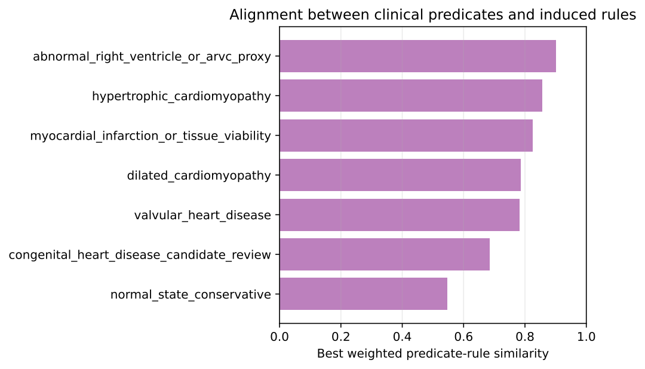
Figure 5: Maximum weighted similarity between physician-style predicates and eligible production rules; unsupported predicates are not forced to match.

Perturbation Diagnostics
All 48 case–transformation runs completed. Table 7 summarizes the four perturbation conditions.
Table 7
Exploratory perturbation summary over 12 sampled cases; semantic change is a mixed-unit mean.
Perturbation | Relative formal change | Semantic change | Mask-count change
Intensity scale 5 % | 1.1 × 10^-8 | 8.8 × 10^-6 | 0
Translation x, 1 px | 0.002591 | 0.622935 | 0
Translation y, 1 px | 0.002135 | 0.545662 | 0
Rotation, 2° | 0.053114 | 9.821420 | 0.000470

The 5 % intensity scaling was numerically negligible, and one-pixel translations produced small formal changes with semantic changes of 0.623 and 0.546. By contrast, a 2° rotation produced relative formal change 0.0531 and mixed-unit semantic change 9.8214, about 20–25 times and 16–18 times the corresponding translation responses. Mask-count change remained 0.000470, indicating orientation sensitivity of the descriptors rather than gross label loss. Because only 12 cases were tested and semantic change mixes units, this is a diagnostic warning rather than a clinical tolerance. The result directly supports canonical orientation normalization before deterministic descriptor extraction and, for future learned encoders, training-only rotational augmentation; neither mitigation is retroactively claimed for the present metrics.

Quantitative Comparison with ACDC State-of-the-Art Systems
Table 8 provides task-aware error and diagnostic-accuracy context rather than a leaderboard claim. The proposed diagnostic accuracy was 0.100 below Khened and 0.060 below Isensee. LVEDV MAE (4.88 mL) was comparable to the reported 4.20 and 5.10 mL, but LVEF MAE (9.17 points) was substantially worse than 2.50 and 2.10 points. Mass MAE was lower descriptively, yet the correlation comparison below shows that this did not imply comparable patient-level fidelity.
Table 9 separately reports correlation, bias, and audit metrics. Bernard et al. [5] evaluated systems that jointly optimized segmentation-derived clinical indices and five-class diagnosis on the official challenge protocol, whereas the present audit uses an independent 85/15/50 split and a deterministic formal representation.
Table 8
Task-aware quantitative context on ACDC test cases. MAE units are mL, percentage points, percentage points, and g, respectively. Dashes indicate unreported audit outputs.
System | Source | Diag. acc. | LVEDV MAE | LVEF MAE | RVEF MAE | Mass MAE | Rule cov./BA
Khened challenge system | [5] | 0.960 | 4.20 | 2.50 | 5.30 | 6.30 | –/–
Isensee challenge system | [5] | 0.920 | 5.10 | 2.10 | 4.70 | 7.30 | –/–
Proposed transition + semantic baseline | This study | 0.860 | 4.88 | 9.17 | 7.52 | 3.83 | 0.640  / 0.644
Table 9
ACDC clinical-index correlation and signed bias. EF bias is in percentage points, LVEDV bias in mL, and mass bias in g. Audit metrics are coverage/abstention/conflict.
System | LVEF r/bias | RVEF r/bias | LVEDV r/bias | Mass r/bias | Audit metrics
Isensee ACDC system | 0.991/+0.5 | 0.925/–3.0 | 0.997/+1.5 | 0.986/–4.0 | –/–/–
Khened ACDC system | 0.989/–0.5 | 0.858/–2.2 | 0.997/+0.6 | 0.990/–2.9 | –/–/–
Proposed transition and rule audit | 0.863/–1.93 | 0.815/+3.56 | 0.710/–2.12 | 0.517/–1.46 | 0.640 / 0.360 / 0.313

The audit transition trailed the published systems in all four listed correlations; in particular, mass correlation was 0.517 versus 0.986–0.990 despite smaller mean bias. Different splits and objectives preclude a controlled ranking. The contribution is therefore complementary: explicit semantic reconstruction, external-failure evidence, conflict, abstention, and rule provenance rather than diagnostic superiority.

Discussion
The study demonstrates an auditable chain from native CMR images and masks to deterministic formal descriptors, reconstructed measurements, symbolic conditions, and selective rule outputs. This chain should not be conflated with an evaluation of deep latent representations: the current formal space is handcrafted and deterministic. The transition is intentionally linear and inspectable, but its coefficients remain associations rather than causal physiological effects. This restraint is consistent with clinical XAI evidence showing that visually plausible attribution maps can fail requirements for truthfully representing model decision processes and decision quality [21].
Three limitations of this study should be highlighted. First, semantic fidelity is target- and domain-dependent, with substantial deterioration on external M&Ms data; scale-sensitive volume and mass targets require recalibration or exclusion before external rule use. Second, the reported discretizer is a training-quantile approximation, not the complete WEDD optimizer, so full WEDD requires a direct leakage-controlled ablation against quantiles and alternative discretizers. Third, the rule layer’s 0.640 coverage and 0.644 non-abstained balanced accuracy materially limit practical utility. The rulebook should therefore be interpreted only as a selective audit artifact that exposes supported, conflicting, and unsupported evidence; it is neither a diagnostic classifier nor a clinically validated decision-support system.
The perturbation experiment identifies a specific engineering weakness rather than a generic robustness claim. A 2° rotation caused the largest change while mask counts were nearly preserved, implicating orientation-sensitive descriptors. Prospective revisions should canonicalize orientation from image spatial metadata before deterministic extraction and evaluate small-angle rotational augmentation when a learned encoder is trained. The current results were not recomputed after such a change, avoiding a post-hoc claim unsupported by the reported experiment. Manual-review triage is also incomplete, and cine-only data cannot support tissue, flow, or complex congenital conclusions.
The next validation stage should attach the same audit layer to frozen high-performing CMR encoders on common patient splits, compare full WEDD with the current quantile approximation, perform vendor-aware recalibration, complete expert QC adjudication, and prospectively test whether provenance, conflict, and abstention improve clinician decisions. These steps align the work with evidence that clinicians prioritize contextual clinical plausibility in XAI and with early-stage clinical-AI evaluation principles.

Conclusion
This study evaluated a transition-matrix and conflict-aware rule layer on 150 ACDC and 100 external M&Ms cases. The reported formal representation is a deterministic image–mask descriptor baseline rather than a trained deep encoder, and the discretization stage uses frozen training tertiles rather than full WEDD. On held-out ACDC, mean SD-NRMSE was 0.767 ± 0.246; LVEF, RVEF, and LVEDV correlations were 0.863, 0.815, and 0.710. The measured-semantic comparator achieved 0.860 accuracy and 0.861 macro-F1. The 200-rule layer provided 0.640 coverage, 0.360 abstention, 0.313 conflict, and 0.644 non-abstained balanced accuracy, which restricts its present role to selective auditing. External SD-NRMSE increased 2.25-fold to 1.726 ± 1.177, and the rotation diagnostic exposed orientation sensitivity. Accordingly, the current evidence supports transparent failure-aware auditing, not autonomous diagnosis or completed clinical validation.
Future work should evaluate frozen deep encoders on common splits, implement and ablate full WEDD, canonicalize orientation and test rotation-aware training, complete expert adjudication, and assess the audit outputs prospectively with clinicians.

Declaration on Generative AI
During the preparation of this work, the authors utilized generative AI tools to enhance the linguistic quality of this manuscript. The language model Gemini 3.1 Pro Preview (Google LLC) and the language service Grammarly (Grammarly, Inc.) were employed for copyediting assistance, specifically to refine grammar, spelling, and stylistic consistency. Following this, the authors conducted a comprehensive review and revision, ensuring all content accurately reflects their research and conclusions. The authors retain full responsibility for the scientific integrity and final content of this paper.

References
- S. B. Patil, Y. P. Patil, K. S. Patil, N. Bandaru, M. S. Gambhire, Integrating AI in cardiovascular systems: innovations in diagnosis, risk prediction, and management, Cardiovascular & Hematological Disorders-Drug Targets 26 (2026) 1–18. doi:10.2174/011871529X414660251209135356.
- Q. Zhang, A. Fotaki, S. Ghadimi, Y. Wang, M. Doneva, J. Wetzl, J. G. Delfino, D. P. O’Regan, C. Prieto, F. H. Epstein, Improving the efficiency and accuracy of cardiovascular magnetic resonance with artificial intelligence—review of evidence and proposition of a roadmap to clinical translation, Journal of Cardiovascular Magnetic Resonance 26 (2024) 101051. doi:10.1016/j.jocmr.2024.101051.
- C. M. Kramer, J. Barkhausen, C. Bucciarelli-Ducci, S. D. Flamm, R. J. Kim, E. Nagel, Standardized cardiovascular magnetic resonance imaging (CMR) protocols: 2020 update, Journal of Cardiovascular Magnetic Resonance 22 (2020) 17. doi:10.1186/s12968-020-00607-1.
- J. Schulz-Menger, D. A. Bluemke, J. Bremerich, S. D. Flamm, M. A. Fogel, M. G. Friedrich, R. J. Kim, F. von Knobelsdorff-Brenkenhoff, C. M. Kramer, D. J. Pennell, S. Plein, E. Nagel, Standardized image interpretation and post-processing in cardiovascular magnetic resonance—2020 update: Society for cardiovascular magnetic resonance (SCMR) board of trustees task force on standardized post-processing, Journal of Cardiovascular Magnetic Resonance 22 (2020) 19. doi:10.1186/s12968-020-00610-6.
- O. Bernard et al., Deep learning techniques for automatic MRI cardiac multi-structures segmentation and diagnosis: is the problem solved?, IEEE Transactions on Medical Imaging 37 (2018) 2514–2525. doi:10.1109/TMI.2018.2837502.
- V. M. Campello et al., Multi-centre, multi-vendor and multi-disease cardiac segmentation: the M&Ms challenge, IEEE Transactions on Medical Imaging 40 (2021) 3543–3554. doi:10.1109/TMI.2021.3090082.
- M. Haupt, M. H. Maurer, R. P. Thomas, Explainable artificial intelligence in radiological cardiovascular imaging—a systematic review, Diagnostics 15 (2025) 1399. doi:10.3390/diagnostics15111399.
- H. Chen, C. Gomez, C.-M. Huang, M. Unberath, Explainable medical imaging AI needs human-centered design: guidelines and evidence from a systematic review, npj Digital Medicine 5 (2022) 156. doi:10.1038/s41746-022-00699-2.
- P. Radiuk, O. Kovalchuk, V. Slobodzian, E. Manziuk, O. Barmak, I. Krak, Human-in-the-loop approach based on MRI and ECG for healthcare diagnosis, in: N. Shakhovska, S. Chrétien, I. Izonin, J. Campos (Eds.), Proceedings of the 5th International Conference on Informatics & Data-Driven Medicine (IDDM 2022), volume 3302 of CEUR Workshop Proceedings, CEUR-WS.org, Lyon, France, 2022, pp. 9–20. URL: https://ceur-ws.org/Vol-3302/paper1.pdf.
- C. Guo, G. Pleiss, Y. Sun, K. Q. Weinberger, On calibration of modern neural networks, in: D. Precup, Y. W. Teh (Eds.), Proceedings of the 34th International Conference on Machine Learning, volume 70 of Proceedings of Machine Learning Research, PMLR, Sydney, Australia, 2017, pp. 1321–1330. URL: https://proceedings.mlr.press/v70/guo17a.html.
- B. Vasey, M. Nagendran, B. Campbell, D. A. Clifton, G. S. Collins, S. Denaxas, A. K. Denniston, L. Faes, B. Geerts, M. Ibrahim, X. Liu, B. A. Mateen, P. Mathur, M. D. McCradden, L. Morgan, J. Ordish, C. Rogers, S. Saria, D. S. W. Ting, P. Watkinson, W. Weber, P. Wheatstone, P. McCulloch, DECIDE-AI Expert Group, Reporting guideline for the early-stage clinical evaluation of decision support systems driven by artificial intelligence: DECIDE-AI, Nature Medicine 28 (2022) 924–933. doi:10.1038/s41591-022-01772-9.
- C. Rudin, Stop explaining black box machine learning models for high stakes decisions and use interpretable models instead, Nature Machine Intelligence 1 (2019) 206–215. doi:10.1038/s42256-019-0048-x.
- F. Isensee, P. F. Jaeger, S. A. A. Kohl, J. Petersen, K. H. Maier-Hein, nnU-Net: a self-configuring method for deep learning-based biomedical image segmentation, Nature Methods 18 (2021) 203–211. doi:10.1038/s41592-020-01008-z.
- R. A. Gonzales, D. H. Ibáñez, E. Hann, I. A. Popescu, M. K. Burrage, Y. P. Lee, İ. Altun, W. S. Weintraub, R. Y. Kwong, C. M. Kramer, S. Neubauer, Hypertrophic Cardiomyopathy Registry (HCMR) Investigators, Oxford Acute Myocardial Infarction (OxAMI) Study, V. M. Ferreira, Q. Zhang, S. K. Piechnik, Quality control-driven deep ensemble for accountable automated segmentation of cardiac magnetic resonance LGE and VNE images, Frontiers in Cardiovascular Medicine 10 (2023) 1213290. doi:10.3389/fcvm.2023.1213290.
- A. Janik, J. Dodd, G. Ifrim, K. Sankaran, K. M. Curran, Interpretability of a deep learning model in the application of cardiac MRI segmentation with an ACDC challenge dataset, in: I. Išgum, B. A. Landman (Eds.), Medical Imaging 2021: Image Processing, volume 11596 of Proceedings of SPIE, SPIE, 2021, p. 1159636. doi:10.1117/12.2582227.
- G. Guo, L. Deng, A. Tandon, A. Endert, B. C. Kwon, MiMICRI: towards domain-centered counterfactual explanations of cardiovascular image classification models, in: Proceedings of the 2024 ACM Conference on Fairness, Accountability, and Transparency, Association for Computing Machinery, Rio de Janeiro, Brazil, 2024, pp. 1861–1874. doi:10.1145/3630106.3659011.
- B. H. M. van der Velden, H. J. Kuijf, K. G. A. Gilhuijs, M. A. Viergever, Explainable artificial intelligence (XAI) in deep learning-based medical image analysis, Medical Image Analysis 79 (2022) 102470. doi:10.1016/j.media.2022.102470.
- K. Borys, Y. A. Schmitt, M. Nauta, C. Seifert, N. Krämer, C. M. Friedrich, F. Nensa, Explainable AI in medical imaging: an overview for clinical practitioners—saliency-based XAI approaches, European Journal of Radiology 162 (2023) 110787. doi:10.1016/j.ejrad.2023.110787.
- M. Nauta, J. Trienes, S. Pathak, E. Nguyen, M. Peters, Y. Schmitt, J. Schlötterer, M. van Keulen, C. Seifert, From anecdotal evidence to quantitative evaluation methods: a systematic review on evaluating explainable AI, ACM Computing Surveys 55 (2023) 295:1–295:42. doi:10.1145/3583558.
- N. Bienefeld, J. M. Boss, R. Lüthy, D. Brodbeck, J. Azzati, M. Blaser, J. Willms, E. Keller, Solving the explainable AI conundrum by bridging clinicians’ needs and developers’ goals, npj Digital Medicine 6 (2023) 94. doi:10.1038/s41746-023-00837-4.
- W. Jin, X. Li, G. Hamarneh, Evaluating explainable AI on a multi-modal medical imaging task: can existing algorithms fulfill clinical requirements?, Proceedings of the AAAI Conference on Artificial Intelligence 36 (2022) 11945–11953. doi:10.1609/aaai.v36i11.21452.
- P. W. Koh, T. Nguyen, Y. S. Tang, S. Mussmann, E. Pierson, B. Kim, P. Liang, Concept bottleneck models, in: H. D. III, A. Singh (Eds.), Proceedings of the 37th International Conference on Machine Learning, volume 119 of Proceedings of Machine Learning Research, PMLR, 2020, pp. 5338–5348. URL: https://proceedings.mlr.press/v119/koh20a.html.
- B. Kim, M. Wattenberg, J. Gilmer, C. J. Cai, J. Wexler, F. B. Viégas, R. Sayres, Interpretability beyond feature attribution: quantitative testing with concept activation vectors (TCAV), in: J. Dy, A. Krause (Eds.), Proceedings of the 35th International Conference on Machine Learning, volume 80 of Proceedings of Machine Learning Research, PMLR, 2018, pp. 2668–2677. URL: https://proceedings.mlr.press/v80/kim18d.html.
- P. Radiuk, O. Barmak, E. Manziuk, I. Krak, Explainable deep learning: a visual analytics approach with transition matrices, Mathematics 12 (2024) 1024. doi:10.3390/math12071024.
- O. Barmak, I. Krak, S. Yakovlev, E. Manziuk, P. Radiuk, V. Kuznetsov, Toward explainable deep learning in healthcare through transition matrix and user-friendly features, Frontiers in Artificial Intelligence 7 (2024) 1482141. doi:10.3389/frai.2024.1482141.
- P. Radiuk, O. Barmak, I. Krak, SEMTRA: global semantic transition and rough-set rules for auditable post-hoc explainability, Machine Learning and Knowledge Extraction 8 (2026) 181. doi:10.3390/make8070181.
- Z. Pawlak, Rough sets, International Journal of Computer & Information Sciences 11 (1982) 341–356. doi:10.1007/BF01001956.
- C.-K. Chow, On optimum recognition error and reject tradeoff, IEEE Transactions on Information Theory 16 (1970) 41–46. doi:10.1109/TIT.1970.1054406.
- C. J. Willmott, K. Matsuura, Advantages of the mean absolute error (MAE) over the root mean square error (RMSE) in assessing average model performance, Climate Research 30 (2005) 79–82. doi:10.3354/cr030079.
- J. Benesty, J. Chen, Y. Huang, I. Cohen, Pearson correlation coefficient, in: Noise Reduction in Speech Processing, volume 2 of Springer Topics in Signal Processing, Springer, Berlin, Heidelberg, 2009, pp. 1–4. doi:10.1007/978-3-642-00296-0_5.

⋆ICST-ODESA: International Scientific and Practical Conference “Information Control Systems and Technologies”, September, 22–24, 2026
⋆ Corresponding author. † These authors contributed equally.  radiukp@khmnu.edu.ua (P. Radiuk); barmako@khmnu.edu.ua (O. Barmak); iurii.krak@knu.ua (I. Krak)  0000-0003-3609-112X (P. Radiuk); 0000-0003-0739-9678 (O. Barmak); 0000-0002-8043-0785 (I. Krak)  © 2026 Copyright for this paper by its authors. Use permitted under Creative Commons License Attribution 4.0 International (CC BY 4.0).

